UNITED STATES
SECURITIES AND EXCHANGE COMMISSION
Washington, D.C. 20549

SCHEDULE 14A

Proxy Statement Pursuant to Section 14(a) of
the Securities Exchange Act of 1934
(Amendment No. )

Filed by the Registrant x
Filed by a Party other than the Registrant o
Check the appropriate box:
o | Preliminary Proxy Statement
o | Confidential, for Use of the Commission Only (as permitted by Rule 14a-6(e)(2))
o | Definitive Proxy Statement
x | Definitive Additional Materials
o | Soliciting Material under §240.14a-12

Clearway Energy, Inc.
(Name of Registrant as Specified In Its Charter)

(Name of Person(s) Filing Proxy Statement, if other than the Registrant)

Payment of Filing Fee (Check the appropriate box):
x | No fee required.
o | Fee paid previously with preliminary materials.
o | Fee computed on table in exhibit required by Item 25(b) per Exchange Act Rules 14a-6(i)(l) and 0-11.

On March 30, 2026, Clearway Energy, Inc. (the “Company”) sent the following letter to its shareholders. The letter was also posted by the Company on its proxy solicitation campaign website at VoteFOR.ClearwayEnergy.com (the “Campaign Website”).

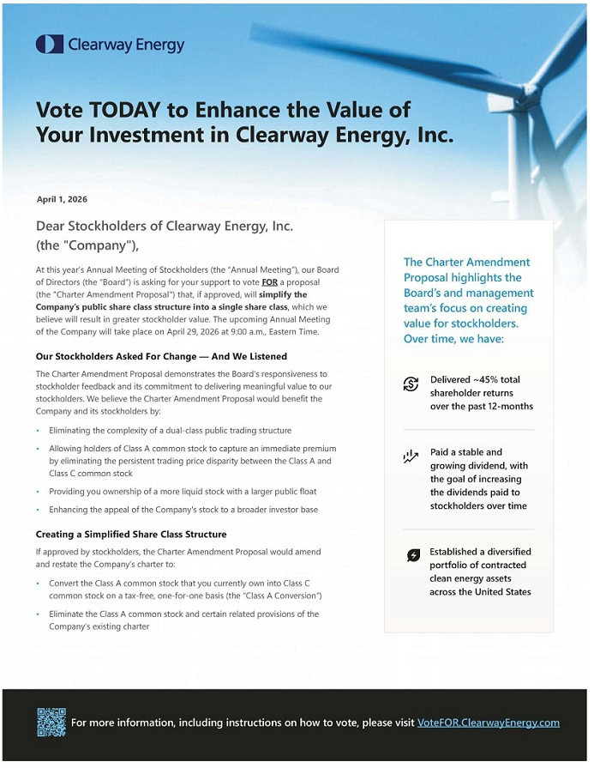

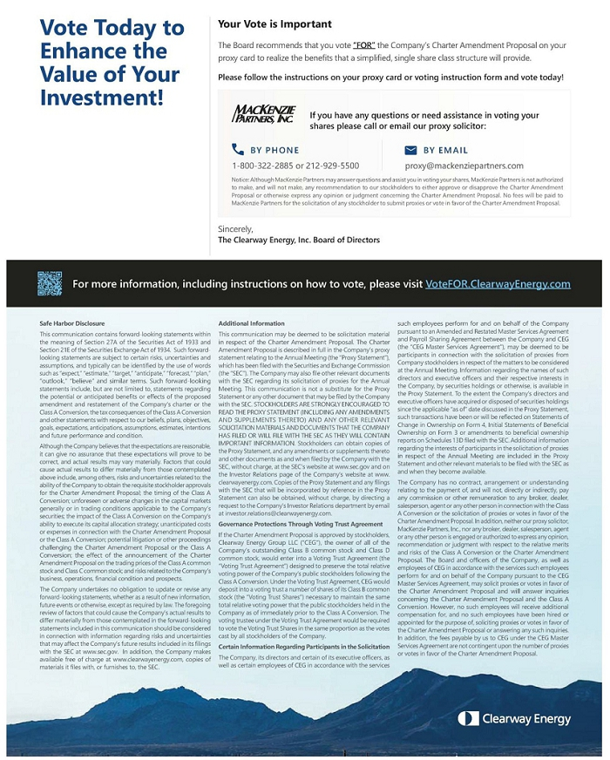

Also on March 30, 2026, the Company posted the following materials to the Campaign Website.

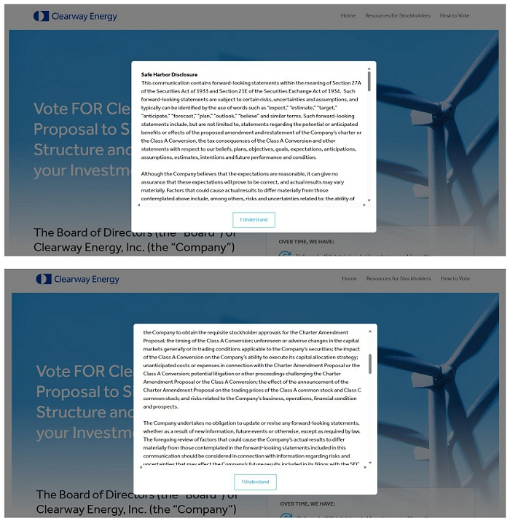

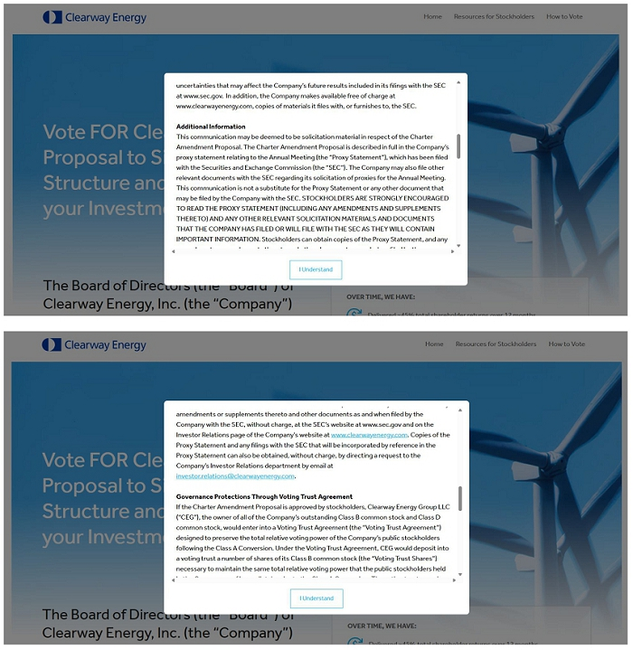

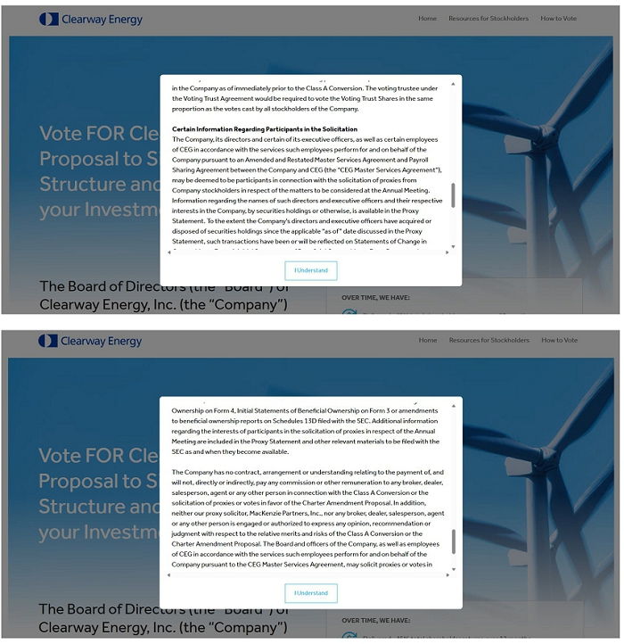

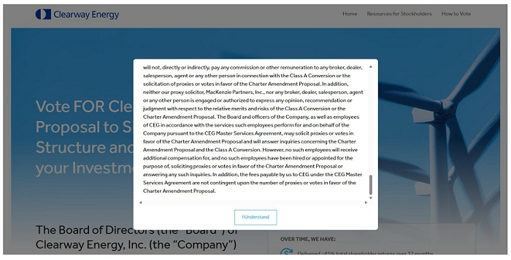

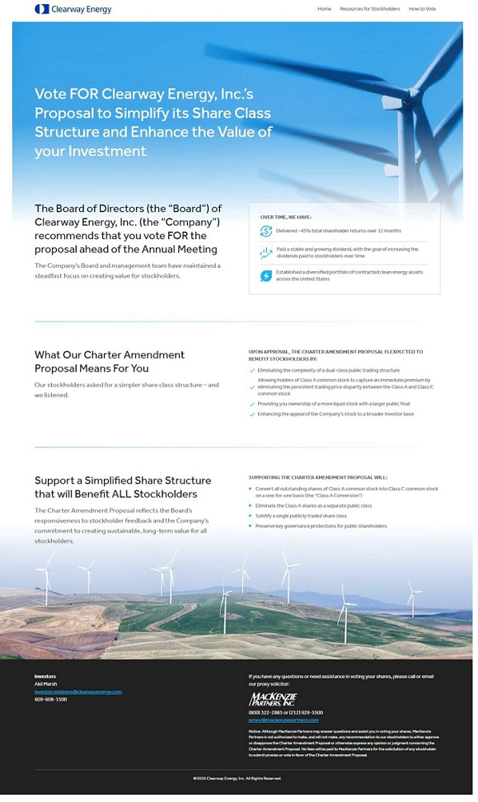

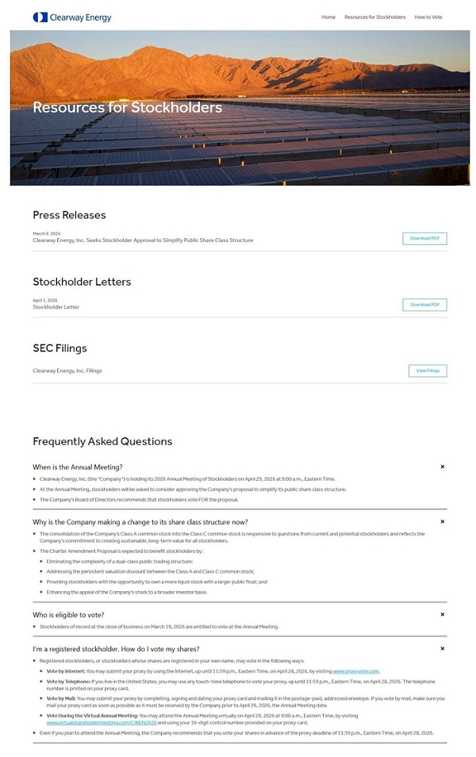

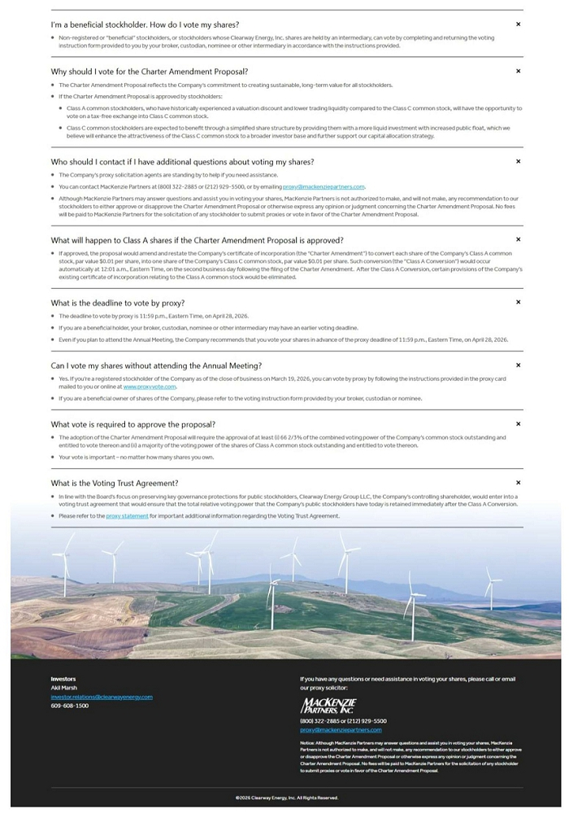

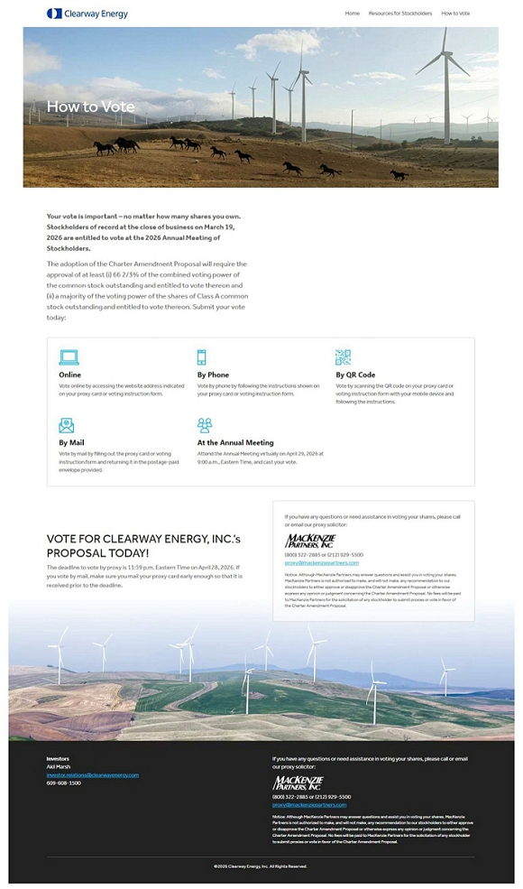

Also on March 30, 2026, the Company posted the following materials on the Investor Relations page of its website at investor.clearwayenergy.com, which page included a hyperlink to the Campaign Website.

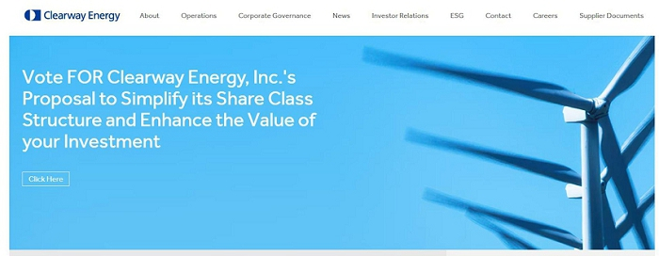

Also on March 30, 2026, the Company issued the following digital advertisements via Google Search and Google Display Network advertising.

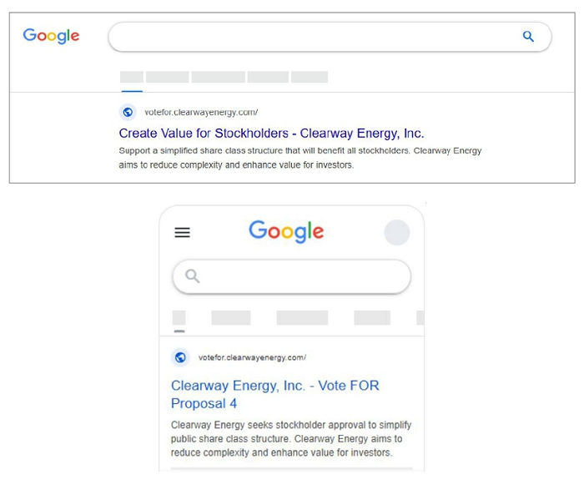

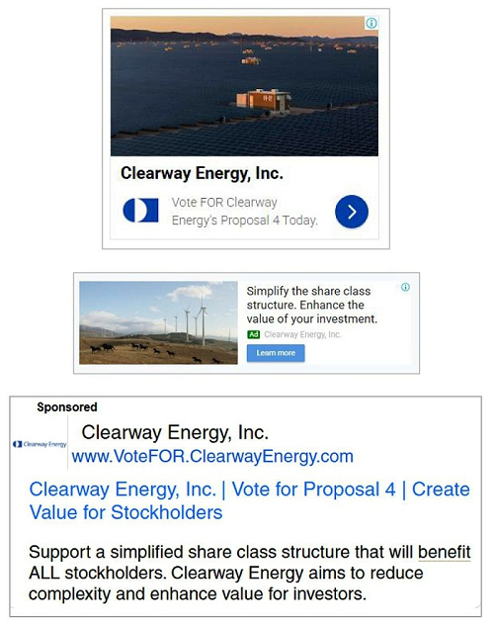

Also on March 30, 2026, the Company posted the following messages on its X account (@ClearwayCWEN).

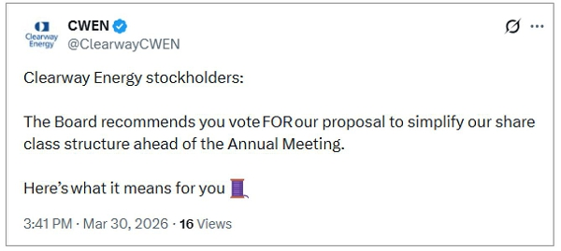

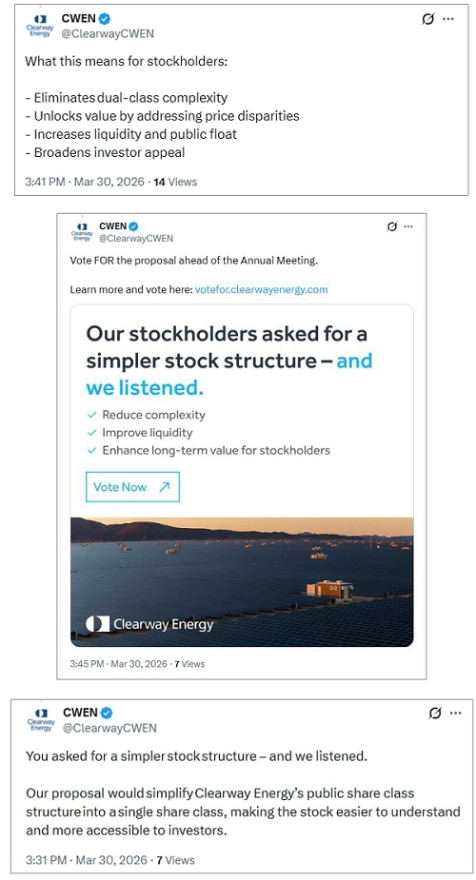

Forward-Looking Statements

This filing contains forward-looking statements within the meaning of Section 27A of the Securities Act of 1933 and Section 21E of the Securities Exchange Act of 1934. Such forward-looking statements are subject to certain risks, uncertainties and assumptions, and typically can be identified by the use of words such as “expect,” “estimate,” “target,” “anticipate,” “forecast,” “plan,” “outlook,” “believe” and similar terms. Such forward-looking statements include, but are not limited to, statements regarding the potential or anticipated benefits or effects of the proposed amendment and restatement of the Company’s certificate of incorporation (the “Charter Amendment”) or the conversion of shares of the Company’s Class A common stock, par value $0.01 per share, into shares of the Company’s Class C common stock, par value $0.01 per share, that would result from the Charter Amendment (the “Class A Conversion”), the tax consequences of the Class A Conversion and other statements with respect to our beliefs, plans, objectives, goals, expectations, anticipations, assumptions, estimates, intentions and future performance and condition.

Although the Company believes that the expectations are reasonable, it can give no assurance that these expectations will prove to be correct, and actual results may vary materially. Factors that could cause actual results to differ materially from those contemplated above include, among others, risks and uncertainties related to: the ability of the Company to obtain the requisite stockholder approvals for the Charter Amendment; the timing of the Class A Conversion; unforeseen or adverse changes in the capital markets generally or in trading conditions applicable to the Company’s securities; the impact of the Class A Conversion on the Company’s ability to execute its capital allocation strategy; unanticipated costs or expenses in connection with the proposal to approve the Charter Amendment (the “Charter Amendment Proposal”) or the Class A Conversion; potential litigation or other proceedings challenging the Charter Amendment Proposal or the Class A Conversion; the effect of the announcement of the Charter Amendment Proposal on the trading prices of the Class A common stock and Class C common stock; and risks related to the Company’s business, operations, financial condition and prospects.

The Company undertakes no obligation to update or revise any forward-looking statements, whether as a result of new information, future events or otherwise, except as required by law. The foregoing review of factors that could cause the Company’s actual results to differ materially from those contemplated in the forward-looking statements included in this filing should be considered in connection with information regarding risks and uncertainties that may affect the Company’s future results included in its filings with the Securities and Exchange Commission (the “SEC”) at www.sec.gov. In addition, the Company makes available free of charge at www.clearwayenergy.com, copies of materials it files with, or furnishes to, the SEC.

Additional Information

The Charter Amendment Proposal is described in full in the Company’s definitive proxy statement (the “Proxy Statement”) relating to its 2026 Annual Meeting of Stockholders (the “2026 Annual Meeting”), which has been filed with the SEC. The Company may also file other relevant documents with the SEC regarding its solicitation of proxies for the 2026 Annual Meeting. STOCKHOLDERS ARE STRONGLY ENCOURAGED TO READ THE PROXY STATEMENT (INCLUDING ANY AMENDMENTS AND SUPPLEMENTS THERETO) AND ANY OTHER RELEVANT SOLICITATION MATERIALS AND DOCUMENTS THAT THE COMPANY HAS FILED OR WILL FILE WITH THE SEC AS THEY WILL CONTAIN IMPORTANT INFORMATION. Stockholders can obtain copies of the Proxy Statement, any amendments or supplements thereto and other documents as and when filed by the Company with the SEC, without charge, at the SEC’s website at www.sec.gov, and on the Investor Relations page of the Company’s website at www.clearwayenergy.com. Copies of the Proxy Statement and any filings with the SEC that will be incorporated by reference in the Proxy Statement can also be obtained, without charge, by directing a request to the Company’s Investor Relations department by email at investor.relations@clearwayenergy.com.

Certain Information Regarding Participants in the Solicitation

The Company, its directors and certain of its executive officers, as well as certain employees of Clearway Energy Group LLC (“CEG”) in accordance with the services such employees perform for and on behalf of the Company pursuant to an Amended and Restated Master Services Agreement and Payroll Sharing Agreement between the Company and CEG (the “CEG Master Services Agreement”), may be deemed to be participants in connection with the solicitation of proxies from Company stockholders in respect of the matters to be considered at the 2026 Annual Meeting. Information regarding the names of such directors and executive officers and their respective interests in the Company, by securities holdings or otherwise, is available in the Proxy Statement. To the extent the Company’s directors and executive officers have acquired or disposed of securities holdings since the applicable “as of” date discussed in the Proxy Statement, such transactions have been or will be reflected on Statements of Change in Ownership on Form 4, Initial Statements of Beneficial Ownership on Form 3 or amendments to beneficial ownership reports on Schedules 13D or 13G filed with the SEC. Additional information regarding the interests of participants in the solicitation of proxies in respect of the 2026 Annual Meeting are included in the Proxy Statement and other relevant materials to be filed with the SEC as and when they become available.

The Company has no contract, arrangement or understanding relating to the payment of, and will not, directly or indirectly, pay any commission or other remuneration to any broker, dealer, salesperson, agent or any other person in connection with the Class A Conversion or the solicitation of proxies or votes in favor of the Charter Amendment Proposal. In addition, neither the Company’s proxy solicitor, MacKenzie Partners, Inc., nor any broker, dealer, salesperson, agent or any other person is engaged or authorized to express any opinion, recommendation or judgment with respect to the relative merits and risks of the Class A Conversion or the Charter Amendment Proposal. The Board and officers of the Company, as well as employees of CEG in accordance with the services such employees perform for and on behalf of the Company pursuant to the CEG Master Services Agreement, may solicit proxies or votes in favor of the Charter Amendment Proposal and will answer inquiries concerning the Charter Amendment Proposal and the Class A Conversion. However, no such employees will receive additional compensation for, and no such employees have been hired or appointed for the purpose of, soliciting proxies or votes in favor of the Charter Amendment Proposal or answering any such inquiries. In addition, the fees payable by the Company to CEG under the CEG Master Services Agreement are not contingent upon the number of proxies or votes in favor of the Charter Amendment Proposal.

