SEC Form 4

FORM 4

Check this box if no longer subject to Section 16. Form 4 or Form 5 obligations may continue. See Instruction 1(b).

UNITED STATES SECURITIES AND EXCHANGE COMMISSION
Washington, D.C. 20549
 |  | OMB APPROVAL
STATEMENT OF CHANGES IN BENEFICIAL OWNERSHIP
 |  | OMB Number: | 3235-0287
 |  | Estimated average burden
Filed pursuant to Section 16(a) of the Securities Exchange Act of 1934 |  | hours per response: | 0.5
or Section 30(h) of the Investment Company Act of 1940
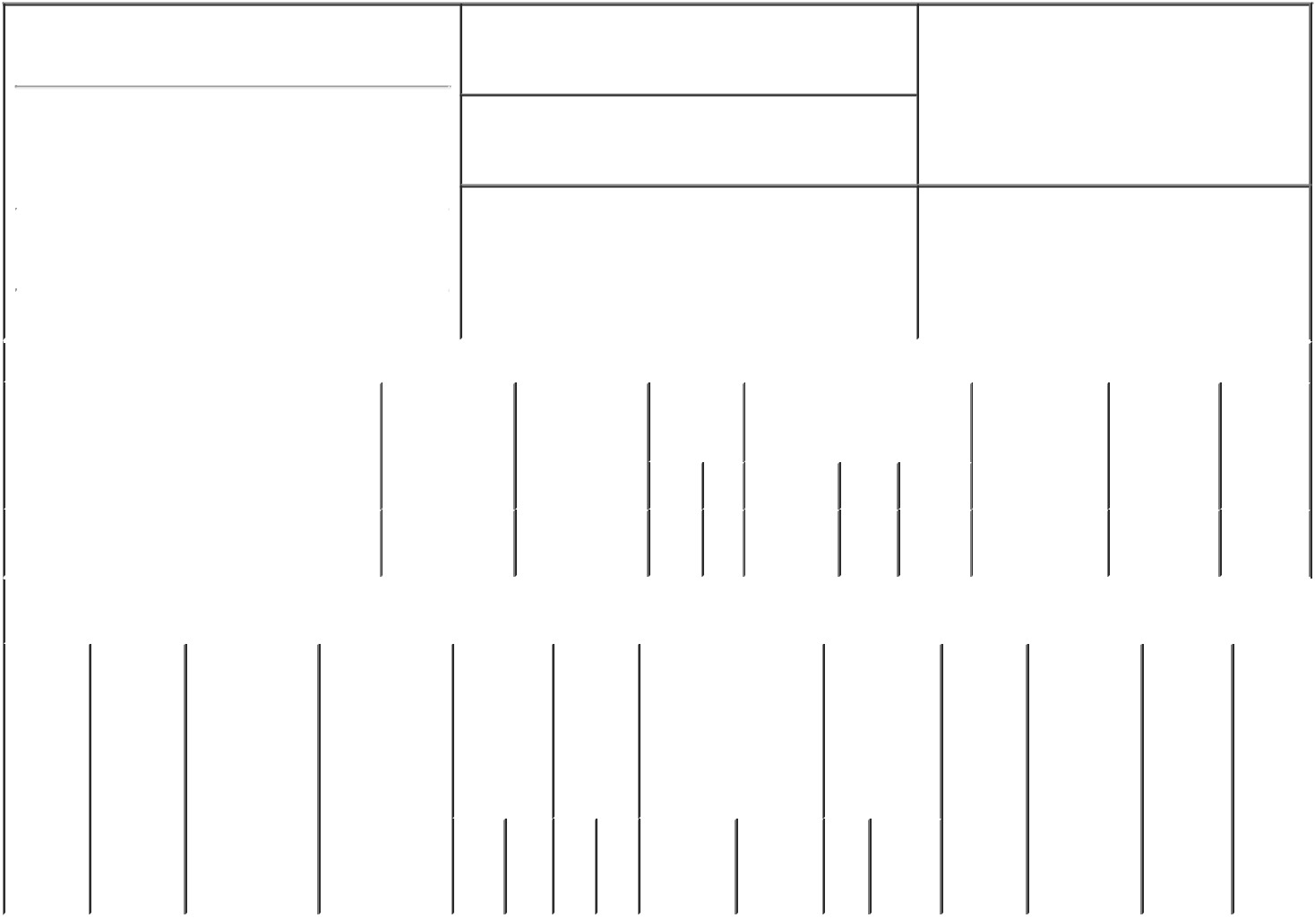

1. Name and Address of Reporting Person*
Rubenstein Sarah

(Last) (First) (Middle)

300 CARNEGIE CENTER

SUITE 300

2. Issuer Name and Ticker or Trading Symbol

Clearway Energy, Inc. [ CWEN ]

3. Date of Earliest Transaction (Month/Day/Year)

10/15/2022

- Relationship of Reporting Person(s) to Issuer (Check all applicable)

 | Director | 10% Owner
X | Officer (give title | Other (specify
 | below) | below)

SVP & CAO

 |  |  |  |  |  |  |  | 4. If Amendment, Date of Original Filed (Month/Day/Year) |  |  |  |  |  |  |  | 6. Individual or Joint/Group Filing (Check Applicable
 | (Street) |  |  |  |  |  |  |  |  |  |  |  |  |  |  | Line)
 |  |  |  |  |  |  |  |  |  |  |  |  |  |  |  |  |  | X Form filed by One Reporting Person
 |  | PRINCETON NJ |  |  | 08540
 |  |  |  |  |  |  |  |  |  |  |  |  |  |  |  |  |  |  | Form filed by More than One Reporting
 |  |  |  |  |  |  |  |  |  |  |  |  |  |  |  |  |  |  | Person
 |  | (City) | (State) |  | (Zip)
 |  |  |  | Table I - Non-Derivative Securities Acquired, Disposed of, or Beneficially Owned
 | 1. Title of Security (Instr. 3) |  |  |  |  | 2. Transaction |  |  | 2A. Deemed |  | 3. |  | 4. Securities Acquired (A) or |  |  |  |  |  | 5. Amount of |  | 6. Ownership | 7. Nature
 |  |  |  |  |  | Date |  |  | Execution Date, |  |  | Transaction | Disposed Of (D) (Instr. 3, 4 and Securities |  |  |  |  |  |  |  | Form: Direct | of Indirect
 |  |  |  |  |  | (Month/Day/Year) |  |  | if any |  |  | Code (Instr. | 5) |  |  |  |  |  | Beneficially |  | (D) or Indirect | Beneficial
 |  |  |  |  |  |  |  |  | (Month/Day/Year) |  | 8) |  |  |  |  |  |  |  | Owned Following |  | (I) (Instr. 4) | Ownership
 |  |  |  |  |  |  |  |  |  |  |  |  |  |  |  |  |  |  | Reported |  |  | (Instr. 4)
 |  |  |  |  |  |  |  |  |  |  |  | Code V | Amount | (A) or |  | Price |  |  | Transaction(s)
 |  |  |  |  |  |  |  |  |  |  |  |  |  | (D) |  |  |  |  | (Instr. 3 and 4)
 | Class C Common Stock, par value $.01 per |  |  |  |  | 10/15/2022 |  |  |  |  |  | F | 268 | D |  | (1) |  | 26,419⁽²⁾ |  |  | D
 | share
 |  |  |  |  | Table II - Derivative Securities Acquired, Disposed of, or Beneficially Owned
 |  |  |  |  |  | (e.g., puts, calls, warrants, options, convertible securities)
 | 1. Title of |  | 2. | 3. Transaction | 3A. Deemed |  | 4. |  |  | 5. Number | 6. Date Exercisable and |  |  | 7. Title and |  |  |  | 8. Price of |  | 9. Number of 10. |  | 11. Nature
 | Derivative |  | Conversion | Date | Execution Date, |  |  | Transaction |  | of | Expiration Date |  |  | Amount of |  |  |  | Derivative |  | derivative | Ownership | of Indirect
 | Security |  | or Exercise | (Month/Day/Year) if any |  |  |  | Code (Instr. |  | Derivative | (Month/Day/Year) |  |  | Securities |  |  |  | Security |  | Securities | Form: | Beneficial
 | (Instr. 3) |  | Price of |  | (Month/Day/Year) |  | 8) |  |  | Securities |  |  |  | Underlying |  |  |  | (Instr. 5) |  | Beneficially | Direct (D) | Ownership
 |  |  | Derivative |  |  |  |  |  |  | Acquired |  |  |  | Derivative |  |  |  |  |  | Owned | or Indirect | (Instr. 4)
 |  |  | Security |  |  |  |  |  |  | (A) or |  |  |  | Security (Instr. |  |  |  |  |  | Following | (I) (Instr. 4)
 |  |  |  |  |  |  |  |  |  | Disposed |  |  |  | 3 and 4) |  |  |  |  |  | Reported
 |  |  |  |  |  |  |  |  |  | of (D) |  |  |  |  |  |  |  |  |  | Transaction(s)
 |  |  |  |  |  |  |  |  |  | (Instr. 3, 4 |  |  |  |  |  |  |  |  |  | (Instr. 4)
 |  |  |  |  |  |  |  |  |  | and 5)
 |  |  |  |  |  |  |  |  |  |  |  |  |  |  | Amount
 |  |  |  |  |  |  |  |  |  |  |  |  |  |  | or
 |  |  |  |  |  |  |  |  |  |  |  |  |  |  | Number
 |  |  |  |  |  |  |  |  |  |  | Date |  | Expiration |  | of
 |  |  |  |  |  |  |  | Code | V | (A) (D) | Exercisable |  | Date | Title | Shares

Explanation of Responses:

- On October 15, 2019, Ms. Rubenstein was issued 2,062 Restricted Stock Units ("RSUs") by Clearway Energy, Inc. (f/k/a NRG Yield, Inc.) under Clearway Energy Inc.'s Amended and Restated 2013 Equity Incentive Plan (the "LTIP"). These RSUs vest ratably over a three-year period beginning on the first anniversary of the date of the grant. Each RSU is equivalent in value to one share of Class C Common Stock of Clearway Energy Inc., par value $.01 per share. On October 15, 2022, 689 shares vested. Ms. Rubenstein elected to satisfy her tax obligation upon the exchange of common stock for RSUs having a value on the date of the exchange equal to the withholding obligation. This form reflects the surrender of 268 shares of Class C Common Stock to satisfy the grantee's tax withholding obligation.

- In connection with the vesting of the RSUs described above, 92 DERs converted to Class C Common Stock, resulting in the reporting person holding 999 dividend equivalent rights that may only be settled in Class C Common Stock. Dividend equivalent rights accrue on the reporting person's restricted stock, which become exercisable proportionately with the restricted stock units to which they relate and may only be settled in Clearway Energy, Inc. Class C Common Stock. Each dividend equivalent right is the economic equivalent of one share of Clearway Energy, Inc. Class C Common Stock.

/s/ Kevin P. Malcarney, |  |  | 10/18/2022
Attorney-in-Fact
** Signature of Reporting Person |  |  | Date

Reminder: Report on a separate line for each class of securities beneficially owned directly or indirectly.

* If the form is filed by more than one reporting person, see Instruction 4 (b)(v).

- Intentional misstatements or omissions of facts constitute Federal Criminal Violations See 18 U.S.C. 1001 and 15 U.S.C. 78ff(a). Note: File three copies of this Form, one of which must be manually signed. If space is insufficient, see Instruction 6 for procedure.

Persons who respond to the collection of information contained in this form are not required to respond unless the form displays a currently valid OMB Number.

