SEC Form 4

FORM 4

Check this box if no longer subject to Section 16. Form 4 or Form 5 obligations may continue. See Instruction 1(b).

UNITED STATES SECURITIES AND EXCHANGE COMMISSION
Washington, D.C. 20549
 |  | OMB APPROVAL
STATEMENT OF CHANGES IN BENEFICIAL OWNERSHIP
 |  | OMB Number: | 3235-0287
 |  | Estimated average burden
Filed pursuant to Section 16(a) of the Securities Exchange Act of 1934 |  | hours per response: | 0.5
or Section 30(h) of the Investment Company Act of 1940
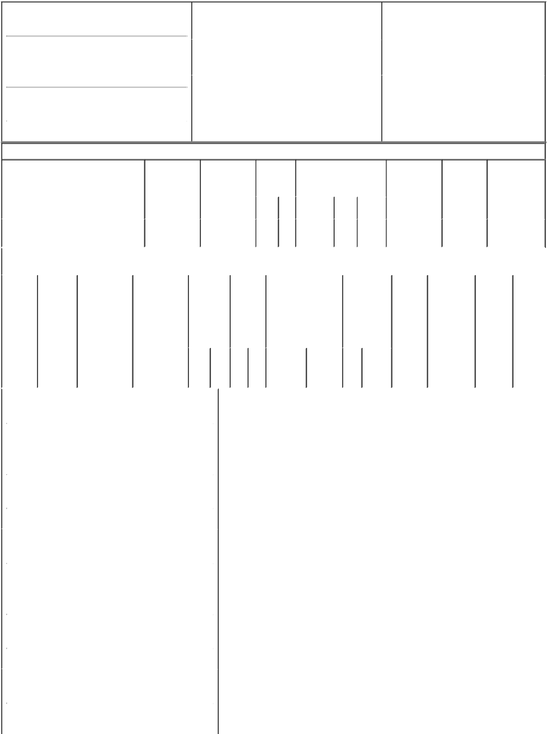

1. Name and Address of Reporting Person*
Global Infrastructure Investors III, LLC

(Last) (First) (Middle)

1345 AVENUE OF THE AMERICAS, 30TH FLOOR

(Street)
 | NEW YORK | NY | 10105
 | (City) | (State) | (Zip)

2. |  | Issuer Name and Ticker or Trading Symbol |  | 5. | Relationship of Reporting Person(s) to Issuer
 | Clearway Energy, Inc. [ CWEN ] |  |  | (Check all applicable)
 |  |  |  |  | X Director | X 10% Owner
 |  |  |  |  | Officer (give title | Other (specify
3. |  | Date of Earliest Transaction (Month/Day/Year) |  |  | below) | below)
10/07/2022
4. |  | If Amendment, Date of Original Filed (Month/Day/Year) |  | 6. | Individual or Joint/Group Filing (Check Applicable
Line)

 | Form filed by One Reporting Person
X | Form filed by More than One Reporting
 | Person

Table I - Non-Derivative Securities Acquired, Disposed of, or Beneficially Owned

 | 1. Title of Security (Instr. 3) |  |  |  |  |  | 2. Transaction |  | 2A. Deemed |  |  |  |  |  | 3. |  | 4. Securities Acquired (A) or |  |  |  | 5. Amount of |  | 6. Ownership |  | 7. Nature of
 |  |  |  |  |  |  | Date |  | Execution Date, |  |  |  |  |  | Transaction |  | Disposed Of (D) (Instr. 3, 4 |  |  |  | Securities |  | Form: Direct |  | Indirect Beneficial
 |  |  |  |  |  |  | (Month/Day/Year) if any |  |  |  |  |  |  |  | Code (Instr. |  | and 5) |  |  |  | Beneficially |  | (D) or |  | Ownership (Instr.
 |  |  |  |  |  |  |  |  | (Month/Day/Year) |  |  |  |  |  | 8) |  |  |  |  |  | Owned |  | Indirect (I) |  | 4)
 |  |  |  |  |  |  |  |  |  |  |  |  |  |  |  |  |  |  |  |  | Following |  | (Instr. 4)
 |  |  |  |  |  |  |  |  |  |  |  |  |  |  |  |  |  | (A) or |  |  | Reported
 |  |  |  |  |  |  |  |  |  |  |  |  |  |  | Code V |  | Amount |  | Price |  | Transaction(s)
 |  |  |  |  |  |  |  |  |  |  |  |  |  |  |  |  |  | (D) |  |  | (Instr. 3 and 4)
 | Class C Common Stock |  |  |  |  | 10/07/2022 |  |  |  |  |  |  |  |  | _{J}(1) |  | 1,278 | A | (1) |  | 72,301 |  | I |  | See
 |  |  |  |  |  |  |  |  |  |  |  |  |  |  |  |  |  |  |  |  |  |  |  |  | _{footnotes}(2)(3)(4)
 |  |  |  |  | Table II - Derivative Securities Acquired, Disposed of, or Beneficially Owned
 |  |  |  |  |  |  | (e.g., puts, calls, warrants, options, convertible securities)
 | 1. Title of |  | 2. | 3. Transaction |  | 3A. Deemed |  |  | 4. |  |  |  | 5. Number |  |  | 6. Date Exercisable and |  | 7. Title and |  |  |  | 8. Price of | 9. Number of | 10. |  | 11. Nature
 | Derivative |  | Conversion | Date |  | Execution Date, |  |  | Transaction |  |  |  | of |  |  | Expiration Date |  | Amount of |  |  |  | Derivative | derivative | Ownership |  | of Indirect
 | Security |  | or Exercise | (Month/Day/Year) |  | if any |  |  | Code (Instr. |  |  |  | Derivative |  |  | (Month/Day/Year) |  | Securities |  |  |  | Security | Securities | Form: |  | Beneficial
 | (Instr. 3) |  | Price of |  |  | (Month/Day/Year) |  |  | 8) |  |  |  | Securities |  |  |  |  | Underlying |  |  |  | (Instr. 5) | Beneficially | Direct (D) |  | Ownership
 |  |  | Derivative |  |  |  |  |  |  |  |  |  | Acquired |  |  |  |  | Derivative |  |  |  |  | Owned | or Indirect |  | (Instr. 4)
 |  |  | Security |  |  |  |  |  |  |  |  |  | (A) or |  |  |  |  | Security (Instr. |  |  |  |  | Following | (I) (Instr. 4)
 |  |  |  |  |  |  |  |  |  |  |  |  | Disposed |  |  |  |  | 3 and 4) |  |  |  |  | Reported
 |  |  |  |  |  |  |  |  |  |  |  |  | of (D) |  |  |  |  |  |  |  |  |  | Transaction(s)
 |  |  |  |  |  |  |  |  |  |  |  |  | (Instr. 3, 4 |  |  |  |  |  |  |  |  |  | (Instr. 4)
 |  |  |  |  |  |  |  |  |  |  |  |  | and 5)
 |  |  |  |  |  |  |  |  |  |  |  |  |  |  |  |  |  |  | Amount
 |  |  |  |  |  |  |  |  |  |  |  |  |  |  |  |  |  |  | or
 |  |  |  |  |  |  |  |  |  |  |  |  |  |  |  |  |  |  | Number
 |  |  |  |  |  |  |  |  |  |  |  |  |  |  |  | Date | Expiration |  | of
 |  |  |  |  |  |  |  |  | Code V |  |  |  | (A) (D) |  |  | Exercisable Date |  | Title | Shares
 | 1. Name and Address of Reporting Person*
 |  | Global Infrastructure Investors III, LLC
 |  | (Last) |  | (First) |  | (Middle)
 |  | 1345 AVENUE OF THE AMERICAS,
 |  | 30TH FLOOR
 | (Street)
 |  | NEW YORK |  | NY |  | 10105
 |  | (City) |  | (State) |  | (Zip)
 | 1. Name and Address of Reporting Person*
 |  | Global Infrastructure GP III, L.P.
 |  | (Last) |  | (First) |  | (Middle)
 |  | 1345 AVENUE OF THE AMERICAS,
 |  | 30TH FLOOR
 | (Street)
 |  | NEW YORK |  | NY |  | 10105
 |  | (City) |  | (State) |  | (Zip)
 | 1. Name and Address of Reporting Person*
 |  | Zephyr Holdings GP, LLC
 |  | (Last) |  | (First) |  | (Middle)

1345 AVENUE OF THE AMERICAS,

30TH FLOOR

(Street)
 | NEW YORK | NY | 10105
 | (City) | (State) | (Zip)

1. Name and Address of Reporting Person*
GIP III Zephyr Midco Holdings, L.P.

 | (Last) | (First) | (Middle)
 | 1345 AVENUE OF THE AMERICAS,
 | 30TH FLOOR
(Street)
 | NEW YORK | NY | 10105
 | (City) | (State) | (Zip)

1. Name and Address of Reporting Person*
GIP III Zephyr Acquisition Partners L.P.

 | (Last) | (First) |  | (Middle)
 | 1345 AVENUE OF THE AMERICAS,
 | 30TH FLOOR
(Street)
 | NEW YORK | NY |  | 10105
 | (City) | (State) |  | (Zip)
1. Name and Address of Reporting Person*
 | Clearway Energy Group LLC
 | (Last) | (First) |  | (Middle)
 | 1345 AVENUE OF THE AMERICAS,
 | 30TH FLOOR
(Street)
 | NEW YORK | NY |  | 10105
 | (City) | (State) |  | (Zip)

Explanation of Responses:

- Reflects the forfeiture of shares of restricted stock of the Issuer previously granted by Clearway Energy Group LLC ("Clearway Energy Group") under its Long Term Equity Incentive Program to one or more of its employees.

- Reflects securities held directly by Clearway Energy Group. Zephyr Holdings GP, LLC ("Zephyr GP") is the general partner of GIP III Zephyr Acquisition Partners, L.P. ("Zephyr") which is the sole member of Clearway Energy Group. Zephyr GP is owned by GIP III Zephyr Midco Holdings, L.P. ("Midco") and TotalEnergies Renewables USA, LLC. Global Infrastructure Investors III, LLC ("Global Investors") is the sole general partner of Global Infrastructure GP III, L.P. ("Global GP"), which is the general partner of Midco. As a result, each of Zephyr GP, Zephyr, Midco, Global GP and Global Investors, may be deemed to share beneficial ownership of the securities owned by Clearway Energy Group.

- Adebayo Ogunlesi, Jonathan Bram, William Brilliant, Matthew Harris, Michael McGhee, Rajaram Rao, William Woodburn, Salim Samaha and Robert O'Brien, as the voting members of the Investment Committee of Global Investors, may be deemed to share beneficial ownership of the Issuer securities beneficially owned by Global Investors. Such individuals expressly disclaim any such beneficial ownership.

- Each of the Reporting Persons disclaims beneficial ownership of the securities reported herein, except to the extent of such Reporting Person's pecuniary interest therein, and, pursuant to Rule 16a-1(a)

(4) under the Securities Exchange Act of 1934, each of the Reporting Persons states that the inclusion of these securities in this report shall not be deemed an admission of beneficial ownership of the securities reported herein for purposes of Section 16 or for any other purpose.

GLOBAL

INFRASTRUCTURE
INVESTORS III, LLC By: /s/
Jonathan Bram Name:
Jonathan Bram Title: President

GLOBAL

INFRASTRUCTURE GP III,
L.P. By: Global Infrastructure
Investors III, LLC, its general
partner By: /s/ Gregg Myers
Name: Gregg Myers Title:
Chief Financial Officer

GIP III ZEPHYR MIDCO

HOLDINGS, L.P. By: Global
Infrastructure GP III, L.P., its
general partner By: Global
Infrastructure Investors III,
LLC, its general partner By:
/s/ Gregg Myers Name: Gregg

10/12/2022

10/12/2022

10/12/2022

Myers Title: Chief Financial

Officer

ZEPHYR HOLDINGS GP,

LLC By: /s/ Jonathan Bram
Name: Jonathan Bram Title:
Officer

GIP III ZEPHYR

ACQUISITION PARTNERS,
L.P. By: Zephyr Holdings GP,
LLC, its general partner By:
/s/ Gregg Myers Name: Gregg
Myers Title: Chief Financial
Officer

CLEARWAY ENERGY

GROUP LLC By: /s/ Stacy
Colby-King Name: Stacy
Colby-King Title: VP of
Human Resources

10/12/2022

10/12/2022

10/12/2022

** Signature of Reporting Person Date

Reminder: Report on a separate line for each class of securities beneficially owned directly or indirectly.

* If the form is filed by more than one reporting person, see Instruction 4 (b)(v).

- Intentional misstatements or omissions of facts constitute Federal Criminal Violations See 18 U.S.C. 1001 and 15 U.S.C. 78ff(a). Note: File three copies of this Form, one of which must be manually signed. If space is insufficient, see Instruction 6 for procedure.

Persons who respond to the collection of information contained in this form are not required to respond unless the form displays a currently valid OMB Number.

