UNITED STATES SECURITIES AND EXCHANGE COMMISSION
Washington, D.C. 20549
Form 10-K
☒ |  |  |  |  |  | ANNUAL REPORT PURSUANT TO SECTION 13 OR 15(d) OF THE SECURITIES EXCHANGE ACT OF 1934
 |  |  |  |  |  | For the Fiscal Year ended |  |  | December 31, 2023
☐ |  |  |  |  |  | TRANSITION REPORT PURSUANT TO SECTION 13 OR 15(d) OF THE SECURITIES EXCHANGE ACT OF 1934  For the Transition period from to .
Commission File Number: 001-36002
Clearway Energy, Inc.
(Exact name of registrant as specified in its charter)
Delaware |  |  |  |  |  |  |  |  | 46-1777204
(State or other jurisdiction  of incorporation or organization) |  |  |  |  |  |  |  |  | (I.R.S. Employer  Identification No.)
300 Carnegie Center, Suite 300 |  |  | Princeton |  |  | New Jersey |  |  | 08540
(Address of principal executive offices) |  |  |  |  |  |  |  |  | (Zip Code)
(609) 608-1525
(Registrant’s telephone number, including area code)
Securities registered pursuant to Section 12(b) of the Act:
Title of each class |  |  | Trading Symbol(s) |  |  | Name of each exchange on which registered
Class A Common Stock, par value $0.01 |  |  | CWEN.A |  |  | New York Stock Exchange
Class C Common Stock, par value $0.01 |  |  | CWEN |  |  | New York Stock Exchange
Securities registered pursuant to Section 12(g) of the Act:
None
Indicate by check mark if the registrant is a well-known seasoned issuer, as defined in Rule 405 of the Securities Act. Yes ☒ No ☐
Indicate by check mark if the registrant is not required to file reports pursuant to Section 13 or Section 15(d) of the Exchange Act. Yes ☐ No ☒
Indicate by check mark whether the registrant (1) has filed all reports required to be filed by Section 13 or 15(d) of the Securities Exchange Act of 1934 during the preceding 12 months (or for such shorter period that the registrant was required to file such reports), and (2) has been subject to such filing requirements for the past 90 days. Yes ☒ No ☐
Indicate by check mark whether the registrant has submitted electronically every Interactive Data File required to be submitted pursuant to Rule 405 of Regulation S-T (§232.405 of this chapter) during the preceding 12 months (or for such shorter period that the registrant was required to submit such files). Yes ☒ No ☐
Indicate by check mark whether the registrant is a large accelerated filer, an accelerated filer, a non-accelerated filer, a smaller reporting company or an emerging growth company. See the definitions of “large accelerated filer,” “accelerated filer,” “smaller reporting company,” and “emerging growth company” in Rule 12b-2 of the Exchange Act.
Large accelerated filer |  |  | ☒ |  |  | Accelerated filer |  |  | ☐
Non-accelerated filer |  |  | ☐ |  |  | Smaller reporting company |  |  | ☐
 |  |  |  |  |  | Emerging growth company |  |  | ☐
If an emerging growth company, indicate by check mark if the registrant has elected not to use the extended transition period for complying with any new or revised financial accounting standards provided pursuant to Section 13(a) of the Exchange Act. ☐
Indicate by check mark whether the registrant is a shell company (as defined in Rule 12b-2 of the Act). Yes ☐ No x
Indicate by check mark whether the registrant has filed a report on and attestation to its management’s assessment of the effectiveness of its internal control over financial reporting under section 404(b) of the Sarbanes-Oxley Act (15 U.S.C. 7262(b)) by the registered public accounting firm that prepared or issued its audit report. x
If securities are registered pursuant to Section 12(b) of the Act, indicate by check mark whether the financial statements of the registrant included in the filing reflect the correction of an error to previously issued financial statements. ☐
Indicate by check mark whether any of those error corrections are restatements that required a recovery analysis of incentive-based compensation received by any of the registrant’s executive officers during the relevant recovery period pursuant to §240.10D-1(b). ☐
As of the last business day of the most recently completed second fiscal quarter, the aggregate market value of the common stock of the registrant held by non-affiliates was approximately $2.54 billion based on the closing sale prices of such shares as reported on the New York Stock Exchange.
Indicate the number of shares outstanding of each of the registrant’s classes of common stock as of the latest practicable date.
Class |  |  |  |  |  | Outstanding at January 31, 2024
Common Stock, Class A, par value $0.01 per share |  |  |  |  |  | 34,613,853
Common Stock, Class B, par value $0.01 per share |  |  |  |  |  | 42,738,750
Common Stock, Class C, par value $0.01 per share |  |  |  |  |  | 82,391,441
Common Stock, Class D, par value $0.01 per share |  |  |  |  |  | 42,336,750
Documents Incorporated by Reference:
Portions of the Registrant’s Definitive Proxy Statement relating to its 2024 Annual Meeting of Stockholders
are incorporated by reference into Part III of this Annual Report on Form 10-K

TABLE OF CONTENTS
Index
GLOSSARY OF TERMS |  |  | 3
PART I |  |  | 6
Item 1 — Business |  |  | 6
Item 1A — Risk Factors |  |  | 14
Item 1B — Unresolved Staff Comments |  |  | 36
Item 1C — Cybersecurity |  |  | 37
Item 2 — Properties |  |  | 39
Item 3 — Legal Proceedings |  |  | 42
Item 4 — Mine Safety Disclosures |  |  | 42
PART II |  |  | 43
Item 5 — Market for Registrant’s Common Equity, Related Stockholder Matters and Issuer Purchases of Equity Securities |  |  | 43
Item 6 — Reserved |  |  | 44
Item 7 — Management’s Discussion and Analysis of Financial Condition and Results of Operations |  |  | 45
Item 7A — Quantitative and Qualitative Disclosures About Market Risk |  |  | 64
Item 8 — Financial Statements and Supplementary Data |  |  | 64
Item 9 — Changes in and Disagreements with Accountants on Accounting and Financial Disclosure |  |  | 65
Item 9A — Controls and Procedures |  |  | 65
Item 9B — Other Information |  |  | 67
PART III |  |  | 68
Item 10 — Information about Directors, Executive Officers and Corporate Governance |  |  | 68
Item 11 — Executive Compensation |  |  | 71
Item 12 — Security Ownership of Certain Beneficial Owners and Management and Related Stockholder Matters |  |  | 71
Item 13 — Certain Relationships and Related Transactions, and Director Independence |  |  | 71
Item 14 — Principal Accounting Fees and Services |  |  | 71
PART IV |  |  | 72
Item 15 — Exhibits, Financial Statement Schedules |  |  | 72
EXHIBIT INDEX |  |  | 130
Item 16 — Form 10-K Summary |  |  | 135

2

GLOSSARY OF TERMS
When the following terms and abbreviations appear in the text of this report, they have the meanings indicated below:
2028 Senior Notes |  |  | $850 million aggregate principal amount of 4.75% unsecured senior notes due 2028, issued by Clearway Energy Operating LLC
2031 Senior Notes |  |  | $925 million aggregate principal amount of 3.75% unsecured senior notes due 2031, issued by Clearway Energy Operating LLC
2032 Senior Notes |  |  | $350 million aggregate principal amount of 3.75% unsecured senior notes due 2032, issued by Clearway Energy Operating LLC
Adjusted EBITDA |  |  | A non-GAAP measure, represents earnings before interest (including loss on debt extinguishment), tax, depreciation and amortization adjusted for mark-to-market gains or losses, asset write offs and impairments; and factors which the Company does not consider indicative of future operating performance
ARO |  |  | Asset Retirement Obligation
ASC |  |  | The FASB Accounting Standards Codification, which the FASB established as the source of authoritative GAAP
ASU |  |  | Accounting Standards Updates – updates to the ASC
ATM Program |  |  | At-The-Market Equity Offering Program
BESS |  |  | Battery energy storage system
BlackRock |  |  | BlackRock, Inc.
Black Start |  |  | The capability of a generating asset to restore the grid in the event of a blackout without relying on the external electric power transmission network
Bridge Loan Agreement |  |  | Senior secured bridge credit agreement entered into by Clearway Energy Operating LLC that provides a term loan facility in an aggregate principal amount of $335 million that was repaid on May 3, 2022
CAFD |  |  | A non-GAAP measure, Cash Available for Distribution is defined as of December 31, 2023 as Adjusted EBITDA plus cash distributions/return of investment from unconsolidated affiliates, cash receipts from notes receivable, cash contributions from noncontrolling interests, adjustments to reflect sales-type lease cash payments and payments for lease expenses, less cash distributions to noncontrolling interests, maintenance capital expenditures, pro-rata Adjusted EBITDA from unconsolidated affiliates, cash interest paid, income taxes paid, principal amortization of indebtedness, changes in prepaid and accrued capacity payments, and adjusted for development expenses
Capistrano Wind Portfolio |  |  | Five wind projects representing 413 MW of capacity, which includes Broken Bow and Crofton Bluffs located in Nebraska, Cedro Hill located in Texas and Mountain Wind 1 and 2 located in Wyoming
CEG |  |  | Clearway Energy Group LLC (formerly Zephyr Renewables LLC)
CEG Master Services Agreement |  |  | Amended and Restated Master Services Agreements, dated as of February 2, 2023, among the Company, Clearway Energy LLC, Clearway Energy Operating LLC and CEG
Clearway Energy LLC |  |  | The holding company through which the projects are owned by Clearway Energy Group LLC, the holder of Class B and Class D units, and Clearway Energy, Inc., the holder of the Class A and Class C units
Clearway Energy Group LLC |  |  | The holder of all shares of the Company’s Class B and Class D common stock and Clearway Energy LLC’s Class B and Class D units, and from time to time, possibly shares of Clearway Energy, Inc.’s Class A and/or Class C common stock
Clearway Energy Operating LLC |  |  | The holder of the project assets that are owned by Clearway Energy LLC
Clearway Renew |  |  | Clearway Renew LLC, a subsidiary of CEG, and its wholly-owned subsidiaries
COD |  |  | Commercial Operation Date
Code |  |  | Internal Revenue Code of 1986, as amended
Company |  |  | Clearway Energy, Inc., together with its consolidated subsidiaries
CVSR |  |  | California Valley Solar Ranch
CVSR Holdco |  |  | CVSR Holdco LLC, the indirect owner of CVSR
Distributed Solar |  |  | Solar power projects, typically less than 20 MW in size (on an alternating current, or AC, basis), that primarily sell power produced to customers for usage on site, or are interconnected to sell power into the local distribution grid
3

Drop Down Assets |  |  | Assets under common control acquired by the Company from CEG
EPA |  |  | United States Environmental Protection Agency
ERCOT |  |  | Electric Reliability Council of Texas, the ISO and the regional reliability coordinator of the various electricity systems within Texas
EWG |  |  | Exempt Wholesale Generator
Exchange Act |  |  | The Securities Exchange Act of 1934, as amended
FASB |  |  | Financial Accounting Standards Board
FERC |  |  | Federal Energy Regulatory Commission
FPA |  |  | Federal Power Act
FWS |  |  | U.S. Fish & Wildlife Service
GAAP |  |  | Accounting principles generally accepted in the U.S.
GenConn |  |  | GenConn Energy LLC
GHG |  |  | Greenhouse gas
GIM |  |  | Global Infrastructure Management, LLC, the manager of GIP
GIP |  |  | Global Infrastructure Partners
HLBV |  |  | Hypothetical Liquidation at Book Value
IRA |  |  | Inflation Reduction Act of 2022
IRS |  |  | Internal Revenue Service
ISO |  |  | Independent System Operator, also referred to as an RTO
ITC |  |  | Investment Tax Credit
KKR |  |  | KKR Thor Bidco, LLC, an affiliate of Kohlberg Kravis Roberts & Co. L.P.
kWh |  |  | Kilowatt Hour
LIBOR |  |  | London Inter-Bank Offered Rate
MBTA |  |  | Migratory Bird Treaty Act
Mesquite Star |  |  | Mesquite Star Special, LLC
MMBtu |  |  | Million British Thermal Units
Mt. Storm |  |  | NedPower Mount Storm LLC
MW |  |  | Megawatt
MWh |  |  | Saleable megawatt hours, net of internal/parasitic load megawatt-hours
MWt |  |  | Megawatts Thermal Equivalent
NEPA |  |  | National Environmental Policy Act
NERC |  |  | North American Electric Reliability Corporation
Net Exposure |  |  | Counterparty credit exposure to Clearway Energy, Inc. net of collateral
NOLs |  |  | Net Operating Losses
NOx |  |  | Nitrogen Oxides
NPNS |  |  | Normal Purchases and Normal Sales
NRG |  |  | NRG Energy, Inc.
OCI/OCL |  |  | Other comprehensive income/loss
O&M |  |  | Operations and Maintenance
PG&E |  |  | Pacific Gas and Electric Company
PJM |  |  | PJM Interconnection, LLC
PPA |  |  | Power Purchase Agreement
PTC |  |  | Production Tax Credit
PUCT |  |  | Public Utility Commission of Texas
PUHCA |  |  | Public Utility Holding Company Act of 2005
PURPA |  |  | Public Utility Regulatory Policies Act of 1978
QF |  |  | Qualifying Facility under PURPA
4

RA |  |  | Resource adequacy
RENOM |  |  | Clearway Renewable Operation & Maintenance LLC, a wholly-owned subsidiary of CEG
Rosie Central BESS |  |  | Rosie BESS Devco LLC
RPS |  |  | Renewable Portfolio Standards
RTO |  |  | Regional Transmission Organization
SCE |  |  | Southern California Edison
SEC |  |  | U.S. Securities and Exchange Commission
Senior Notes |  |  | Collectively, the 2028 Senior Notes, the 2031 Senior Notes and the 2032 Senior Notes
SO2 |  |  | Sulfur Dioxide
SOFR |  |  | Secured Overnight Financing Rate
SPP |  |  | Solar Power Partners
SREC |  |  | Solar Renewable Energy Credit
Thermal Business |  |  | The Company’s thermal business, which consisted of thermal infrastructure assets that provided steam, hot water and/or chilled water, and in some instances electricity, to commercial businesses, universities, hospitals and governmental units
Thermal Disposition |  |  | The Company’s sale of 100% of its interests in the Thermal Business to KKR, which was completed on May 1, 2022
TotalEnergies |  |  | TotalEnergies SE
U.S. |  |  | United States of America
Utah Solar Portfolio |  |  | Seven utility-scale solar farms located in Utah, representing 530 MW of capacity
Utility Scale Solar |  |  | Solar power projects, typically 20 MW or greater in size (on an alternating current, or AC, basis), that are interconnected into the transmission or distribution grid to sell power at a wholesale level
VIE |  |  | Variable Interest Entity

5

PART I

Item 1 — Business
General
Clearway Energy, Inc., together with its consolidated subsidiaries, or the Company, is a publicly-traded energy infrastructure investor with a focus on investments in clean energy and owner of modern, sustainable and long-term contracted assets across North America. The Company was formed as a Delaware corporation on December 20, 2012. The Company is sponsored by GIP and TotalEnergies through the portfolio company, Clearway Energy Group LLC, or CEG, which is equally owned by GIP and TotalEnergies. GIP is an independent infrastructure fund manager that makes equity and debt investments in infrastructure assets and businesses. TotalEnergies is a global multi-energy company. CEG is a leading developer of renewable energy infrastructure in the U.S. On January 12, 2024, BlackRock entered into a definitive agreement to acquire 100% of the business and assets of GIM, which is the investment manager of the GIP funds that own an interest in CEG. BlackRock has indicated that the transaction is expected to close in the third quarter of 2024, subject to regulatory approvals and other customary closing conditions. BlackRock is a publicly-traded global investment management firm.
The Company is one of the largest renewable energy owners in the U.S. with approximately 6,000 net MW of installed wind, solar and energy storage projects. The Company’s approximately 8,500 net MW of assets also includes approximately 2,500 net MW of environmentally-sound, highly efficient natural gas-fired generation facilities. Through this environmentally-sound, diversified and primarily contracted portfolio, the Company endeavors to provide its investors with stable and growing dividend income. The majority of the Company’s revenues are derived from long-term contractual arrangements for the output or capacity from these assets. The weighted average remaining contract duration of these offtake agreements was approximately 10 years as of December 31, 2023 based on CAFD. A complete listing of the Company’s interests in facilities, operations and/or projects owned or leased as of December 31, 2023 can be found in Item 2 — Properties.
The Company is the sole managing member of Clearway Energy LLC and operates and controls all of its business and affairs and consolidates the financial results of Clearway Energy LLC and its subsidiaries. Clearway Energy LLC is a holding company for the companies that directly and indirectly own and operate the Company’s assets. The Company consolidates the results of Clearway Energy LLC through its controlling interest, with CEG’s interest shown as noncontrolling interest in the consolidated financial statements. The holders of the Company’s outstanding shares of Class A and Class C common stock are entitled to dividends as declared. CEG receives its distributions from Clearway Energy LLC through its ownership of Clearway Energy LLC Class B and Class D units. As a result of its current ownership of the Class B common stock and Class D common stock of the Company, CEG controls the Company. From time to time, CEG may also hold shares of the Company’s Class A and/or Class C common stock.
As of December 31, 2023, the Company owned 57.90% of the economic interests of Clearway Energy LLC, with CEG owning 42.10% of the economic interests of Clearway Energy LLC.
6

The diagram below represents a summarized structure of the Company as of December 31, 2023:
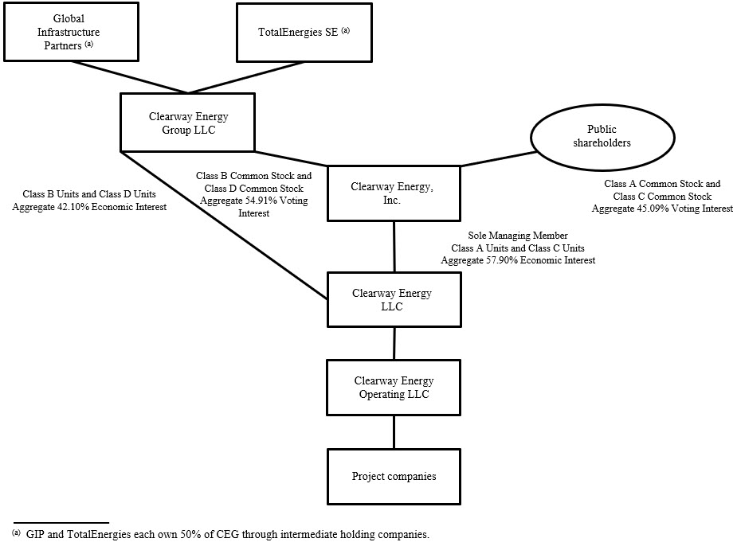
Business Strategy
The Company’s primary business strategy is to focus on the acquisition and ownership of assets with predictable, long-term cash flows in order that it may be able to increase the dividends paid to holders of the Company’s Class A and Class C common stock over time without compromising the ongoing stability of the business.
The Company’s plan for executing its business strategy includes the following key components:
Focus on contracted renewable energy and conventional generation. The Company owns and operates utility scale and distributed renewable energy and natural gas-fired generation assets, as well as energy storage assets, with proven technologies, generally low operating risks and stable cash flows. The Company believes by focusing on this core asset class and leveraging its industry knowledge, it will maximize its strategic opportunities, be a leader in operational efficiency and maximize its overall financial performance.
7

Growing the business through acquisitions of contracted operating assets. The Company believes that its base of operations provides a platform for strategic growth through cash accretive and tax advantaged acquisitions complementary to its existing portfolio. In addition to acquiring generation facilities from third parties where the Company believes its knowledge of the market and operating expertise provides it with a competitive advantage, the Company may consummate future acquisitions from CEG. The Company believes that CEG’s project development expertise provides the Company access to a development platform with an extensive pipeline of potential renewable energy and energy storage projects that are aligned to support the Company’s growth. The Company and CEG work collaboratively in considering new assets to be acquired by the Company. The assets listed below represent the Company’s currently committed investments in projects with CEG:
Asset |  |  |  |  |  | Technology |  |  |  |  |  | Gross Capacity (MW) |  |  |  |  |  | State |  |  |  |  |  | Estimated COD
Cedar Creek |  |  |  |  |  | Wind |  |  |  |  |  | 160 |  |  |  |  |  | ID |  |  |  |  |  | 1H24
Cedro Hill Repowering |  |  |  |  |  | Wind |  |  |  |  |  | 160 |  |  |  |  |  | TX |  |  |  |  |  | 2H24
Texas Solar Nova 2 (a) |  |  |  |  |  | Solar |  |  |  |  |  | 200 |  |  |  |  |  | TX |  |  |  |  |  | 1H24
(a) Included in a co-investment partnership.
Primary focus on North America. The Company intends to focus its investments in North America. The Company believes that industry fundamentals in North America present it with significant opportunity to grow its portfolio without creating significant exposure to currency and sovereign risk. By focusing its efforts on North America, the Company believes it will best leverage its regional knowledge of power markets, industry relationships and skill sets to maximize the performance of the Company.
Maintain sound financial practices to grow the dividend. The Company intends to maintain a commitment to disciplined financial analysis and a balanced capital structure to enable it to increase its quarterly dividend over time and serve the long-term interests of its stockholders. The Company’s financial practices include a risk and credit policy focused on transacting with creditworthy counterparties; a financing policy, which focuses on seeking an optimal capital structure through various capital formation alternatives to minimize interest rate and refinancing risks, ensure stable long-term dividends and maximize value; and a dividend policy that is based on distributing a significant portion of CAFD each quarter that the Company receives from Clearway Energy LLC, subject to available capital, market conditions and compliance with associated laws, regulations and other contractual obligations.
Competition
Power generation is a capital-intensive business with numerous and diverse industry participants. The Company competes on the basis of the location of its plants and on the basis of contract price and terms of individual projects. Within the power industry, there is a wide variation in terms of the capabilities, resources, nature and identity of the companies with whom the Company competes depending on the market. Competitors for energy supply are utilities, independent power producers and other providers of distributed generation. The Company also competes to acquire new projects with renewable developers who retain renewable power plant ownership, independent power producers, financial investors and other dividend, growth-oriented companies. Competitive conditions may be substantially affected by capital market conditions and by various forms of energy legislation and regulation considered by federal, state and local legislatures and administrative agencies, including tax policy. Such laws and regulations may substantially increase the costs of acquiring, constructing and operating projects, and it could be difficult for the Company to adapt to and operate under such laws and regulations.
Competitive Strengths
Stable, high quality cash flows. The Company’s facilities have a stable, predictable cash flow profile consisting of long-life electric generation assets that primarily sell electricity under long-term fixed priced contracts or pursuant to regulated rates with investment-grade and certain other creditworthy counterparties. The majority of the Company’s facilities have minimal fuel risk, as the Renewables facilities have no fuel costs, however, the Company’s merchant conventional assets need to procure their own fuel. The offtake agreements for the Company’s conventional and renewable facilities have a weighted-average remaining duration, based on CAFD, of approximately 10 years as of December 31, 2023, providing long-term cash flow stability. The Company’s offtake agreements with counterparties for whom credit ratings are available have a weighted-average Moody’s rating of Ba1 based on rated capacity under contract. All of the Company’s assets are in the U.S. and accordingly have no currency or repatriation risks.
8

Environmentally well-positioned portfolio of assets. The Company’s portfolio consists of approximately 6,000 net MW of installed wind, solar and energy storage projects that are predominantly non-emitting sources of power generation. Additionally, the Company’s California conventional assets consist of efficient gas generation facilities that support electric system reliability. The Company does not anticipate having to expend any significant capital expenditures in the foreseeable future to comply with current environmental regulations applicable to its generation assets. Taken as a whole, the Company believes its strategy will be a net beneficiary of current and potential environmental legislation and regulatory requirements that may serve as a catalyst for capacity retirements and improve market opportunities for environmentally well-positioned assets like the Company’s assets once its current offtake agreements expire.
High quality, long-lived assets with low operating and capital requirements. The Company benefits from a portfolio of relatively newer assets. The Company’s assets are largely comprised of proven and reliable technologies, provided by leading original wind, solar and energy storage equipment manufacturers, including First Solar, General Electric, Siemens Energy AG, SunPower, Vestas and Wärtsilä. Given the nature of the portfolio, which includes a substantial number of relatively low operating and maintenance cost wind, solar and energy storage projects, the Company expects to achieve high fleet availability and expend modest maintenance-related capital expenditures.
Significant scale and diversity. The Company is one of the largest renewable energy owners in the U.S. with approximately 6,000 net MW of installed wind, solar and energy storage projects. The Company’s approximately 8,500 net MW of assets also includes approximately 2,500 net MW of environmentally-sound, highly efficient natural gas-fired generation facilities. The Company’s contracted renewable and conventional generation assets benefit from significant diversification in terms of technology, fuel type, counterparty and geography. The Company believes its scale and access to best practices across the fleet improves its business development opportunities through enhanced industry relationships, reputation and understanding of regional power market dynamics. Furthermore, the Company’s diversification reduces its operating risk profile and reliance on any single market.
Relationship with GIP, TotalEnergies and CEG. The Company believes that its relationship with GIP, TotalEnergies and CEG provides significant benefits. Global Infrastructure Management, LLC, or GIM, the manager of GIP, is an independent infrastructure fund manager that makes equity and debt investments in infrastructure assets and businesses in both the Organization for Economic Co-operation and Development (OECD) and select emerging market countries. GIM has a strong track record of investment and value creation in the renewable energy sector. GIM also has extensive experience with publicly traded yield vehicles and development platforms, ranging from Europe’s first application of a yield company/development company model to the largest renewable platform in Asia-Pacific. TotalEnergies is a global multi-energy company that produces and markets energies in more than 130 countries. Additionally, the Company believes that CEG provides the Company access to a highly capable renewable development and operations platform that is aligned to support the Company’s growth.
Segment Review
The following tables summarize the Company’s operating revenues, net income (loss) and assets by segment, as discussed in Item 15 — Note 13, Segment Reporting.
 |  |  | Year ended December 31, 2023
(In millions) |  |  | Conventional Generation |  |  |  |  |  | Renewables |  |  |  |  |  | Corporate |  |  |  |  |  | Total
Operating revenues |  |  | $ | 420 |  |  |  |  | $ | 894 |  |  |  |  | $ | — |  |  |  |  | $ | 1,314
Net income (loss) |  |  | 109 |  |  |  |  |  | (12) |  |  |  |  |  | (111) |  |  |  |  |  | (14)
Total assets |  |  | 2,058 |  |  |  |  |  | 12,205 |  |  |  |  |  | 438 |  |  |  |  |  | 14,701
 |  |  | Year ended December 31, 2022
(In millions) |  |  | Conventional Generation |  |  |  |  |  | Renewables |  |  |  |  |  | Thermal |  |  |  |  |  | Corporate |  |  |  |  |  | Total
Operating revenues |  |  | $ | 417 |  |  |  |  | $ | 696 |  |  |  |  | $ | 77 |  |  |  |  | $ | — |  |  |  |  | $ | 1,190
Net income (loss) (a) |  |  | 161 |  |  |  |  |  | (58) |  |  |  |  |  | 17 |  |  |  |  |  | 940 |  |  |  |  |  | 1,060
Total assets |  |  | 2,251 |  |  |  |  |  | 9,515 |  |  |  |  |  | — |  |  |  |  |  | 546 |  |  |  |  |  | 12,312
(a) Corporate net income includes the $1.29 billion gain on the sale of the Thermal Business to KKR, which was completed on May 1, 2022.
9

 |  |  | Year ended December 31, 2021
(In millions) |  |  | Conventional Generation |  |  |  |  |  | Renewables |  |  |  |  |  | Thermal |  |  |  |  |  | Corporate |  |  |  |  |  | Total
Operating revenues |  |  | $ | 441 |  |  |  |  | $ | 641 |  |  |  |  | $ | 204 |  |  |  |  | $ | — |  |  |  |  | $ | 1,286
Net income (loss) |  |  | 172 |  |  |  |  |  | (65) |  |  |  |  |  | 22 |  |  |  |  |  | (204) |  |  |  |  |  | (75)
Policy Incentives
U.S. federal, state and local governments have established various policy incentives to support the development, financing, ownership and operation of renewable energy projects. These incentives include PTCs, ITCs, accelerated tax depreciation, cash grants, tax abatements and RPS programs which have the effect of decreasing the costs and risks associated with developing and operating such projects or creating demand for renewable energy assets. In particular,
•Owners of wind facilities are eligible to claim the PTC, or an ITC in lieu of the PTC, provided that certain requirements are met. Similarly, owners of solar facilities are eligible to claim the ITC or, for facilities placed in service after August 16, 2022, the PTC, or an ITC in lieu of the PTC, provided certain requirements are met. Additionally, owners of energy storage facilities are eligible to claim the ITC for facilities placed in service after December 31, 2022, provided certain requirements are met. The PTC is an annual credit that is based on the amount of electricity sold by the facility during the first ten years after the facility is first placed in service. The ITC is a one-time credit that is based on a percentage of the cost of the facility and is claimed for the tax year in which the facility is first placed in service. Depending on the type of taxpayer, the PTC or ITC may be sold to an unrelated third party for cash, or in certain cases, direct payment from the government may be received. In order to qualify for the full amount of these credits in the case of facilities whose construction began on or after January 30, 2023, certain prevailing wage and apprenticeship requirements generally must be satisfied. For facilities that begin construction after December 31, 2024, the PTC and ITC will no longer apply and such facilities may instead be eligible for the clean electricity production credit or clean electricity investment credit, respectively. In order to qualify for these new credits, the facility’s greenhouse gas emissions cannot be greater than zero.
•Pursuant to the U.S. federal Modified Accelerated Cost Recovery System, or MACRS, wind and solar projects are generally depreciable for tax purposes over a five-year period (before taking into account certain conventions) even though the useful life of such projects is generally much longer than five years. Federal income tax law also provides for immediate and 100% expensing and deductibility for eligible property acquired and placed in service after September 27, 2017, and before January 1, 2023, with phase downs permitting 80%, 60%, 40% and 20% expensing and deductibility for property acquired and placed in service during 2023, 2024, 2025 and 2026, respectively.
•RPS programs, currently in place in certain states and territories, require electricity providers in the state or territory to meet a certain percentage of their retail sales with energy from renewable sources. Additionally, other states in the U.S. have set renewable energy goals to reduce GHG emissions from historic levels. The Company believes that these standards and goals will create incremental demand for renewable energy in the future.
The elimination of, loss of, or reduction in, the incentives discussed above could decrease the attractiveness of renewable energy projects to developers, including, but not limited to, CEG, which could reduce the Company’s acquisition or development opportunities. Such an elimination, loss or reduction could also reduce the Company’s willingness to pursue or develop certain renewable energy projects due to higher operating costs or decreased revenues under its PPAs.
Regulatory Matters
As owners of power plants and participants in wholesale energy markets, certain of the Company’s subsidiaries are subject to regulation by various federal and state government agencies. These agencies include FERC and the PUCT, as well as other public utility commissions in certain states where the Company’s assets are located. Each of the Company’s U.S. generating facilities qualifies as an EWG or QF. In addition, the Company is subject to the market rules, procedures and protocols of the various ISO and RTO markets in which it participates. Likewise, certain of the Company’s subsidiaries must also comply with the mandatory reliability requirements imposed by NERC and the regional reliability entities in the regions where the Company has generating facilities subject to NERC’s reliability authority. The Company’s operations within the ERCOT footprint are not subject to rate regulation by FERC, as they are deemed to operate solely within the ERCOT market and not in interstate commerce. These operations are subject to regulation by PUCT. Similarly, the Company’s operations within Hawaii are not subject to rate regulation by FERC, as they are deemed to operate solely within the State of Hawaii and not in interstate commerce.
10

FERC
FERC, among other things, regulates the transmission and the wholesale sale of electricity in interstate commerce under the authority of the FPA. The transmission and sale of electric energy occurring wholly within ERCOT and Hawaii is not subject to FERC’s jurisdiction. Under existing regulations, FERC has the authority to determine whether an entity owning a generation facility is an EWG, as defined in the PUHCA. FERC also has the authority to determine whether a generation facility meets the applicable criteria of a QF under the PURPA. Each of the Company’s U.S. generating facilities qualifies as either an EWG or QF.
The FPA gives FERC exclusive rate-making jurisdiction over the wholesale sale of electricity and transmission of electricity in interstate commerce of public utilities (as defined by the FPA). Under the FPA, FERC, with certain exceptions, regulates owners and operators of facilities used for the wholesale sale of electricity or transmission in interstate commerce as public utilities, and is charged with ensuring that market rules are just and reasonable.
Public utilities are required to obtain FERC’s acceptance, pursuant to Section 205 of the FPA, of their rate schedules for the wholesale sale of electricity. Several of the Company’s QF generating facilities and all of the Company’s non-QF generating facilities located in the U.S. outside of ERCOT and Hawaii make sales of electricity pursuant to market-based rates, as opposed to traditional cost-of-service regulated rates. FERC conducts a review of the market-based rates of Company public utilities and potential market power every three years according to a regional schedule established by FERC.
In accordance with the Energy Policy Act of 2005, FERC has approved the NERC as the national Energy Reliability Organization, or ERO. As the ERO, NERC is responsible for the development and enforcement of mandatory reliability standards for the wholesale electric power system, with such authority delegated in part to regional reliability entities charged with enforcement of mandatory reliability standards for the region which they are responsible for overseeing.
The PURPA was passed in 1978 in large part to promote increased energy efficiency and development of independent power producers. The PURPA created QFs to further both goals, and FERC is primarily charged with administering the PURPA as it applies to QFs. QFs are exempt from certain regulations under the FPA.
The PUHCA provides FERC with certain authority over and access to books and records of public utility holding companies not otherwise exempt by virtue of their ownership of EWGs and QFs. The Company is exempt from many of the accounting, record retention, and reporting requirements of the PUHCA.
Environmental Matters
The Company is subject to a wide range of environmental laws during the development, construction, ownership and operation of facilities. These existing and future laws generally require that governmental permits and approvals be obtained before construction and maintained during operation of facilities. The Company is obligated to comply with all environmental laws and regulations applicable within each jurisdiction and required to implement environmental programs and procedures to monitor and control risks associated with the construction, operation and decommissioning of regulated or permitted energy assets. Federal and state environmental laws have historically become more stringent over time, although this trend could change in the future.
A number of regulations that may affect the Company are under review for potential revision or rescission in 2024. The Company will evaluate the impact of the legislation and regulations as they are revised but cannot fully predict the impact of each until anticipated revisions and legal challenges are resolved. To the extent that proposed legislation and new or revised regulations restrict or otherwise impact the Company’s operations, the proposed legislation and regulations could have a negative impact on the Company’s financial performance.
Proposed Federal MBTA Incidental Take Legislation and Regulations — On October 4, 2021, U.S. Fish and Wildlife Service, or FWS, issued the final MBTA rule, effective December 3, 2021, restoring the MBTA to prohibit the incidental take of migratory birds. In 2021, FWS issued an advance notice of proposed rulemaking advising that it intends to gather information necessary to develop proposed regulations to authorize the incidental take of migratory birds under prescribed conditions and prepare a draft environmental review pursuant to the National Environmental Policy Act, or NEPA. Throughout 2022, FWS sought comments on the content of the proposed rule. In November 2023, FWS withdrew the draft MBTA permit program rule from the Office of Information and Regulatory Affairs to address technical comments received from agencies. FWS has indicated that the rule is likely to be published in the second half of 2024.
11

Federal Eagle Incidental Take Permit Rule — On September 30, 2022, FWS published in the Federal Register a draft rule revising the eagle incidental take permit program. Comments on the revised rule continued to be accepted during 2023. The final eagle incidental take permit rule was published in the Federal Register on February 12, 2024 and will become effective on April 13, 2024. The final rule is anticipated to provide an expedited eagle take permitting and lower cost path for many wind facilities.
Local California Air District Rules — Air districts, including the Bay Area Air Quality Management District and the San Diego Air Pollution Control District, have recently proposed and/or updated new source review permitting requirements, including to incorporate public notice requirements as well as updates to programs addressing toxic air contaminants. Rulemaking in the Los Angeles Air Basin, as regulated by South Coast Air Quality Management District, or SCAQMD, continues to update command-and-control regulations that limit NOx emissions for stationary sources in preparation for sunsetting SCAQMD’s Regional Clean Air Market, or RECLAIM, cap and trade program in the next few years. The Company’s conventional generation plants meet the district’s existing and proposed amendments to command-and-control regulations. Proposed updates to local California Air District Rules are not expected to affect the operations nor compliance of the Company’s conventional generation plants.
Amendments to NEPA — On June 3, 2023, President Biden signed the Fiscal Responsibility Act of 2023, or FRA, into law, which includes amendments to the NEPA, aimed at streamlining the environmental review process. Following the FRA, on July 31, 2023, the White House Council on Environmental Quality, or CEQ, published a proposed rule, the Bipartisan Permitting Reform Implementation Rule, which seeks to revise, update and modernize the existing regulations under the NEPA and includes provisions regarding robust public involvement, environmental justice, and climate change, or the Phase 2 Proposed Rule. The public comment period on the Phase 2 Proposed Rule closed on September 29, 2023 and the final rule has not yet been published.
Customers
The Company sells its electricity and environmental attributes, including RECs, primarily to local utilities under contractual arrangements. During the year ended December 31, 2023, the Company derived approximately 24% of its consolidated revenue from Southern California Edison, or SCE, and approximately 17% of its consolidated revenue from PG&E.
Human Capital
As of December 31, 2023, the Company had 61 employees. The Company also depends upon personnel of CEG for the provision of asset management, administration and O&M services.
The Company focuses on attracting, developing and retaining a team of highly talented and motivated employees. The Company regularly conducts assessments of its compensation and benefit practices and pay levels to help ensure that staff members are compensated equitably and competitively. The Company devotes extensive resources to staff development and training, including tuition assistance for career-enhancing academic and professional programs. Employee performance is measured in part based on goals that are aligned with the Company’s annual objectives. The Company recognizes that its success is based on the talents and dedication of those it employs, and the Company is highly invested in their success.
The Company is committed to maintaining a workplace that acknowledges, encourages, and values diversity and inclusion and provides its employees with unconscious bias training. The Company believes that individual differences, experiences, and strengths enrich the culture and fabric of its organization. Having employees with backgrounds and orientations that reflect a variety of viewpoints and experiences also helps the Company to better understand the needs of its customers and the communities in which it operates.
By leveraging the multitude of backgrounds and perspectives of its team and developing ongoing relationships with diverse vendors, the Company achieves a collective strength that enhances the workplace and makes the Company a better business partner to its customers and others with a stake in the Company’s success.
12

The Company also has an Equity, Partnership & Inclusion Council, or EPIC. As part of its commitment, the Company provides education on topics related to diversity, inclusion and equity. The Company identified three areas of focus: Our People; Our Brand, Customers and Community; and Our Purchasing. With the involvement of its employees, EPIC is advancing efforts in each of these areas to identify and implement opportunities for the Company to address equity, partnership and inclusion issues in its business activities.
Our People focuses on education and training; diversity, equity and inclusion policies and recruitment strategies; community and industry partnerships; and maintaining high employee engagement and retention.
Our Brand, Customers & Community focuses on pursuing opportunities that provide more equitable access to renewable energy; broadening participation for small to medium enterprises; supporting the diversity, equity and inclusion goals of the Company’s offtakers; building robust community engagement relationships; and meaningfully representing that work in the external market.
Our Purchasing focuses on establishing a non-discriminatory practices standard for the Company’s suppliers, diverse vendor sourcing and benchmarking.
In addition to the personnel of CEG, the Company relies on other third-party service providers in the daily operations of its conventional facilities and certain renewable facilities.
Environmental, Social and Governance (ESG)
The Company is committed to engaging with its stakeholders on environmental, social and governance, or ESG, matters in a proactive, holistic and integrated manner. The Company strives to provide recent, credible and comparable data to investors around ESG issues and to comply with ESG disclosure requirements. The Company’s Board of Directors reviews developing trends and emerging ESG matters as well as the Company’s strategies, activities, policies and communications regarding ESG matters, and reviews and considers potential actions the Company could take regarding ESG matters.
Aligned with the Company’s strategy of owning and acquiring environmentally-sound power generation and energy storage assets, the Company has issued $2.1 billion of corporate green bonds under a green bond framework that applies the net proceeds to finance or refinance, in part or in full, new and existing projects and assets meeting certain criteria focused on the supply of energy from renewable resources, including solar energy and wind energy.
As discussed in greater detail above, the Company, through EPIC, has focused its diversity, equity and inclusion efforts in three areas: Our People; Our Brand, Customers and Community; and Our Purchasing. With the involvement of the Company’s employees, EPIC is advancing efforts in each of these areas to identify and implement opportunities for the Company to address equity, partnership and inclusion issues in its business activities.
Available Information
The Company’s annual reports on Form 10-K, quarterly reports on Form 10-Q, current reports on Form 8-K, and amendments to those reports filed or furnished pursuant to section 13(a) or 15(d) of the Exchange Act are available free of charge through the SEC’s website, www.sec.gov, and through the “Investor Relations” section of the Company’s website, www.clearwayenergy.com, as soon as reasonably practicable after they are electronically filed with, or furnished to, the SEC. The Company also routinely posts press releases, presentations, webcasts, and other information regarding the Company on its website. The information posted on the Company’s website is not a part of this report.

13

Item 1A — Risk Factors
Summary of Risk Factors
The Company’s business is subject to numerous risks and uncertainties, discussed in more detail in the following section. These risks include, among others, the following key risks:
Risks Related to the Company’s Business
•The Company’s ability to grow and make acquisitions through cash on hand is limited.
•The Company may not be able to effectively identify or consummate any future acquisitions on favorable terms, or at all, and future acquisitions may not be accretive as a result of incorrect assumptions in the Company’s evaluation of such acquisitions, unforeseen consequences or other external events beyond the Company’s control.
•Counterparties to the Company’s offtake agreements may not fulfill their obligations and, as the contracts expire, the Company may not be able to replace them with agreements on similar terms in light of increasing competition in the markets in which the Company operates.
•The Company’s ability to effectively consummate future acquisitions will also depend on the Company’s ability to arrange the required or desired financing for acquisitions.
•The Company’s indebtedness could adversely affect its ability to raise additional capital to fund the Company’s operations or pay dividends.
•The operation of electric generation facilities depends on suitable meteorological conditions and involves significant risks and hazards customary to the power industry that could have a material adverse effect on the Company’s business, financial condition, results of operations and cash flows. These facilities may operate without long-term power sales agreements.
•Maintenance, expansion and refurbishment of electric generation facilities involve significant risks that could result in unplanned power outages or reduced output.
•Supplier and/or customer concentration at certain of the Company’s facilities may expose the Company to significant financial credit or performance risks.
•The Company currently owns, and in the future may acquire, certain assets in which the Company has limited control over management decisions and its interests in such assets may be subject to transfer or other related restrictions.
•The Company is exposed to risks inherent in the use of interest rate swaps and energy-related financial instruments. The Company may be exposed to additional risks in the future if it utilizes other derivative instruments.
•The Company does not own all of the land on which its power generation and energy storage assets are located, which could result in disruption to its operations. The Company’s use and enjoyment of real property rights for its projects may be adversely affected by the rights of lienholders and leaseholders that are superior to those of the grantors of those real property rights to the Company.
•The Company’s businesses are subject to physical, market and economic risks relating to potential effects of climate change and public and governmental initiatives to address climate change.
•Risks that are beyond the Company’s control, including but not limited to acts of terrorism or related acts of war, natural disasters, severe weather, changes in weather patterns, flooding, pandemics (such as the COVID-19 pandemic), inflation, supply chain disruptions, hostile cyber intrusions or other catastrophic events, could have a material adverse effect on the business, financial condition, results of operations and cash flows.
•The operation of the Company’s businesses is subject to cyber-based security and integrity risk.
•The Company relies on electric distribution and transmission facilities that it does not own or control and that are subject to transmission constraints within a number of the Company’s regions. If these facilities fail to provide the Company with adequate transmission capacity, it may be restricted in its ability to deliver electric power to its customers and may either incur additional costs or forego revenues.
•The Company’s costs, results of operations, financial condition and cash flows could be adversely impacted by the disruption of the fuel supplies necessary to generate power at its conventional generation facilities.
•The Company depends on key personnel and its ability to attract and retain additional skilled management and other personnel, the loss of any of which could have a material adverse effect on the Company’s financial condition and results of operations.
•The Company may potentially be adversely affected by emerging technologies that may over time impact capacity markets and the energy industry overall.
14

Risks Related to the Company’s Relationship with GIP, TotalEnergies and CEG
•GIP and TotalEnergies, through their equal ownership of CEG, the Company’s controlling stockholder, exercise substantial influence over the Company. The Company is highly dependent on GIP, TotalEnergies and CEG.
•CEG controls the Company and has the ability to designate a majority of the members of the Company’s Board.
•The Company may not be able to consummate future acquisitions from CEG.
•The Company may be unable to terminate the CEG Master Services Agreement, in certain circumstances.
•If CEG terminates the CEG Master Services Agreement or defaults in the performance of its obligations under the agreement, the Company may be unable to contract with a substitute service provider on similar terms, or at all.
•The Company is a “controlled company”, controlled by CEG, and as a result, is exempt from certain corporate governance requirements that are designed to provide protection to stockholders of companies that are not controlled companies.
Risks Related to Regulation
•The Company’s business is subject to restrictions resulting from environmental, health and safety laws and regulations.
•The electric generation business is subject to substantial governmental regulation, including environmental laws, and may be adversely affected by changes in laws or regulations, as well as liability under, or any future inability to comply with, existing or future regulations or other legal requirements.
•The Company’s business is subject to complex and evolving U.S. laws and regulations regarding privacy and data protection.
•Government regulations providing incentives for renewable power generation could change at any time and such changes may negatively impact the Company’s growth strategy.
Risks Related to the Company’s Common Stock
•The Company may not be able to continue paying comparable or growing cash dividends to holders of its common stock in the future. The Company is a holding company and its only material asset is its interest in Clearway Energy LLC, and the Company is accordingly dependent upon distributions from Clearway Energy LLC and its subsidiaries to pay dividends and taxes and other expenses.
•Market interest rates may have an effect on the value of the Company’s Class A and Class C common stock.
•Market volatility and reports by securities and industry analysts may affect the price of the Company’s Class A and Class C common stock, and the future issuance of additional shares of common stock or sales of common stock by CEG may cause dilution of investors’ ownership interest or cause the price of the Company’s Class A or Class C common stock to fall.
•Provisions of the Company’s charter documents or Delaware law could delay or prevent an acquisition of the Company, even if the acquisition would be beneficial to holders of the Company’s Class A and Class C common stock, and could make it more difficult to change management.
Risks Related to Taxation
•The Company’s future tax liability may be greater than expected if the Company does not generate NOLs sufficient to offset taxable income, if federal, state and local tax authorities challenge certain of the Company’s tax positions and exemptions or if changes in federal, state and local tax laws occur.
•The Company’s ability to use NOLs to offset future income may be limited.
•A valuation allowance may be required for the Company’s deferred tax assets.
•Distributions to holders of the Company’s Class A and Class C common stock may be taxable.
•Changes in tax laws or policies, including but not limited to changes in corporate income tax rates, as well as judgments and estimates used in the determination of tax-related asset and liability amounts, could materially adversely affect the Company’s business, financial condition, results of operations and prospects.
•The Company’s ability to comply with tax laws and policies may depend on its contractual arrangements and information provided by third parties and may require significant resources.

15

Risks Related to the Company’s Business
Pursuant to the Company’s cash dividend policy, the Company intends to distribute a significant amount of the CAFD through regular quarterly distributions and dividends, and the Company’s ability to grow and make acquisitions through cash on hand is limited.
The Company expects to distribute a significant amount of the CAFD each quarter and to rely primarily upon external financing sources, including the issuance of debt and equity securities and, if applicable, borrowings under the Company’s revolving credit facility to fund acquisitions and growth capital expenditures. The Company may be precluded from pursuing otherwise attractive acquisitions if the projected short-term cash flow from the acquisition or investment is not adequate to service the capital raised to fund the acquisition or investment, after giving effect to the Company’s available cash reserves. To the extent the Company issues additional equity securities in connection with any acquisitions or growth capital expenditures, the payment of dividends on these additional equity securities may increase the risk that the Company will be unable to maintain or increase its per share dividend. The incurrence of bank borrowings or other debt by Clearway Energy Operating LLC or by the Company’s project-level subsidiaries to finance the Company’s growth strategy will result in increased interest expense and the imposition of additional or more restrictive covenants, which, in turn, may impact the cash distributions the Company receives to distribute to holders of the Company’s common stock.
The Company may not be able to effectively identify or consummate any future acquisitions on favorable terms, or at all, and future acquisitions may not be accretive as a result of incorrect assumptions in the Company’s evaluation of such acquisitions, unforeseen consequences or other external events beyond the Company’s control.
The Company’s business strategy includes growth through the acquisitions of additional generation assets (including through corporate acquisitions). This strategy depends on the Company’s ability to successfully identify and evaluate acquisition opportunities and consummate acquisitions on favorable terms. However, the number of acquisition opportunities is limited. In addition, the Company will compete with other companies for these limited acquisition opportunities, which may increase the Company’s cost of making acquisitions or cause the Company to refrain from making acquisitions at all. Some of the Company’s competitors for acquisitions are much larger than the Company with substantially greater resources. These companies may be able to pay more for acquisitions and may be able to identify, evaluate, bid for and purchase a greater number of assets than the Company’s financial or human resources permit. If the Company is unable to identify and consummate future acquisitions, it will impede the Company’s ability to execute its growth strategy and limit the Company’s ability to increase the amount of dividends paid to holders of the Company’s common stock.
The Company’s ability to acquire future renewable facilities may depend on the viability of renewable assets generally. These assets currently are largely contingent on public policy mechanisms including ITCs, cash grants, loan guarantees, accelerated depreciation, RPS and carbon trading plans. These mechanisms have been implemented at the state and federal levels to support the development of renewable generation, demand-side and smart grid and other clean infrastructure technologies. The availability and continuation of public policy support mechanisms will drive a significant part of the economics and viability of the Company’s growth strategy and expansion into clean energy investments.
The acquisition of companies and assets are subject to substantial risks, including the failure to identify material problems during due diligence (for which the Company may not be indemnified post-closing) and the risk of overpaying for assets (or not making acquisitions on an accretive basis). The integration and consolidation of acquisitions requires substantial human, financial and other resources and, ultimately, the Company’s acquisitions may divert management’s attention from the Company’s existing business concerns, disrupt the Company’s ongoing business or not be successfully integrated. There can be no assurances that any future acquisitions will perform as expected or that the returns from such acquisitions will support the financing utilized to acquire them or maintain them. A failure to achieve the financial returns the Company expects when it acquires generation assets could have a material adverse effect on the Company’s ability to grow its business and make cash distributions to its stockholders. Any failure of the Company’s acquired generation assets to be accretive or difficulty in integrating such acquisition into the Company’s business could have a material adverse effect on the Company’s ability to grow its business and make cash distributions to its stockholders. As a result, the consummation of acquisitions could have a material adverse effect on the Company’s business, financial condition, results of operations, cash flows and ability to pay dividends to holders of the Company’s common stock.
16

Counterparties to the Company’s offtake agreements may not fulfill their obligations and, as the contracts expire, the Company may not be able to replace them with agreements on similar terms in light of increasing competition in the markets in which the Company operates.
The majority of the electric power the Company generates is sold under long-term offtake agreements with public utilities or industrial or commercial end-users, with a weighted average remaining duration, based on CAFD, of approximately 10 years. As of December 31, 2023, the largest customers of the Company’s power generation and energy storage assets, including assets in which the Company has less than a 100% membership interest, were SCE and PG&E, which represented 24% and 17%, respectively, of total consolidated revenues generated by the Company during the year ended December 31, 2023.
If, for any reason, any of the purchasers of power under these agreements are unable or unwilling to fulfill their related contractual obligations or if they refuse to accept delivery of power delivered thereunder or if they otherwise terminate such agreements prior to the expiration thereof, the Company’s assets, liabilities, business, financial condition, results of operations and cash flows could be materially and adversely affected. Furthermore, to the extent any of the Company’s power purchasers are, or are controlled by, governmental entities, the Company’s facilities may be subject to legislative or other political action that may impair their contractual performance.
The power generation industry is characterized by intense competition and the Company’s electric generation assets encounter competition from utilities, industrial companies and independent power producers, in particular with respect to uncontracted output. In recent years, there has been increasing competition among generators for offtake agreements and this has contributed to a reduction in electricity prices in certain markets characterized by excess supply above designated reserve margins. In light of these market conditions, the Company may not be able to replace an expiring or terminated agreement with an agreement on equivalent terms and conditions, including at prices that permit operation of the related facility on a profitable basis. In addition, the Company believes many of its competitors have well-established relationships with the Company’s current and potential suppliers, lenders and customers, and have extensive knowledge of its target markets. As a result, these competitors may be able to respond more quickly than the Company to evolving industry standards and changing customer requirements. The adoption of more advanced technology could reduce its competitors’ power production costs resulting in their having a lower cost structure than is achievable with the technologies currently employed by the Company and adversely affect its ability to compete for offtake agreement renewals. If the Company is unable to replace an expiring or terminated offtake agreement, the affected facility may temporarily or permanently cease operations. External events, such as a severe economic downturn or force majeure events, could also impair the ability of some counterparties to the Company’s offtake agreements and other customer agreements to pay for energy and/or other products and services received.
The Company’s inability to enter into new or replacement offtake agreements or to compete successfully against current and future competitors in the markets in which the Company operates could have a material adverse effect on the Company’s business, financial condition, results of operations and cash flows.
The Company’s ability to effectively consummate future acquisitions will also depend on the Company’s ability to arrange the required or desired financing for acquisitions.
The Company may not have sufficient availability under the Company’s credit facilities or have access to project-level financing on commercially reasonable terms when acquisition opportunities arise. An inability to obtain the required or desired financing could significantly limit the Company’s ability to consummate future acquisitions and effectuate the Company’s growth strategy. If financing is available, utilization of the Company’s credit facilities or project-level financing for all or a portion of the purchase price of an acquisition could significantly increase the Company’s interest expense, impose additional or more restrictive covenants and reduce CAFD. Similarly, the issuance of additional equity securities as consideration for acquisitions could cause significant stockholder dilution and reduce the Company’s dividends if the acquisitions are not sufficiently accretive. The Company’s ability to consummate future acquisitions may also depend on the Company’s ability to obtain any required regulatory approvals for such acquisitions.
The Company’s indebtedness could adversely affect its ability to raise additional capital to fund the Company’s operations or pay dividends. It could also expose the Company to the risk of increased interest rates and limit the Company’s ability to react to changes in the economy or the Company’s industry as well as impact the Company’s results of operations, financial condition and cash flows.
As of December 31, 2023, the Company had approximately $8.10 billion of total consolidated indebtedness, $5.97 billion of which was incurred by the Company’s non-guarantor subsidiaries. In addition, the Company’s share of its unconsolidated affiliates’ total indebtedness and letters of credit outstanding as of December 31, 2023, totaled approximately $303 million and $37 million, respectively (calculated as the Company’s unconsolidated affiliates’ total indebtedness as of such date multiplied by the Company’s percentage membership interest in such assets).
17

The Company’s substantial debt could have important negative consequences on the Company’s financial condition, including:
•increasing the Company’s vulnerability to general economic and industry conditions;
•requiring a substantial portion of the Company’s cash flow from operations to be dedicated to the payment of principal and interest on the Company’s indebtedness, therefore reducing the Company’s ability to pay dividends to holders of the Company’s capital stock (including the Class A and Class C common stock) or to use the Company’s cash flow to fund its operations, capital expenditures and future business opportunities;
•limiting the Company’s ability to enter into long-term power sales or fuel purchases which require credit support;
•limiting the Company’s ability to fund operations or future acquisitions;
•restricting the Company’s ability to make certain distributions with respect to the Company’s capital stock (including the Class A and Class C common stock) and the ability of the Company’s subsidiaries to make certain distributions to it, in light of restricted payment and other financial covenants in the Company’s credit facilities and other financing agreements;
•exposing the Company to the risk of increased interest rates because certain of the Company’s borrowings, which may include borrowings under the Company’s revolving credit facility, are at variable rates of interest;
•limiting the Company’s ability to obtain additional financing for working capital including collateral postings, capital expenditures, debt service requirements, acquisitions and general corporate or other purposes; and
•limiting the Company’s ability to adjust to changing market conditions and placing it at a competitive disadvantage compared to the Company’s competitors who have less debt.
The Company’s revolving credit facility contains financial and other restrictive covenants that limit the Company’s ability to return capital to stockholders or otherwise engage in activities that may be in the Company’s long-term best interests. The Company’s inability to satisfy certain financial covenants could prevent the Company from paying cash dividends, and the Company’s failure to comply with those and other covenants could result in an event of default which, if not cured or waived, may entitle the related lenders to demand repayment or enforce their security interests, which could have a material adverse effect on the Company’s business, financial condition, results of operations and cash flows. In addition, failure to comply with such covenants may entitle the related lenders to demand repayment and accelerate all such indebtedness.
The agreements governing the Company’s project-level financing contain financial and other restrictive covenants that limit the Company’s project subsidiaries’ ability to make distributions to the Company or otherwise engage in activities that may be in the Company’s long-term best interests. The project-level financing agreements generally prohibit distributions from the project entities to the Company unless certain specific conditions are met, including the satisfaction of certain financial ratios. The Company’s inability to satisfy certain financial covenants may prevent cash distributions by the particular project(s) to it and, the Company’s failure to comply with those and other covenants could result in an event of default which, if not cured or waived may entitle the related lenders to demand repayment or enforce their security interests, which could have a material adverse effect on the Company’s business, results of operations and financial condition. In addition, failure to comply with such covenants may entitle the related lenders to demand repayment and accelerate all such indebtedness. If the Company is unable to make distributions from the Company’s project-level subsidiaries, it would likely have a material adverse effect on the Company’s ability to pay dividends to holders of the Company’s common stock.
Letter of credit facilities to support project-level contractual obligations generally have a limited term that may require future renewal, at which time the Company or relevant project-level subsidiary will need to satisfy applicable financial ratios and covenants. If the Company is unable to renew the Company’s letters of credit as expected or replace them with letters of credit under different facilities on favorable terms or at all, the Company may experience a material adverse effect on its business, financial condition, results of operations and cash flows. Furthermore, such inability may constitute a default under certain project-level financing arrangements, restrict the ability of the project-level subsidiary to make distributions to it and/or reduce the amount of cash available at such subsidiary to make distributions to the Company.
18

In addition, the Company’s ability to arrange financing, either at the corporate level or at a non-recourse project-level subsidiary, and the costs of such capital, are dependent on numerous factors, including:
•general economic and capital market conditions;
•credit availability from banks and other financial institutions;
•investor confidence in the Company, its partners, GIP and TotalEnergies, through CEG, the Company’s principal stockholder (on a combined voting basis), and the regional wholesale power markets;
•the Company’s financial performance and the financial performance of the Company subsidiaries;
•the Company’s level of indebtedness and compliance with covenants in debt agreements;
•maintenance of acceptable project credit ratings or credit quality;
•cash flow; and
•provisions of tax and securities laws that may impact raising capital.
The Company may not be successful in obtaining additional capital for these or other reasons. Furthermore, the Company may be unable to refinance or replace project-level financing arrangements or other credit facilities on favorable terms or at all upon the expiration or termination thereof. The Company’s failure, or the failure of any of the Company’s projects, to obtain additional capital or enter into new or replacement financing arrangements when due may constitute a default under such existing indebtedness and may have a material adverse effect on the Company’s business, financial condition, results of operations and cash flows.
Certain of the Company’s long-term bilateral contracts result from state-mandated procurements and could be declared invalid by a court of competent jurisdiction.
A portion of the Company’s revenues are derived from long-term bilateral contracts with utilities that are regulated by their respective states and have been entered into pursuant to certain state programs. Certain long-term contracts that other companies have with state-regulated utilities have been challenged in federal court and have been declared unconstitutional on the grounds that the rate for energy and capacity established by the contracts impermissibly conflicts with the rate for energy and capacity established by FERC pursuant to the FPA. If certain of the Company’s state-mandated agreements with utilities are ever held to be invalid or unenforceable due to the financial conditions or other conditions of such utility, the Company may be unable to replace such contracts, which could have a material adverse effect on the Company’s business, financial condition, results of operations and cash flows.
The generation of electric energy from solar and wind energy sources depends heavily on suitable meteorological conditions.
If solar or wind conditions are unfavorable, the Company’s electricity generation and revenue from renewable generation facilities may be substantially below the Company’s expectations. The electricity produced and revenues generated by a solar or wind energy generation facility is highly dependent on suitable solar or wind conditions, as applicable, and associated weather conditions, which are beyond the Company’s control. Disruption in the generation of solar or wind energy could limit a facility’s ability to generate electricity at its desired level. Should a generation facility fail to perform at the required levels, or other unplanned disruptions occur, the facility may be forced to fulfill an underlying contractual obligation by purchasing electricity at higher prices. In addition, the Company’s facilities may be exposed, based on specific contractual terms, to a locational basis risk resulting from a difference in the price received for generation sold at the location where the power is generated and the price paid for generation purchased at the contracted delivery point, which could lead to potential lower revenues in circumstances where the price received is lower than the price that is paid. Furthermore, components of the Company’s systems, such as solar panels and inverters, could be damaged by severe weather, such as wildfires, hailstorms, lightning, tornadoes or freezing temperatures and other winter weather conditions. Unfavorable weather and atmospheric conditions could impair the effectiveness of the Company’s assets or reduce their output beneath their rated capacity or require shutdown of key equipment, impeding operation of the Company’s renewable assets. For example, in February 2021, the Company’s wind projects in Texas were unable to operate and experienced outages for a few days as a result of the extreme winter weather conditions. In addition, climate change may have the long-term effect of changing wind patterns at the Company’s projects. Changing wind patterns could cause changes in expected electricity generation. These events could also degrade equipment or components and the interconnection and transmission facilities’ lives or maintenance costs.
19

Although the Company bases its investment decisions with respect to each renewable generation facility on the findings of related wind and solar studies conducted on-site prior to construction or based on historical conditions at existing facilities, actual climatic conditions at a facility site, particularly wind conditions, may not conform to the findings of these studies and may be affected by variations in weather patterns, including any potential impact of climate change. Therefore, the Company’s solar and wind energy facilities may not meet anticipated production levels or the rated capacity of the Company’s generation assets, which could adversely affect the Company’s business, financial condition, results of operations and cash flows.
Operation of electric generation facilities involves significant risks and hazards customary to the power industry that could have a material adverse effect on the Company’s business, financial condition, results of operations and cash flows.
The ongoing operation of the Company’s facilities involves risks that include the breakdown or failure of equipment or processes or performance below expected levels of output or efficiency due to wear and tear, latent defect, design error, operator error or force majeure events, among other things. The Company’s facilities are subject to the risks inherent with power generation facilities, including, but not limited to, degradation of equipment in excess of the Company’s expectations, system failures and outages, which could impair the ability of the facilities to meet the Company’s performance expectations. In addition, replacement and spare parts for key components may be difficult or costly to acquire or may be unavailable. Operation of the Company’s facilities also involves risks that the Company will be unable to transport its products to its customers in an efficient manner due to a lack of transmission capacity. Unplanned outages of generating units, including extensions of scheduled outages due to mechanical failures or other problems, occur from time to time and are an inherent risk of the business. Unplanned outages typically increase operation and maintenance expenses, capital expenditures and may reduce revenues as a result of selling fewer MWh or require the Company to incur significant costs as a result of obtaining substitute RA or replacement power from third parties in the open market to satisfy forward power sales obligations. The Company’s inability to operate its electric generation assets efficiently, manage capital expenditures and costs and generate earnings and cash flow from the Company’s asset-based businesses could have a material adverse effect on the Company’s business, financial condition, results of operations and cash flows. While the Company maintains insurance, obtains warranties from vendors and obligates contractors to meet certain performance levels, the proceeds of such insurance, warranties or performance guarantees may not cover the Company’s lost revenues, increased expenses or liquidated damages payments should it experience equipment breakdown or non-performance by contractors or vendors. The Company maintains an amount of insurance protection that it considers adequate but cannot provide any assurance that the Company’s insurance will be sufficient or effective under all circumstances and against all hazards or liabilities to which the Company may be subject. Furthermore, the Company’s insurance coverage is subject to deductibles, caps, exclusions and other limitations. A loss for which the Company is not fully insured (which may include a significant judgment against any facility or facility operator) could have a material adverse effect on the Company’s business, financial condition, results of operations or cash flows. Further, due to rising insurance costs and changes in the insurance markets, the Company cannot provide any assurance that its insurance coverage will continue to be available at all or at rates or on terms similar to those presently available. Any losses not covered by insurance could have a material adverse effect on the Company’s business, financial condition, results of operations and cash flows.
Power generation involves hazardous activities, including acquiring, transporting and unloading fuel, operating large pieces of rotating equipment and delivering electricity to transmission and distribution systems. In addition to natural risks such as earthquakes, floods, lightning, hurricanes and strong wind, other hazards, such as fire, explosion, structural collapse and machinery failure are inherent risks in the Company’s operations. These and other hazards can cause significant personal injury or loss of life, severe damage to and destruction of property, plant and equipment and contamination of, or damage to, the environment and suspension of operations. To the extent an event was not covered by insurance policies, such incidents could subject the Company to substantial liabilities arising from emergency response, environmental cleanup and restoration costs, claims made by neighboring landowners and other third parties for personal injury and property damage, and fines or penalties for any related violations of environmental laws or regulations.
The Company’s facilities may operate, wholly or partially, without long-term power sales agreements.
The Company’s facilities may operate without long-term power sales agreements for some or all of their generating capacity and output and therefore be exposed to market fluctuations. Without the benefit of long-term power sales agreements for the facilities, the Company cannot be sure that it will be able to sell any or all of the power generated by the facilities at economic rates or that the facilities will be able to operate profitably. This could lead to less predictable revenues, future impairments of the Company’s property, plant and equipment or to the closing of certain of its facilities, resulting in economic losses and liabilities, which could have a material adverse effect on the Company’s results of operations, financial condition or cash flows.
20

Maintenance, expansion and refurbishment of electric generation facilities involve significant risks that could result in unplanned power outages or reduced output.
The Company’s facilities may require periodic upgrading and improvement. Any unexpected operational or mechanical failure, including failure associated with breakdowns and forced outages, could reduce the Company’s facilities’ generating capacity below expected levels, reducing the Company’s revenues and jeopardizing the Company’s ability to pay dividends to holders of its common stock at expected levels or at all. Degradation of the performance of the Company’s solar facilities above levels provided for in the related offtake agreements may also reduce the Company’s revenues. Unanticipated capital expenditures associated with maintaining, upgrading or repairing the Company’s facilities may also reduce profitability.
If the Company makes any major modifications to its conventional power generation facilities, it may be required to install the best available control technology or to achieve the lowest achievable emission rates as such terms are defined under the new source review provisions of the Clean Air Act in the future. Any such modifications could likely result in substantial additional capital expenditures. The Company may also choose to repower, refurbish or upgrade its facilities based on its assessment that such activity will provide adequate financial returns. Such facilities require time for development and capital expenditures before commencement of commercial operations, and key assumptions underpinning a decision to make such an investment may prove incorrect, including assumptions regarding construction costs, timing, available financing and future fuel and power prices. These events could have a material adverse effect on the Company’s business, financial condition, results of operations and cash flows.
Supplier and/or customer concentration at certain of the Company’s facilities may expose the Company to significant financial credit or performance risks.
The Company often relies on a single contracted supplier or a small number of suppliers for the provision of fuel, transportation of fuel, equipment, technology and/or other services required for the operation of certain facilities. In addition, certain of the Company’s suppliers provide long-term warranties with respect to the performance of their products or services. If any of these suppliers cannot perform under their agreements with the Company, or satisfy their related warranty obligations, the Company will need to utilize the marketplace to provide or repair these products and services. There can be no assurance that the marketplace can provide these products and services as, when and where required. The Company may not be able to enter into replacement agreements on favorable terms or at all. If the Company is unable to enter into replacement agreements to provide for fuel, equipment, technology and other required services, it would seek to purchase the related goods or services at market prices, exposing the Company to market price volatility and the risk that fuel and transportation may not be available during certain periods at any price. The Company may also be required to make significant capital contributions to remove, replace or redesign equipment that cannot be supported or maintained by replacement suppliers, which could have a material adverse effect on the business, financial condition, results of operations, credit support terms and cash flows.
The failure of any supplier to fulfill its contractual obligations to the Company or the Company’s loss of potential or existing customers could have a material adverse effect on its financial results. Consequently, the financial performance of the Company’s facilities is dependent on the credit quality of, and continued performance by, the Company’s suppliers and vendors and the Company’s ability to solicit and retain customers.
The Company currently owns, and in the future may acquire, certain assets in which the Company has limited control over management decisions and its interests in such assets may be subject to transfer or other related restrictions.
As described in Item 15 — Note 5, Investments Accounted for by the Equity Method and Variable Interest Entities, the Company has limited control over the operation of certain of its assets, because the Company beneficially owns less than a majority of the membership interests in such assets. The Company may seek to acquire additional assets in which it owns less than a majority of the related membership interests in the future. In these investments, the Company will seek to exert a degree of influence with respect to the management and operation of assets in which it owns less than a majority of the membership interests by negotiating to obtain positions on management committees or to receive certain limited governance rights, such as rights to veto significant actions. However, the Company may not always succeed in such negotiations. The Company may be dependent on its co-venturers to operate such assets. The Company’s co-venturers may not have the level of experience, technical expertise, human resources management and other attributes necessary to operate these assets optimally. In addition, conflicts of interest may arise in the future between the Company and its stockholders, on the one hand, and the Company’s co-venturers, on the other hand, where the Company’s co-venturers’ business interests are inconsistent with the interests of the Company and its stockholders. Further, disagreements or disputes between the Company and its co-venturers could result in litigation, which could increase expenses and potentially limit the time and effort the Company’s officers and directors are able to devote to the business.
21

The approval of co-venturers may also be required for the Company to receive distributions of funds from assets or to sell, pledge, transfer, assign or otherwise convey its interest in such assets, or for the Company to acquire CEG’s interests in such co-ventures as an initial matter. Alternatively, the Company’s co-venturers may have rights of first refusal or rights of first offer in the event of a proposed sale or transfer of the Company’s interests in such assets. These restrictions may limit the price or interest level for interests in such assets, in the event the Company wants to sell such interests.
Furthermore, certain of the Company’s facilities are operated by third-party operators. To the extent that third-party operators do not fulfill their obligations to manage operations of the facilities or are not effective in doing so, the amount of CAFD may be adversely affected.
The Company is exposed to risks inherent in the use of interest rate swaps and energy-related financial instruments. The Company may be exposed to additional risks in the future if it utilizes other derivative instruments.
The Company uses interest rate swaps to manage interest rate risk and uses energy-related financial instruments to manage variability in earnings due to fluctuations in market prices. As a result, changes in the underlying assumptions or use of alternative valuation methods could affect the reported fair value of these contracts. If the values of these financial contracts change in a manner that the Company does not anticipate, or if a counterparty fails to perform under a contract, it could harm the business, financial condition, results of operations and cash flows.
The Company does not own all of the land on which its power generation and energy storage assets are located, which could result in disruption to its operations.
The Company does not own all of the land on which its power generation and energy storage assets are located, and the Company is, therefore, subject to the possibility of less desirable terms and increased costs to retain necessary land use if it does not have valid leases or rights-of-way or if such rights-of-way lapse or terminate. Although the Company has obtained rights to construct and operate these assets pursuant to related lease arrangements, the rights to conduct those activities are subject to certain exceptions, including the term of the lease arrangement. The Company is also at risk of condemnation on land it owns. The loss of these rights, through the Company’s inability to renew right-of-way contracts, condemnation or otherwise, may adversely affect the Company’s ability to operate its assets.
The Company’s use and enjoyment of real property rights for its projects may be adversely affected by the rights of lienholders and leaseholders that are superior to those of the grantors of those real property rights to the Company.
Wind, solar and energy storage projects generally are, and are likely to be, located on land occupied by the project pursuant to long-term easements and leases. The ownership interests in the land subject to these easements and leases may be subject to mortgages securing loans or other liens (such as tax liens) and other easement and lease rights of third parties (such as leases of oil or mineral rights) that were created prior to the project’s easements and leases. As a result, the project’s rights under these easements or leases may be subject, and subordinate, to the rights of those third parties. The Company performs title searches and obtains title insurance to protect itself against these risks. Such measures may, however, be inadequate to protect the Company against all risk of loss of its rights to use the land on which the wind projects are located, which could have a material adverse effect on the Company’s business, financial condition and results of operations.
The Company’s businesses are subject to physical, market and economic risks relating to potential effects of climate change and public and governmental initiatives to address climate change.
Climate change creates uncertainty in weather and other environmental conditions, including temperature and precipitation levels, and thus may affect consumer demand for electricity. For example, deviations from normal weather may reduce demand or availability of electricity and gas distribution services. In addition, the potential physical effects of climate change, such as increased frequency and severity of storms, cloud coverage, precipitation, floods and other climatic events, could disrupt the Company’s operations and supply chain, and cause them to incur significant costs in preparing for or responding to these effects. These or other meteorological changes could lead to increased operating costs, capital expenses or power purchase costs.
22

Furthermore, governmental, scientific and public concern over the threat of climate change arising from GHG emissions may limit the Company’s access to natural gas or decrease demand for energy generated by the Company’s conventional assets. State, national and foreign governments and agencies continue to evaluate, and in some instances adopt, climate-related legislation and other regulatory initiatives that would restrict GHG emissions. Changes in environmental requirements related to GHG, climate change and alternative energy sources may impact demand for the Company’s services. For example, the Inflation Reduction Act of 2022, or IRA, includes incentives to promote the construction of wind and solar electric generation, as well as energy storage, and encourages consumers to use these alternative energy sources. While this could benefit the Company by increasing the demand for the Company’s solar or wind energy, the clean energy incentives included in the IRA or similar state or federal initiatives to incentivize a shift away from fossil fuels could reduce demand for energy generated by fossil fuels, and therefore have an adverse effect on the Company’s natural gas generation business, financial condition and results of operations.
Risks that are beyond the Company’s control, including but not limited to acts of terrorism or related acts of war, natural disasters, severe weather, changes in weather patterns, flooding, pandemics (such as the COVID-19 pandemic), inflation, supply chain disruptions, hostile cyber intrusions or other catastrophic events, could have a material adverse effect on the business, financial condition, results of operations and cash flows.
The Company’s generation facilities that were acquired or those that the Company otherwise acquires or constructs and the facilities of third parties on which they rely may be targets of terrorist activities, as well as events occurring in response to or in connection with them, that could cause environmental repercussions and/or result in full or partial disruption of the facilities ability to generate, transmit, transport or distribute electricity or natural gas. Strategic targets, such as energy-related facilities, may be at greater risk of future terrorist activities than other domestic targets. Inflation, disruption in global and domestic supply chains, and other economic conditions could negatively impact the Company’s business in a manner that could adversely affect the Company’s results of operations and financial condition. Hostile cyber intrusions, including those targeting information systems as well as electronic control systems used at the generating plants and for the related distribution systems, could severely disrupt business operations and result in loss of service to customers, as well as create significant expense to repair security breaches or system damage.
Furthermore, certain of the Company’s power generation and energy storage assets are located in active earthquake zones in California and Arizona, and certain project companies and suppliers conduct their operations in the same region or in other locations that are susceptible to natural disasters. In addition, California and some of the locations where certain suppliers are located, from time to time, have experienced shortages of water, electric power and natural gas. Catastrophic events, such as an earthquake, wildfire, drought, flood, pandemics (such as the COVID-19 pandemic) or localized extended outages of critical utilities or transportation systems, or any critical resource shortages, affecting the Company or its suppliers, could cause a significant interruption in the business, damage or destroy the Company’s facilities or those of its suppliers or the manufacturing equipment or inventory of the Company’s suppliers. The Company has a limited number of highly skilled employees for some of its operations and relies on certain independent contractors and other service providers. If a large proportion of the Company’s employees in those critical positions, or independent contractors or other service providers to the Company or its customers were to be negatively impacted by a catastrophic event at the same time, the Company would rely upon its business continuity plans in an effort to continue operations at its facilities, but there is no certainty that such measures will be sufficient to mitigate the adverse impact to its operations that could result from shortages of highly skilled employees, independent contractors or service providers. Any such terrorist acts, environmental repercussions or disruptions or natural disasters could result in a significant decrease in revenues or significant reconstruction or remediation costs, beyond what could be recovered through insurance policies, which could have a material adverse effect on the business, financial condition, results of operations and cash flows.
The operation of the Company’s businesses is subject to cyber-based security and integrity risk.
Numerous functions affecting the efficient operation of the Company’s businesses depend on the secure and reliable storage, processing and communication of electronic data and the use of sophisticated computer hardware and software systems. The operation of the Company’s generating assets relies on cyber-based technologies and has been the target of disruptive actions. In addition, our business is dependent upon the computer systems of third-party providers to process certain data necessary to conduct our business, including sensitive employee information, credit card transaction information and other sensitive data.
23

Potential disruptive actions could result from cyber-attack or cyber intrusion, including by computer hackers, foreign governments and cyber terrorists, or otherwise be compromised by unintentional events with respect to the Company or any of its contractors or customers. As a result, operations could be interrupted, property could be damaged and sensitive employee, customer or supplier information could be lost or stolen, causing the Company to incur significant losses of revenues, other substantial liabilities and damages, costs to replace or repair damaged equipment and damage to the Company’s reputation. Our insurance may not fully protect us against such losses. In addition, the Company may experience increased capital and operating costs to implement increased security for its cyber systems and generating assets.
In addition, cyberattacks against us or others in our industry could result in additional regulations, which could lead to increased regulatory compliance costs, insurance coverage cost or capital expenditures. Any failure by us to comply with these additional regulations could result in significant penalties and liability to us. We cannot predict the potential impact to our business or the energy industry resulting from such additional regulations.
The Company relies on electric distribution and transmission facilities that it does not own or control and that are subject to transmission constraints within a number of the Company’s regions. If these facilities fail to provide the Company with adequate transmission capacity, it may be restricted in its ability to deliver electric power to its customers and may either incur additional costs or forego revenues.
The Company depends on electric distribution and transmission facilities owned and operated by others to deliver the wholesale power it will sell from its electric generation assets to its customers. A failure or delay in the operation or development of these facilities or a significant increase in the cost of the development of such facilities could result in lost revenues. Such failures or delays could limit the amount of power the Company’s operating facilities deliver or delay the completion of the Company’s construction projects. Additionally, such failures, delays or increased costs could have a material adverse effect on the business, financial condition and results of operations. If a region’s power transmission infrastructure is inadequate, the Company’s recovery of wholesale costs and profits may be limited. If restrictive transmission price regulation is imposed, the transmission companies may not have a sufficient incentive to invest in expansion of transmission infrastructure. The Company also cannot predict whether distribution or transmission facilities will be expanded in specific markets to accommodate competitive access to those markets. In addition, certain of the Company’s operating facilities’ generation of electricity may be curtailed without compensation due to transmission limitations or limitations on the electricity grid’s ability to accommodate intermittent and other electricity generating sources, reducing the Company’s revenues and impairing its ability to capitalize fully on a particular facility’s generating potential. Such curtailments could have a material adverse effect on the business, financial condition, results of operations and cash flows. Furthermore, economic congestion on transmission networks in certain of the markets in which the Company operates may occur and the Company may be deemed responsible for congestion costs. If the Company were liable for such congestion costs, its financial results could be adversely affected.
The Company’s costs, results of operations, financial condition and cash flows could be adversely impacted by the disruption of the fuel supplies necessary to generate power at its conventional power generation facilities.
Delivery of fossil fuels to fuel the Company’s conventional generation facilities is dependent upon the infrastructure (including natural gas pipelines) available to serve each such generation facility as well as upon the continuing financial viability of contractual counterparties. As a result, the Company is subject to the risks of disruptions or curtailments in the production of power at these generation facilities if a counterparty fails to perform or if there is a disruption in the fuel delivery infrastructure.
The Company depends on key personnel and its ability to attract and retain additional skilled management and other personnel, the loss of any of which could have a material adverse effect on the Company’s financial condition and results of operations.
The Company believes its current operations and future success depend largely on the continued services of key personnel that it employs. Although the Company currently has access to the resources of CEG, the loss of key personnel employed by the Company or CEG could have a material adverse effect on the Company’s financial condition and results of operations.
The Company may potentially be adversely affected by emerging technologies that may over time impact capacity markets and the energy industry overall.
Research and development activities are ongoing in the Company’s industry to provide alternative and more efficient technologies to produce power, including wind, photovoltaic (solar) cells, hydrogen, energy storage, and improvements in traditional technologies and equipment, such as more efficient gas turbines. Advances in these or other technologies could reduce the costs of power production to a level below what the Company has currently forecasted, which could adversely affect its cash flows, results of operations or competitive position.
24

Some emerging technologies, such as distributed renewable energy technologies, broad consumer adoption of electric vehicles and energy storage devices, could affect the price of energy. These emerging technologies may affect the financial viability of utility counterparties and could have significant impacts on market prices, which could ultimately have a material adverse effect on the Company’s financial condition, results of operations and cash flows.
Risks Related to the Company’s Relationships with GIP, TotalEnergies and CEG
GIP and TotalEnergies, through their equal ownership of CEG, the Company’s controlling stockholder, exercise substantial influence over the Company. The Company is highly dependent on CEG.
CEG owns all of the Company’s outstanding Class B and Class D common stock. The Company’s outstanding Class B and Class D common stock is entitled to one vote per share and 1/100th of a vote per share, respectively. As a result of its ownership of the Class B and Class D common stock, CEG owns 54.91% of the combined voting power of the Company’s common stock as of December 31, 2023. CEG is equally owned by GIP and TotalEnergies. On January 12, 2024, BlackRock entered into a definitive agreement to acquire 100% of the business and assets of GIM, which is the investment manager of the GIP funds that own an interest in CEG. BlackRock has indicated that the transaction is expected to close in the third quarter of 2024, subject to regulatory approvals and other customary closing conditions.
As a result of this ownership, CEG has substantial influence on the Company’s affairs and CEG’s voting power will constitute a large percentage of any quorum of the Company’s stockholders voting on any matter requiring the approval of the Company’s stockholders. Such matters include the election of directors, the adoption of amendments to the Company’s amended and restated certificate of incorporation and fourth amended and restated bylaws and approval of mergers or sale of all or substantially all of its assets. This concentration of ownership may also have the effect of delaying or preventing a change in control of the Company or discouraging others from making tender offers for the Company’s shares. In addition, CEG has the right to elect all of the Company’s directors. CEG may cause corporate actions to be taken that do not fully align with the interests of the Company’s other stockholders (including holders of the Company’s Class A and Class C common stock).
Furthermore, the Company depends on certain services provided by or under the direction of CEG under the CEG Master Services Agreement, including numerous processes related to the Company’s internal control over financial reporting. CEG personnel and support staff that provide services to the Company under the CEG Master Services Agreement are not required to, and the Company does not expect that they will, have as their primary responsibility the management and administration of the Company or to act exclusively for the Company and the CEG Master Services Agreement does not require any specific individuals to be provided by CEG. Under the CEG Master Services Agreement, CEG has the discretion to determine which of its employees perform assignments required to be provided to the Company. Any failure to effectively manage the Company’s processes related to internal controls over financial reporting, operations or to implement its strategy could have a material adverse effect on the business, financial condition, results of operations and cash flows. The CEG Master Services Agreement will continue in perpetuity, until terminated in accordance with its terms.
The Company also depends upon CEG and third parties for the provision of management, administration, O&M and certain other services at certain of the Company’s facilities. Any failure by CEG or third parties to perform its requirements under these arrangements or the failure by the Company to identify and contract with replacement service providers, if required, could adversely affect the operation of the Company’s facilities and have a material adverse effect on the business, financial condition, results of operations and cash flows.
CEG controls the Company and has the ability to designate a majority of the members of the Company’s Board.
Due to CEG’s approximate 54.91% combined voting power in the Company, the ability of other holders of the Company’s Class A and Class C common stock to exercise control over the corporate governance of the Company is limited. CEG has a substantial influence on the Company’s affairs and CEG’s voting power constitutes a large percentage of any quorum of the Company’s stockholders voting on any matter requiring the approval of the Company’s stockholders. It is possible that the interests of CEG and its affiliates may in certain circumstances differ from the interests of the Company or other holders of the Company’s Class A and Class C common stock.
25

The Company may not be able to consummate future acquisitions from CEG.
The Company’s ability to grow through acquisitions depends, in part, on CEG’s ability to identify and present the Company with acquisition opportunities. CEG has not agreed to commit a specific level of dedicated resources for the pursuit of renewable power-related acquisitions. There are a number of factors which could materially and adversely impact the extent to which suitable acquisition opportunities are made available from CEG, including that the same professionals within CEG’s organization that are involved in acquisitions that are suitable for the Company have responsibilities within CEG’s broader asset management business, which may include sourcing acquisition opportunities for CEG. Limits on the availability of such individuals will likewise result in a limitation on the availability of acquisition opportunities for the Company. In making these determinations, CEG may be influenced by factors that result in a misalignment with the Company’s interests or conflict of interest.
The Company may be unable to terminate the CEG Master Services Agreement, in certain circumstances.
The CEG Master Services Agreement provides that the Company may terminate the agreement upon 30 days prior written notice to CEG upon the occurrence of any of the following: (i) CEG defaults in the performance or observance of any material term, condition or covenant contained therein in a manner that results in material harm to the Company and the default continues unremedied for a period of 30 days after written notice thereof is given to CEG; (ii) CEG engages in any act of fraud, misappropriation of funds or embezzlement that results in material harm to the Company; (iii) CEG is grossly negligent in the performance of its duties under the agreement and such negligence results in material harm to the Company; or (iv) upon the happening of certain events relating to the bankruptcy or insolvency of CEG. Furthermore, if the Company requests an amendment to the scope of services provided by CEG under the CEG Master Services Agreement and is not able to agree with CEG as to a change to the service fee resulting from a change in the scope of services within 180 days of the request, the Company will be able to terminate the agreement upon 30 days prior notice to CEG. The Company will not be able to terminate the agreement for any other reason, including if CEG experiences a change of control, and the agreement continues in perpetuity, until terminated in accordance with its terms. If CEG’s performance does not meet the expectations of investors, and the Company is unable to terminate the CEG Master Services Agreement, the market price of the Class A and Class C common stock could suffer.
If CEG terminates the CEG Master Services Agreement or defaults in the performance of its obligations under the agreement, the Company may be unable to contract with a substitute service provider on similar terms, or at all.
The Company relies on CEG to provide certain services under the CEG Master Services Agreement. The CEG Master Services Agreement provides that CEG may terminate the agreement upon 180 days prior written notice of termination to the Company if the Company defaults in the performance or observance of any material term, condition or covenant contained in the agreement in a manner that results in material harm and the default continues unremedied for a period of 30 days after written notice of the breach is given. If CEG terminates the Management Services Agreement or defaults in the performance of its obligations under the agreement, the Company may be unable to contract with CEG or a substitute service provider on similar terms or at all, and the costs of substituting service providers may be substantial. In addition, in light of CEG’s familiarity with the Company’s assets, a substitute service provider may not be able to provide the same level of service due to lack of pre-existing synergies.
The liability of CEG is limited under the Company’s arrangements with it and the Company has agreed to indemnify CEG against claims that it may face in connection with such arrangements, which may lead CEG to assume greater risks when making decisions relating to the Company than it otherwise might if acting solely for its own account.
Under the CEG Master Services Agreement, CEG does not assume any responsibility other than to provide or arrange for the provision of the services described in the CEG Master Services Agreement in good faith. In addition, under the CEG Master Services Agreement, the liability of CEG and its affiliates is limited to the fullest extent permitted by law to conduct involving bad faith, fraud, willful misconduct or gross negligence or, in the case of a criminal matter, action that was known to have been unlawful. In addition, the Company has agreed to indemnify CEG to the fullest extent permitted by law from and against any claims, liabilities, losses, damages, costs or expenses incurred by an indemnified person or threatened in connection with the Company’s operations, investments and activities or in respect of or arising from the CEG Master Services Agreement or the services provided by CEG, except to the extent that the claims, liabilities, losses, damages, costs or expenses are determined to have resulted from the conduct in respect of which such persons have liability as described above. These protections may result in CEG tolerating greater risks when making decisions than otherwise might be the case, including when determining whether to use leverage in connection with acquisitions. The indemnification arrangements to which CEG is a party may also give rise to legal claims for indemnification that are adverse to the Company and holders of its common stock.
26

Certain of the Company’s PPAs and project-level financing arrangements include provisions that would permit the counterparty to terminate the contract or accelerate maturity in the event CEG ceases to control or own, directly or indirectly, a majority of the voting power of the Company.
Certain of the Company’s PPAs and project-level financing arrangements contain change in control provisions that provide the counterparty with a termination right or the ability to accelerate maturity in the event of a change of control of the Company without the counterparty’s consent. These provisions are triggered in the event CEG ceases to own, directly or indirectly, capital stock representing more than 50% of the voting power of the Company’s capital stock outstanding on such date, or, in some cases, if CEG ceases to be the majority owner, directly or indirectly, of the applicable project subsidiary. As a result, if CEG ceases to control, or in some cases, own a majority of the voting power of the Company, the counterparties could terminate such contracts or accelerate the maturity of such financing arrangements. The termination of any of the Company’s PPAs or the acceleration of the maturity of any of the Company’s project-level financing could have a material adverse effect on the Company’s business, financial condition, results of operations and cash flow.
The Company is a “controlled company”, controlled by CEG, and as a result, is exempt from certain corporate governance requirements that are designed to provide protection to stockholders of companies that are not controlled companies.
As of December 31, 2023, CEG controls 54.91% of the Company’s combined voting power and is able to elect all of the Company’s board of directors. As a result, the Company is considered a “controlled company” for the purposes of the NYSE listing requirements. As a “controlled company,” the Company is permitted to, and the Company may, opt out of the NYSE listing requirements that would require (i) a majority of the members of the Company’s board of directors to be independent, (ii) that the Company establish a compensation committee and a nominating and governance committee, each comprised entirely of independent directors, or (iii) an annual performance evaluation of the nominating and governance and compensation committees. The NYSE listing requirements are intended to ensure that directors who meet the independence standards are free of any conflicting interest that could influence their actions as directors. While the Company has elected to have a Corporate Governance, Conflicts and Nominating Committee consisting entirely of independent directors and to conduct an annual performance evaluation of this committee, the majority of the members of the Company’s board of directors are not considered independent and the Company’s compensation committee is not comprised entirely of independent directors. Therefore, the Company’s stockholders may not have the same protections afforded to stockholders of companies that are subject to all of the applicable NYSE listing requirements.
Risks Related to Regulation
The Company’s business is subject to restrictions resulting from environmental, health and safety laws and regulations.
The Company is subject to various federal, state and local environmental and health and safety laws and regulations. In addition, the Company may be held primarily or jointly and severally liable for costs relating to the investigation and clean-up of any property where there has been a release or threatened release of a hazardous regulated material as well as other affected properties, regardless of whether the Company knew of or caused the release. In addition to these costs, which are typically not limited by law or regulation and could exceed an affected property’s value, the Company could be liable for certain other costs, including governmental fines and injuries to persons, property or natural resources. Further, some environmental laws provide for the creation of a lien on a contaminated site in favor of the government as security for damages and any costs the government incurs in connection with such contamination and associated clean-up. Although the Company generally requires its operators to indemnify it for environmental liabilities the operators cause, the amount of such liabilities could exceed the financial ability of the operator to indemnify the Company. The presence of contamination or the failure to remediate contamination may adversely affect the Company’s ability to operate the business.
Local, state, federal and international regulatory bodies have increasingly focused on greenhouse gas (GHG) regulation, which could increase the cost of electricity generated by fossil fuels and reduce demand for the power the Company’s conventional assets generate and market. The EPA regulates GHG emissions from new and modified facilities that are potential major sources of criteria pollutants under the Clean Air Act and has adopted regulations that require, among other things, preconstruction and operating permits for certain large stationary sources and the monitoring and reporting of GHGs from certain oil and natural gas facilities. Further, the EPA recently announced strict new methane emissions regulations for oil and natural gas facilities, and the IRA established a charge on excess methane emissions from the same facilities. On the international level, under the Paris Agreement, the U.S. established an economy-wide target of reducing its net GHG emissions by 50-52 percent below 2005 levels by 2030 and achieving net zero GHG emissions economy-wide by no later than 2050. In December 2023, the United Nations Climate Change Conference issued a call on parties to the Paris Agreement, including the U.S., to contribute to the transitioning away from fossil fuels, reduction of methane emissions, and increase in renewable energy capacity to achieve net zero emissions by 2050. Many state and local officials have stated their intent to intensify efforts to uphold the commitments set forth in the international accord.
27

Legislation or regulation that restricts carbon emissions could increase the cost of environmental compliance for the Company’s conventional assets by requiring the Company to install new equipment to reduce emissions from larger facilities and/or purchase emission allowances. Climate change and GHG legislation or regulation could also delay or otherwise negatively affect efforts to obtain and maintain permits and other regulatory approvals for the Company’s conventional assets’ existing and new facilities, impose additional monitoring and reporting requirements or adversely affect demand for the natural gas the Company gathers, transports and stores. The effect on the Company of any new legislative or regulatory measures will depend on the particular provisions that are ultimately adopted.
Governmental, scientific and public concern over the threat of climate change arising from GHG emissions has resulted in increasing political risks in the United States. Companies across all industries are facing increased scrutiny from the public, stakeholders and government agencies related to their environmental, social, and governance, or ESG, practices and commitments to address climate change. For example, the SEC proposed enhanced climate-related disclosures in March 2022, which are expected to be finalized in the first half of 2024, and in September 2023, California passed climate-related disclosure mandates, which are broader than the SEC’s proposed rules. In recent years, investor advocacy groups, institutional investors, investment funds, and other influential investors have placed increasing importance on ESG practices. Increased focus and activism related to ESG and similar matters may hinder access to capital, as investors may decide to reallocate capital or to not commit capital as a result of their assessment of a company’s ESG practices. While the Company is committed to engaging with its stakeholders on ESG practices in a proactive, holistic and integrated manner, changes in the public or stakeholder sentiment could impact the Company’s ability to fund its conventional assets or decrease the demand for the energy generated by these assets. In addition, the additional disclosure requirements involve a significant recordkeeping requirement, which could result in the need for additional resources to support compliance. The Company will also be reliant upon its vendors in providing the necessary information for compliance, which may provide additional challenges in meeting compliance requirements.
The electric generation business is subject to substantial governmental regulation and may be adversely affected by changes in laws or regulations, as well as liability under, or any future inability to comply with, existing or future regulations or other legal requirements.
The Company’s electric generation business is subject to extensive U.S. federal, state and local laws and regulations. Compliance with the requirements under these various regulatory regimes may cause the Company to incur significant additional costs, and failure to comply with such requirements could result in the shutdown of the non-complying facility, the imposition of liens, fines, and/or civil or criminal liability. Public utilities under the FPA are required to obtain FERC acceptance of their rate schedules for wholesale sales of electric energy, capacity and ancillary services. Except for generating facilities located in Hawaii or in Texas within the footprint of ERCOT, all of the Company’s generating companies are public utilities under the FPA with market-based rate authority unless exempt from FPA public utility rate regulation. FERC’s orders that grant market-based rate authority to wholesale power sellers reserve the right to revoke or revise that authority if FERC subsequently determines that the seller can exercise market power in transmission or generation, create barriers to entry, or engage in abusive affiliate transactions. In addition, public utilities are subject to FERC reporting requirements that impose administrative burdens and that, if violated, can expose the company to criminal and civil penalties or other risks.
The Company’s market-based sales are subject to certain rules prohibiting manipulative or deceptive conduct, and if any of the Company’s generating companies with market-based rate authority are deemed to have violated those rules, they could be subject to potential disgorgement of profits associated with the violation, penalties, suspension or revocation of market-based rate authority. If such generating companies were to lose their market-based rate authority, such companies would be required to obtain FERC’s acceptance of a cost-of-service rate schedule and could become subject to the significant accounting, record-keeping, and reporting requirements that are imposed on utilities with cost-based rate schedules. This could have a material adverse effect on the rates the Company is able to charge for power from its facilities.
All of the Company’s generating assets are operating either as EWGs as defined under the PUHCA, or as QFs as defined under the PURPA, as amended, and therefore are exempt from certain regulation under the PUHCA and the FPA. If a facility fails to maintain its status as an EWG or a QF or there are legislative or regulatory changes revoking or limiting the exemptions to the PUHCA and/or the FPA, then the Company may be subject to significant accounting, record-keeping, access to books and records and reporting requirements, and failure to comply with such requirements could result in the imposition of penalties and additional compliance obligations.
28

Substantially all of the Company’s generation assets are also subject to the reliability standards promulgated by the designated Electric Reliability Organization (currently the North American Electric Reliability Corporation, or NERC) and approved by FERC. If the Company fails to comply with the mandatory reliability standards, it could be subject to sanctions, including substantial monetary penalties and increased compliance obligations. The Company will also be affected by legislative and regulatory changes, as well as changes to market design, market rules, tariffs, cost allocations and bidding rules that occur in the existing regional markets operated by RTOs or ISOs, such as PJM. The RTOs/ISOs that oversee most of the wholesale power markets impose, and in the future may continue to impose, mitigation, including price limitations, offer caps, non-performance penalties and other mechanisms to address some of the volatility and the potential exercise of market power in these markets. These types of price limitations and other regulatory mechanisms may have a material adverse effect on the profitability of the Company’s generation facilities acquired in the future that sell energy, capacity and ancillary products into the wholesale power markets. The regulatory environment for electric generation has undergone significant changes in the last several years due to state and federal policies affecting wholesale competition and the creation of incentives for the addition of large amounts of new renewable generation and, in some cases, transmission assets. These changes are ongoing, and the Company cannot predict the future design of the wholesale power markets or the ultimate effect that the changing regulatory environment will have on the Company’s business. In addition, in some of these markets, interested parties have proposed to re-regulate the markets or require divestiture of electric generation assets by asset owners or operators to reduce their market share. Other proposals to re-regulate may be made and legislative or other attention to the electric power market restructuring process may delay or reverse the deregulation process. If competitive restructuring of the electric power markets is reversed, discontinued, or delayed, the Company’s business prospects and financial results could be negatively impacted.
The Company is subject to environmental laws and regulations that impose extensive and increasingly stringent requirements on its operations, as well as potentially substantial liabilities arising out of environmental contamination.
The Company’s assets are subject to numerous and significant federal, state and local laws, including statutes, regulations, guidelines, policies, directives and other requirements governing or relating to, among other things: protection of wildlife, including threatened and endangered species; air emissions; discharges into water; water use; the storage, handling, use, transportation and distribution of dangerous goods and hazardous, residual and other regulated materials, such as chemicals; the prevention of releases of hazardous materials into the environment; the prevention, presence and remediation of hazardous materials in soil and groundwater, both on and offsite; land use and zoning matters; and workers’ health and safety matters. The Company’s facilities could experience incidents, malfunctions and other unplanned events that could result in spills or emissions in excess of permitted levels and result in personal injury, penalties and property damage. Any failure to comply with applicable environmental laws and regulations, including those relating to equipment failures, or obtain required governmental approvals and permits, may result in the assessment of administrative, civil or criminal penalties, imposition of investigatory or remedial activities and, in certain, less common circumstances, issuance of temporary or permanent injunctions, or construction or operation bans or delays. As such, the operation of the Company’s facilities carries an inherent risk of environmental, health and safety liabilities (including potential civil actions, compliance or remediation orders, fines and other penalties), and may result in the assets being involved from time to time in administrative and judicial proceedings relating to such matters. The Company has implemented environmental, health and safety management programs designed to continually improve environmental, health and safety performance. Environmental laws and regulations have generally become more stringent over time. Significant costs may be incurred for capital expenditures under environmental programs to keep the assets compliant with such environmental laws and regulations. If it is not economical to make those expenditures, it may be necessary to retire or mothball facilities or restrict or modify the Company’s operations to comply with more stringent standards. These environmental requirements and liabilities could have a material adverse effect on the business, financial condition, results of operations and cash flows.
The Company’s business is subject to complex and evolving U.S. laws and regulations regarding privacy and data protection (“data protection laws”). Many of these laws and regulations are subject to change and uncertain interpretation, and could result in claims, increased cost of operations, or otherwise harm the Company’s business.
The regulatory environment surrounding data privacy and protection is constantly evolving and can be subject to significant change. New data protection laws pose increasingly complex compliance challenges and potentially elevate the Company’s costs. Complying with varying jurisdictional requirements could increase the costs and complexity of compliance, and violations of applicable data protection laws can result in significant penalties. Any failure, or perceived failure, by the Company to comply with applicable data protection laws could result in proceedings or actions against the Company by governmental entities or others, subject the Company to significant fines, penalties, judgments, and negative publicity, require the Company to change its business practices, increase the costs and complexity of compliance, and adversely affect the Company’s business. As noted above, the Company is also subject to the possibility of cyberattacks, which themselves may result in a violation of these laws. Additionally, if the Company acquires a company that has violated or is not in compliance with applicable data protection laws, the Company may incur significant liabilities and penalties as a result.
29

Government regulations providing incentives for renewable power generation could change at any time and such changes may negatively impact the Company’s growth strategy.
The Company’s growth strategy depends in part on government policies that support renewable generation and energy storage and enhance the economic viability of owning renewable power generation assets. Renewable power generation assets currently benefit from various federal, state and local governmental incentives such as ITCs, PTCs, loan guarantee programs, RPS programs and accelerated depreciation for tax purposes. These laws, regulations and policies have had a significant impact on the development of renewable power generation projects and they could be changed, reduced or eliminated at any time. These incentives make the development of renewable power generation projects more competitive by providing tax credits or grants and accelerated depreciation for a portion of the development costs, decreasing the costs and risks associated with developing such projects or creating demand for renewable power assets through RPS programs.
The elimination or loss of, or reduction in, such incentives could (i) decrease the attractiveness of renewable power generation projects to developers, including, but not limited to, CEG, which could reduce the Company’s acquisition opportunities, (ii) reduce the Company’s willingness to pursue or develop certain renewable power projects due to higher operating costs or decreased revenues under its PPAs, (iii) cause the market for future renewable energy PPAs to be smaller and the prices for future renewable energy PPAs to be lower and/or (iv) result in increased financing costs and difficulty in obtaining financing on acceptable terms.
Any of the foregoing could have a material adverse effect on the Company’s business, financial condition, results of operations and ability to grow its business and make cash distributions.
Revenue earned by GenConn is established each year in a rate case; accordingly, the profitability of its assets is dependent on regulatory approval.
Revenues related to GenConn are established each year by the Connecticut Public Utilities Regulatory Authority. While such regulatory oversight is generally premised on the recovery of prudently incurred costs and a reasonable rate of return on invested capital, the rates that GenConn may charge, or the revenue that the Company may earn through its GenConn investment, which is accounted for under the equity method, with respect to this capacity are subject to authorization of the applicable regulatory authorities. There can be no assurance that such regulatory authorities will consider all of the costs to have been prudently incurred or that the regulatory process by which rates or revenues are determined will always result in rates or revenues that achieve full recovery of costs or an adequate return on the Company’s capital investments. While GenConn’s rates and revenues are generally established based on an analysis of costs incurred in a base year, the rates GenConn is allowed to charge, and the revenues GenConn is authorized to earn, may or may not match the costs at any given time. If GenConn’s costs are not adequately recovered through these regulatory processes, it could have a material adverse effect on the Company’s business, financial condition, results of operations and cash flows.
Risks Related to the Company’s Common Stock
The Company may not be able to continue paying comparable or growing cash dividends to holders of its common stock in the future.
The amount of CAFD principally depends upon the amount of cash the Company generates from its operations, which will fluctuate from quarter to quarter based on, among other things:
•variations in revenues generated by the business, due to seasonality, weather, unplanned plant outages, contractual pricing structures or otherwise;
•the level and timing of capital expenditures the Company makes;
•the level of operating and general and administrative expenses, including reimbursements to CEG for services provided to the Company in accordance with the CEG Master Services Agreement;
•debt service requirements and other liabilities;
•the Company’s ability to borrow funds and access capital markets;
•restrictions contained in the Company’s debt agreements (including project-level financing and, if applicable, corporate debt); and
•other business risks affecting cash levels.
As a result of all these factors, the Company cannot guarantee that it will have sufficient cash generated from operations to pay a specific level of cash dividends to holders of its Class A or Class C common stock. Furthermore, holders of the Company’s Class A or Class C common stock should be aware that the amount of CAFD depends primarily on operating cash flow, and is not solely a function of profitability, which can be affected by non-cash items.
30

The Company may incur other expenses or liabilities during a period that could significantly reduce or eliminate its CAFD and, in turn, impair its ability to pay dividends to holders of the Company’s Class A or Class C common stock during the period. Because the Company is a holding company, its ability to pay dividends on the Company’s Class A or Class C common stock is restricted and further limited by the ability of the Company’s subsidiaries to make distributions to the Company, including restrictions under the terms of the agreements governing the Company’s corporate debt and project-level financing. For example, as a result of the bankruptcy of PG&E, between early 2019 and mid-2020, certain of the Company’s assets and investments were unable to make distributions to the Company. The project-level financing agreements generally prohibit distributions from the project entities prior to COD and thereafter prohibit distributions to the Company unless certain specific conditions are met, including the satisfaction of financial ratios. The Company’s revolving credit facility also restricts the Company’s ability to declare and pay dividends if an event of default has occurred and is continuing or if the payment of the dividend would result in an event of default.
Clearway Energy LLC’s cash flow will likely fluctuate from quarter to quarter, in some cases significantly, due to seasonality, weather volatility and other factors. As a result, the Company may cause Clearway Energy LLC to reduce the amount of cash it distributes to its members in a particular quarter to establish reserves to fund distributions to its members in future periods for which the cash distributions the Company would otherwise receive from Clearway Energy LLC would be insufficient to fund its quarterly dividend. If the Company fails to cause Clearway Energy LLC to establish sufficient reserves, the Company may not be able to maintain its quarterly dividend with respect to a quarter adversely affected by seasonality.
Finally, dividends to holders of the Company’s Class A or Class C common stock will be paid at the discretion of the Company’s board of directors. The Company’s board of directors may decrease the level, or entirely discontinue payment, of dividends.
The Company is a holding company and its only material asset is its interest in Clearway Energy LLC, and the Company is accordingly dependent upon distributions from Clearway Energy LLC and its subsidiaries to pay dividends and taxes and other expenses.
The Company is a holding company and has no material assets other than its ownership of membership interests in Clearway Energy LLC, a holding company that has no material assets other than its interest in Clearway Energy Operating LLC, whose sole material assets are the project companies. None of the Company, Clearway Energy LLC or Clearway Energy Operating LLC has any independent means of generating revenue. The Company intends to continue to cause Clearway Energy Operating LLC’s subsidiaries to make distributions to Clearway Energy Operating LLC and, in turn, make distributions to Clearway Energy LLC, and, in turn, to make distributions to the Company in an amount sufficient to cover all applicable taxes payable and dividends, if any, declared by the Company. To the extent that the Company needs funds for a quarterly cash dividend to holders of the Company’s Class A and Class C common stock or otherwise, and Clearway Energy Operating LLC or Clearway Energy LLC is restricted from making such distributions under applicable law or regulation or is otherwise unable to provide such funds (including as a result of Clearway Energy Operating LLC’s operating subsidiaries being unable to make distributions), it could materially adversely affect the Company’s liquidity and financial condition and limit the Company’s ability to pay dividends to holders of the Company’s Class A and Class C common stock.
Market interest rates may have an effect on the value of the Company’s Class A and Class C common stock.
One of the factors that influences the price of shares of the Company’s Class A and Class C common stock is the effective dividend yield of such shares (i.e., the yield as a percentage of the then market price of the Company’s shares) relative to market interest rates. An increase in market interest rates may lead investors of shares of the Company’s Class A and Class C common stock to expect a higher dividend yield and the Company’s inability to increase its dividend as a result of an increase in borrowing costs, insufficient CAFD or otherwise, could result in selling pressure on, and a decrease in the market prices of the Company’s Class A and Class C common stock as investors seek alternative investments with higher yield.
Market volatility and reports by securities or industry analysts may affect the price of the Company’s Class A and Class C common stock.
The market price of the Company’s Class A and Class C common stock may fluctuate significantly in response to a number of factors, most of which the Company cannot predict or control, including general market and economic conditions, disruptions, downgrades, credit events and perceived problems in the credit markets; actual or anticipated variations in its quarterly operating results or dividends; natural disasters, wildfires and other weather-related events; changes in the Company’s investments or asset composition; write-downs or perceived credit or liquidity issues affecting the Company’s assets; market perception of CEG or its owners, the Company’s business and the Company’s assets; the Company’s level of indebtedness and/or adverse market reaction to any indebtedness that the Company may incur in the future; the Company’s ability to raise capital on favorable terms or at all; loss of any major funding source; changes in market valuations of similar power generation companies; and speculation in the press or investment community regarding the Company or CEG (or its owners).
31

Securities markets in general have experienced extreme volatility that has often been unrelated to the operating performance of particular companies. Any broad market fluctuations may adversely affect the trading price of the Company’s Class A and Class C common stock.
Furthermore, any significant disruption to the Company’s ability to access the capital markets, or a significant increase in interest rates, could make it difficult for the Company to successfully acquire attractive projects from third parties and may also limit the Company’s ability to obtain debt or equity financing to complete such acquisitions. If the Company is unable to raise adequate proceeds when needed to fund such acquisitions, the ability to grow the Company’s project portfolio may be limited, which could have a material adverse effect on the Company’s ability to implement its growth strategy and, ultimately, its business, financial condition, results of operations and cash flows.
The trading market for the Company’s Class A and Class C common stock is influenced by the research and reports that industry or securities analysts may publish about the Company, the Company’s business, the Company’s market or the Company’s competitors. If any of the analysts who may cover the Company change their recommendation regarding the Company’s Class A and/or Class C common stock adversely or provide more favorable relative recommendations about the Company’s competitors, the price of the Company’s Class A and/or Class C common stock could decline. If any analyst who covers the Company were to cease coverage of the Company or fail to regularly publish reports on the Company, the Company could lose visibility in the financial markets, which in turn could cause the stock price or trading volume of the Company’s Class A and/or Class C common stock to decline.
Provisions of the Company’s charter documents or Delaware law could delay or prevent an acquisition of the Company, even if the acquisition would be beneficial to holders of the Company’s Class A and Class C common stock, and could make it more difficult to change management.
Provisions of the Company’s amended and restated certificate of incorporation and fourth amended and restated bylaws may discourage, delay or prevent a merger, acquisition or other change in control that holders of the Company’s Class A and Class C common stock may consider favorable, including transactions in which such stockholders might otherwise receive a premium for their shares. This is because these provisions may prevent or frustrate attempts by stockholders to replace or remove members of the Company’s management. These provisions include:
•a prohibition on stockholder action through written consent;
•a requirement that special meetings of stockholders be called upon a resolution approved by a majority of the Company’s directors then in office;
•advance notice requirements for stockholder proposals and nominations; and
•the authority of the board of directors to issue preferred stock with such terms as the board of directors may determine.
Section 203 of the Delaware General Corporation Law prohibits a publicly held Delaware corporation from engaging in a business combination with an interested stockholder, generally a person that together with its affiliates owns or within the last three years has owned 15% of voting stock, for a period of three years after the date of the transaction in which the person became an interested stockholder, unless the business combination is approved in a prescribed manner. Additionally, the Company’s restated certificate of incorporation prohibits any person and any of its associate or affiliate companies in the aggregate, public utility or holding company from acquiring, other than secondary market transactions, an amount of the Company’s Class A or Class C common stock sufficient to result in a transfer of control without the prior written consent of the Company’s board of directors. Any such change of control, in addition to prior approval from the Company’s board of directors, would require prior authorization from FERC. Similar restrictions may apply to certain purchasers of the Company’s securities which are holding companies regardless of whether the Company’s securities are purchased in offerings by the Company, in open market transactions or otherwise. A purchaser of the Company’s securities which is a holding company will need to determine whether a given purchase of the Company’s securities may require prior FERC approval.
32

Investors may experience dilution of ownership interest due to the future issuance of additional shares of the Company’s Class A or Class C common stock.
The Company is in a capital intensive business and may not have sufficient funds to finance the growth of the Company’s business, future acquisitions or to support the Company’s projected capital expenditures. As a result, the Company may require additional funds from further equity or debt financings, including tax equity financing transactions, sales under the ATM Program or sales of preferred shares or convertible debt to complete future acquisitions, expansions and capital expenditures and pay the general and administrative costs of the Company’s business. In the future, the Company may issue shares under its ATM Program and the Company’s previously authorized and unissued securities, resulting in the dilution of the ownership interests of purchasers of the Company’s Class A and Class C common stock. Under the Company’s restated certificate of incorporation, the Company is authorized to issue 500,000,000 shares of Class A common stock, 500,000,000 shares of Class B common stock, 1,000,000,000 shares of Class C common stock, 1,000,000,000 shares of Class D common stock and 10,000,000 shares of preferred stock with preferences and rights as determined by the Company’s board of directors. The potential issuance of additional shares of common stock or preferred stock or convertible debt may create downward pressure on the trading price of the Company’s Class A and Class C common stock.
Future sales of the Company’s Class A or Class C common stock by CEG may cause the price of the Company’s Class A or Class C common stock to fall.
The market price of the Company’s Class A or Class C common stock could decline as a result of sales by CEG of such shares (issuable to CEG upon the exchange of some or all of its Clearway Energy LLC Class B or Class D units, respectively) in the market, or the perception that these sales could occur.
The market price of the Company’s Class A or Class C common stock may also decline as a result of CEG disposing or transferring some or all of the Company’s outstanding Class B or Class D common stock, which disposals or transfers would reduce CEG’s ownership interest in, and voting control over, the Company. These sales might also make it more difficult for the Company to sell equity securities at a time and price that the Company deems appropriate. CEG and certain of its affiliates have certain demand and piggyback registration rights with respect to shares of the Company’s Class A common stock issuable upon the exchange of Clearway Energy LLC’s Class B units and/or Class C common stock issuable upon the exchange of Clearway Energy LLC’s Class D units. The presence of additional shares of the Company’s Class A and/or Class C common stock trading in the public market, as a result of the exercise of such registration rights, could have a material adverse effect on the market price of the Company’s securities.
Risks Related to Taxation
The Company’s future tax liability may be greater than expected if the Company does not generate NOLs sufficient to offset taxable income, if federal, state and local tax authorities challenge certain of the Company’s tax positions and exemptions or if changes in federal, state and local tax laws occur.
The Company expects to (i) carryforward prior year NOL balances to offset future taxable income and (ii) generate tax credits and carryforward prior year tax credits to offset future income tax liabilities. Based on the Company’s current portfolio of assets, which include renewable assets that benefit from accelerated tax depreciation deductions and federal tax credits, the Company estimates it will not pay material income tax payments through 2026.
While the Company expects its NOLs and tax credits will be available as a future benefit, in the event that they are not generated as expected, successfully challenged by the IRS or state and local jurisdictions (in a tax audit or otherwise) or subject to future limitations from a potential change in ownership, the Company’s ability to realize these benefits may be limited. In addition, the Company’s ability to realize state and local tax exemptions, including property or sales and use tax exemptions, is subject to various tax law requirements. If these exemptions are successfully challenged by state and local jurisdictions or if a change in tax law occurs, the Company’s ability to realize these exemptions could be affected. A reduction in the Company’s expected NOLs or tax credits, a limitation on the Company’s ability to use such losses or tax credits and challenges by tax authorities to the Company’s tax positions may result in a material increase in the Company’s estimated future income, sales/use and property tax liability and may negatively impact the Company’s liquidity and financial condition.
33

The Company’s ability to use NOLs to offset future income may be limited.
The Company’s ability to use NOLs could be substantially limited if the Company is unable to generate future taxable income or were to experience an “ownership change” as defined under Section 382 of the Code. In general, an “ownership change” would occur if the Company’s “5-percent shareholders,” as defined under Section 382 of the Code, collectively increased their ownership in the Company by more than 50 percentage points over a rolling three-year period. A corporation that experiences an ownership change will generally be subject to an annual limitation on the use of its pre-ownership change NOLs equal to the equity value of the corporation immediately before the ownership change, multiplied by the long-term tax-exempt rate for the month in which the ownership change occurs, increased by certain adjustments for built-in gains at the time of the ownership change. Future sales of any class of the Company’s common stock by CEG, as well as future issuances by the Company, could contribute to a potential ownership change.
A valuation allowance may be required for the Company’s deferred tax assets.
The Company’s expected NOLs and tax credits will be reflected as a deferred tax asset as they are generated until utilized to offset income. Valuation allowances may need to be maintained for deferred tax assets that the Company estimates are more likely than not to be unrealizable, based on available evidence at the time the estimate is made. Valuation allowances related to deferred tax assets can be affected by changes to tax laws, statutory tax rates and future taxable income levels. In the event that the Company was to determine that it would not be able to realize all or a portion of its net deferred tax assets in the future, the Company would reduce such amounts through a charge to income tax expense in the period in which that determination was made, which could have a material adverse impact on the Company’s financial condition and results of operations.
Distributions to holders of the Company’s Class A and Class C common stock may be taxable.
The amount of distributions to holders of the Company’s Class A and Class C common stock that will be treated as taxable for U.S. federal income tax purposes to such holders will depend on the amount of the Company’s current and accumulated earnings and profits. It is difficult to predict whether the Company will generate earnings or profits as computed for federal income tax purposes in any given tax year. Generally, a corporation’s earnings and profits are computed based upon taxable income, with certain specified adjustments. Distributions will constitute ordinary dividend income to the extent paid from the Company’s current or accumulated earnings and profits. Distributions in excess of the Company’s current and accumulated earnings and profits will constitute a nontaxable return of capital to the extent of a stockholder’s basis in his or her Class A or Class C common stock. Distributions in excess of the Company’s current and accumulated earnings and profits and in excess of a stockholder’s basis will be treated as gain from the sale of the common stock.
For U.S. tax purposes, the Company’s distributions to its stockholders in 2022 were classified as taxable dividends. A portion of the Company’s distributions to its stockholders in 2023 were classified as taxable dividends and the remaining distributions were classified as either a nontaxable return of capital and a reduction of a U.S. stockholder’s tax basis, to the extent of a U.S. stockholder’s tax basis in each of the Company’s common shares, or taxed as a capital gain. The Company anticipates that it will be in a cumulative earnings and profits deficit position as of the end of 2023. As a result, any distributions made to holders of the Company’s Class A and Class C Common stock in 2024 and beyond may be treated as a nontaxable return of capital or capital gain for U.S. federal income tax purposes. The portion of distributions that will be treated as nontaxable return of capital or capital gain will depend upon a number of factors, including but not limited to, the Company’s overall performance and the gross amount of any distributions made to stockholders in 2024 and beyond.
Changes in tax laws or policies, including but not limited to changes in corporate income tax rates, as well as judgments and estimates used in the determination of tax-related asset and liability amounts, could materially adversely affect the Company’s business, financial condition, results of operations and prospects.
The Company’s provision for income taxes and reporting of tax-related assets and liabilities require significant judgments and the use of estimates. Amounts of tax-related assets and liabilities involve judgments and estimates of the timing and probability of recognition of income, deductions and tax credits, including, but not limited to, estimates for potential adverse outcomes regarding tax positions that have been taken and the ability to utilize tax benefit carryforwards, such as NOL and tax credit carryforwards. Actual income taxes could vary significantly from estimated amounts due to the future impacts of, among other things, changes in tax laws, guidance or policies, including changes in corporate income tax rates, the financial conditions and results of operations of the Company, and the resolution of audit issues raised by taxing authorities. These factors, including the ultimate resolution of income tax matters, may result in material adjustments to tax-related assets and liabilities, which could materially adversely affect the Company’s business, financial condition, results of operations and prospects.
34

The IRA contains a number of revisions to the Internal Revenue Code, including (i) a 15% corporate minimum income tax for certain taxpayers, (ii) a 1% excise tax on corporate stock repurchases in tax years beginning after December 31, 2022 and (iii) business tax credits and incentives for the development of clean energy projects and the production of clean energy. In order to qualify for the full amount of business tax credits and incentives for clean energy projects whose construction began on or after January 30, 2023, certain wage and apprenticeship requirements must be met. The Company continues to analyze the potential impact of the IRA and monitor guidance to be issued by the United States Department of the Treasury.
The Company’s ability to comply with tax laws and policies may depend on its contractual arrangements and information provided by third parties and may require significant resources.
The IRA contains stringent compliance, recordkeeping and certification requirements in order to claim tax credits and incentives available. Additionally, in order to avoid possibly losing available credits, the Company must comply with prevailing wage and apprenticeship requirements applicable to projects on which construction began on or after December 31, 2022. The IRA does permit that certain defects in meeting the requirements may be timely cured under certain conditions rather than causing a loss of the tax credits.
Moreover, the documentation required for this compliance will come from third-party vendors, including equipment manufacturers and engineering, procurement and construction contractors and subcontractors as well as the Company’s internal sources. In addition, if there are defects in compliance with the prevailing wages and apprenticeship requirements, the payments to cure such deficiencies will need to be made by these third parties to their employees. The conduct of these third parties can also impact the right to claim tax credits and/or the exposure to penalties if they fail to adequately comply with the tax laws.
While the Company has secured and will continue to attempt to secure the necessary access to the information required to meet its compliance and certification requirements under the tax law and has included and will continue to include in contracts with third parties rights to have third parties make cure payments if necessary, the Company may not be able to control whether appropriate documentation is actually available or provided in a timely manner and/or whether cure actions are taken by a third party in a timely fashion. This may result in the incurrence of penalties and loss of tax credits. It is also possible that the terms negotiated with third parties fail to meet the requirements of tax law either with respect to compliance requirements, documentation or conduct of third-parties. The impact of such noncompliance could materially adversely affect the Company’s business, financial condition and results of operations.
Moreover, the costs and resources required to adequately comply with the requirements of the IRA and to monitor the activities of third parties are still to be determined as the Company puts in place its compliance and documentation program and as guidance from the Treasury in the form of notices and regulations continues to be issued.
35

CAUTIONARY STATEMENT REGARDING FORWARD-LOOKING INFORMATION
This Annual Report on Form 10-K of Clearway Energy, Inc., together with its consolidated subsidiaries, or the Company, includes forward-looking statements within the meaning of Section 27A of the Securities Act of 1933, as amended, or the Securities Act, and Section 21E of the Securities Exchange Act of 1934, as amended, or the Exchange Act. The words “believes,” “projects,” “anticipates,” “plans,” “expects,” “intends,” “estimates” and similar expressions are intended to identify forward-looking statements. These forward-looking statements involve known and unknown risks, uncertainties and other factors that may cause the Company’s actual results, performance and achievements, or industry results, to be materially different from any future results, performance or achievements expressed or implied by such forward-looking statements. These factors, risks and uncertainties include the factors described under Item 1A — Risk Factors and the following:
•The Company’s ability to maintain and grow its quarterly dividend;
•Potential risks related to the Company’s relationships with CEG and its owners;
•The Company’s ability to successfully identify, evaluate and consummate acquisitions from, and dispositions to, third parties;
•The Company’s ability to acquire assets from CEG;
•The Company’s ability to borrow additional funds and access capital markets, as well as the Company’s substantial indebtedness and the possibility that the Company may incur additional indebtedness going forward;
•Changes in law, including judicial decisions;
•Hazards customary to the power production industry and power generation operations such as fuel and electricity price volatility, unusual weather conditions (including wind and solar conditions), catastrophic weather-related or other damage to facilities, unscheduled generation outages, maintenance or repairs, unanticipated changes to fuel supply costs or availability due to higher demand, shortages, transportation problems or other developments, environmental incidents, or electric transmission or gas pipeline system constraints and the possibility that the Company may not have adequate insurance to cover losses as a result of such hazards;
•The Company’s ability to operate its businesses efficiently, manage maintenance capital expenditures and costs effectively, and generate earnings and cash flows from its asset-based businesses in relation to its debt and other obligations;
•The willingness and ability of counterparties to the Company’s offtake agreements to fulfill their obligations under such agreements;
•The Company’s ability to enter into contracts to sell power and procure fuel on acceptable terms and prices;
•Government regulation, including compliance with regulatory requirements and changes in market rules, rates, tariffs and environmental laws;
•Operating and financial restrictions placed on the Company that are contained in the project-level debt facilities and other agreements of certain subsidiaries and project-level subsidiaries generally, in the Clearway Energy Operating LLC amended and restated revolving credit facility and in the indentures governing the Senior Notes; and
•Cyber terrorism and inadequate cybersecurity, or the occurrence of a catastrophic loss and the possibility that the Company may not have adequate insurance to cover losses resulting from such hazards or the inability of the Company’s insurers to provide coverage.
Forward-looking statements speak only as of the date they were made, and the Company undertakes no obligation to publicly update or revise any forward-looking statements, whether as a result of new information, future events or otherwise. The foregoing review of factors that could cause the Company’s actual results to differ materially from those contemplated in any forward-looking statements included in this Annual Report on Form 10-K should not be construed as exhaustive.

Item 1B — Unresolved Staff Comments
None.

36

Item 1C — Cybersecurity
Risk Management and Strategy
The Company recognizes the critical importance of developing, implementing and maintaining robust cybersecurity measures to safeguard information systems and protect the confidentiality, integrity and availability of data.
Managing Material Risks & Integrated Overall Risk Management
The Company has strategically integrated cybersecurity risk management into its broader risk management framework to promote a company-wide culture of cybersecurity risk management. The Company’s risk management team works closely with the IT department to continuously evaluate and address cybersecurity risks in alignment with business objectives and operational needs. In addition, the Company follows the National Institute of Standards and Technology (NIST) 800-53 Cybersecurity Framework.
Engage Third Parties on Risk Management
Recognizing the complexity and evolving nature of cybersecurity threats, the Company engages with a range of external experts, including cybersecurity consultants in evaluating and testing its risk management systems. The Company’s collaboration with these third parties includes regular audits; threat and vulnerability assessments; incident response plan testing; company-wide monitoring of cybersecurity risks; and consultation on security enhancements.
Oversee Third-Party Risk
Due to the risks associated with the engagement of third-party vendors, service providers and business partners, the Company applies stringent processes to manage these risks. Thorough security assessments of all third-party providers with access to internal data and information systems occurs before engagement, as well as ongoing monitoring to ensure compliance with relevant cybersecurity standards. The monitoring includes annual assessments by CEG’s Vice President of Information Technology and its Director of Cybersecurity and assessments on an ongoing basis by the internal cybersecurity team. These services are provided to the Company pursuant to the CEG Master Services Agreement. This approach is designed to mitigate risks related to data breaches or other security incidents originating from third parties.
Risks from Cybersecurity Threats
The Company has not been subject to cybersecurity challenges or incidents that have materially affected, or are reasonably likely to materially affect the Company, its operations or financial standing.
Governance
Board of Directors Oversight
The Company’s Board of Directors has oversight of cybersecurity risks and is well informed with respect to the nature and scope of such risks. The Board of Directors is acutely aware of the critical nature of managing risks associated with cybersecurity threats. The Board has established oversight mechanisms to ensure effective governance in managing risks associated with cybersecurity as they recognize the significance of these risks and threats to operational integrity and stakeholder confidence.
Reporting to Board of Directors
The Vice President of Information Technology and Director of Cybersecurity play a pivotal role in informing the Board of Directors on cybersecurity risks. They provide briefings to the Board of Directors on a regular basis, with a minimum frequency of once per year. These briefings encompass a broad range of topics, including:
•Current cybersecurity threat landscape and emerging threats;
•Status of ongoing cybersecurity initiatives and strategies;
•Incident reports and learnings from any meaningful cybersecurity events; and
•Compliance status and efforts with regulatory requirements and industry standards.
37

In addition to scheduled meetings, the Board of Directors, the Vice President of Information Technology and the Director of Cybersecurity maintain an ongoing dialogue regarding emerging cybersecurity risks. Together, they receive updates on significant developments in the cybersecurity domain. The Board of Directors actively participates in strategic decisions related to cybersecurity, offering guidance and approval for major strategic decisions and initiatives. This involvement advances the Company’s overall strategy that cybersecurity considerations are integrated into its broader strategic objectives. The Board of Directors conducts an annual review of the Company’s cybersecurity posture and the effectiveness of its risk management strategies through the information, findings and recommendations from the Company’s internal cybersecurity team as well as third-party audits, penetration tests and incident response plan testing outcomes. This review helps identify areas for improvement and helps align cybersecurity efforts with the overall risk management framework.
Cybersecurity Risk Management Personnel
Primary responsibility for assessing, monitoring and managing cybersecurity risks is overseen by the Vice President of Information Technology and Director of Cybersecurity, whose services are provided to the Company under the CEG Master Services Agreement.
With over 20 years of experience in the field of cybersecurity, the current Vice President of Information Technology brings a wealth of expertise to their role. Their background includes extensive experience in information technology, and their in-depth knowledge and experience are instrumental in developing and executing the Company’s cybersecurity strategies. They oversee the Company’s IT governance programs; test compliance with internal, industry and regulatory standards; remediate known risks; and lead the Company’s employee training program.
The current Director of Cybersecurity has over 30 years of experience in information technology across a variety of industries and compliance programs. The Director of Cybersecurity has been heavily focused on cybersecurity in regulated industries for the past 10 years.
Management’s Role Managing Cybersecurity Risk
The Vice President of Information Technology and Director of Cybersecurity regularly inform the Company’s management of all aspects related to cybersecurity risks and incidents. This ensures that the highest levels of management are kept abreast of the cybersecurity posture and potential risks facing the Company. Furthermore, significant cybersecurity matters and strategic risk management decisions are escalated to the Board of Directors, ensuring that they have insight and can provide guidance on critical cybersecurity issues.
Monitor Cybersecurity Incidents
The Vice President of Information Technology and Director of Cybersecurity are continually informed about the latest developments in cybersecurity, including emerging threats and innovative risk management techniques. They implement and oversee processes for the regular monitoring of the Company’s information systems. This includes the deployment of advanced security measures and regular system audits to identify potential vulnerabilities. In the event of a cybersecurity incident, the Company is equipped with a defined and practiced incident response plan, which includes retainers from respected third parties. This plan includes immediate actions to mitigate the impact of the incident, long-term strategies for remediation and the prevention of future incidents.

38

Item 2 — Properties
Listed below are descriptions of the Company’s interests in facilities, operations and/or projects owned or leased that were operating as of December 31, 2023.
 |  |  |  |  |  |  |  |  |  |  |  | Capacity
 |  |  |  |  |  |  |  |  |  |  |  | Rated MW |  |  |  |  |  | Net MW(a) |  |  |  |  |  | Ownership |  |  |  |  |  |  |  |  |  |  |  |  |  |  |  |  |  | Long-term Contract Terms
Assets |  |  |  |  |  | Location |  |  |  |  |  |  |  |  |  |  |  |  |  |  |  |  |  |  |  |  |  |  |  | Fuel |  |  |  |  |  | COD |  |  |  |  |  | Counterparty |  |  |  |  |  | Expiration
Conventional
Carlsbad |  |  |  |  |  | Carlsbad, CA |  |  |  |  |  | 527 |  |  |  |  |  | 527 |  |  |  |  |  | 100 |  | % |  |  |  | Natural Gas |  |  |  |  |  | December 2018 |  |  |  |  |  | San Diego Gas & Electric |  |  |  |  |  | 2038
El Segundo |  |  |  |  |  | El Segundo, CA |  |  |  |  |  | 550 |  |  |  |  |  | 550 |  |  |  |  |  | 100 |  | % |  |  |  | Natural Gas |  |  |  |  |  | August 2013 |  |  |  |  |  | SCE |  |  |  |  |  | 2026 - 2027
GenConn Devon |  |  |  |  |  | Milford, CT |  |  |  |  |  | 190 |  |  |  |  |  | 95 |  |  |  |  |  | 50 |  | % |  |  |  | Natural Gas/Oil |  |  |  |  |  | June 2010 |  |  |  |  |  | Connecticut Light & Power |  |  |  |  |  | 2040
GenConn Middletown |  |  |  |  |  | Middletown, CT |  |  |  |  |  | 190 |  |  |  |  |  | 95 |  |  |  |  |  | 50 |  | % |  |  |  | Natural Gas/Oil |  |  |  |  |  | June 2011 |  |  |  |  |  | Connecticut Light & Power |  |  |  |  |  | 2041
Marsh Landing |  |  |  |  |  | Antioch, CA |  |  |  |  |  | 720 |  |  |  |  |  | 720 |  |  |  |  |  | 100 |  | % |  |  |  | Natural Gas |  |  |  |  |  | May 2013 |  |  |  |  |  | Various |  |  |  |  |  | 2026 - 2030
Walnut Creek |  |  |  |  |  | City of Industry, CA |  |  |  |  |  | 485 |  |  |  |  |  | 485 |  |  |  |  |  | 100 |  | % |  |  |  | Natural Gas |  |  |  |  |  | May 2013 |  |  |  |  |  | SCE |  |  |  |  |  | 2026
Total Conventional |  |  |  |  |  |  |  |  |  |  |  | 2,662 |  |  |  |  |  | 2,472
Utility Scale Solar
Agua Caliente |  |  |  |  |  | Dateland, AZ |  |  |  |  |  | 290 |  |  |  |  |  | 148 |  |  |  |  |  | 51 |  | % |  |  |  | Solar |  |  |  |  |  | June 2014 |  |  |  |  |  | PG&E |  |  |  |  |  | 2039
Alpine |  |  |  |  |  | Lancaster, CA |  |  |  |  |  | 66 |  |  |  |  |  | 66 |  |  |  |  |  | 100 |  | % |  |  |  | Solar |  |  |  |  |  | January 2013 |  |  |  |  |  | PG&E |  |  |  |  |  | 2033
Avenal |  |  |  |  |  | Avenal, CA |  |  |  |  |  | 45 |  |  |  |  |  | 23 |  |  |  |  |  | 50 |  | % |  |  |  | Solar |  |  |  |  |  | August 2011 |  |  |  |  |  | PG&E |  |  |  |  |  | 2031
Avra Valley |  |  |  |  |  | Pima County, AZ |  |  |  |  |  | 27 |  |  |  |  |  | 27 |  |  |  |  |  | 100 |  | % |  |  |  | Solar |  |  |  |  |  | December 2012 |  |  |  |  |  | Tucson Electric Power |  |  |  |  |  | 2032
Blythe |  |  |  |  |  | Blythe, CA |  |  |  |  |  | 21 |  |  |  |  |  | 21 |  |  |  |  |  | 100 |  | % |  |  |  | Solar |  |  |  |  |  | December 2009 |  |  |  |  |  | SCE |  |  |  |  |  | 2029
Borrego |  |  |  |  |  | Borrego Springs, CA |  |  |  |  |  | 26 |  |  |  |  |  | 26 |  |  |  |  |  | 100 |  | % |  |  |  | Solar |  |  |  |  |  | February 2013 |  |  |  |  |  | San Diego Gas and Electric |  |  |  |  |  | 2038
Buckthorn Solar (b) |  |  |  |  |  | Fort Stockton, TX |  |  |  |  |  | 150 |  |  |  |  |  | 150 |  |  |  |  |  | 100 |  | % |  |  |  | Solar |  |  |  |  |  | July 2018 |  |  |  |  |  | City of Georgetown, TX |  |  |  |  |  | 2043
CVSR |  |  |  |  |  | San Luis Obispo, CA |  |  |  |  |  | 250 |  |  |  |  |  | 250 |  |  |  |  |  | 100 |  | % |  |  |  | Solar |  |  |  |  |  | October 2013 |  |  |  |  |  | PG&E |  |  |  |  |  | 2038
Daggett 2 (b) |  |  |  |  |  | San Bernardino, CA |  |  |  |  |  | 182 |  |  |  |  |  | 46 |  |  |  |  |  | 25 |  | % |  |  |  | Solar |  |  |  |  |  | December 2023 |  |  |  |  |  | Various |  |  |  |  |  | 2038
 |  |  |  |  |  |  |  |  |  |  |  | 131 |  |  |  |  |  | 33 |  |  |  |  |  | 25 |  | % |  |  |  | BESS
Daggett 3 (b) |  |  |  |  |  | San Bernardino, CA |  |  |  |  |  | 300 |  |  |  |  |  | 75 |  |  |  |  |  | 25 |  | % |  |  |  | Solar |  |  |  |  |  | July - November 2023 |  |  |  |  |  | Various |  |  |  |  |  | 2033 - 2038
 |  |  |  |  |  |  |  |  |  |  |  | 149 |  |  |  |  |  | 37 |  |  |  |  |  | 25 |  | % |  |  |  | BESS
Desert Sunlight 250 |  |  |  |  |  | Desert Center, CA |  |  |  |  |  | 250 |  |  |  |  |  | 63 |  |  |  |  |  | 25 |  | % |  |  |  | Solar |  |  |  |  |  | December 2014 |  |  |  |  |  | SCE |  |  |  |  |  | 2034
Desert Sunlight 300 |  |  |  |  |  | Desert Center, CA |  |  |  |  |  | 300 |  |  |  |  |  | 75 |  |  |  |  |  | 25 |  | % |  |  |  | Solar |  |  |  |  |  | December 2014 |  |  |  |  |  | PG&E |  |  |  |  |  | 2039
Kansas South |  |  |  |  |  | Lemoore, CA |  |  |  |  |  | 20 |  |  |  |  |  | 20 |  |  |  |  |  | 100 |  | % |  |  |  | Solar |  |  |  |  |  | June 2013 |  |  |  |  |  | PG&E |  |  |  |  |  | 2033
Mililani I (b) |  |  |  |  |  | Honolulu, HI |  |  |  |  |  | 39 |  |  |  |  |  | 20 |  |  |  |  |  | 50 |  | % |  |  |  | Solar |  |  |  |  |  | July 2022 |  |  |  |  |  | Hawaiian Electric Company |  |  |  |  |  | 2042
 |  |  |  |  |  |  |  |  |  |  |  | 39 |  |  |  |  |  | 20 |  |  |  |  |  | 50 |  | % |  |  |  | BESS
Oahu Solar Projects (b) |  |  |  |  |  | Oahu, HI |  |  |  |  |  | 61 |  |  |  |  |  | 61 |  |  |  |  |  | 100 |  | % |  |  |  | Solar |  |  |  |  |  | September 2019 |  |  |  |  |  | Hawaiian Electric Company |  |  |  |  |  | 2041
Roadrunner |  |  |  |  |  | Santa Teresa, NM |  |  |  |  |  | 20 |  |  |  |  |  | 20 |  |  |  |  |  | 100 |  | % |  |  |  | Solar |  |  |  |  |  | August 2011 |  |  |  |  |  | El Paso Electric |  |  |  |  |  | 2031
Rosamond Central (b) |  |  |  |  |  | Rosamond, CA |  |  |  |  |  | 192 |  |  |  |  |  | 96 |  |  |  |  |  | 50 |  | % |  |  |  | Solar |  |  |  |  |  | December 2020 |  |  |  |  |  | Various |  |  |  |  |  | 2035 - 2047
TA High Desert |  |  |  |  |  | Lancaster, CA |  |  |  |  |  | 20 |  |  |  |  |  | 20 |  |  |  |  |  | 100 |  | % |  |  |  | Solar |  |  |  |  |  | March 2013 |  |  |  |  |  | SCE |  |  |  |  |  | 2033
Texas Solar Nova 1 (b) |  |  |  |  |  | Kent County, TX |  |  |  |  |  | 252 |  |  |  |  |  | 126 |  |  |  |  |  | 50 |  | % |  |  |  | Solar |  |  |  |  |  | December 2023 |  |  |  |  |  | Verizon |  |  |  |  |  | 2042
Utah Solar Portfolio |  |  |  |  |  | Various |  |  |  |  |  | 530 |  |  |  |  |  | 530 |  |  |  |  |  | 100 |  | % |  |  |  | Solar |  |  |  |  |  | July - September 2016 |  |  |  |  |  | PacifiCorp |  |  |  |  |  | 2036
Waiawa (b) |  |  |  |  |  | Honolulu, HI |  |  |  |  |  | 36 |  |  |  |  |  | 18 |  |  |  |  |  | 50 |  | % |  |  |  | Solar |  |  |  |  |  | January 2023 |  |  |  |  |  | Hawaiian Electric Company |  |  |  |  |  | 2043
 |  |  |  |  |  |  |  |  |  |  |  | 36 |  |  |  |  |  | 18 |  |  |  |  |  | 50 |  | % |  |  |  | BESS
Total Utility Scale Solar |  |  |  |  |  |  |  |  |  |  |  | 3,432 |  |  |  |  |  | 1,989
39

 |  |  |  |  |  |  |  |  |  |  |  | Capacity
 |  |  |  |  |  |  |  |  |  |  |  | Rated MW |  |  |  |  |  | Net MW(a) |  |  |  |  |  | Ownership |  |  |  |  |  |  |  |  |  |  |  |  |  |  |  |  |  | Long-term Contract Terms
Assets |  |  |  |  |  | Location |  |  |  |  |  |  |  |  |  |  |  |  |  |  |  |  |  |  |  |  |  |  |  | Fuel |  |  |  |  |  | COD |  |  |  |  |  | Counterparty |  |  |  |  |  | Expiration
Distributed Solar
DGPV Fund Projects (b) |  |  |  |  |  | Various |  |  |  |  |  | 286 |  |  |  |  |  | 286 |  |  |  |  |  | 100 |  | % |  |  |  | Solar |  |  |  |  |  | September 2015 - March 2019 |  |  |  |  |  | Various |  |  |  |  |  | 2030 - 2044
Solar Power Partners (SPP) Projects |  |  |  |  |  | Various |  |  |  |  |  | 25 |  |  |  |  |  | 25 |  |  |  |  |  | 100 |  | % |  |  |  | Solar |  |  |  |  |  | June 2008 - June 2012 |  |  |  |  |  | Various |  |  |  |  |  | 2024 - 2037
Other DG Projects |  |  |  |  |  | Various |  |  |  |  |  | 21 |  |  |  |  |  | 21 |  |  |  |  |  | 100 |  | % |  |  |  | Solar |  |  |  |  |  | December 2010 - October 2015 |  |  |  |  |  | Various |  |  |  |  |  | 2025 - 2039
Total Distributed Solar |  |  |  |  |  |  |  |  |  |  |  | 332 |  |  |  |  |  | 332
Wind
Alta I |  |  |  |  |  | Tehachapi, CA |  |  |  |  |  | 150 |  |  |  |  |  | 150 |  |  |  |  |  | 100 |  | % |  |  |  | Wind |  |  |  |  |  | December 2010 |  |  |  |  |  | SCE |  |  |  |  |  | 2035
Alta II |  |  |  |  |  | Tehachapi, CA |  |  |  |  |  | 150 |  |  |  |  |  | 150 |  |  |  |  |  | 100 |  | % |  |  |  | Wind |  |  |  |  |  | December 2010 |  |  |  |  |  | SCE |  |  |  |  |  | 2035
Alta III |  |  |  |  |  | Tehachapi, CA |  |  |  |  |  | 150 |  |  |  |  |  | 150 |  |  |  |  |  | 100 |  | % |  |  |  | Wind |  |  |  |  |  | February 2011 |  |  |  |  |  | SCE |  |  |  |  |  | 2035
Alta IV |  |  |  |  |  | Tehachapi, CA |  |  |  |  |  | 102 |  |  |  |  |  | 102 |  |  |  |  |  | 100 |  | % |  |  |  | Wind |  |  |  |  |  | March 2011 |  |  |  |  |  | SCE |  |  |  |  |  | 2035
Alta V |  |  |  |  |  | Tehachapi, CA |  |  |  |  |  | 168 |  |  |  |  |  | 168 |  |  |  |  |  | 100 |  | % |  |  |  | Wind |  |  |  |  |  | April 2011 |  |  |  |  |  | SCE |  |  |  |  |  | 2035
Alta X |  |  |  |  |  | Tehachapi, CA |  |  |  |  |  | 137 |  |  |  |  |  | 137 |  |  |  |  |  | 100 |  | % |  |  |  | Wind |  |  |  |  |  | February 2014 |  |  |  |  |  | SCE |  |  |  |  |  | 2038
Alta XI |  |  |  |  |  | Tehachapi, CA |  |  |  |  |  | 90 |  |  |  |  |  | 90 |  |  |  |  |  | 100 |  | % |  |  |  | Wind |  |  |  |  |  | February 2014 |  |  |  |  |  | SCE |  |  |  |  |  | 2038
Black Rock (b) |  |  |  |  |  | Mineral and Grant Counties, WV |  |  |  |  |  | 115 |  |  |  |  |  | 58 |  |  |  |  |  | 50 |  | % |  |  |  | Wind |  |  |  |  |  | December 2021 |  |  |  |  |  | Toyota and AEP |  |  |  |  |  | 2036
Broken Bow |  |  |  |  |  | Custer County, NE |  |  |  |  |  | 80 |  |  |  |  |  | 80 |  |  |  |  |  | 100 |  | % |  |  |  | Wind |  |  |  |  |  | December 2012 |  |  |  |  |  | Nebraska Public Power District |  |  |  |  |  | 2032
Buffalo Bear |  |  |  |  |  | Buffalo, OK |  |  |  |  |  | 19 |  |  |  |  |  | 19 |  |  |  |  |  | 100 |  | % |  |  |  | Wind |  |  |  |  |  | December 2008 |  |  |  |  |  | Western Farmers Electric Co-operative |  |  |  |  |  | 2033
Cedro Hill |  |  |  |  |  | Webb County, TX |  |  |  |  |  | 150 |  |  |  |  |  | 150 |  |  |  |  |  | 100 |  | % |  |  |  | Wind |  |  |  |  |  | November 2010 |  |  |  |  |  | CPS Energy |  |  |  |  |  | 2030
Crofton Bluffs |  |  |  |  |  | Knox County, NE |  |  |  |  |  | 42 |  |  |  |  |  | 42 |  |  |  |  |  | 100 |  | % |  |  |  | Wind |  |  |  |  |  | November 2012 |  |  |  |  |  | Nebraska Public Power District |  |  |  |  |  | 2032
Elbow Creek (b) |  |  |  |  |  | Howard County, TX |  |  |  |  |  | 122 |  |  |  |  |  | 122 |  |  |  |  |  | 100 |  | % |  |  |  | Wind |  |  |  |  |  | November 2019 |  |  |  |  |  | Various |  |  |  |  |  | 2029
Elkhorn Ridge |  |  |  |  |  | Bloomfield, NE |  |  |  |  |  | 81 |  |  |  |  |  | 54 |  |  |  |  |  | 66.7 |  | % |  |  |  | Wind |  |  |  |  |  | March 2009 |  |  |  |  |  | Nebraska Public Power District |  |  |  |  |  | 2029
Forward |  |  |  |  |  | Berlin, PA |  |  |  |  |  | 29 |  |  |  |  |  | 29 |  |  |  |  |  | 100 |  | % |  |  |  | Wind |  |  |  |  |  | April 2008 |  |  |  |  |  | Constellation NewEnergy, Inc. |  |  |  |  |  | 2025
Goat Wind |  |  |  |  |  | Sterling City, TX |  |  |  |  |  | 150 |  |  |  |  |  | 150 |  |  |  |  |  | 100 |  | % |  |  |  | Wind |  |  |  |  |  | April 2008/June 2009 |  |  |  |  |  | Dow Pipeline Company |  |  |  |  |  | 2025
Langford (b) |  |  |  |  |  | Christoval, TX |  |  |  |  |  | 160 |  |  |  |  |  | 160 |  |  |  |  |  | 100 |  | % |  |  |  | Wind |  |  |  |  |  | November 2020 |  |  |  |  |  | Goldman Sachs |  |  |  |  |  | 2033
Laredo Ridge |  |  |  |  |  | Petersburg, NE |  |  |  |  |  | 81 |  |  |  |  |  | 81 |  |  |  |  |  | 100 |  | % |  |  |  | Wind |  |  |  |  |  | February 2011 |  |  |  |  |  | Nebraska Public Power District |  |  |  |  |  | 2031
Lookout |  |  |  |  |  | Berlin, PA |  |  |  |  |  | 38 |  |  |  |  |  | 38 |  |  |  |  |  | 100 |  | % |  |  |  | Wind |  |  |  |  |  | October 2008 |  |  |  |  |  | Southern Maryland Electric Cooperative |  |  |  |  |  | 2030
Mesquite Sky (b) |  |  |  |  |  | Callahan County, TX |  |  |  |  |  | 340 |  |  |  |  |  | 170 |  |  |  |  |  | 50 |  | % |  |  |  | Wind |  |  |  |  |  | December 2021 |  |  |  |  |  | Various |  |  |  |  |  | 2033 - 2036
Mesquite Star (b) |  |  |  |  |  | Fisher County, TX |  |  |  |  |  | 419 |  |  |  |  |  | 210 |  |  |  |  |  | 50 |  | % |  |  |  | Wind |  |  |  |  |  | May 2020 |  |  |  |  |  | Various |  |  |  |  |  | 2032 - 2035
Mountain Wind 1 |  |  |  |  |  | Uinta County, Wyoming |  |  |  |  |  | 61 |  |  |  |  |  | 61 |  |  |  |  |  | 100 |  | % |  |  |  | Wind |  |  |  |  |  | July 2008 |  |  |  |  |  | PacifiCorp |  |  |  |  |  | 2033
Mountain Wind 2 |  |  |  |  |  | Uinta County, Wyoming |  |  |  |  |  | 80 |  |  |  |  |  | 80 |  |  |  |  |  | 100 |  | % |  |  |  | Wind |  |  |  |  |  | September 2008 |  |  |  |  |  | PacifiCorp |  |  |  |  |  | 2033
Mt. Storm |  |  |  |  |  | Grant County, WV |  |  |  |  |  | 264 |  |  |  |  |  | 264 |  |  |  |  |  | 100 |  | % |  |  |  | Wind |  |  |  |  |  | October 2008 |  |  |  |  |  | Citigroup |  |  |  |  |  | 2031
Ocotillo |  |  |  |  |  | Forsan, TX |  |  |  |  |  | 55 |  |  |  |  |  | 55 |  |  |  |  |  | 100 |  | % |  |  |  | Wind |  |  |  |  |  | December 2023 |  |  |  |  |  | N/A
Odin |  |  |  |  |  | Mountain Lake, MN |  |  |  |  |  | 21 |  |  |  |  |  | 21 |  |  |  |  |  | 100 |  | % |  |  |  | Wind |  |  |  |  |  | June 2008 |  |  |  |  |  | Missouri River Energy Services |  |  |  |  |  | 2028
Pinnacle (b) |  |  |  |  |  | Keyser, WV |  |  |  |  |  | 54 |  |  |  |  |  | 54 |  |  |  |  |  | 100 |  | % |  |  |  | Wind |  |  |  |  |  | December 2021 |  |  |  |  |  | Maryland Department of General Services and University System of Maryland |  |  |  |  |  | 2031
Rattlesnake (b) (c) |  |  |  |  |  | Ritzville, WA |  |  |  |  |  | 160 |  |  |  |  |  | 160 |  |  |  |  |  | 100 |  | % |  |  |  | Wind |  |  |  |  |  | December 2020 |  |  |  |  |  | Avista Corporation |  |  |  |  |  | 2040
San Juan Mesa |  |  |  |  |  | Elida, NM |  |  |  |  |  | 120 |  |  |  |  |  | 90 |  |  |  |  |  | 75 |  | % |  |  |  | Wind |  |  |  |  |  | December 2005 |  |  |  |  |  | Southwestern Public Service Company |  |  |  |  |  | 2025
40

 |  |  |  |  |  |  |  |  |  |  |  | Capacity
 |  |  |  |  |  |  |  |  |  |  |  | Rated MW |  |  |  |  |  | Net MW(a) |  |  |  |  |  | Ownership |  |  |  |  |  |  |  |  |  |  |  |  |  |  |  |  |  | Long-term Contract Terms
Assets |  |  |  |  |  | Location |  |  |  |  |  |  |  |  |  |  |  |  |  |  |  |  |  |  |  |  |  |  |  | Fuel |  |  |  |  |  | COD |  |  |  |  |  | Counterparty |  |  |  |  |  | Expiration
Sleeping Bear |  |  |  |  |  | Woodward, OK |  |  |  |  |  | 95 |  |  |  |  |  | 95 |  |  |  |  |  | 100 |  | % |  |  |  | Wind |  |  |  |  |  | October 2007 |  |  |  |  |  | Public Service Company of Oklahoma |  |  |  |  |  | 2032
South Trent |  |  |  |  |  | Sweetwater, TX |  |  |  |  |  | 101 |  |  |  |  |  | 101 |  |  |  |  |  | 100 |  | % |  |  |  | Wind |  |  |  |  |  | January 2009 |  |  |  |  |  | AEP Energy Partners |  |  |  |  |  | 2029
Spanish Fork |  |  |  |  |  | Spanish Fork, UT |  |  |  |  |  | 19 |  |  |  |  |  | 19 |  |  |  |  |  | 100 |  | % |  |  |  | Wind |  |  |  |  |  | July 2008 |  |  |  |  |  | PacifiCorp |  |  |  |  |  | 2028
Spring Canyon II (b) |  |  |  |  |  | Logan County, CO |  |  |  |  |  | 34 |  |  |  |  |  | 31 |  |  |  |  |  | 90.1 |  | % |  |  |  | Wind |  |  |  |  |  | October 2014 |  |  |  |  |  | Platte River Power Authority |  |  |  |  |  | 2039
Spring Canyon III (b) |  |  |  |  |  | Logan County, CO |  |  |  |  |  | 29 |  |  |  |  |  | 26 |  |  |  |  |  | 90.1 |  | % |  |  |  | Wind |  |  |  |  |  | December 2014 |  |  |  |  |  | Platte River Power Authority |  |  |  |  |  | 2039
Taloga |  |  |  |  |  | Putnam, OK |  |  |  |  |  | 130 |  |  |  |  |  | 130 |  |  |  |  |  | 100 |  | % |  |  |  | Wind |  |  |  |  |  | July 2011 |  |  |  |  |  | Oklahoma Gas & Electric |  |  |  |  |  | 2031
Wildorado (b) |  |  |  |  |  | Vega, TX |  |  |  |  |  | 161 |  |  |  |  |  | 161 |  |  |  |  |  | 100 |  | % |  |  |  | Wind |  |  |  |  |  | December 2019 - January 2020 |  |  |  |  |  | Southwestern Public Service Company |  |  |  |  |  | 2027
Total Wind |  |  |  |  |  |  |  |  |  |  |  | 4,157 |  |  |  |  |  | 3,658
Total Clearway Energy, Inc. |  |  |  |  |  |  |  |  |  |  |  | 10,583 |  |  |  |  |  | 8,451
(a) Net capacity represents the maximum, or rated, generating capacity or storage capacity of the facility multiplied by the Company’s percentage ownership in the facility as of December 31, 2023.
(b) Projects are part of tax equity arrangements, as further described in Item 15 — Note 2, Summary of Significant Accounting Policies.
(c) Rattlesnake has a deliverable capacity of 144 MW.

41

Item 3 — Legal Proceedings
See Item 15 — Note 16, Commitments and Contingencies, to the Consolidated Financial Statements for discussion of the material legal proceedings to which the Company is a party or of which any of its properties is subject.

Item 4 — Mine Safety Disclosures
Not applicable.

42

PART II

Item 5 — Market for Registrant’s Common Equity, Related Stockholder Matters and Issuer Purchases of Equity Securities
Market Information, Equity Holders and Dividends
The Company’s Class A common stock and Class C common stock are listed on the New York Stock Exchange and trade under the ticker symbols “CWEN.A” and “CWEN,” respectively. The Company’s Class B common stock and Class D common stock are not publicly traded.
As of January 31, 2024, there were two holders of record of the Class A common stock, one holder of record of the Class B common stock, three holders of record of the Class C common stock and one holder of record of the Class D common stock.
On February 14, 2024, the Company declared a quarterly dividend on its Class A and Class C common stock of $0.4033 per share payable on March 15, 2024 to stockholders of record as of March 1, 2024.
The Company’s Class A and Class C common stock dividends are subject to available capital, market conditions, and compliance with associated laws and regulations. The Company expects that, based on current circumstances, comparable cash dividends will continue to be paid in the foreseeable future.
Stock Performance Graph
The performance graph below compares the Company’s cumulative total stockholder return on the Company’s Class A common stock and Class C common stock from December 31, 2018 through December 31, 2023, with the cumulative total return of the Standard & Poor’s 500 Composite Stock Price Index, or S&P 500, and the Philadelphia Utility Sector Index, or UTY.
The performance graph shown below is being furnished and compares each period assuming that $100 was invested on December 31, 2018 in each of the Class A common stock of the Company, the Class C common stock of the Company, the stocks included in the S&P 500 and the stocks included in the UTY, and that all dividends were reinvested.
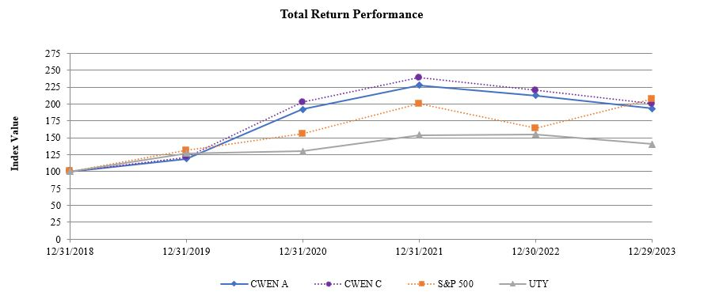
 |  |  |  |  |  | December 31, 2018 |  |  |  |  |  | December 31, 2019 |  |  |  |  |  | December 31, 2020 |  |  |  |  |  | December 31, 2021 |  |  |  |  |  | December 31, 2022 |  |  |  |  |  | December 31, 2023
Clearway Energy, Inc. Class A common stock |  |  |  |  |  | $ | 100.00 |  |  |  |  | $ | 118.83 |  |  |  |  | $ | 192.13 |  |  |  |  | $ | 227.94 |  |  |  |  | $ | 212.81 |  |  |  |  | $ | 193.10
Clearway Energy, Inc. Class C common stock |  |  |  |  |  | 100.00 |  |  |  |  |  | 121.37 |  |  |  |  |  | 202.74 |  |  |  |  |  | 238.89 |  |  |  |  |  | 220.05 |  |  |  |  |  | 200.40
S&P 500 |  |  |  |  |  | 100.00 |  |  |  |  |  | 131.49 |  |  |  |  |  | 155.68 |  |  |  |  |  | 200.37 |  |  |  |  |  | 164.08 |  |  |  |  |  | 207.21
UTY |  |  |  |  |  | 100.00 |  |  |  |  |  | 126.82 |  |  |  |  |  | 130.27 |  |  |  |  |  | 154.04 |  |  |  |  |  | 155.04 |  |  |  |  |  | 140.83

43

Item 6 — Reserved

44

Item 7 — Management’s Discussion and Analysis of Financial Condition and the Results of Operations

As you read this discussion and analysis, refer to the Company’s Consolidated Statements of Income to this Form 10-K. Also refer to Item 1 — Business and Item 1A — Risk Factors, which include detailed discussions of various items impacting the Company’s business, results of operations and financial condition. Discussions of the year ended December 31, 2021 that are not included in this Annual Report on Form 10-K and year-to-year comparisons of the year ended December 31, 2022 and the year ended December 31, 2021 can be found in “Management’s Discussion and Analysis of Financial Condition and the Results of Operations” in Part II, Item 7 of the Company’s Annual Report on Form 10-K for the year ended December 31, 2022.
The discussion and analysis below has been organized as follows:
•Executive Summary, including a description of the business and significant events that are important to understanding the results of operations and financial condition;
•Results of operations, including an explanation of significant differences between the periods in the specific line items of the consolidated statements of income;
•Financial condition addressing liquidity position, sources and uses of cash, capital resources and requirements, commitments and off-balance sheet arrangements;
•Known trends that may affect the Company’s results of operations and financial condition in the future; and
•Critical accounting policies which are most important to both the portrayal of the Company’s financial condition and results of operations, and which require management’s most difficult, subjective or complex judgment.

45

Executive Summary
Introduction and Overview
Clearway Energy, Inc., together with its consolidated subsidiaries, or the Company, is a publicly-traded energy infrastructure investor with a focus on investments in clean energy and owner of modern, sustainable and long-term contracted assets across North America. The Company is sponsored by GIP and TotalEnergies through the portfolio company, Clearway Energy Group LLC, or CEG, which is equally owned by GIP and TotalEnergies. GIP is an independent infrastructure fund manager that makes equity and debt investments in infrastructure assets and businesses. TotalEnergies is a global multi-energy company. CEG is a leading developer of renewable energy infrastructure in the U.S. On January 12, 2024, BlackRock entered into a definitive agreement to acquire 100% of the business and assets of GIM, which is the investment manager of the GIP funds that own an interest in CEG. BlackRock has indicated that the transaction is expected to close in the third quarter of 2024, subject to regulatory approvals and other customary closing conditions. BlackRock is a publicly-traded global investment management firm.
The Company is one of the largest renewable energy owners in the U.S. with approximately 6,000 net MW of installed wind, solar and energy storage projects. The Company’s approximately 8,500 net MW of assets also includes approximately 2,500 net MW of environmentally-sound, highly efficient natural gas-fired generation facilities. Through this environmentally-sound, diversified and primarily contracted portfolio, the Company endeavors to provide its investors with stable and growing dividend income. The majority of the Company’s revenues are derived from long-term contractual arrangements for the output or capacity from these assets. The weighted average remaining contract duration of these offtake agreements was approximately 10 years as of December 31, 2023 based on CAFD.
Significant Events
Drop Down Transactions
•On December 28, 2023, the Company, through its indirect subsidiary, Lighthouse Renewable Holdco 2 LLC, acquired TSN1 BL Borrower Holdco LLC, the indirect owner of Texas Solar Nova 1, a 252 MW solar project that is located in Kent County, Texas, from Clearway Renew for cash consideration of $23 million. Lighthouse Renewable Holdco 2 LLC is a partnership between the Company and a cash equity investor. The cash equity investor also contributed cash consideration of $109 million to acquire their portion of the acquired entity. TSN1 BL Borrower Holdco LLC consolidates as primary beneficiary, TSN1 TE Holdco LLC, a tax equity fund that owns the Texas Solar Nova 1 solar project. See Item 15 — Note 3, Acquisitions and Dispositions, for further discussion of the transaction.
•On October 31, 2023, the Company, through its indirect subsidiary, VP-Arica Parent Holdco LLC, acquired the Class A membership interests in VP-Arica TargetCo LLC, a partnership and the indirect owner of Victory Pass, a 200 MW solar project that is paired with 50 MW of energy storage, and Arica, a 263 MW solar project that is paired with 136 MW of energy storage, which are both currently under construction in Riverside, California, from Clearway Renew for initial cash consideration of $46 million. Simultaneously, a cash equity investor acquired the Class B membership interests in VP-Arica TargetCo LLC from Clearway Renew for initial cash consideration of $87 million. At substantial completion, which is expected to occur in the first half of 2024, the Company estimates it will pay an additional $182 million to Clearway Renew and the cash equity investor will contribute an additional $347 million. VP-Arica TargetCo LLC consolidates as primary beneficiary, VP-Arica TE Holdco LLC, a tax equity fund that owns the Victory Pass and Arica solar projects. See Item 15 — Note 3, Acquisitions and Dispositions, for further discussion of the transaction.
•On August 30, 2023, the Company, through an indirect subsidiary, entered into an agreement with Clearway Renew to acquire the Class A membership interests in Texas Solar Nova 2, a 200 MW solar project currently under construction in Kent County, Texas, upon the project meeting certain milestones. The Company expects to invest approximately $17 million, subject to closing adjustments. Commercial operations of the facilities and the Company’s investment is expected in the first half of 2024.
•On August 30, 2023, the Company, through its indirect subsidiary, Daggett Solar Investment LLC, acquired the Class A membership interests in Daggett 2 TargetCo LLC, a partnership and the indirect owner of Daggett 2, a 182 MW solar project that is paired with 131 MW of energy storage and is located in San Bernardino, California, from CEG for cash consideration of $13 million. Daggett 2 TargetCo LLC consolidates as primary beneficiary, Daggett 2 TE Holdco LLC, a tax equity fund that owns the Daggett 2 solar project. See Item 15 — Note 3, Acquisitions and Dispositions, for further discussion of the transaction.
46

•On June 30, 2023, the Company, through its indirect subsidiary, Rosie Class B LLC, the indirect owner of the Rosamond Central solar project, became the owner of the Class B membership interests of Rosie Central BESS in order to facilitate and fund the construction of a 147 MW BESS project that is co-located at the Rosamond Central solar facility. Clearway Renew indirectly owns the Class A membership interests and controls Rosie Central BESS. As of December 31, 2023, the Company’s investment consisted of $28 million contributed into Rosie Central BESS, funded through contributions from the Company and its cash equity investor in Rosie TargetCo LLC, which consolidates Rosie Class B LLC. On December 1, 2023, the Rosamond Central solar project acquired the BESS project from Clearway Renew for initial cash consideration of $70 million, $16 million of which was funded by the Company with the remaining $54 million funded through contributions from third-party investors. At substantial completion, which is expected to occur in the first half of 2024, the Company estimates it will pay an additional $279 million to Clearway Renew, $61 million of which will be funded by the Company with the remaining $218 million to be funded through contributions from third-party investors. Also at substantial completion, Clearway Renew will return Rosie Class B LLC’s equity investment. See Item 15 — Note 3, Acquisitions and Dispositions and Note 5, Investments Accounted for by the Equity Method and Variable Interest Entities, for further discussion of the transactions.
•On May 19, 2023, the Company, through an indirect subsidiary, entered into an agreement with Clearway Renew to acquire Cedar Creek Holdco LLC, which is the indirect owner of Cedar Creek, a 160 MW wind project under construction in Bingham County, Idaho, for $107 million in cash, subject to customary working capital adjustments. Upon the closing of the transaction, the Company will indirectly own all of the Class B membership interests in Cedar Creek TE Holdco LLC, a tax equity fund which will consolidate the Cedar Creek wind project, while a tax equity investor will own all of the Class A membership interests. The consummation of the transaction is subject to customary closing conditions and certain third-party approvals and is expected in the first half of 2024.
•On May 3, 2023, the Company entered into an agreement with Clearway Renew to repower the Cedro Hill wind project, which is included in the Capistrano Wind Portfolio and is located in Bruni, Texas. The Company expects to invest approximately $36 million in net corporate capital, subject to closing adjustments. Contingent upon achieving repowering commercial operations in the second half of 2024, the 160 MW project will sell power to its existing counterparty, an investment-grade utility, for an additional 15 years ending in 2045 under an amended PPA.
•On February 17, 2023, the Company, through its indirect subsidiary, Daggett Solar Investment LLC, acquired the Class A membership interests in Daggett TargetCo LLC, the indirect owner of Daggett 3, a 300 MW solar project that is paired with 149 MW of energy storage and located in San Bernardino, California, from Clearway Renew for cash consideration of $21 million. Simultaneously, a cash equity investor acquired the Class B membership interests in Daggett TargetCo LLC from Clearway Renew for cash consideration of $129 million. The Company and the cash equity investor then contributed their Class A and B membership interests, respectively, into Daggett Renewable Holdco LLC, a partnership that consolidates Daggett TargetCo LLC. Daggett TargetCo LLC consolidates as primary beneficiary, Daggett TE Holdco LLC, a tax equity fund that owns the Daggett 3 solar project. See Item 15 — Note 3, Acquisitions and Dispositions, for further discussion of the transaction.
Resource Adequacy Agreements
•In October 2023, the Company contracted with a load serving entity to sell approximately 400 MW of Marsh Landing’s RA commencing in September 2026 and ending in December 2027. Marsh Landing is now contracted for 100% of its capacity through the majority of 2026 and 63% of its capacity in 2027.
•In October 2023, the Company contracted with a load serving entity to sell approximately 274 MW of El Segundo’s RA commencing in August 2026 and ending in December 2027. El Segundo is now contracted for 100% of its capacity through the majority of 2026 and 50% of its capacity in 2027.
Corporate Financing Activities
•On March 15, 2023, Clearway Energy Operating LLC refinanced the Amended and Restated Credit Agreement. See Item 15 — Note 10, Long-term Debt, for further discussion of the amendment.
Project-level Financing Activities
•In connection with the Drop Downs of Daggett 3, Daggett 2, Victory Pass, Arica and Texas Solar Nova 1, the Company assumed non-recourse project-level debt. See Item 15 — Note 10, Long-term Debt, for further discussion of the non-recourse project-level debt associated with each project.
47

•On December 12, 2023, the Company entered into a financing agreement for non-recourse debt for a total commitment of $254 million related to the repowering of the Cedro Hill wind project. The Company’s initial borrowing under the agreement was $165 million. See Item 15 — Note 10, Long-term Debt, for further discussion of the project financing activities.
•On June 30, 2023, Rosie Class B LLC amended its financing agreement. During the year ended December 31, 2023, Rosie Class B LLC received total loan proceeds of $265 million under the amended financing agreement. On July 3, 2023, Rosie Class B LLC issued a loan to Clearway Renew, utilizing a portion of the loan proceeds under the amended financing agreement, in order to finance the construction of the BESS project. On December 1, 2023, Clearway Renew partially repaid the loan utilizing the $70 million in proceeds that was paid by the Company to acquire the BESS project. As of December 31, 2023, the loan had an aggregate principal amount of $174 million. The loan matures when the project reaches substantial completion, which is expected in the first half of 2024. See Item 15 — Note 10, Long-term Debt, for further discussion of the project financing activities. Also, during the year ended December 31, 2023, the Company utilized a portion of the loan proceeds received under the amended financing agreement to contribute $18 million into Rosie Central BESS, which is an investment accounted for under the equity method of accounting, as further described above and in Item 15 — Note 5, Investments Accounted for by the Equity Method and Variable Interest Entities.
Environmental Matters and Regulatory Matters
Details of environmental matters and regulatory matters are presented in Item 1 — Business, Regulatory Matters and Item 1A — Risk Factors. Details of some of this information relate to costs that may impact the Company’s financial results.

48

Consolidated Results of Operations
The following table provides selected financial information:
 |  |  | Year ended December 31,
(In millions) |  |  | 2023 |  |  |  |  |  | 2022 |  |  |  |  |  | 2021
Operating Revenues
Energy and capacity revenues |  |  | $ | 1,382 |  |  |  |  | $ | 1,465 |  |  |  |  | $ | 1,425
Other revenue |  |  | 99 |  |  |  |  |  | 82 |  |  |  |  |  | 92
Contract amortization |  |  | (186) |  |  |  |  |  | (175) |  |  |  |  |  | (144)
Mark-to-market for economic hedges |  |  | 19 |  |  |  |  |  | (182) |  |  |  |  |  | (87)
Total operating revenues |  |  | 1,314 |  |  |  |  |  | 1,190 |  |  |  |  |  | 1,286
Operating Costs and Expenses
Cost of fuels |  |  | 62 |  |  |  |  |  | 29 |  |  |  |  |  | 75
Operations and maintenance |  |  | 314 |  |  |  |  |  | 295 |  |  |  |  |  | 279
Mark-to-market for economic hedges |  |  | (2) |  |  |  |  |  | — |  |  |  |  |  | —
Other costs of operations |  |  | 99 |  |  |  |  |  | 111 |  |  |  |  |  | 97
Depreciation, amortization and accretion |  |  | 526 |  |  |  |  |  | 512 |  |  |  |  |  | 509
Impairment losses |  |  | 12 |  |  |  |  |  | 16 |  |  |  |  |  | 6
General and administrative |  |  | 36 |  |  |  |  |  | 40 |  |  |  |  |  | 40
Transaction and integration costs |  |  | 4 |  |  |  |  |  | 7 |  |  |  |  |  | 7
Development costs |  |  | — |  |  |  |  |  | 2 |  |  |  |  |  | 6
Total operating costs and expenses |  |  | 1,051 |  |  |  |  |  | 1,012 |  |  |  |  |  | 1,019
Gain on sale of business |  |  | — |  |  |  |  |  | 1,292 |  |  |  |  |  | —
Operating Income |  |  | 263 |  |  |  |  |  | 1,470 |  |  |  |  |  | 267
Other Income (Expense)
Equity in earnings of unconsolidated affiliates |  |  | 12 |  |  |  |  |  | 29 |  |  |  |  |  | 32
Other income, net |  |  | 52 |  |  |  |  |  | 17 |  |  |  |  |  | 3
Loss on debt extinguishment |  |  | (6) |  |  |  |  |  | (2) |  |  |  |  |  | (53)
Derivative interest (expense) income |  |  | (17) |  |  |  |  |  | 100 |  |  |  |  |  | 53
Other interest expense |  |  | (320) |  |  |  |  |  | (332) |  |  |  |  |  | (365)
Total other expense, net |  |  | (279) |  |  |  |  |  | (188) |  |  |  |  |  | (330)
(Loss) Income Before Income Taxes |  |  | (16) |  |  |  |  |  | 1,282 |  |  |  |  |  | (63)
Income tax (benefit) expense |  |  | (2) |  |  |  |  |  | 222 |  |  |  |  |  | 12
Net (Loss) Income |  |  | (14) |  |  |  |  |  | 1,060 |  |  |  |  |  | (75)
Less: Net (loss) income attributable to noncontrolling interests and redeemable noncontrolling interests |  |  | (93) |  |  |  |  |  | 478 |  |  |  |  |  | (126)
Net Income Attributable to Clearway Energy, Inc. |  |  | $ | 79 |  |  |  |  | $ | 582 |  |  |  |  | $ | 51
 |  |  | Year ended December 31,
Business metrics: |  |  | 2023 |  |  |  |  |  | 2022 |  |  |  |  |  | 2021
Solar MWh generated/sold (in thousands) (a) |  |  | 5,425 |  |  |  |  |  | 4,991 |  |  |  |  |  | 3,585
Wind MWh generated/sold (in thousands) (a) |  |  | 9,414 |  |  |  |  |  | 9,343 |  |  |  |  |  | 7,728
Renewables MWh generated/sold (in thousands) (a) |  |  | 14,839 |  |  |  |  |  | 14,334 |  |  |  |  |  | 11,313
Solar weighted-average capacity factor (b) (c) |  |  | 27.5 |  | % |  |  |  | 28.4 |  | % |  |  |  | 24.2 |  | %
Wind weighted-average capacity factor (d) |  |  | 28.3 |  | % |  |  |  | 29.9 |  | % |  |  |  | 29.1 |  | %
Thermal MWt sold (in thousands) (e) |  |  | — |  |  |  |  |  | 835 |  |  |  |  |  | 2,035
Thermal MWh sold (in thousands) (e) |  |  | — |  |  |  |  |  | 19 |  |  |  |  |  | 59
Conventional MWh generated (in thousands) (a) (f) |  |  | 996 |  |  |  |  |  | 1,236 |  |  |  |  |  | 1,108
Conventional equivalent availability factor |  |  | 90.2 |  | % |  |  |  | 92.2 |  | % |  |  |  | 94.7 |  | %
(a) Volumes do not include the MWh generated/sold by the Company’s equity method investments.
(b) Typical average capacity factors for solar facilities is 25%. The weighted-average capacity factors can vary based on seasonality and weather.
(c) The 2021 solar weighted-average capacity factor is lower, due to the Company owning the Utah Solar Portfolio for one month.
(d) Typical average capacity factors for wind facilities is 25-45%. The weighted-average capacity factors can vary based on seasonality and weather.
(e) On May 1, 2022, the Company completed the sale of 100% of its interests in the Thermal Business to KKR.
(f) Volumes generated in 2022 and 2021 were not sold as the Conventional facilities sold only capacity rather than energy prior to 2023.

49

Management’s discussion of the results of operations for the years ended December 31, 2023 and 2022
Operating Revenues
Operating revenues increased by $124 million for the year ended December 31, 2023, compared to the same period in 2022, due to a combination of the drivers summarized in the table below:
 |  |  |  |  |  | (In millions)
Renewables Segment |  |  | Increase driven by the acquisition of the Capistrano Wind Portfolio in August 2022. |  |  | $ | 44
 |  |  | Increase for solar acquisitions driven by Mililani I, Waiawa and Daggett 3, which reached commercial operations in July 2022, January 2023 and July 2023, respectively, offset by the disposition of Kawailoa in August 2022. |  |  | 22
 |  |  | Decrease driven primarily by lower than average wind production primarily during the second quarter of 2023, compared with higher than average wind production during the second quarter of 2022. |  |  | (43)
 |  |  | Decrease driven primarily by lower solar generation due to weather. |  |  | (16)
Conventional Segment |  |  | Increase primarily driven by higher energy revenue due to the commencement of merchant operations following the expiration of PPAs at the Walnut Creek and Marsh Landing facilities during the second quarter of 2023 and the El Segundo facility during the third quarter of 2023. |  |  | 81
 |  |  | Increase driven by the sales-type lease revenue recognition of the Marsh Landing Black Start addition that commenced operations on May 31, 2023. |  |  | 21
 |  |  | Increase primarily driven by increased availability at the El Segundo facility in 2023 due to longer maintenance outages in 2022. |  |  | 7
 |  |  | Decrease primarily driven by lower prices for capacity revenue due to the expiration of PPAs and commencement of RA capacity revenue at the Walnut Creek, Marsh Landing and El Segundo facilities during 2023. |  |  | (105)
Thermal Segment |  |  | Decrease primarily driven by the sale of the Thermal Business on May 1, 2022. |  |  | (77)
Contract amortization |  |  | Increase primarily driven by a full year of amortization for intangible assets related to PPAs from the acquisition of the Capistrano Wind Portfolio in August 2022, partially offset by the Walnut Creek PPA, which was fully amortized in the first half of 2023. |  |  | (11)
Mark-to-market economic hedges |  |  | Increase driven by decreases in forward power prices in the ERCOT and PJM markets. |  |  | 196
 |  |  | Increase due to heat rate call option entered into by El Segundo, Marsh Landing and Walnut Creek during 2023. |  |  | 5
 |  |  |  |  |  | $ | 124
Cost of Fuels
Cost of fuels increased by $33 million during the year ended December 31, 2023, compared to the same period in 2022, due to a combination of the drivers summarized in the table below:
 |  |  |  |  |  | (In millions)
Conventional Segment |  |  | Increase primarily driven by fuel purchases and the related cost of emissions obligations at the Walnut Creek, Marsh Landing and El Segundo facilities as a result of the expiration of PPAs and the facilities commencing merchant operations during 2023. |  |  | $ | 48
 |  |  | Increase due to the associated costs of the sales-type lease recognition of the Marsh Landing Black Start addition that commenced operations on May 31, 2023. |  |  | 13
Thermal Segment |  |  | Decrease primarily driven by the sale of the Thermal Business on May 1, 2022. |  |  | (28)
 |  |  |  |  |  | $ | 33
50

Operations and Maintenance Expense
Operations and maintenance expense increased by $19 million during the year ended December 31, 2023, compared to the same period in 2022, due to a combination of the drivers summarized in the table below:
 |  |  |  |  |  | (In millions)
Renewables Segment |  |  | Increase driven by the acquisition of the Capistrano Wind Portfolio in August 2022. |  |  | $ | 16
 |  |  | Increase for solar acquisitions driven by Daggett 3 in February 2023, Mililani I in March 2022 and Waiawa in November 2022, partially offset by the disposition of Kawailoa in August 2022. |  |  | 8
 |  |  | Increase primarily driven by maintenance activities at the wind facilities. |  |  | 4
Conventional Segment |  |  | Increase primarily driven by higher costs related to outages at the Walnut Creek and Marsh Landing facilities. |  |  | 5
 |  |  | Increase primarily driven by higher costs related to planned maintenance outages at the Carlsbad and El Segundo facilities. |  |  | 4
Thermal Segment |  |  | Decrease primarily driven by the sale of the Thermal Business on May 1, 2022. |  |  | (18)
 |  |  |  |  |  | $ | 19
Gain on Sale of Business
On May 1, 2022, the Company completed the sale of 100% of its interests in the Thermal Business to KKR resulting in a gain on sale of business of approximately $1.29 billion, as further described in Item 15 — Note 3, Acquisitions and Dispositions.
Equity in Earnings of Unconsolidated Affiliates
Equity in earnings of unconsolidated affiliates decreased by $17 million during the year ended December 31, 2023, compared to the same period in 2022, primarily due to the change in fair value of interest swaps and higher depreciation expense, as well as lower wind production during the second quarter of 2023.
Other Income, Net
Other income, net increased $35 million during the year ended December 31, 2023, compared to the same period in 2022, primarily due to higher interest income earned on investments in money market and time deposit accounts, which have retained larger balances as a result of the proceeds received from the sale of the Thermal Business on May 1, 2022, along with higher interest income earned across the portfolio as a result of higher interest rates.
Interest Expense
Interest expense increased by $105 million during the year ended December 31, 2023, compared to the same period in 2022, primarily due to the following:
 |  |  | (In millions)
Change in fair value of interest rate swaps due to changes in interest rates |  |  | $ | 117
Increase in interest expense due to an increase in principal balances of Renewables segment project-level debt |  |  | 14
Decrease in interest expense due to a decrease in principal balances of Conventional segment project-level debt |  |  | (17)
Decrease in interest expense due to the sale of the Thermal Business on May 1, 2022 |  |  | (6)
Decrease in interest expense due to decreased principal balances of Corporate debt, which includes repayment of the outstanding borrowings under the Bridge Loan Agreement and the revolving credit facility on May 3, 2022 |  |  | (3)
 |  |  | $ | 105
Income Tax (Benefit) Expense
For the year ended December 31, 2023, the Company recorded an income tax benefit of $2 million on pretax loss of $16 million. For the same period in 2022, the Company recorded an income tax expense of $222 million on pretax income of $1,282 million.
51

A reconciliation of the U.S. federal statutory rate of 21% to the Company’s effective rate is as follows:
 |  |  | Year Ended December 31,
 |  |  | 2023 |  |  |  |  |  | 2022
 |  |  | (In millions, except percentages)
(Loss) Income Before Income Taxes |  |  | $ | (16) |  |  |  |  | $ | 1,282
Tax at 21% |  |  | (3) |  |  |  |  |  | 269
State taxes, net of federal benefit |  |  | (2) |  |  |  |  |  | 58
Impact of non-taxable partnership earnings (losses) |  |  | 21 |  |  |  |  |  | (101)
Valuation allowance |  |  | 3 |  |  |  |  |  | —
Investment tax credits |  |  | (1) |  |  |  |  |  | —
Production tax credits (a) |  |  | (16) |  |  |  |  |  | (2)
Rate change |  |  | 1 |  |  |  |  |  | (2)
State taxes assessed at subsidiaries |  |  | (3) |  |  |  |  |  | 2
Other |  |  | (2) |  |  |  |  |  | (2)
Income tax (benefit) expense |  |  | $ | (2) |  |  |  |  | $ | 222
Effective income tax rate |  |  | 12.5 |  | % |  |  |  | 17.3 |  | %
(a) On December 6, 2023, the Company executed an agreement with a third party to sell the PTCs generated by the Alta X and Alta XI wind projects, which resulted in a $14 million income tax benefit (reduction to income tax expense) during the year ended December 31, 2023.
The effective income tax rate may vary from period to period depending on, among other factors, the geographic and business mix of earnings and losses, earnings and losses allocated to partners’ interest in Clearway Energy LLC which includes the effects of applying the HLBV method of accounting for book purposes to certain partnerships and changes in valuation allowances in accordance with ASC 740. These factors and others, including the Company’s history of pre-tax earnings and losses, are taken into account in assessing the ability to realize deferred tax assets.
Net (Loss) Income Attributable to Noncontrolling Interests and Redeemable Noncontrolling Interests
For the year ended December 31, 2023, the Company had a net loss of $93 million attributable to noncontrolling interests and redeemable noncontrolling interests comprised of the following:
 |  |  |  |  |  | (In millions)
Losses attributable to tax equity financing arrangements and the application of the HLBV method (primarily due to Daggett TE Holdco LLC and Daggett 2 TE Holdco LLC HLBV losses) |  |  |  |  |  | $ | (388)
Income attributable to third-party partnerships (primarily due to Daggett TE Holdco LLC and Daggett 2 TE Holdco LLC HLBV losses) |  |  |  |  |  | 226
CEG’s economic interest in Clearway Energy LLC |  |  |  |  |  | 69
 |  |  |  |  |  | $ | (93)
For the year ended December 31, 2022, the Company had a net income of $478 million attributable to noncontrolling interests and redeemable noncontrolling interests comprised of the following:
 |  |  |  |  |  | (In millions)
CEG’s economic interest in Clearway Energy LLC (primarily driven by the gain on sale of the Thermal Business on May 1, 2022) |  |  |  |  |  | $ | 584
Losses attributable to tax equity financing arrangements and the application of HLBV |  |  |  |  |  | (87)
Losses attributable to third-party partnerships |  |  |  |  |  | (19)
 |  |  |  |  |  | $ | 478

52

Liquidity and Capital Resources
The Company’s principal liquidity requirements are to meet its financial commitments, finance current operations, fund capital expenditures, including acquisitions from time to time, service debt and pay dividends. As a normal part of the Company’s business, depending on market conditions, the Company will from time to time consider opportunities to repay, redeem, repurchase or refinance its indebtedness. Changes in the Company’s operating plans, lower than anticipated sales, increased expenses, acquisitions or other events may cause the Company to seek additional debt or equity financing in future periods. There can be no guarantee that financing will be available on acceptable terms or at all. Debt financing, if available, could impose additional cash payment obligations and additional covenants and operating restrictions.
Current Liquidity Position
As of December 31, 2023 and 2022, the Company’s liquidity was approximately $1.51 billion and $1.37 billion, respectively, comprised of cash, restricted cash and availability under the Company’s revolving credit facility.
 |  |  | As of December 31,
 |  |  | 2023 |  |  |  |  |  | 2022
 |  |  | (In millions)
Cash and cash equivalents:
Clearway Energy, Inc. and Clearway Energy LLC, excluding subsidiaries |  |  | $ | 410 |  |  |  |  | $ | 536
Subsidiaries |  |  | 125 |  |  |  |  |  | 121
Restricted cash:
Operating accounts |  |  | 176 |  |  |  |  |  | 109
Reserves, including debt service, distributions, performance obligations and other reserves |  |  | 340 |  |  |  |  |  | 230
Total cash, cash equivalents and restricted cash |  |  | 1,051 |  |  |  |  |  | 996
Revolving credit facility availability |  |  | 454 |  |  |  |  |  | 370
Total liquidity |  |  | $ | 1,505 |  |  |  |  | $ | 1,366
The Company’s liquidity includes $516 million and $339 million of restricted cash balances as of December 31, 2023 and 2022, respectively. Restricted cash consists primarily of funds to satisfy the requirements of certain debt arrangements and funds held within the Company’s projects that are restricted in their use. As of December 31, 2023, these restricted funds were comprised of $176 million designated to fund operating expenses, approximately $178 million designated for current debt service payments, and $85 million restricted for reserves including debt service, performance obligations and other reserves, as well as capital expenditures. The remaining $77 million is held in distribution reserve accounts.
Clearway Energy LLC and Clearway Energy Operating LLC Revolving Credit Facility
On March 15, 2023, Clearway Energy Operating LLC refinanced the Amended and Restated Credit Agreement, which (i) replaced LIBOR with SOFR plus a credit spread adjustment of 0.10% as the applicable reference rate, (ii) increased the available revolving commitments to an aggregate principal amount of $700 million, (iii) extended the maturity date to March 15, 2028, (iv) increased the letter of credit sublimit to $594 million and (v) implemented certain other technical modifications.
As of December 31, 2023, the Company had no outstanding borrowings under the revolving credit facility and $246 million in letters of credit outstanding. The facility will continue to be used for general corporate purposes, including financing of future acquisitions and posting letters of credit.
Management believes that the Company’s liquidity position, cash flows from operations and availability under its revolving credit facility will be adequate to meet the Company’s financial commitments; debt service obligations; growth, operating and maintenance capital expenditures; and to fund dividends to holders of the Company’s Class A common stock and Class C common stock. Management continues to regularly monitor the Company’s ability to finance the needs of its operating, financing and investing activity within the dictates of prudent balance sheet management.
Credit Ratings
Credit rating agencies rate a firm’s public debt securities. These ratings are utilized by the debt markets in evaluating a firm’s credit risk. Ratings influence the price paid to issue new debt securities by indicating to the market the Company’s ability to pay principal, interest and preferred dividends. Rating agencies evaluate a firm’s industry, cash flow, leverage, liquidity and hedge profile, among other factors, in their credit analysis of a firm’s credit risk.
53

The following table summarizes the credit ratings for the Company and its Senior Notes as of December 31, 2023. The ratings outlook is stable.
 |  |  | S&P |  |  |  |  |  | Moody’s
Clearway Energy, Inc. |  |  | BB |  |  |  |  |  | Ba2
4.750% Senior Notes, due 2028 |  |  | BB |  |  |  |  |  | Ba2
3.750% Senior Notes, due 2031 |  |  | BB |  |  |  |  |  | Ba2
3.750% Senior Notes, due 2032 |  |  | BB |  |  |  |  |  | Ba2

Sources of Liquidity
The Company’s principal sources of liquidity include cash on hand, cash generated from operations, proceeds from sales of assets, borrowings under new and existing financing arrangements and the issuance of additional equity and debt securities as appropriate given market conditions. As described in Item 15 — Note 10, Long-term Debt, the Company’s financing arrangements consist of corporate level debt, which includes Senior Notes and the revolving credit facility; the ATM Program; and project-level financings for its various assets.
Cedro Hill Repowering Financing — On December 12, 2023, the Company entered into a financing agreement for non-recourse debt for a total commitment of $254 million related to the repowering of the Cedro Hill wind project. The Company’s initial borrowing of $165 million was utilized to repay the $72 million of outstanding principal under the original financing agreement, to pay $55 million to Clearway Renew for the future delivery of equipment, to pay $27 million to a third party for the future delivery of equipment, to pay a $4 million development services fee to Clearway Renew, to pay for $4 million in debt issuance costs that were deferred and to pay for $3 million in capital expenditures.

Uses of Liquidity
The Company’s requirements for liquidity and capital resources, other than for operating its facilities, are categorized as: (i) debt service obligations, as described more fully in Item 15 — Note 10, Long-term Debt; (ii) capital expenditures; (iii) off-balance sheet arrangements; (iv) acquisitions and investments, as described more fully in Item 15 — Note 3, Acquisitions and Dispositions and Note 5, Investments Accounted for by the Equity Method and Variable Interest Entities; and (v) cash dividends to investors.
54

Debt Service Obligations
Principal payments on debt as of December 31, 2023, are due in the following periods:
Description |  |  | 2024 |  |  |  |  |  | 2025 |  |  |  |  |  | 2026 |  |  |  |  |  | 2027 |  |  |  |  |  | 2028 |  |  |  |  |  | There-after |  |  |  |  |  | Total
 |  |  | (In millions)
Corporate-level debt:
Clearway Energy Operating LLC Senior Notes, due 2028 |  |  | $ | — |  |  |  |  | $ | — |  |  |  |  | $ | — |  |  |  |  | $ | — |  |  |  |  | $ | 850 |  |  |  |  | $ | — |  |  |  |  | $ | 850
Clearway Energy Operating LLC Senior Notes, due 2031 |  |  | — |  |  |  |  |  | — |  |  |  |  |  | — |  |  |  |  |  | — |  |  |  |  |  | — |  |  |  |  |  | 925 |  |  |  |  |  | 925
Clearway Energy Operating LLC Senior Notes, due 2032 |  |  | — |  |  |  |  |  | — |  |  |  |  |  | — |  |  |  |  |  | — |  |  |  |  |  | — |  |  |  |  |  | 350 |  |  |  |  |  | 350
Total Corporate-level debt |  |  | — |  |  |  |  |  | — |  |  |  |  |  | — |  |  |  |  |  | — |  |  |  |  |  | 850 |  |  |  |  |  | 1,275 |  |  |  |  |  | 2,125
Project-level debt:
Agua Caliente Solar LLC, due 2037 |  |  | 38 |  |  |  |  |  | 39 |  |  |  |  |  | 40 |  |  |  |  |  | 41 |  |  |  |  |  | 43 |  |  |  |  |  | 411 |  |  |  |  |  | 612
Alta Wind Asset Management LLC, due 2031 |  |  | 1 |  |  |  |  |  | 1 |  |  |  |  |  | 1 |  |  |  |  |  | 2 |  |  |  |  |  | 2 |  |  |  |  |  | 4 |  |  |  |  |  | 11
Alta Wind I-V lease financing arrangements, due 2034 and 2035 |  |  | 52 |  |  |  |  |  | 54 |  |  |  |  |  | 55 |  |  |  |  |  | 57 |  |  |  |  |  | 60 |  |  |  |  |  | 382 |  |  |  |  |  | 660
Alta Wind Realty Investments LLC, due 2031 |  |  | 2 |  |  |  |  |  | 2 |  |  |  |  |  | 3 |  |  |  |  |  | 3 |  |  |  |  |  | 3 |  |  |  |  |  | 7 |  |  |  |  |  | 20
Borrego, due 2024 and 2038 |  |  | 3 |  |  |  |  |  | 2 |  |  |  |  |  | 3 |  |  |  |  |  | 3 |  |  |  |  |  | 3 |  |  |  |  |  | 34 |  |  |  |  |  | 48
Broken Bow, due 2031 |  |  | 4 |  |  |  |  |  | 5 |  |  |  |  |  | 5 |  |  |  |  |  | 5 |  |  |  |  |  | 6 |  |  |  |  |  | 16 |  |  |  |  |  | 41
Buckthorn Solar, due 2025 |  |  | 4 |  |  |  |  |  | 112 |  |  |  |  |  | — |  |  |  |  |  | — |  |  |  |  |  | — |  |  |  |  |  | — |  |  |  |  |  | 116
Carlsbad Energy Holdings LLC, due 2027 |  |  | 23 |  |  |  |  |  | 24 |  |  |  |  |  | 26 |  |  |  |  |  | 20 |  |  |  |  |  | — |  |  |  |  |  | — |  |  |  |  |  | 93
Carlsbad Energy Holdings LLC, due 2038 |  |  | — |  |  |  |  |  | — |  |  |  |  |  | — |  |  |  |  |  | 7 |  |  |  |  |  | 25 |  |  |  |  |  | 375 |  |  |  |  |  | 407
Carlsbad Holdco, LLC, due 2038 |  |  | 2 |  |  |  |  |  | 3 |  |  |  |  |  | 9 |  |  |  |  |  | 11 |  |  |  |  |  | 9 |  |  |  |  |  | 161 |  |  |  |  |  | 195
Cedro Hill, due 2024 and 2029 (a) |  |  | 165 |  |  |  |  |  | — |  |  |  |  |  | — |  |  |  |  |  | — |  |  |  |  |  | — |  |  |  |  |  | — |  |  |  |  |  | 165
Crofton Bluffs, due 2031 |  |  | 3 |  |  |  |  |  | 3 |  |  |  |  |  | 3 |  |  |  |  |  | 3 |  |  |  |  |  | 4 |  |  |  |  |  | 11 |  |  |  |  |  | 27
CVSR, due 2037 |  |  | 28 |  |  |  |  |  | 30 |  |  |  |  |  | 32 |  |  |  |  |  | 35 |  |  |  |  |  | 37 |  |  |  |  |  | 439 |  |  |  |  |  | 601
CVSR Holdco Notes, due 2037 |  |  | 9 |  |  |  |  |  | 9 |  |  |  |  |  | 9 |  |  |  |  |  | 9 |  |  |  |  |  | 10 |  |  |  |  |  | 106 |  |  |  |  |  | 152
Daggett 2, due 2028 |  |  | 1 |  |  |  |  |  | 1 |  |  |  |  |  | 1 |  |  |  |  |  | 1 |  |  |  |  |  | 152 |  |  |  |  |  | — |  |  |  |  |  | 156
Daggett 3, due 2028 |  |  | — |  |  |  |  |  | — |  |  |  |  |  | — |  |  |  |  |  | — |  |  |  |  |  | 217 |  |  |  |  |  | — |  |  |  |  |  | 217
DG-CS Master Borrower LLC, due 2040 |  |  | 29 |  |  |  |  |  | 30 |  |  |  |  |  | 30 |  |  |  |  |  | 28 |  |  |  |  |  | 20 |  |  |  |  |  | 248 |  |  |  |  |  | 385
Mililani Class B Member Holdco LLC, due 2028 |  |  | 3 |  |  |  |  |  | 3 |  |  |  |  |  | 3 |  |  |  |  |  | 3 |  |  |  |  |  | 80 |  |  |  |  |  | — |  |  |  |  |  | 92
NIMH Solar, due 2024 |  |  | 148 |  |  |  |  |  | — |  |  |  |  |  | — |  |  |  |  |  | — |  |  |  |  |  | — |  |  |  |  |  | — |  |  |  |  |  | 148
Oahu Solar Holdings LLC, due 2026 |  |  | 3 |  |  |  |  |  | 3 |  |  |  |  |  | 75 |  |  |  |  |  | — |  |  |  |  |  | — |  |  |  |  |  | — |  |  |  |  |  | 81
Rosie Class B LLC, due 2024 and 2029 (a) |  |  | 347 |  |  |  |  |  | — |  |  |  |  |  | — |  |  |  |  |  | — |  |  |  |  |  | — |  |  |  |  |  | — |  |  |  |  |  | 347
Texas Solar Nova 1, due 2028 |  |  | 2 |  |  |  |  |  | 3 |  |  |  |  |  | 4 |  |  |  |  |  | 4 |  |  |  |  |  | 89 |  |  |  |  |  | — |  |  |  |  |  | 102
Utah Solar Portfolio, due 2036 |  |  | 14 |  |  |  |  |  | 15 |  |  |  |  |  | 16 |  |  |  |  |  | 16 |  |  |  |  |  | 12 |  |  |  |  |  | 169 |  |  |  |  |  | 242
Viento Funding II, LLC, due 2029 |  |  | 16 |  |  |  |  |  | 17 |  |  |  |  |  | 20 |  |  |  |  |  | 24 |  |  |  |  |  | 24 |  |  |  |  |  | 74 |  |  |  |  |  | 175
Victory Pass and Arica, due 2024 (a) |  |  | 757 |  |  |  |  |  | — |  |  |  |  |  | — |  |  |  |  |  | — |  |  |  |  |  | — |  |  |  |  |  | — |  |  |  |  |  | 757
Other |  |  | 15 |  |  |  |  |  | 15 |  |  |  |  |  | 16 |  |  |  |  |  | 16 |  |  |  |  |  | 16 |  |  |  |  |  | 46 |  |  |  |  |  | 124
Total project-level debt |  |  | 1,669 |  |  |  |  |  | 371 |  |  |  |  |  | 351 |  |  |  |  |  | 288 |  |  |  |  |  | 812 |  |  |  |  |  | 2,483 |  |  |  |  |  | 5,974
Total debt |  |  | $ | 1,669 |  |  |  |  | $ | 371 |  |  |  |  | $ | 351 |  |  |  |  | $ | 288 |  |  |  |  | $ | 1,662 |  |  |  |  | $ | 3,758 |  |  |  |  | $ | 8,099
(a) At December 31, 2023, amount includes $1.11 billion of construction-related financings recorded in long-term debt on the Company’s consolidated balance sheet that is due in 2024 and is either being funded through long-term equity contributions or is converting to long-term debt.

Capital Expenditures
The Company’s capital spending program is mainly focused on maintenance capital expenditures, consisting of costs to maintain the assets currently operating, such as costs to replace or refurbish assets during routine maintenance, and growth capital expenditures consisting of costs to construct new assets, and costs to complete the construction of assets where construction is in process.
55

For the years ended December 31, 2023 and 2022, the Company used approximately $212 million and $112 million, respectively, to fund capital expenditures, including maintenance capital expenditures of $22 million and $25 million, respectively. Growth capital expenditures in 2023 of $190 million in the Renewables segment were funded through construction-related financing. Renewables segment capital expenditures included $121 million incurred in connection with the Daggett 3 solar project, $23 million incurred in connection with the Daggett 2 solar project, $20 million incurred in connection with the Victory Pass and Arica solar projects, $11 million incurred in connection with the Waiawa solar project and $15 million incurred by other wind and solar projects.
The Company estimates $40 million of maintenance capital expenditures for 2024. These estimates are subject to continuing review and adjustment and actual capital expenditures may vary from these estimates.
Off-Balance Sheet Arrangements
Obligations under Certain Guarantee Contracts
The Company may enter into guarantee arrangements in the normal course of business to facilitate commercial transactions with third parties.
Retained or Contingent Interests
The Company does not have any material retained or contingent interests in assets transferred to an unconsolidated entity.
Obligations Arising Out of a Variable Interest in an Unconsolidated Entity
Variable interest in equity investments — As of December 31, 2023, the Company has several investments with an ownership interest percentage of 50% or less. GenConn and Rosie Central BESS are variable interest entities for which the Company is not the primary beneficiary. The Company’s pro-rata share of non-recourse debt held by unconsolidated affiliates was approximately $303 million as of December 31, 2023. This indebtedness may restrict the ability of these subsidiaries to issue dividends or distributions to the Company. See also Item 15 — Note 5, Investments Accounted for by the Equity Method and Variable Interest Entities.
Contractual Obligations and Commercial Commitments
In addition to the Company’s capital expenditure programs, the Company has a variety of contractual obligations and other commercial commitments that represent prospective cash requirements. The following table summarizes the Company’s contractual obligations. See Item 15 — Note 10, Long-term Debt and Note 17, Leases, for additional discussion.
 |  |  | By Remaining Maturity at December 31,
 |  |  | 2023 |  |  |  |  |  |  |  |  |  |  |  |  |  |  |  |  |  |  |  |  |  |  |  |  |  |  |  |  |  | 2022
Contractual Cash Obligations |  |  | Under  1 Year |  |  |  |  |  | 1-3 Years |  |  |  |  |  | 3-5 Years |  |  |  |  |  | Over  5 Years |  |  |  |  |  | Total |  |  |  |  |  | Total
 |  |  | (In millions)
Long-term debt (including estimated interest) |  |  | $ | 1,989 |  |  |  |  | $ | 1,258 |  |  |  |  | $ | 2,395 |  |  |  |  | $ | 4,286 |  |  |  |  | $ | 9,928 |  |  |  |  | $ | 8,861
Operating leases |  |  | 34 |  |  |  |  |  | 69 |  |  |  |  |  | 72 |  |  |  |  |  | 980 |  |  |  |  |  | 1,155 |  |  |  |  |  | 982
Natural gas transportation obligations (a) |  |  | 2 |  |  |  |  |  | 5 |  |  |  |  |  | — |  |  |  |  |  | — |  |  |  |  |  | 7 |  |  |  |  |  | —
Other liabilities (b) |  |  | 29 |  |  |  |  |  | 55 |  |  |  |  |  | 46 |  |  |  |  |  | 315 |  |  |  |  |  | 445 |  |  |  |  |  | 300
Total |  |  | $ | 2,054 |  |  |  |  | $ | 1,387 |  |  |  |  | $ | 2,513 |  |  |  |  | $ | 5,581 |  |  |  |  | $ | 11,535 |  |  |  |  | $ | 10,143
(a) These contractual cash obligations relate to reservation charges under the backbone transportation service contracts.
(b) Includes water right agreements, service and maintenance agreements and LTSA commitments.
Acquisitions and Investments
The Company intends to acquire generation assets developed and constructed by CEG as well as generation assets from third parties where the Company believes its knowledge of the market and operating expertise provides a competitive advantage, and to utilize such acquisitions as a means to grow its business.
56

Texas Solar Nova 1 Drop Down — On December 28, 2023, the Company, through its indirect subsidiary, Lighthouse Renewable Holdco 2 LLC, acquired TSN1 BL Borrower Holdco LLC, the indirect owner of Texas Solar Nova 1, a 252 MW solar project that is located in Kent County, Texas, from Clearway Renew for cash consideration of $23 million. Lighthouse Renewable Holdco 2 LLC is a partnership between the Company and a cash equity investor. The cash equity investor also contributed cash consideration of $109 million to acquire their portion of the acquired entity. TSN1 BL Borrower Holdco LLC consolidates as primary beneficiary, TSN1 TE Holdco LLC, a tax equity fund that owns the Texas Solar Nova 1 solar project. Texas Solar Nova 1 has an 18-year PPA with an investment-grade counterparty that commenced in January 2024. The acquisition was funded with existing sources of liquidity. Additionally, the Company assumed the project’s financing agreement, which included a construction loan that converted to a term loan at acquisition date along with a sponsor equity bridge loan and tax equity bridge loan that were both repaid at acquisition date.
Victory Pass and Arica Drop Down — On October 31, 2023, the Company, through its indirect subsidiary, VP-Arica Parent Holdco LLC, acquired the Class A membership interests in VP-Arica TargetCo LLC, a partnership and the indirect owner of the Victory Pass and Arica solar projects, from Clearway Renew for initial cash consideration of $46 million. At substantial completion, which is expected to occur in the first half of 2024, the Company estimates it will pay an additional $182 million to Clearway Renew. VP Arica TargetCo LLC consolidates as primary beneficiary, VP-Arica TE Holdco LLC, a tax equity fund that owns the Victory Pass and Arica solar projects. Victory Pass and Arica each have PPAs with investment-grade counterparties that have a 15-year and 14-year weighted average contract duration, respectively, that commence when the underlying operating assets reach commercial operations, which is expected to occur in the first half of 2024. The acquisition was funded with existing sources of liquidity. As part of the acquisition of Victory Pass and Arica, the Company assumed the project’s financing agreement, which included a sponsor equity bridge loan that was partially paid off at acquisition date, and a tax equity bridge loan, both of which will be completely paid off when the projects reach substantial completion. Subsequent to the acquisition, the Company borrowed an additional $22 million in tax equity bridge loans.
Daggett 2 Drop Down — On August 30, 2023, the Company, through its indirect subsidiary, Daggett Solar Investment LLC, acquired the Class A membership interests in Daggett 2 TargetCo LLC, a partnership and the indirect owner of the Daggett 2 solar project, from CEG for cash consideration of $13 million. Daggett 2 TargetCo LLC consolidates as primary beneficiary, Daggett 2 TE Holdco LLC, a tax equity fund that owns the Daggett 2 solar project. Daggett 2 has PPAs with investment-grade counterparties that have a 15-year weighted average contract duration that commenced in December 2023. The acquisition was funded with existing sources of liquidity. Additionally, the Company assumed the project’s financing agreement, which included a construction loan, a tax equity bridge loan and a sponsor equity bridge loan that was repaid at acquisition date. Subsequent to the acquisition, the Company borrowed an additional $49 million in construction loans. Upon the project reaching substantial completion on December 22, 2023, the tax equity bridge loan was repaid and the total outstanding construction loans were converted to a term loan in the amount of $156 million.
Rosamond Central BESS Drop Down and Financing Activities — On June 30, 2023, the Company, through its indirect subsidiary, Rosie Class B LLC, the indirect owner of the Rosamond Central solar project, became the owner of the Class B membership interests of Rosie Central BESS in order to facilitate and fund the construction of a BESS project that is co-located at the Rosamond Central solar facility. Clearway Renew indirectly owns the Class A membership interests and controls Rosie Central BESS. As of December 31, 2023, the Company’s investment, which is accounted for under the equity method of accounting, consisted of $28 million contributed into Rosie Central BESS, funded through contributions from the Company and its cash equity investor in Rosie TargetCo LLC, which consolidates Rosie Class B LLC. On December 1, 2023, the Rosamond Central solar project acquired the BESS project from Clearway Renew for initial cash consideration of $70 million, $16 million of which was funded by the Company with the remaining $54 million funded through contributions from third-party investors. At substantial completion, which is expected to occur in the first half of 2024, the Company estimates it will pay an additional $279 million to Clearway Renew, $61 million of which will be funded by the Company with the remaining $218 million to be funded through contributions from the third-party investors. Also, at substantial completion, Clearway Renew will return Rosie Class B LLC’s equity investment. The BESS project has a PPA for capacity with an investment-grade utility that has a 15-year contract duration that commences when the project reaches commercial operations, which is expected to occur in the first half of 2024. The Company’s portion of the initial consideration was funded with existing sources of liquidity.
On June 30, 2023, Rosie Class B LLC amended its financing agreement. During the year ended December 31, 2023, Rosie Class B LLC received total loan proceeds of $265 million under the amended financing agreement. On July 3, 2023, Rosie Class B LLC issued a loan to Clearway Renew, utilizing a portion of the loan proceeds under the amended financing agreement, in order to finance the construction of the BESS project. On December 1, 2023, Clearway Renew partially repaid the loan utilizing the $70 million in proceeds that was paid by the Company to acquire the BESS project. As of December 31, 2023, the loan had an aggregate principal amount of $174 million and matures when the project reaches substantial completion. Also, during the year ended December 31, 2023, the Company utilized a portion of the loan proceeds received under the amended financing agreement to contribute $18 million into Rosie Central BESS.
57

Waiawa Drop Down — In connection with the 2022 Drop Down of Waiawa, the Company assumed the project’s financing agreement, which includes a construction loan that converted to a term loan on March 30, 2023 upon the project reaching substantial completion and a tax equity bridge loan that was repaid on March 30, 2023.
Daggett 3 Drop Down — On February 17, 2023, the Company, through its indirect subsidiary, Daggett Solar Investment LLC, acquired the Class A membership interests in Daggett TargetCo LLC, the indirect owner of the Daggett 3 solar project, from Clearway Renew for cash consideration of $21 million and then contributed its Class A membership interests into Daggett Renewable Holdco LLC, a partnership that consolidates Daggett TargetCo LLC. Daggett TargetCo LLC consolidates as primary beneficiary, Daggett TE Holdco LLC, a tax equity fund that owns the Daggett 3 solar project. Daggett 3 has PPAs with investment-grade counterparties that have a 15-year weighted average contract duration that commenced between July 2023 and November 2023. The acquisition was funded with existing sources of liquidity. Additionally, the Company assumed the project’s financing agreement, which included a construction loan, a tax equity bridge loan and a sponsor equity bridge loan that was repaid at acquisition date. Subsequent to the acquisition, the Company borrowed an additional $36 million in construction loans. Upon the project reaching substantial completion on December 1, 2023, the tax equity bridge loan was repaid and the total outstanding construction loans were converted to a term loan in the amount of $217 million. CEG also funded an additional $54 million in project completion costs subsequent to the acquisition, which was repaid to CEG in October 2023.

Cash Dividends to Investors
The Company intends to use the amount of cash that it receives from its distributions from Clearway Energy LLC to pay quarterly dividends to the holders of its Class A common stock and Class C common stock. Clearway Energy LLC intends to distribute to its unit holders in the form of a quarterly distribution all of the CAFD that is generated each quarter less reserves for the prudent conduct of the business. Dividends on the Class A common stock and Class C common stock are subject to available capital, market conditions, and compliance with associated laws, regulations and other contractual obligations. The Company expects that, based on current circumstances, comparable cash dividends will continue to be paid in the foreseeable future.
The following table lists the dividends paid on the Company’s Class A common stock and Class C common stock during the year ended December 31, 2023:
 |  |  | Fourth Quarter 2023 |  |  |  |  |  | Third Quarter 2023 |  |  |  |  |  | Second Quarter 2023 |  |  |  |  |  | First Quarter 2023
Dividends per Class A share |  |  | $ | 0.3964 |  |  |  |  | $ | 0.3891 |  |  |  |  | $ | 0.3818 |  |  |  |  | $ | 0.3745
Dividends per Class C share |  |  | 0.3964 |  |  |  |  |  | 0.3891 |  |  |  |  |  | 0.3818 |  |  |  |  |  | 0.3745
On February 14, 2024, the Company declared a quarterly dividend on its Class A and Class C common stock of $0.4033 per share payable on March 15, 2024 to stockholders of record as of March 1, 2024.

58

Cash Flow Discussion
The following table reflects the changes in cash flows for the comparative periods:
 |  |  | Year ended December 31,
 |  |  | 2023 |  |  |  |  |  | 2022 |  |  |  |  |  | Change
 |  |  | (In millions)
Net cash provided by operating activities |  |  | $ | 702 |  |  |  |  | $ | 787 |  |  |  |  | $ | (85)
Net cash (used in) provided by investing activities |  |  | (523) |  |  |  |  |  | 1,065 |  |  |  |  |  | (1,588)
Net cash used in financing activities |  |  | (124) |  |  |  |  |  | (1,510) |  |  |  |  |  | 1,386
Net Cash Provided by Operating Activities
Changes to net cash provided by operating activities were driven by: |  |  | (In millions)
Decrease in working capital primarily driven by the timing of accounts receivable collections and payments of current liabilities, including accounts payable and current income taxes |  |  | $ | (106)
Decrease in distributions from unconsolidated affiliates |  |  | (7)
Increase in operating income after adjusting for non-cash items |  |  | 10
Transaction expenses paid on May 1, 2022 in connection with the sale of the Thermal Business |  |  | 18
 |  |  | $ | (85)
Net Cash (Used In) Provided by Investing Activities
Changes to net cash (used in) provided by investing activities were driven by: |  |  | (In millions)
Proceeds from the sale of the Thermal Business in 2022 |  |  | $ | (1,457)
Increase in note receivable — affiliate |  |  | (174)
Increase in capital expenditures |  |  | (100)
Payment for equipment deposit from affiliate in 2023 |  |  | (55)
Increase in investments in unconsolidated affiliates |  |  | (28)
Payment for equipment deposit in 2023 |  |  | (27)
Acquisition of the Capistrano Wind Portfolio in 2022 |  |  | 223
Decrease in cash paid for Drop Down assets, net of cash acquired |  |  | 26
Other |  |  | 4
 |  |  | $ | (1,588)
Net Cash Used In Financing Activities
Changes in net cash used in financing activities were driven by: |  |  | (In millions)
Increase in contributions from noncontrolling interests, net of distributions |  |  | $ | 968
Decrease in payments for the revolving credit facility, net of proceeds |  |  | 245
Increase in proceeds for long-term debt, net of an increase in payments |  |  | 168
Cash released from escrow distributed to CEG in 2022 |  |  | 64
Increase in dividends paid to common stockholders and distributions paid to CEG unit holders |  |  | (22)
Increase in payments of debt issuance costs |  |  | (14)
Buyout of noncontrolling interest and redeemable noncontrolling interest in 2023 |  |  | (13)
Increase in tax-related distributions |  |  | (13)
Other |  |  | 3
 |  |  | $ | 1,386

59

NOLs, Deferred Tax Assets and Uncertain Tax Position Implications, under ASC 740
As of December 31, 2023, the Company has a cumulative federal NOL carryforward balance of $353 million for financial statement purposes, none of which are subject to expiration. Additionally, as of December 31, 2023, the Company has a cumulative state NOL carryforward balance of $102 million for financial statement purposes, which will expire between 2024 and 2040 if unutilized. The Company does not anticipate material income tax payments through 2026. In addition, the Company has PTC and ITC carryforward balances totaling $21 million, which will expire between 2035 and 2043 if unutilized.
As of December 31, 2023, the Company has an interest disallowance carryforward of $75 million as a result of Internal Revenue Code §163(j). The disallowed interest deduction has an indefinite carryforward period and any limitations on the utilization of this carryforward have been factored into the Company’s valuation allowance analysis. As of December 31, 2022, the Company did not have an interest disallowance carryforward due to the Thermal Disposition.
The Company, after the utilization of various state NOL carryforwards, paid $31 million in income taxes during the year ended December 31, 2023. The Company does not anticipate being subject to the corporate minimum tax on financial statement income as enacted by the recently passed the IRA, which is discussed in further detail below.
On February 9, 2022, the governor of California signed Senate Bill 113, or SB 113, removing the suspension of California NOL utilization for tax year 2022. After assessing the law change, the Company expects SB 113 to have an immaterial impact on the consolidated financial statements.
The IRA contains a number of revisions to the Internal Revenue Code, including a 15% corporate minimum income tax for certain taxpayers, a 1% excise tax on corporate stock repurchases in tax years beginning after December 31, 2022 and business tax credits and incentives for the development of clean energy projects and the production of clean energy. The Company continues to analyze the potential impact of the IRA and monitor guidance to be issued by the United States Department of the Treasury, but it does not anticipate the corporate minimum tax will apply to it or that the IRA will otherwise have a material impact on its consolidated financial statements.
The Company is subject to examination by taxing authorities for income tax returns filed in the U.S. federal and various state jurisdictions. All tax returns filed by the Company for the year ended December 31, 2013 and forward remain subject to audit. As of December 31, 2023, the U.S. federal partnership returns of three of the Company’s subsidiaries are under audit by the IRS. The IRS has issued proposed adjustments with respect to one of the subsidiaries under audit, which the Company believes that such proposed adjustments are without merit and would not impact the Company’s tax liability or the tax liability of such subsidiary. The IRS has not yet issued any proposed adjustments with respect to the other two subsidiaries under audit. The Company believes that the ultimate resolution of each of these audits will not be material to the Company’s financial condition, results of operations or liquidity. The Company believes that an adequate provision has been made for any adjustments that may result from tax examinations. The outcome of tax audits cannot be predicted with certainty and if any issues addressed in tax audits of the Company are resolved in a manner inconsistent with its expectations, the Company could be required to adjust its provision for income taxes in the period such resolution occurs.
The Company has no material uncertain tax benefits.

60

Fair Value of Derivative Instruments
The Company may enter into energy-related commodity contracts to mitigate variability in earnings due to fluctuations in spot market prices. In addition, in order to mitigate interest rate risk associated with the issuance of variable rate debt, the Company enters into interest rate swap agreements.
The tables below disclose the activities of non-exchange traded contracts accounted for at fair value in accordance with ASC 820. Specifically, these tables disaggregate realized and unrealized changes in fair value; disaggregate estimated fair values at December 31, 2023, based on their level within the fair value hierarchy defined in ASC 820; and indicate the maturities of contracts at December 31, 2023. For a full discussion of the Company’s valuation methodology of its contracts, see Derivative Fair Value Measurements in Item 15 — Note 6, Fair Value of Financial Instruments.
Derivative Activity (Losses)/Gains |  |  | (In millions)
Fair value of contracts as of December 31, 2022 |  |  | $ | (264)
Contracts realized or otherwise settled during the period |  |  | 34
Contracts acquired during the period |  |  | 47
Changes in fair value |  |  | (26)
Fair value of contracts as of December 31, 2023 |  |  | $ | (209)
 |  |  | Fair value of contracts as of December 31, 2023
 |  |  | Maturity
Fair Value Hierarchy Losses |  |  | 1 Year or Less |  |  |  |  |  | Greater Than 1 Year to 3 Years |  |  |  |  |  | Greater Than 3 Years to 5 Years |  |  |  |  |  | Greater Than 5 Years |  |  |  |  |  | Total Fair  Value
 |  |  | (In millions)
Level 2 |  |  | $ | 41 |  |  |  |  | $ | 25 |  |  |  |  | $ | 41 |  |  |  |  | $ | 14 |  |  |  |  | $ | 121
Level 3 |  |  | (51) |  |  |  |  |  | (97) |  |  |  |  |  | (85) |  |  |  |  |  | (97) |  |  |  |  |  | (330)
Total |  |  | $ | (10) |  |  |  |  | $ | (72) |  |  |  |  | $ | (44) |  |  |  |  | $ | (83) |  |  |  |  | $ | (209)
The Company has elected to disclose derivative assets and liabilities on a trade-by-trade basis and does not offset amounts at the counterparty master agreement level.

Critical Accounting Policies and Estimates
The Company’s discussion and analysis of the financial condition and results of operations are based upon the consolidated financial statements, which have been prepared in accordance with GAAP. The preparation of these financial statements and related disclosures in compliance with GAAP requires the application of appropriate technical accounting rules and guidance as well as the use of estimates and judgments that affect the reported amounts of assets, liabilities, revenues and expenses, and related disclosures of contingent assets and liabilities. The application of these policies necessarily involves judgments regarding future events, including the likelihood of success of particular projects, legal and regulatory challenges and the fair value of certain assets and liabilities. These judgments, in and of themselves, could materially affect the financial statements and disclosures based on varying assumptions, which may be appropriate to use. In addition, the financial and operating environment may also have a significant effect, not only on the operation of the business, but on the results reported through the application of accounting measures used in preparing the financial statements and related disclosures, even if the nature of the accounting policies has not changed.
On an ongoing basis, the Company evaluates these estimates, utilizing historic experience, consultation with experts and other methods the Company considers reasonable. Actual results may differ substantially from the Company’s estimates. Any effects on the Company’s business, financial position or results of operations resulting from revisions to these estimates are recorded in the period in which the information that gives rise to the revision becomes known.
The Company’s significant accounting policies are summarized in Item 15 — Note 2, Summary of Significant Accounting Policies. The Company identifies its most critical accounting policies as those that are the most pervasive and important to the portrayal of the Company’s financial position and results of operations, and that require the most difficult, subjective and/or complex judgments by management regarding estimates about matters that are inherently uncertain. The Company’s critical accounting policies include income taxes and valuation allowance for deferred tax assets, accounting utilizing Hypothetical Liquidation at Book Value, or HLBV, acquisition accounting and determining the fair value of financial instruments.
61

Accounting Policy |  |  | Judgments/Uncertainties Affecting Application
Income Taxes and Valuation Allowance for Deferred Tax Assets |  |  | Ability to withstand legal challenges of tax authority decisions or appeals
 |  |  | Anticipated future decisions of tax authorities
 |  |  | Application of tax statutes and regulations to transactions
 |  |  | Ability to utilize tax benefits through carry backs to prior periods and carryforwards to future periods
Hypothetical Liquidation at Book Value (HLBV) |  |  | Estimates of taxable income (loss) and tax capital accounts
 |  |  | Estimated calculation of specified target investor returns
 |  |  | Application of liquidation provisions of operating agreements
Acquisition Accounting |  |  | Identification of assets acquired
 |  |  | Inputs for fair values of assets and liabilities acquired
 |  |  | Application of appropriate fair value methodologies
Financial Instruments |  |  | Use of unobservable market inputs such as future electricity prices, future interest rates and discount rates
Income Taxes and Valuation Allowance for Deferred Tax Assets
In determining whether a valuation allowance is required for deferred tax assets, the Company must assess whether it believes it is more likely than not that the results of future operations will generate sufficient taxable income which includes the future reversal of existing taxable temporary differences to realize deferred tax assets. The Company considers the timing and future realization of net deferred tax assets, the profit before tax generated in recent years as well as projections of future earnings and estimates of taxable income in arriving at this conclusion. The realization of deferred tax assets is primarily dependent upon earnings in federal and various state and local jurisdictions. Judgment is also required to continually assess changing tax regulations, interpretations and new legislation to determine the impact on the Company’s tax position.
Hypothetical Liquidation at Book Value (HLBV)
Certain portions of the Company’s redeemable noncontrolling interest and noncontrolling interest represent third-party interests in the net assets under certain tax equity arrangements, which are consolidated by the Company, that were established to finance the cost of facilities eligible for certain tax credits and benefits. The Company has determined that the provisions in the contractual agreements of these structures represent substantive profit sharing arrangements. Further, the Company has determined that the appropriate methodology for calculating the redeemable noncontrolling interest and noncontrolling interest that reflects the substantive profit sharing arrangements is a balance sheet approach utilizing the HLBV method. Under the HLBV method, the amounts reported as redeemable noncontrolling interest and noncontrolling interest represent the amounts the investors to the tax equity arrangements would hypothetically receive at each balance sheet date under the liquidation provisions of the contractual agreements, assuming the net assets of the funding structures were liquidated at their recorded amounts determined in accordance with GAAP. The investors’ interests in the results of operations of the funding structures are determined as the difference in redeemable noncontrolling interest and noncontrolling interest at the start and end of each reporting period, after taking into account any capital transactions between the structures and the funds’ investors. The calculations utilized to apply the HLBV method include estimated calculations of taxable income or losses for each reporting period as well as estimated calculations of tax capital accounts based on the relevant provisions of each agreement and the related tax guidance. In addition, these calculations often take into account the stipulated targeted investor return specified in the subsidiaries’ operating agreement and agreed by the members of the arrangement. In certain circumstances, the Company and its partners in the tax equity arrangements agree that certain tax benefits are to be utilized outside of the tax equity arrangements, which may result in differences in the amount an investor would hypothetically receive at the initial balance sheet date calculated strictly in accordance with related contractual agreements. These differences are recognized in the consolidated statements of income using a systematic and rational method over the period during which the investor is expected to achieve its target return. In certain cases, the Company must apply judgment in determining the methodology for applying these concepts in the HLBV method and changes in certain factors may have a significant impact on the amounts that an investor would receive upon a hypothetical liquidation. The use of the HLBV method to allocate income (loss) to the noncontrolling interest holders may create volatility in the consolidated statements of income.
62

Acquisition Accounting
The Company applies ASC 805, Business Combinations, when accounting for acquisitions, with identifiable assets acquired and liabilities assumed recorded at their estimated fair values at acquisition date. For many of the Company’s acquisitions, the Company applies ASC 805-50, which provides that acquisitions of entities under common control are recorded at historical cost, except in the case where the ultimate parent has a different basis, such as when an acquiree did not elect to apply pushdown accounting. In those circumstances, the Company may also be required to record its acquired assets and liabilities at acquisition date fair value.
Significant judgment is required in determining the acquisition date fair value of the assets acquired and liabilities assumed, predominantly with respect to property, plant and equipment, power purchase agreements, asset retirement obligations and other contractual arrangements for third-party acquisitions. Evaluations include numerous inputs including forecasted cash flows that incorporate the specific attributes of each asset including age, useful life, equipment condition and technology as well as current replacement costs for similar assets. Other key inputs that require judgment include discount rates, comparable market transactions, estimated useful lives and probability of future transactions. The Company evaluates all available information as well as all appropriate methodologies, when determining the fair value of assets acquired and liabilities assumed in a business combination. In addition, once the appropriate fair values are determined, the Company must determine the remaining useful life for property, plant and equipment and the amortization period and method of amortization for each finite-lived intangible asset.
Financial Instruments
The Company records its financial instruments, which primarily consist of derivative financial instruments, at fair value. The Company determines the fair value of its financial instruments using discounted cash flow models that require the use of assumptions concerning the amount of estimated future cash flows. The assumptions are determined using external, observable market inputs when available. When observable market inputs are not available, the Company must apply significant judgment to determine market participant assumptions such as future electricity prices, future natural gas prices, future interest rates and discount rates. As these inputs are based on estimates, fair values may not reflect the amounts actually realized from the related transaction.
Recent Accounting Developments
See Item 15 — Note 2, Summary of Significant Accounting Policies, for a discussion of recent accounting developments.

63

Item 7A — Quantitative and Qualitative Disclosures About Market Risk
The Company is exposed to several market risks in its normal business activities. Market risk is the potential loss that may result from market changes associated with the Company’s power generation or with an existing or forecasted financial or commodity transaction. The types of market risks the Company is exposed to are commodity price risk, interest rate risk, liquidity risk and credit risk.
Commodity Price Risk
Commodity price risks result from exposures to changes in spot prices, forward prices, volatilities, and correlations between various commodities, such as electricity, natural gas and emissions credits. The Company manages the commodity price risk of certain of its merchant generation operations by entering into derivative or non-derivative instruments to hedge the variability in future cash flows from forecasted power sales. The portion of forecasted transactions hedged may vary based upon management’s assessment of market, weather, operation and other factors. See Item 15 — Note 7, Accounting for Derivative Instruments and Hedging Activities, for more information.
Based on a sensitivity analysis using simplified assumptions, the impact of a $0.50 per MWh increase or decrease in power prices across the term of the long-term power commodity contracts would cause a change of approximately $6 million to the net value of the related derivatives as of December 31, 2023.
Interest Rate Risk
The Company is exposed to fluctuations in interest rates through its issuance of variable rate debt. Exposures to interest rate fluctuations may be mitigated by entering into derivative instruments known as interest rate swaps, caps, collars and put or call options. These contracts reduce exposure to interest rate volatility and result in primarily fixed rate debt obligations when taking into account the combination of the variable rate debt and the interest rate derivative instrument. See Item 15 — Note 7, Accounting for Derivative Instruments and Hedging Activities, for more information.
Most of the Company’s project subsidiaries enter into interest rate swaps intended to hedge the risks associated with interest rates on non-recourse project level debt. See Item 15 — Note 10, Long-term Debt, for more information about interest rate swaps of the Company’s project subsidiaries.
If all of the above swaps had been discontinued on December 31, 2023, the counterparties would have owed the Company $127 million. Based on the credit ratings of the counterparties, the Company believes its exposure to credit risk due to nonperformance by counterparties to its hedge contracts to be insignificant.
The Company has long-term debt instruments that subject it to the risk of loss associated with movements in market interest rates. As of December 31, 2023, a 1% change in interest rates would result in an approximately $4 million change in interest expense on a rolling twelve-month basis.
As of December 31, 2023, the fair value of the Company’s debt was $7.61 billion and the carrying value was $8.10 billion. The Company estimates that a 1% decrease in market interest rates would have increased the fair value of its long-term debt by $338 million.
Liquidity Risk
Liquidity risk arises from the general funding needs of the Company’s activities and in the management of the Company’s assets and liabilities.
Counterparty Credit Risk
Credit risk relates to the risk of loss resulting from non-performance or non-payment by counterparties pursuant to the terms of their contractual obligations. The Company monitors and manages credit risk through credit policies that include: (i) an established credit approval process, and (ii) the use of credit mitigation measures such as prepayment arrangements or volumetric limits. Risks surrounding counterparty performance and credit could ultimately impact the amount and timing of expected cash flows. The Company seeks to mitigate counterparty risk by having a diversified portfolio of counterparties. See Item 15 — Note 6, Fair Value of Financial Instruments, for more information about concentration of credit risk.

Item 8 — Financial Statements and Supplementary Data
The financial statements and schedules are listed in Part IV, Item 15 of this Form 10-K.

64

Item 9 — Changes in and Disagreements with Accountants on Accounting and Financial Disclosure
None.

Item 9A — Controls and Procedures
Conclusion Regarding the Effectiveness of Disclosure Controls and Procedures and Internal Control Over Financial Reporting
Under the supervision and with the participation of the Company’s management, including its principal executive officer, principal financial officer and principal accounting officer, the Company conducted an evaluation of the effectiveness of the design and operation of its disclosure controls and procedures, as such term is defined in Rules 13a-15(e) or 15d-15(e) of the Exchange Act. Based on this evaluation, the Company’s principal executive officer, principal financial officer and principal accounting officer concluded that the disclosure controls and procedures were effective as of the end of the period covered by this Annual Report on Form 10-K.
Changes in Internal Control over Financial Reporting
There were no changes in the Company’s internal control over financial reporting (as such term is defined in Rule 13a-15(f) under the Exchange Act) during the quarter ended December 31, 2023, that materially affected, or are reasonably likely to materially affect, the Company’s internal control over financial reporting.
Inherent Limitations over Internal Controls
The Company’s internal control over financial reporting is designed to provide reasonable assurance regarding the reliability of financial reporting and the preparation of consolidated financial statements for external purposes in accordance with GAAP. The Company’s internal control over financial reporting includes those policies and procedures that:
1. Pertain to the maintenance of records that, in reasonable detail, accurately and fairly reflect the transactions and dispositions of the Company’s assets;
2. Provide reasonable assurance that transactions are recorded as necessary to permit preparation of consolidated financial statements in accordance with GAAP, and that the Company’s receipts and expenditures are being made only in accordance with authorizations of its management and directors; and
3. Provide reasonable assurance regarding prevention or timely detection of unauthorized acquisition, use or disposition of the Company’s assets that could have a material effect on the consolidated financial statements.
Internal control over financial reporting cannot provide absolute assurance of achieving financial reporting objectives because of its inherent limitations, including the possibility of human error and circumvention by collusion or overriding of controls. Accordingly, even an effective internal control system may not prevent or detect material misstatements on a timely basis. Also, projections of any evaluation of effectiveness to future periods are subject to the risk that controls may become inadequate because of changes in conditions or that the degree of compliance with the policies or procedures may deteriorate.
Management’s Report on Internal Control over Financial Reporting
The Company’s management is responsible for establishing and maintaining adequate internal control over financial reporting, as such term is defined in Exchange Act Rule 13a-15(f). Under the supervision and with the participation of the Company’s management, including its principal executive officer, principal financial officer and principal accounting officer, the Company conducted an evaluation of the effectiveness of its internal control over financial reporting based on the framework in Internal Control — Integrated Framework (2013) issued by the Committee of Sponsoring Organizations of the Treadway Commission. Based on the Company’s evaluation under the framework in Internal Control — Integrated Framework (2013), the Company’s management concluded that its internal control over financial reporting was effective as of December 31, 2023.
The effectiveness of the Company’s internal control over financial reporting as of December 31, 2023, has been audited by Ernst & Young LLP, the Company’s independent registered public accounting firm, as stated in its report which is included in this Form 10-K.
65

Report of Independent Registered Public Accounting Firm
To the Stockholders and the Board of Directors of Clearway Energy, Inc.:
Opinion on Internal Control over Financial Reporting
We have audited Clearway Energy, Inc.’s (the Company) internal control over financial reporting as of December 31, 2023, based on criteria established in Internal Control-Integrated Framework issued by the Committee of Sponsoring Organizations of the Treadway Commission (2013 framework) (the COSO criteria). In our opinion, the Company maintained, in all material respects, effective internal control over financial reporting as of December 31, 2023, based on the COSO criteria.
We also have audited, in accordance with the standards of the Public Company Accounting Oversight Board (United States) (PCAOB), the 2023 consolidated financial statements of the Company and our report dated February 22, 2024 expressed an unqualified opinion thereon.
Basis for Opinion
The Company’s management is responsible for maintaining effective internal control over financial reporting and for its assessment of the effectiveness of internal control over financial reporting included in the accompanying Management’s Report on Internal Control over Financial Reporting. Our responsibility is to express an opinion on the Company’s internal control over financial reporting based on our audit. We are a public accounting firm registered with the PCAOB and are required to be independent with respect to the Company in accordance with the U.S. federal securities laws and the applicable rules and regulations of the Securities and Exchange Commission and the PCAOB.
We conducted our audit in accordance with the standards of the PCAOB. Those standards require that we plan and perform the audit to obtain reasonable assurance about whether effective internal control over financial reporting was maintained in all material respects.

Our audit included obtaining an understanding of internal control over financial reporting, assessing the risk that a material weakness exists, testing and evaluating the design and operating effectiveness of internal control based on the assessed risk, and performing such other procedures as we considered necessary in the circumstances. We believe that our audit provides a reasonable basis for our opinion.

Definition and Limitations of Internal Control Over Financial Reporting
A company’s internal control over financial reporting is a process designed to provide reasonable assurance regarding the reliability of financial reporting and the preparation of financial statements for external purposes in accordance with generally accepted accounting principles. A company’s internal control over financial reporting includes those policies and procedures that (1) pertain to the maintenance of records that, in reasonable detail, accurately and fairly reflect the transactions and dispositions of the assets of the company; (2) provide reasonable assurance that transactions are recorded as necessary to permit preparation of financial statements in accordance with generally accepted accounting principles, and that receipts and expenditures of the company are being made only in accordance with authorizations of management and directors of the company; and (3) provide reasonable assurance regarding prevention or timely detection of unauthorized acquisition, use, or disposition of the company’s assets that could have a material effect on the financial statements.
Because of its inherent limitations, internal control over financial reporting may not prevent or detect misstatements. Also, projections of any evaluation of effectiveness to future periods are subject to the risk that controls may become inadequate because of changes in conditions, or that the degree of compliance with the policies or procedures may deteriorate.
/s/ Ernst & Young LLP
Philadelphia, Pennsylvania
February 22, 2024

66

Item 9B — Other Information
During the three months ended December 31, 2023, no director or officer (as defined in Rule 16a-1(f) under the Exchange Act) of the Company adopted, modified or terminated a “Rule 10b5-1 trading arrangement” or “non-Rule 10b5-1 trading arrangement,” as each term is defined in Item 408(a) of Regulation S-K.

67

PART III

Item 10 — Information about Directors, Executive Officers and Corporate Governance
Directors
Nathaniel Anschuetz, 36, has served as a director since August 2018. Mr. Anschuetz is a Principal at GIP. Prior to joining GIP in 2012, Mr. Anschuetz was an Analyst in the Power & Utilities Coverage Group at Citigroup from June 2010 through June 2012. Mr. Anschuetz is also a member of the board of directors of Zephyr Acquisition Holdings, L.P., or Zephyr Acquisition Holdings, the indirect parent of CEG, Eolian, L.P. and SunPower Corporation. Mr. Anschuetz graduated with cum laude honors from Columbia College in 2010 with an A.B. in Economics and Operations Research, and a concentration in Sustainable Development. Mr. Anschuetz’s financial expertise provides significant value to the Company’s board of directors.
Jonathan Bram, 58, has served as a director and Chairman of the board of directors of the Company since August 2018. Mr. Bram is a founding partner of GIP and serves on its Investment and Operating Committees and chairs the Investment Committee of its credit funds. Prior to the formation of GIP in 2006, Mr. Bram spent 15 years at Credit Suisse as a managing director in the Investment Banking Division, where he served in a variety of positions including co-head of the Global Industrial and Services Group, chief operating officer of the Investment Banking Division, and co-head of corporate finance for the 150-person U.S. Energy Group. He has experience financing and investing in renewables companies and projects that utilize wind, solar, geothermal and hydroelectric technologies. Mr. Bram is a member of the board of directors of Zephyr Acquisition Holdings, SunPower Corporation and Chile Renovables, SpA. He previously served on the boards of Terra-Gen Power, Guacolda Energy and Channelview Cogeneration. Mr. Bram holds a B.A. in economics from Columbia College. Mr. Bram’s significant experience in investment banking for, and investments in, energy and power companies, as well as his leadership role at GIP, provide strong financial and transactional experience to the Company’s board of directors.
Brian R. Ford, 75, has served as a director since July 2013 and Lead Independent Director since January 2019. Mr. Ford was the Chief Executive Officer of Washington Philadelphia Partners, LP, a real estate investment company, from 2008 through 2010. He retired as a partner from Ernst & Young LLP in June 2008 where he had been employed since 1971. Mr. Ford currently serves on the board of various companies, including FS Investment Corporation portfolios, a specialty finance company that invests primarily in the debt securities of private U.S. middle-market companies, since 2013, where he also serves as the chairman of the audit committee. He also serves on the boards of Drexel University and BAYADA Home Health. From 2013 to 2020, Mr. Ford served on the board of AmeriGas Propane, Inc., where he also served as a member of its audit and corporate governance committees. Mr. Ford received his B.S. in Economics from Rutgers University. Mr. Ford’s extensive experience in accounting and public company matters provides strong financial, audit and accounting skills to the Company’s board of directors.
Bruce MacLennan, 57, has served as a director since August 2018. Mr. MacLennan is a Partner of GIP and focuses on the energy and power sectors. Prior to joining GIP at its formation in 2006, Mr. MacLennan was a Director in the Investment Banking Division of Credit Suisse. During his time at Credit Suisse, he worked in the Global Energy Group, the Global Project Finance Group and the Global Industrial and Services Group. Mr. MacLennan holds an A.B. from Harvard University and an M.B.A. from the Wharton School of the University of Pennsylvania. He is currently a member of the board of directors of Eolian, L.P. and previously served on the boards of Competitive Power Ventures and CEG. Mr. MacLennan’s significant experience in investment banking for, and investments in, energy and power companies, as well as his leadership role at GIP, provide strong financial and transactional experience to the Company’s board of directors.
Daniel B. More, 67, has served as a director since February 2019. Mr. More has been a Senior Advisor with Guggenheim Securities since October 2015. Mr. More retired as a Managing Director and Global Head of Utility Mergers & Acquisitions of the Investment Banking Division of Morgan Stanley in 2014. He held such position since 1996. Mr. More has been an investment banker since 1978 and has specialized in the utility sector since 1986. Mr. More has served as a director of SJW Group since April 2015. He served as a director of Saeta Yield from February 2015 to June 2018 and served as a director of the New York Independent System Operator from April 2014 until February 2016. Mr. More’s extensive experience in investment banking, including capital raising and strategic initiatives, combined with experience as a director of energy industry companies, provides significant value to the Company’s board of directors.
68

E. Stanley O’Neal, 72, has served as a director since August 2018. Mr. O’Neal served as Chairman of the Board and Chief Executive Officer of Merrill Lynch & Co., Inc. until October 2007. He became Chief Executive Officer of Merrill Lynch in 2002 and was elected Chairman of the Board in 2003. Mr. O’Neal was employed with Merrill Lynch for 21 years, serving as President and Chief Operating Officer from July 2001 to December 2002; President of U.S. Private Client from February 2000 to July 2001; Chief Financial Officer from 1998 to 2000 and Executive Vice President and Co-head of Global Markets and Investment Banking from 1997 to 1998. Before joining Merrill Lynch, Mr. O’Neal was employed at General Motors Corporation where he held a number of financial positions of increasing responsibility. Currently, Mr. O’Neal is chairman of the nominating and governance committee and a member of the committee of Arconic Corp., an aluminum manufacturing company and the former parent company of Alcoa Inc. Mr. O’Neal is also a director and member of the nominating and governance committee of Element Solutions Inc. (formerly Platform Specialty Products Corporation), a global, diversified producer of high technology specialty chemical products and provider of technical services. Mr. O’Neal is also a director of Hut 8 Corp, a cryptocurrency mining company, which was formed in November 2023 as a merger between Hut 8 Mining Corp and U.S. Data Mining Group, Inc. Mr. O’Neal was a director of General Motors Corporation from 2001 to 2006, chairman of the board of Merrill Lynch & Co., Inc. from 2003 to 2007, and a director of American Beacon Advisors, Inc. (investment advisor registered with the Securities and Exchange Commission) from 2009 to September 2012. Mr. O’Neal’s extensive executive experience, financial expertise and leadership skills enable him to provide unique guidance to the Company’s board of directors and management team.
Jennifer Lowry, 55, has served as a director since February 2022. Ms. Lowry served as Vice President of Risk, Treasury and Corporate Finance for McCormick & Company, Inc. from October 2019 through July 2021, and as Vice President of Corporate Finance from November 2016 through October 2019. From 2012 to 2016, Ms. Lowry held management positions with Exelon Corporation as Senior Vice President, Generation Company Strategy and Constellation Energy Group, Inc as Vice President and Treasurer. Prior to that, she held executive positions at companies within the electric power industry including AES Corporation and Cogentrix Energy Group, Inc. Ms. Lowry served on numerous governing committees within Constellation and Exelon and was recently Chair of the Maryland Zoo Board of Trustees. Ms. Lowry has also been a board member of Electriq Power Holdings, Inc. since August 2023 and serves on its compensation committee. Ms. Lowry has also been a member of the board of directors of MYR Group, Inc. since 2018, and is currently chair of its Audit Committee. Ms. Lowry’s financial and energy industry experience provides significant value to the Company’s board of directors.
Guillaume Hédiard, 42, has served as a director since October 2022. Mr. Hédiard is Vice President Transactions and is in charge of M&A, Structured Finance, and Legal activities for TotalEnergies Renewables. Mr. Hédiard also serves on the board of Casa dos Ventos. Prior to joining TotalEnergies in 2018, Mr. Hédiard spent 12 years at Crédit Agricole Corporate and Investment Bank in Paris and London, where he served as Executive Director in CA-CIB’s Power & Utilities EMEA team in charge of debt arranging and structured finance advisory mandates in the power sector for the EMEA region. Mr. Hédiard holds a BA Corporate Finance and Financial Engineering from the Paris Dauphine University. Mr. Hédiard’s extensive financial and power industry experience provides significant value to the Company’s board of directors.
Vincent Stoquart, 49, has served as a director since October 2022. Mr. Stoquart has served as senior vice president of the Renewables division of TotalEnergies S.E. since December 6, 2021. Mr. Stoquart is also a member of the board of SunPower Corporation and serves on its compensation committee. From October 2019 to December 2021, he served as Senior Vice President, Refining and Petrochemicals Americas, and President and Chief Executive Officer of Total Petrochemicals & Refining USA, Inc. He was, during this period, also the country chair for TotalEnergies in the United States, based in Houston, Texas. Prior to that, Mr. Stoquart served as Senior Vice President, Polymers, of TotalEnergies Refining & Chemicals in Brussels, Belgium. From 2012 to 2017, Mr. Stoquart managed TotalEnergies’s Flanders Refinery in Dunkirk, France, before joining TotalEnergies Global Services where he became President, TotalEnergies Learning Solutions. Mr. Stoquart began his career with TotalEnergies in 1998 as an engineering project manager at the Feluy Polymers Plant in Belgium, working as a production manager in various positions from 2002 to 2009 before being appointed as human resources and communications manager of the Feluy Plant in 2010. Mr. Stoquart graduated as a mechanical engineer from the Catholic University of Louvain, Belgium. He also has a diploma in aeronautics and aerospace from the von Karman Institute for Fluid Dynamics. Mr. Stoquart’s engineering, energy and leadership experience provides significant value to the Company’s board of directors.
Emmanuel Barrois, 41, has served as a director since October 2022. Mr. Barrois has 15 years of experience in the energy industry. Starting as a petroleum engineer in France and in Nigeria, he moved on to management positions in the Republic of Congo and the UAE. In 2019, he joined the strategy team in the Exploration & Production branch of TotalEnergies, where he led the Long Term Business Plan team. Since 2022, he has been in charge of TotalEnergies’ Renewables portfolio management team. He holds Masters of Engineering from Ecole Nationale des Ponts et Chaussées and Ecole Nationale Supérieure des Pétroles et Moteurs, and a Master of Science from Colorado School of Mines. Mr. Barrois’ engineering, energy and leadership experience provides significant value to the Company’s board of directors.
69

Christopher S. Sotos, 52, has served as President and Chief Executive Officer of the Company since May 2016, and as a director since May 2013. Mr. Sotos had also served in various positions at NRG, including most recently as Executive Vice President - Strategy and Mergers and Acquisitions from February 2016 through May 2016 and Senior Vice President - Strategy and Mergers and Acquisitions from November 2012 through February 2016. In this role, he led NRG’s corporate strategy, mergers and acquisitions, strategic alliances and other special projects for NRG. Previously, he served as NRG’s Senior Vice President and Treasurer from March 2008 to September 2012, where he was responsible for all treasury functions, including raising capital, valuation, debt administration and cash management. Mr. Sotos also previously served as a director of FuelCell Energy, Inc. from September 2014 to April 2019. As President and Chief Executive Officer of the Company, Mr. Sotos provides the Company’s board of directors with management’s perspective regarding the Company’s day to day operations and overall strategic plan. Mr. Sotos also brings strong financial and accounting skills to the Company’s board of directors.
Executive Officers
Christopher S. Sotos has served as President and Chief Executive Officer of the Company since May 2016, and as a director of the Company since May 2013. For additional biographical information for Mr. Sotos, see above under “Directors.”
Sarah Rubenstein, 46, has served as Executive Vice President and Chief Financial Officer of the Company since April 2023 and previously served as Senior Vice President and Chief Accounting Officer of the Company from January 2022 to March 2023 and as Vice President, Accounting and Controller from November 2020 through December 2021, where she was responsible for providing oversight of the Company’s financial accounting and reporting functions. Ms. Rubenstein previously served as Assistant Controller of the Company from August 2018 through November 2020, where she was responsible for managing corporate accounting and financial reporting activities, and immediately prior to that, as Director of Accounting Research and Financial Reporting at NRG Energy, Inc. from August 2012 through August 2018. Ms. Rubenstein’s prior roles include Director of Finance at EPV Solar, Inc. and Senior Director of Financial Reporting at Warner Music Group. Ms. Rubenstein began her career as an auditor with PricewaterhouseCoopers.
Kevin P. Malcarney, 57, has served as the Company’s General Counsel and Corporate Secretary since May 11, 2018, and was promoted from Senior Vice President to Executive Vice President in January 2022. Mr. Malcarney served as Interim General Counsel of the Company from March 16, 2018 to May 11, 2018. Mr. Malcarney was previously Vice President and Deputy General Counsel and served in various other roles at NRG since September 2008. Prior to NRG, Mr. Malcarney worked at two major law firms in Princeton, New Jersey and Philadelphia, Pennsylvania, and handled mergers and acquisitions, project financing and general corporate matters.
Code of Ethics
The Company has adopted a code of ethics entitled “Clearway Energy, Inc. Code of Business Conduct and Ethics” that applies to all of the Company’s directors and employees, including the Company’s Officers (e.g., CEO, CFO, and Principal Accounting Officer). It may be accessed through the “Corporate Governance” section of the Company’s website at http://www.clearwayenergy.com. The Company also elects to disclose the information required by Form 8-K, Item 5.05, “Amendments to the Registrant’s Code of Ethics, or Waiver of a Provision of the Code of Ethics,” through the Company’s website, and such information will remain available on this website for at least a 12-month period. A copy of the “Clearway Energy, Inc. Code of Business Conduct and Ethics” is available in print to any stockholder who requests it.
Other information required by this Item will be incorporated by reference to the similarly named section of the Company’s Definitive Proxy Statement for its 2024 Annual Meeting of Stockholders.

70

Item 11 — Executive Compensation
Information required by this Item will be incorporated by reference to the similarly named section of the Company’s Definitive Proxy Statement for its 2024 Annual Meeting of Stockholders.

Item 12 — Security Ownership of Certain Beneficial Owners and Management and Related Stockholder Matters
Securities Authorized for Issuance under the Clearway Energy, Inc. Amended and Restated 2013 Equity Compensation Plan
Plan Category |  |  | (a)  Number of Securities  to be Issued Upon  Exercise of  Outstanding Options,  Warrants and Rights |  |  |  |  |  | (b)  Weighted-Average Exercise  Price of Outstanding  Options, Warrants and  Rights |  |  |  |  |  | (c)  Number of Securities  Remaining Available  for Future Issuance  Under Equity Compensation  Plans (Excluding  Securities Reflected  in Column (a)) (1)
Equity compensation plans approved by security holders - Class A common stock |  |  | 7,626 |  |  |  |  |  | $ | — |  |  |  |  | —
Equity compensation plans approved by security holders - Class C common stock |  |  | 645,494 |  |  |  |  |  | — |  |  |  |  |  | 2,855,350
Equity compensation plans not approved by security holders |  |  | — |  |  |  |  |  | N/A |  |  |  |  |  | —
Total |  |  | 653,120 |  |  |  |  |  | $ | — |  |  |  |  | 2,855,350
(1) Beginning in May 2015, awards to be granted and associated dividend equivalent rights to be issued under the Clearway Energy, Inc. Amended and Restated 2013 Equity Incentive Plan convert to Class C common stock upon vesting.
Other information required by this Item will be incorporated by reference to the similarly named section of the Company’s Definitive Proxy Statement for its 2024 Annual Meeting of Stockholders.

Item 13 — Certain Relationships and Related Transactions, and Director Independence
Information required by this Item will be incorporated by reference to the similarly named section of the Company’s Definitive Proxy Statement for its 2024 Annual Meeting of Stockholders.

Item 14 — Principal Accounting Fees and Services
Information required by this Item will be incorporated by reference to the similarly named section of the Company’s Definitive Proxy Statement for its 2024 Annual Meeting of Stockholders.

71

PART IV
Item 15 — Exhibits, Financial Statement Schedules
(a)(1) Financial Statements
The following consolidated financial statements of Clearway Energy, Inc. and related notes thereto, together with the Report of Independent Registered Public Accounting Firm of Ernst & Young LLP (PCAOB ID: 42) thereon, are included herein:
Consolidated Statements of Income — Years ended December 31, 2023, 2022 and 2021
Consolidated Statements of Comprehensive Income — Years ended December 31, 2023, 2022 and 2021
Consolidated Balance Sheets — As of December 31, 2023 and 2022
Consolidated Statements of Cash Flows — Years ended December 31, 2023, 2022 and 2021
Consolidated Statements of Stockholders’ Equity — Years ended December 31, 2023, 2022 and 2021
Notes to Consolidated Financial Statements
(a)(2) Financial Statement Schedules
The following schedules of Clearway Energy, Inc. are filed as part of Item 15 of this report and should be read in conjunction with the Consolidated Financial Statements:
Schedule I — Clearway Energy, Inc. (Parent) Condensed Financial Statements for the years ended December 31, 2023, 2022 and 2021, are included in Clearway Energy, Inc.’s Annual Report on Form 10-K pursuant to the requirements of Rule 5-04(c) of Regulation S-X
Schedule II — Valuation and Qualifying Accounts
All other schedules for which provision is made in the applicable accounting regulation of the Securities and Exchange Commission are not required under the related instructions or are inapplicable, and therefore, have been omitted
(a)(3) Exhibits: See Exhibit Index submitted as a separate section of this report
(b) Exhibits
See Exhibit Index submitted as a separate section of this report
(c) Not applicable
72

Report of Independent Registered Public Accounting Firm
To the Stockholders and the Board of Directors of Clearway Energy, Inc.
Opinion on the Financial Statements
We have audited the accompanying consolidated balance sheets of Clearway Energy, Inc. (the Company) as of December 31, 2023 and 2022, the related consolidated statements of income, comprehensive income, stockholders’ equity, and cash flows for each of the three years in the period ended December 31, 2023, and the related notes and financial statement schedules listed in the Index at Item 15(a)(2) (collectively referred to as the “consolidated financial statements”). In our opinion, the consolidated financial statements present fairly, in all material respects, the financial position of the Company at December 31, 2023 and 2022 and the results of its operations and its cash flows for each of the three years in the period ended December 31, 2023, in conformity with U.S. generally accepted accounting principles.
We also have audited, in accordance with the standards of the Public Company Accounting Oversight Board (United States) (PCAOB), the Company’s internal control over financial reporting as of December 31, 2023, based on criteria established in Internal Control-Integrated Framework issued by the Committee of Sponsoring Organizations of the Treadway Commission (2013 framework), and our report dated February 22, 2024, expressed an unqualified opinion thereon.
Basis for Opinion
These financial statements are the responsibility of the Company’s management. Our responsibility is to express an opinion on the Company’s financial statements based on our audits. We are a public accounting firm registered with the PCAOB and are required to be independent with respect to the Company in accordance with the U.S. federal securities laws and the applicable rules and regulations of the Securities and Exchange Commission and the PCAOB.
We conducted our audits in accordance with the standards of the PCAOB. Those standards require that we plan and perform the audit to obtain reasonable assurance about whether the financial statements are free of material misstatement, whether due to error or fraud. Our audits included performing procedures to assess the risks of material misstatement of the financial statements, whether due to error or fraud, and performing procedures that respond to those risks. Such procedures included examining, on a test basis, evidence regarding the amounts and disclosures in the financial statements. Our audits also included evaluating the accounting principles used and significant estimates made by management, as well as evaluating the overall presentation of the financial statements. We believe that our audits provide a reasonable basis for our opinion.
Critical Audit Matters
The critical audit matters communicated below are matters arising from the current period audit of the financial statements that were communicated or required to be communicated to the audit committee and that: (1) relate to accounts or disclosures that are material to the financial statements and (2) involved our especially challenging, subjective or complex judgments. The communication of critical audit matters does not alter in any way our opinion on the consolidated financial statements, taken as a whole, and we are not, by communicating the critical audit matters below, providing separate opinions on the critical audit matters or on the accounts or disclosures to which they relate.
 |  |  | Allocation of earnings to noncontrolling interests in tax equity arrangements
Description of the Matter |  |  | As described in Note 5 to the consolidated financial statements, during 2023, tax equity investors purchased noncontrolling interests in Daggett TE Holdco LLC, Daggett 2 TE Holdco LLC, VP-Arica TE Holdco LLC and TSN1 TE Holdco LLC (the “new tax equity arrangements”). Each tax equity investor received Class A membership interests in the respective entity. The Company utilizes the output of a hypothetical liquidation at book value (HLBV) model to determine the earnings allocated to the tax equity noncontrolling interest holders as the contractual agreements between the parties represent substantive profit-sharing arrangements.  Auditing the allocation of earnings using the HLBV method to the new tax equity arrangements was complex due to the judgments required at the inception of the arrangement to evaluate whether the HLBV model appropriately reflects the unique substantive profit-sharing terms and features within each arrangement. A greater extent of audit effort and specialized skill and knowledge was required with respect to evaluating the appropriateness of the tax capital account balances used in the HLBV model for compliance with the provisions of the Internal Revenue Code, as well as compliance with the contractual provisions in each agreement.
73

How We Addressed the Matter in Our Audit |  |  | We obtained an understanding, evaluated the design and tested the operating effectiveness of the control over the Company’s process for establishing the HLBV model for the new tax equity arrangements. For example, we tested a control over management’s review of the substantive profit-sharing terms and features within each arrangement and evaluated whether they are properly reflected in each HLBV model.  To test the allocation of earnings to noncontrolling interest holders in the new tax equity arrangements, we read the related agreements to understand the business purpose and the substantive profit-sharing provisions. We evaluated each HLBV model for consistency with the contractual provisions in the related agreements and tested the initial recognition of the noncontrolling interest balance by agreeing capital contributions to supporting documentation. We involved tax subject matter professionals to assist in evaluating the calculation of the tax capital accounts used in each HLBV model for compliance with the provisions of the Internal Revenue Code, as well as compliance with the contractual provisions in the agreements. Additionally, we tested the year end noncontrolling interest balances for the new tax equity arrangements by agreeing contributions and distributions to supporting documentation and recalculating the allocation of earnings reflected in each HLBV model.
 |  |  | Fair value of Level 3 long-term power commodity contracts
Description of the Matter |  |  | As described in Note 6 to the consolidated financial statements, as of December 31, 2023, the aggregate fair value of long-term power commodity contracts classified as Level 3 derivative instruments was $325 million. The Company’s determination of the fair value of long-term power commodity contracts executed in illiquid markets are considered Level 3 fair value measurements as they contain significant unobservable inputs, including forward market energy pricing curves. The Company uses a discounted cash flow valuation technique to determine the fair value of its long-term power commodity contracts.  Auditing the fair value measurement of long-term power commodity contracts classified as Level 3 financial instruments was complex due to the judgmental nature of the forward market energy pricing curve assumptions used as an input into the valuation models.
How We Addressed the Matter in Our Audit |  |  | We obtained an understanding, evaluated the design and tested the operating effectiveness of controls over the Company’s processes for reviewing the key assumptions in estimating Level 3 fair values related to long-term power commodity contracts. For example, we tested controls over management’s review of the specific forward market energy pricing curves used as an input into the valuation models.  To test the fair value of Level 3 long-term power commodity contracts, our audit procedures included, among others, evaluating the valuation methodologies used by the Company and testing significant inputs, estimates and the mathematical accuracy of the calculations. In certain instances, with the assistance of our valuation specialists, we independently determined the significant assumptions, calculated the resultant fair values and compared them to the Company’s estimates. We obtained forward market energy prices from independent sources, including pricing service providers and counterparty fair values, and evaluated the Company’s assumptions related to their forward curves and confirmed key inputs with counterparties. We also performed sensitivity analyses using independent sources of market data to evaluate the significance of the change in fair value of Level 3 long-term power commodity contracts that would result from changes in underlying assumptions.
/s/ Ernst & Young LLP
We have served as the Company’s auditor since 2021.
Philadelphia, Pennsylvania
February 22, 2024

74

CLEARWAY ENERGY, INC.
CONSOLIDATED STATEMENTS OF INCOME
 |  |  | Year ended December 31,
(In millions, except per share amounts) |  |  | 2023 |  |  |  |  |  | 2022 |  |  |  |  |  | 2021
Operating Revenues
Total operating revenues |  |  | $ | 1,314 |  |  |  |  | $ | 1,190 |  |  |  |  | $ | 1,286
Operating Costs and Expenses
Cost of operations, exclusive of depreciation, amortization and accretion shown separately below |  |  | 473 |  |  |  |  |  | 435 |  |  |  |  |  | 451
Depreciation, amortization and accretion |  |  | 526 |  |  |  |  |  | 512 |  |  |  |  |  | 509
Impairment losses |  |  | 12 |  |  |  |  |  | 16 |  |  |  |  |  | 6
General and administrative |  |  | 36 |  |  |  |  |  | 40 |  |  |  |  |  | 40
Transaction and integration costs |  |  | 4 |  |  |  |  |  | 7 |  |  |  |  |  | 7
Development costs |  |  | — |  |  |  |  |  | 2 |  |  |  |  |  | 6
Total operating costs and expenses |  |  | 1,051 |  |  |  |  |  | 1,012 |  |  |  |  |  | 1,019
Gain on sale of business |  |  | — |  |  |  |  |  | 1,292 |  |  |  |  |  | —
Operating Income |  |  | 263 |  |  |  |  |  | 1,470 |  |  |  |  |  | 267
Other Income (Expense)
Equity in earnings of unconsolidated affiliates |  |  | 12 |  |  |  |  |  | 29 |  |  |  |  |  | 32
Other income, net |  |  | 52 |  |  |  |  |  | 17 |  |  |  |  |  | 3
Loss on debt extinguishment |  |  | (6) |  |  |  |  |  | (2) |  |  |  |  |  | (53)
Interest expense |  |  | (337) |  |  |  |  |  | (232) |  |  |  |  |  | (312)
Total other expense, net |  |  | (279) |  |  |  |  |  | (188) |  |  |  |  |  | (330)
(Loss) Income Before Income Taxes |  |  | (16) |  |  |  |  |  | 1,282 |  |  |  |  |  | (63)
Income tax (benefit) expense |  |  | (2) |  |  |  |  |  | 222 |  |  |  |  |  | 12
Net (Loss) Income |  |  | (14) |  |  |  |  |  | 1,060 |  |  |  |  |  | (75)
Less: Net (loss) income attributable to noncontrolling interests and redeemable noncontrolling interests |  |  | (93) |  |  |  |  |  | 478 |  |  |  |  |  | (126)
Net Income Attributable to Clearway Energy, Inc. |  |  | $ | 79 |  |  |  |  | $ | 582 |  |  |  |  | $ | 51
Earnings Per Share Attributable to Clearway Energy, Inc. Class A and Class C Common Stockholders
Weighted average number of Class A common shares outstanding - basic and diluted |  |  | 35 |  |  |  |  |  | 35 |  |  |  |  |  | 35
Weighted average number of Class C common shares outstanding - basic and diluted |  |  | 82 |  |  |  |  |  | 82 |  |  |  |  |  | 82
Earnings per Weighted Average Class A and Class C Common Share - Basic and Diluted |  |  | $ | 0.67 |  |  |  |  | $ | 4.99 |  |  |  |  | $ | 0.44
Dividends Per Class A Common Share |  |  | $ | 1.54 |  |  |  |  | $ | 1.43 |  |  |  |  | $ | 1.33
Dividends Per Class C Common Share |  |  | $ | 1.54 |  |  |  |  | $ | 1.43 |  |  |  |  | $ | 1.33
See accompanying notes to consolidated financial statements.

75

CLEARWAY ENERGY, INC.
CONSOLIDATED STATEMENTS OF COMPREHENSIVE INCOME
 |  |  | Year ended December 31,
 |  |  | 2023 |  |  |  |  |  | 2022 |  |  |  |  |  | 2021
(In millions)
Net (Loss) Income |  |  | $ | (14) |  |  |  |  | $ | 1,060 |  |  |  |  | $ | (75)
Other Comprehensive (Loss) Income, net of tax
Unrealized (loss) gain on derivatives and changes in accumulated OCI/OCL, net of income tax (benefit) expense of $(1), $5 and $(3) |  |  | (6) |  |  |  |  |  | 28 |  |  |  |  |  | 19
Other comprehensive (loss) income |  |  | (6) |  |  |  |  |  | 28 |  |  |  |  |  | 19
Comprehensive (Loss) Income |  |  | (20) |  |  |  |  |  | 1,088 |  |  |  |  |  | (56)
Less: Comprehensive (loss) income attributable to noncontrolling interests and redeemable noncontrolling interests |  |  | (97) |  |  |  |  |  | 495 |  |  |  |  |  | (115)
Comprehensive Income Attributable to Clearway Energy, Inc. |  |  | $ | 77 |  |  |  |  | $ | 593 |  |  |  |  | $ | 59
See accompanying notes to consolidated financial statements.

76

CLEARWAY ENERGY, INC.
CONSOLIDATED BALANCE SHEETS
(In millions, except shares) |  |  | December 31, 2023 |  |  |  |  |  | December 31, 2022
ASSETS
Current Assets
Cash and cash equivalents |  |  | $ | 535 |  |  |  |  | $ | 657
Restricted cash |  |  | 516 |  |  |  |  |  | 339
Accounts receivable — trade |  |  | 171 |  |  |  |  |  | 153
Inventory |  |  | 55 |  |  |  |  |  | 47
Derivative instruments |  |  | 41 |  |  |  |  |  | 26
Note receivable — affiliate |  |  | 174 |  |  |  |  |  | —
Prepayments and other current assets |  |  | 68 |  |  |  |  |  | 54
Total current assets |  |  | 1,560 |  |  |  |  |  | 1,276
Property, plant and equipment, net |  |  | 9,526 |  |  |  |  |  | 7,421
Other Assets
Equity investments in affiliates |  |  | 360 |  |  |  |  |  | 364
Intangible assets for power purchase agreements, net |  |  | 2,303 |  |  |  |  |  | 2,488
Other intangible assets, net |  |  | 71 |  |  |  |  |  | 77
Derivative instruments |  |  | 82 |  |  |  |  |  | 63
Right-of-use assets, net |  |  | 597 |  |  |  |  |  | 527
Other non-current assets |  |  | 202 |  |  |  |  |  | 96
Total other assets |  |  | 3,615 |  |  |  |  |  | 3,615
Total Assets |  |  | $ | 14,701 |  |  |  |  | $ | 12,312
LIABILITIES AND STOCKHOLDERS’ EQUITY
Current Liabilities
Current portion of long-term debt |  |  | $ | 558 |  |  |  |  | $ | 322
Accounts payable — trade |  |  | 130 |  |  |  |  |  | 55
Accounts payable — affiliates |  |  | 31 |  |  |  |  |  | 22
Derivative instruments |  |  | 51 |  |  |  |  |  | 50
Accrued interest expense |  |  | 57 |  |  |  |  |  | 54
Accrued expenses and other current liabilities |  |  | 79 |  |  |  |  |  | 114
Total current liabilities |  |  | 906 |  |  |  |  |  | 617
Other Liabilities
Long-term debt |  |  | 7,479 |  |  |  |  |  | 6,491
Deferred income taxes |  |  | 127 |  |  |  |  |  | 119
Derivative instruments |  |  | 281 |  |  |  |  |  | 303
Long-term lease liabilities |  |  | 627 |  |  |  |  |  | 548
Other non-current liabilities |  |  | 286 |  |  |  |  |  | 201
Total other liabilities |  |  | 8,800 |  |  |  |  |  | 7,662
Total Liabilities |  |  | 9,706 |  |  |  |  |  | 8,279
Redeemable noncontrolling interest in subsidiaries |  |  | 1 |  |  |  |  |  | 7
Commitments and Contingencies
Stockholders’ Equity
Preferred stock, $0.01 par value; 10,000,000 shares authorized; none issued |  |  | — |  |  |  |  |  | —
Class A, Class B, Class C and Class D common stock, $0.01 par value; 3,000,000,000 shares authorized (Class A 500,000,000, Class B 500,000,000, Class C 1,000,000,000, Class D 1,000,000,000); 202,080,794 shares issued and outstanding (Class A 34,613,853, Class B 42,738,750, Class C 82,391,441, Class D 42,336,750) at December 31, 2023 and 201,972,813 shares issued and outstanding (Class A 34,613,853, Class B 42,738,750, Class C 82,283,460, Class D 42,336,750) at December 31, 2022 |  |  | 1 |  |  |  |  |  | 1
Additional paid-in capital |  |  | 1,732 |  |  |  |  |  | 1,761
Retained earnings |  |  | 361 |  |  |  |  |  | 463
Accumulated other comprehensive income |  |  | 7 |  |  |  |  |  | 9
Noncontrolling interest |  |  | 2,893 |  |  |  |  |  | 1,792
Total Stockholders’ Equity |  |  | 4,994 |  |  |  |  |  | 4,026
Total Liabilities and Stockholders’ Equity |  |  | $ | 14,701 |  |  |  |  | $ | 12,312
See accompanying notes to consolidated financial statements.

77

CLEARWAY ENERGY, INC.
CONSOLIDATED STATEMENTS OF CASH FLOWS
 |  |  | Year ended December 31,
 |  |  | 2023 |  |  |  |  |  | 2022 |  |  |  |  |  | 2021
Cash Flows from Operating Activities |  |  | (In millions)
Net (loss) income |  |  | $ | (14) |  |  |  |  | $ | 1,060 |  |  |  |  | $ | (75)
Adjustments to reconcile net (loss) income to net cash provided by operating activities:
Equity in earnings of unconsolidated affiliates |  |  | (12) |  |  |  |  |  | (29) |  |  |  |  |  | (32)
Distributions from unconsolidated affiliates |  |  | 30 |  |  |  |  |  | 37 |  |  |  |  |  | 38
Depreciation, amortization and accretion |  |  | 526 |  |  |  |  |  | 512 |  |  |  |  |  | 509
Amortization of financing costs and debt discounts |  |  | 13 |  |  |  |  |  | 14 |  |  |  |  |  | 14
Amortization of intangibles |  |  | 185 |  |  |  |  |  | 172 |  |  |  |  |  | 146
Loss on debt extinguishment |  |  | 6 |  |  |  |  |  | 2 |  |  |  |  |  | 53
Reduction in carrying amount of right-of-use assets |  |  | 15 |  |  |  |  |  | 14 |  |  |  |  |  | 11
Gain on sale of business |  |  | — |  |  |  |  |  | (1,292) |  |  |  |  |  | —
Impairment losses |  |  | 12 |  |  |  |  |  | 16 |  |  |  |  |  | 6
Change in deferred income taxes |  |  | 13 |  |  |  |  |  | 194 |  |  |  |  |  | 12
Changes in derivative instruments and amortization of accumulated OCI/OCL |  |  | (2) |  |  |  |  |  | 69 |  |  |  |  |  | 28
Cash (used in) provided by changes in other working capital
Changes in prepaid and accrued liabilities for tolling agreements |  |  | (32) |  |  |  |  |  | 10 |  |  |  |  |  | 5
Changes in other working capital |  |  | (38) |  |  |  |  |  | 8 |  |  |  |  |  | (14)
Net Cash Provided by Operating Activities |  |  | 702 |  |  |  |  |  | 787 |  |  |  |  |  | 701
Cash Flows from Investing Activities
Acquisitions, net of cash acquired |  |  | — |  |  |  |  |  | — |  |  |  |  |  | (533)
Acquisition of Drop Down Assets, net of cash acquired |  |  | (45) |  |  |  |  |  | (71) |  |  |  |  |  | (229)
Acquisition of Capistrano Wind Portfolio, net of cash acquired |  |  | — |  |  |  |  |  | (223) |  |  |  |  |  | —
Capital expenditures |  |  | (212) |  |  |  |  |  | (112) |  |  |  |  |  | (151)
Payment for equipment deposit |  |  | (27) |  |  |  |  |  | — |  |  |  |  |  | —
Payment for equipment deposit and asset purchase from affiliate |  |  | (55) |  |  |  |  |  | — |  |  |  |  |  | (21)
Return of investments from unconsolidated affiliates |  |  | 14 |  |  |  |  |  | 13 |  |  |  |  |  | 47
Increase in note receivable — affiliate |  |  | (174) |  |  |  |  |  | — |  |  |  |  |  | —
Investments in unconsolidated affiliates |  |  | (28) |  |  |  |  |  | — |  |  |  |  |  | —
Proceeds from sale of business |  |  | — |  |  |  |  |  | 1,457 |  |  |  |  |  | —
Other |  |  | 4 |  |  |  |  |  | 1 |  |  |  |  |  | 22
Net Cash (Used in) Provided by Investing Activities |  |  | (523) |  |  |  |  |  | 1,065 |  |  |  |  |  | (865)
Cash Flows from Financing Activities
Contributions from noncontrolling interests, net of distributions |  |  | 1,028 |  |  |  |  |  | 60 |  |  |  |  |  | 967
Payments of dividends and distributions |  |  | (311) |  |  |  |  |  | (289) |  |  |  |  |  | (268)
Distributions to CEG of escrowed amounts |  |  | — |  |  |  |  |  | (64) |  |  |  |  |  | —
Tax-related distributions |  |  | (21) |  |  |  |  |  | (8) |  |  |  |  |  | —
Buyout of noncontrolling interest and redeemable noncontrolling interest |  |  | (13) |  |  |  |  |  | — |  |  |  |  |  | —
Proceeds from the revolving credit facility |  |  | — |  |  |  |  |  | 80 |  |  |  |  |  | 622
Payments for the revolving credit facility |  |  | — |  |  |  |  |  | (325) |  |  |  |  |  | (377)
Proceeds from issuance of long-term debt |  |  | 563 |  |  |  |  |  | 244 |  |  |  |  |  | 1,728
Payments of debt issuance costs |  |  | (18) |  |  |  |  |  | (4) |  |  |  |  |  | (20)
Payments for long-term debt |  |  | (1,349) |  |  |  |  |  | (1,198) |  |  |  |  |  | (2,292)
Other |  |  | (3) |  |  |  |  |  | (6) |  |  |  |  |  | 7
Net Cash (Used in) Provided by Financing Activities |  |  | (124) |  |  |  |  |  | (1,510) |  |  |  |  |  | 367
Reclassification of Cash to Assets Held-for-Sale |  |  | — |  |  |  |  |  | — |  |  |  |  |  | (14)
Net Increase in Cash, Cash Equivalents and Restricted Cash |  |  | 55 |  |  |  |  |  | 342 |  |  |  |  |  | 189
Cash, Cash Equivalents and Restricted Cash at Beginning of Period |  |  | 996 |  |  |  |  |  | 654 |  |  |  |  |  | 465
Cash, Cash Equivalents and Restricted Cash at End of Period |  |  | $ | 1,051 |  |  |  |  | $ | 996 |  |  |  |  | $ | 654
Supplemental Disclosures:
Interest paid, net of amount capitalized |  |  | $ | (304) |  |  |  |  | $ | (317) |  |  |  |  | $ | (337)
Income taxes paid |  |  | (31) |  |  |  |  |  | (9) |  |  |  |  |  | —
Non-cash investing and financing activities:
Non-cash adjustment for change in tax basis |  |  | 4 |  |  |  |  |  | (1) |  |  |  |  |  | (7)
Non-cash (distributions to), contributions from noncontrolling interests |  |  | (7) |  |  |  |  |  | (4) |  |  |  |  |  | 31
See accompanying notes to consolidated financial statements.

78

CLEARWAY ENERGY, INC.
CONSOLIDATED STATEMENTS OF STOCKHOLDERS’ EQUITY
(In millions) |  |  | Preferred Stock |  |  |  |  |  | Common Stock |  |  |  |  |  | Additional  Paid-In  Capital |  |  |  |  |  | (Accumulated Deficit) Retained Earnings |  |  |  |  |  | Accumulated  Other  Comprehensive (Loss) Income |  |  |  |  |  | Non-controlling  Interest |  |  |  |  |  | Total  Stockholders’  Equity
Balances at December 31, 2020 |  |  | $ | — |  |  |  |  | $ | 1 |  |  |  |  | $ | 1,922 |  |  |  |  | $ | (84) |  |  |  |  | $ | (14) |  |  |  |  | $ | 890 |  |  |  |  | $ | 2,715
Net income (loss) |  |  | — |  |  |  |  |  | — |  |  |  |  |  | — |  |  |  |  |  | 51 |  |  |  |  |  | — |  |  |  |  |  | (130) |  |  |  |  |  | (79)
Unrealized gain on derivatives and changes in accumulated OCL, net of tax |  |  | — |  |  |  |  |  | — |  |  |  |  |  | — |  |  |  |  |  | — |  |  |  |  |  | 8 |  |  |  |  |  | 11 |  |  |  |  |  | 19
Contributions from CEG, net of distributions, non-cash |  |  | — |  |  |  |  |  | — |  |  |  |  |  | — |  |  |  |  |  | — |  |  |  |  |  | — |  |  |  |  |  | 31 |  |  |  |  |  | 31
Contributions from CEG, net of distributions, cash |  |  | — |  |  |  |  |  | — |  |  |  |  |  | — |  |  |  |  |  | — |  |  |  |  |  | — |  |  |  |  |  | 296 |  |  |  |  |  | 296
Contributions from noncontrolling interests, net of distributions, cash |  |  | — |  |  |  |  |  | — |  |  |  |  |  | — |  |  |  |  |  | — |  |  |  |  |  | — |  |  |  |  |  | 676 |  |  |  |  |  | 676
Lighthouse Partnership Yield Protection Agreement Amendment |  |  | — |  |  |  |  |  | — |  |  |  |  |  | 15 |  |  |  |  |  | — |  |  |  |  |  | — |  |  |  |  |  | — |  |  |  |  |  | 15
Agua Caliente Acquisition |  |  | — |  |  |  |  |  | — |  |  |  |  |  | — |  |  |  |  |  | — |  |  |  |  |  | — |  |  |  |  |  | 273 |  |  |  |  |  | 273
Transfer of assets under common control |  |  | — |  |  |  |  |  | — |  |  |  |  |  | 94 |  |  |  |  |  | — |  |  |  |  |  | — |  |  |  |  |  | (468) |  |  |  |  |  | (374)
Stock-based compensation |  |  | — |  |  |  |  |  | — |  |  |  |  |  | 3 |  |  |  |  |  | — |  |  |  |  |  | — |  |  |  |  |  | — |  |  |  |  |  | 3
Non-cash adjustment for change in tax basis |  |  | — |  |  |  |  |  | — |  |  |  |  |  | (7) |  |  |  |  |  | — |  |  |  |  |  | — |  |  |  |  |  | — |  |  |  |  |  | (7)
Common stock dividends and distributions to CEG |  |  | — |  |  |  |  |  | — |  |  |  |  |  | (155) |  |  |  |  |  | — |  |  |  |  |  | — |  |  |  |  |  | (113) |  |  |  |  |  | (268)
Balances at December 31, 2021 |  |  | — |  |  |  |  |  | 1 |  |  |  |  |  | 1,872 |  |  |  |  |  | (33) |  |  |  |  |  | (6) |  |  |  |  |  | 1,466 |  |  |  |  |  | 3,300
Net income |  |  | — |  |  |  |  |  | — |  |  |  |  |  | — |  |  |  |  |  | 582 |  |  |  |  |  | — |  |  |  |  |  | 467 |  |  |  |  |  | 1,049
Unrealized gain on derivatives and changes in accumulated OCL, net of tax |  |  | — |  |  |  |  |  | — |  |  |  |  |  | — |  |  |  |  |  | — |  |  |  |  |  | 11 |  |  |  |  |  | 17 |  |  |  |  |  | 28
Distributions to CEG, net of contributions, non-cash |  |  | — |  |  |  |  |  | — |  |  |  |  |  | — |  |  |  |  |  | — |  |  |  |  |  | — |  |  |  |  |  | (4) |  |  |  |  |  | (4)
Contributions from CEG, net of distributions, cash |  |  | — |  |  |  |  |  | — |  |  |  |  |  | — |  |  |  |  |  | — |  |  |  |  |  | — |  |  |  |  |  | 16 |  |  |  |  |  | 16
Contributions from noncontrolling interests, net of distributions, cash |  |  | — |  |  |  |  |  | — |  |  |  |  |  | — |  |  |  |  |  | — |  |  |  |  |  | — |  |  |  |  |  | 51 |  |  |  |  |  | 51
Transfer of assets under common control |  |  | — |  |  |  |  |  | — |  |  |  |  |  | (29) |  |  |  |  |  | — |  |  |  |  |  | — |  |  |  |  |  | (29) |  |  |  |  |  | (58)
Capistrano Wind Portfolio Acquisition |  |  | — |  |  |  |  |  | — |  |  |  |  |  | — |  |  |  |  |  | — |  |  |  |  |  | 4 |  |  |  |  |  | 7 |  |  |  |  |  | 11
Kawailoa Sale to Clearway Renew |  |  | — |  |  |  |  |  | — |  |  |  |  |  | — |  |  |  |  |  | — |  |  |  |  |  | — |  |  |  |  |  | (69) |  |  |  |  |  | (69)
Tax-related distributions |  |  | — |  |  |  |  |  | — |  |  |  |  |  | — |  |  |  |  |  | — |  |  |  |  |  | — |  |  |  |  |  | (8) |  |  |  |  |  | (8)
Non-cash adjustments for change in tax basis |  |  | — |  |  |  |  |  | — |  |  |  |  |  | (1) |  |  |  |  |  | — |  |  |  |  |  | — |  |  |  |  |  | — |  |  |  |  |  | (1)
Stock-based compensation |  |  | — |  |  |  |  |  | — |  |  |  |  |  | 1 |  |  |  |  |  | (1) |  |  |  |  |  | — |  |  |  |  |  | — |  |  |  |  |  | —
Common stock dividends and distributions to CEG unit holders |  |  | — |  |  |  |  |  | — |  |  |  |  |  | (82) |  |  |  |  |  | (85) |  |  |  |  |  | — |  |  |  |  |  | (122) |  |  |  |  |  | (289)
Balances at December 31, 2022 |  |  | — |  |  |  |  |  | 1 |  |  |  |  |  | 1,761 |  |  |  |  |  | 463 |  |  |  |  |  | 9 |  |  |  |  |  | 1,792 |  |  |  |  |  | 4,026
Net income (loss) |  |  | — |  |  |  |  |  | — |  |  |  |  |  | — |  |  |  |  |  | 79 |  |  |  |  |  | — |  |  |  |  |  | (110) |  |  |  |  |  | (31)
Unrealized loss on derivatives and changes in accumulated OCI, net of tax |  |  | — |  |  |  |  |  | — |  |  |  |  |  | — |  |  |  |  |  | — |  |  |  |  |  | (2) |  |  |  |  |  | (4) |  |  |  |  |  | (6)
Distributions to CEG, net of contributions, cash |  |  | — |  |  |  |  |  | — |  |  |  |  |  | — |  |  |  |  |  | — |  |  |  |  |  | — |  |  |  |  |  | (78) |  |  |  |  |  | (78)
Contributions from noncontrolling interests, net of distributions, cash |  |  | — |  |  |  |  |  | — |  |  |  |  |  | — |  |  |  |  |  | — |  |  |  |  |  | — |  |  |  |  |  | 1,123 |  |  |  |  |  | 1,123
Distributions to noncontrolling interests, non-cash |  |  | — |  |  |  |  |  | — |  |  |  |  |  | — |  |  |  |  |  | — |  |  |  |  |  | — |  |  |  |  |  | (7) |  |  |  |  |  | (7)
Tax-related distributions |  |  | — |  |  |  |  |  | — |  |  |  |  |  | — |  |  |  |  |  | — |  |  |  |  |  | — |  |  |  |  |  | (21) |  |  |  |  |  | (21)
Transfer of assets under common control |  |  | — |  |  |  |  |  | — |  |  |  |  |  | (62) |  |  |  |  |  | — |  |  |  |  |  | — |  |  |  |  |  | 348 |  |  |  |  |  | 286
Buyout of noncontrolling interest |  |  | — |  |  |  |  |  | — |  |  |  |  |  | 16 |  |  |  |  |  | — |  |  |  |  |  | — |  |  |  |  |  | (26) |  |  |  |  |  | (10)
Buyout of redeemable noncontrolling interest |  |  | — |  |  |  |  |  | — |  |  |  |  |  | 10 |  |  |  |  |  | — |  |  |  |  |  | — |  |  |  |  |  | 7 |  |  |  |  |  | 17
Non-cash adjustments for change in tax basis |  |  | — |  |  |  |  |  | — |  |  |  |  |  | 4 |  |  |  |  |  | — |  |  |  |  |  | — |  |  |  |  |  | — |  |  |  |  |  | 4
Stock-based compensation |  |  | — |  |  |  |  |  | — |  |  |  |  |  | 3 |  |  |  |  |  | (1) |  |  |  |  |  | — |  |  |  |  |  | — |  |  |  |  |  | 2
Common stock dividends and distributions to CEG unit holders |  |  | — |  |  |  |  |  | — |  |  |  |  |  | — |  |  |  |  |  | (180) |  |  |  |  |  | — |  |  |  |  |  | (131) |  |  |  |  |  | (311)
Balances at December 31, 2023 |  |  | $ | — |  |  |  |  | $ | 1 |  |  |  |  | $ | 1,732 |  |  |  |  | $ | 361 |  |  |  |  | $ | 7 |  |  |  |  | $ | 2,893 |  |  |  |  | $ | 4,994
See accompanying notes to consolidated financial statements.

79

CLEARWAY ENERGY, INC.
NOTES TO CONSOLIDATED FINANCIAL STATEMENTS

Note 1 — Nature of Business
Clearway Energy, Inc., together with its consolidated subsidiaries, or the Company, is a publicly-traded energy infrastructure investor with a focus on investments in clean energy and owner of modern, sustainable and long-term contracted assets across North America. The Company is sponsored by GIP and TotalEnergies through the portfolio company, Clearway Energy Group LLC, or CEG, which is equally owned by GIP and TotalEnergies. GIP is an independent infrastructure fund manager that makes equity and debt investments in infrastructure assets and businesses. TotalEnergies is a global multi-energy company. CEG is a leading developer of renewable energy infrastructure in the U.S.
The Company is one of the largest renewable energy owners in the U.S. with approximately 6,000 net MW of installed wind, solar and energy storage projects. The Company’s approximately 8,500 net MW of assets also includes approximately 2,500 net MW of environmentally-sound, highly efficient natural gas-fired generation facilities. Through this environmentally-sound, diversified and primarily contracted portfolio, the Company endeavors to provide its investors with stable and growing dividend income. The majority of the Company’s revenues are derived from long-term contractual arrangements for the output or capacity from these assets.
The Company consolidates the results of Clearway Energy LLC through its controlling interest, with CEG’s interest shown as noncontrolling interest in the consolidated financial statements. The holders of the Company’s outstanding shares of Class A and Class C common stock are entitled to dividends as declared. CEG receives its distributions from Clearway Energy LLC through its ownership of Clearway Energy LLC Class B and Class D units. From time to time, CEG may also hold shares of the Company’s Class A and/or Class C common stock.
As of December 31, 2023, the Company owned 57.90% of the economic interests of Clearway Energy LLC, with CEG owning 42.10% of the economic interests of Clearway Energy LLC. For further discussion, see Note 12, Stockholders’ Equity.
80

The diagram below represents a summarized structure of the Company as of December 31, 2023:

Note 2 — Summary of Significant Accounting Policies
Basis of Presentation and Principles of Consolidation
The Company’s consolidated financial statements have been prepared in accordance with GAAP. The FASB ASC is the source of authoritative GAAP to be applied by nongovernmental entities. In addition, the rules and interpretative releases of the SEC under authority of federal securities laws are also sources of authoritative GAAP for SEC registrants.
The consolidated financial statements include the Company’s accounts and operations and those of its subsidiaries in which it has a controlling financial interest. All significant intercompany transactions and balances have been eliminated in consolidation. The usual condition for a controlling financial interest is ownership of the majority of the voting interests of an entity. However, a controlling financial interest may also exist through arrangements that do not involve controlling voting interests. As such, the Company applies the guidance of ASC 810, Consolidations, to determine when an entity that is insufficiently capitalized or not controlled through its voting interests, referred to as a variable interest entity, or VIE, should be consolidated.
81

Cash, Cash Equivalents and Restricted Cash
Cash and cash equivalents include highly liquid investments with an original maturity of three months or less at the time of purchase. Cash and cash equivalents held at project subsidiaries was $125 million and $121 million as of December 31, 2023 and 2022, respectively.
The following table provides a reconciliation of cash, cash equivalents and restricted cash reported within the consolidated balance sheets that sum to the total of the same such amounts shown in the consolidated statements of cash flows:
 |  |  | December 31,
 |  |  | 2023 |  |  |  |  |  | 2022
 |  |  | (In millions)
Cash and cash equivalents |  |  | $ | 535 |  |  |  |  | $ | 657
Restricted cash |  |  | 516 |  |  |  |  |  | 339
Cash, cash equivalents and restricted cash shown in the consolidated statements of cash flows |  |  | $ | 1,051 |  |  |  |  | $ | 996
Restricted cash consists primarily of funds held to satisfy the requirements of certain debt agreements and funds held within the Company’s projects that are restricted in their use. As of December 31, 2023, these restricted funds were comprised of $176 million designated to fund operating expenses, $178 million designated for current debt service payments and $85 million restricted for reserves including debt service, performance obligations and other reserves as well as capital expenditures. The remaining $77 million is held in distributions reserve accounts.
Supplemental Cash Flow Information
The following table provides a disaggregation of the amounts classified as Acquisition of Drop Down Assets, net of cash acquired, shown in the consolidated statements of cash flows:
 |  |  |  |  |  | Year ended December 31,
 |  |  |  |  |  | 2023 |  |  |  |  |  | 2022 |  |  |  |  |  | 2021
 |  |  |  |  |  | (In millions)
Cash paid to acquire Drop Down Assets |  |  |  |  |  | $ | (173) |  |  |  |  | $ | (71) |  |  |  |  | $ | (230)
Cash acquired from the acquisition of Drop Down Assets |  |  |  |  |  | 128 |  |  |  |  |  | — |  |  |  |  |  | 1
Acquisition of Drop Down Assets, net of cash acquired |  |  |  |  |  | $ | (45) |  |  |  |  | $ | (71) |  |  |  |  | $ | (229)
Accounts Receivable — Trade and Allowance for Credit Losses
Accounts receivable — trade are reported on the consolidated balance sheet at the invoiced amount adjusted for any write-offs and the allowance for credit losses. The majority of the Company’s customers typically receive invoices monthly with payment due within 30 days. The allowance for credit losses is reviewed periodically based on amounts past due and their significance. The allowance for credit losses was immaterial as of December 31, 2023 and 2022.
Inventory
Inventory consists of spare parts and is valued at weighted average cost, unless evidence indicates that the weighted average cost will not be recovered with a normal profit in the ordinary course of business. Inventory is removed when used for repairs, maintenance or capital projects.
Property, Plant and Equipment
Property, plant and equipment are stated at cost, however impairment adjustments are recorded whenever events or changes in circumstances indicate that their carrying amounts may not be recoverable. Significant additions or improvements extending asset lives are capitalized as incurred, while repairs and maintenance that do not improve or extend the life of the respective asset are charged to expense as incurred. Depreciation is computed using the straight-line method over the estimated useful lives. Certain assets and their related accumulated depreciation amounts are adjusted for asset retirements and disposals with the resulting gain or loss included in cost of operations in the consolidated statements of income. For further discussion of the Company’s property, plant and equipment refer to Note 4, Property, Plant and Equipment.
Interest incurred on funds borrowed to finance capital projects is capitalized until the project under construction is ready for its intended use. The amount of interest capitalized for the years ended December 31, 2023, 2022 and 2021 was $36 million, $2 million and $3 million, respectively.
82

Construction in-progress represents cumulative construction costs, including the costs incurred for the purchase of major equipment and engineering costs and capitalized interest. Once the project achieves commercial operation, the Company reclassifies the amounts recorded in construction in progress to facilities and equipment.
Asset Impairments
Long-lived assets that are held and used are reviewed for impairment whenever events or changes in circumstances indicate their carrying amounts may not be recoverable. Such reviews are performed in accordance with ASC 360, Property, Plant and Equipment. An impairment loss is indicated if the total future estimated undiscounted cash flows expected from an asset are less than its carrying amount. An impairment charge is measured as the excess of an asset’s carrying amount over its fair value with the difference recorded in operating costs and expenses in the consolidated statements of income. Fair values are determined by a variety of valuation methods, including appraisals, sales prices of similar assets and present value techniques. For further discussion of the Company’s long-lived asset impairments, refer to Note 9, Asset Impairments.
Investments accounted for by the equity method are reviewed for impairment in accordance with ASC 323, Investments-Equity Method and Joint Ventures, which requires that a loss in value of an investment that is an other-than-temporary decline should be recognized. The Company identifies and measures losses in the value of equity method investments based upon a comparison of fair value to carrying value.
Debt Issuance Costs
Debt issuance costs are capitalized and amortized as interest expense on a basis which approximates the effective interest method over the term of the related debt. Debt issuance costs related to the long-term debt are presented as a direct deduction from the carrying amount of the related debt. Debt issuance costs related to the senior secured revolving credit facility line of credit are recorded as a non-current asset on the consolidated balance sheet and are amortized over the term of the credit facility.
Intangible Assets
Intangible assets represent contractual rights held by the Company. The Company recognizes specifically identifiable intangible assets including power purchase agreements, leasehold rights, emission allowances, RECs and development rights when specific rights and contracts are acquired. These intangible assets are amortized primarily on a straight-line basis. For further discussion of the Company’s intangible assets, refer to Note 8, Intangible Assets.
Revenue Recognition
Revenue from Contracts with Customers
The Company applies the guidance in ASC 606, Revenue from Contracts with Customers, or Topic 606, when recognizing revenue associated with its contracts with customers. The Company’s policies with respect to its various revenue streams are detailed below. In general, the Company applies the invoicing practical expedient to recognize revenue for the revenue streams detailed below, except in circumstances where the invoiced amount does not represent the value transferred to the customer.
Conventional Generation Revenues
The majority of the conventional energy plants commenced merchant operations during 2023 following the expiration of the PPAs. These facilities generate revenues from selling electricity and/or RA to the California Independent System Operator and to public utility and load serving entities, as the power is delivered at the interconnection point.
Thermal Revenues
On May 1, 2022, the Company completed the sale of 100% of its interests in the Thermal Business to KKR. For further details of the Thermal Disposition refer to Note 3, Acquisitions and Dispositions.
Prior to the Thermal Disposition, steam and chilled water revenue was recognized as the Company transferred the product to the customer, based on customer usage as determined by meter readings taken at month-end. Some locations read customer meters throughout the month and recognized estimated revenue for the period between meter read date and month-end. For thermal contracts, the Company’s performance obligation to deliver steam and chilled water was satisfied over time and revenue was recognized based on the invoiced amount. The Thermal Business subsidiaries collected and remitted state and local taxes associated with sales to their customers, as required by governmental authorities. These taxes were presented on a net basis in the consolidated statements of income.
83

Power Purchase Agreements, or PPAs
The majority of the Company’s revenues are obtained through PPAs or similar contractual agreements. Energy, capacity and, where applicable, renewable attributes, from the majority of the Company’s renewable energy assets and certain conventional energy plants is sold through long-term PPAs and tolling agreements to a single counterparty, which is often a utility or commercial customer. Certain revenue agreements also provide for the sale of BESS capacity. As discussed above, the majority of the conventional energy plants commenced merchant operations during 2023 following the expiration of the PPAs. The majority of these PPAs are accounted for as operating leases as the Company retained its historical lease assessments and classification upon adoption of ASC 842, Leases. ASC 842 requires the minimum lease payments received to be amortized over the term of the lease and contingent rentals are recorded when the achievement of the contingency becomes probable. The Company’s BESS arrangements include variable payments not based on an index or rate and sales-type lease treatment would result in a loss at lease commencement. As a result, the Company accounts for these arrangements as operating leases under ASC 842. Judgment is required by management in determining the economic life of each generating facility, in evaluating whether certain lease provisions constitute minimum payments or represent contingent rent and other factors in determining whether a contract contains a lease and whether the lease is an operating lease or finance lease.
Certain of these PPAs have no minimum lease payments and all of the lease revenue under these PPAs is recorded as contingent rent on an actual basis when the electricity is delivered. The contingent lease revenue recognized in the years ended December 31, 2023, 2022 and 2021 was $780 million, $850 million and $741 million, respectively. See Note 17, Leases, for additional information related to the Company’s PPAs accounted for as leases.
Renewable Energy Credits, or RECs
Renewable energy credits, or RECs, are usually sold through long-term PPAs or through REC contracts with counterparties. Revenue from the sale of self-generated RECs is recognized when the related energy is generated and simultaneously delivered even in cases where there is a certification lag as it has been deemed to be perfunctory.
In a bundled contract to sell energy, capacity and/or self-generated RECs, all performance obligations are deemed to be delivered at the same time and hence, timing of recognition of revenue for all performance obligations is the same and occurs over time. In such cases, it is often unnecessary to allocate transaction price to multiple performance obligations.
Disaggregated Revenues
The following tables represent the Company’s disaggregation of revenue from contracts with customers, along with the reportable segment for each category:
 |  |  | Year ended December 31, 2023
(In millions) |  |  | Conventional Generation |  |  |  |  |  | Renewables |  |  |  |  |  |  |  | Total
Energy revenue (a) |  |  | $ | 81 |  |  |  |  | $ | 942 |  |  |  |  |  |  | $ | 1,023
Capacity revenue (a) |  |  | 336 |  |  |  |  |  | 23 |  |  |  |  |  |  |  | 359
Other revenue (a) |  |  | 28 |  |  |  |  |  | 71 |  |  |  |  |  |  |  | 99
Contract amortization |  |  | (20) |  |  |  |  |  | (166) |  |  |  |  |  |  |  | (186)
Mark-to-market for economic hedges |  |  | (5) |  |  |  |  |  | 24 |  |  |  |  |  |  |  | 19
Total operating revenues |  |  | 420 |  |  |  |  |  | 894 |  |  |  |  |  |  |  | 1,314
Less: Contract amortization |  |  | 20 |  |  |  |  |  | 166 |  |  |  |  |  |  |  | 186
Less: Mark-to-market for economic hedges |  |  | 5 |  |  |  |  |  | (24) |  |  |  |  |  |  |  | (19)
Less: Lease revenue |  |  | (274) |  |  |  |  |  | (780) |  |  |  |  |  |  |  | (1,054)
Total revenue from contracts with customers |  |  | $ | 171 |  |  |  |  | $ | 256 |  |  |  |  |  |  | $ | 427
(a) See Note 17, Leases, for the amounts of energy, capacity and other revenue that relate to leases and are accounted for under ASC 842.
84

 |  |  | Year ended December 31, 2022
(In millions) |  |  | Conventional Generation |  |  |  |  |  | Renewables |  |  |  |  |  | Thermal |  |  |  |  |  |  |  | Total
Energy revenue (a) |  |  | $ | 6 |  |  |  |  | $ | 956 |  |  |  |  | $ | 48 |  |  |  |  |  |  | $ | 1,010
Capacity revenue (a) |  |  | 435 |  |  |  |  |  | 2 |  |  |  |  |  | 18 |  |  |  |  |  |  |  | 455
Other revenue |  |  | — |  |  |  |  |  | 71 |  |  |  |  |  | 11 |  |  |  |  |  |  |  | 82
Contract amortization |  |  | (24) |  |  |  |  |  | (151) |  |  |  |  |  | — |  |  |  |  |  |  |  | (175)
Mark-to-market for economic hedges |  |  | — |  |  |  |  |  | (182) |  |  |  |  |  | — |  |  |  |  |  |  |  | (182)
Total operating revenues |  |  | 417 |  |  |  |  |  | 696 |  |  |  |  |  | 77 |  |  |  |  |  |  |  | 1,190
Less: Contract amortization |  |  | 24 |  |  |  |  |  | 151 |  |  |  |  |  | — |  |  |  |  |  |  |  | 175
Less: Mark-to-market for economic hedges |  |  | — |  |  |  |  |  | 182 |  |  |  |  |  | — |  |  |  |  |  |  |  | 182
Less: Lease revenue |  |  | (441) |  |  |  |  |  | (809) |  |  |  |  |  | (1) |  |  |  |  |  |  |  | (1,251)
Total revenue from contracts with customers |  |  | $ | — |  |  |  |  | $ | 220 |  |  |  |  | $ | 76 |  |  |  |  |  |  | $ | 296
(a) See Note 17, Leases, for the amounts of energy and capacity revenue that relate to leases and are accounted for under ASC 842.
 |  |  | Year ended December 31, 2021
(In millions) |  |  | Conventional Generation |  |  |  |  |  | Renewables |  |  |  |  |  | Thermal |  |  |  |  |  |  |  | Total
Energy revenue (a) |  |  | $ | 9 |  |  |  |  | $ | 784 |  |  |  |  | $ | 122 |  |  |  |  |  |  | $ | 915
Capacity revenue (a) |  |  | 455 |  |  |  |  |  | 2 |  |  |  |  |  | 53 |  |  |  |  |  |  |  | 510
Other revenue |  |  | — |  |  |  |  |  | 60 |  |  |  |  |  | 32 |  |  |  |  |  |  |  | 92
Contract amortization |  |  | (23) |  |  |  |  |  | (118) |  |  |  |  |  | (3) |  |  |  |  |  |  |  | (144)
Mark-to-market for economic hedges |  |  | — |  |  |  |  |  | (87) |  |  |  |  |  | — |  |  |  |  |  |  |  | (87)
Total operating revenues |  |  | 441 |  |  |  |  |  | 641 |  |  |  |  |  | 204 |  |  |  |  |  |  |  | 1,286
Less: Contract amortization |  |  | 23 |  |  |  |  |  | 118 |  |  |  |  |  | 3 |  |  |  |  |  |  |  | 144
Less: Mark-to-market for economic hedges |  |  | — |  |  |  |  |  | 87 |  |  |  |  |  | — |  |  |  |  |  |  |  | 87
Less: Lease revenue |  |  | (464) |  |  |  |  |  | (716) |  |  |  |  |  | (2) |  |  |  |  |  |  |  | (1,182)
Total revenue from contracts with customers |  |  | $ | — |  |  |  |  | $ | 130 |  |  |  |  | $ | 205 |  |  |  |  |  |  | $ | 335
(a) See Note 17, Leases, for the amounts of energy and capacity revenue that relate to leases and are accounted for under ASC 842.
Contract Amortization
Assets and liabilities recognized from power sales agreements assumed through acquisitions relating to the sale of electric capacity and energy in future periods arising from differences in contract and market prices are amortized to revenue over the term of each underlying contract based on actual generation and/or contracted volumes or on a straight-line basis, where applicable.
Contract Balances
The following table reflects the contract assets and liabilities included on the Company’s consolidated balance sheets:
(In millions) |  |  |  |  |  | December 31, 2023 |  |  |  |  |  | December 31, 2022
Accounts receivable, net - Contracts with customers |  |  |  |  |  | $ | 66 |  |  |  |  | $ | 37
Accounts receivable, net - Leases |  |  |  |  |  | 105 |  |  |  |  |  | 116
Total accounts receivable, net |  |  |  |  |  | $ | 171 |  |  |  |  | $ | 153
Derivative Financial Instruments
The Company accounts for derivative financial instruments under ASC 815, Derivatives and Hedging, or ASC 815, which requires the Company to record all derivatives on the balance sheet at fair value unless they qualify for a NPNS exception. Changes in the fair value of non-hedge derivatives are immediately recognized in earnings. Changes in the fair value of derivatives accounted for as hedges, if elected for hedge accounting, are deferred and recorded as a component of accumulated OCI until the hedged transactions occur and are recognized in earnings.
85

The Company’s primary derivative financial instruments are interest rate instruments used to mitigate variability in earnings due to fluctuations in interest rates and energy-related instruments used to mitigate variability in earnings due to fluctuations in power market prices or natural gas market prices for conventional facilities. Certain derivative contracts contain provisions providing the counterparties a lien on specific assets as collateral. On an ongoing basis, the Company qualitatively assesses the effectiveness of its derivatives that are designated as hedges for accounting purposes in order to determine that each derivative continues to be highly effective in offsetting changes in cash flows of hedged items. If necessary, the Company will perform an analysis to measure the statistical correlation between the derivative and the associated hedged item to determine the effectiveness of such a contract designated as a hedge. The Company will discontinue hedge accounting if it is determined that the hedge is no longer effective. In this case, the gain or loss previously deferred in accumulated OCI would be frozen until the underlying hedged item is delivered unless the transaction being hedged is no longer probable of occurring in which case the amount in accumulated OCI would be immediately reclassified into earnings. If the derivative financial instrument is terminated, the effective portion of this derivative deferred in accumulated OCI will be frozen until the underlying hedged item is delivered.
Revenues and expenses on contracts that qualify for the NPNS exception are recognized when the underlying physical transaction is delivered. While these contracts are considered derivative financial instruments under ASC 815, they are not recorded at fair value, but on an accrual basis of accounting. If it is determined that a transaction designated as NPNS no longer meets the scope exception, the fair value of the related contract is recorded on the balance sheet and immediately recognized through earnings.
Cash flows from derivative financial instruments, including derivatives designated as cash flow hedges and derivatives not designated as cash flow hedges, are classified as operating activities in the consolidated statements of cash flows.
Concentrations of Credit Risk
Financial instruments which potentially subject the Company to concentrations of credit risk consist primarily of accounts receivable — trade and derivative financial instruments, which are concentrated within entities engaged in the energy and financial industries. These industry concentrations may impact the overall exposure to credit risk, either positively or negatively, in that the customers may be similarly affected by changes in economic, industry or other conditions. In addition, many of the Company’s projects have only one customer. See Item 1A, Risk Factors, Risks Related to the Company’s Business, for a discussion on the Company’s dependence on major customers. See Note 6, Fair Value of Financial Instruments, for a further discussion of derivative concentrations and Note 13, Segment Reporting, for concentration of counterparties.
Fair Value of Financial Instruments
The carrying amount of cash and cash equivalents, restricted cash, accounts receivable — trade, note receivable — affiliate, accounts payable — trade, account payable — affiliates and accrued expenses and other current liabilities approximate fair value because of the short-term maturity of these instruments. See Note 6, Fair Value of Financial Instruments, for a further discussion of fair value of financial instruments.
Asset Retirement Obligations
Asset retirement obligations, or AROs, are accounted for in accordance with ASC 410-20, Asset Retirement Obligations, or ASC 410-20. Retirement obligations associated with long-lived assets included within the scope of ASC 410-20 are those for which a legal obligation exists under enacted laws, statutes, and written or oral contracts, including obligations arising under the doctrine of promissory estoppel, and for which the timing and/or method of settlement may be conditional on a future event. ASC 410-20 requires an entity to recognize the fair value of a liability for an ARO in the period in which it is incurred and a reasonable estimate of fair value can be made.
Upon initial recognition of a liability for an ARO, other than when an ARO is assumed in an acquisition of the related long-lived asset, the asset retirement cost is capitalized by increasing the carrying amount of the related long-lived asset by the same amount. Over time, the liability is accreted to its future value, while the capitalized cost is depreciated over the useful life of the related asset. The Company’s AROs are primarily related to the future dismantlement of equipment on leased property and environmental obligations related to site closures and fuel storage facilities. The Company records AROs as part of other non-current liabilities on its consolidated balance sheet.
86

The following table represents the balance of ARO obligations, along with the related activity:
(In millions)
Balance as of December 31, 2022 |  |  | $ | 157
Revisions in estimated cash flows |  |  | 3
Liabilities incurred |  |  | 67
Accretion expense |  |  | 12
Balance as of December 31, 2023 |  |  | $ | 239
Guarantees
The Company enters into various contracts that include indemnification and guarantee provisions as a routine part of its business activities. Examples of these contracts include operation and maintenance agreements, service agreements, commercial sales arrangements and other types of contractual agreements with vendors and other third parties as well as affiliates. These contracts generally indemnify the counterparty for tax, environmental liability, litigation and other matters as well as breaches of representations, warranties and covenants set forth in these agreements. Because many of the guarantees and indemnities the Company issues to third parties and affiliates do not limit the amount or duration of its obligations to perform under them, there exists a risk that the Company may have obligations in excess of the amounts agreed upon in the contracts mentioned above. For those guarantees and indemnities that do not limit the liability exposure, the Company may not be able to estimate what the liability would be, until a claim is made for payment or performance, due to the contingent nature of these contracts.
Investments Accounted for by the Equity Method
The Company has investments in various energy projects accounted for by the equity method, several of which are VIEs, where the Company is not a primary beneficiary, as described in Note 5, Investments Accounted for by the Equity Method and Variable Interest Entities. The equity method of accounting is applied to these investments in affiliates because the ownership structure prevents the Company from exercising a controlling influence over the operating and financial policies of the projects. Under this method, equity in pre-tax income or losses of the investments is reflected as equity in earnings of unconsolidated affiliates. Distributions from equity method investments that represent earnings on the Company’s investment are included within cash flows from operating activities and distributions from equity method investments that represent a return of the Company’s investment are included within cash flows from investing activities.
Sale-Leaseback Arrangements
The Company is party to sale-leaseback arrangements that provide for the sale of certain assets to a third-party and simultaneous leaseback to the Company. In accordance with ASC 840-40, Sale-Leaseback Transactions, if the seller-lessee retains, through the leaseback, substantially all of the benefits and risks incident to the ownership of the property sold, the sale-leaseback transaction is accounted for as a financing arrangement. An example of this type of continuing involvement would include an option to repurchase the assets or the buyer-lessor having the option to sell the assets back to the Company. This provision is included in most of the Company’s sale-leaseback arrangements. As such, the Company accounts for these arrangements as financings.
Under the financing method, the Company does not recognize as income any of the sale proceeds received from the lessor that contractually constitutes payment to acquire the assets subject to these arrangements. Instead, the sale proceeds received are accounted for as financing obligations and leaseback payments made by the Company are allocated between interest expense and a reduction to the financing obligation. Interest on the financing obligation is calculated using the Company’s incremental borrowing rate at the inception of the arrangement on the outstanding financing obligation. Judgment is required to determine the appropriate borrowing rate for the arrangement and in determining any gain or loss on the transaction that would be recorded either at the end of or over the lease term.
Income Taxes
The Company accounts for income taxes using the liability method in accordance with ASC 740, Income Taxes, or ASC 740, which requires that the Company use the asset and liability method of accounting for deferred income taxes and provide deferred income taxes for all significant temporary differences.
87

The Company has two categories of income tax expense or benefit — current and deferred, as follows:
•Current income tax expense or benefit consists solely of current taxes payable less applicable tax credits, and
•Deferred income tax expense or benefit is the change in the net deferred income tax asset or liability, excluding amounts charged or credited to accumulated other comprehensive income (loss).
The Company reports some of its revenues and expenses differently for financial statement purposes than for income tax return purposes, resulting in temporary and permanent differences between the Company’s financial statements and income tax returns. The tax effects of such temporary differences are recorded as either deferred income tax assets or deferred income tax liabilities in the Company’s consolidated balance sheets. The Company measures its deferred income tax assets and deferred income tax liabilities using income tax rates that are currently in effect. The Company believes it is more likely than not that the results of future operations will generate sufficient taxable income which includes the future reversal of existing taxable temporary differences to realize deferred tax assets, net of valuation allowances. In arriving at this conclusion to utilize projections of future profit before tax in its estimate of future taxable income, the Company considered the profit before tax generated in recent years. A valuation allowance is recorded to reduce the net deferred tax assets to an amount that is more-likely-than-not to be realized.
The Company accounts for uncertain tax positions in accordance with ASC 740, which applies to all tax positions related to income taxes. Under ASC 740, tax benefits are recognized when it is more-likely-than-not that a tax position will be sustained upon examination by the authorities. The benefit recognized from a position that has surpassed the more-likely-than-not threshold is the largest amount of benefit that is more than 50% likely to be realized upon settlement.
In accordance with ASC 740 and as discussed further in Note 14, Income Taxes, changes to existing net deferred tax assets, valuation allowances, or changes to uncertain tax benefits, are recorded to income tax expense.
Asset Acquisitions
The Company accounts for its acquisitions in accordance with ASC 805, Business Combinations, or ASC 805. For third-party acquisitions, ASC 805 requires an acquirer to recognize and measure in its financial statements the identifiable assets acquired, the liabilities assumed and any noncontrolling interest in the acquiree at fair value at the acquisition date. No goodwill is recognized, and excess purchase price or negative goodwill are allocated to the acquired assets on a relative fair value basis. For acquisitions that relate to entities under common control, the difference between the cash paid and historical value of the entities’ equity is recorded as a distribution/contribution from/to CEG with the offset to noncontrolling interest.
Tax Equity Arrangements
Certain portions of the Company’s redeemable noncontrolling interest in subsidiaries and noncontrolling interest represent third-party interests in the net assets under certain tax equity arrangements, which are consolidated by the Company, that have been entered into to finance the cost of solar and wind facilities eligible for certain tax credits. The Company has determined that the provisions in the contractual agreements of these structures represent substantive profit sharing arrangements. Further, the Company has determined that the appropriate methodology for calculating the redeemable noncontrolling interest and noncontrolling interest that reflects the substantive profit sharing arrangements is a balance sheet approach utilizing the hypothetical liquidation at book value, or HLBV, method. Under the HLBV method, the amounts reported as redeemable noncontrolling interest and noncontrolling interest represent the amounts the investors to the tax equity arrangements would hypothetically receive at each balance sheet date under the liquidation provisions of the contractual agreements, assuming the net assets of the funding structures were liquidated at their recorded amounts determined in accordance with GAAP. The investors’ interests in the results of operations of the funding structures are determined as the difference in redeemable noncontrolling interest and noncontrolling interest at the start and end of each reporting period, after taking into account any capital transactions between the structures and the funds’ investors. The calculations utilized to apply the HLBV method include estimated calculations of taxable income or losses for each reporting period. In addition, in certain circumstances, the Company and its partners in the tax equity arrangements agree that certain tax benefits are to be utilized outside of the tax equity arrangements, which may result in differences in the amount an investor would hypothetically receive at the initial balance sheet date calculated strictly in accordance with related contractual agreements. These differences are recognized in the consolidated statements of income using a systematic and rational method over the period during which the investor is expected to achieve its target return.
88

Redeemable Noncontrolling Interest
To the extent that a third party has the right to redeem their interests for cash or other assets, the Company has included the noncontrolling interest attributable to the third party as a component of temporary equity in the mezzanine section of the consolidated balance sheet. During the fourth quarter of 2023, the Company repurchased a partner’s equity interest, as further described in Note 5, Investments Accounted for by the Equity Method and Variable Interest Entities. The following table reflects the changes in the Company’s redeemable noncontrolling interest balance:
 |  |  |  |  |  | (In millions)
Balance at December 31, 2021 |  |  |  |  |  | $ | —
Cash distributions to redeemable noncontrolling interests |  |  |  |  |  | (4)
Comprehensive income attributable to redeemable noncontrolling interests |  |  |  |  |  | 11
Balance at December 31, 2022 |  |  |  |  |  | 7
Cash distributions to redeemable noncontrolling interests |  |  |  |  |  | (3)
Comprehensive income attributable to redeemable noncontrolling interests |  |  |  |  |  | 17
Repurchase of redeemable noncontrolling interest |  |  |  |  |  | (20)
Balance at December 31, 2023 |  |  |  |  |  | $ | 1
Use of Estimates
The preparation of consolidated financial statements in accordance with GAAP requires management to make estimates and assumptions. These estimates and assumptions impact the reported amounts of assets and liabilities and disclosures of contingent assets and liabilities as of the date of the consolidated financial statements. They also impact the reported amounts of net earnings during the reporting periods. Actual results could be different from these estimates.
In recording transactions and balances resulting from business operations, the Company uses estimates based on the best information available. Estimates are used for such items as plant depreciable lives, tax provisions, uncollectible accounts, AROs, acquisition accounting, fair value of financial instruments and legal costs incurred in connection with recorded loss contingencies, among others. In addition, estimates are used to test long-lived assets for impairment and to determine the fair value of impaired assets. As better information becomes available or actual amounts are determinable, the recorded estimates are revised. Consequently, operating results can be affected by revisions to prior accounting estimates.
Reclassification
Certain prior year amounts have been reclassified for comparative purposes.
Recently Adopted Accounting Standards
In March 2020, the FASB issued ASU No. 2020-4, Facilitation of the Effects of Reference Rate Reform on Financial Reporting. The amendments provide for optional expedients and exceptions for applying GAAP to contracts, hedging relationships and other transactions affected by reference rate reform if certain criteria are met. These amendments apply only to contracts that reference LIBOR or another reference rate expected to be discontinued because of reference rate reform, which affects certain of the Company’s debt and interest rate swap agreements. The guidance is effective for all entities as of March 12, 2020 through December 31, 2022. In December 2022, the FASB issued ASU No. 2022-6, Deferral of the Sunset Date of Reference Rate Reform, to extend the end of the transition period to December 31, 2024. As of December 31, 2023, all of the applicable contracts that previously used LIBOR as a reference rate were amended and the Company elected to apply the practical expedient to certain modified cash flow interest rate swap and debt agreements. The adoption did not have a material impact on the Company’s financial statements.
Recent Accounting Standards Not Yet Adopted
In November 2023, the FASB issued ASU No. 2023-7, Segment Reporting (Topic 280): Improvements to Reportable Segment Disclosures. The amendment improves reportable segment disclosure requirements, primarily through enhanced disclosures about significant segment expense categories and details regarding information utilized to assess segment performance. Additionally, the amendment increases the frequency of disclosures by requiring Topic 280 to be applied to interim financial statements. This guidance will be applied retrospectively and is effective for annual reporting periods in fiscal years beginning after December 15, 2023, and interim reporting periods in fiscal years beginning after December 31, 2024. As of December 31, 2023, the Company has not elected to early adopt the standard and is evaluating the effect of the new guidance on its consolidated financial statements.
89

In December 2023, the FASB issued ASU No. 2023-9, Income Taxes (Topic 740): Improvements to Income Tax Disclosures. The amendment improves income tax disclosure requirements requiring public entities, on an annual basis, to provide disclosure of defined categories in the income tax rate reconciliation, as well as disclosure of income taxes paid disaggregated by jurisdiction. This guidance will be applied prospectively and is effective for annual reporting periods in fiscal years beginning after December 15, 2024. As of December 31, 2023, the Company has not elected to early adopt the standard and is evaluating the effect of the new guidance on its consolidated financial statements.

Note 3 — Acquisitions and Dispositions
Acquisitions
As further described in Note 2, Summary of Significant Accounting Policies, the Company records the assets acquired and liabilities assumed at acquisition-date fair value, except in the case of acquisitions under common control by CEG, for which assets acquired and liabilities assumed are recorded at historical cost on the acquisition date, which in certain circumstances represent the acquired cost.
Texas Solar Nova 1 Drop Down — On December 28, 2023, the Company, through its indirect subsidiary, Lighthouse Renewable Holdco 2 LLC, acquired TSN1 BL Borrower Holdco LLC, the indirect owner of Texas Solar Nova 1, a 252 MW solar project that is located in Kent County, Texas, from Clearway Renew for cash consideration of $23 million. Lighthouse Renewable Holdco 2 LLC is a partnership between the Company and a cash equity investor. The cash equity investor also contributed cash consideration of $109 million to acquire their portion of the acquired entity. TSN1 BL Borrower Holdco LLC consolidates as primary beneficiary, TSN1 TE Holdco LLC, a tax equity fund that owns the Texas Solar Nova 1 solar project, as further described in Note 5, Investments Accounted for by the Equity Method and Variable Interest Entities. Texas Solar Nova 1 has an 18-year PPA with an investment-grade counterparty that commenced in January 2024. The Texas Solar Nova 1 operations are reflected in the Company’s Renewables segment and the acquisition was funded with existing sources of liquidity. The acquisition was determined to be an asset acquisition and the Company consolidates Texas Solar Nova 1 on a prospective basis in its financial statements. The assets and liabilities transferred to the Company relate to interests under common control and were recorded at historical cost in accordance with ASC 805-50, Business Combinations - Related Issues. The sum of the cash paid of $23 million and the historical cost of the Company’s net liabilities assumed of $6 million was recorded as an adjustment to CEG’s noncontrolling interest balance. In addition, the Company reflected the entire $23 million of the Company’s purchase price, which was contributed back to the Company by CEG to pay down the acquired long-term debt, in the line item distributions to CEG, net of contributions in the consolidated statements of stockholders’ equity.
The following is a summary of assets and liabilities transferred in connection with the acquisition as of December 28, 2023:
(In millions) |  |  |  |  |  | Texas Solar Nova 1
Cash |  |  |  |  |  | $ | 3
Property, plant and equipment |  |  |  |  |  | 362
Right-of-use assets, net |  |  |  |  |  | 21
Derivative assets |  |  |  |  |  | 4
Other non-current assets |  |  |  |  |  | 6
Total assets acquired |  |  |  |  |  | 396
Long-term debt (a) |  |  |  |  |  | 349
Long-term lease liabilities |  |  |  |  |  | 19
Other current and non-current liabilities |  |  |  |  |  | 34
Total liabilities assumed |  |  |  |  |  | 402
Net liabilities assumed |  |  |  |  |  | $ | (6)
(a) Includes a $90 million construction loan, $109 million sponsor equity bridge loan and $151 million tax equity bridge loan, offset by $1 million in unamortized debt issuance costs. See Note 10, Long-term Debt, for further discussion of the long-term debt assumed in the acquisition.
90

Rosamond Central BESS Drop Down — On December 1, 2023, the Rosamond Central solar project acquired a 147 MW BESS project that is co-located at the Rosamond Central solar facility from Clearway Renew for initial cash consideration of $70 million, $16 million of which was funded by the Company with the remaining $54 million funded through contributions from the cash equity investor in Rosie TargetCo LLC and the tax equity investor in Rosie TE HoldCo LLC. At substantial completion, which is expected to occur in the first half of 2024, the Company estimates it will pay an additional $279 million to Clearway Renew, $61 million of which will be funded by the Company with the remaining $218 million to be funded through contributions from the cash equity and tax equity investors. In order to facilitate and fund the construction of the BESS project, Rosie Class B LLC, the indirect owner of the Rosamond Central solar project, utilizing the proceeds from borrowings received under the refinanced debt facility, issued a loan to Clearway Renew that is included in note receivable — affiliate on the Company’s consolidated balance sheet, as further discussed in Note 10, Long-term Debt, and also made equity contributions to Rosie BESS Devco LLC, or Rosie Central BESS, which is an investment accounted for under the equity method of accounting, as further discussed in Note 5, Investments Accounted for by the Equity Method and Variable Interest Entities. The BESS project has a PPA for capacity with an investment-grade utility that has a 15-year contract duration that commences when the project reaches commercial operations, which is expected to occur in the first half of 2024. The Rosamond Central BESS operations are reflected in the Company’s Renewables segment and the Company’s portion of the initial consideration was funded with existing sources of liquidity. The acquisition was determined to be an asset acquisition and the Company consolidates the Rosamond Central BESS project net assets on a prospective basis in its financial statements. The assets and liabilities transferred to the Company relate to interests under common control and were recorded at historical cost in accordance with ASC 805-50, Business Combinations - Related Issues. The difference between the historical cost of the Company’s net assets acquired of $266 million and the cash paid of $70 million was recorded as an adjustment to CEG’s noncontrolling interest balance.
The following is a summary of assets and liabilities transferred in connection with the acquisition as of December 1, 2023:
(In millions) |  |  |  |  |  | Rosamond Central BESS
Property, plant and equipment (a) |  |  |  |  |  | $ | 275
Total assets acquired |  |  |  |  |  | 275
Other current and non-current liabilities |  |  |  |  |  | 9
Total liabilities assumed |  |  |  |  |  | 9
Net assets acquired |  |  |  |  |  | $ | 266
(a) Includes Construction in progress of $272 million.

Victory Pass and Arica Drop Down — On October 31, 2023, the Company, through its indirect subsidiary, VP-Arica Parent Holdco LLC, acquired the Class A membership interests in VP-Arica TargetCo LLC, a partnership and the indirect owner of Victory Pass, a 200 MW solar project that is paired with 50 MW of energy storage, and Arica, a 263 MW solar project that is paired with 136 MW of energy storage, which are both currently under construction in Riverside, California, from Clearway Renew for initial cash consideration of $46 million. Simultaneously, a cash equity investor acquired the Class B membership interests in VP-Arica TargetCo LLC from Clearway Renew for initial cash consideration of $87 million. At substantial completion, which is expected to occur in the first half of 2024, the Company estimates it will pay an additional $182 million to Clearway Renew and the cash equity investor will contribute an additional $347 million. VP-Arica TargetCo LLC consolidates as primary beneficiary, VP-Arica TE Holdco LLC, a tax equity fund that owns the Victory Pass and Arica solar projects, as further described in Note 5, Investments Accounted for by the Equity Method and Variable Interest Entities. Victory Pass and Arica each have PPAs with investment-grade counterparties that have a 15-year and 14-year weighted average contract duration, respectively, that commence when the underlying operating assets reach commercial operations, which is expected to occur in the first half of 2024. The Victory Pass and Arica operations are reflected in the Company’s Renewables segment and the acquisition was funded with existing sources of liquidity. The acquisition was determined to be an asset acquisition and the Company consolidates Victory Pass and Arica on a prospective basis in its financial statements. The assets and liabilities transferred to the Company relate to interests under common control and were recorded at historical cost in accordance with ASC 805-50, Business Combinations - Related Issues. The sum of the cash paid of $46 million and the historical cost of the Company’s net liabilities assumed of $1 million was recorded as an adjustment to CEG’s noncontrolling interest balance. In addition, the Company reflected the entire $46 million of the Company’s purchase price, which was contributed back to the Company by CEG to pay down the acquired long-term debt, in the line item distributions to CEG, net of contributions in the consolidated statements of stockholders’ equity.
91

The following is a summary of assets and liabilities transferred in connection with the acquisition as of October 31, 2023:
(In millions) |  |  |  |  |  | Victory Pass and Arica
Cash |  |  |  |  |  | $ | 1
Property, plant and equipment (a) |  |  |  |  |  | 937
Right-of-use assets, net |  |  |  |  |  | 4
Derivative assets |  |  |  |  |  | 1
Other non-current assets |  |  |  |  |  | 6
Total assets acquired |  |  |  |  |  | 949
Long-term debt (b) |  |  |  |  |  | 864
Long-term lease liabilities |  |  |  |  |  | 4
Other current and non-current liabilities |  |  |  |  |  | 82
Total liabilities assumed |  |  |  |  |  | 950
Net liabilities assumed |  |  |  |  |  | $ | (1)
(a) Includes Construction in progress of $893 million.
(b) Includes a $483 million sponsor equity bridge loan and $385 million tax equity bridge loan, offset by $4 million in unamortized debt issuance costs. See Note 10, Long-term Debt, for further discussion of the long-term debt assumed in the acquisition.
Daggett 2 Drop Down — On August 30, 2023, the Company, through its indirect subsidiary, Daggett Solar Investment LLC, acquired the Class A membership interests in Daggett 2 TargetCo LLC, a partnership and the indirect owner of Daggett 2, a 182 MW solar project that is paired with 131 MW of energy storage and is located in San Bernardino, California, from CEG for cash consideration of $13 million. Daggett 2 TargetCo LLC consolidates as primary beneficiary, Daggett 2 TE Holdco LLC, a tax equity fund that owns the Daggett 2 solar project, as further described in Note 5, Investments Accounted for by the Equity Method and Variable Interest Entities. Daggett 2 has PPAs with investment-grade counterparties that have a 15-year weighted average contract duration that commenced in December 2023. The Daggett 2 operations are reflected in the Company’s Renewables segment and the acquisition was funded with existing sources of liquidity. The acquisition was determined to be an asset acquisition and the Company consolidates Daggett 2 on a prospective basis in its financial statements. The assets, liabilities and noncontrolling interests transferred to the Company relate to interests under common control and were recorded at historical cost in accordance with ASC 805-50, Business Combinations - Related Issues. The sum of the historical cost of the Company’s acquired interests of $29 million and the cash paid of $13 million was recorded as an adjustment to CEG’s noncontrolling interest balance.
92

The following is a summary of assets and liabilities transferred in connection with the acquisition as of August 30, 2023:
(In millions) |  |  |  |  |  | Daggett 2
Cash |  |  |  |  |  | $ | 1
Restricted cash (a) |  |  |  |  |  | 119
Property, plant and equipment |  |  |  |  |  | 379
Right-of-use assets, net |  |  |  |  |  | 22
Derivative assets |  |  |  |  |  | 22
Total assets acquired |  |  |  |  |  | 543
Long-term debt (b) |  |  |  |  |  | 308
Long-term lease liabilities |  |  |  |  |  | 23
Other current and non-current liabilities |  |  |  |  |  | 28
Total liabilities assumed |  |  |  |  |  | 359
Noncontrolling interests |  |  |  |  |  | 213
Net assets acquired less noncontrolling interests |  |  |  |  |  | $ | (29)
(a) Includes funds that were contributed by the cash equity investor and tax equity investor, which were primarily used to pay off the tax equity bridge loan when the project reached substantial completion on December 22, 2023, as further discussed in Note 10, Long-term Debt.
(b) Includes a $107 million construction loan and $204 million tax equity bridge loan, offset by $3 million in unamortized debt issuance costs. See Note 10, Long-term Debt, for further discussion of the long-term debt assumed in the acquisition.
Daggett 3 Drop Down — On February 17, 2023, the Company, through its indirect subsidiary, Daggett Solar Investment LLC, acquired the Class A membership interests in Daggett TargetCo LLC, the indirect owner of Daggett 3, a 300 MW solar project that is paired with 149 MW of energy storage and located in San Bernardino, California, from Clearway Renew for cash consideration of $21 million. Simultaneously, a cash equity investor acquired the Class B membership interests in Daggett TargetCo LLC from Clearway Renew for cash consideration of $129 million. The Company and the cash equity investor then contributed their Class A and B membership interests, respectively, into Daggett Renewable Holdco LLC, a partnership that consolidates Daggett TargetCo LLC. Daggett TargetCo LLC consolidates as primary beneficiary, Daggett TE Holdco LLC, a tax equity fund that owns the Daggett 3 solar project, as further described in Note 5, Investments Accounted for by the Equity Method and Variable Interest Entities. Daggett 3 has PPAs with investment-grade counterparties that have a 15-year weighted average contract duration that commenced between July 2023 and November 2023. The Daggett 3 operations are reflected in the Company’s Renewables segment and the acquisition was funded with existing sources of liquidity. The acquisition was determined to be an asset acquisition and the Company consolidates Daggett 3 on a prospective basis in its financial statements. The assets and liabilities transferred to the Company relate to interests under common control and were recorded at historical cost in accordance with ASC 805-50, Business Combinations - Related Issues. The difference between the cash paid of $21 million and the historical cost of the Company’s net assets acquired of $15 million was recorded as an adjustment to CEG’s noncontrolling interest balance. In addition, the Company reflected the entire $21 million of the Company’s purchase price, which was contributed back to the Company by CEG to pay down the acquired long-term debt, in the line item distributions to CEG, net of contributions in the consolidated statements of stockholders’ equity.
93

The following is a summary of assets and liabilities transferred in connection with the acquisition as of February 17, 2023:
(In millions) |  |  |  |  |  | Daggett 3
Restricted cash |  |  |  |  |  | $ | 4
Property, plant and equipment |  |  |  |  |  | 534
Right-of-use assets, net |  |  |  |  |  | 31
Derivative assets |  |  |  |  |  | 27
Total assets acquired |  |  |  |  |  | 596
Long-term debt (a) |  |  |  |  |  | 480
Long-term lease liabilities |  |  |  |  |  | 33
Other current and non-current liabilities (b) |  |  |  |  |  | 68
Total liabilities assumed |  |  |  |  |  | 581
Net assets acquired |  |  |  |  |  | $ | 15
(a) Includes a $181 million construction loan, $75 million sponsor equity bridge loan and $229 million tax equity bridge loan, offset by $5 million in unamortized debt issuance costs. See Note 10, Long-term Debt, for further discussion of the long-term debt assumed in the acquisition.
(b) Includes $32 million of project costs that were subsequently funded by CEG. Subsequent to the acquisition date, CEG funded an additional $22 million in project costs. The combined $54 million funded by CEG was repaid to CEG in October 2023.
Waiawa Drop Down — On October 3, 2022, the Company, through its indirect subsidiary, Lighthouse Renewable Holdco LLC, acquired Waiawa BL Borrower Holdco LLC, the indirect owner of the Waiawa solar project, a 36 MW solar project that is paired with 36 MW of energy storage and located in Honolulu, Hawaii, from Clearway Renew for cash consideration of $20 million. Lighthouse Renewable Holdco LLC is a partnership between the Company and a cash equity investor. The cash equity investor also contributed cash consideration of $12 million, which was utilized to acquire their portion of the acquired entity. At the time of the acquisition, Waiawa BL Borrower Holdco LLC consolidated as primary beneficiary, Waiawa TE Holdco LLC, a tax equity fund that held the Waiawa solar project. Waiawa has a 20-year PPA with an investment-grade utility that commenced in January 2023. The Waiawa solar project is reflected in the Company’s Renewables segment and the acquisition was funded with existing sources of liquidity. The acquisition was determined to be an asset acquisition and the Company consolidates Waiawa on a prospective basis in its financial statements. The assets and liabilities transferred to the Company relate to interests under common control and were recorded at historical cost in accordance with ASC 805-50, Business Combinations - Related Issues. The sum of the cash paid of $20 million and the historical cost of the Company’s net liabilities assumed of $1 million was recorded as an adjustment to CEG’s noncontrolling interest balance. In addition, the Company reflected $16 million of the Company’s purchase price, which was contributed back to the Company by CEG to pay down the acquired long-term debt, in the line item distributions to CEG, net of contributions, in the consolidated statement of stockholders’ equity.
The following is a summary of assets and liabilities transferred in connection with the acquisition as of October 3, 2022:
(In millions) |  |  |  |  |  | Waiawa
Other current and non-current assets |  |  |  |  |  | $ | 7
Property, plant and equipment |  |  |  |  |  | 118
Total assets acquired |  |  |  |  |  | 125
Long-term debt (a) |  |  |  |  |  | 102
Other current and non-current liabilities |  |  |  |  |  | 24
Total liabilities assumed |  |  |  |  |  | 126
Net liabilities assumed |  |  |  |  |  | $ | (1)
(a) Includes a $22 million construction loan, $26 million sponsor equity bridge loan and $55 million tax equity bridge loan, offset by $1 million in unamortized debt issuance costs. See Note 10, Long-term Debt, for further discussion of the long-term debt assumed in the acquisition.
94

Capistrano Wind Portfolio Acquisition — On August 22, 2022, the Company, through its wholly-owned indirect subsidiary, Capistrano Portfolio Holdco LLC, acquired the Capistrano Wind Portfolio from Capistrano Wind Partners LLC, an indirect subsidiary of CEG, for a base purchase price of approximately $255 million, less working capital adjustments in the net amount of approximately $16 million, representing total net consideration of approximately $239 million. Concurrent with the acquisition, the Company also entered into a development agreement with Clearway Renew, whereby Clearway Renew paid $10 million to the Company at acquisition date for an exclusive right to develop, construct and repower the projects in the Capistrano Wind Portfolio, which was utilized to partially fund the acquisition of the Capistrano Wind Portfolio. The Capistrano Wind Portfolio consists of five wind projects located in Texas, Nebraska and Wyoming with a combined capacity of 413 MW that reached commercial operations between 2008 and 2012. The assets within the portfolio sell power under PPAs with investment-grade counterparties that have a weighted average remaining contract duration of approximately 8 years. The Capistrano Wind Portfolio operations are reflected in the Company’s Renewables segment and the acquisition was funded with existing sources of liquidity. The acquisition was determined to be an asset acquisition and the Company consolidates the Capistrano Wind Portfolio on a prospective basis in its financial statements. The assets and liabilities transferred to the Company relate to interests under common control and were transferred at historical cost in accordance with ASC 805-50, Business Combinations - Related Issues, which reflects GIP’s basis. The difference between the historical cost of the Company’s net assets acquired of $250 million, less the sum of the cash paid of $239 million and the $4 million in accumulated other comprehensive income transferred to the Company, was recorded as an adjustment to CEG’s noncontrolling interest balance.
The following is a summary of assets and liabilities transferred in connection with the acquisition as of August 22, 2022:
(In millions) |  |  |  |  |  | Capistrano Wind Portfolio
Other current and non-current assets (a) |  |  |  |  |  | $ | 39
Property, plant and equipment, net |  |  |  |  |  | 147
Intangible assets for power purchase agreements |  |  |  |  |  | 237
Right-of-use assets, net |  |  |  |  |  | 27
Total assets acquired |  |  |  |  |  | 450
Long-term debt |  |  |  |  |  | 162
Long-term lease liabilities |  |  |  |  |  | 28
Other current and non-current liabilities |  |  |  |  |  | 10
Total liabilities assumed |  |  |  |  |  | 200
Net assets acquired |  |  |  |  |  | $ | 250
(a) Includes cash of $12 million and restricted cash of $4 million.
Mililani I Drop Down — On March 25, 2022, the Company, through its indirect subsidiary, Lighthouse Renewable Holdco LLC, acquired Mililani BL Borrower Holdco LLC, the indirect owner of the Mililani I solar project, a 39 MW solar project that is paired with 39 MW of energy storage and located in Honolulu, Hawaii, from Clearway Renew for cash consideration of $22 million. The cash equity investor in Lighthouse Renewable Holdco LLC also contributed cash consideration of $14 million utilized to acquire their portion of the acquired entity. Mililani BL Borrower Holdco LLC consolidates as primary beneficiary, Mililani TE Holdco LLC, a tax equity fund that owns the Mililani I solar project. Mililani I has a 20-year PPA with an investment-grade utility that commenced in July 2022. The Mililani I operations are reflected in the Company’s Renewables segment and the acquisition was funded with existing sources of liquidity. The acquisition was determined to be an asset acquisition and the Company consolidates Mililani I on a prospective basis in its financial statements. The assets and liabilities transferred to the Company relate to interests under common control and were recorded at historical cost in accordance with ASC 805-50, Business Combinations - Related Issues. The sum of the cash paid of $22 million and the historical cost of the Company’s net liabilities assumed of $8 million was recorded as an adjustment to CEG’s noncontrolling interest balance. In addition, the Company reflected $15 million of the Company’s purchase price, which was contributed back to the Company by CEG to pay down the acquired long-term debt, in the line item distributions to CEG, net of contributions, in the consolidated statement of stockholders’ equity.
95

The following is a summary of assets and liabilities transferred in connection with the acquisition as of March 25, 2022:
(In millions) |  |  |  |  |  | Mililani I
Other current and non-current assets |  |  |  |  |  | $ | 2
Property, plant and equipment |  |  |  |  |  | 118
Right-of-use assets |  |  |  |  |  | 19
Total assets acquired |  |  |  |  |  | 139
Long-term debt (a) |  |  |  |  |  | 100
Long-term lease liabilities |  |  |  |  |  | 20
Other current and non-current liabilities |  |  |  |  |  | 27
Total liabilities assumed |  |  |  |  |  | 147
Net liabilities assumed |  |  |  |  |  | $ | (8)
(a) Includes a $16 million construction loan, $27 million sponsor equity bridge loan and $60 million tax equity bridge loan, offset by $3 million in unamortized debt issuance costs. See Note 10, Long-term Debt, for further discussion of the long-term debt assumed in the acquisition.
Dispositions
Kawailoa Sale — On August 1, 2022, the Company sold 100% of its Class A membership interests in the Kawailoa Partnership to Clearway Renew for cash proceeds of $9 million, which equals the Company’s initial investment. The Kawailoa Partnership is a partnership that consolidates, through its 51% controlling majority interest, a lower-level partnership that is 49% owned by a cash equity investor, and which consolidates the Kawailoa solar project through its ownership of a controlling interest in the tax equity fund that holds the project. The assets and liabilities transferred to Clearway Renew relate to interests under common control and were transferred at historical cost in accordance with ASC 805-50, Business Combinations - Related Issues. This resulted in the Company removing $69 million from noncontrolling interest related to the Kawailoa Partnership at the time of sale. Noncontrolling interests prior to the sale include the interests of the cash equity investor, tax equity investor and Clearway Renew.
Thermal Disposition — On May 1, 2022, the Company completed the sale of 100% of its interests in the Thermal Business to KKR for net proceeds of approximately $1.46 billion, inclusive of working capital adjustments, which excludes approximately $18 million in transaction expenses that were incurred in connection with the disposition. The Thermal Disposition resulted in a gain on sale of business of approximately $1.29 billion, which is net of the $18 million in transaction expenses referenced above. The proceeds from the sale were utilized to repay certain borrowings outstanding as further described in Note 10, Long-term Debt, with the remaining proceeds invested in short-term investments classified as cash and cash equivalents on the Company’s consolidated balance sheet. The Company’s Thermal segment was comprised solely of the Thermal Business’s results of operations.

Note 4 — Property, Plant and Equipment
The Company’s major classes of property, plant, and equipment were as follows:
 |  |  | December 31, 2023 |  |  |  |  |  | December 31, 2022 |  |  |  |  |  | Depreciable Lives
 |  |  | (In millions)
Facilities and equipment |  |  | $ | 11,426 |  |  |  |  | $ | 9,992 |  |  |  |  | 3 - 41 Years
Land and improvements |  |  | 365 |  |  |  |  |  | 293
Construction in progress (a) (b) |  |  | 1,220 |  |  |  |  |  | 160
Total property, plant and equipment |  |  | 13,011 |  |  |  |  |  | 10,445
Accumulated depreciation |  |  | (3,485) |  |  |  |  |  | (3,024)
Net property, plant and equipment |  |  | $ | 9,526 |  |  |  |  | $ | 7,421
(a) As of December 31, 2023 and 2022, construction in progress includes $21 million and $17 million, respectively, of capital expenditures that relate to prepaid long-term service agreements in the Conventional segment.
(b) As of December 31, 2023 and 2022, construction in progress includes $72 million and $9 million, respectively, of accrued capital expenditures.
96

Depreciation expense related to property, plant and equipment during the years ended December 31, 2023, 2022 and 2021 was $514 million, $502 million and $499 million, respectively.
The Company recorded long-lived asset impairments during each of the years ended December 31, 2023, 2022 and 2021, as further described in Note 9, Asset Impairments.

Note 5 — Investments Accounted for by the Equity Method and Variable Interest Entities
Equity Method Investments
The Company’s maximum exposure to loss as of December 31, 2023 is limited to its equity investment in the unconsolidated entities, as further summarized in the table below:
Name |  |  |  |  |  | Economic Interest |  |  |  |  |  | Investment Balance
 |  |  |  |  |  |  |  |  |  |  |  | (In millions)
Avenal |  |  |  |  |  | 50% |  |  |  |  |  | $ | 7
Desert Sunlight |  |  |  |  |  | 25% |  |  |  |  |  | 224
Elkhorn Ridge |  |  |  |  |  | 66.7% |  |  |  |  |  | 15
GenConn (a) |  |  |  |  |  | 50% |  |  |  |  |  | 79
Rosie Central BESS (a) |  |  |  |  |  | 50% |  |  |  |  |  | 28
San Juan Mesa |  |  |  |  |  | 75% |  |  |  |  |  | 7
 |  |  |  |  |  |  |  |  |  |  |  | $ | 360
(a) GenConn and Rosie Central BESS are variable interest entities.
As of December 31, 2023 and 2022, the Company had $17 million and $19 million, respectively, of undistributed earnings from its equity method investments.
The Company acquired its interest in Desert Sunlight on June 30, 2015, for $285 million, which resulted in a difference between the purchase price and the basis of the acquired assets and liabilities of $181 million. The difference is attributable to the fair value of the property, plant and equipment and power purchase agreements. The Company is amortizing the related basis differences to equity in earnings of unconsolidated subsidiaries over the related useful life of the underlying assets acquired. As of December 31, 2023, the carrying value of the basis difference is $122 million.
The Company’s pro-rata share of non-recourse debt held by unconsolidated affiliates was $303 million as of December 31, 2023.
Rosie Central BESS — On June 30, 2023, the Company, through its indirect subsidiary, Rosie Class B LLC, the indirect owner of the Rosamond Central solar project, became the owner of the Class B membership interests of Rosie Central BESS in order to facilitate and fund the construction of a BESS project that is co-located at the Rosamond Central solar facility. Clearway Renew indirectly owns the Class A membership interests and controls Rosie Central BESS. The Company accounts for its investment in Rosie Central BESS as an equity method investment. As of December 31, 2023, the Company’s investment consisted of $28 million contributed into Rosie Central BESS, funded through contributions from the Company and its cash equity investor in Rosie TargetCo LLC, which consolidates Rosie Class B LLC. On December 1, 2023, the Rosamond Central solar project acquired the BESS project from Clearway Renew, as further discussed in Note 3, Acquisitions and Dispositions. When the BESS project reaches substantial completion, which is expected to occur in the first half of 2024, Clearway Renew will return Rosie Class B LLC’s equity investment.
97

The following tables present summarized financial information for the Company’s equity method investments:
 |  |  | Year Ended December 31,
 |  |  | 2023 |  |  |  |  |  | 2022 |  |  |  |  |  | 2021
Income Statement Data: |  |  | (In millions)
GenConn
Operating revenues |  |  | $ | 51 |  |  |  |  | $ | 50 |  |  |  |  | $ | 55
Operating income |  |  | 14 |  |  |  |  |  | 16 |  |  |  |  |  | 22
Net income |  |  | 6 |  |  |  |  |  | 7 |  |  |  |  |  | 13
Desert Sunlight
Operating revenues |  |  | 202 |  |  |  |  |  | 203 |  |  |  |  |  | 205
Operating income |  |  | 144 |  |  |  |  |  | 137 |  |  |  |  |  | 146
Net income |  |  | 108 |  |  |  |  |  | 114 |  |  |  |  |  | 112
Other (a)
Operating revenues |  |  | 43 |  |  |  |  |  | 52 |  |  |  |  |  | 49
Operating income |  |  | 9 |  |  |  |  |  | 18 |  |  |  |  |  | 16
Net income |  |  | 7 |  |  |  |  |  | 15 |  |  |  |  |  | 13
 |  |  |  |  |  |  |  |  | As of December 31,
 |  |  |  |  |  |  |  |  | 2023 |  |  |  |  |  | 2022
Balance Sheet Data: |  |  |  |  |  |  |  |  | (In millions)
GenConn
Current assets |  |  |  |  |  |  |  |  | $ | 39 |  |  |  |  | $ | 39
Non-current assets |  |  |  |  |  |  |  |  | 294 |  |  |  |  |  | 312
Current liabilities |  |  |  |  |  |  |  |  | 15 |  |  |  |  |  | 16
Non-current liabilities |  |  |  |  |  |  |  |  | 162 |  |  |  |  |  | 170
Desert Sunlight
Current assets |  |  |  |  |  |  |  |  | 80 |  |  |  |  |  | 79
Non-current assets |  |  |  |  |  |  |  |  | 1,131 |  |  |  |  |  | 1,175
Current liabilities |  |  |  |  |  |  |  |  | 61 |  |  |  |  |  | 61
Non-current liabilities |  |  |  |  |  |  |  |  | 776 |  |  |  |  |  | 824
Other (a)
Current assets |  |  |  |  |  |  |  |  | 19 |  |  |  |  |  | 22
Non-current assets |  |  |  |  |  |  |  |  | 135 |  |  |  |  |  | 157
Current liabilities |  |  |  |  |  |  |  |  | 13 |  |  |  |  |  | 12
Non-current liabilities |  |  |  |  |  |  |  |  | 81 |  |  |  |  |  | 91
(a) Includes Avenal, Elkhorn Ridge, San Juan Mesa and Rosie Central BESS.
Variable Interest Entities, or VIEs
Entities that are Consolidated
The Company has a controlling financial interest in certain entities which have been identified as VIEs under ASC 810, Consolidations. These arrangements are primarily related to tax equity arrangements entered into with third parties in order to monetize certain tax credits associated with wind and solar facilities. The Company also has a controlling financial interest in certain partnership arrangements with third-party investors, which also have been identified as VIEs. Under the Company’s arrangements that have been identified as VIEs, the third-party investors are allocated earnings, tax attributes and distributable cash in accordance with the respective limited liability company agreements. Many of these arrangements also provide a mechanism to facilitate achievement of the investor’s specified return by providing incremental cash distributions to the investor at a specified date if the specified return has not yet been achieved.
98

The following is a summary of significant activity during 2023 related to the Company’s consolidated VIEs:
DGPV Funds — On December 29, 2023, the Company, through its indirect subsidiary, DGPV 4 LLC, acquired 100% of the Class A membership interests in DGPV Fund 4 LLC, a tax equity fund that owns several distributed solar projects, from the tax equity investor in DGPV Fund 4 LLC for $3 million. Prior to the acquisition, the Company consolidated DGPV Fund 4 LLC through its ownership of the Class B membership interests and role as managing member and the Class A membership interests were reflected as redeemable noncontrolling interest on the Company’s consolidated balance sheet. The difference between the historical cost of the Company’s redeemable noncontrolling interest of $20 million and the cash paid of $3 million was recorded as an adjustment between additional paid-in capital and CEG’s noncontrolling interest balance.
Alta TE Holdco — On December 6, 2023, the Company, through its indirect subsidiary, Clearway Energy Operating LLC, acquired 100% of the Class A membership interests in Alta X-XI TE Holdco, LLC, or Alta TE Holdco, a tax equity fund that owns the Alta X and XI wind projects, from the tax equity investor in Alta TE Holdco for $10 million. Prior to the acquisition, the Company consolidated Alta TE Holdco through its ownership of the Class B membership interests and role as managing member, and the Class A membership interests were reflected as noncontrolling interest on the Company’s consolidated balance sheet. The difference between the historical cost of the Company’s noncontrolling interest of $37 million and the cash paid of $10 million was recorded as an adjustment between additional paid-in capital and CEG’s noncontrolling interest balance.
Lighthouse Partnerships
As described in Note 3, Acquisitions and Dispositions, on December 28, 2023, Lighthouse Renewable Holdco 2 LLC, an indirect subsidiary of the Company, acquired TSN1 BL Borrower Holdco LLC. The Company consolidates Lighthouse Renewable Holdco 2 LLC, a partnership between the Company and a cash equity investor, as a VIE as the Company is the primary beneficiary, through its role as managing member. The Company recorded the noncontrolling interest of the cash equity investor in TSN1 BL Borrower Holdco LLC at historical carrying amount, with the offset to additional paid-in capital. TSN1 BL Borrower Holdco LLC consolidates as primary beneficiary, TSN1 TE Holdco LLC, a tax equity fund that owns the Texas Solar Nova 1 solar project. The Class A membership interests in TSN1 TE Holdco LLC are held by a tax equity investor and are reflected as noncontrolling interest on the Company’s consolidated balance sheet.
On August 30, 2023, the Company and the cash equity investor in Lighthouse Renewable Holdco LLC and Lighthouse Renewable Holdco 2 LLC agreed to transfer Mesquite Star Class B Holdco LLC, the indirect owner of the Mesquite Star wind project, from Lighthouse Renewable Holdco LLC to Lighthouse Renewable Holdco 2 LLC. As the transfer was among entities under common control, the transaction was recognized at historical cost and no gain or loss was recognized.
VP-Arica TargetCo LLC — As described in Note 3, Acquisitions and Dispositions, on October 31, 2023, VP-Arica Parent Holdco LLC, an indirect subsidiary of the Company, acquired the Class A membership interests in VP-Arica TargetCo LLC, which is a partnership. The Company consolidates VP-Arica TargetCo LLC as a VIE as the Company is the primary beneficiary. Through its membership interests in VP-Arica TargetCo LLC, the Company receives 40% of distributable cash. The Company recorded the noncontrolling interest of the cash equity investor in VP-Arica TargetCo LLC at historical carrying amount, with the offset to additional paid-in capital. VP-Arica TargetCo LLC consolidates as primary beneficiary and through its ownership of the Class B membership interests, VP-Arica TE Holdco LLC, a tax equity fund that owns the Victory Pass and Arica solar projects. The Class A membership interests in VP-Arica TE Holdco LLC are held by a tax equity investor and are reflected as noncontrolling interest on the Company’s consolidated balance sheet.
Daggett Partnerships
As described in Note 3, Acquisitions and Dispositions, on August 30, 2023, Daggett Solar Investment LLC, an indirect subsidiary of the Company, acquired the Class A membership interests in Daggett 2 TargetCo LLC, which is a partnership. The Company consolidates Daggett 2 TargetCo LLC as a VIE as the Company is the primary beneficiary, through its role as managing member. Through its membership interests in Daggett 2 TargetCo LLC, the Company receives 25% of distributable cash. The Company recorded the acquired noncontrolling interest of the cash equity investor in Daggett 2 TargetCo LLC at historical carrying amount. Daggett 2 TargetCo LLC consolidates as primary beneficiary and through its ownership of the Class B membership interests, Daggett 2 TE Holdco LLC, a tax equity fund that owns the Daggett 2 solar project. The Class A membership interests in Daggett 2 TE Holdco LLC are held by a tax equity investor and are reflected as noncontrolling interest on the Company’s consolidated balance sheet.
99

As described in Note 3, Acquisitions and Dispositions, on February 17, 2023, Daggett Solar Investment LLC acquired the Class A membership interests in Daggett TargetCo LLC while a cash equity investor acquired the Class B membership interests. The Company and the cash equity investor then contributed their Class A and B membership interests, respectively, into Daggett Renewable Holdco LLC, which is a partnership, and concurrently, Daggett TargetCo LLC became a wholly-owned subsidiary of Daggett Renewable Holdco LLC. Through its membership interests in Daggett Renewable Holdco LLC, the Company receives 25% of distributable cash. The Company consolidates Daggett Renewable Holdco LLC as a VIE as the Company is the primary beneficiary, through its role as managing member. The Company recorded the noncontrolling interest of the cash equity investor in Daggett Renewable Holdco LLC at historical carrying amount, with the offset to additional paid-in capital. Daggett TargetCo LLC consolidates as primary beneficiary and through its ownership of the Class B membership interests, Daggett TE Holdco LLC, a tax equity fund that owns the Daggett 3 solar project. The Class A membership interests in Daggett TE Holdco LLC are held by a tax equity investor and are reflected as noncontrolling interest on the Company’s consolidated balance sheet.
Summarized financial information for the Company’s consolidated VIEs consisted of the following as of December 31, 2023:
(In millions) |  |  | Buckthorn Holdings, LLC |  |  |  |  |  | DGPV Funds (a) |  |  |  |  |  | Langford TE Partnership LLC |  |  |  |  |  | Daggett Partnerships (b) |  |  |  |  |  | Lighthouse Renewable Holdco LLC (c) |  |  |  |  |  | Lighthouse Renewable Holdco 2 LLC (d)
Other current and non-current assets |  |  | $ | 4 |  |  |  |  | $ | 58 |  |  |  |  | $ | 23 |  |  |  |  | $ | 167 |  |  |  |  | $ | 68 |  |  |  |  | $ | 135
Property, plant and equipment |  |  | 185 |  |  |  |  |  | 381 |  |  |  |  |  | 115 |  |  |  |  |  | 988 |  |  |  |  |  | 415 |  |  |  |  |  | 1,086
Intangible assets |  |  | — |  |  |  |  |  | 1 |  |  |  |  |  | — |  |  |  |  |  | — |  |  |  |  |  | — |  |  |  |  |  | 2
Total assets |  |  | 189 |  |  |  |  |  | 440 |  |  |  |  |  | 138 |  |  |  |  |  | 1,155 |  |  |  |  |  | 483 |  |  |  |  |  | 1,223
Current and non-current liabilities |  |  | 12 |  |  |  |  |  | 50 |  |  |  |  |  | 63 |  |  |  |  |  | 464 |  |  |  |  |  | 139 |  |  |  |  |  | 447
Total liabilities |  |  | 12 |  |  |  |  |  | 50 |  |  |  |  |  | 63 |  |  |  |  |  | 464 |  |  |  |  |  | 139 |  |  |  |  |  | 447
Noncontrolling interest |  |  | 15 |  |  |  |  |  | 3 |  |  |  |  |  | 66 |  |  |  |  |  | 827 |  |  |  |  |  | 254 |  |  |  |  |  | 590
Net assets less noncontrolling interest |  |  | $ | 162 |  |  |  |  | $ | 387 |  |  |  |  | $ | 9 |  |  |  |  | $ | (136) |  |  |  |  | $ | 90 |  |  |  |  | $ | 186
(a) DGPV Funds is comprised of Clearway & EFS Distributed Solar LLC, Golden Puma Fund LLC, Renew Solar CS4 Fund LLC and Chestnut Fund LLC, which are all tax equity funds.
(b) Daggett Partnerships includes Daggett 2 TargetCo LLC, which consolidates Daggett 2 TE Holdco LLC, a consolidated VIE, and Daggett Renewable Holdco LLC, which consolidates Daggett TE Holdco LLC, a consolidated VIE.
(c) Lighthouse Renewable Holdco LLC consolidates Black Rock TE Holdco LLC and Mililani TE Holdco LLC, which are consolidated VIEs.
(d) Lighthouse Renewable Holdco 2 LLC consolidates Mesquite Sky TE Holdco LLC, Mesquite Star Tax Equity Holdco LLC and TSN1 TE Holdco LLC, which are consolidated VIEs.
(In millions) |  |  | Oahu Solar LLC |  |  |  |  |  | Rattlesnake TE Holdco LLC |  |  |  |  |  | Rosie TargetCo LLC |  |  |  |  |  | VP-Arica TargetCo LLC (a) |  |  |  |  |  | Wildorado TE Holdco LLC |  |  |  |  |  | Other (b)
Other current and non-current assets |  |  | $ | 38 |  |  |  |  | $ | 13 |  |  |  |  | $ | 298 |  |  |  |  | $ | 101 |  |  |  |  | $ | 20 |  |  |  |  | $ | 24
Property, plant and equipment |  |  | 157 |  |  |  |  |  | 176 |  |  |  |  |  | 507 |  |  |  |  |  | 960 |  |  |  |  |  | 194 |  |  |  |  |  | 238
Intangible assets |  |  | — |  |  |  |  |  | — |  |  |  |  |  | — |  |  |  |  |  | — |  |  |  |  |  | — |  |  |  |  |  | 16
Total assets |  |  | 195 |  |  |  |  |  | 189 |  |  |  |  |  | 805 |  |  |  |  |  | 1,061 |  |  |  |  |  | 214 |  |  |  |  |  | 278
Current and non-current liabilities |  |  | 22 |  |  |  |  |  | 17 |  |  |  |  |  | 376 |  |  |  |  |  | 834 |  |  |  |  |  | 18 |  |  |  |  |  | 85
Total liabilities |  |  | 22 |  |  |  |  |  | 17 |  |  |  |  |  | 376 |  |  |  |  |  | 834 |  |  |  |  |  | 18 |  |  |  |  |  | 85
Noncontrolling interest |  |  | 23 |  |  |  |  |  | 77 |  |  |  |  |  | 181 |  |  |  |  |  | 67 |  |  |  |  |  | 99 |  |  |  |  |  | 95
Net assets less noncontrolling interest |  |  | $ | 150 |  |  |  |  | $ | 95 |  |  |  |  | $ | 248 |  |  |  |  | $ | 160 |  |  |  |  | $ | 97 |  |  |  |  | $ | 98
(a) VP-Arica TargetCo LLC consolidates VP-Arica TE Holdco LLC, a consolidated VIE that owns the Victory Pass and Arica solar projects.
(b) Other is comprised of Elbow Creek TE Holdco LLC, Pinnacle Repowering TE Holdco LLC and the Spring Canyon projects.

100

Note 6 — Fair Value of Financial Instruments
Fair Value Accounting under ASC 820
ASC 820 establishes a fair value hierarchy that prioritizes the inputs to valuation techniques used to measure fair value into three levels as follows:
•Level 1—quoted prices (unadjusted) in active markets for identical assets or liabilities that the Company has the ability to access as of the measurement date.
•Level 2—inputs other than quoted prices included within Level 1 that are directly observable for the asset or liability or indirectly observable through corroboration with observable market data.
•Level 3—unobservable inputs for the asset or liability only used when there is little, if any, market activity for the asset or liability at the measurement date.
In accordance with ASC 820, the Company determines the level in the fair value hierarchy within which each fair value measurement in its entirety falls, based on the lowest level input that is significant to the fair value measurement.
For cash and cash equivalents, restricted cash, accounts receivable — trade, note receivable — affiliate, accounts payable — trade, accounts payable — affiliates and accrued expenses and other current liabilities, the carrying amounts approximates fair value because of the short-term maturity of those instruments and are classified as Level 1 within the fair value hierarchy.
The carrying amounts and estimated fair values of the Company’s recorded financial instruments not carried at fair market value or that do not approximate fair value are as follows:
 |  |  | As of December 31, 2023 |  |  |  |  |  |  |  |  |  |  |  | As of December 31, 2022
 |  |  | Carrying Amount |  |  |  |  |  | Fair Value |  |  |  |  |  | Carrying Amount |  |  |  |  |  | Fair Value
 |  |  | (In millions)
Liabilities:
Long-term debt, including current portion (a) |  |  | $ | 8,102 |  |  |  |  | $ | 7,611 |  |  |  |  | $ | 6,874 |  |  |  |  | $ | 6,288
(a) Excludes net debt issuance costs, which are recorded as a reduction to long-term debt on the Company’s consolidated balance sheets.
The fair value of the Company’s publicly-traded long-term debt is based on quoted market prices and is classified as Level 2 within the fair value hierarchy. The fair value of debt securities, non-publicly traded long-term debt and certain notes receivable of the Company are based on expected future cash flows discounted at market interest rates, or current interest rates for similar instruments with equivalent credit quality and are classified as Level 3 within the fair value hierarchy. The following table presents the level within the fair value hierarchy for long-term debt, including current portion:
 |  |  | As of December 31, 2023 |  |  |  |  |  |  |  |  |  |  |  | As of December 31, 2022
 |  |  | Level 2 |  |  |  |  |  | Level 3 |  |  |  |  |  | Level 2 |  |  |  |  |  | Level 3
 |  |  | (In millions)
Long-term debt, including current portion |  |  | $ | 1,939 |  |  |  |  | $ | 5,672 |  |  |  |  | $ | 1,834 |  |  |  |  | $ | 4,454
101

Recurring Fair Value Measurements
The Company records its derivative assets and liabilities at fair market value on its consolidated balance sheets. The following table presents assets and liabilities measured and recorded at fair value on the Company’s consolidated balance sheets on a recurring basis and their level within the fair value hierarchy:
 |  |  |  |  | As of December 31, 2023 |  |  |  |  |  |  |  |  |  |  |  | As of December 31, 2022
 |  |  |  |  | Fair Value |  |  |  |  |  | Fair Value (a) |  |  |  |  |  | Fair Value |  |  |  |  |  | Fair Value (a)
(In millions) |  |  |  |  | Level 2 (b) |  |  |  |  |  | Level 3 |  |  |  |  |  | Level 2 |  |  |  |  |  | Level 3
Derivative assets
Energy-related commodity contracts (c) |  |  |  |  | $ | 2 |  |  |  |  | $ | — |  |  |  |  | $ | — |  |  |  |  | $ | —
Interest rate contracts |  |  |  |  | 121 |  |  |  |  |  | — |  |  |  |  |  | 89 |  |  |  |  |  | —
Other financial instruments (d) |  |  |  |  | — |  |  |  |  |  | 13 |  |  |  |  |  | — |  |  |  |  |  | 17
Total assets |  |  |  |  | $ | 123 |  |  |  |  | $ | 13 |  |  |  |  | $ | 89 |  |  |  |  | $ | 17
Derivative liabilities
Energy-related commodity contracts (e) |  |  |  |  | $ | — |  |  |  |  | $ | 330 |  |  |  |  | $ | — |  |  |  |  | $ | 353
Interest rate contracts |  |  |  |  | 2 |  |  |  |  |  | — |  |  |  |  |  | — |  |  |  |  |  | —
Total liabilities |  |  |  |  | $ | 2 |  |  |  |  | $ | 330 |  |  |  |  | $ | — |  |  |  |  | $ | 353
(a) There were no derivative assets or liabilities classified as Level 1 as of December 31, 2023 and 2022.
(b) The Company’s interest rate swaps are measured at fair value using an income approach, which use readily observable inputs, such as forward interest rates (e.g., SOFR) and contractual terms to estimate fair value.
(c) Includes long-term backbone transportation service contracts entered into by El Segundo and Walnut Creek during 2023.
(d) Includes SREC contract.
(e) Includes $325 million related to long-term power commodity contracts and $5 million related to short-term heat rate call option contracts entered into by El Segundo, Marsh Landing and Walnut Creek during 2023.
The following table reconciles the beginning and ending balances for instruments that are recognized at fair value in the consolidated financial statements using significant unobservable inputs:
 |  |  |  |  |  | Year ended December 31,
 |  |  |  |  |  |  |  |  |  | 2023 |  |  |  |  |  | 2022
(In millions) |  |  |  |  |  | Fair Value Measurement Using Significant Unobservable Inputs (Level 3)
Beginning balance |  |  |  |  |  |  |  |  |  | $ | (336) |  |  |  |  | $ | (154)
Settlements |  |  |  |  |  |  |  |  |  | 28 |  |  |  |  |  | 61
Additions due to loss of NPNS exception |  |  |  |  |  |  |  |  |  | — |  |  |  |  |  | (22)
Total losses for the period included in earnings |  |  |  |  |  |  |  |  |  | (9) |  |  |  |  |  | (221)
Ending balance |  |  |  |  |  |  |  |  |  | $ | (317) |  |  |  |  | $ | (336)
Change in unrealized losses included in earnings for derivatives and other financial instruments held as of December 31, |  |  |  |  |  |  |  |  |  | $ | (9) |  |  |  |  | $ | (221)
Derivative and Financial Instruments Fair Value Measurements
The Company’s contracts are non-exchange-traded and valued using prices provided by external sources. The Company uses quoted observable forward prices to value its energy-related commodity contracts, which includes long-term power commodity contracts and heat rate call option contracts. To the extent that observable forward prices are not available, the quoted prices reflect the average of the forward prices from the prior year, adjusted for inflation. As of December 31, 2023, contracts valued with prices provided by models and other valuation techniques make up 99% of derivative liabilities and 100% of other financial instruments.
The Company’s significant positions classified as Level 3 include physical and financial energy-related commodity contracts executed in illiquid markets. The significant unobservable inputs used in developing fair value include illiquid power tenors and location pricing, which is derived by extrapolating pricing as a basis to liquid locations. The tenor pricing and basis spread are based on observable market data when available or derived from historic prices and forward market prices from similar observable markets when not available.
102

The following table quantifies the significant unobservable inputs used in developing the fair value of the Company’s Level 3 positions as of December 31, 2023:
 |  |  | December 31, 2023
 |  |  | Fair Value |  |  |  |  |  |  |  |  |  |  |  | Input/Range
 |  |  | Assets |  |  | Liabilities |  |  | Valuation Technique |  |  | Significant Unobservable Input |  |  | Low |  |  | High |  |  | Weighted Average
 |  |  | (In millions)
Long-term Power Commodity Contracts |  |  | $ | — |  | $ | 325 |  | Discounted Cash Flow |  |  | Forward Market Price (per MWh) |  |  | $ | 18.18 |  | $ | 81.62 |  | $ | 39.91
Heat Rate Call Option Commodity Contracts |  |  | — |  |  | 5 |  |  | Option Model |  |  | Forward Market Price (per MWh) |  |  | $ | (43.96) |  | $ | 343.61 |  | $ | 64.34
 |  |  |  |  |  |  |  |  | Option Model |  |  | Forward Market Price (per MMBtu) |  |  | $ | 1.25 |  | $ | 13.69 |  | $ | 4.93
Other Financial Instruments |  |  | 13 |  |  | — |  |  | Discounted Cash Flow |  |  | Forecast annual generation levels of certain DG solar facilities |  |  | 60,801 MWh |  |  | 121,602 MWh |  |  | 115,622 MWh
The following table provides the impact on the fair value measurements to increases/(decreases) in significant unobservable inputs as of December 31, 2023:
Type |  |  | Significant Observable Input |  |  | Position |  |  | Change In Input |  |  | Impact on Fair Value Measurement
Energy-Related Commodity Contracts |  |  | Forward Market Price Power |  |  | Sell |  |  | Increase/(Decrease) |  |  | Lower/(Higher)
Energy-Related Commodity Contracts |  |  | Forward Market Price Gas |  |  | Sell |  |  | Increase/(Decrease) |  |  | Higher/(Lower)
Other Financial Instruments |  |  | Forecast Generation Levels |  |  | Sell |  |  | Increase/(Decrease) |  |  | Higher/(Lower)
The fair value of each contract is discounted using a risk-free interest rate. In addition, a credit reserve is applied to reflect credit risk, which is, for interest rate swaps, calculated based on credit default swaps using the bilateral method. For commodities, to the extent that the Net Exposure under a specific master agreement is an asset, the Company uses the counterparty’s default swap rate. If the Net Exposure under a specific master agreement is a liability, the Company uses a proxy of its own default swap rate. For interest rate swaps and commodities, the credit reserve is added to the discounted fair value to reflect the exit price that a market participant would be willing to receive to assume the liabilities or that a market participant would be willing to pay for the assets. As of December 31, 2023, the non-performance reserve was a $15 million gain recorded primarily to total operating revenues in the consolidated statements of income. It is possible that future market prices could vary from those used in recording assets and liabilities and such variations could be material.
Concentration of Credit Risk
In addition to the credit risk discussion as disclosed in Note 2, Summary of Significant Accounting Policies, the following item is a discussion of the concentration of credit risk for the Company’s financial instruments. Credit risk relates to the risk of loss resulting from non-performance or non-payment by counterparties pursuant to the terms of their contractual obligations. The Company monitors and manages credit risk through credit policies that include: (i) an established credit approval process; (ii) monitoring of counterparties’ credit limits on as needed basis; (iii) as applicable, the use of credit mitigation measures such as margin, collateral, prepayment arrangements, or volumetric limits; (iv) the use of payment netting agreements; and (v) the use of master netting agreements that allow for the netting of positive and negative exposures of various contracts associated with a single counterparty. Risks surrounding counterparty performance and credit could ultimately impact the amount and timing of expected cash flows. The Company seeks to mitigate counterparty risk by having a diversified portfolio of counterparties.
103

Counterparty credit exposure includes credit risk exposure under certain long-term agreements, including solar and other PPAs. As external sources or observable market quotes are not available to estimate such exposure, the Company estimates the exposure related to these contracts based on various techniques including, but not limited to, internal models based on a fundamental analysis of the market and extrapolation of observable market data with similar characteristics. A significant portion of these energy-related commodity contracts are with utilities with strong credit quality and public utility commission or other regulatory support. However, such regulated utility counterparties can be impacted by changes in government regulations or adverse financial conditions, which the Company is unable to predict. Certain subsidiaries of the Company sell the output of their facilities to PG&E, a significant counterparty of the Company, under long-term PPAs, and PG&E’s credit rating is below investment-grade.

Note 7 — Accounting for Derivative Instruments and Hedging Activities
ASC 815 requires the Company to recognize all derivative instruments on the balance sheet as either assets or liabilities and to measure them at fair value each reporting period unless they qualify for a NPNS exception. The Company may elect to designate certain derivatives as cash flow hedges, if certain conditions are met, and defer the change in fair value of the derivatives to accumulated OCI/OCL, until the hedged transactions occur and are recognized in earnings. For derivatives that are not designated as cash flow hedges or do not qualify for hedge accounting treatment, the changes in the fair value will be immediately recognized in earnings. Certain derivative instruments may qualify for the NPNS exception and are therefore exempt from fair value accounting treatment. ASC 815 applies to the Company’s energy-related commodity contracts and interest rate swaps.
Interest Rate Swaps
The Company enters into interest rate swap agreements in order to hedge the variability of expected future cash interest payments. As of December 31, 2023, the Company had interest rate derivative instruments on non-recourse debt extending through 2040, a portion of which were designated as cash flow hedges. Under the interest rate swap agreements, the Company pays a fixed rate and the counterparties to the agreements pay a variable interest rate.
Energy-Related Commodity Contracts
As of December 31, 2023, the Company had energy-related derivative instruments extending through 2033. At December 31, 2023, these contracts were not designated as cash flow or fair value hedges.
Volumetric Underlying Derivative Transactions
The following table summarizes the net notional volume buy/(sell) of the Company’s open derivative transactions broken out by commodity:
 |  |  |  |  |  |  |  |  | Total Volume
 |  |  |  |  |  |  |  |  | December 31, 2023 |  |  |  |  |  | December 31, 2022
Commodity |  |  | Units |  |  |  |  |  | (In millions)
Power |  |  | MWh |  |  |  |  |  | (23) |  |  |  |  |  | (18)
Natural Gas |  |  | MMBtu |  |  |  |  |  | 17 |  |  |  |  |  | —
Interest |  |  | Dollars |  |  |  |  |  | $ | 2,467 |  |  |  |  | $ | 1,084
104

Fair Value of Derivative Instruments
The following table summarizes the fair value within the derivative instrument valuation on the consolidated balance sheets:
 |  |  | Fair Value
 |  |  | Derivative Assets |  |  |  |  |  |  |  |  |  |  |  | Derivative Liabilities
 |  |  | December 31, 2023 |  |  |  |  |  | December 31, 2022 |  |  |  |  |  | December 31, 2023 |  |  |  |  |  | December 31, 2022
 |  |  | (In millions)
Derivatives Designated as Cash Flow Hedges:
Interest rate contracts current |  |  | $ | 7 |  |  |  |  | $ | 7 |  |  |  |  | $ | — |  |  |  |  | $ | —
Interest rate contracts long-term |  |  | 12 |  |  |  |  |  | 18 |  |  |  |  |  | 2 |  |  |  |  |  | —
Total Derivatives Designated as Cash Flow Hedges |  |  | $ | 19 |  |  |  |  | $ | 25 |  |  |  |  | $ | 2 |  |  |  |  | $ | —
Derivatives Not Designated as Cash Flow Hedges:
Interest rate contracts current |  |  | $ | 33 |  |  |  |  | $ | 19 |  |  |  |  | $ | — |  |  |  |  | $ | —
Interest rate contracts long-term |  |  | 69 |  |  |  |  |  | 45 |  |  |  |  |  | — |  |  |  |  |  | —
Energy-related commodity contracts current |  |  | 1 |  |  |  |  |  | — |  |  |  |  |  | 51 |  |  |  |  |  | 50
Energy-related commodity contracts long-term |  |  | 1 |  |  |  |  |  | — |  |  |  |  |  | 279 |  |  |  |  |  | 303
Total Derivatives Not Designated as Cash Flow Hedges |  |  | $ | 104 |  |  |  |  | $ | 64 |  |  |  |  | $ | 330 |  |  |  |  | $ | 353
Total Derivatives |  |  | $ | 123 |  |  |  |  | $ | 89 |  |  |  |  | $ | 332 |  |  |  |  | $ | 353
The Company has elected to present derivative assets and liabilities on the balance sheet on a trade-by-trade basis and does not offset amounts at the counterparty level. As of December 31, 2023 and 2022, the amount of outstanding collateral paid or received was immaterial. The following tables summarize the offsetting of derivatives by counterparty:
 |  |  | Gross Amounts Not Offset in the Statement of Financial Position
As of December 31, 2023 |  |  | Gross Amounts of Recognized Assets/Liabilities |  |  |  |  |  | Derivative Instruments |  |  |  |  |  | Net Amount
Energy-related commodity contracts |  |  | (In millions)
Derivative assets |  |  | $ | 2 |  |  |  |  | $ | — |  |  |  |  | $ | 2
Derivative liabilities |  |  | (330) |  |  |  |  |  | — |  |  |  |  |  | (330)
Total energy-related commodity contracts |  |  | $ | (328) |  |  |  |  | $ | — |  |  |  |  | $ | (328)
Interest rate contracts
Derivative assets |  |  | $ | 121 |  |  |  |  | $ | (2) |  |  |  |  | $ | 119
Derivative liabilities |  |  | (2) |  |  |  |  |  | 2 |  |  |  |  |  | —
Total interest rate contracts |  |  | $ | 119 |  |  |  |  | $ | — |  |  |  |  | $ | 119
Total derivative instruments |  |  | $ | (209) |  |  |  |  | $ | — |  |  |  |  | $ | (209)
 |  |  | Gross Amounts Not Offset in the Statement of Financial Position
As of December 31, 2022 |  |  | Gross Amounts of Recognized Assets/Liabilities |  |  |  |  |  | Derivative Instruments |  |  |  |  |  | Net Amount
Energy-related commodity contracts |  |  | (In millions)
Derivative liabilities |  |  | $ | (353) |  |  |  |  | $ | — |  |  |  |  | $ | (353)
Total energy-related commodity contracts |  |  | $ | (353) |  |  |  |  | $ | — |  |  |  |  | $ | (353)
Interest rate contracts
Derivative assets |  |  | $ | 89 |  |  |  |  | $ | — |  |  |  |  | $ | 89
Total interest rate contracts |  |  | $ | 89 |  |  |  |  | $ | — |  |  |  |  | $ | 89
Total derivative instruments |  |  | $ | (264) |  |  |  |  | $ | — |  |  |  |  | $ | (264)
105

Accumulated Other Comprehensive Income (Loss)
The following table summarizes the effects on the Company’s accumulated OCI (OCL) balance attributable to interest rate swaps designated as cash flow hedge derivatives, net of tax:
 |  |  | Year ended December 31,
 |  |  | 2023 |  |  |  |  |  | 2022 |  |  |  |  |  | 2021
 |  |  | (In millions)
Accumulated OCI (OCL) beginning balance |  |  | $ | 24 |  |  |  |  | $ | (11) |  |  |  |  | $ | (30)
Reclassified from accumulated OCI (OCL) to income due to realization of previously deferred amounts |  |  | (4) |  |  |  |  |  | 4 |  |  |  |  |  | 8
Capistrano Wind Portfolio Acquisition (a) |  |  | — |  |  |  |  |  | 7 |  |  |  |  |  | —
Mark-to-market of cash flow hedge accounting contracts |  |  | (2) |  |  |  |  |  | 24 |  |  |  |  |  | 11
Accumulated OCI (OCL) ending balance, net of income tax expense (benefit) of $2, $3 and $(2), respectively |  |  | 18 |  |  |  |  |  | 24 |  |  |  |  |  | (11)
Accumulated OCI (OCL) attributable to noncontrolling interests |  |  | 11 |  |  |  |  |  | 15 |  |  |  |  |  | (5)
Accumulated OCI (OCL) attributable to Clearway Energy, Inc. |  |  | $ | 7 |  |  |  |  | $ | 9 |  |  |  |  | $ | (6)
Income expected to be realized from OCI during the next 12 months, net of income tax expense of $1 |  |  | $ | 4
(a) Represents $4 million attributable to Clearway Energy, Inc. and $3 million attributable to noncontrolling interests.
Amounts reclassified from accumulated OCI (OCL) into income are recorded to interest expense.
Impact of Derivative Instruments on the Consolidated Statements of Income
Mark-to-market gains/(losses) related to the Company’s derivatives are recorded in the consolidated statements of income as follows:
 |  |  | Year ended December 31,
 |  |  | 2023 |  |  |  |  |  | 2022 |  |  |  |  |  | 2021
 |  |  | (In millions)
Interest Rate Contracts (Interest expense) |  |  | $ | (17) |  |  |  |  | $ | 100 |  |  |  |  | $ | 53
Energy-Related Commodity Contracts (Mark-to-market for economic hedging activities included in Total operating revenues) (a) |  |  | 23 |  |  |  |  |  | (174) |  |  |  |  |  | (83)
Energy-Related Commodity Contracts (Mark-to-market for economic hedging activities included in Cost of operations) (b) |  |  | 2 |  |  |  |  |  | — |  |  |  |  |  | —
(a) Relates to long-term energy-related commodity contracts at Elbow Creek, Mesquite Star, Mt. Storm, Langford and Mesquite Sky and short-term heat rate call option energy-related commodity contracts at El Segundo, Marsh Landing and Walnut Creek. During the year ended December 31, 2022, the energy-related commodity contract for Langford, which previously met the NPNS exception, no longer qualified for NPNS treatment and, accordingly, is accounted for as a derivative and marked to fair value through operating revenues.
(b) Relates to long-term backbone transportation service energy-related commodity contracts at El Segundo and Walnut Creek.
See Note 6, Fair Value of Financial Instruments, for a discussion regarding concentration of credit risk.

Note 8 — Intangible Assets
Intangible Assets — The Company’s intangible assets as of December 31, 2023 and 2022 primarily reflect intangible assets established from its business acquisitions and are comprised of the following:
•PPAs — Established predominantly with the acquisitions of the Alta Wind Portfolio, Walnut Creek, Tapestry, Laredo Ridge, Carlsbad Energy Center, Agua Caliente, the Utah Solar Portfolio and the Capistrano Wind Portfolio. These represent the fair value of the PPAs acquired. These are amortized on a straight-line basis, over the term of the PPA.
•Leasehold Rights — Established with the acquisition of the Alta Wind Portfolio, this represents the fair value of contractual rights to receive royalty payments equal to a percentage of PPA revenue from certain projects. These are amortized as a reduction to operating revenue on a straight-line basis over the term of the PPAs.
106

•Emission Allowances — These intangibles primarily consist of SO2 and NOx emission allowances established with the El Segundo, Walnut Creek and Carlsbad Energy Center acquisitions. These emission allowances are held-for-use and are amortized to cost of operations, with NOx allowances amortized on a straight-line basis and SO2 allowances amortized based on units of production.
•Other — Consists of a) the acquisition date fair value of the contractual rights to a ground lease for South Trent and to utilize certain interconnection facilities for Blythe as well as land rights acquired in connection with the acquisition of Elbow Creek; b) development rights related to certain solar business acquisitions; c) purchased software for certain solar projects; d) RECs acquired in connection with the acquisition of the Utah Solar Portfolio; and e) favorable land leases acquired in connection with the acquisition of the Utah Star Portfolio.
The following tables summarize the components of intangible assets subject to amortization:
Year ended December 31, 2023 |  |  | PPAs |  |  |  |  |  | Leasehold Rights |  |  |  |  |  |  |  |  |  | Emission Allowances |  |  |  |  |  |  |  | Other |  |  |  |  |  | Total
(In millions)
January 1, 2023 |  |  | $ | 3,321 |  |  |  |  | $ | 86 |  |  |  |  |  |  |  |  | $ | 17 |  |  |  |  |  |  | $ | 18 |  |  |  |  | $ | 3,442
Walnut Creek PPA expiration |  |  | (50) |  |  |  |  |  | — |  |  |  |  |  |  |  |  |  | — |  |  |  |  |  |  |  | — |  |  |  |  |  | (50)
Other |  |  | (6) |  |  |  |  |  | — |  |  |  |  |  |  |  |  |  | — |  |  |  |  |  |  |  | (3) |  |  |  |  |  | (9)
December 31, 2023 |  |  | 3,265 |  |  |  |  |  | 86 |  |  |  |  |  |  |  |  |  | 17 |  |  |  |  |  |  |  | 15 |  |  |  |  |  | 3,383
Less accumulated amortization |  |  | (962) |  |  |  |  |  | (38) |  |  |  |  |  |  |  |  |  | (4) |  |  |  |  |  |  |  | (5) |  |  |  |  |  | (1,009)
Net carrying amount |  |  | $ | 2,303 |  |  |  |  | $ | 48 |  |  |  |  |  |  |  |  | $ | 13 |  |  |  |  |  |  | $ | 10 |  |  |  |  | $ | 2,374
Year ended December 31, 2022 |  |  | PPAs |  |  |  |  |  | Leasehold Rights |  |  |  |  |  |  |  |  |  | Emission  Allowances |  |  |  |  |  |  |  | Other |  |  |  |  |  | Total
(In millions)
January 1, 2022 |  |  | $ | 2,985 |  |  |  |  | $ | 86 |  |  |  |  |  |  |  |  | $ | 17 |  |  |  |  |  |  | $ | 16 |  |  |  |  | $ | 3,104
Acquisitions (a) |  |  | 336 |  |  |  |  |  | — |  |  |  |  |  |  |  |  |  | — |  |  |  |  |  |  |  | — |  |  |  |  |  | 336
Other |  |  | — |  |  |  |  |  | — |  |  |  |  |  |  |  |  |  | — |  |  |  |  |  |  |  | 2 |  |  |  |  |  | 2
December 31, 2022 |  |  | 3,321 |  |  |  |  |  | 86 |  |  |  |  |  |  |  |  |  | 17 |  |  |  |  |  |  |  | 18 |  |  |  |  |  | 3,442
Less accumulated amortization |  |  | (833) |  |  |  |  |  | (34) |  |  |  |  |  |  |  |  |  | (4) |  |  |  |  |  |  |  | (6) |  |  |  |  |  | (877)
Net carrying amount |  |  | $ | 2,488 |  |  |  |  | $ | 52 |  |  |  |  |  |  |  |  | $ | 13 |  |  |  |  |  |  | $ | 12 |  |  |  |  | $ | 2,565
(a) The weighted average life of acquired intangibles was 10 years for PPAs.
The Company recorded amortization expense of $186 million, $174 million and $143 million during the years ended December 31, 2023, 2022 and 2021, respectively. Of these amounts, $181 million, $168 million and $135 million during the years ended December 31, 2023, 2022 and 2021, respectively, were related to the amortization of intangible assets for power purchase agreements and were recorded to contract amortization expense, which reduced operating revenues in the consolidated statements of income. The Company estimates the future amortization expense for its intangibles for the next five years as follows:
 |  |  | (In millions)
2024 |  |  | $ | 184
2025 |  |  | 184
2026 |  |  | 184
2027 |  |  | 183
2028 |  |  | 183

107

Note 9 — Asset Impairments
2023 Impairment Losses
During the fourth quarter of 2023, in preparation and review of its annual budget, the Company updated its long-term estimates of operating and capital expenditures and revised its assessment of long-term merchant power prices, which was primarily informed by present conditions and did not contemplate future policy changes, which could impact renewable energy power prices. The impairment analysis reviews certain qualitative factors as well as the results of long-term operating expectations and its carrying value to determine if impairment indicators are present. The impairment analysis indicated that the projected future cash flows for certain projects within the Renewables segment no longer supported the recoverability of the carrying value of the related long-lived assets. As such, the Company recorded an impairment loss of $12 million, which primarily related to property, plant, and equipment to reflect the assets at fair market value. The fair value of the facilities was determined using an income approach by applying a discounted cash flow methodology to the updated long-term budgets for each respective plant. The income approach included key inputs such as forecasted merchant power prices, operations and maintenance expense, and discount rates. The resulting fair value is a Level 3 fair value measurement.
2022 Impairment Losses
The impairment analysis indicated that the projected future cash flows for certain projects within the Renewables segment no longer supported the recoverability of the carrying value of the related long-lived assets. As such, the Company recorded an impairment loss of $16 million, which primarily related to property, plant, and equipment to reflect the assets at fair market value. The fair value of the facilities was determined using an income approach by applying a discounted cash flow methodology to the updated long-term budgets for each respective plant. The income approach included key inputs such as forecasted merchant power prices, operations and maintenance expense, and discount rates. The resulting fair value is a Level 3 fair value measurement.
2021 Impairment Losses
The impairment analysis indicated that the projected future cash flows for several wind projects within the Renewables segment no longer supported the recoverability of the carrying value of the related long-lived assets. As such, the Company recorded an impairment loss of $6 million, which primarily related to property, plant, and equipment to reflect the assets at fair market value. The fair value of the facilities was determined using an income approach by applying a discounted cash flow methodology to the updated long-term budgets for each respective plant. The income approach included key inputs such as forecasted merchant power prices, operations and maintenance expense, and discount rates. The resulting fair value is a Level 3 fair value measurement.

108

Note 10 — Long-term Debt
The Company’s borrowings, including short-term and long-term portions, consisted of the following:
 |  |  | December 31, 2023 |  |  |  |  |  | December 31, 2022 |  |  |  |  |  | Interest rate % (a)(b) |  |  |  |  |  | Letters of Credit Outstanding at December 31, 2023
 |  |  | (In millions, except rates)
2028 Senior Notes |  |  | $ | 850 |  |  |  |  | $ | 850 |  |  |  |  | 4.750
2031 Senior Notes |  |  | 925 |  |  |  |  |  | 925 |  |  |  |  |  | 3.750
2032 Senior Notes |  |  | 350 |  |  |  |  |  | 350 |  |  |  |  |  | 3.750
Clearway Energy LLC and Clearway Energy Operating LLC Revolving Credit Facility, due 2023 (b) |  |  | — |  |  |  |  |  | — |  |  |  |  |  | S+1.850 |  |  |  |  |  | $ | 246
Non-recourse project-level debt: |  |  | —
Agua Caliente Solar LLC, due 2037 |  |  | 612 |  |  |  |  |  | 649 |  |  |  |  |  | 2.395-3.633 |  |  |  |  |  | 45
Alta Wind Asset Management LLC, due 2031 |  |  | 11 |  |  |  |  |  | 12 |  |  |  |  |  | S+2.775 |  |  |  |  |  | —
Alta Wind I-V lease financing arrangements, due 2034 and 2035 |  |  | 660 |  |  |  |  |  | 709 |  |  |  |  |  | 5.696-7.015 |  |  |  |  |  | 67
Alta Wind Realty Investments LLC, due 2031 |  |  | 20 |  |  |  |  |  | 22 |  |  |  |  |  | 7.000 |  |  |  |  |  | —
Borrego, due 2024 and 2038 |  |  | 48 |  |  |  |  |  | 51 |  |  |  |  |  | Various |  |  |  |  |  | 4
Broken Bow, due 2031 |  |  | 41 |  |  |  |  |  | 45 |  |  |  |  |  | S+2.100 |  |  |  |  |  | 6
Buckthorn Solar, due 2025 |  |  | 116 |  |  |  |  |  | 119 |  |  |  |  |  | S+2.100 |  |  |  |  |  | 20
Carlsbad Energy Holdings LLC, due 2027 |  |  | 93 |  |  |  |  |  | 115 |  |  |  |  |  | S+1.900 |  |  |  |  |  | 63
Carlsbad Energy Holdings LLC, due 2038 |  |  | 407 |  |  |  |  |  | 407 |  |  |  |  |  | 4.120 |  |  |  |  |  | —
Carlsbad Holdco, LLC, due 2038 |  |  | 195 |  |  |  |  |  | 197 |  |  |  |  |  | 4.210 |  |  |  |  |  | 5
Cedro Hill, due 2024 and 2029 |  |  | 165 |  |  |  |  |  | 82 |  |  |  |  |  | S+1.375 |  |  |  |  |  | —
Crofton Bluffs, due 2031 |  |  | 27 |  |  |  |  |  | 29 |  |  |  |  |  | S+2.100 |  |  |  |  |  | 3
CVSR, due 2037 |  |  | 601 |  |  |  |  |  | 627 |  |  |  |  |  | 2.339-3.775 |  |  |  |  |  | —
CVSR Holdco Notes, due 2037 |  |  | 152 |  |  |  |  |  | 160 |  |  |  |  |  | 4.680 |  |  |  |  |  | 12
Daggett 2, due 2028 |  |  | 156 |  |  |  |  |  | — |  |  |  |  |  | S+1.762 |  |  |  |  |  | 36
Daggett 3, due 2028 |  |  | 217 |  |  |  |  |  | — |  |  |  |  |  | S+1.762 |  |  |  |  |  | 43
DG-CS Master Borrower LLC, due 2040 |  |  | 385 |  |  |  |  |  | 413 |  |  |  |  |  | 3.510 |  |  |  |  |  | 30
Mililani I, due 2027 (c) |  |  | — |  |  |  |  |  | 47 |  |  |  |  |  | S+1.600 |  |  |  |  |  | —
Mililani Class B Member Holdco LLC, due 2028 (c) |  |  | 92 |  |  |  |  |  | — |  |  |  |  |  | S+1.600 |  |  |  |  |  | 18
NIMH Solar, due 2024 |  |  | 148 |  |  |  |  |  | 163 |  |  |  |  |  | S+2.275 |  |  |  |  |  | 10
Oahu Solar Holdings LLC, due 2026 |  |  | 81 |  |  |  |  |  | 83 |  |  |  |  |  | S+1.525 |  |  |  |  |  | 9
Rosie Class B LLC, due 2024 and 2029 |  |  | 347 |  |  |  |  |  | 76 |  |  |  |  |  | S+1.250-1.375 |  |  |  |  |  | 24
Texas Solar Nova 1, due 2028 |  |  | 102 |  |  |  |  |  | — |  |  |  |  |  | S+1.750 |  |  |  |  |  | 55
Utah Solar Portfolio, due 2036 |  |  | 242 |  |  |  |  |  | 257 |  |  |  |  |  | 3.590 |  |  |  |  |  | 155
Viento Funding II, LLC, due 2029 |  |  | 175 |  |  |  |  |  | 184 |  |  |  |  |  | S+1.475 |  |  |  |  |  | 25
Victory Pass and Arica, due 2024 |  |  | 757 |  |  |  |  |  | — |  |  |  |  |  | S+1.125 |  |  |  |  |  | 5
Waiawa, due 2028 (c) |  |  | — |  |  |  |  |  | 97 |  |  |  |  |  | S+1.600 |  |  |  |  |  | —
Other |  |  | 124 |  |  |  |  |  | 201 |  |  |  |  |  | Various |  |  |  |  |  | 63
Subtotal non-recourse project-level debt |  |  | 5,974 |  |  |  |  |  | 4,745
Total debt |  |  | 8,099 |  |  |  |  |  | 6,870
Less current maturities |  |  | (558) |  |  |  |  |  | (322)
Less net debt issuance costs |  |  | (65) |  |  |  |  |  | (61)
Add premiums (d) |  |  | 3 |  |  |  |  |  | 4
Total long-term debt |  |  | $ | 7,479 |  |  |  |  | $ | 6,491
(a) As of December 31, 2023, S+ equals SOFR plus x%.
(b) Applicable rate is determined by the borrower leverage ratio, as defined in the credit agreement.
(c) On July 21, 2023, Mililani I’s financing agreement was amended to merge the project-level debt of Mililani I and Waiawa as a combined term loan under Mililani Class B Member Holdco LLC.
(d) Premiums relate to the 2028 Senior Notes.
109

The financing arrangements listed above contain certain covenants, including financial covenants that the Company is required to be in compliance with during the term of the respective arrangement. Under the project-level financing arrangements, each project is permitted to pay distributions out of available cash as long as certain conditions are satisfied, including that no default under the applicable arrangements has occurred and that each project is otherwise in compliance with all relevant conditions under the financing agreements, including meeting required financial ratios, where applicable. The Company’s project-level financing arrangements are non-recourse to the Company, thus, each project pledges its underlying assets as collateral, and if a project is in default of its financing arrangement, then the related lender could demand repayment of the project or enforce their security interests with respect to the pledged collateral.
As of December 31, 2023, the Company was in compliance with all of the required covenants.
Clearway Energy LLC and Clearway Energy Operating LLC Revolving Credit Facility
On March 15, 2023, Clearway Energy Operating LLC refinanced the Amended and Restated Credit Agreement, which (i) replaced LIBOR with SOFR plus a credit spread adjustment of 0.10% as the applicable reference rate, (ii) increased the available revolving commitments to an aggregate principal amount of $700 million, (iii) extended the maturity date to March 15, 2028, (iv) increased the letter of credit sublimit to $594 million and (v) implemented certain other technical modifications.
As of December 31, 2023, the Company had no outstanding borrowings under the revolving credit facility and $246 million in letters of credit outstanding. The facility will continue to be used for general corporate purposes, including financing of future acquisitions and posting letters of credit.
Bridge Loan Agreement
On November 30, 2021, Clearway Energy Operating LLC entered into a senior secured bridge credit agreement, or the Bridge Loan Agreement. The Bridge Loan Agreement provided for a senior secured term loan facility in an aggregate principal amount of $335 million. The borrowings under the term loan facility were used to acquire the Utah Solar Portfolio on December 1, 2021.
On May 3, 2022, the Company repaid the $335 million in outstanding borrowings under the Bridge Loan Agreement utilizing proceeds received from the Thermal Disposition, as further described in Note 3, Acquisitions and Dispositions.
Project-level Debt
Texas Solar Nova 1
On December 28, 2023, as part of the acquisition of Texas Solar Nova 1, as further described in Note 3, Acquisitions and Dispositions, the Company assumed the project’s financing agreement, which included a $90 million construction loan, $109 million sponsor equity bridge loan and $151 million tax equity bridge loan, offset by $1 million in unamortized debt issuance costs. At acquisition date, the tax equity investor contributed $148 million, which was utilized, along with the Company’s entire purchase price that was contributed back to the Company by CEG and the proceeds from the cash equity investor, to repay the $109 million sponsor equity bridge loan, to repay the $151 million tax equity bridge loan, to fund $18 million in construction completion reserves, which is included in restricted cash on the Company’s consolidated balance sheet, and to pay $5 million in associated fees with the remaining $9 million distributed back to CEG. Also at acquisition date, the $90 million construction loan was converted into a term loan in the amount of $102 million, which includes an additional borrowing of $12 million.
Cedro Hill Repowering
On December 12, 2023, the Company entered into a financing agreement for non-recourse debt for a total commitment of $254 million, which consists of construction loans, a tax equity bridge loan and a sponsor equity bridge loan, related to the repowering of the Cedro Hill wind project. The Company’s initial borrowing of $165 million was utilized to repay the $72 million of outstanding principal under the original financing agreement, to pay $55 million to Clearway Renew for the future delivery of equipment, which is included in other non-current assets on the Company’s consolidated balance sheet, to pay $27 million to a third party for the future delivery of equipment, which is included in other non-current assets on the Company’s balance sheet, to pay a $4 million development services fee to Clearway Renew, to pay for $4 million in debt issuance costs that were deferred and to pay for $3 million in capital expenditures.
110

Victory Pass and Arica
On October 31, 2023, as part of the acquisition of Victory Pass and Arica, as further described in Note 3, Acquisitions and Dispositions, the Company assumed the project’s financing agreement, which included a $483 million sponsor equity bridge loan and a $385 million tax equity bridge loan, offset by $4 million in unamortized debt issuance costs. A partial payment of $133 million was made on the sponsor equity bridge loan at acquisition date utilizing all of the proceeds from the Company, which were contributed back to the Company by CEG, and the contribution from the cash equity investor. The tax equity bridge loan and the remaining sponsor equity bridge loan will be repaid with the final proceeds received from the tax equity investor and cash equity investor upon Victory Pass and Arica reaching substantial completion, which is expected to occur in the first half of 2024, along with the $100 million that was contributed into escrow by the tax equity investor at acquisition date, which is included in restricted cash on the Company’s consolidated balance sheet. Subsequent to the acquisition, the Company borrowed an additional $22 million in tax equity bridge loans.
Daggett 2
On August 30, 2023, as part of the acquisition of Daggett 2, as further described in Note 3, Acquisitions and Dispositions, the Company assumed the project’s financing agreement, which included a $107 million construction loan and a $204 million tax equity bridge loan, offset by $3 million in unamortized debt issuance costs. On December 22, 2023, when the project reached substantial completion, the tax equity investor contributed an additional $202 million, which was utilized, along with the $120 million in escrow and $10 million in construction loan proceeds, to repay the $204 million tax equity bridge loan, to fund $36 million in construction completion reserves, which is included in restricted cash on the Company’s consolidated balance sheet, and to pay $1 million in associated fees with the remaining $91 million distributed to CEG. Subsequent to the acquisition, the Company borrowed an additional $49 million in construction loans and the total outstanding construction loans were converted to a term loan in the amount of $156 million on December 22, 2023.
Rosamond Central (Rosie Class B LLC)
On June 30, 2023, Rosie Class B LLC, the indirect owner of the Rosamond Central solar project, amended its financing agreement to provide for (i) a refinanced term loan in the amount of $77 million, (ii) construction loans up to $115 million, which will convert to a term loan upon the BESS project reaching substantial completion, (iii) tax equity bridge loans up to $188 million, which will be repaid with tax equity proceeds received upon the BESS project reaching substantial completion, (iv) an increase to the letter of credit sublimit to $41 million and (v) an extension of the maturity date of the term loan and construction loans to five years subsequent to term conversions. During the year ended December 31, 2023, Rosie Class B LLC received total loan proceeds of $265 million, which was comprised of $115 million in construction loans and $155 million in tax equity bridge loans, net of $5 million in debt issuance costs that were deferred.
On July 3, 2023, Rosie Class B LLC issued a loan to Clearway Renew, utilizing a portion of the loan proceeds under the amended financing agreement, in order to finance the construction of the BESS project. On December 1, 2023, the Rosamond Central solar project acquired the BESS project from Clearway Renew for initial cash consideration of $70 million, as further discussed in Note 3, Acquisitions and Dispositions, and Clearway Renew utilized the funds to partially repay the loan. As of December 31, 2023, the loan had an aggregate principal amount of $174 million. The loan bears interest at a fixed annual rate of 9.00% and matures when the project reaches substantial completion, which is expected to occur in the first half of 2024 and is included in note receivable — affiliate on the Company’s consolidated balance sheet.
Also, during the year ended December 31, 2023, the Company utilized a portion of the loan proceeds received under the amended financing agreement to contribute $18 million into Rosie Central BESS, which is an investment accounted for under the equity method of accounting, as further described in Note 5, Investments Accounted for by the Equity Method and Variable Interest Entities.
111

Daggett 3
On February 17, 2023, as part of the acquisition of Daggett 3, as further described in Note 3, Acquisitions and Dispositions, the Company assumed the project’s financing agreement, which included a $181 million construction loan, a $229 million tax equity bridge loan and a $75 million sponsor equity bridge loan, offset by $5 million in unamortized debt issuance costs. The sponsor equity bridge loan was repaid at acquisition date, along with $8 million in associated fees, utilizing all of the proceeds from the Company, which were contributed back to the Company by CEG, and the contribution from the cash equity investor. On December 1, 2023, when the project reached substantial completion, the tax equity investor contributed an additional $252 million, which was utilized along with the $69 million in escrow, to repay the $229 million tax equity bridge loan, to fund $40 million in construction completion reserves, which is included in restricted cash on the Company’s consolidated balance sheet, and to pay $7 million in associated fees with the remaining $45 million distributed to CEG. Subsequent to the acquisition, the Company borrowed an additional $36 million in construction loans and the total outstanding construction loans were converted to a term loan in the amount of $217 million on December 1, 2023.
El Segundo Energy Center
On December 15, 2022, the Company repaid the outstanding project-level debt of El Segundo Energy Center in the amount of approximately $130 million, utilizing cash on hand. The project-level debt had an original maturity of August 2023.
Capistrano Wind Portfolio
On August 22, 2022, as part of the acquisition of the Capistrano Wind Portfolio, as further described in Note 3, Acquisitions and Dispositions, the Company assumed non-recourse project-level debt totaling $164 million held by the Broken Bow, Cedro Hill and Crofton Bluffs wind projects, which is net of $2 million in previously deferred unamortized debt issuance costs. As discussed above, in connection with the Company’s entry into a new financing agreement related to the repowering of the Cedro Hill wind project, the Company repaid $72 million of outstanding principal under the original financing agreement.
Mililani I and Waiawa
On October 3, 2022, as part of the acquisition of Waiawa, as further described in Note 3, Acquisitions and Dispositions, the Company assumed the project’s financing agreement, which included a $22 million construction loan, a $55 million tax equity bridge loan and a $27 million sponsor equity bridge loan, offset by $1 million in unamortized debt issuance costs. The sponsor equity bridge loan was repaid at acquisition date, along with $2 million in associated fees, utilizing $12 million from the cash equity investor, as well as $16 million of the Company’s purchase price, which was contributed back by CEG. On March 30, 2023, when the project reached substantial completion, the tax equity investor contributed an additional $41 million and CEG contributed an additional $8 million, which was utilized, along with the $17 million in escrow, to repay the $55 million tax equity bridge loan, to fund $10 million in construction completion reserves and to pay $1 million in associated fees. Subsequent to the acquisition, the Company borrowed an additional $25 million in construction loans and the total outstanding construction loans were converted to a term loan in the amount of $47 million on March 30, 2023.
On March 25, 2022, as part of the acquisition of Mililani I, as further described in Note 3, Acquisitions and Dispositions, the Company assumed the project’s financing agreement, which included a $16 million construction loan, a $60 million tax equity bridge loan and a $27 million sponsor equity bridge loan, offset by $3 million in unamortized debt issuance costs. The sponsor equity bridge loan was repaid at acquisition date, along with $2 million in associated fees, utilizing $14 million from the cash equity investor, as well as $15 million of the Company’s purchase price, which was contributed back by CEG. On December 7, 2022, when the project reached substantial completion, the tax equity investor contributed an additional $42 million and CEG contributed an additional $11 million, which was utilized, along with the $18 million in escrow, to repay the $60 million tax equity bridge loan, to fund $7 million in construction completion reserves and to pay $4 million in associated fees. Subsequent to the acquisition, the Company borrowed an additional $32 million in construction loans and the total outstanding construction loans were converted to a term loan in the amount of $48 million on December 7, 2022.
On July 21, 2023, Mililani I’s financing agreement was amended to merge the project-level debt of Mililani I and Waiawa as a combined term loan under Mililani Class B Member Holdco LLC that matures on July 21, 2028.
112

Viento Funding II, LLC
On March 16, 2022, the Company, through its indirect subsidiary, Viento Funding II, LLC, entered into a financing agreement which included the issuance of a $190 million term loan as well as $35 million in letters of credit, supported by the Company’s interests in the Elkhorn Ridge, Laredo Ridge, San Juan Mesa and Taloga wind projects. The proceeds from the term loan were used to pay off the existing debt in the amount of $186 million related to Laredo Ridge, Tapestry Wind LLC and Viento Funding II, LLC and to pay related financing costs. The Company recorded a loss on debt extinguishment of $2 million to expense unamortized debt issuance costs.
Interest Rate Swaps — Project Financings
Many of the Company’s project subsidiaries entered into interest rate swaps, intended to hedge the risks associated with interest rates on non-recourse project level debt. These swaps amortize in proportion to their respective loans and are floating for a fixed rate where the project subsidiary pays its counterparty the equivalent of a fixed interest payment on a predetermined notional amount and will receive quarterly the equivalent of a floating interest payment based on the same notional amount. All interest rate swap payments by the project subsidiary and its counterparty are made quarterly and the SOFR is determined in advance of each interest period.
The following table summarizes the swaps, some of which are forward starting as indicated, related to the Company’s project level debt:
 |  |  |  |  |  | % of Principal |  |  |  |  |  | Fixed Interest Rate |  |  |  |  |  | Floating Interest Rate |  |  |  |  |  | Notional Amount at December 31, 2023 (In millions) |  |  |  |  |  | Effective Date |  |  |  |  |  | Maturity Date
Avra Valley |  |  |  |  |  | 85 |  | % |  |  |  | 2.20 |  | % |  |  |  | SOFR |  |  |  |  |  | $ | 29 |  |  |  |  | March 31, 2023 |  |  |  |  |  | January 31, 2031
Alta Wind Asset Management |  |  |  |  |  | 100 |  | % |  |  |  | 2.22 |  | % |  |  |  | SOFR |  |  |  |  |  | 11 |  |  |  |  |  | May 22, 2013 |  |  |  |  |  | May 15, 2031
Borrego |  |  |  |  |  | 100 |  | % |  |  |  | 0.21 |  | % |  |  |  | SOFR |  |  |  |  |  | 3 |  |  |  |  |  | June 30, 2020 |  |  |  |  |  | December 31, 2024
Broken Bow |  |  |  |  |  | 90 |  | % |  |  |  | Various |  |  |  |  |  | SOFR |  |  |  |  |  | 37 |  |  |  |  |  | Various |  |  |  |  |  | Various
Buckthorn Solar |  |  |  |  |  | 80 |  | % |  |  |  | Various |  |  |  |  |  | SOFR |  |  |  |  |  | 93 |  |  |  |  |  | February 28, 2018 |  |  |  |  |  | December 31, 2041
Carlsbad Energy Holdings |  |  |  |  |  | 100 |  | % |  |  |  | Various |  |  |  |  |  | SOFR |  |  |  |  |  | 93 |  |  |  |  |  | Various |  |  |  |  |  | September 30, 2027
Cedro Hill |  |  |  |  |  | 86 |  | % |  |  |  | Various |  |  |  |  |  | SOFR |  |  |  |  |  | 142 |  |  |  |  |  | December 12, 2023 |  |  |  |  |  | Various
Crofton Bluffs |  |  |  |  |  | 90 |  | % |  |  |  | Various |  |  |  |  |  | SOFR |  |  |  |  |  | 24 |  |  |  |  |  | Various |  |  |  |  |  | Various
Daggett 2 |  |  |  |  |  | 90 |  | % |  |  |  | 2.22 |  | % |  |  |  | SOFR |  |  |  |  |  | 141 |  |  |  |  |  | August 3, 2022 |  |  |  |  |  | March 31, 2043
Daggett 3 |  |  |  |  |  | 86 |  | % |  |  |  | 1.91 |  | % |  |  |  | SOFR |  |  |  |  |  | 186 |  |  |  |  |  | Various |  |  |  |  |  | September 30, 2043
Kansas South |  |  |  |  |  | 75 |  | % |  |  |  | 1.93 |  | % |  |  |  | SOFR |  |  |  |  |  | 12 |  |  |  |  |  | June 28, 2013 |  |  |  |  |  | December 31, 2030
Mililani Class B |  |  |  |  |  | 98 |  | % |  |  |  | Various |  |  |  |  |  | SOFR |  |  |  |  |  | 90 |  |  |  |  |  | Various |  |  |  |  |  | Various
NIMH Solar |  |  |  |  |  | 100 |  | % |  |  |  | Various |  |  |  |  |  | SOFR |  |  |  |  |  | 148 |  |  |  |  |  | September 30, 2020 |  |  |  |  |  | Various
Oahu Solar |  |  |  |  |  | 96 |  | % |  |  |  | 2.47 |  | % |  |  |  | SOFR |  |  |  |  |  | 77 |  |  |  |  |  | November 30, 2019 |  |  |  |  |  | October 31, 2040
Rosie Class B |  |  |  |  |  | 53 |  | % |  |  |  | Various |  |  |  |  |  | SOFR |  |  |  |  |  | 182 |  |  |  |  |  | Various |  |  |  |  |  | Various
South Trent |  |  |  |  |  | 90 |  | % |  |  |  | Various |  |  |  |  |  | SOFR |  |  |  |  |  | 22 |  |  |  |  |  | June 14, 2019 |  |  |  |  |  | June 30, 2028
Texas Solar Nova 1 |  |  |  |  |  | 94 |  | % |  |  |  | 2.92 |  | % |  |  |  | SOFR |  |  |  |  |  | 97 |  |  |  |  |  | October 31, 2022 |  |  |  |  |  | June 30, 2043
Viento Funding II |  |  |  |  |  | 90 |  | % |  |  |  | 2.53 |  | % |  |  |  | SOFR |  |  |  |  |  | 158 |  |  |  |  |  | Various |  |  |  |  |  | December 31, 2032
Victory Pass and Arica |  |  |  |  |  | 122 |  | % |  |  |  | 4.18 |  | % |  |  |  | SOFR |  |  |  |  |  | 922 |  |  |  |  |  | November 30, 2022 |  |  |  |  |  | January 31, 2024
Total |  |  |  |  |  |  |  |  |  |  |  |  |  |  |  |  |  |  |  |  |  |  |  | $ | 2,467
113

Annual Maturities
Annual payments based on the maturities of the Company’s debt, for the years ending after December 31, 2023, are as follows:
 |  |  | (In millions)
2024 (a) |  |  | $ | 1,669
2025 |  |  | 371
2026 |  |  | 351
2027 |  |  | 288
2028 |  |  | 1,662
Thereafter |  |  | 3,758
Total |  |  | $ | 8,099
(a) At December 31, 2023, amount includes $1.11 billion of construction-related financings recorded in long-term debt on the Company’s consolidated balance sheet that is due in 2024 and is either being funded through long-term equity contributions or is converting to long-term debt.

114

Note 11 — Earnings Per Share
Basic earnings per common share is computed by dividing net income by the weighted average number of common shares outstanding. Shares issued during the year are weighted for the portion of the year that they were outstanding. Diluted earnings per share is computed in a manner consistent with that of basic earnings per share while giving effect to all potentially dilutive common shares that were outstanding during the period.
The reconciliation of the Company’s basic and diluted earnings per share is shown in the following table:
 |  |  | Year Ended December 31,
 |  |  | 2023 |  |  |  |  |  |  |  |  |  |  |  | 2022 |  |  |  |  |  |  |  |  |  |  |  | 2021
(In millions, except per share data) (a) |  |  | Common Class A |  |  |  |  |  | Common Class C |  |  |  |  |  | Common Class A |  |  |  |  |  | Common Class C |  |  |  |  |  | Common Class A |  |  |  |  |  | Common Class C
Basic and diluted income per share attributable to Clearway Energy, Inc. common stockholders
Net income attributable to Clearway Energy, Inc. |  |  | $ | 23 |  |  |  |  | $ | 56 |  |  |  |  | $ | 172 |  |  |  |  | $ | 410 |  |  |  |  | $ | 15 |  |  |  |  | $ | 36
Weighted average number of common shares outstanding — basic and diluted |  |  | 35 |  |  |  |  |  | 82 |  |  |  |  |  | 35 |  |  |  |  |  | 82 |  |  |  |  |  | 35 |  |  |  |  |  | 82
Earnings per weighted average common share — basic and diluted |  |  | $ | 0.67 |  |  |  |  | $ | 0.67 |  |  |  |  | $ | 4.99 |  |  |  |  | $ | 4.99 |  |  |  |  | $ | 0.44 |  |  |  |  | $ | 0.44
(a) Net income attributable to Clearway Energy, Inc. and basic and diluted earnings per share might not recalculate due to presenting amounts in millions rather than whole dollars.

Note 12 — Stockholders’ Equity
At-the-Market Equity Offering Program, or the ATM Program
Under the Company’s ATM Program, the Company may offer and sell shares of its Class C common stock from time to time up to an aggregate sales price of $150 million through an at-the-market equity offering program, or the ATM Program. During the years ended December 31, 2023, 2022 and 2021, the Company did not sell any Class C common stock shares under the ATM Program. As of December 31, 2023, approximately $126 million of Class C common stock remains available for issuance under the ATM Program.
Dividends to Class A and Class C common stockholders
The following table lists the dividends paid on the Company’s Class A and Class C common stock during the year ended December 31, 2023:
 |  |  | Fourth Quarter 2023 |  |  |  |  |  | Third Quarter 2023 |  |  |  |  |  | Second Quarter 2023 |  |  |  |  |  | First Quarter 2023
Dividends per Class A share |  |  | $ | 0.3964 |  |  |  |  | $ | 0.3891 |  |  |  |  | $ | 0.3818 |  |  |  |  | $ | 0.3745
Dividends per Class C share |  |  | 0.3964 |  |  |  |  |  | 0.3891 |  |  |  |  |  | 0.3818 |  |  |  |  |  | 0.3745
Dividends on the Class A and Class C common stock are subject to available capital, market conditions, and compliance with associated laws, regulations and other contractual obligations. The Company expects that, based on current circumstances, comparable cash dividends will continue to be paid in the foreseeable future.
On February 14, 2024, the Company declared a quarterly dividend on its Class A and Class C common stock of $0.4033 per share payable on March 15, 2024 to stockholders of record as of March 1, 2024.
The Company has also authorized 10,000,000 shares of preferred stock, par value $0.01 per share. None of the shares of preferred stock have been issued.

115

Distributions to CEG
The following table lists the distributions paid to CEG during the year ended December 31, 2023 on Clearway Energy LLC’s Class B and D units:
 |  |  | Fourth Quarter 2023 |  |  |  |  |  | Third Quarter 2023 |  |  |  |  |  | Second Quarter 2023 |  |  |  |  |  | First Quarter 2023
Distributions per Class B unit |  |  | $ | 0.3964 |  |  |  |  | $ | 0.3891 |  |  |  |  | $ | 0.3818 |  |  |  |  | $ | 0.3745
Distributions per Class D unit |  |  | 0.3964 |  |  |  |  |  | 0.3891 |  |  |  |  |  | 0.3818 |  |  |  |  |  | 0.3745
In addition to the quarterly distributions paid to CEG, Clearway Energy LLC distributed an additional $21 million to CEG during the year ended December 31, 2023, which represents CEG’s pro-rata share of distributions that were paid in order for the Company to make certain additional tax payments primarily associated with the sale of the Thermal Business. The Company’s share of the distribution was $30 million.
The portion of the distributions paid by Clearway Energy LLC to CEG is recorded as a reduction to the Company’s noncontrolling interest balance. The portion of the distributions paid by Clearway Energy LLC to the Company was utilized to fund the dividends to the Class A and Class C common stockholders described above.
On February 14, 2024, Clearway Energy LLC declared a quarterly distribution on its Class B and Class D units of $0.4033 per unit payable to CEG on March 15, 2024.

116

Note 13 — Segment Reporting
The Company’s segment structure reflects how management currently operates and allocates resources. The Company’s businesses are segregated based on conventional power generation and renewable businesses, which consist of solar, wind and energy storage. The Corporate segment reflects the Company’s corporate costs and includes eliminating entries. The Company’s chief operating decision maker, its Chief Executive Officer, evaluates the performance of its segments based on operational measures including adjusted earnings before interest, taxes, depreciation and amortization, or Adjusted EBITDA and CAFD, as well as net income (loss).
Approximately 50% of the Company’s operating revenues and assets relate to operations located in California. Also, the Company generated more than 10% of its revenues from the following customers for the years ended December 31, 2023, 2022 and 2021:
 |  |  | 2023 |  |  |  |  |  |  |  |  |  |  |  | 2022 |  |  |  |  |  |  |  |  |  |  |  | 2021
Customer |  |  | Conventional |  |  |  |  |  | Renewables |  |  |  |  |  | Conventional |  |  |  |  |  | Renewables |  |  |  |  |  | Conventional |  |  |  |  |  | Renewables
SCE |  |  | 11% |  |  |  |  |  | 13% |  |  |  |  |  | 17% |  |  |  |  |  | 17% |  |  |  |  |  | 17% |  |  |  |  |  | 16%
PG&E |  |  | 4% |  |  |  |  |  | 13% |  |  |  |  |  | 10% |  |  |  |  |  | 15% |  |  |  |  |  | 10% |  |  |  |  |  | 13%
 |  |  | Year ended December 31, 2023
(In millions) |  |  | Conventional Generation |  |  |  |  |  | Renewables |  |  |  |  |  | Corporate (a) |  |  |  |  |  | Total
Operating revenues |  |  | $ | 420 |  |  |  |  | $ | 894 |  |  |  |  | $ | — |  |  |  |  | $ | 1,314
Cost of operations, exclusive of depreciation, amortization and accretion shown separately below |  |  | 154 |  |  |  |  |  | 321 |  |  |  |  |  | (2) |  |  |  |  |  | 473
Depreciation, amortization and accretion |  |  | 129 |  |  |  |  |  | 397 |  |  |  |  |  | — |  |  |  |  |  | 526
Impairment losses |  |  | — |  |  |  |  |  | 12 |  |  |  |  |  | — |  |  |  |  |  | 12
General and administrative |  |  | — |  |  |  |  |  | — |  |  |  |  |  | 36 |  |  |  |  |  | 36
Transaction and integration costs |  |  | — |  |  |  |  |  | — |  |  |  |  |  | 4 |  |  |  |  |  | 4
Operating income (loss) |  |  | 137 |  |  |  |  |  | 164 |  |  |  |  |  | (38) |  |  |  |  |  | 263
Equity in earnings of unconsolidated affiliates |  |  | 3 |  |  |  |  |  | 9 |  |  |  |  |  | — |  |  |  |  |  | 12
Other income, net |  |  | 4 |  |  |  |  |  | 24 |  |  |  |  |  | 24 |  |  |  |  |  | 52
Loss on debt extinguishment |  |  | — |  |  |  |  |  | (6) |  |  |  |  |  | — |  |  |  |  |  | (6)
Interest expense |  |  | (35) |  |  |  |  |  | (205) |  |  |  |  |  | (97) |  |  |  |  |  | (337)
Income (loss) before income taxes |  |  | 109 |  |  |  |  |  | (14) |  |  |  |  |  | (111) |  |  |  |  |  | (16)
Income tax (benefit) expense |  |  | — |  |  |  |  |  | (2) |  |  |  |  |  | — |  |  |  |  |  | (2)
Net Income (Loss) |  |  | 109 |  |  |  |  |  | (12) |  |  |  |  |  | (111) |  |  |  |  |  | (14)
Net Income (Loss) Attributable to Clearway Energy, Inc. |  |  | $ | 109 |  |  |  |  | $ | 150 |  |  |  |  | $ | (180) |  |  |  |  | $ | 79
Balance Sheet
Equity investments in affiliates |  |  | $ | 79 |  |  |  |  | $ | 281 |  |  |  |  | $ | — |  |  |  |  | $ | 360
Capital expenditures (b) |  |  | 11 |  |  |  |  |  | 146 |  |  |  |  |  | — |  |  |  |  |  | 157
Total Assets |  |  | $ | 2,058 |  |  |  |  | $ | 12,205 |  |  |  |  | $ | 438 |  |  |  |  | $ | 14,701
(a) Includes eliminations.
(b) Includes accruals.
117

 |  |  | Year ended December 31, 2022
(In millions) |  |  | Conventional Generation |  |  |  |  |  | Renewables |  |  |  |  |  | Thermal |  |  |  |  |  | Corporate (a) |  |  |  |  |  | Total
Operating revenues |  |  | $ | 417 |  |  |  |  | $ | 696 |  |  |  |  | $ | 77 |  |  |  |  | $ | — |  |  |  |  | $ | 1,190
Cost of operations, exclusive of depreciation, amortization and accretion shown separately below |  |  | 89 |  |  |  |  |  | 298 |  |  |  |  |  | 50 |  |  |  |  |  | (2) |  |  |  |  |  | 435
Depreciation, amortization and accretion |  |  | 131 |  |  |  |  |  | 381 |  |  |  |  |  | — |  |  |  |  |  | — |  |  |  |  |  | 512
Impairment losses |  |  | — |  |  |  |  |  | 16 |  |  |  |  |  | — |  |  |  |  |  | — |  |  |  |  |  | 16
General and administrative |  |  | — |  |  |  |  |  | — |  |  |  |  |  | 2 |  |  |  |  |  | 38 |  |  |  |  |  | 40
Transaction and integration costs |  |  | — |  |  |  |  |  | — |  |  |  |  |  | — |  |  |  |  |  | 7 |  |  |  |  |  | 7
Development costs |  |  | — |  |  |  |  |  | — |  |  |  |  |  | 2 |  |  |  |  |  | — |  |  |  |  |  | 2
Total operating costs and expenses |  |  | 220 |  |  |  |  |  | 695 |  |  |  |  |  | 54 |  |  |  |  |  | 43 |  |  |  |  |  | 1,012
Gain on sale of business |  |  | — |  |  |  |  |  | — |  |  |  |  |  | — |  |  |  |  |  | 1,292 |  |  |  |  |  | 1,292
Operating income |  |  | 197 |  |  |  |  |  | 1 |  |  |  |  |  | 23 |  |  |  |  |  | 1,249 |  |  |  |  |  | 1,470
Equity in earnings of unconsolidated affiliates |  |  | 3 |  |  |  |  |  | 26 |  |  |  |  |  | — |  |  |  |  |  | — |  |  |  |  |  | 29
Other income, net |  |  | 1 |  |  |  |  |  | 6 |  |  |  |  |  | — |  |  |  |  |  | 10 |  |  |  |  |  | 17
Loss on debt extinguishment |  |  | — |  |  |  |  |  | (2) |  |  |  |  |  | — |  |  |  |  |  | — |  |  |  |  |  | (2)
Interest expense |  |  | (40) |  |  |  |  |  | (87) |  |  |  |  |  | (6) |  |  |  |  |  | (99) |  |  |  |  |  | (232)
Income (loss) before income taxes |  |  | 161 |  |  |  |  |  | (56) |  |  |  |  |  | 17 |  |  |  |  |  | 1,160 |  |  |  |  |  | 1,282
Income tax expense |  |  | — |  |  |  |  |  | 2 |  |  |  |  |  | — |  |  |  |  |  | 220 |  |  |  |  |  | 222
Net Income (Loss) |  |  | 161 |  |  |  |  |  | (58) |  |  |  |  |  | 17 |  |  |  |  |  | 940 |  |  |  |  |  | 1,060
Net Income Attributable to Clearway Energy, Inc. |  |  | $ | 161 |  |  |  |  | $ | 49 |  |  |  |  | $ | 17 |  |  |  |  | $ | 355 |  |  |  |  | $ | 582
Balance Sheet
Equity investments in affiliates |  |  | $ | 82 |  |  |  |  | $ | 282 |  |  |  |  | $ | — |  |  |  |  | $ | — |  |  |  |  | $ | 364
Capital expenditures (b)(c) |  |  | 11 |  |  |  |  |  | 33 |  |  |  |  |  | 11 |  |  |  |  |  | 1 |  |  |  |  |  | 56
Total Assets |  |  | $ | 2,251 |  |  |  |  | $ | 9,515 |  |  |  |  | $ | — |  |  |  |  | $ | 546 |  |  |  |  | $ | 12,312
(a) Includes eliminations.
(b) Includes accruals.
(c) Thermal capital expenditures, including accruals, prior to the sale of the Thermal Business on May 1, 2022.
 |  |  | Year ended December 31, 2021
(In millions) |  |  | Conventional Generation |  |  |  |  |  | Renewables |  |  |  |  |  | Thermal |  |  |  |  |  | Corporate (a) |  |  |  |  |  | Total
Operating revenues |  |  | $ | 441 |  |  |  |  | $ | 641 |  |  |  |  | $ | 204 |  |  |  |  | $ | — |  |  |  |  | $ | 1,286
Cost of operations, exclusive of depreciation, amortization and accretion shown separately below |  |  | 90 |  |  |  |  |  | 229 |  |  |  |  |  | 134 |  |  |  |  |  | (2) |  |  |  |  |  | 451
Depreciation, amortization and accretion |  |  | 132 |  |  |  |  |  | 354 |  |  |  |  |  | 23 |  |  |  |  |  | — |  |  |  |  |  | 509
Impairment losses |  |  | — |  |  |  |  |  | 6 |  |  |  |  |  | — |  |  |  |  |  | — |  |  |  |  |  | 6
General and administrative |  |  | — |  |  |  |  |  | — |  |  |  |  |  | 4 |  |  |  |  |  | 36 |  |  |  |  |  | 40
Transaction and integration costs |  |  | — |  |  |  |  |  | — |  |  |  |  |  | — |  |  |  |  |  | 7 |  |  |  |  |  | 7
Development costs |  |  | — |  |  |  |  |  | — |  |  |  |  |  | 4 |  |  |  |  |  | 2 |  |  |  |  |  | 6
Operating income (loss) |  |  | 219 |  |  |  |  |  | 52 |  |  |  |  |  | 39 |  |  |  |  |  | (43) |  |  |  |  |  | 267
Equity in earnings of unconsolidated affiliates |  |  | 6 |  |  |  |  |  | 26 |  |  |  |  |  | — |  |  |  |  |  | — |  |  |  |  |  | 32
Other income, net |  |  | — |  |  |  |  |  | 2 |  |  |  |  |  | 1 |  |  |  |  |  | — |  |  |  |  |  | 3
Loss on debt extinguishment |  |  | — |  |  |  |  |  | (1) |  |  |  |  |  | — |  |  |  |  |  | (52) |  |  |  |  |  | (53)
Interest expense |  |  | (53) |  |  |  |  |  | (142) |  |  |  |  |  | (18) |  |  |  |  |  | (99) |  |  |  |  |  | (312)
Income (loss) before income taxes |  |  | 172 |  |  |  |  |  | (63) |  |  |  |  |  | 22 |  |  |  |  |  | (194) |  |  |  |  |  | (63)
Income tax expense |  |  | — |  |  |  |  |  | 2 |  |  |  |  |  | — |  |  |  |  |  | 10 |  |  |  |  |  | 12
Net Income (Loss) |  |  | 172 |  |  |  |  |  | (65) |  |  |  |  |  | 22 |  |  |  |  |  | (204) |  |  |  |  |  | (75)
Net Income (Loss) Attributable to Clearway Energy, Inc. |  |  | $ | 172 |  |  |  |  | $ | 109 |  |  |  |  | $ | 22 |  |  |  |  | $ | (252) |  |  |  |  | $ | 51
(a) Includes eliminations.

118

Note 14 — Income Taxes
Effective Tax Rate
The income tax provision consisted of the following amounts:
 |  |  | Year Ended December 31,
 |  |  | 2023 |  |  |  |  |  | 2022 |  |  |  |  |  | 2021
 |  |  | (In millions)
Current
U.S. Federal |  |  | $ | (13) |  |  |  |  | $ | — |  |  |  |  | $ | —
State |  |  | (2) |  |  |  |  |  | 28 |  |  |  |  |  | —
Total — current |  |  | (15) |  |  |  |  |  | 28 |  |  |  |  |  | —
Deferred
U.S. Federal |  |  | $ | 13 |  |  |  |  | $ | 150 |  |  |  |  | $ | (2)
State |  |  | — |  |  |  |  |  | 44 |  |  |  |  |  | 14
Total — deferred |  |  | 13 |  |  |  |  |  | 194 |  |  |  |  |  | 12
Total income tax (benefit) expense |  |  | $ | (2) |  |  |  |  | $ | 222 |  |  |  |  | $ | 12
A reconciliation of the U.S. federal statutory rate of 21% to the Company’s effective rate is as follows:
 |  |  | Year Ended December 31,
 |  |  | 2023 |  |  |  |  |  | 2022 |  |  |  |  |  | 2021
 |  |  | (In millions, except percentages)
(Loss) Income Before Income Taxes |  |  | $ | (16) |  |  |  |  | $ | 1,282 |  |  |  |  | $ | (63)
Tax at 21% |  |  | (3) |  |  |  |  |  | 269 |  |  |  |  |  | (13)
State taxes, net of federal benefit |  |  | (2) |  |  |  |  |  | 58 |  |  |  |  |  | (4)
Impact of non-taxable partnership earnings (losses) |  |  | 21 |  |  |  |  |  | (101) |  |  |  |  |  | 34
Valuation allowance |  |  | 3 |  |  |  |  |  | — |  |  |  |  |  | (14)
Investment tax credits |  |  | (1) |  |  |  |  |  | — |  |  |  |  |  | —
Production tax credits (a) |  |  | (16) |  |  |  |  |  | (2) |  |  |  |  |  | (1)
Rate change |  |  | 1 |  |  |  |  |  | (2) |  |  |  |  |  | (2)
Partnership state basis |  |  | — |  |  |  |  |  | — |  |  |  |  |  | 8
State taxes assessed at subsidiaries |  |  | (3) |  |  |  |  |  | 2 |  |  |  |  |  | 2
Other |  |  | (2) |  |  |  |  |  | (2) |  |  |  |  |  | 2
Income tax (benefit) expense |  |  | $ | (2) |  |  |  |  | $ | 222 |  |  |  |  | $ | 12
Effective income tax rate |  |  | 12.5 |  | % |  |  |  | 17.3 |  | % |  |  |  | (19.0) |  | %
(a) On December 6, 2023, the Company executed an agreement with a third party to sell the PTCs generated by the Alta X and Alta XI wind projects, which resulted in a $14 million income tax benefit (reduction to income tax expense) during the year ended December 31, 2023.

For the year ended December 31, 2023, the overall effective tax rate was different than the statutory rate of 21% primarily due to the allocation of taxable earnings and losses based on the partners’ interest in Clearway Energy LLC, which includes the effects of applying the HLBV method of accounting for book purposes for certain partnerships, partially offset by the impact of PTCs generated.

For the year ended December 31, 2022, the overall effective tax rate was different than the statutory rate of 21% primarily due to the allocation of taxable earnings and losses, including the gain on the sale of the Thermal Business, based on the partners’ interest in Clearway Energy LLC, which includes the effects of applying the HLBV method of accounting for book purposes for certain partnerships.
For the year ended December 31, 2021, the overall effective tax rate was different than the statutory rate of 21% primarily due to the allocation of taxable earnings and losses based on the partners’ interest in Clearway Energy LLC, which includes the effects of applying the HLBV method of accounting for book purposes for certain partnerships.
For tax purposes, Clearway Energy LLC is treated as a partnership; therefore, the Company and CEG each record their respective share of taxable income or loss.

119

The temporary differences, which gave rise to the Company’s deferred tax balances consisted of the following:
 |  |  | As of December 31,
 |  |  | 2023 |  |  |  |  |  | 2022
 |  |  | (In millions)
Deferred tax liabilities:
Investment in projects |  |  | $ | 241 |  |  |  |  | $ | 240
Total deferred tax liabilities |  |  | 241 |  |  |  |  |  | 240
Deferred tax assets:
Interest expense disallowance carryforward - Investment in Projects |  |  | $ | 17 |  |  |  |  | $ | —
Production tax credits |  |  | 15 |  |  |  |  |  | 13
Investment tax credits |  |  | 6 |  |  |  |  |  | 5
U.S. Federal net operating loss carryforwards |  |  | 73 |  |  |  |  |  | 100
State net operating loss carryforwards |  |  | 7 |  |  |  |  |  | 4
Total deferred tax assets |  |  | 118 |  |  |  |  |  | 122
Valuation allowance |  |  | (4) |  |  |  |  |  | (1)
Total deferred tax assets, net of valuation allowance |  |  | 114 |  |  |  |  |  | 121
Net deferred non-current tax liability |  |  | $ | (127) |  |  |  |  | $ | (119)
Tax Receivable
As of December 31, 2023, the Company has a $13 million tax receivable.
Deferred Tax Balances and Valuation Allowance
Net deferred tax balances — As of December 31, 2023 and 2022, the Company recorded a net deferred tax liability of $127 million and $119 million, respectively. The Company believes it is more likely than not that the results of future operations will generate sufficient taxable income, which includes the future reversal of existing taxable temporary differences to realize deferred tax assets. The Company considered the profit before tax generated in recent years as well as projections of future earnings and estimates of taxable income in arriving at this conclusion. The Company believes that $4 million of existing state NOLs, based on forecasted future earnings and estimated taxable income, will expire unutilized, resulting in the recording of a valuation allowance.
NOL and Tax Credit carryforwards — As of December 31, 2023, the Company had tax-effected domestic NOL carryforwards for federal income tax purposes of $73 million. Additionally, the Company has a cumulative tax-effected state NOL carryforward of $7 million, which will expire between 2024 and 2040 if unutilized. In addition, the Company has PTC and ITC carryforward balances totaling $21 million, which will expire between 2035 and 2043 if unutilized.
Uncertain Tax Positions
The Company has not identified any material uncertain tax positions to be reported as of December 31, 2023.

Note 15 — Related Party Transactions
In addition to the transactions and relationships described elsewhere in the notes to the consolidated financial statements, certain subsidiaries of CEG provide services to the Company and its project entities. Amounts due to CEG subsidiaries are recorded as accounts payable — affiliates and amounts due to the Company from CEG subsidiaries are recorded as accounts receivable — affiliates in the Company’s consolidated balance sheets. The disclosures below summarize the Company’s material related party transactions with CEG and its subsidiaries that are included in the Company’s operating costs.
O&M Services Agreements by and between the Company and Clearway Renewable Operation & Maintenance LLC
Various wholly-owned subsidiaries of the Company in the Renewables segment are party to services agreements with Clearway Renewable Operation & Maintenance LLC, or RENOM, a wholly-owned subsidiary of CEG, which provides operation and maintenance, or O&M, services to these subsidiaries. The Company incurred total expenses for these services of $73 million, $71 million and $56 million for the years ended December 31, 2023, 2022 and 2021, respectively. There was a balance of $13 million and $14 million due to RENOM as of December 31, 2023 and 2022, respectively.
120

Administrative Services Agreements by and between the Company and CEG
Various wholly-owned subsidiaries of the Company are parties to services agreements with Clearway Asset Services LLC and Clearway Solar Asset Management LLC, two wholly-owned subsidiaries of CEG, which provide various administrative services to the Company’s subsidiaries. The Company incurred expenses under these agreements of $20 million, $16 million and $14 million for the years ended December 31, 2023, 2022 and 2021, respectively. There was a balance of $2 million and $3 million due to CEG as of December 31, 2023 and 2022, respectively.

CEG Master Services Agreements
The Company is a party to the CEG Master Services Agreements, pursuant to which CEG and certain of its affiliates or third-party service providers provide certain services to the Company, including operational and administrative services, which include human resources, information systems, cybersecurity, external affairs, accounting, procurement and risk management services, and the Company provides certain services to CEG, including accounting, internal audit, tax and treasury services, in exchange for the payment of fees in respect of such services. The Company incurred net expenses of $5 million under these agreements for each of the years ended December 31, 2023 and 2022 and $4 million for the year ended December 31, 2021.

Note 16 — Commitments and Contingencies
Gas and Transportation Commitments
The Company previously entered into contractual arrangements to procure power, fuel and associated transportation services for the Thermal Business, which was sold to KKR on May 1, 2022, as further discussed in Note 3, Acquisitions and Dispositions. Under these arrangements, the Company purchased $20 million and $40 million for the years ended December 31, 2022 and 2021, respectively.
Contingencies
The Company records reserves for estimated losses from contingencies when information available indicates that a loss is probable and the amount of the loss, or range of loss, can be reasonably estimated. As applicable, the Company will establish an adequate reserve for ongoing legal matters. In addition, legal costs are expensed as incurred. Management assesses such matters based on current information and makes a judgment concerning its potential outcome, considering the nature of the claim, the amount and nature of damages sought and the probability of success. The Company is unable to predict the outcome of ongoing legal proceedings or reasonably estimate the scope or amount of any associated costs and potential liabilities. As additional information becomes available, management adjusts its assessment and estimate of contingencies accordingly. Because litigation is subject to inherent uncertainties and unfavorable rulings or developments, it is possible that the ultimate resolution of the Company’s liabilities and contingencies could be at amounts that are different from its currently recorded reserves and that such difference could be material.
The Company and its subsidiaries are party to litigation or legal proceedings arising in the ordinary course of business. In management’s opinion, the disposition of these ordinary course matters will not materially adversely affect the Company’s consolidated financial position, results of operations or cash flows.
Buckthorn Solar Litigation
On October 8, 2019, the City of Georgetown, Texas, or Georgetown, filed a petition in the District Court of Williamson County, Texas naming Buckthorn Westex, LLC, the Company’s subsidiary that owns the Buckthorn Westex solar project, as the defendant, alleging fraud by nondisclosure and breach of contract in connection with the project and the PPA, and seeking (i) rescission and/or cancellation of the PPA, (ii) declaratory judgment that the alleged breaches constitute an event of default under the PPA entitling Georgetown to terminate, and (iii) recovery of all damages, costs of court, and attorneys’ fees. On November 15, 2019, Buckthorn Westex filed an original answer and counterclaims (i) denying Georgetown’s claims, (ii) alleging Georgetown has breached its contracts with Buckthorn Westex by failing to pay amounts due, and (iii) seeking relief in the form of (x) declaratory judgment that Georgetown’s alleged failure to pay amounts due constitute breaches of and an event of default under the PPA and that Buckthorn did not commit any events of default under the PPA, (y) recovery of costs, expenses, interest, and attorneys’ fees, and (z) such other relief to which it is entitled at law or in equity. On November 14, 2023, the two parties entered into a settlement agreement to resolve all claims related to this litigation, following which settlement the claims were dismissed by the court with prejudice. The amounts paid pursuant to the settlement agreement had an immaterial impact to the Company’s financial statements.

121

Note 17 — Leases
Accounting for Leases
The Company evaluates each arrangement at inception to determine if it contains a lease. Substantially all of the Company’s leases are operating leases.
Lessee
The Company records its operating lease liabilities at the present value of the lease payments over the lease term at lease commencement date. Lease payments include fixed payment amounts as well as variable rate payments based on an index initially measured at lease commencement date. Variable payments, including payments based on future performance and based on index changes, are recorded when the expense is probable. The Company determines the relevant lease term by evaluating whether renewal and termination options are reasonably certain to be exercised. The Company uses its incremental borrowing rate to calculate the present value of the lease payments, based on information available at the lease commencement date.
The Company’s leases consist of land leases for numerous operating asset locations, real estate leases and equipment leases. The terms and conditions for these leases vary by the type of underlying asset. Certain of these leases have both lease and non-lease components and the Company has elected to apply the practical expedient to not separate these components.
Lease expense was comprised of the following:
 |  |  |  |  |  | Year Ended December 31,
(In millions) |  |  |  |  |  | 2023 |  |  |  |  |  | 2022 |  |  |  |  |  | 2021
Operating lease cost - Fixed |  |  |  |  |  | $ | 40 |  |  |  |  | $ | 36 |  |  |  |  | $ | 27
Operating lease cost - Variable |  |  |  |  |  | 11 |  |  |  |  |  | 11 |  |  |  |  |  | 15
Total lease cost |  |  |  |  |  | $ | 51 |  |  |  |  | $ | 47 |  |  |  |  | $ | 42
Operating lease information was as follows:
(In millions, except term and rate) |  |  |  |  |  | December 31, 2023 |  |  |  |  |  | December 31, 2022
Right-of-use assets - operating leases, net (a) |  |  |  |  |  | $ | 597 |  |  |  |  | $ | 527
Short-term lease liability - operating leases (b) |  |  |  |  |  | $ | 7 |  |  |  |  | $ | 6
Long-term lease liability - operating leases (a) |  |  |  |  |  | 627 |  |  |  |  |  | 548
Total lease liabilities |  |  |  |  |  | $ | 634 |  |  |  |  | $ | 554
Weighted average remaining lease term (in years) |  |  |  |  |  | 28 |  |  |  |  |  | 27
Weighted average discount rate |  |  |  |  |  | 4.2 |  | % |  |  |  | 4.1 |  | %
Cash paid for operating leases |  |  |  |  |  | $ | 30 |  |  |  |  | $ | 28
(a) Increases in right-of-use assets and long-term lease liabilities are primarily due to Drop Down Asset acquisitions, as further described in Note 3, Acquisitions and Dispositions.
(b) Short-term lease liability balances are included within the accrued expenses and other current liabilities line item of the consolidated balance sheets as of December 31, 2023 and 2022.
122

Minimum future rental payments of operating lease liabilities as of December 31, 2023 are as follows:
 |  |  |  |  |  | (In millions)
2024 |  |  |  |  |  | $ | 34
2025 |  |  |  |  |  | 34
2026 |  |  |  |  |  | 35
2027 |  |  |  |  |  | 36
2028 |  |  |  |  |  | 36
Thereafter |  |  |  |  |  | 980
Total lease payments |  |  |  |  |  | 1,155
Less imputed interest |  |  |  |  |  | (521)
Total lease liability - operating leases |  |  |  |  |  | $ | 634
The Company is party to various land lease agreements with wholly-owned subsidiaries of CEG that are accounted for as operating leases. The following table summarizes the land lease agreements:
(In millions) |  |  |  |  |  | Right-of-use assets, net |  |  |  |  |  | Long-term lease liabilities |  |  |  |  |  | Lease expiration
As of December 31, 2023
Daggett 2 |  |  |  |  |  | $ | 22 |  |  |  |  | $ | 23 |  |  |  |  | June 30, 2058
Daggett 3 |  |  |  |  |  | 31 |  |  |  |  |  | 33 |  |  |  |  |  | December 18, 2062
Mililani I |  |  |  |  |  | 19 |  |  |  |  |  | 20 |  |  |  |  |  | March 31, 2057
Oahu Solar (a) |  |  |  |  |  | 17 |  |  |  |  |  | 20 |  |  |  |  |  | August 1, 2057
Rosamond Central (a) |  |  |  |  |  | 11 |  |  |  |  |  | 12 |  |  |  |  |  | March 31, 2056
As of December 31, 2022
Mililani I |  |  |  |  |  | $ | 19 |  |  |  |  | $ | 20
Oahu Solar (a) |  |  |  |  |  | 17 |  |  |  |  |  | 20
Rosamond Central (a) |  |  |  |  |  | 11 |  |  |  |  |  | 12
(a) The Company has the ability to extend each of these leases for two additional five-year periods.
Lessor
The majority of the Company’s revenue is obtained through PPAs or other contractual agreements that are accounted for as leases. These leases are comprised of both fixed payments and variable payments contingent upon volumes or performance metrics. The terms of the Company’s leases are further described in Item 2 — Properties of this Form 10-K. Many of the leases have renewal options at the end of the lease term. Termination may be allowed under specific circumstances in the lease arrangements, such as under an event of default. All but one of the Company’s active leases are operating leases. This sales-type lease is further described below. Certain of these operating leases have both lease and non-lease components, and the Company allocates the transaction price to the components based on standalone selling prices.
The following amounts of energy, capacity and other revenue are related to the Company’s operating leases:
 |  |  |  |  |  | Conventional Generation |  |  |  |  |  | Renewables |  |  |  |  |  |  |  | Total
December 31, 2023 |  |  |  |  |  | (In millions)
Energy revenue |  |  |  |  |  | $ | 4 |  |  |  |  | $ | 760 |  |  |  |  |  |  | $ | 764
Capacity revenue |  |  |  |  |  | 249 |  |  |  |  |  | 20 |  |  |  |  |  |  |  | 269
Other revenue (a) |  |  |  |  |  | 21 |  |  |  |  |  | — |  |  |  |  |  |  |  | 21
Operating revenues |  |  |  |  |  | $ | 274 |  |  |  |  | $ | 780 |  |  |  |  |  |  | $ | 1,054
(a) On May 31, 2023, the Marsh Landing Black Start addition reached commercial operations and the Company will receive an annual fixed fee over a five-year term under the related agreement. The agreement was determined to be a sales-type lease resulting in the Company recording a lease receivable of $21 million included in total operating revenues, offset by net investment costs of $13 million included in cost of operations, resulting in a net pre-tax profit of $8 million. The lease receivable is included in other current and non-current assets on the Company’s consolidated balance sheet.
123

 |  |  |  |  |  | Conventional Generation |  |  |  |  |  | Renewables |  |  |  |  |  | Thermal |  |  |  |  |  | Total
December 31, 2022 |  |  |  |  |  | (In millions)
Energy revenue |  |  |  |  |  | $ | 6 |  |  |  |  | $ | 809 |  |  |  |  | $ | 1 |  |  |  |  | $ | 816
Capacity revenue |  |  |  |  |  | 435 |  |  |  |  |  | — |  |  |  |  |  | — |  |  |  |  |  | 435
Operating revenues |  |  |  |  |  | $ | 441 |  |  |  |  | $ | 809 |  |  |  |  | $ | 1 |  |  |  |  | $ | 1,251
 |  |  |  |  |  | Conventional Generation |  |  |  |  |  | Renewables |  |  |  |  |  | Thermal |  |  |  |  |  | Total
December 31, 2021 |  |  |  |  |  | (In millions)
Energy revenue |  |  |  |  |  | $ | 9 |  |  |  |  | $ | 716 |  |  |  |  | $ | 2 |  |  |  |  | $ | 727
Capacity revenue |  |  |  |  |  | 455 |  |  |  |  |  | — |  |  |  |  |  | — |  |  |  |  |  | 455
Operating revenues |  |  |  |  |  | $ | 464 |  |  |  |  | $ | 716 |  |  |  |  | $ | 2 |  |  |  |  | $ | 1,182
Minimum future rent payments for the remaining periods related to the Company’s operating leases as of December 31, 2023 were as follows:
 |  |  | (In millions)
2024 |  |  | $ | 146
2025 |  |  | 147
2026 |  |  | 148
2027 |  |  | 149
2028 |  |  | 150
Thereafter |  |  | 1,635
Total lease payments |  |  | $ | 2,375
Property, plant and equipment, net related to the Company’s operating leases were as follows:
(In millions) |  |  | December 31, 2023 |  |  |  |  |  | December 31, 2022
Property, plant and equipment |  |  | $ | 5,720 |  |  |  |  | $ | 8,630
Accumulated depreciation |  |  | (1,991) |  |  |  |  |  | (2,855)
Net property, plant and equipment |  |  | $ | 3,729 |  |  |  |  | $ | 5,775

124

Schedule I
Clearway Energy, Inc. (Parent)
Condensed Financial Information of Registrant
Condensed Statements of Income
 |  |  | Year ended December 31,
(In millions) |  |  | 2023 |  |  |  |  |  | 2022 |  |  |  |  |  | 2021
Total operating costs and expenses |  |  | $ | 1 |  |  |  |  | $ | 2 |  |  |  |  | $ | 2
Equity in (losses) earnings of consolidated subsidiaries |  |  | (13) |  |  |  |  |  | 1,282 |  |  |  |  |  | (63)
Total other (expense) income, net |  |  | (13) |  |  |  |  |  | 1,282 |  |  |  |  |  | (63)
(Loss) Income Before Income Taxes |  |  | (14) |  |  |  |  |  | 1,280 |  |  |  |  |  | (65)
Income tax expense |  |  | — |  |  |  |  |  | 220 |  |  |  |  |  | 10
Net (Loss) Income |  |  | (14) |  |  |  |  |  | 1,060 |  |  |  |  |  | (75)
Less: Net (loss) income attributable to noncontrolling interests and redeemable noncontrolling interests |  |  | (93) |  |  |  |  |  | 478 |  |  |  |  |  | (126)
Net Income Attributable to Clearway Energy, Inc. |  |  | $ | 79 |  |  |  |  | $ | 582 |  |  |  |  | $ | 51
See accompanying notes to condensed financial statements.

125

Schedule I
Clearway Energy, Inc. (Parent)
Condensed Balance Sheets
 |  |  | December 31, |  |  |  |  |  | December 31,
 |  |  | 2023 |  |  |  |  |  | 2022
ASSETS |  |  | (In millions)
Current Assets
Accounts receivable — affiliates |  |  | $ | 3 |  |  |  |  | $ | 2
Note receivable — Clearway Energy Operating LLC |  |  | 1 |  |  |  |  |  | 2
Other current assets |  |  | 13 |  |  |  |  |  | —
Other Assets
Investment in consolidated subsidiaries |  |  | 5,106 |  |  |  |  |  | 4,161
Total Assets |  |  | $ | 5,123 |  |  |  |  | $ | 4,165
LIABILITIES AND STOCKHOLDERS’ EQUITY
Current Liabilities
Other current liabilities |  |  | $ | — |  |  |  |  | $ | 19
Other Liabilities
Deferred income taxes |  |  | 125 |  |  |  |  |  | 115
Other non-current liabilities |  |  | 4 |  |  |  |  |  | 5
Total Liabilities |  |  | 129 |  |  |  |  |  | 139
Commitments and Contingencies
Stockholders’ Equity
Preferred stock, $0.01 par value; 10,000,000 shares authorized; none issued |  |  | — |  |  |  |  |  | —
Class A, Class B, Class C and Class D common stock, $0.01 par value; 3,000,000,000 shares authorized (Class A 500,000,000, Class B 500,000,000, Class C 1,000,000,000, Class D 1,000,000,000); 202,080,794 shares issued and outstanding (Class A 34,613,853, Class B 42,738,750, Class C 82,391,441, Class D 42,336,750) at December 31, 2023 and 201,972,813 shares issued and outstanding (Class A 34,613,853, Class B 42,738,750, Class C 82,283,460, Class D 42,336,750) at December 31, 2022 |  |  | 1 |  |  |  |  |  | 1
Additional paid-in capital |  |  | 1,732 |  |  |  |  |  | 1,761
Retained earnings |  |  | 361 |  |  |  |  |  | 463
Accumulated other comprehensive income |  |  | 7 |  |  |  |  |  | 9
Noncontrolling interest |  |  | 2,893 |  |  |  |  |  | 1,792
Total Stockholders’ Equity |  |  | 4,994 |  |  |  |  |  | 4,026
Total Liabilities and Stockholders’ Equity |  |  | $ | 5,123 |  |  |  |  | $ | 4,165
See accompanying notes to condensed financial statements.

126

Schedule I
Clearway Energy, Inc. (Parent)
Condensed Statements of Cash Flows
 |  |  | Year ended December 31,
 |  |  | 2023 |  |  |  |  |  | 2022 |  |  |  |  |  | 2021
 |  |  | (In millions)
Net Cash Used in Operating Activities |  |  | $ | (31) |  |  |  |  | $ | (10) |  |  |  |  | $ | (2)
Cash Flows from Investing Activities
Investments in consolidated affiliates |  |  | — |  |  |  |  |  | — |  |  |  |  |  | 2
Cash advances for notes receivable — affiliate |  |  | — |  |  |  |  |  | (4) |  |  |  |  |  | (2)
Cash received from notes receivable — affiliate |  |  | 1 |  |  |  |  |  | 3 |  |  |  |  |  | 2
Net Cash Provided by (Used in) Investing Activities |  |  | 1 |  |  |  |  |  | (1) |  |  |  |  |  | 2
Cash Flows from Financing Activities
Cash received from Clearway Energy LLC for tax-related distributions |  |  | 30 |  |  |  |  |  | 11 |  |  |  |  |  | —
Cash received from Clearway Energy LLC for the payment of dividends |  |  | 180 |  |  |  |  |  | 167 |  |  |  |  |  | 155
Payment of dividends |  |  | (180) |  |  |  |  |  | (167) |  |  |  |  |  | (155)
Net Cash Provided by Financing Activities |  |  | 30 |  |  |  |  |  | 11 |  |  |  |  |  | —
Net Change in Cash |  |  | — |  |  |  |  |  | — |  |  |  |  |  | —
Cash at Beginning of Period |  |  | — |  |  |  |  |  | — |  |  |  |  |  | —
Cash at End of Period |  |  | $ | — |  |  |  |  | $ | — |  |  |  |  | $ | —
See accompanying notes to condensed financial statements.

127

Schedule I
Clearway Energy, Inc. (Parent)
Notes to Condensed Financial Statements
Note 1 — Background and Basis of Presentation
Background
Clearway Energy, Inc., together with its consolidated subsidiaries, or the Company, is a publicly-traded energy infrastructure investor with a focus on investments in clean energy and owner of modern, sustainable and long-term contracted assets across North America. The Company is sponsored by GIP and TotalEnergies through the portfolio company, Clearway Energy Group LLC, or CEG, which is equally owned by GIP and TotalEnergies. GIP is an independent infrastructure fund manager that makes equity and debt investments in infrastructure assets and businesses. TotalEnergies is a global multi-energy company. CEG is a leading developer of renewable energy infrastructure in the U.S.
The Company is one of the largest renewable energy owners in the U.S. with approximately 6,000 net MW of installed wind, solar and energy storage projects. The Company’s approximately 8,500 net MW of assets includes approximately 2,500 net MW of environmentally-sound, highly efficient natural gas-fired generation facilities. Through this environmentally-sound, diversified and primarily contracted portfolio, the Company endeavors to provide its investors with stable and growing dividend income. The majority of the Company’s revenues are derived from long-term contractual arrangements for the output or capacity from these assets.
The Company consolidates the results of Clearway Energy LLC through its controlling interest, with CEG’s interest shown as noncontrolling interest in the financial statements. The holders of the Company’s outstanding shares of Class A and Class C common stock are entitled to dividends as declared. CEG receives its distributions from Clearway Energy LLC through its ownership of Clearway Energy LLC Class B and Class D units. From time to time, CEG may also hold shares of the Company’s Class A and/or Class C common stock.
As of December 31, 2023, the Company owned 57.90% of the economic interests of Clearway Energy LLC, with CEG owning 42.10% of the economic interests of Clearway Energy LLC.
Basis of Presentation
The condensed parent-only company financial statements have been prepared in accordance with Rule 12-04 of Regulation S-X, as the restricted net assets of Clearway Energy, Inc.’s subsidiaries exceed 25% of the consolidated net assets of Clearway Energy, Inc. The parent’s 100% investment in its subsidiaries has been recorded using the equity basis of accounting in the accompanying condensed parent-only financial statements. These statements should be read in conjunction with the consolidated financial statements and notes thereto of Clearway Energy, Inc.
Note 2 — Long-Term Debt
For a discussion of Clearway Energy, Inc.’s financing arrangements, see Note 10, Long-term Debt, to the Company’s consolidated financial statements.
Note 3 — Commitments, Contingencies and Guarantees
See Note 14, Income Taxes, and Note 16, Commitments and Contingencies, to the Company’s consolidated financial statements for a detailed discussion of Clearway Energy, Inc.’s commitments and contingencies.
Note 4 — Dividends
Cash distributions paid to Clearway Energy, Inc. by its subsidiary, Clearway Energy LLC, were $180 million, $167 million and $155 million for the years ended December 31, 2023, 2022, and 2021, respectively.

128

SCHEDULE II. VALUATION AND QUALIFYING ACCOUNTS
For the Years Ended December 31, 2023, 2022, and 2021
(In millions) |  |  | Balance at  Beginning of  Period |  |  |  |  |  | Charged to  Costs and  Expenses |  |  |  |  |  | Charged to  Other Accounts |  |  |  |  |  |  |  | Balance at  End of Period
Income tax valuation allowance, deducted from deferred tax assets
Year Ended December 31, 2023 |  |  | $ | 1 |  |  |  |  | $ | 3 |  |  |  |  | $ | — |  |  |  |  |  |  | $ | 4
Year Ended December 31, 2022 |  |  | 1 |  |  |  |  |  | — |  |  |  |  |  | — |  |  |  |  |  |  |  | 1
Year Ended December 31, 2021 |  |  | 15 |  |  |  |  |  | (14) |  |  |  |  |  | — |  |  |  |  |  |  |  | 1

129

EXHIBIT INDEX
Number |  |  |  |  |  | Description |  |  |  |  |  | Method of Filing
2.3 |  |  |  |  |  | Purchase and Sale Agreement, dated as of November 19, 2020, by and between NRG Solar Sunrise LLC and Clearway AC Solar Holdings LLC. |  |  |  |  |  | Incorporated herein by reference to Exhibit 2.1 to the Company’s Current Report on Form 8-K, filed on November 20, 2020.
3.1 |  |  |  |  |  | Amended and Restated Certificate of Incorporation of Clearway Energy, Inc. |  |  |  |  |  | Incorporated herein by reference to Exhibit 3.1 to the Company’s Current Report on Form 10-Q filed on May 4, 2020.
3.2 |  |  |  |  |  | Fourth Amended and Restated Bylaws of Clearway Energy, Inc., dated August 31, 2018. |  |  |  |  |  | Incorporated herein by reference to Exhibit 3.2 to the Company’s Current Report on Form 8-K filed on September 5, 2018.
4.1 |  |  |  |  |  | Fourth Amended and Restated Limited Liability Company Agreement of NRG Yield LLC, dated as of August 31, 2018, by and between NRG Yield, Inc. and Zephyr Renewables LLC. |  |  |  |  |  | Incorporated herein by reference to Exhibit 10.6 to the Company’s Current Report on Form 8-K filed on September 5, 2018.
4.2 |  |  |  |  |  | Specimen Class A Common Stock Certificate. |  |  |  |  |  | Incorporated herein by reference to Exhibit 4.13 to the Company’s Annual Report on Form 10-K filed on February 28, 2019.
4.3 |  |  |  |  |  | Specimen Class C Common Stock Certificate. |  |  |  |  |  | Incorporated herein by reference to Exhibit 4.14 to the Company’s Annual Report on Form 10-K filed on February 28, 2019.
4.4 |  |  |  |  |  | Indenture, dated December 11, 2019, among Clearway Energy Operating LLC, the guarantors named therein and Delaware Trust Company, as trustee. |  |  |  |  |  | Incorporated herein by reference to Exhibit 4.1 to the Company’s Current Report on Form 8-K filed on December 12, 2019.
4.5 |  |  |  |  |  | Form of 4.750% Senior Notes due 2028. |  |  |  |  |  | Incorporated herein by reference to Exhibit 4.2 to the Company’s Current Report on Form 8-K filed on December 12, 2019.
4.6 |  |  |  |  |  | First Supplemental Indenture, dated as of January 6, 2020, among Clearway Energy Operating LLC, the guarantors named therein and Delaware Trust Company. |  |  |  |  |  | Incorporated herein by reference to Exhibit 4.3 to the Company’s Current Report on Form 8-K filed on January 8, 2020.
4.7 |  |  |  |  |  | Second Supplemental Indenture, dated as of February 26, 2020, among Clearway Energy Operating LLC, the guarantors named therein and Delaware Trust Company. |  |  |  |  |  | Incorporated herein by reference to Exhibit 4.3 to the Company’s Current Report on Form 8-K filed on March 3, 2020.
4.8 |  |  |  |  |  | Third Supplemental Indenture, dated as of July 17, 2020, among Clearway Energy Operating LLC, the guarantors named therein and Delaware Trust Company. |  |  |  |  |  | Incorporated herein by reference to Exhibit 4.3 to the Company’s Current Report on Form 8-K filed on July 21, 2020.
4.9 |  |  |  |  |  | Fourth Supplemental Indenture, dated as of August 17, 2020, among Clearway Energy Operating LLC, the guarantors named therein and Delaware Trust Company. |  |  |  |  |  | Incorporated herein by reference to Exhibit 4.3 to the Company’s Current Report on Form 8-K filed on August 20, 2020.
4.10 |  |  |  |  |  | Fifth Supplemental Indenture, dated as of November 18, 2020, among Clearway Energy Operating LLC, the guarantors named therein and Delaware Trust Company. |  |  |  |  |  | Incorporated herein by reference to Exhibit 4.3 to the Company’s Current Report on Form 8-K filed on November 19, 2020.
4.11 |  |  |  |  |  | Sixth Supplemental Indenture, dated as of December 1, 2020, among Clearway Energy Operating LLC, the guarantors named therein and Delaware Trust Company. |  |  |  |  |  | Incorporated herein by reference to Exhibit 4.3 to the Company’s Current Report on Form 8-K filed on December 4, 2020.
4.12 |  |  |  |  |  | Seventh Supplemental Indenture, dated as of December 23, 2020, among Clearway Energy Operating LLC, the guarantors named therein and Delaware Trust Company. |  |  |  |  |  | Incorporated herein by reference to Exhibit 4.3 to the Company’s Current Report on Form 8-K filed on December 29, 2020.
4.13 |  |  |  |  |  | Eighth Supplemental Indenture, dated as of February 3, 2021, among Clearway Energy Operating LLC, the guarantors named therein and Delaware Trust Company. |  |  |  |  |  | Incorporated herein by reference to Exhibit 4.3 to the Company’s Current Report on Form 8-K filed on February 5, 2021.
4.14 |  |  |  |  |  | Indenture, dated March 9, 2021, among Clearway Energy Operating LLC, the guarantors named therein and Delaware Trust Company, as trustee. |  |  |  |  |  | Incorporated herein by reference to Exhibit 4.1 to the Company’s Current Report on Form 8-K filed on March 9, 2021.
4.15 |  |  |  |  |  | Form of 3.750% Senior Notes due 2031. |  |  |  |  |  | Incorporated herein by reference to Exhibit 4.2 to the Company’s Current Report on Form 8-K filed on March 9, 2021.
4.16 |  |  |  |  |  | Ninth Supplemental Indenture, dated as of May 14, 2021, among Clearway Energy Operating LLC, the guarantors named therein and Delaware Trust Company. |  |  |  |  |  | Incorporated herein by reference to Exhibit 4.2 to the Company’s Current Report on Form 8-K filed on May 19, 2021.
4.17 |  |  |  |  |  | First Supplemental Indenture, dated as of May 14, 2021, among Clearway Energy Operating LLC, the guarantors named therein and Delaware Trust Company. |  |  |  |  |  | Incorporated herein by reference to Exhibit 4.3 to the Company’s Current Report on Form 8-K filed on May 19, 2021.
4.18 |  |  |  |  |  | Indenture, dated October 1, 2021, among Clearway Energy Operating LLC, the guarantors named therein and Delaware Trust Company, as trustee. |  |  |  |  |  | Incorporated herein by reference to Exhibit 4.1 to the Company’s Current Report on Form 8-K filed on October 1, 2021.
130

4.19 |  |  |  |  |  | Form of 3.750% Senior Notes due 2032. |  |  |  |  |  | Incorporated herein by reference to Exhibit 4.2 to the Company’s Current Report on Form 8-K filed on October 1, 2021.
4.20 |  |  |  |  |  | Tenth Supplemental Indenture, dated as of October 7, 2021, among Clearway Energy Operating LLC, the guarantors named therein and Delaware Trust Company. |  |  |  |  |  | Incorporated herein by reference to Exhibit 4.2 to the Company’s Current Report on Form 8-K filed on October 8, 2021.
4.21 |  |  |  |  |  | Second Supplemental Indenture, dated as of October 7, 2021, among Clearway Energy Operating LLC, the guarantors named therein and Delaware Trust Company. |  |  |  |  |  | Incorporated herein by reference to Exhibit 4.3 to the Company’s Current Report on Form 8-K filed on October 8, 2021.
4.22 |  |  |  |  |  | First Supplemental Indenture, dated as of October 7, 2021, among Clearway Energy Operating LLC, the guarantors named therein and Delaware Trust Company. |  |  |  |  |  | Incorporated herein by reference to Exhibit 4.4 to the Company’s Current Report on Form 8-K filed on October 8, 2021.
4.23 |  |  |  |  |  | Eleventh Supplemental Indenture, dated as of May 25, 2022, among Clearway Energy Operating LLC, the guarantors named therein and Delaware Trust Company. |  |  |  |  |  | Incorporated herein by reference to Exhibit 4.1 to the Company’s Current Report on Form 8-K filed on June 1, 2022.
4.24 |  |  |  |  |  | Third Supplemental Indenture, dated as of May 25, 2022, among Clearway Energy Operating LLC, the guarantors named therein and Delaware Trust Company. |  |  |  |  |  | Incorporated herein by reference to Exhibit 4.2 to the Company’s Current Report on Form 8-K filed on June 1, 2022.
4.25 |  |  |  |  |  | Second Supplemental Indenture, dated as of May 25, 2022, among Clearway Energy Operating LLC, the guarantors named therein and Delaware Trust Company. |  |  |  |  |  | Incorporated herein by reference to Exhibit 4.3 to the Company’s Current Report on Form 8-K filed on June 1, 2022.
4.26 |  |  |  |  |  | Twelfth Supplemental Indenture, dated as of February 14, 2023, among Clearway Energy Operating LLC, the guarantors named therein and Delaware Trust Company. |  |  |  |  |  | Incorporated herein by reference to Exhibit 4.1 to the Company’s Current Report on Form 8-K filed on February 21, 2023.
4.27 |  |  |  |  |  | Fourth Supplemental Indenture, dated as of February 14, 2023, among Clearway Energy Operating LLC, the guarantors named therein and Delaware Trust Company. |  |  |  |  |  | Incorporated herein by reference to Exhibit 4.2 to the Company’s Current Report on Form 8-K filed on February 21, 2023.
4.28 |  |  |  |  |  | Third Supplemental Indenture, dated as of February 14, 2023, among Clearway Energy Operating LLC, the guarantors named therein and Delaware Trust Company. |  |  |  |  |  | Incorporated herein by reference to Exhibit 4.3 to the Company’s Current Report on Form 8-K filed on February 21, 2023.
4.29 |  |  |  |  |  | Description of Securities. |  |  |  |  |  | Filed herewith.
10.1 |  |  |  |  |  | Zephyr Voting and Governance Agreement, dated as of August 31, 2018, by and between NRG Yield, Inc. and Zephyr Renewables LLC. |  |  |  |  |  | Incorporated herein by reference to Exhibit 10.4 to the Company’s Current Report on Form 8-K filed on September 5, 2018.
10.2 |  |  |  |  |  | Transition Services Agreement, dated August 31, 2018, by and between NRG Yield, Inc. and NRG Energy, Inc. |  |  |  |  |  | Incorporated herein by reference to Exhibit 10.7 to the Company’s Current Report on Form 8-K filed on September 5, 2018.
10.3 |  |  |  |  |  | Termination Agreement, dated as of August 31, 2018, by and among NRG Yield, Inc., NRG Yield LLC, NRG Yield Operating LLC and NRG Energy, Inc. |  |  |  |  |  | Incorporated herein by reference to Exhibit 10.9 to the Company’s Current Report on Form 8-K filed on September 5, 2018.
10.4 |  |  |  |  |  | Form of Indemnification Agreement. |  |  |  |  |  | Incorporated herein by reference to Exhibit 10.10 to the Company’s Annual Report on Form 10-K filed on February 28, 2019.
10.5.1 |  |  |  |  |  | Amended and Restated Credit Agreement, dated April 25, 2014, by and among NRG Yield Operating LLC, NRG Yield LLC, Royal Bank of Canada, as Administrative Agent, the lenders party thereto, Royal Bank of Canada, Goldman Sachs Bank USA and Bank of America, N.A., as L/C Issuers and RBC Capital Markets as Sole Left Lead Arranger and Sole Left Lead Book Runner. |  |  |  |  |  | Incorporated herein by reference to Exhibit 10.1 to the Company’s Current Report on Form 8-K filed on April 28, 2014.
10.5.2 |  |  |  |  |  | First Amendment to Amended & Restated Credit Agreement, dated June 26, 2015, by and among NRG Yield Operating LLC, NRG Yield LLC, Royal Bank of Canada and the Lenders party thereto. |  |  |  |  |  | Incorporated herein by reference to Exhibit 10.9 to the Company’s Quarterly Report on Form 10-Q filed on August 4, 2015.
10.5.3 |  |  |  |  |  | Second Amendment to Amended & Restated Credit Agreement, dated February 6, 2018, by and among NRG Yield Operating LLC, NRG Yield LLC, the guarantors party thereto, Royal Bank of Canada, as Administrative Agent, and the lenders party thereto. |  |  |  |  |  | Incorporated herein by reference to Exhibit 10.1 to the Company’s Current Report on Form 8-K filed on February 12, 2018.
10.5.4 |  |  |  |  |  | Third Amendment to Amended and Restated Credit Agreement and Administrative Agent Resignation and Appointment Agreement, dated as of April 30, 2018, by and among NRG Yield Operating LLC, NRG Yield LLC, the guarantors party thereto, Royal Bank of Canada, as Resigning Administrative Agent, JPMorgan Chase Bank, N.A., as Successor Administrative Agent, and the lenders party thereto. |  |  |  |  |  | Incorporated herein by reference to Exhibit 10.1 to the Company’s Quarterly Report on Form 10-Q filed on May 3, 2018.
131

10.5.5 |  |  |  |  |  | Fourth Amendment to Amended and Restated Credit Agreement, dated as of November 30, 2018, by and among Clearway Energy Operating LLC, Clearway Energy LLC, the guarantors party thereto, JPMorgan Chase Bank, N.A., as administrative agent, and the lenders party thereto. |  |  |  |  |  | Incorporated herein by reference to Exhibit 10.1 to the Company’s Current Report on Form 8-K filed on December 6, 2018.
10.5.6 |  |  |  |  |  | Fifth Amendment to Amended and Restated Credit Agreement, dated as of December 20, 2019, by and among Clearway Energy Operating LLC, Clearway Energy LLC, the guarantors party thereto, JPMorgan Chase Bank, N.A., as administrative agent, and the lenders party thereto. |  |  |  |  |  | Incorporated herein by reference to Exhibit 10.1 to the Company’s Current Report on Form 8-K filed on December 23, 2019.
10.5.7 |  |  |  |  |  | Sixth Amendment to Amended and Restated Credit Agreement, effective as of November 30, 2021, by and among Clearway Energy Operating LLC, Clearway Energy LLC, the guarantors party thereto, JPMorgan Chase Bank, N.A., as administrative agent, and the lenders party thereto. |  |  |  |  |  | Incorporated herein by reference to Exhibit 10.1 to the Company’s Current Report on Form 8-K filed on December 1, 2021.
10.5.8 |  |  |  |  |  | Seventh Amendment to Amended and Restated Credit Agreement, entered into as of August 15, 2022, by and among Clearway Energy Operating LLC, Clearway Energy LLC, the guarantors party thereto, JPMorgan Chase Bank, N.A., as administrative agent, and the lenders party thereto. |  |  |  |  |  | Incorporated herein by reference to Exhibit 10.1 to the Company’s Current Report on Form 8-K filed on August 19, 2022.
10.5.9 |  |  |  |  |  | Eighth Amendment to Amended and Restated Credit Agreement, entered into as of March 15, 2023, by and among Clearway Energy Operating LLC, Clearway Energy LLC, the guarantors party thereto, JPMorgan Chase Bank, N.A., as administrative agent, and the lenders party thereto. |  |  |  |  |  | Incorporated herein by reference to Exhibit 10.1 to the Company’s Current Report on Form 8-K filed on March 20, 2023.
10.6† |  |  |  |  |  | Form of Clearway Energy, Inc. 2013 Equity Incentive Plan Restricted Stock Unit Agreement for Officers. |  |  |  |  |  | Incorporated herein by reference to Exhibit 10.22 to the Company’s Annual Report on Form 10-K filed on February 28, 2019.
10.7† |  |  |  |  |  | Form of Clearway Energy, Inc. 2013 Equity Incentive Plan Restricted Stock Unit Agreement for Non-officers. |  |  |  |  |  | Incorporated herein by reference to Exhibit 10.23 to the Company’s Annual Report on Form 10-K filed on February 28, 2019.
10.8† |  |  |  |  |  | Form of Clearway Energy, Inc. 2013 Equity Incentive Plan Relative Performance Stock Unit Agreement. |  |  |  |  |  | Incorporated herein by reference to Exhibit 10.24 to the Company’s Annual Report on Form 10-K filed on February 28, 2019.
10.9 |  |  |  |  |  | Consent and Indemnity Agreement, dated as of February 6, 2018, by and among NRG Energy, Inc., NRG Repowering Holdings LLC, NRG Yield, Inc., and GIP III Zephyr Acquisition Partners, L.P., and NRG Yield Operating LLC (solely with respect to Sections E.5, E.6 and G.12). |  |  |  |  |  | Incorporated by reference to Exhibit 10.34 to the Company’s Annual Report on Form 10-K, filed on March 1, 2018.
10.10 |  |  |  |  |  | Assignment and Assumption Agreement, effective as of February 26, 2019, among Clearway Energy Operating LLC and GIP III Zephyr Carlsbad Holdings, LLC. |  |  |  |  |  | Incorporated herein by reference to Exhibit 10.30 to the Company’s Annual Report on Form 10-K filed on February 28, 2019.
10.11 |  |  |  |  |  | Amended and Restated Exchange Agreement, dated as of May 14, 2015, by and among NRG Energy, Inc., NRG Yield, Inc., and NRG Yield LLC and, pursuant to a joinder thereto, dated as of August 31, 2018, Zephyr Renewables LLC. |  |  |  |  |  | Incorporated herein by reference to Exhibit 10.1 to the Company’s Current Report on Form 8-K filed on May 15, 2015.
10.12 |  |  |  |  |  | Amended and Restated Registration Rights Agreement, dated as of May 14, 2015, by and between NRG Energy, Inc. and NRG Yield, Inc. and, pursuant to a joinder thereto, dated as of August 31, 2018, Zephyr Renewables LLC. |  |  |  |  |  | Incorporated herein by reference to Exhibit 10.2 to the Company’s Current Report on Form 8-K filed on May 15, 2015.
10.13*^ |  |  |  |  |  | Purchase and Sale Agreement, dated as of April 17, 2020, by and between Clearway Energy Operating LLC and Clearway Renew LLC. |  |  |  |  |  | Incorporated herein by reference to Exhibit 10.1 to the Company’s Current Report on Form 8-K filed on April 20, 2020.
10.14*^ |  |  |  |  |  | Membership Interest Purchase Agreement, dated as of April 17, 2020, by and between Clearway Energy Operating LLC and SP Wind Holdings, LLC. |  |  |  |  |  | Incorporated herein by reference to Exhibit 10.2 to the Company’s Current Report on Form 8-K filed on April 20, 2020.
10.15*^ |  |  |  |  |  | Membership Interest Purchase Agreement, dated as of April 17, 2020, by and between CWSP Wildorado Elbow Holding LLC and Wind TE Holdco LLC. |  |  |  |  |  | Incorporated herein by reference to Exhibit 10.3 to the Company’s Current Report on Form 8-K filed on April 20, 2020.
10.16†* |  |  |  |  |  | Membership Interest Purchase Agreement, dated as of December 21, 2020, by and between Renew Development HoldCo LLC and Rosamond Solar Investment LLC. |  |  |  |  |  | Incorporated herein by reference to Exhibit 10.1 to the Company’s Current Report on Form 8-K filed on December 22, 2020.
10.17†* |  |  |  |  |  | Membership Interest Purchase Agreement, dated as of December 21, 2020, by and between Clearway Renew LLC and Lighthouse Renewable Class A LLC. |  |  |  |  |  | Incorporated herein by reference to Exhibit 10.2 to the Company’s Current Report on Form 8-K filed on December 22, 2020.
10.18†* |  |  |  |  |  | Membership Interest Purchase Agreement, dated as of December 21, 2020, by and between Clearway Renew LLC and Lighthouse Renewable Class A LLC. |  |  |  |  |  | Incorporated herein by reference to Exhibit 10.3 to the Company’s Current Report on Form 8-K filed on December 22, 2020.
132

10.19*^ |  |  |  |  |  | Second Amended and Restated Limited Liability Company Agreement of Pinnacle Repowering Partnership LLC, dated as of February 26, 2021. |  |  |  |  |  | Incorporated by reference to Exhibit 10.31 to the Company’s Annual Report on Form 10-K, filed on March 1, 2021.
10.20 |  |  |  |  |  | Purchase and Sale Agreement, dated as of August 20, 2021, by and between Dominion Solar Projects III, Inc. and Utah Solar Holdings II LLC. |  |  |  |  |  | Incorporated by reference to Exhibit 10.1 to the Company’s Current Report on Form 8-K, filed on August 23, 2021.
10.21 |  |  |  |  |  | Amended and Restated Employment Agreement, dated September 23, 2021, by and between Clearway Energy, Inc. and Christopher Sotos. |  |  |  |  |  | Incorporated by reference to Exhibit 10.1 to the Company’s Current Report on Form 8-K, filed on September 23, 2021.
10.22 |  |  |  |  |  | Membership Interest Purchase Agreement, dated as of October 22, 2021, by and between Clearway Energy Operating LLC and KKR Thor Bidco, LLC. |  |  |  |  |  | Incorporated by reference to Exhibit 10.1 to the Company’s Current Report on Form 8-K, filed on October 26, 2021.
10.23 |  |  |  |  |  | Senior Secured Bridge Credit Agreement, dated as of November 30, 2021, by and among Clearway Energy Operating LLC, Clearway Energy LLC, the guarantors party thereto, Bank of America, N.A., as administrative agent, and the lenders party thereto. |  |  |  |  |  | Incorporated by reference to Exhibit 10.2 to the Company’s Current Report on Form 8-K, filed on December 1, 2021.
10.24 |  |  |  |  |  | First Amendment to Membership Interest Purchase Agreement, dated as of December 17, 2021, by and among Lighthouse Renewable Class A LLC, Clearway Renew LLC and Clearway Energy Operating LLC. |  |  |  |  |  | Incorporated herein by reference to Exhibit 10.1 to the Company’s Current Report on Form 8-K filed on January 18, 2022.
10.25 |  |  |  |  |  | First Amendment to Membership Interest Purchase Agreement, dated as of December 29, 2021, by and among Lighthouse Renewable Class A LLC and Clearway Renew LLC. |  |  |  |  |  | Incorporated herein by reference to Exhibit 10.2 to the Company’s Current Report on Form 8-K filed on January 18, 2022.
10.26† |  |  |  |  |  | Clearway Energy, Inc. Involuntary Severance Plan, effective as of January 1, 2022. |  |  |  |  |  | Incorporated herein by reference to Exhibit 10.5 to the Company’s Quarterly Report on Form 10-Q filed on May 5, 2022.
10.27† |  |  |  |  |  | Clearway Energy, Inc. Key Management Change-in-Control and General Severance Plan, effective as of January 1, 2022. |  |  |  |  |  | Incorporated herein by reference to Exhibit 10.6 to the Company’s Quarterly Report on Form 10-Q filed on May 5, 2022.
10.28† |  |  |  |  |  | Clearway Energy, Inc. Executive Change-in-Control and General Severance Plan, effective as of January 1, 2022. |  |  |  |  |  | Incorporated herein by reference to Exhibit 10.7 to the Company’s Quarterly Report on Form 10-Q filed on May 5, 2022.
10.29*^ |  |  |  |  |  | Membership Interest Purchase Agreement, dated as of December 23, 2022, by and between VP-Arica CE Seller LLC and VP-Arica Parent Holdco LLC. |  |  |  |  |  | Incorporated herein by reference to Exhibit 10.1 to the Company’s Current Report on Form 8-K filed on December 29, 2022.
10.30 |  |  |  |  |  | Amended and Restated Master Services Agreement, dated as of February 2, 2023, by and among Clearway Energy Group LLC, Clearway Energy, Inc., Clearway Energy LLC and Clearway Energy Operating LLC. |  |  |  |  |  | Incorporated by reference to Exhibit 10.42 to the Company’s Annual Report on Form 10-K, filed on February 23, 2023.
10.31 |  |  |  |  |  | Amended and Restated Master Services Agreement, dated as of February 2, 2023, by and among Clearway Energy, Inc., Clearway Energy LLC, Clearway Energy Operating LLC and Clearway Energy Group LLC. |  |  |  |  |  | Incorporated by reference to Exhibit 10.43 to the Company’s Annual Report on Form 10-K, filed on February 23, 2023.
10.32 |  |  |  |  |  | Membership Interest Purchase Agreement, dated as of May 19, 2023, by and between Renew Development HoldCo LLC and Cedar Creek Wind Holdco LLC. |  |  |  |  |  | Incorporated herein by reference to Exhibit 10.1 to the Company’s Current Report on Form 8-K filed on May 24, 2023.
10.33† |  |  |  |  |  | Clearway Energy, Inc. Amended and Restated 2013 Equity Incentive Plan, as amended and restated effective January 1, 2024. |  |  |  |  |  | Filed herewith.
10.34† |  |  |  |  |  | Clearway Energy, Inc. Annual Incentive Plan, as amended and restated effective January 1, 2024. |  |  |  |  |  | Filed herewith.
21.1 |  |  |  |  |  | Subsidiaries of Clearway Energy, Inc. |  |  |  |  |  | Filed herewith.
23.1 |  |  |  |  |  | Consent of Ernst & Young LLP. |  |  |  |  |  | Filed herewith.
24.1 |  |  |  |  |  | Power of Attorney |  |  |  |  |  | Included on the signature page of this Annual Report on Form 10-K.
31.1 |  |  |  |  |  | Rule 13a-14(a)/15d-14(a) certification of Christopher S. Sotos. |  |  |  |  |  | Filed herewith.
31.2 |  |  |  |  |  | Rule 13a-14(a)/15d-14(a) certification of Sarah Rubenstein. |  |  |  |  |  | Filed herewith.
32 |  |  |  |  |  | Section 1350 Certification. |  |  |  |  |  | Furnished herewith.
97 |  |  |  |  |  | Clearway Energy, Inc. Policy on Recoupment of Incentive Compensation. |  |  |  |  |  | Filed herewith.
101 INS |  |  |  |  |  | Inline XBRL Instance Document. |  |  |  |  |  | Filed herewith.
101 SCH |  |  |  |  |  | Inline XBRL Taxonomy Extension Schema. |  |  |  |  |  | Filed herewith.
101 CAL |  |  |  |  |  | Inline XBRL Taxonomy Extension Calculation Linkbase. |  |  |  |  |  | Filed herewith.
101 DEF |  |  |  |  |  | Inline XBRL Taxonomy Extension Definition Linkbase. |  |  |  |  |  | Filed herewith.
133

101 LAB |  |  |  |  |  | Inline XBRL Taxonomy Extension Label Linkbase. |  |  |  |  |  | Filed herewith.
101 PRE |  |  |  |  |  | Inline XBRL Taxonomy Extension Presentation Linkbase. |  |  |  |  |  | Filed herewith.
104 |  |  |  |  |  | Cover Page Interactive Data File (the cover page interactive data file does not appear in Exhibit 104 because its Inline XBRL tags are embedded within the Inline XBRL document)
† |  |  |  |  |  | Indicates exhibits that constitute compensatory plans or arrangements.
* |  |  |  |  |  | This filing excludes schedules pursuant to Item 601(a)(5) of Regulation S-K, which the registrant agrees to furnish supplementary to the Securities and Exchange Commission upon request by the Commission.
^ |  |  |  |  |  | Information in this exhibit identified by the mark “[***]” is confidential and has been excluded pursuant to Item 601(b)(10)(iv) of Regulation S-K because it (i) is not material and (ii) would likely cause competitive harm to the Registrant if disclosed.

134

Item 16 — Form 10-K Summary
None.
135

SIGNATURES
Pursuant to the requirements of Section 13 or 15(d) of the Securities Exchange Act of 1934, the registrant has duly caused this report to be signed on its behalf by the undersigned thereunto duly authorized.
CLEARWAY ENERGY, INC.
(Registrant)
/s/ CHRISTOPHER S. SOTOS
Christopher S. Sotos
Chief Executive Officer
(Principal Executive Officer)
Date: February 22, 2024

136

POWER OF ATTORNEY
Each person whose signature appears below constitutes and appoints Christopher S. Sotos, Kevin P. Malcarney and Amelia McKeithen, each or any of them, such person’s true and lawful attorney-in-fact and agent with full power of substitution and resubstitution for such person and in such person’s name, place and stead, in any and all capacities, to sign any and all amendments to this report on Form 10-K, and to file the same with all exhibits thereto, and other documents in connection therewith, with the Securities and Exchange Commission, granting unto said attorneys-in-fact and agents, and each of them, full power and authority to do and perform each and every act and thing necessary or desirable to be done in and about the premises, as fully to all intents and purposes as such person, hereby ratifying and confirming all that said attorneys-in-fact and agents, or any of them or his or their substitute or substitutes, may lawfully do or cause to be done by virtue hereof.
Pursuant to the requirements of the Securities Exchange Act of 1934, this report has been signed below by the following persons on behalf of the registrant and in the capacities and on the dates indicated.
Signature |  |  |  |  |  | Title |  |  |  |  |  | Date
/s/ CHRISTOPHER S. SOTOS |  |  |  |  |  | President, Chief Executive Officer and Director |  |  |  |  |  | February 22, 2024
Christopher S. Sotos |  |  |  |  |  | (Principal Executive Officer)
/s/ SARAH RUBENSTEIN |  |  |  |  |  | Executive Vice President and Chief Financial Officer |  |  |  |  |  | February 22, 2024
Sarah Rubenstein |  |  |  |  |  | (Principal Financial Officer and  Principal Accounting Officer)
/s/ JONATHAN BRAM |  |  |  |  |  | Chairman of the Board |  |  |  |  |  | February 22, 2024
Jonathan Bram
/s/ NATHANIEL ANSCHUETZ |  |  |  |  |  | Director |  |  |  |  |  | February 22, 2024
Nathaniel Anschuetz
/s/ BRIAN FORD |  |  |  |  |  | Director |  |  |  |  |  | February 22, 2024
Brian Ford
/s/ BRUCE MACLENNAN |  |  |  |  |  | Director |  |  |  |  |  | February 22, 2024
Bruce MacLennan
/s/ DANIEL B. MORE |  |  |  |  |  | Director |  |  |  |  |  | February 22, 2024
Daniel B. More
/s/ E. STANLEY O’NEAL |  |  |  |  |  | Director |  |  |  |  |  | February 22, 2024
E. Stanley O’Neal
/s/ JENNIFER LOWRY |  |  |  |  |  | Director |  |  |  |  |  | February 22, 2024
Jennifer Lowry
/s/ GUILLAUME HÉDIARD |  |  |  |  |  | Director |  |  |  |  |  | February 22, 2024
Guillaume Hédiard
/s/ VINCENT STOQUART |  |  |  |  |  | Director |  |  |  |  |  | February 22, 2024
Vincent Stoquart
/s/ EMMANUEL BARROIS |  |  |  |  |  | Director |  |  |  |  |  | February 22, 2024
Emmanuel Barrois

Exhibit 4.29
137
DESCRIPTION OF THE REGISTRANT’S SECURITIES
REGISTERED PURSUANT TO SECTION 12 OF THE SECURITIES
EXCHANGE ACT OF 1934

As of December 31, 2023, Clearway Energy, Inc. (the “Registrant” or “Clearway Inc.”) had two classes of securities registered under Section 12 of the Securities Exchange Act of 1934, as amended (the “Exchange Act”): (i) Common Stock, Class A, par value $0.01 per share, and (ii) Common Stock, Class C, par value $0.01 per share.
Description of Clearway Inc.’s Capital Stock
The following description of Clearway Inc.’s common stock is a summary and does not purport to be complete. It is subject to and qualified in its entirety by reference to Clearway Inc.’s amended and restated certificate of incorporation, and Clearway Inc.’s fourth amended and restated bylaws, which are exhibits to this Annual Report on Form 10-K and are incorporated by reference herein. The following description may not contain all of the information that is important to you. To understand them fully, you should read Clearway Inc.’s amended and restated certificate of incorporation, Clearway Inc.’s fourth amended and restated bylaws and the applicable provisions of the Delaware General Corporation Law (the “DGCL”).
Authorized Capitalization
Clearway Inc.’s authorized capital stock consists, as of December 31, 2023, of:
(i)500,000,000 shares of Class A common stock, par value $0.01 per share (“Class A common stock”), of which 34,613,853 shares are issued and outstanding;
(ii)500,000,000 shares of Class B common stock, par value $0.01 per share (“Class B common stock”), of which 42,738,750 shares are issued and outstanding;
(iii)1,000,000,000 shares of Class C common stock, par value $0.01 per share (“Class C common stock”), of which 82,391,441 shares are issued and outstanding;
(iv)1,000,000,000 shares of Class D common stock, par value $0.01 per share (“Class D common stock”), of which 42,336,750 shares are issued and outstanding; and
(v)10,000,000 shares of preferred stock, par value $0.01 per share, none of which are issued and outstanding.
In addition, as of December 31, 2023, (i) an aggregate of 2,855,350 shares of Class A common stock and Class C common stock are reserved for issuance under Clearway Inc.’s equity-based compensation plans, (ii) an aggregate of 42,738,750 shares of Class A common stock are reserved for issuance upon the exchange of Class B units of Clearway Energy LLC (“Clearway LLC”), a direct subsidiary of Clearway Inc., and (iii) an aggregate of 42,336,750 shares of Class C common stock are reserved for issuance upon the exchange of Class D units of Clearway LLC. Unless Clearway Inc.’s Board of Directors (the “Board of Directors”) determines otherwise, Clearway Inc. will issue all shares of its capital stock in uncertificated form.
Exhibit 4.29

Class A Common Stock
Voting Rights
Each share of Class A common stock entitles the holder to one vote with respect to each matter presented to Clearway Inc.’s stockholders on which the holders of Class A common stock are entitled to vote. Holders of shares of Class A common stock, Class B common stock, Class C common stock and Class D common stock vote together as a single class on all matters presented to Clearway Inc.’s stockholders for their vote or approval, except as otherwise required by applicable law or the listing requirements of any exchange on which shares of Clearway Inc.’s common stock are listed. Holders of Class A common stock do not have cumulative voting rights. Except in respect of matters relating to the election and removal of directors on the Board of Directors and as otherwise provided in Clearway Inc.’s amended and restated certificate of incorporation or required by law, all matters to be voted on by holders of the Class A common stock, Class B common stock, Class C common stock and Class D common stock must be approved by a majority, on a combined basis, of such shares present in person or by proxy at the meeting and entitled to vote on the subject matter. In the case of election of directors, all matters to be voted on by Clearway Inc.’s stockholders must be approved by a plurality of the votes entitled to be cast by all shares of common stock on a combined basis.
Dividend Rights
Subject to preferences that may be applicable to any then outstanding preferred stock, the holders of Clearway Inc.’s outstanding shares of Class A common stock are entitled to receive dividends, if any, as may be declared from time to time by the Board of Directors out of legally available funds. Dividends upon shares of the Class A common stock may be declared by the Board of Directors at any regular or special meeting, and may be paid in cash, in property or in shares of capital stock. The holders of shares of Class A common stock and Class C common stock will share ratably in all dividends as may be declared by the Board of Directors in respect of the outstanding common stock. Before payment of any dividend, there may be set aside out of any of Clearway Inc.’s funds available for dividends, such sums as the Board of Directors deems proper as reserves to meet contingencies, or for equalizing dividends, or for repairing or maintaining any of Clearway Inc.’s property or for any proper purpose, and the Board of Directors may modify or abolish any such reserve. Furthermore, because Clearway Inc. is a holding company, its ability to pay dividends on the Class A common stock is limited by restrictions on the ability of its subsidiaries to pay dividends or make other distributions to Clearway Inc., including restrictions under the terms of the agreements governing its indebtedness.
Liquidation Rights
In the event of any voluntary or involuntary liquidation, dissolution or winding up of Clearway Inc.’s affairs, holders of shares of Class A common stock would be entitled to share ratably in Clearway Inc.’s assets that are legally available for distribution to stockholders after payment of its debts and other liabilities and the liquidation preference of any of the outstanding shares of preferred stock, subject only to the right of the holders of shares of Class B common stock and Class D common stock to receive payment for the par value of their shares in connection with Clearway Inc.’s liquidation.
Other Rights
Holders of shares of Clearway Inc.’s Class A common stock have no preemptive, conversion or other rights to subscribe for additional shares. All outstanding shares are, when sold, validly issued, fully paid and nonassessable. The rights, preferences and privileges of the holders of shares of Class A common stock are subject to, and may be adversely affected by, the rights of the holders of shares of any series of preferred stock that Clearway Inc. may designate and issue in the future.
Listing
The Class A common stock is listed on the NYSE under the symbol “CWEN.A.”
Exhibit 4.29

Transfer Agent and Registrar
The transfer agent and registrar for the Class A common stock is Computershare Shareowner Services, LLC.
Class B Common Stock
Voting Rights
Each share of Class B common stock entitles the holder to one vote with respect to each matter presented to Clearway Inc.’s stockholders on which the holders of Class B common stock are entitled to vote. Holders of shares of Class A common stock, Class B common stock, Class C common stock and Class D common stock vote together as a single class on all matters presented to Clearway Inc.’s stockholders for their vote or approval, except as otherwise required by applicable law or the listing requirements of any exchange on which shares of Clearway Inc.’s common stock are listed. Holders of shares of Class B common stock do not have cumulative voting rights. Except in respect of matters relating to the election and removal of directors on the Board of Directors and as otherwise provided in Clearway Inc.’s amended and restated certificate of incorporation or required by law, all matters to be voted on by holders of shares of Class A common stock, Class B common stock, Class C common stock and Class D common stock must be approved by a majority, on a combined basis, of such shares present in person or by proxy at the meeting and entitled to vote on the subject matter. In the case of election of directors, all matters to be voted on by Clearway Inc.’s stockholders must be approved by a plurality of the votes entitled to be cast by all shares of common stock on a combined basis.
Dividend and Liquidation Rights
Holders of shares of Class B common stock do not have any right to receive dividends, other than dividends payable solely in shares of Class B common stock in the event of payment of a dividend in shares of common stock payable to holders of Class A common stock and Class C common stock, or to receive a distribution upon liquidation or winding up except for their right to receive payment for the par value of their shares of Class B common stock in connection with Clearway Inc.’s liquidation.
Mandatory Redemption
Shares of Class B common stock are subject to redemption at a price per share equal to par value upon the conversion of Class B units of Clearway LLC to Class A units of Clearway LLC. Shares of Class B common stock so redeemed are automatically cancelled and are not available to be reissued.
Class C Common Stock
Voting Rights
Each share of Class C common stock entitles the holder to 1/100th of one vote with respect to each matter presented to Clearway Inc.’s stockholders on which the holders of Class C common stock are entitled to vote. Holders of shares of Class A common stock, Class B common stock, Class C common stock and Class D common stock vote together as a single class on all matters presented to stockholders for their vote or approval, except as otherwise required by applicable law or the listing requirements of any exchange on which shares of Clearway Inc.’s common stock are listed. Holders of shares of Class C common stock do not have cumulative voting rights. Except in respect of matters relating to the election and removal of directors on the Board of Directors and as otherwise provided in Clearway Inc.’s amended and restated certificate of incorporation or required by law, all matters to be voted on by holders of shares of the Class A common stock, Class B common stock, Class C common stock and Class D common stock must be approved by a majority, on a combined basis, of such shares present in person or by proxy at the meeting and entitled to vote on the subject matter. In the case of election of directors, all matters to be voted on by stockholders must be approved by a plurality of the votes entitled to be cast by all shares of common stock on a combined basis.
Exhibit 4.29

Dividend Rights
Subject to preferences that may be applicable to any then outstanding preferred stock, the holders of Clearway Inc.’s outstanding shares of Class C common stock are entitled to receive dividends, if any, as may be declared from time to time by the Board of Directors out of legally available funds. Dividends upon shares of Class C common stock may be declared by the Board of Directors at any regular or special meeting, and may be paid in cash, in property or in shares of capital stock. The holders of shares of Class C common stock and Class A common stock will share ratably in all dividends as may be declared by the Board of Directors in respect of the outstanding common stock. Before payment of any dividend, there may be set aside out of any of Clearway Inc.’s funds available for dividends, such sums as the Board of Directors deems proper as reserves to meet contingencies, or for equalizing dividends, or for repairing or maintaining any of Clearway Inc.’s property or for any proper purpose, and the Board of Directors may modify or abolish any such reserve. Furthermore, because Clearway Inc. is a holding company, its ability to pay dividends on shares of Class C common stock is limited by restrictions on the ability of its subsidiaries to pay dividends or make other distributions to Clearway Inc., including restrictions under the terms of the agreements governing its indebtedness.
Liquidation Rights
In the event of any voluntary or involuntary liquidation, dissolution or winding up of Clearway Inc.’s affairs, holders of shares of Class C common stock would be entitled to share ratably in Clearway Inc.’s assets that are legally available for distribution to stockholders after payment of its debts and other liabilities and the liquidation preference of any of the outstanding shares of preferred stock, subject only to the right of the holders of shares of Class B common stock and Class D common stock to receive payment for the par value of their shares in connection with Clearway Inc.’s liquidation.
Other Rights
Holders of shares of Clearway Inc.’s Class C common stock have no preemptive, conversion or other rights to subscribe for additional shares. All outstanding shares are, when issued, validly issued, fully paid and nonassessable. The rights, preferences and privileges of the holders of shares of Class C common stock are subject to, and may be adversely affected by, the rights of the holders of shares of any series of preferred stock that Clearway Inc. may designate and issue in the future.
Equal Status
Except as expressly provided in Clearway Inc.’s amended and restated certificate of incorporation, including with respect to voting rights, shares of Class C common stock have the same rights and privileges and rank equally, share ratably and are identical in all respects to the shares of Class A common stock as to all matters, including in the event of a liquidation or in connection with a change of control. In the event of any merger, consolidation, or other business combination requiring the approval of Clearway Inc.’s stockholders entitled to vote thereon (whether or not Clearway Inc. is the surviving entity), the holders of shares of Class C common stock will receive the same amount and form of consideration on a per share basis as the consideration, if any, received by holders of shares of Class A common stock in connection with such merger, consolidation or combination (and if holders of shares of Class A common stock are entitled to make an election as to the amount or form of consideration that such holders will receive in any such merger, consolidation or combination with respect to their shares of Class A common stock, then the holders of shares of Class C common stock will be entitled to make the same election as to their shares of Class C common stock). In the event of any (i) tender or exchange offer to acquire any shares of Class A common stock or Class B common stock by any third party pursuant to an agreement to which Clearway Inc. is a party; or (ii) any tender or exchange offer or any other redemption or repurchase by Clearway Inc. to acquire any shares of Class A common stock or Class B common stock, the holders of shares of Class C common stock will receive the same amount and form of consideration on a per share basis as the consideration received by holders of shares of Class A common stock (and if holders of shares of Class A common stock are entitled to make an election as to the amount or form of consideration that such holders will receive in any such tender or exchange offer or other repurchase with respect to their shares of Class A common stock, then the holders of shares of Class C common stock will be entitled to make the same election as to their shares of Class C common stock).
Exhibit 4.29

Listing
The Class C common stock is listed on the NYSE under the symbol “CWEN.”
Transfer Agent and Registrar
The transfer agent and registrar for the Class C common stock is Computershare Shareowner Services, LLC.
Class D Common Stock
Voting Rights
Each share of Class D common stock entitles the holder to 1/100th of one vote with respect to each matter presented to Clearway Inc.’s stockholders on which the holders of Class D common stock are entitled to vote. Holders of shares of Class A common stock, Class B common stock, Class C common stock and Class D common stock vote together as a single class on all matters presented to Clearway Inc.’s stockholders for their vote or approval, except as otherwise required by applicable law or the listing requirements of any exchange on which shares of Clearway Inc.’s common stock are listed. Holders of shares of Class D common stock do not have cumulative voting rights. Except in respect of matters relating to the election and removal of directors on the Board of Directors and as otherwise provided in Clearway Inc.’s amended and restated certificate of incorporation or required by law, all matters to be voted on by holders of shares of Class A common stock, Class B common stock, Class C common stock, and Class D common stock must be approved by a majority, on a combined basis, of such shares present in person or by proxy at the meeting and entitled to vote on the subject matter. In the case of election of directors, all matters to be voted on by Clearway Inc.’s stockholders must be approved by a plurality of the votes entitled to be cast by all shares of common stock on a combined basis.
Dividend and Liquidation Rights
Holders of shares of Class D common stock do not have any right to receive dividends, other than dividends payable solely in shares of Class D common stock in the event of payment of a dividend in shares of common stock payable to holders of Class A common stock and Class C common stock, or to receive a distribution upon Clearway Inc.’s liquidation or winding up except for their right to receive payment for the par value of their shares of Class D common stock in connection with Clearway Inc.’s liquidation.
Mandatory Redemption
Shares of Class D common stock are subject to redemption at a price per share equal to par value upon the conversion of Class D units of Clearway LLC. Shares of Class D common stock so redeemed are automatically cancelled and are not available to be reissued.
Authorized but Unissued Capital Stock
Delaware law does not require stockholder approval for any issuance of authorized shares. However, the listing requirements of the NYSE, which would apply so long as the shares of Class A common stock and Class C common stock remain listed on the NYSE, require stockholder approval of certain issuances equal to or exceeding 20% of the then outstanding voting power or the then outstanding number of shares of Class A common stock and Class C common stock. These additional shares may be used for a variety of corporate purposes, including future public offerings, to raise additional capital or to facilitate acquisitions.
One of the effects of the existence of unissued and unreserved common stock or preferred stock may be to enable the Board of Directors to issue shares to persons friendly to current management, which issuance could render more difficult or discourage an attempt to obtain control of Clearway Inc. by means of a merger, tender offer, proxy contest or otherwise, and thereby protect the continuity of Clearway Inc.’s management and possibly deprive the stockholders of opportunities to sell their shares at prices higher than prevailing market prices.
Exhibit 4.29

Preferred Stock
Under Clearway Inc.’s amended and restated certificate of incorporation, Clearway Inc. will continue to be authorized to issue up to 10,000,000 shares of preferred stock, par value $0.01 per share, none of which is issued and outstanding.
The Board of Directors is authorized to provide for the issuance of shares of preferred stock in one or more series and to fix the preferences, powers and relative, participating, optional or other special rights, and qualifications, limitations or restrictions thereof, including the dividend rate, conversion rights, voting rights, redemption rights and liquidation preference and to fix the number of shares to be included in any such series without any further vote or action by Clearway Inc.’s stockholders. Any preferred stock so issued may rank senior to Clearway Inc.’s common stock with respect to the payment of dividends or amounts upon liquidation, dissolution or winding up, or both. The issuance of preferred stock may have the effect of delaying, deferring or preventing a change in control of Clearway Inc. without further action by Clearway Inc.’s stockholders and may adversely affect the voting and other rights of the holders of common stock. The issuance of preferred stock with voting and conversion rights may adversely affect the voting power of the holders of common stock, including the loss of voting control to others. At present, Clearway Inc. has no plans to issue any preferred stock.
Antitakeover Effects of Delaware Law and Clearway Inc.’s Certificate of Incorporation and Bylaws
In addition to the disproportionate voting rights that Clearway Energy Group LLC (“CEG”) has as a result of its ownership of Class B common stock and Class D common stock, some provisions of Delaware law contain, and Clearway Inc.’s amended and restated certificate of incorporation and Clearway Inc.’s fourth amended and restated bylaws described below contain, a number of provisions which may have the effect of encouraging persons considering unsolicited tender offers or other unilateral takeover proposals to negotiate with the Board of Directors rather than pursue non-negotiated takeover attempts, which Clearway Inc. believes may result in an improvement of the terms of any such acquisition in favor of Clearway Inc.’s stockholders. However, these provisions also give the Board of Directors the power to discourage acquisitions that some stockholders may favor.
Undesignated Preferred Stock
The ability to authorize undesignated preferred stock will make it possible for the Board of Directors to issue preferred stock with superior voting, special approval, dividend or other rights or preferences on a discriminatory basis that could impede the success of any attempt to acquire Clearway Inc. These and other provisions may have the effect of deferring, delaying or discouraging hostile takeovers, or changes in control or management of the company.
Meetings and Elections of Directors
Special Meetings of Stockholders. Clearway Inc.’s amended and restated certificate of incorporation provides that a special meeting of stockholders may be called only by the Board of Directors by a resolution adopted by the affirmative vote of a majority of the total number of directors then in office.
Elimination of Stockholder Action by Written Consent. Clearway Inc.’s amended and restated certificate of incorporation and its fourth amended and restated bylaws provide that holders of Clearway Inc.’s common stock cannot act by written consent in lieu of a meeting.
Vacancies. Any vacancy occurring on the Board of Directors and any newly created directorship may be filled only by a majority of the directors remaining in office (even if less than a quorum), subject to the rights of holders of any series of preferred stock.
Amendments
Amendments of Certificate of Incorporation. The provisions described above under “—Special Meetings of Stockholders,” “—Elimination of Stockholder Action by Written Consent” and “—Vacancies” may be amended only by the affirmative vote of holders of at least two-thirds of the combined voting power of outstanding shares of Clearway Inc.’s capital stock entitled to vote in the election of directors, voting together as a single class.
Exhibit 4.29

Amendment of Bylaws. The Board of Directors has the power to make, alter, amend, change or repeal Clearway Inc.’s bylaws or adopt new bylaws by the affirmative vote of a majority of the total number of directors then in office.
Notice Provisions Relating to Stockholder Proposals and Nominees
Clearway Inc.’s fourth amended and restated bylaws also impose some procedural requirements on stockholders who wish to make nominations in the election of directors or propose any other business to be brought before an annual or special meeting of stockholders.
Specifically, a stockholder may (i) bring a proposal before an annual meeting of stockholders, (ii) nominate a candidate for election to the Board of Directors at an annual meeting of stockholders, or (iii) nominate a candidate for election to the Board of Directors at a special meeting of stockholders that has been called for the purpose of electing directors, only if such stockholder delivers timely notice to Clearway Inc.’s corporate secretary. The notice must be in writing and must include certain information and comply with the delivery requirements as set forth in Clearway Inc.’s fourth amended and restated bylaws.
To be timely, a stockholder’s notice must be received at Clearway Inc.’s principal executive offices:
•in the case of a nomination or other business in connection with an annual meeting of stockholders, not later than the close of business on the 90th day nor earlier than the close of business on the 120th day prior to the first anniversary of the previous year’s annual meeting of stockholders; provided, however, that if the date of the annual meeting is advanced more than 30 days before or delayed more than 70 days after the first anniversary of the preceding year’s annual meeting, notice by the stockholder must be delivered not earlier than the close of business on the 120th day prior to such annual meeting and not later than the close of business on the later of the 90th day prior to such annual meeting or the 10th day following the day on which public announcement of the date of such meeting is first made by Clearway Inc.;
•in the case of a nomination in connection with a special meeting of stockholders, not earlier than the close of business on the 120th day prior to such special meeting and not later than the close of business on the later of the 90th day before such special meeting or the 10th day following the day on which public announcement of the date of such meeting is first made by Clearway Inc..
With respect to special meetings of stockholders, Clearway Inc.’s fourth amended and restated bylaws provide that only such business shall be conducted as shall have been stated in the notice of the meeting.
Delaware Antitakeover Law
Clearway Inc. has opted out of Section 203 of the DGCL. However, Clearway Inc.’s amended and restated certificate of incorporation provides that in the event Global Infrastructure Investors III, LLC and its affiliates cease to beneficially own at least 5% of the total voting power of all the then outstanding shares of Clearway Inc.’s capital stock, Clearway Inc. will automatically become subject to Section 203 of the DGCL. Section 203 provides that, subject to certain exceptions specified in the law, a Delaware corporation shall not engage in certain “business combinations” with any “interested stockholder” for a three-year period following the time that the stockholder became an interested stockholder unless:
•prior to such time, the Board of Directors approved either the business combination or the transaction that resulted in the stockholder becoming an interested stockholder;
•upon consummation of the transaction that resulted in the stockholder becoming an interested stockholder, the interested stockholder owned at least 85% of the voting stock outstanding at the time the transaction commenced, excluding certain shares; or
•at or subsequent to that time, the business combination is approved by the Board of Directors and by the affirmative vote of holders of at least 66 2/3% of the outstanding voting stock that is not owned by the interested stockholder.
Exhibit 4.29

Generally, a “business combination” includes a merger, asset or stock sale or other transaction resulting in a financial benefit to the interested stockholder. Subject to certain exceptions, an “interested stockholder” is a person who, together with that person’s affiliates and associates, owns, or within the previous three years did own, 15% or more of Clearway Inc.’s voting stock.
Under certain circumstances, Section 203 makes it more difficult for a person who would be an “interested stockholder” to effect various business combinations with a corporation for a three-year period. The provisions of Section 203 may encourage companies interested in acquiring Clearway Inc. to negotiate in advance with the Board of Directors because the stockholder approval requirement would be avoided if the Board of Directors approves either the business combination or the transaction that results in the stockholder becoming an interested stockholder. These provisions also may make it more difficult to accomplish transactions that stockholders may otherwise deem to be in their best interests.
Amendments
Any amendments to Clearway Inc.’s amended and restated certificate of incorporation, subject to the rights of holders of Clearway Inc.’s preferred stock, regarding the provisions thereof summarized under “—Antitakeover Effects of Delaware Law and Clearway Inc.’s Certificate of Incorporation and Bylaws” will require the affirmative vote of at least 66 2/3% of the voting power of all shares of common stock then outstanding.
Fourth Amended and Restated Limited Liability Company Agreement of Clearway Energy LLC
The following is a description of the material terms of the fourth amended and restated limited liability company agreement of Clearway LLC.
Governance
Clearway Inc. serves as the sole managing member of Clearway LLC. As such, Clearway Inc., and effectively the Board of Directors, controls the business and affairs of Clearway LLC and is responsible for the management of its business. No other member of Clearway LLC, in its capacity as such, has any authority or right to control the management of Clearway LLC or to bind it in connection with any matter. Any amendment, supplement or waiver of the Clearway LLC operating agreement must be approved by a majority of Clearway Inc.’s independent directors.
Voting and Economic Rights of Members
Clearway LLC has issued four classes of units: Class A units and Class C units, which may only be issued to Clearway Inc., as the sole managing member, and Class B units and Class D units, which may only be issued to CEG and held by CEG or its permitted transferees (collectively, the “CEG Member”). Units of each of the four classes have equivalent economic and other rights, except that upon issuance, each holder of a Class B unit will also be issued a share of Clearway Inc.’s Class B common stock and each holder of a Class D unit will also be issued a share of Clearway Inc.’s Class D common stock. Each Class B unit is exchangeable for a share of Clearway Inc.’s Class A common stock, subject to equitable adjustments for stock splits, dividends and reclassifications in accordance with the terms of the Amended and Restated Exchange Agreement (as described below), and each Class D unit is exchangeable for a share of Clearway Inc.’s Class C common stock, subject to equitable adjustments for stock splits, dividends and reclassifications in accordance with the terms of the Amended and Restated Exchange Agreement. When the CEG Member exchanges a Class B unit of Clearway LLC for a share of Clearway Inc.’s Class A common stock, Clearway Inc. will automatically redeem and cancel a corresponding share of Class B common stock, and the Class B unit will automatically convert into a Class A unit of Clearway LLC issued to Clearway Inc. When the CEG Member exchanges a Class D unit of Clearway LLC for a share of Clearway Inc.’s Class C common stock, Clearway Inc. will automatically redeem and cancel a corresponding share of Clearway Inc.’s Class D common stock, and the Class D unit will automatically convert into a Class C unit of Clearway LLC issued to Clearway Inc. None of the units have any voting rights.
Exhibit 4.29

Net profits and net losses and distributions by Clearway LLC are allocated and made to holders of units in accordance with the respective number of membership units of Clearway LLC held. Clearway LLC will make distributions to Clearway Inc. and CEG for the purpose of funding tax obligations in respect of income of Clearway LLC that is allocated to the members of Clearway LLC. However, Clearway LLC may not make any distributions to its members if doing so would violate any agreement to which it is then a party or any law then applicable to it, have the effect of rendering it insolvent or result in it having net capital lower than that required by applicable law. Additionally, because all of Clearway Inc.’s operations are conducted through Clearway Energy Operating LLC (“Clearway Operating LLC”), a wholly owned subsidiary of Clearway LLC, and Clearway Operating LLC’s Amended and Restated Credit Agreement restricts the ability of Clearway Operating LLC to make distributions to Clearway LLC, Clearway LLC may not have any funds available to make distributions to Clearway Inc. and CEG (including with respect to tax obligations).
Coordination of Clearway Inc. and Clearway LLC
At any time Clearway Inc. issues a share of its Class A common stock or Class C common stock for cash, the net proceeds therefrom will promptly be transferred to Clearway LLC and Clearway LLC will either:
•(i) transfer a newly issued Class A unit of Clearway LLC to Clearway Inc. in the case of the issuance of a share of Class A common stock, or transfer a newly issued Class C unit of Clearway LLC to Clearway Inc. in the case of the issuance of a share of Class C common stock or (ii) purchase Class B Units or Class D Units from the CEG Member, which Class B Units or Class D Units, as applicable, will automatically be reclassified into Class A Units or Class Units, as applicable; or
•use a portion of the net proceeds to purchase a Class B unit of Clearway LLC from the CEG Member in the case of the issuance of a share of Class A common stock, which Class B unit will automatically convert into a Class A unit of Clearway LLC when transferred to Clearway Inc. or use the net proceeds to purchase a Class D unit of Clearway LLC from the CEG Member in the case of the issuance of a share of Class C common stock, which Class D unit will automatically convert into a Class C unit of Clearway LLC when transferred to Clearway Inc.
In the event Clearway LLC purchases a Class B unit or a Class D unit of Clearway LLC from the CEG Member, Clearway Inc. will concurrently redeem and cancel the corresponding share of its Class B common stock or Class D common stock, as applicable.
If Clearway Inc. issues other classes or series of equity securities, Clearway LLC will issue, and Clearway Inc. will use the net proceeds therefrom to purchase, an equal amount of units with designations, preferences and other rights and terms that are substantially the same as Clearway Inc.’s newly-issued equity securities. Conversely, if Clearway Inc. elects to redeem any shares of its Class A common stock or Class C common stock (or its equity securities of other classes or series) for cash, Clearway LLC will, immediately prior to such redemption, redeem an equal number of Class A units or Class C units (or its units of the corresponding classes or series) held by Clearway Inc. upon the same terms and for the same price, as the shares of Class A common stock or Class C common stock (or equity securities of such other classes or series) so redeemed.
Issuances and Transfer of Units
Class A units and Class C units may only be issued to Clearway Inc., as the sole managing member of Clearway LLC, and are non-transferable except upon redemption by Clearway LLC. Class B units and Class D units may only be issued to the CEG Member. Class B units and Class D units may not be transferred without Clearway Inc.’s consent, which may not be unreasonably withheld, conditioned or delayed, except the CEG Member may transfer Class B units or Class D units to any of its direct or indirect limited partners or other equityholders and to a permitted transferee (including an affiliate) without Clearway Inc.’s consent. The CEG Member may not transfer any Class B units or Class D units to any person unless the CEG Member transfers an equal number of shares of Clearway Inc.’s Class B common stock or Class D common stock, as applicable, to the same transferee.
Exhibit 4.29

Amended and Restated Exchange Agreement
Clearway Inc. entered into an amended and restated exchange agreement pursuant to which CEG (as successor-in-interest to NRG Energy, Inc.) (and certain permitted assignees and permitted transferees who acquire Class B units or Class D units of Clearway LLC) may from time to time cause Clearway LLC to exchange its Class B units for shares of Clearway Inc.’s Class A common stock on a one-for-one basis, subject to adjustments for stock splits, stock dividends and reclassifications, or to exchange its Class D units for shares of Clearway Inc.’s Class C common stock on a one-for-one basis, subject to adjustments for stock splits, stock dividends, and reclassifications (the “Amended and Restated Exchange Agreement”). The Amended and Restated Exchange Agreement also provides that, subject to certain exceptions, holders do not have the right to cause Clearway LLC to exchange Class B or Class D units if Clearway LLC determines that such exchange would be prohibited by law or regulation or would violate other agreements to which Clearway Inc. may be subject, and Clearway Inc. may impose additional restrictions on exchange that it determines necessary or advisable so that Clearway LLC is not treated as a “publicly traded partnership” for U.S. federal income tax purposes.
When CEG or its permitted transferee exchanges a Class B unit of Clearway LLC for a share of Clearway Inc.’s Class A common stock, Clearway Inc. will automatically redeem and cancel a corresponding share of Clearway Inc.’s Class B common stock and the Class B unit will automatically convert into a Class A unit when issued to Clearway Inc. Similarly, when CEG or its permitted transferee exchanges a Class D unit of Clearway LLC for a share of Clearway Inc.’s Class C common stock, Clearway Inc. will automatically redeem and cancel a corresponding share of Clearway Inc.’s Class D common stock and the Class D unit will automatically convert into a Class C unit when issued to Clearway Inc. As a result, when a holder exchanges its Class B units for shares of Clearway Inc.’s Class A common stock, or its Class D units for shares of Clearway Inc.’s Class C common stock, Clearway Inc.’s interest in Clearway LLC will be correspondingly increased. Clearway Inc. has reserved for issuance 42,738,750 shares of Clearway Inc.’s Class A common stock, which is the aggregate number of shares of Class A common stock expected to be issued over time upon the exchange of all Class B units of Clearway LLC currently outstanding, and 42,336,750 shares of Clearway Inc.’s Class C common stock, which is the aggregate number of shares of Class C common stock expected to be issued over time upon the exchange of all Class D units of Clearway LLC currently outstanding.
Indemnification and Exculpation
To the extent permitted by applicable law, Clearway LLC will indemnify its managing member, Clearway Inc.’s authorized officers and Clearway Inc.’s other employees and agents from and against any losses, liabilities, damages, costs, expenses, fees or penalties incurred in connection with serving in such capacities, provided that the acts or omissions of these indemnified persons are not the result of fraud, intentional misconduct or a violation of the implied contractual duty of good faith and fair dealing, or any lesser standard of conduct permitted under applicable law.
Such authorized officers and other employees and agents will not be liable to Clearway LLC, its members or their affiliates for damages incurred as a result of any acts or omissions of these persons, provided that the acts or omissions of these exculpated persons are not the result of fraud, intentional misconduct or a violation of the implied contractual duty of good faith and fair dealing, or any lesser standard of conduct permitted under applicable law.
Amended and Restated Registration Rights Agreement
Clearway Inc. entered into an amended and restated registration rights agreement with CEG (as successor-in-interest to NRG Energy, Inc.), pursuant to which CEG and its affiliates will be entitled to demand registration rights, including the right to demand that a shelf registration statement be filed, and “piggyback” registration rights, for shares of Clearway Inc.’s Class A common stock that are issuable upon exchange of Class B units of Clearway LLC that CEG owns, and for shares of Clearway Inc.’s Class C common stock that are issuable upon exchange of Class D units of Clearway LLC that CEG owns.

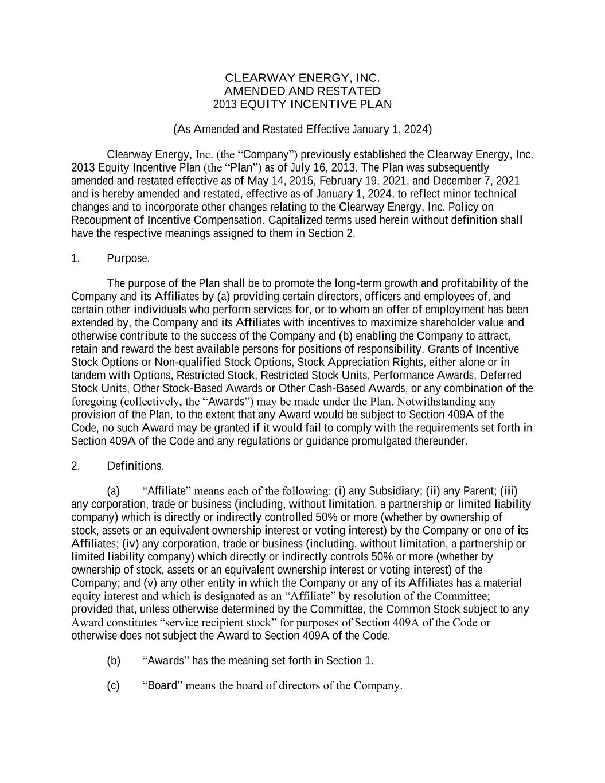

CLEARWAY ENERGY, INC. AMENDED AND RESTATED 2013 EQUITY INCENTIVE PLAN (As Amended and Restated Effective January 1, 2024) Clearway Energy, Inc. (the “Company”) previously established the Clearway Energy, Inc. 2013 Equity Incentive Plan (the “Plan”) as of July 16, 2013. The Plan was subsequently amended and restated effective as of May 14, 2015, February 19, 2021, and December 7, 2021 and is hereby amended and restated, effective as of January 1, 2024, to reflect minor technical changes and to incorporate other changes relating to the Clearway Energy, Inc. Policy on Recoupment of Incentive Compensation. Capitalized terms used herein without definition shall have the respective meanings assigned to them in Section 2. 1. Purpose. The purpose of the Plan shall be to promote the long-term growth and profitability of the Company and its Affiliates by (a) providing certain directors, officers and employees of, and certain other individuals who perform services for, or to whom an offer of employment has been extended by, the Company and its Affiliates with incentives to maximize shareholder value and otherwise contribute to the success of the Company and (b) enabling the Company to attract, retain and reward the best available persons for positions of responsibility. Grants of Incentive Stock Options or Non-qualified Stock Options, Stock Appreciation Rights, either alone or in tandem with Options, Restricted Stock, Restricted Stock Units, Performance Awards, Deferred Stock Units, Other Stock-Based Awards or Other Cash-Based Awards, or any combination of the foregoing (collectively, the “Awards”) may be made under the Plan. Notwithstanding any provision of the Plan, to the extent that any Award would be subject to Section 409A of the Code, no such Award may be granted if it would fail to comply with the requirements set forth in Section 409A of the Code and any regulations or guidance promulgated thereunder. 2. Definitions. (a) “Affiliate” means each of the following: (i) any Subsidiary; (ii) any Parent; (iii) any corporation, trade or business (including, without limitation, a partnership or limited liability company) which is directly or indirectly controlled 50% or more (whether by ownership of stock, assets or an equivalent ownership interest or voting interest) by the Company or one of its Affiliates; (iv) any corporation, trade or business (including, without limitation, a partnership or limited liability company) which directly or indirectly controls 50% or more (whether by ownership of stock, assets or an equivalent ownership interest or voting interest) of the Company; and (v) any other entity in which the Company or any of its Affiliates has a material equity interest and which is designated as an “Affiliate” by resolution of the Committee; provided that, unless otherwise determined by the Committee, the Common Stock subject to any Award constitutes “service recipient stock” for purposes of Section 409A of the Code or otherwise does not subject the Award to Section 409A of the Code. (b) “Awards” has the meaning set forth in Section 1. (c) “Board” means the board of directors of the Company.

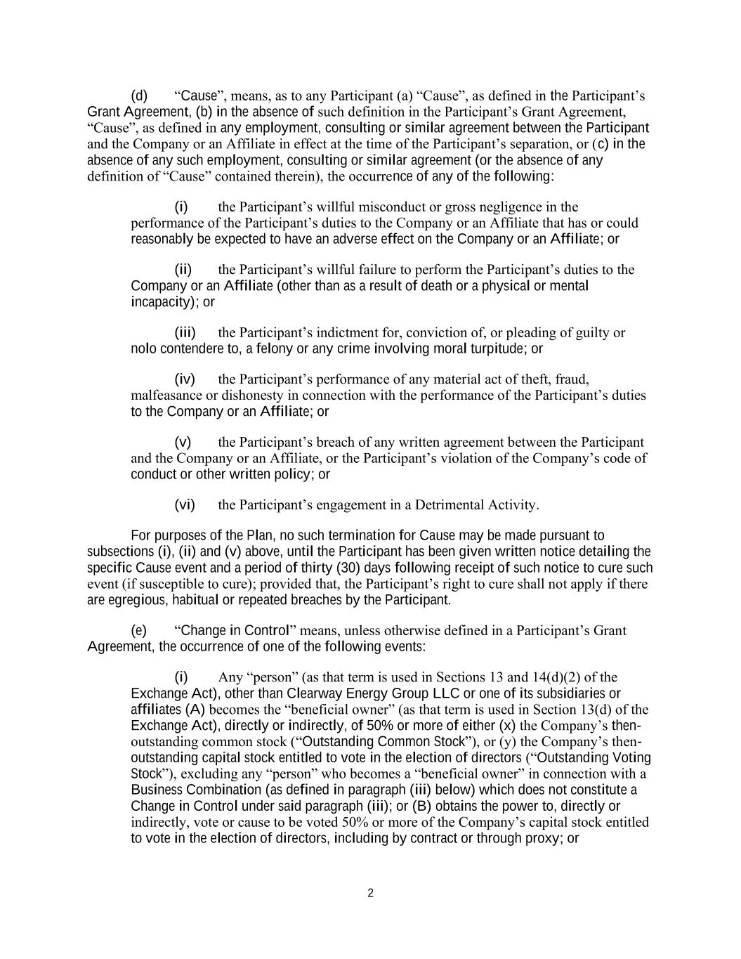
2 (d) “Cause”, means, as to any Participant (a) “Cause”, as defined in the Participant’s Grant Agreement, (b) in the absence of such definition in the Participant’s Grant Agreement, “Cause”, as defined in any employment, consulting or similar agreement between the Participant and the Company or an Affiliate in effect at the time of the Participant’s separation, or (c) in the absence of any such employment, consulting or similar agreement (or the absence of any definition of “Cause” contained therein), the occurrence of any of the following: (i) the Participant’s willful misconduct or gross negligence in the performance of the Participant’s duties to the Company or an Affiliate that has or could reasonably be expected to have an adverse effect on the Company or an Affiliate; or (ii) the Participant’s willful failure to perform the Participant’s duties to the Company or an Affiliate (other than as a result of death or a physical or mental incapacity); or (iii) the Participant’s indictment for, conviction of, or pleading of guilty or nolo contendere to, a felony or any crime involving moral turpitude; or (iv) the Participant’s performance of any material act of theft, fraud, malfeasance or dishonesty in connection with the performance of the Participant’s duties to the Company or an Affiliate; or (v) the Participant’s breach of any written agreement between the Participant and the Company or an Affiliate, or the Participant’s violation of the Company’s code of conduct or other written policy; or (vi) the Participant’s engagement in a Detrimental Activity. For purposes of the Plan, no such termination for Cause may be made pursuant to subsections (i), (ii) and (v) above, until the Participant has been given written notice detailing the specific Cause event and a period of thirty (30) days following receipt of such notice to cure such event (if susceptible to cure); provided that, the Participant’s right to cure shall not apply if there are egregious, habitual or repeated breaches by the Participant. (e) “Change in Control” means, unless otherwise defined in a Participant’s Grant Agreement, the occurrence of one of the following events: (i) Any “person” (as that term is used in Sections 13 and 14(d)(2) of the Exchange Act), other than Clearway Energy Group LLC or one of its subsidiaries or affiliates (A) becomes the “beneficial owner” (as that term is used in Section 13(d) of the Exchange Act), directly or indirectly, of 50% or more of either (x) the Company’s then- outstanding common stock (“Outstanding Common Stock”), or (y) the Company’s then- outstanding capital stock entitled to vote in the election of directors (“Outstanding Voting Stock”), excluding any “person” who becomes a “beneficial owner” in connection with a Business Combination (as defined in paragraph (iii) below) which does not constitute a Change in Control under said paragraph (iii); or (B) obtains the power to, directly or indirectly, vote or cause to be voted 50% or more of the Company’s capital stock entitled to vote in the election of directors, including by contract or through proxy; or

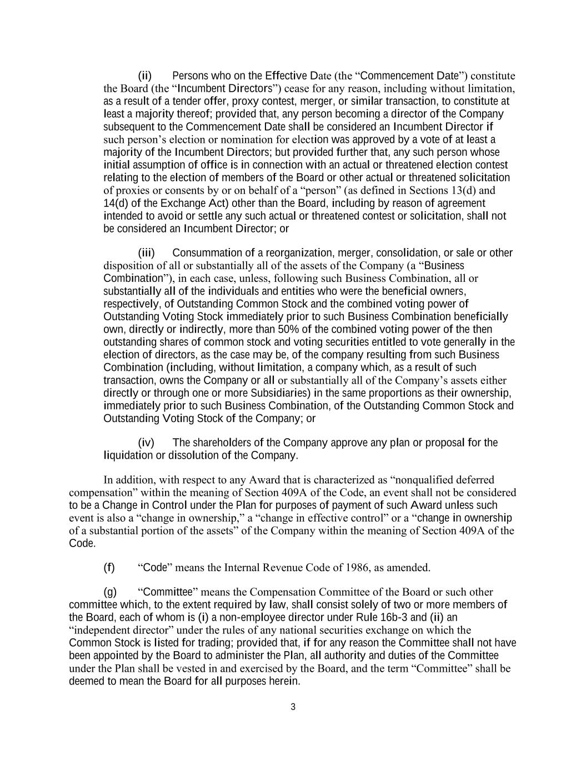
3 (ii) Persons who on the Effective Date (the “Commencement Date”) constitute the Board (the “Incumbent Directors”) cease for any reason, including without limitation, as a result of a tender offer, proxy contest, merger, or similar transaction, to constitute at least a majority thereof; provided that, any person becoming a director of the Company subsequent to the Commencement Date shall be considered an Incumbent Director if such person’s election or nomination for election was approved by a vote of at least a majority of the Incumbent Directors; but provided further that, any such person whose initial assumption of office is in connection with an actual or threatened election contest relating to the election of members of the Board or other actual or threatened solicitation of proxies or consents by or on behalf of a “person” (as defined in Sections 13(d) and 14(d) of the Exchange Act) other than the Board, including by reason of agreement intended to avoid or settle any such actual or threatened contest or solicitation, shall not be considered an Incumbent Director; or (iii) Consummation of a reorganization, merger, consolidation, or sale or other disposition of all or substantially all of the assets of the Company (a “Business Combination”), in each case, unless, following such Business Combination, all or substantially all of the individuals and entities who were the beneficial owners, respectively, of Outstanding Common Stock and the combined voting power of Outstanding Voting Stock immediately prior to such Business Combination beneficially own, directly or indirectly, more than 50% of the combined voting power of the then outstanding shares of common stock and voting securities entitled to vote generally in the election of directors, as the case may be, of the company resulting from such Business Combination (including, without limitation, a company which, as a result of such transaction, owns the Company or all or substantially all of the Company’s assets either directly or through one or more Subsidiaries) in the same proportions as their ownership, immediately prior to such Business Combination, of the Outstanding Common Stock and Outstanding Voting Stock of the Company; or (iv) The shareholders of the Company approve any plan or proposal for the liquidation or dissolution of the Company. In addition, with respect to any Award that is characterized as “nonqualified deferred compensation” within the meaning of Section 409A of the Code, an event shall not be considered to be a Change in Control under the Plan for purposes of payment of such Award unless such event is also a “change in ownership,” a “change in effective control” or a “change in ownership of a substantial portion of the assets” of the Company within the meaning of Section 409A of the Code. (f) “Code” means the Internal Revenue Code of 1986, as amended. (g) “Committee” means the Compensation Committee of the Board or such other committee which, to the extent required by law, shall consist solely of two or more members of the Board, each of whom is (i) a non-employee director under Rule 16b-3 and (ii) an “independent director” under the rules of any national securities exchange on which the Common Stock is listed for trading; provided that, if for any reason the Committee shall not have been appointed by the Board to administer the Plan, all authority and duties of the Committee under the Plan shall be vested in and exercised by the Board, and the term “Committee” shall be deemed to mean the Board for all purposes herein.

4 (h) “Common Stock” means the Class A Common Stock, par value $0.01 per share, of the Company (as described in the Company’s Amended and Restated Certificate of Incorporation, as it may be amended from time to time); the Class C Common Stock, par value $0.01 per share, of the Company (as described in the Company’s Amended and Restated Certificate of Incorporation, as it may be amended from time to time); and any other shares into which such stock may be changed by reason of a recapitalization, reorganization, merger, consolidation or any other change in the corporate structure or capital stock of the Company. (i) “Company” has the meaning set forth in the introductory paragraph above. (j) “Confidential Information” means any confidential information or proprietary information, relating to the business of the Company or any of its affiliates. (k) “Consultant” means any natural person who is an advisor or consultant to the Company or its Affiliates. (l) “Deferral Period” has the meaning set forth in Section 10. (m) “Deferred Stock Unit” means any deferred stock unit granted to a Participant or converted from a Restricted Stock Unit at the election of a Participant pursuant to Section 10. (n) “Detrimental Activity” means a Participant’s: (i) disclosure to anyone outside the Company or any of its Affiliates, or the use in any manner other than in the furtherance of the Company’s or any of its affiliates’ business, without written authorization from the Company, of any Confidential Information; (ii) activity while employed or performing services that results, or if known could result, in the Participant’s termination of employment that is classified by the Company as a termination for Cause; (iii) during the Restrictive Period, attempt, directly or indirectly, to solicit, induce or hire (or the identification for solicitation, inducement or hiring of) any employee of the Company or any of its affiliates to be employed by, or to perform services for, the Participant or any Person with which the Participant is associated (including, but not limited to, due to the Participant’s employment by, consultancy for, equity interest in, or creditor relationship with such Person) or any Person from which the Participant receives direct or indirect compensation or fees as a result of such solicitation, inducement or hire (or the identification for solicitation, inducement or hire) without, in all cases, written authorization from the Company; (iv) during the Restrictive Period, attempt, directly or indirectly, to solicit in a competitive manner any current or prospective customer of the Company or any of its affiliates without, in all cases, written authorization from the Company; (v) making of negative comments regarding, or otherwise disparaging (or inducing others to do so), the Company, its subsidiaries or parents, or any of their respective officers, directors, employees, shareholders, members, agents or products; (vi) during the Restrictive Period, without written authorization from the Company, rendering of services in the United States for any organization, or engaging, directly or indirectly, in any business, which is competitive with the Company or its affiliates, or rendering of services to such organization or business if such organization or business is otherwise prejudicial to or in conflict with the interests of the Company or any of its affiliates; provided, however, that competitive activities shall only be those competitive with any business unit or affiliate of the Company with regard to which the Participant performed services at any time within the 2 years prior to the Participant’s termination of employment; or (vii) material breach of any agreement between the Participant and the Company or any of its Affiliates

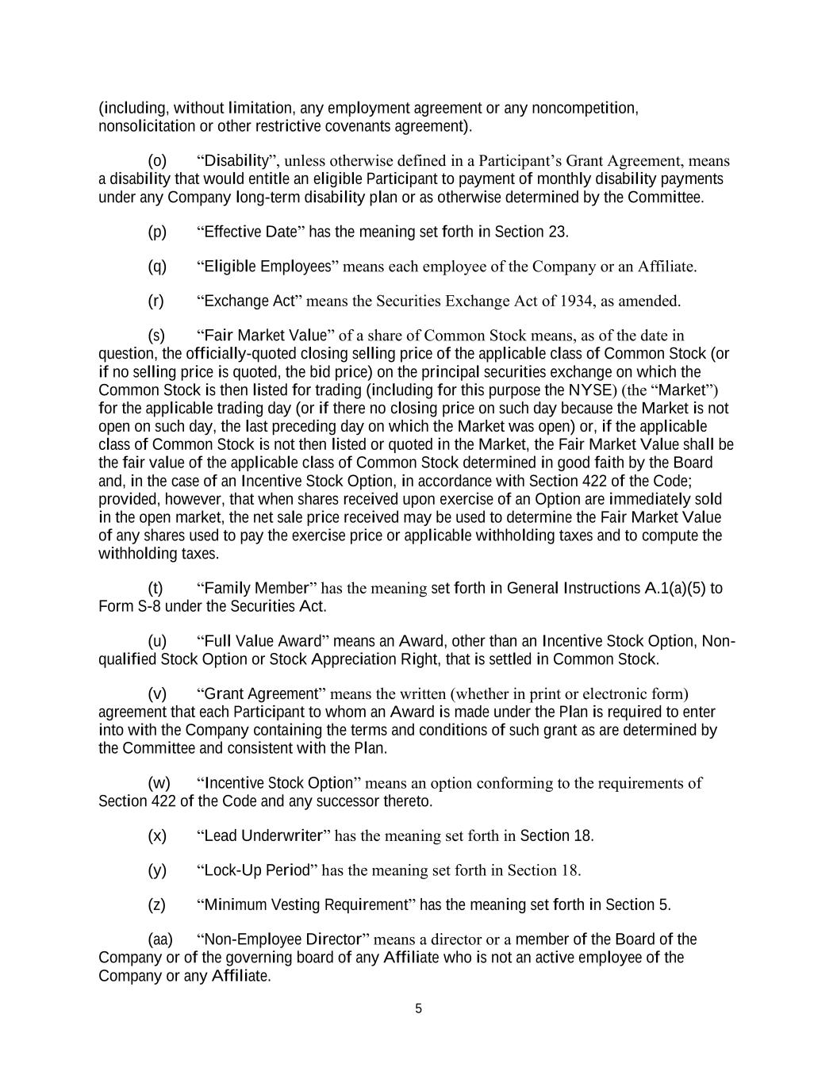
5 (including, without limitation, any employment agreement or any noncompetition, nonsolicitation or other restrictive covenants agreement). (o) “Disability”, unless otherwise defined in a Participant’s Grant Agreement, means a disability that would entitle an eligible Participant to payment of monthly disability payments under any Company long-term disability plan or as otherwise determined by the Committee. (p) “Effective Date” has the meaning set forth in Section 23. (q) “Eligible Employees” means each employee of the Company or an Affiliate. (r) “Exchange Act” means the Securities Exchange Act of 1934, as amended. (s) “Fair Market Value” of a share of Common Stock means, as of the date in question, the officially-quoted closing selling price of the applicable class of Common Stock (or if no selling price is quoted, the bid price) on the principal securities exchange on which the Common Stock is then listed for trading (including for this purpose the NYSE) (the “Market”) for the applicable trading day (or if there no closing price on such day because the Market is not open on such day, the last preceding day on which the Market was open) or, if the applicable class of Common Stock is not then listed or quoted in the Market, the Fair Market Value shall be the fair value of the applicable class of Common Stock determined in good faith by the Board and, in the case of an Incentive Stock Option, in accordance with Section 422 of the Code; provided, however, that when shares received upon exercise of an Option are immediately sold in the open market, the net sale price received may be used to determine the Fair Market Value of any shares used to pay the exercise price or applicable withholding taxes and to compute the withholding taxes. (t) “Family Member” has the meaning set forth in General Instructions A.1(a)(5) to Form S-8 under the Securities Act. (u) “Full Value Award” means an Award, other than an Incentive Stock Option, Non- qualified Stock Option or Stock Appreciation Right, that is settled in Common Stock. (v) “Grant Agreement” means the written (whether in print or electronic form) agreement that each Participant to whom an Award is made under the Plan is required to enter into with the Company containing the terms and conditions of such grant as are determined by the Committee and consistent with the Plan. (w) “Incentive Stock Option” means an option conforming to the requirements of Section 422 of the Code and any successor thereto. (x) “Lead Underwriter” has the meaning set forth in Section 18. (y) “Lock-Up Period” has the meaning set forth in Section 18. (z) “Minimum Vesting Requirement” has the meaning set forth in Section 5. (aa) “Non-Employee Director” means a director or a member of the Board of the Company or of the governing board of any Affiliate who is not an active employee of the Company or any Affiliate.

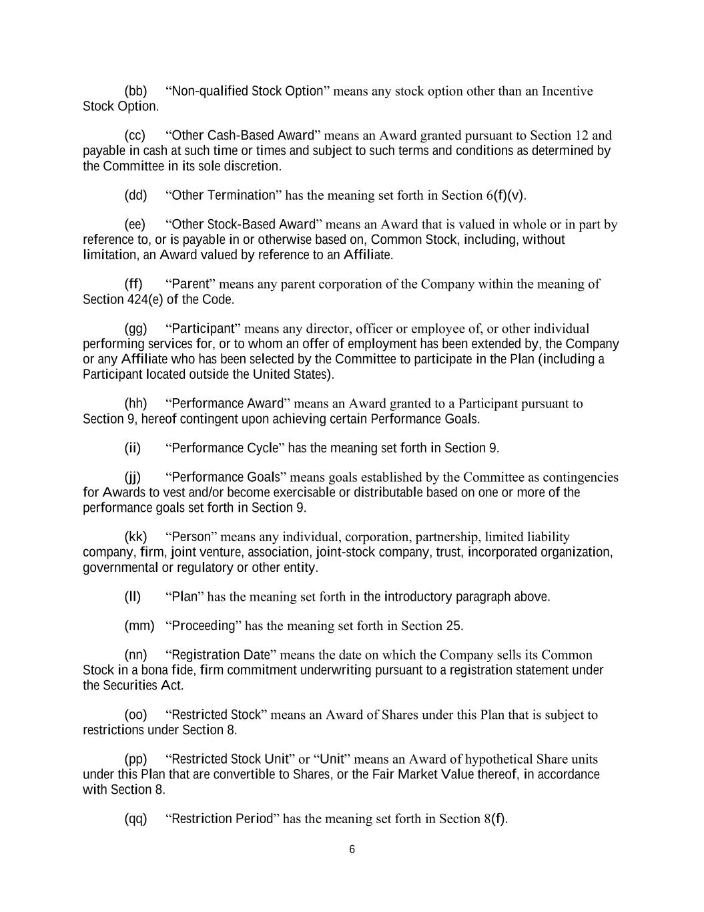
6 (bb) “Non-qualified Stock Option” means any stock option other than an Incentive Stock Option. (cc) “Other Cash-Based Award” means an Award granted pursuant to Section 12 and payable in cash at such time or times and subject to such terms and conditions as determined by the Committee in its sole discretion. (dd) “Other Termination” has the meaning set forth in Section 6(f)(v). (ee) “Other Stock-Based Award” means an Award that is valued in whole or in part by reference to, or is payable in or otherwise based on, Common Stock, including, without limitation, an Award valued by reference to an Affiliate. (ff) “Parent” means any parent corporation of the Company within the meaning of Section 424(e) of the Code. (gg) “Participant” means any director, officer or employee of, or other individual performing services for, or to whom an offer of employment has been extended by, the Company or any Affiliate who has been selected by the Committee to participate in the Plan (including a Participant located outside the United States). (hh) “Performance Award” means an Award granted to a Participant pursuant to Section 9, hereof contingent upon achieving certain Performance Goals. (ii) “Performance Cycle” has the meaning set forth in Section 9. (jj) “Performance Goals” means goals established by the Committee as contingencies for Awards to vest and/or become exercisable or distributable based on one or more of the performance goals set forth in Section 9. (kk) “Person” means any individual, corporation, partnership, limited liability company, firm, joint venture, association, joint-stock company, trust, incorporated organization, governmental or regulatory or other entity. (ll) “Plan” has the meaning set forth in the introductory paragraph above. (mm) “Proceeding” has the meaning set forth in Section 25. (nn) “Registration Date” means the date on which the Company sells its Common Stock in a bona fide, firm commitment underwriting pursuant to a registration statement under the Securities Act. (oo) “Restricted Stock” means an Award of Shares under this Plan that is subject to restrictions under Section 8. (pp) “Restricted Stock Unit” or “Unit” means an Award of hypothetical Share units under this Plan that are convertible to Shares, or the Fair Market Value thereof, in accordance with Section 8. (qq) “Restriction Period” has the meaning set forth in Section 8(f).

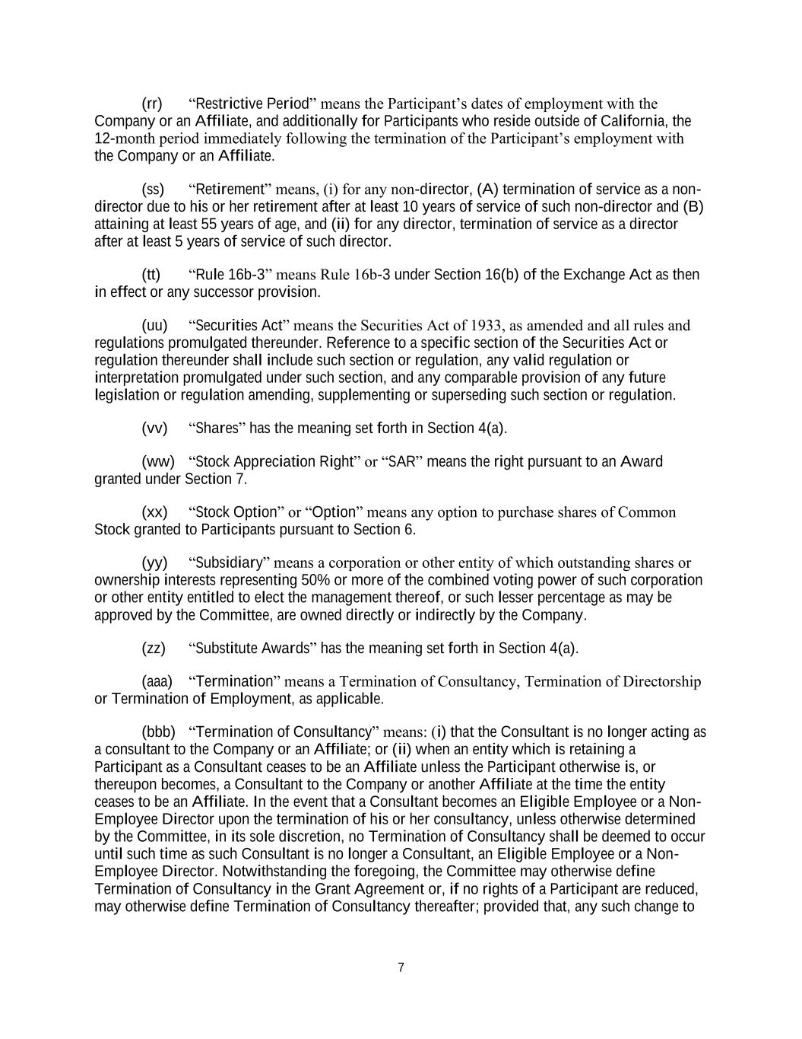
7 (rr) “Restrictive Period” means the Participant’s dates of employment with the Company or an Affiliate, and additionally for Participants who reside outside of California, the 12-month period immediately following the termination of the Participant’s employment with the Company or an Affiliate. (ss) “Retirement” means, (i) for any non-director, (A) termination of service as a non- director due to his or her retirement after at least 10 years of service of such non-director and (B) attaining at least 55 years of age, and (ii) for any director, termination of service as a director after at least 5 years of service of such director. (tt) “Rule 16b-3” means Rule 16b-3 under Section 16(b) of the Exchange Act as then in effect or any successor provision. (uu) “Securities Act” means the Securities Act of 1933, as amended and all rules and regulations promulgated thereunder. Reference to a specific section of the Securities Act or regulation thereunder shall include such section or regulation, any valid regulation or interpretation promulgated under such section, and any comparable provision of any future legislation or regulation amending, supplementing or superseding such section or regulation. (vv) “Shares” has the meaning set forth in Section 4(a). (ww) “Stock Appreciation Right” or “SAR” means the right pursuant to an Award granted under Section 7. (xx) “Stock Option” or “Option” means any option to purchase shares of Common Stock granted to Participants pursuant to Section 6. (yy) “Subsidiary” means a corporation or other entity of which outstanding shares or ownership interests representing 50% or more of the combined voting power of such corporation or other entity entitled to elect the management thereof, or such lesser percentage as may be approved by the Committee, are owned directly or indirectly by the Company. (zz) “Substitute Awards” has the meaning set forth in Section 4(a). (aaa) “Termination” means a Termination of Consultancy, Termination of Directorship or Termination of Employment, as applicable. (bbb) “Termination of Consultancy” means: (i) that the Consultant is no longer acting as a consultant to the Company or an Affiliate; or (ii) when an entity which is retaining a Participant as a Consultant ceases to be an Affiliate unless the Participant otherwise is, or thereupon becomes, a Consultant to the Company or another Affiliate at the time the entity ceases to be an Affiliate. In the event that a Consultant becomes an Eligible Employee or a Non- Employee Director upon the termination of his or her consultancy, unless otherwise determined by the Committee, in its sole discretion, no Termination of Consultancy shall be deemed to occur until such time as such Consultant is no longer a Consultant, an Eligible Employee or a Non- Employee Director. Notwithstanding the foregoing, the Committee may otherwise define Termination of Consultancy in the Grant Agreement or, if no rights of a Participant are reduced, may otherwise define Termination of Consultancy thereafter; provided that, any such change to

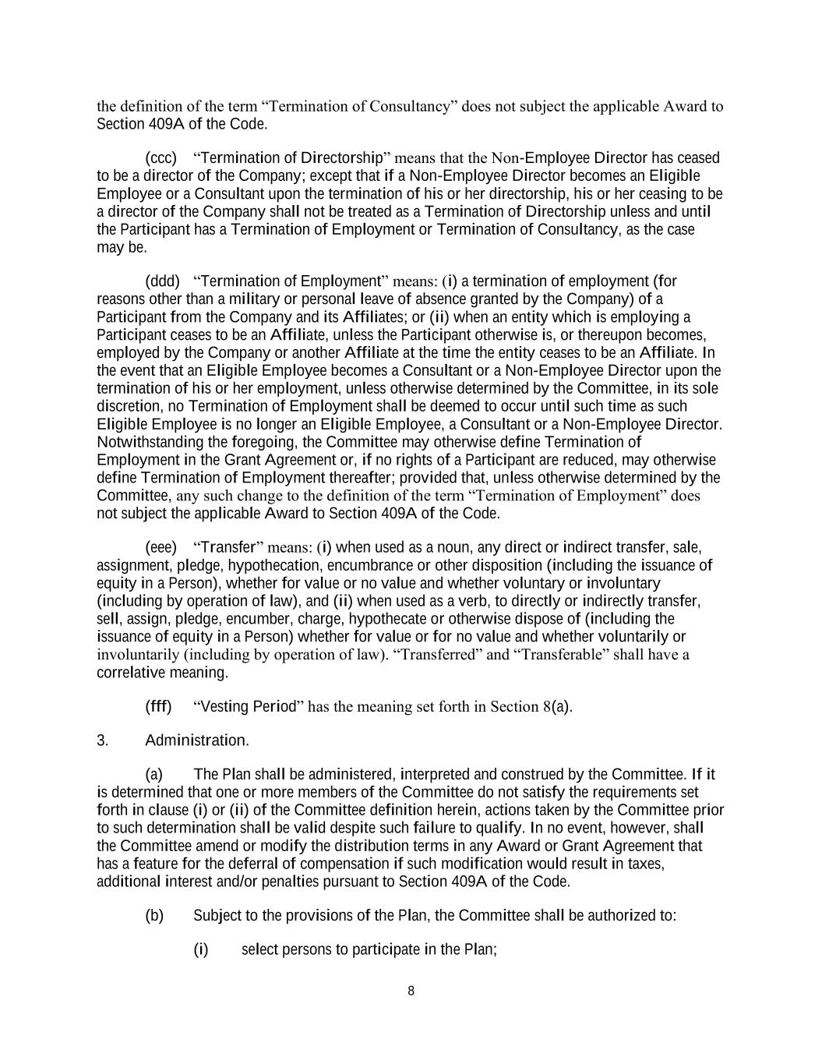
8 the definition of the term “Termination of Consultancy” does not subject the applicable Award to Section 409A of the Code. (ccc) “Termination of Directorship” means that the Non-Employee Director has ceased to be a director of the Company; except that if a Non-Employee Director becomes an Eligible Employee or a Consultant upon the termination of his or her directorship, his or her ceasing to be a director of the Company shall not be treated as a Termination of Directorship unless and until the Participant has a Termination of Employment or Termination of Consultancy, as the case may be. (ddd) “Termination of Employment” means: (i) a termination of employment (for reasons other than a military or personal leave of absence granted by the Company) of a Participant from the Company and its Affiliates; or (ii) when an entity which is employing a Participant ceases to be an Affiliate, unless the Participant otherwise is, or thereupon becomes, employed by the Company or another Affiliate at the time the entity ceases to be an Affiliate. In the event that an Eligible Employee becomes a Consultant or a Non-Employee Director upon the termination of his or her employment, unless otherwise determined by the Committee, in its sole discretion, no Termination of Employment shall be deemed to occur until such time as such Eligible Employee is no longer an Eligible Employee, a Consultant or a Non-Employee Director. Notwithstanding the foregoing, the Committee may otherwise define Termination of Employment in the Grant Agreement or, if no rights of a Participant are reduced, may otherwise define Termination of Employment thereafter; provided that, unless otherwise determined by the Committee, any such change to the definition of the term “Termination of Employment” does not subject the applicable Award to Section 409A of the Code. (eee) “Transfer” means: (i) when used as a noun, any direct or indirect transfer, sale, assignment, pledge, hypothecation, encumbrance or other disposition (including the issuance of equity in a Person), whether for value or no value and whether voluntary or involuntary (including by operation of law), and (ii) when used as a verb, to directly or indirectly transfer, sell, assign, pledge, encumber, charge, hypothecate or otherwise dispose of (including the issuance of equity in a Person) whether for value or for no value and whether voluntarily or involuntarily (including by operation of law). “Transferred” and “Transferable” shall have a correlative meaning. (fff) “Vesting Period” has the meaning set forth in Section 8(a). 3. Administration. (a) The Plan shall be administered, interpreted and construed by the Committee. If it is determined that one or more members of the Committee do not satisfy the requirements set forth in clause (i) or (ii) of the Committee definition herein, actions taken by the Committee prior to such determination shall be valid despite such failure to qualify. In no event, however, shall the Committee amend or modify the distribution terms in any Award or Grant Agreement that has a feature for the deferral of compensation if such modification would result in taxes, additional interest and/or penalties pursuant to Section 409A of the Code. (b) Subject to the provisions of the Plan, the Committee shall be authorized to: (i) select persons to participate in the Plan;

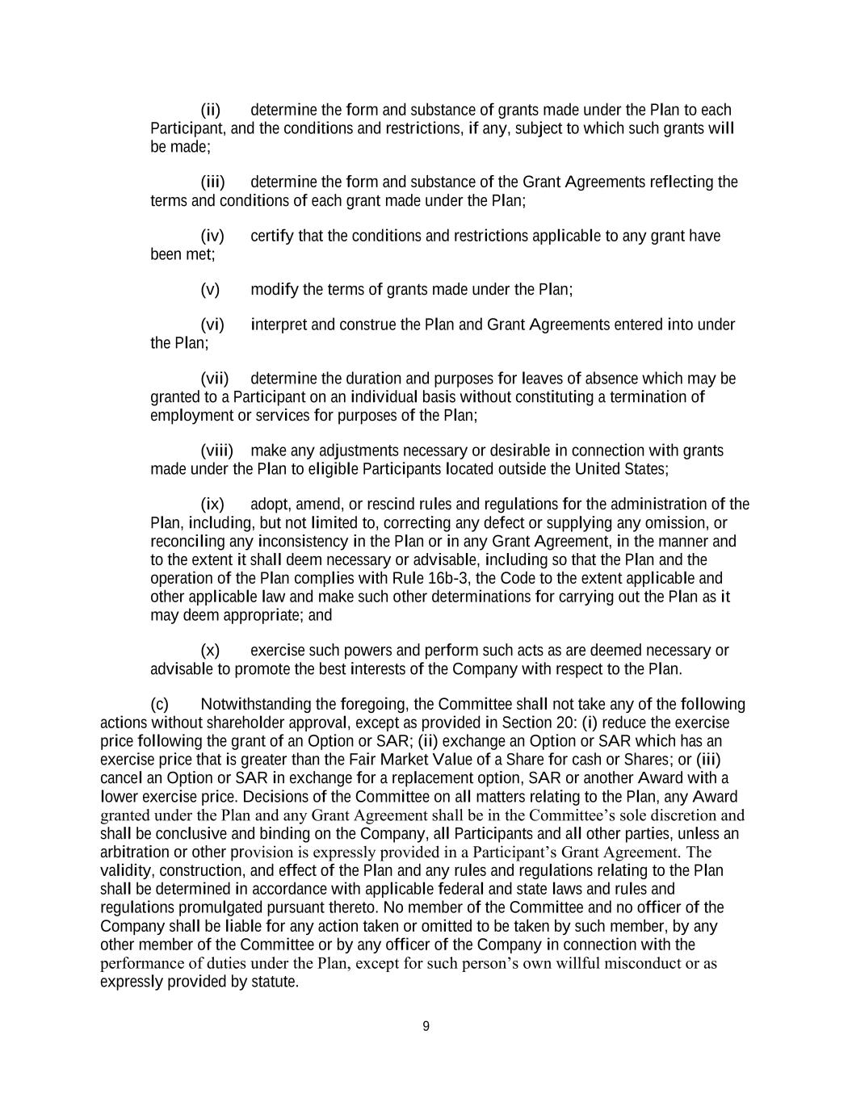
9 (ii) determine the form and substance of grants made under the Plan to each Participant, and the conditions and restrictions, if any, subject to which such grants will be made; (iii) determine the form and substance of the Grant Agreements reflecting the terms and conditions of each grant made under the Plan; (iv) certify that the conditions and restrictions applicable to any grant have been met; (v) modify the terms of grants made under the Plan; (vi) interpret and construe the Plan and Grant Agreements entered into under the Plan; (vii) determine the duration and purposes for leaves of absence which may be granted to a Participant on an individual basis without constituting a termination of employment or services for purposes of the Plan; (viii) make any adjustments necessary or desirable in connection with grants made under the Plan to eligible Participants located outside the United States; (ix) adopt, amend, or rescind rules and regulations for the administration of the Plan, including, but not limited to, correcting any defect or supplying any omission, or reconciling any inconsistency in the Plan or in any Grant Agreement, in the manner and to the extent it shall deem necessary or advisable, including so that the Plan and the operation of the Plan complies with Rule 16b-3, the Code to the extent applicable and other applicable law and make such other determinations for carrying out the Plan as it may deem appropriate; and (x) exercise such powers and perform such acts as are deemed necessary or advisable to promote the best interests of the Company with respect to the Plan. (c) Notwithstanding the foregoing, the Committee shall not take any of the following actions without shareholder approval, except as provided in Section 20: (i) reduce the exercise price following the grant of an Option or SAR; (ii) exchange an Option or SAR which has an exercise price that is greater than the Fair Market Value of a Share for cash or Shares; or (iii) cancel an Option or SAR in exchange for a replacement option, SAR or another Award with a lower exercise price. Decisions of the Committee on all matters relating to the Plan, any Award granted under the Plan and any Grant Agreement shall be in the Committee’s sole discretion and shall be conclusive and binding on the Company, all Participants and all other parties, unless an arbitration or other provision is expressly provided in a Participant’s Grant Agreement. The validity, construction, and effect of the Plan and any rules and regulations relating to the Plan shall be determined in accordance with applicable federal and state laws and rules and regulations promulgated pursuant thereto. No member of the Committee and no officer of the Company shall be liable for any action taken or omitted to be taken by such member, by any other member of the Committee or by any officer of the Company in connection with the performance of duties under the Plan, except for such person’s own willful misconduct or as expressly provided by statute.

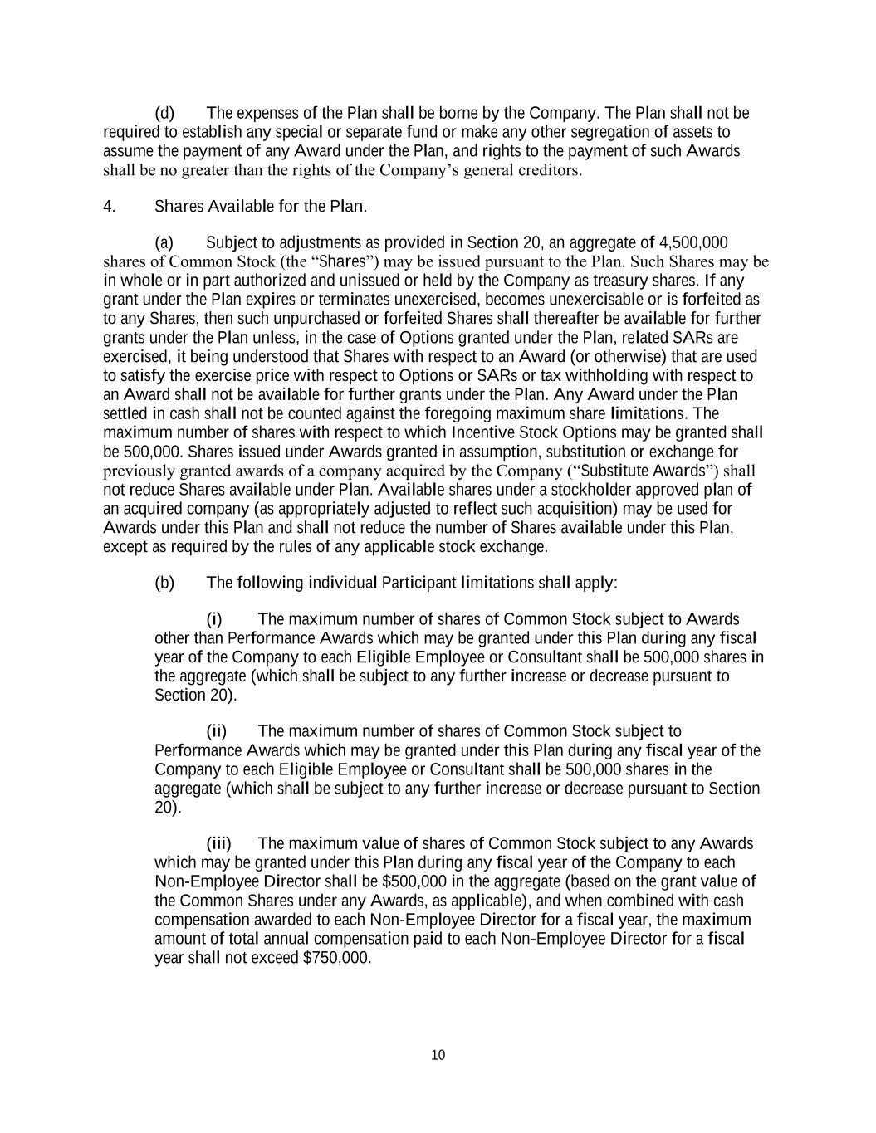
10 (d) The expenses of the Plan shall be borne by the Company. The Plan shall not be required to establish any special or separate fund or make any other segregation of assets to assume the payment of any Award under the Plan, and rights to the payment of such Awards shall be no greater than the rights of the Company’s general creditors. 4. Shares Available for the Plan. (a) Subject to adjustments as provided in Section 20, an aggregate of 4,500,000 shares of Common Stock (the “Shares”) may be issued pursuant to the Plan. Such Shares may be in whole or in part authorized and unissued or held by the Company as treasury shares. If any grant under the Plan expires or terminates unexercised, becomes unexercisable or is forfeited as to any Shares, then such unpurchased or forfeited Shares shall thereafter be available for further grants under the Plan unless, in the case of Options granted under the Plan, related SARs are exercised, it being understood that Shares with respect to an Award (or otherwise) that are used to satisfy the exercise price with respect to Options or SARs or tax withholding with respect to an Award shall not be available for further grants under the Plan. Any Award under the Plan settled in cash shall not be counted against the foregoing maximum share limitations. The maximum number of shares with respect to which Incentive Stock Options may be granted shall be 500,000. Shares issued under Awards granted in assumption, substitution or exchange for previously granted awards of a company acquired by the Company (“Substitute Awards”) shall not reduce Shares available under Plan. Available shares under a stockholder approved plan of an acquired company (as appropriately adjusted to reflect such acquisition) may be used for Awards under this Plan and shall not reduce the number of Shares available under this Plan, except as required by the rules of any applicable stock exchange. (b) The following individual Participant limitations shall apply: (i) The maximum number of shares of Common Stock subject to Awards other than Performance Awards which may be granted under this Plan during any fiscal year of the Company to each Eligible Employee or Consultant shall be 500,000 shares in the aggregate (which shall be subject to any further increase or decrease pursuant to Section 20). (ii) The maximum number of shares of Common Stock subject to Performance Awards which may be granted under this Plan during any fiscal year of the Company to each Eligible Employee or Consultant shall be 500,000 shares in the aggregate (which shall be subject to any further increase or decrease pursuant to Section 20). (iii) The maximum value of shares of Common Stock subject to any Awards which may be granted under this Plan during any fiscal year of the Company to each Non-Employee Director shall be $500,000 in the aggregate (based on the grant value of the Common Shares under any Awards, as applicable), and when combined with cash compensation awarded to each Non-Employee Director for a fiscal year, the maximum amount of total annual compensation paid to each Non-Employee Director for a fiscal year shall not exceed $750,000.

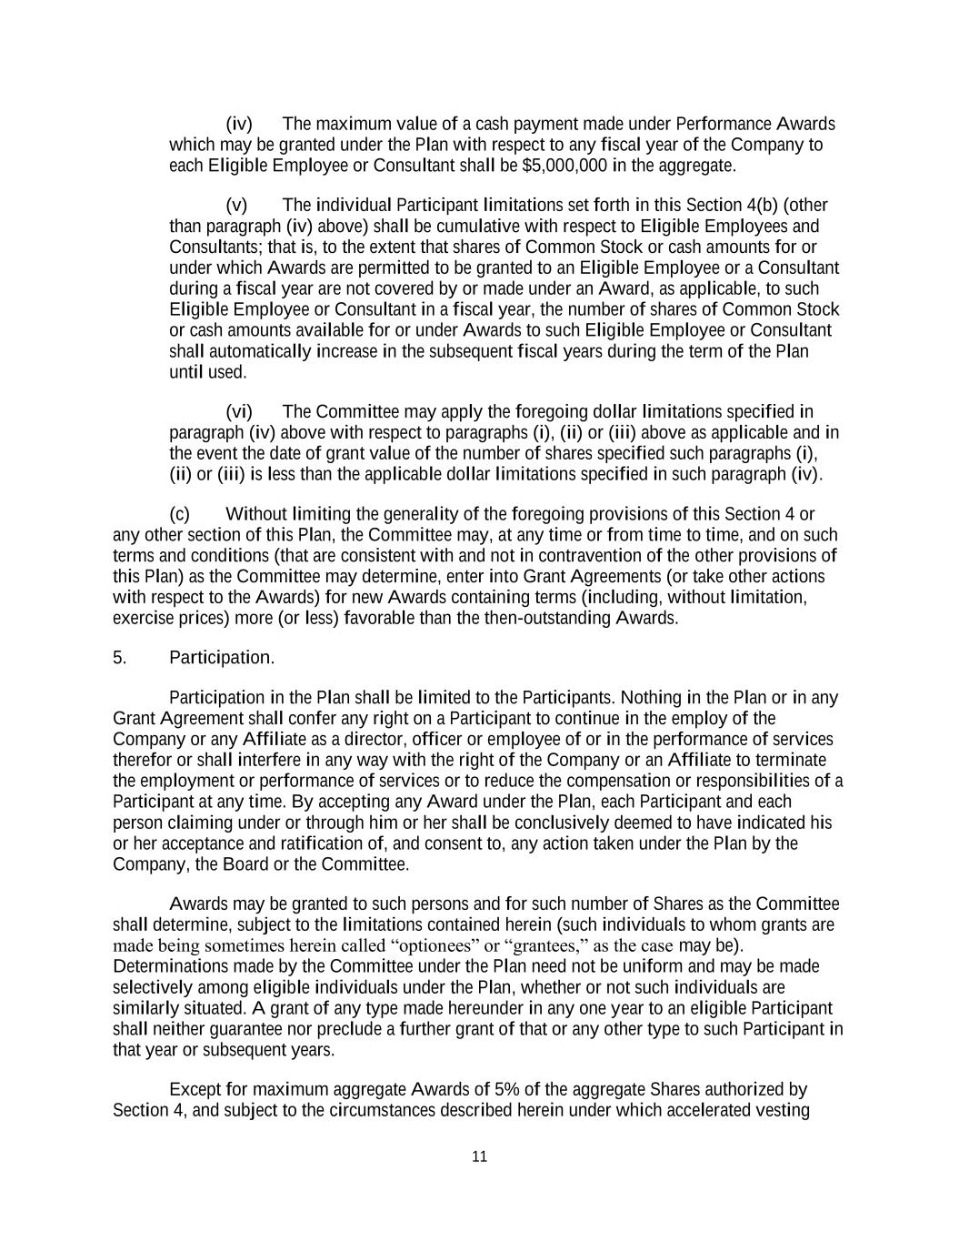
11 (iv) The maximum value of a cash payment made under Performance Awards which may be granted under the Plan with respect to any fiscal year of the Company to each Eligible Employee or Consultant shall be $5,000,000 in the aggregate. (v) The individual Participant limitations set forth in this Section 4(b) (other than paragraph (iv) above) shall be cumulative with respect to Eligible Employees and Consultants; that is, to the extent that shares of Common Stock or cash amounts for or under which Awards are permitted to be granted to an Eligible Employee or a Consultant during a fiscal year are not covered by or made under an Award, as applicable, to such Eligible Employee or Consultant in a fiscal year, the number of shares of Common Stock or cash amounts available for or under Awards to such Eligible Employee or Consultant shall automatically increase in the subsequent fiscal years during the term of the Plan until used. (vi) The Committee may apply the foregoing dollar limitations specified in paragraph (iv) above with respect to paragraphs (i), (ii) or (iii) above as applicable and in the event the date of grant value of the number of shares specified such paragraphs (i), (ii) or (iii) is less than the applicable dollar limitations specified in such paragraph (iv). (c) Without limiting the generality of the foregoing provisions of this Section 4 or any other section of this Plan, the Committee may, at any time or from time to time, and on such terms and conditions (that are consistent with and not in contravention of the other provisions of this Plan) as the Committee may determine, enter into Grant Agreements (or take other actions with respect to the Awards) for new Awards containing terms (including, without limitation, exercise prices) more (or less) favorable than the then-outstanding Awards. 5. Participation. Participation in the Plan shall be limited to the Participants. Nothing in the Plan or in any Grant Agreement shall confer any right on a Participant to continue in the employ of the Company or any Affiliate as a director, officer or employee of or in the performance of services therefor or shall interfere in any way with the right of the Company or an Affiliate to terminate the employment or performance of services or to reduce the compensation or responsibilities of a Participant at any time. By accepting any Award under the Plan, each Participant and each person claiming under or through him or her shall be conclusively deemed to have indicated his or her acceptance and ratification of, and consent to, any action taken under the Plan by the Company, the Board or the Committee. Awards may be granted to such persons and for such number of Shares as the Committee shall determine, subject to the limitations contained herein (such individuals to whom grants are made being sometimes herein called “optionees” or “grantees,” as the case may be). Determinations made by the Committee under the Plan need not be uniform and may be made selectively among eligible individuals under the Plan, whether or not such individuals are similarly situated. A grant of any type made hereunder in any one year to an eligible Participant shall neither guarantee nor preclude a further grant of that or any other type to such Participant in that year or subsequent years. Except for maximum aggregate Awards of 5% of the aggregate Shares authorized by Section 4, and subject to the circumstances described herein under which accelerated vesting

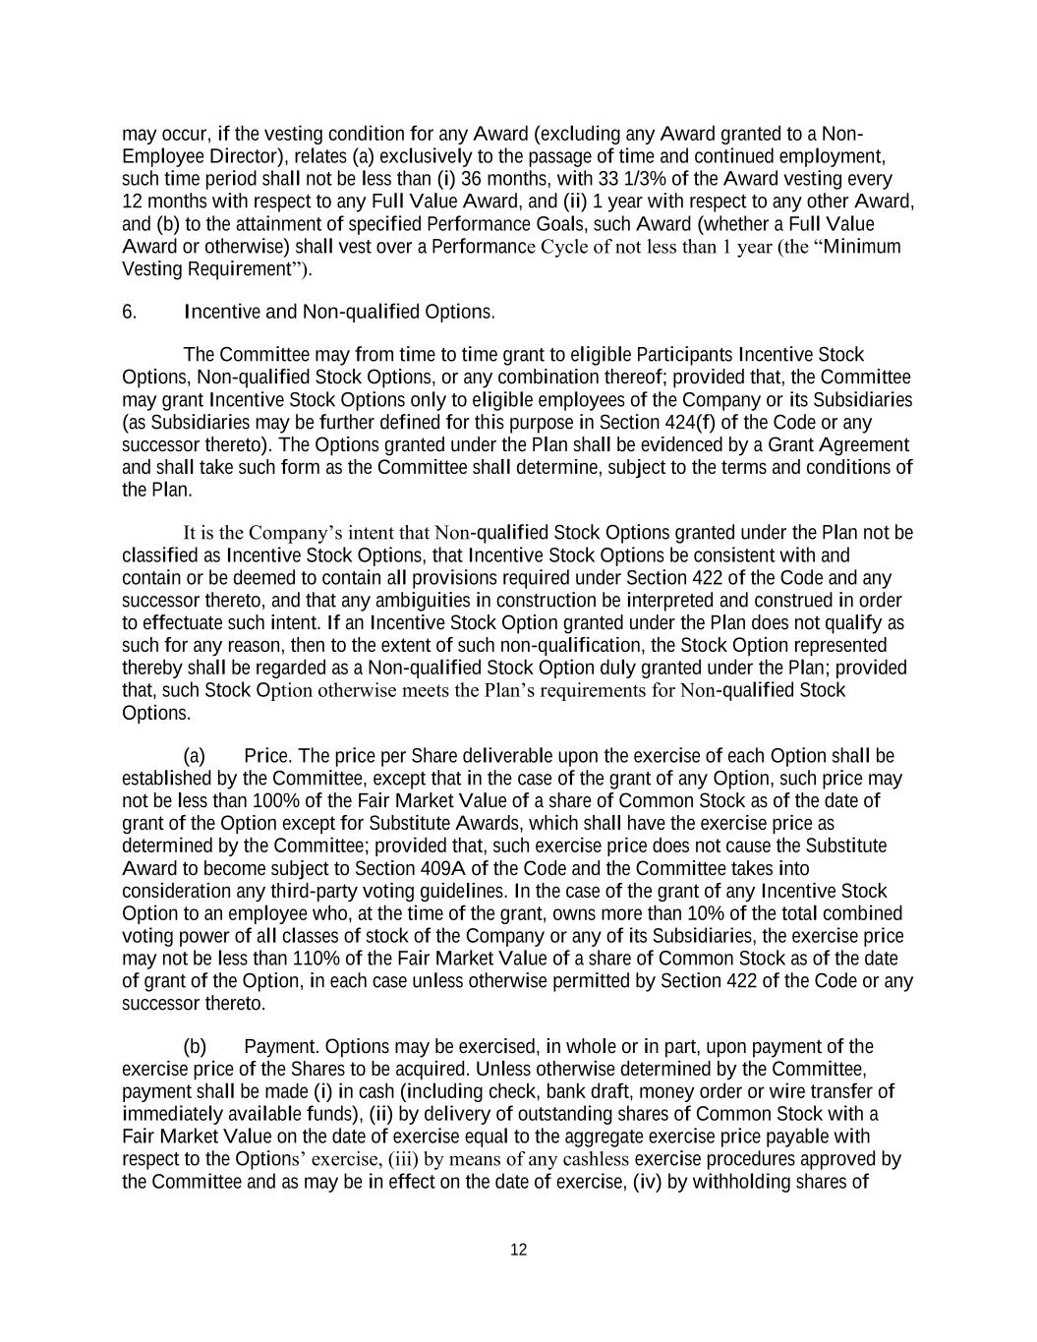
12 may occur, if the vesting condition for any Award (excluding any Award granted to a Non- Employee Director), relates (a) exclusively to the passage of time and continued employment, such time period shall not be less than (i) 36 months, with 33 1/3% of the Award vesting every 12 months with respect to any Full Value Award, and (ii) 1 year with respect to any other Award, and (b) to the attainment of specified Performance Goals, such Award (whether a Full Value Award or otherwise) shall vest over a Performance Cycle of not less than 1 year (the “Minimum Vesting Requirement”). 6. Incentive and Non-qualified Options. The Committee may from time to time grant to eligible Participants Incentive Stock Options, Non-qualified Stock Options, or any combination thereof; provided that, the Committee may grant Incentive Stock Options only to eligible employees of the Company or its Subsidiaries (as Subsidiaries may be further defined for this purpose in Section 424(f) of the Code or any successor thereto). The Options granted under the Plan shall be evidenced by a Grant Agreement and shall take such form as the Committee shall determine, subject to the terms and conditions of the Plan. It is the Company’s intent that Non-qualified Stock Options granted under the Plan not be classified as Incentive Stock Options, that Incentive Stock Options be consistent with and contain or be deemed to contain all provisions required under Section 422 of the Code and any successor thereto, and that any ambiguities in construction be interpreted and construed in order to effectuate such intent. If an Incentive Stock Option granted under the Plan does not qualify as such for any reason, then to the extent of such non-qualification, the Stock Option represented thereby shall be regarded as a Non-qualified Stock Option duly granted under the Plan; provided that, such Stock Option otherwise meets the Plan’s requirements for Non-qualified Stock Options. (a) Price. The price per Share deliverable upon the exercise of each Option shall be established by the Committee, except that in the case of the grant of any Option, such price may not be less than 100% of the Fair Market Value of a share of Common Stock as of the date of grant of the Option except for Substitute Awards, which shall have the exercise price as determined by the Committee; provided that, such exercise price does not cause the Substitute Award to become subject to Section 409A of the Code and the Committee takes into consideration any third-party voting guidelines. In the case of the grant of any Incentive Stock Option to an employee who, at the time of the grant, owns more than 10% of the total combined voting power of all classes of stock of the Company or any of its Subsidiaries, the exercise price may not be less than 110% of the Fair Market Value of a share of Common Stock as of the date of grant of the Option, in each case unless otherwise permitted by Section 422 of the Code or any successor thereto. (b) Payment. Options may be exercised, in whole or in part, upon payment of the exercise price of the Shares to be acquired. Unless otherwise determined by the Committee, payment shall be made (i) in cash (including check, bank draft, money order or wire transfer of immediately available funds), (ii) by delivery of outstanding shares of Common Stock with a Fair Market Value on the date of exercise equal to the aggregate exercise price payable with respect to the Options’ exercise, (iii) by means of any cashless exercise procedures approved by the Committee and as may be in effect on the date of exercise, (iv) by withholding shares of

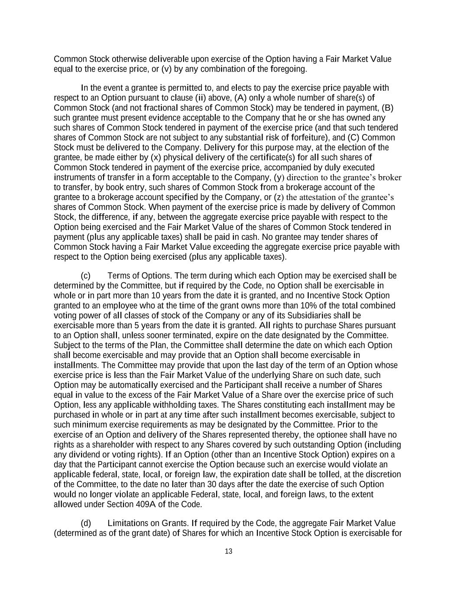
13 Common Stock otherwise deliverable upon exercise of the Option having a Fair Market Value equal to the exercise price, or (v) by any combination of the foregoing. In the event a grantee is permitted to, and elects to pay the exercise price payable with respect to an Option pursuant to clause (ii) above, (A) only a whole number of share(s) of Common Stock (and not fractional shares of Common Stock) may be tendered in payment, (B) such grantee must present evidence acceptable to the Company that he or she has owned any such shares of Common Stock tendered in payment of the exercise price (and that such tendered shares of Common Stock are not subject to any substantial risk of forfeiture), and (C) Common Stock must be delivered to the Company. Delivery for this purpose may, at the election of the grantee, be made either by (x) physical delivery of the certificate(s) for all such shares of Common Stock tendered in payment of the exercise price, accompanied by duly executed instruments of transfer in a form acceptable to the Company, (y) direction to the grantee’s broker to transfer, by book entry, such shares of Common Stock from a brokerage account of the grantee to a brokerage account specified by the Company, or (z) the attestation of the grantee’s shares of Common Stock. When payment of the exercise price is made by delivery of Common Stock, the difference, if any, between the aggregate exercise price payable with respect to the Option being exercised and the Fair Market Value of the shares of Common Stock tendered in payment (plus any applicable taxes) shall be paid in cash. No grantee may tender shares of Common Stock having a Fair Market Value exceeding the aggregate exercise price payable with respect to the Option being exercised (plus any applicable taxes). (c) Terms of Options. The term during which each Option may be exercised shall be determined by the Committee, but if required by the Code, no Option shall be exercisable in whole or in part more than 10 years from the date it is granted, and no Incentive Stock Option granted to an employee who at the time of the grant owns more than 10% of the total combined voting power of all classes of stock of the Company or any of its Subsidiaries shall be exercisable more than 5 years from the date it is granted. All rights to purchase Shares pursuant to an Option shall, unless sooner terminated, expire on the date designated by the Committee. Subject to the terms of the Plan, the Committee shall determine the date on which each Option shall become exercisable and may provide that an Option shall become exercisable in installments. The Committee may provide that upon the last day of the term of an Option whose exercise price is less than the Fair Market Value of the underlying Share on such date, such Option may be automatically exercised and the Participant shall receive a number of Shares equal in value to the excess of the Fair Market Value of a Share over the exercise price of such Option, less any applicable withholding taxes. The Shares constituting each installment may be purchased in whole or in part at any time after such installment becomes exercisable, subject to such minimum exercise requirements as may be designated by the Committee. Prior to the exercise of an Option and delivery of the Shares represented thereby, the optionee shall have no rights as a shareholder with respect to any Shares covered by such outstanding Option (including any dividend or voting rights). If an Option (other than an Incentive Stock Option) expires on a day that the Participant cannot exercise the Option because such an exercise would violate an applicable federal, state, local, or foreign law, the expiration date shall be tolled, at the discretion of the Committee, to the date no later than 30 days after the date the exercise of such Option would no longer violate an applicable Federal, state, local, and foreign laws, to the extent allowed under Section 409A of the Code. (d) Limitations on Grants. If required by the Code, the aggregate Fair Market Value (determined as of the grant date) of Shares for which an Incentive Stock Option is exercisable for

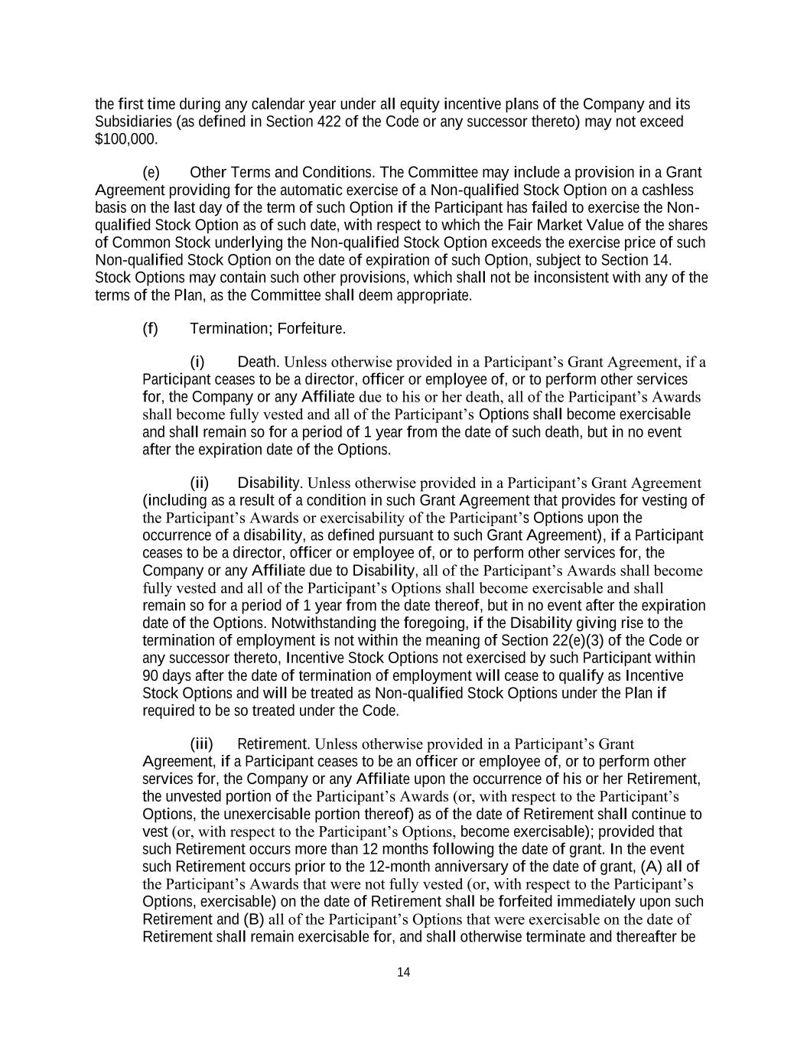
14 the first time during any calendar year under all equity incentive plans of the Company and its Subsidiaries (as defined in Section 422 of the Code or any successor thereto) may not exceed $100,000. (e) Other Terms and Conditions. The Committee may include a provision in a Grant Agreement providing for the automatic exercise of a Non-qualified Stock Option on a cashless basis on the last day of the term of such Option if the Participant has failed to exercise the Non- qualified Stock Option as of such date, with respect to which the Fair Market Value of the shares of Common Stock underlying the Non-qualified Stock Option exceeds the exercise price of such Non-qualified Stock Option on the date of expiration of such Option, subject to Section 14. Stock Options may contain such other provisions, which shall not be inconsistent with any of the terms of the Plan, as the Committee shall deem appropriate. (f) Termination; Forfeiture. (i) Death. Unless otherwise provided in a Participant’s Grant Agreement, if a Participant ceases to be a director, officer or employee of, or to perform other services for, the Company or any Affiliate due to his or her death, all of the Participant’s Awards shall become fully vested and all of the Participant’s Options shall become exercisable and shall remain so for a period of 1 year from the date of such death, but in no event after the expiration date of the Options. (ii) Disability. Unless otherwise provided in a Participant’s Grant Agreement (including as a result of a condition in such Grant Agreement that provides for vesting of the Participant’s Awards or exercisability of the Participant’s Options upon the occurrence of a disability, as defined pursuant to such Grant Agreement), if a Participant ceases to be a director, officer or employee of, or to perform other services for, the Company or any Affiliate due to Disability, all of the Participant’s Awards shall become fully vested and all of the Participant’s Options shall become exercisable and shall remain so for a period of 1 year from the date thereof, but in no event after the expiration date of the Options. Notwithstanding the foregoing, if the Disability giving rise to the termination of employment is not within the meaning of Section 22(e)(3) of the Code or any successor thereto, Incentive Stock Options not exercised by such Participant within 90 days after the date of termination of employment will cease to qualify as Incentive Stock Options and will be treated as Non-qualified Stock Options under the Plan if required to be so treated under the Code. (iii) Retirement. Unless otherwise provided in a Participant’s Grant Agreement, if a Participant ceases to be an officer or employee of, or to perform other services for, the Company or any Affiliate upon the occurrence of his or her Retirement, the unvested portion of the Participant’s Awards (or, with respect to the Participant’s Options, the unexercisable portion thereof) as of the date of Retirement shall continue to vest (or, with respect to the Participant’s Options, become exercisable); provided that such Retirement occurs more than 12 months following the date of grant. In the event such Retirement occurs prior to the 12-month anniversary of the date of grant, (A) all of the Participant’s Awards that were not fully vested (or, with respect to the Participant’s Options, exercisable) on the date of Retirement shall be forfeited immediately upon such Retirement and (B) all of the Participant’s Options that were exercisable on the date of Retirement shall remain exercisable for, and shall otherwise terminate and thereafter be

15 forfeited at the end of, a period of 12 months after the date of Retirement, but in no event after the expiration date of the Options. Notwithstanding anything to the contrary in this Section 6(f)(iii), (x) upon Retirement, a Participant’s Awards may become fully vested (and, with respect to the Participant’s Options, exercisable) in the discretion of the Committee and (y) Incentive Stock Options not exercised by such Participant within 90 days after Retirement will cease to qualify as Incentive Stock Options and will be treated as Non-qualified Stock Options under the Plan if required to be so treated under the Code. Unless otherwise provided in a Participant’s Grant Agreement, if a Participant ceases to be a director of the Company or any Affiliate upon the occurrence of his or her Retirement, all of the Participant’s Awards shall become fully vested and all of the Participant’s Options shall become exercisable and shall remain so for a period of 12 months after the date of Retirement, but in no event after the expiration date of the Options. (iv) Detrimental Activity; Discharge for Cause. If a Participant (A) engages in a Detrimental Activity, (B) ceases to be a director, officer or employee of, or to perform other services for, the Company or any Affiliate due to Cause (or at a time when such employment or services were, or would have been, terminable for Cause), or (C) does not become a director, officer or employee of, or does not begin performing other services for, the Company or any Affiliate for any reason, all of the Participant’s Awards shall be forfeited immediately and all of the Participant’s Options shall expire and be forfeited immediately, whether or not then exercisable, upon such cessation or non- commencement. Notwithstanding any other provision of the Plan, nothing in the Plan is intended to, or does, preclude the Participant from (i) disclosing Confidential Information as part of a government investigation; (ii) contacting, reporting to, responding to an inquiry from, filing a charge or complaint with, communicating with, or otherwise participating in an investigation conducted by, any federal, state, or local governmental agency, commission, or regulatory body; (iii) reporting possible violations of federal and/or state law or regulation to any federal, state, or local governmental agency or entity, including with respect to alleged criminal conduct or unlawful employment practices, or from making other disclosures that are protected under the whistleblower provisions of federal and/or state law or regulation; (iv) making truthful statements or disclosures regarding alleged unlawful employment practices; (v) giving truthful testimony or making statements under oath in response to a subpoena or other valid legal process or in any legal proceeding; (vi) otherwise making truthful statements as required by law or valid legal process; (vii) engaging in protected concerted activity under the National Labor Relations Act for the purpose of collective bargaining or other mutual aid or protection, including (A) making disclosures concerning the Plan in aid of such concerted activities; (B) filing unfair labor practice charges with the National Labor Relations Board; (C) assisting others who are filing such charges; or (D) cooperating with the investigative process of the National Labor Relations Board and other government agencies; or (viii) disclosing a trade secret in confidence to a governmental official, directly or indirectly, or to an attorney, if the disclosure is made solely for the purpose of reporting or investigating a suspected violation of law. Accordingly, the Participant understands that he or she will not be held criminally or civilly liable under any federal or state trade secret law for the disclosure of a trade secret that (A) is made (x) in confidence

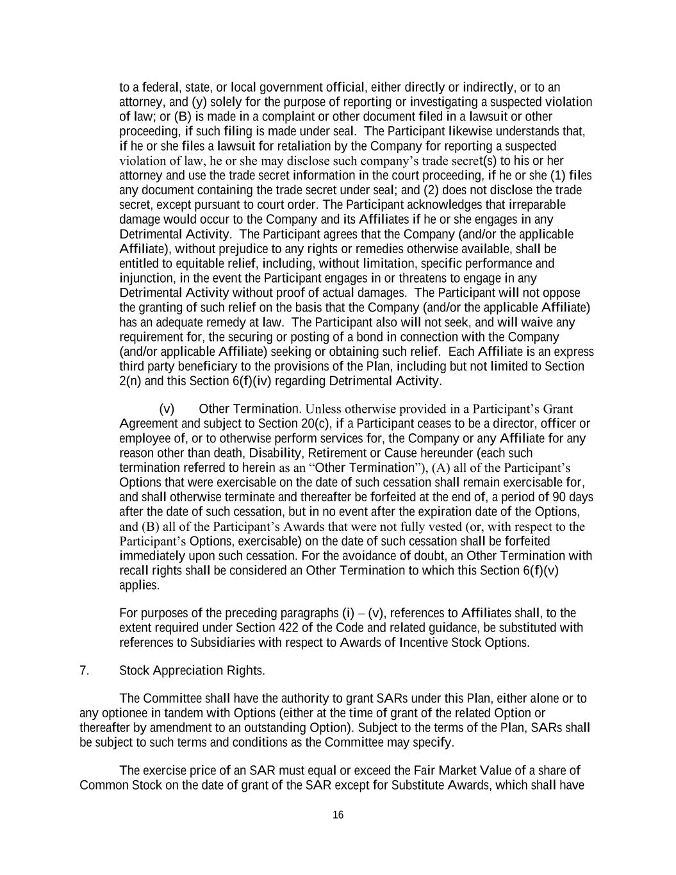
16 to a federal, state, or local government official, either directly or indirectly, or to an attorney, and (y) solely for the purpose of reporting or investigating a suspected violation of law; or (B) is made in a complaint or other document filed in a lawsuit or other proceeding, if such filing is made under seal. The Participant likewise understands that, if he or she files a lawsuit for retaliation by the Company for reporting a suspected violation of law, he or she may disclose such company’s trade secret(s) to his or her attorney and use the trade secret information in the court proceeding, if he or she (1) files any document containing the trade secret under seal; and (2) does not disclose the trade secret, except pursuant to court order. The Participant acknowledges that irreparable damage would occur to the Company and its Affiliates if he or she engages in any Detrimental Activity. The Participant agrees that the Company (and/or the applicable Affiliate), without prejudice to any rights or remedies otherwise available, shall be entitled to equitable relief, including, without limitation, specific performance and injunction, in the event the Participant engages in or threatens to engage in any Detrimental Activity without proof of actual damages. The Participant will not oppose the granting of such relief on the basis that the Company (and/or the applicable Affiliate) has an adequate remedy at law. The Participant also will not seek, and will waive any requirement for, the securing or posting of a bond in connection with the Company (and/or applicable Affiliate) seeking or obtaining such relief. Each Affiliate is an express third party beneficiary to the provisions of the Plan, including but not limited to Section 2(n) and this Section 6(f)(iv) regarding Detrimental Activity. (v) Other Termination. Unless otherwise provided in a Participant’s Grant Agreement and subject to Section 20(c), if a Participant ceases to be a director, officer or employee of, or to otherwise perform services for, the Company or any Affiliate for any reason other than death, Disability, Retirement or Cause hereunder (each such termination referred to herein as an “Other Termination”), (A) all of the Participant’s Options that were exercisable on the date of such cessation shall remain exercisable for, and shall otherwise terminate and thereafter be forfeited at the end of, a period of 90 days after the date of such cessation, but in no event after the expiration date of the Options, and (B) all of the Participant’s Awards that were not fully vested (or, with respect to the Participant’s Options, exercisable) on the date of such cessation shall be forfeited immediately upon such cessation. For the avoidance of doubt, an Other Termination with recall rights shall be considered an Other Termination to which this Section 6(f)(v) applies. For purposes of the preceding paragraphs (i) – (v), references to Affiliates shall, to the extent required under Section 422 of the Code and related guidance, be substituted with references to Subsidiaries with respect to Awards of Incentive Stock Options. 7. Stock Appreciation Rights. The Committee shall have the authority to grant SARs under this Plan, either alone or to any optionee in tandem with Options (either at the time of grant of the related Option or thereafter by amendment to an outstanding Option). Subject to the terms of the Plan, SARs shall be subject to such terms and conditions as the Committee may specify. The exercise price of an SAR must equal or exceed the Fair Market Value of a share of Common Stock on the date of grant of the SAR except for Substitute Awards, which shall have

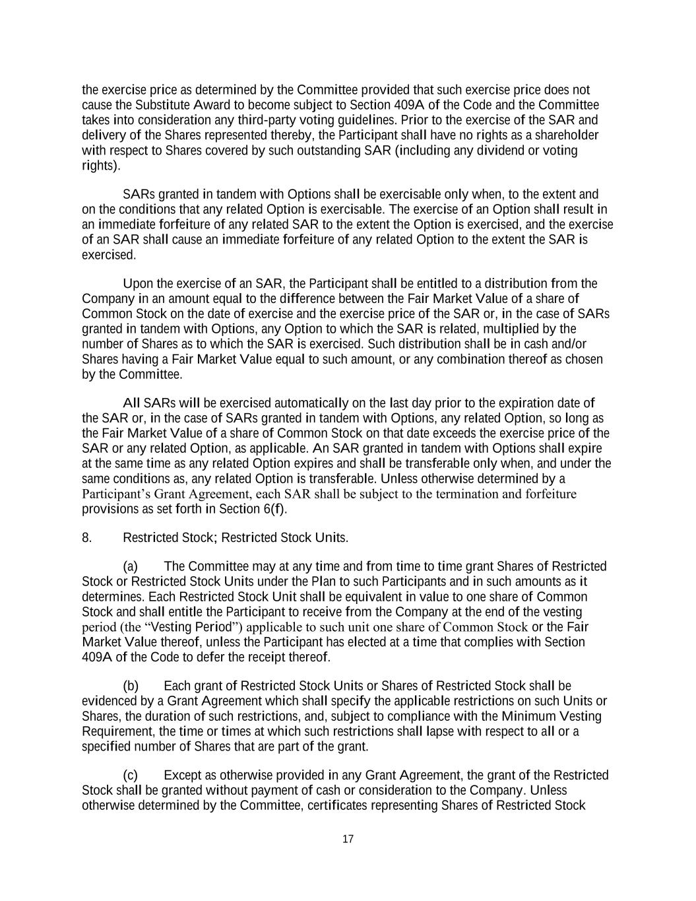
17 the exercise price as determined by the Committee provided that such exercise price does not cause the Substitute Award to become subject to Section 409A of the Code and the Committee takes into consideration any third-party voting guidelines. Prior to the exercise of the SAR and delivery of the Shares represented thereby, the Participant shall have no rights as a shareholder with respect to Shares covered by such outstanding SAR (including any dividend or voting rights). SARs granted in tandem with Options shall be exercisable only when, to the extent and on the conditions that any related Option is exercisable. The exercise of an Option shall result in an immediate forfeiture of any related SAR to the extent the Option is exercised, and the exercise of an SAR shall cause an immediate forfeiture of any related Option to the extent the SAR is exercised. Upon the exercise of an SAR, the Participant shall be entitled to a distribution from the Company in an amount equal to the difference between the Fair Market Value of a share of Common Stock on the date of exercise and the exercise price of the SAR or, in the case of SARs granted in tandem with Options, any Option to which the SAR is related, multiplied by the number of Shares as to which the SAR is exercised. Such distribution shall be in cash and/or Shares having a Fair Market Value equal to such amount, or any combination thereof as chosen by the Committee. All SARs will be exercised automatically on the last day prior to the expiration date of the SAR or, in the case of SARs granted in tandem with Options, any related Option, so long as the Fair Market Value of a share of Common Stock on that date exceeds the exercise price of the SAR or any related Option, as applicable. An SAR granted in tandem with Options shall expire at the same time as any related Option expires and shall be transferable only when, and under the same conditions as, any related Option is transferable. Unless otherwise determined by a Participant’s Grant Agreement, each SAR shall be subject to the termination and forfeiture provisions as set forth in Section 6(f). 8. Restricted Stock; Restricted Stock Units. (a) The Committee may at any time and from time to time grant Shares of Restricted Stock or Restricted Stock Units under the Plan to such Participants and in such amounts as it determines. Each Restricted Stock Unit shall be equivalent in value to one share of Common Stock and shall entitle the Participant to receive from the Company at the end of the vesting period (the “Vesting Period”) applicable to such unit one share of Common Stock or the Fair Market Value thereof, unless the Participant has elected at a time that complies with Section 409A of the Code to defer the receipt thereof. (b) Each grant of Restricted Stock Units or Shares of Restricted Stock shall be evidenced by a Grant Agreement which shall specify the applicable restrictions on such Units or Shares, the duration of such restrictions, and, subject to compliance with the Minimum Vesting Requirement, the time or times at which such restrictions shall lapse with respect to all or a specified number of Shares that are part of the grant. (c) Except as otherwise provided in any Grant Agreement, the grant of the Restricted Stock shall be granted without payment of cash or consideration to the Company. Unless otherwise determined by the Committee, certificates representing Shares of Restricted Stock

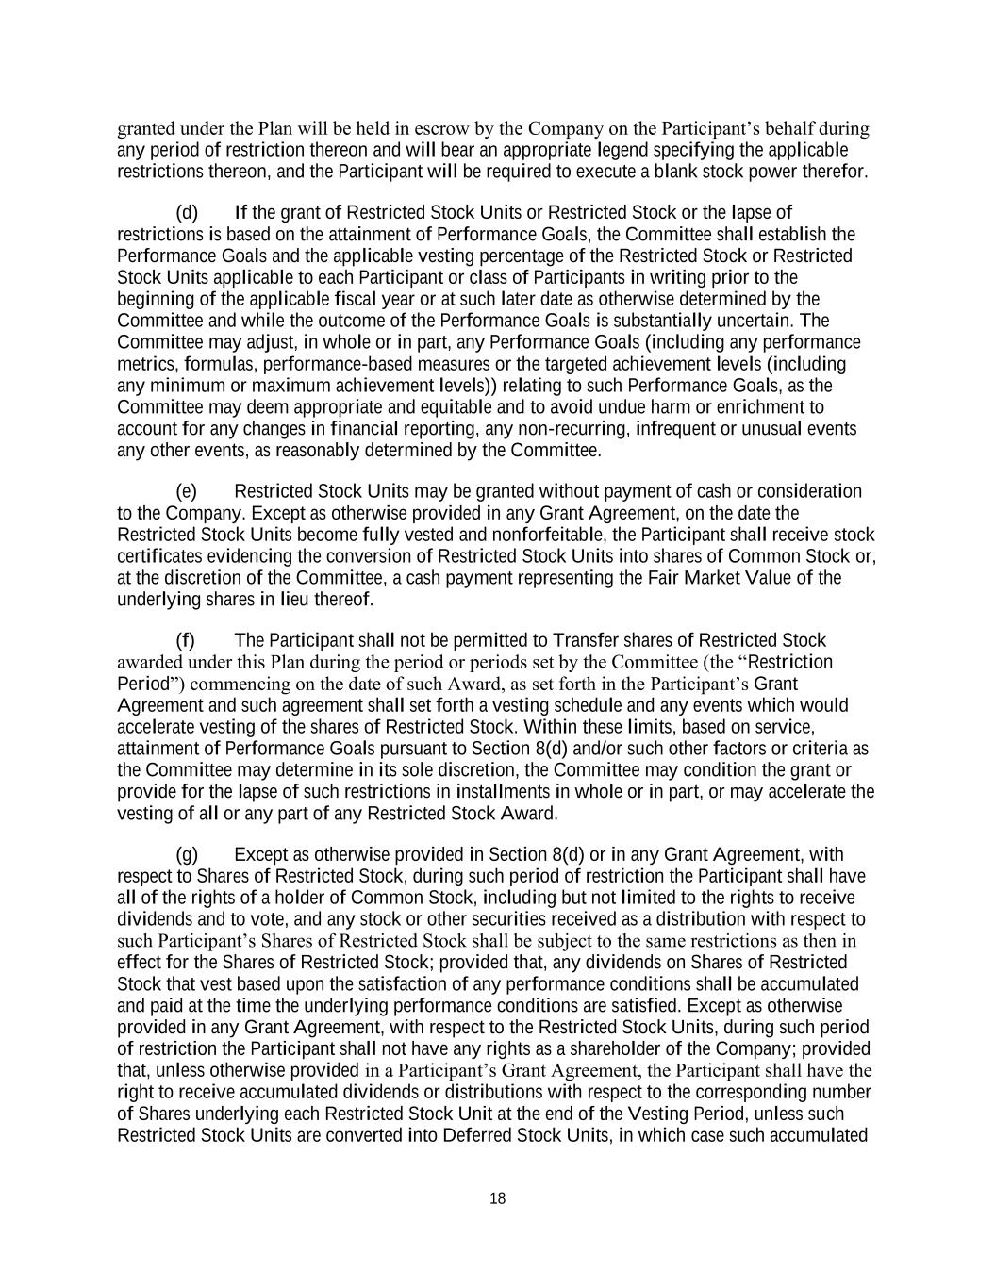
18 granted under the Plan will be held in escrow by the Company on the Participant’s behalf during any period of restriction thereon and will bear an appropriate legend specifying the applicable restrictions thereon, and the Participant will be required to execute a blank stock power therefor. (d) If the grant of Restricted Stock Units or Restricted Stock or the lapse of restrictions is based on the attainment of Performance Goals, the Committee shall establish the Performance Goals and the applicable vesting percentage of the Restricted Stock or Restricted Stock Units applicable to each Participant or class of Participants in writing prior to the beginning of the applicable fiscal year or at such later date as otherwise determined by the Committee and while the outcome of the Performance Goals is substantially uncertain. The Committee may adjust, in whole or in part, any Performance Goals (including any performance metrics, formulas, performance-based measures or the targeted achievement levels (including any minimum or maximum achievement levels)) relating to such Performance Goals, as the Committee may deem appropriate and equitable and to avoid undue harm or enrichment to account for any changes in financial reporting, any non-recurring, infrequent or unusual events any other events, as reasonably determined by the Committee. (e) Restricted Stock Units may be granted without payment of cash or consideration to the Company. Except as otherwise provided in any Grant Agreement, on the date the Restricted Stock Units become fully vested and nonforfeitable, the Participant shall receive stock certificates evidencing the conversion of Restricted Stock Units into shares of Common Stock or, at the discretion of the Committee, a cash payment representing the Fair Market Value of the underlying shares in lieu thereof. (f) The Participant shall not be permitted to Transfer shares of Restricted Stock awarded under this Plan during the period or periods set by the Committee (the “Restriction Period”) commencing on the date of such Award, as set forth in the Participant’s Grant Agreement and such agreement shall set forth a vesting schedule and any events which would accelerate vesting of the shares of Restricted Stock. Within these limits, based on service, attainment of Performance Goals pursuant to Section 8(d) and/or such other factors or criteria as the Committee may determine in its sole discretion, the Committee may condition the grant or provide for the lapse of such restrictions in installments in whole or in part, or may accelerate the vesting of all or any part of any Restricted Stock Award. (g) Except as otherwise provided in Section 8(d) or in any Grant Agreement, with respect to Shares of Restricted Stock, during such period of restriction the Participant shall have all of the rights of a holder of Common Stock, including but not limited to the rights to receive dividends and to vote, and any stock or other securities received as a distribution with respect to such Participant’s Shares of Restricted Stock shall be subject to the same restrictions as then in effect for the Shares of Restricted Stock; provided that, any dividends on Shares of Restricted Stock that vest based upon the satisfaction of any performance conditions shall be accumulated and paid at the time the underlying performance conditions are satisfied. Except as otherwise provided in any Grant Agreement, with respect to the Restricted Stock Units, during such period of restriction the Participant shall not have any rights as a shareholder of the Company; provided that, unless otherwise provided in a Participant’s Grant Agreement, the Participant shall have the right to receive accumulated dividends or distributions with respect to the corresponding number of Shares underlying each Restricted Stock Unit at the end of the Vesting Period, unless such Restricted Stock Units are converted into Deferred Stock Units, in which case such accumulated

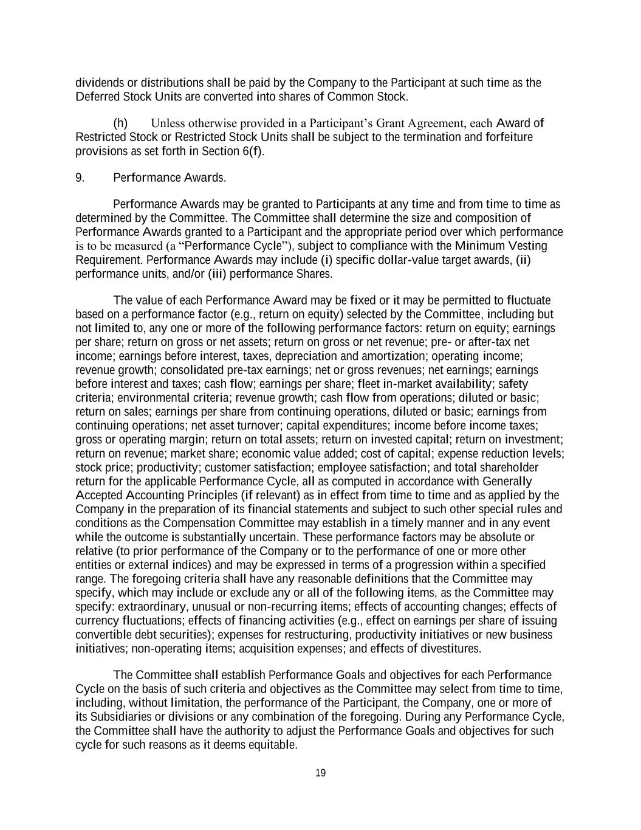
19 dividends or distributions shall be paid by the Company to the Participant at such time as the Deferred Stock Units are converted into shares of Common Stock. (h) Unless otherwise provided in a Participant’s Grant Agreement, each Award of Restricted Stock or Restricted Stock Units shall be subject to the termination and forfeiture provisions as set forth in Section 6(f). 9. Performance Awards. Performance Awards may be granted to Participants at any time and from time to time as determined by the Committee. The Committee shall determine the size and composition of Performance Awards granted to a Participant and the appropriate period over which performance is to be measured (a “Performance Cycle”), subject to compliance with the Minimum Vesting Requirement. Performance Awards may include (i) specific dollar-value target awards, (ii) performance units, and/or (iii) performance Shares. The value of each Performance Award may be fixed or it may be permitted to fluctuate based on a performance factor (e.g., return on equity) selected by the Committee, including but not limited to, any one or more of the following performance factors: return on equity; earnings per share; return on gross or net assets; return on gross or net revenue; pre- or after-tax net income; earnings before interest, taxes, depreciation and amortization; operating income; revenue growth; consolidated pre-tax earnings; net or gross revenues; net earnings; earnings before interest and taxes; cash flow; earnings per share; fleet in-market availability; safety criteria; environmental criteria; revenue growth; cash flow from operations; diluted or basic; return on sales; earnings per share from continuing operations, diluted or basic; earnings from continuing operations; net asset turnover; capital expenditures; income before income taxes; gross or operating margin; return on total assets; return on invested capital; return on investment; return on revenue; market share; economic value added; cost of capital; expense reduction levels; stock price; productivity; customer satisfaction; employee satisfaction; and total shareholder return for the applicable Performance Cycle, all as computed in accordance with Generally Accepted Accounting Principles (if relevant) as in effect from time to time and as applied by the Company in the preparation of its financial statements and subject to such other special rules and conditions as the Compensation Committee may establish in a timely manner and in any event while the outcome is substantially uncertain. These performance factors may be absolute or relative (to prior performance of the Company or to the performance of one or more other entities or external indices) and may be expressed in terms of a progression within a specified range. The foregoing criteria shall have any reasonable definitions that the Committee may specify, which may include or exclude any or all of the following items, as the Committee may specify: extraordinary, unusual or non-recurring items; effects of accounting changes; effects of currency fluctuations; effects of financing activities (e.g., effect on earnings per share of issuing convertible debt securities); expenses for restructuring, productivity initiatives or new business initiatives; non-operating items; acquisition expenses; and effects of divestitures. The Committee shall establish Performance Goals and objectives for each Performance Cycle on the basis of such criteria and objectives as the Committee may select from time to time, including, without limitation, the performance of the Participant, the Company, one or more of its Subsidiaries or divisions or any combination of the foregoing. During any Performance Cycle, the Committee shall have the authority to adjust the Performance Goals and objectives for such cycle for such reasons as it deems equitable.

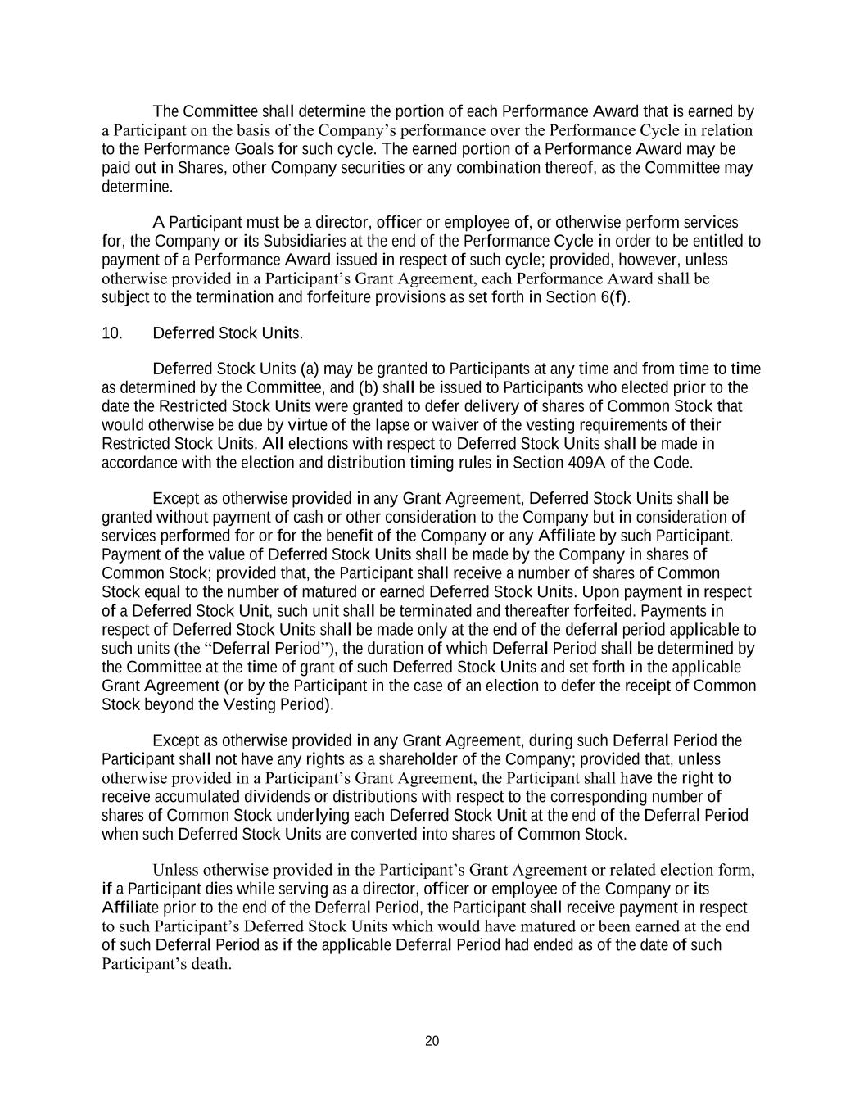
20 The Committee shall determine the portion of each Performance Award that is earned by a Participant on the basis of the Company’s performance over the Performance Cycle in relation to the Performance Goals for such cycle. The earned portion of a Performance Award may be paid out in Shares, other Company securities or any combination thereof, as the Committee may determine. A Participant must be a director, officer or employee of, or otherwise perform services for, the Company or its Subsidiaries at the end of the Performance Cycle in order to be entitled to payment of a Performance Award issued in respect of such cycle; provided, however, unless otherwise provided in a Participant’s Grant Agreement, each Performance Award shall be subject to the termination and forfeiture provisions as set forth in Section 6(f). 10. Deferred Stock Units. Deferred Stock Units (a) may be granted to Participants at any time and from time to time as determined by the Committee, and (b) shall be issued to Participants who elected prior to the date the Restricted Stock Units were granted to defer delivery of shares of Common Stock that would otherwise be due by virtue of the lapse or waiver of the vesting requirements of their Restricted Stock Units. All elections with respect to Deferred Stock Units shall be made in accordance with the election and distribution timing rules in Section 409A of the Code. Except as otherwise provided in any Grant Agreement, Deferred Stock Units shall be granted without payment of cash or other consideration to the Company but in consideration of services performed for or for the benefit of the Company or any Affiliate by such Participant. Payment of the value of Deferred Stock Units shall be made by the Company in shares of Common Stock; provided that, the Participant shall receive a number of shares of Common Stock equal to the number of matured or earned Deferred Stock Units. Upon payment in respect of a Deferred Stock Unit, such unit shall be terminated and thereafter forfeited. Payments in respect of Deferred Stock Units shall be made only at the end of the deferral period applicable to such units (the “Deferral Period”), the duration of which Deferral Period shall be determined by the Committee at the time of grant of such Deferred Stock Units and set forth in the applicable Grant Agreement (or by the Participant in the case of an election to defer the receipt of Common Stock beyond the Vesting Period). Except as otherwise provided in any Grant Agreement, during such Deferral Period the Participant shall not have any rights as a shareholder of the Company; provided that, unless otherwise provided in a Participant’s Grant Agreement, the Participant shall have the right to receive accumulated dividends or distributions with respect to the corresponding number of shares of Common Stock underlying each Deferred Stock Unit at the end of the Deferral Period when such Deferred Stock Units are converted into shares of Common Stock. Unless otherwise provided in the Participant’s Grant Agreement or related election form, if a Participant dies while serving as a director, officer or employee of the Company or its Affiliate prior to the end of the Deferral Period, the Participant shall receive payment in respect to such Participant’s Deferred Stock Units which would have matured or been earned at the end of such Deferral Period as if the applicable Deferral Period had ended as of the date of such Participant’s death.

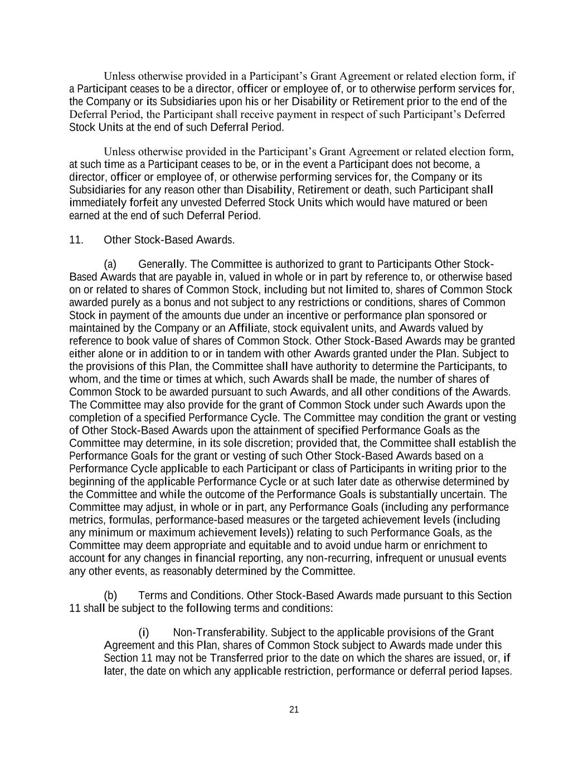
21 Unless otherwise provided in a Participant’s Grant Agreement or related election form, if a Participant ceases to be a director, officer or employee of, or to otherwise perform services for, the Company or its Subsidiaries upon his or her Disability or Retirement prior to the end of the Deferral Period, the Participant shall receive payment in respect of such Participant’s Deferred Stock Units at the end of such Deferral Period. Unless otherwise provided in the Participant’s Grant Agreement or related election form, at such time as a Participant ceases to be, or in the event a Participant does not become, a director, officer or employee of, or otherwise performing services for, the Company or its Subsidiaries for any reason other than Disability, Retirement or death, such Participant shall immediately forfeit any unvested Deferred Stock Units which would have matured or been earned at the end of such Deferral Period. 11. Other Stock-Based Awards. (a) Generally. The Committee is authorized to grant to Participants Other Stock- Based Awards that are payable in, valued in whole or in part by reference to, or otherwise based on or related to shares of Common Stock, including but not limited to, shares of Common Stock awarded purely as a bonus and not subject to any restrictions or conditions, shares of Common Stock in payment of the amounts due under an incentive or performance plan sponsored or maintained by the Company or an Affiliate, stock equivalent units, and Awards valued by reference to book value of shares of Common Stock. Other Stock-Based Awards may be granted either alone or in addition to or in tandem with other Awards granted under the Plan. Subject to the provisions of this Plan, the Committee shall have authority to determine the Participants, to whom, and the time or times at which, such Awards shall be made, the number of shares of Common Stock to be awarded pursuant to such Awards, and all other conditions of the Awards. The Committee may also provide for the grant of Common Stock under such Awards upon the completion of a specified Performance Cycle. The Committee may condition the grant or vesting of Other Stock-Based Awards upon the attainment of specified Performance Goals as the Committee may determine, in its sole discretion; provided that, the Committee shall establish the Performance Goals for the grant or vesting of such Other Stock-Based Awards based on a Performance Cycle applicable to each Participant or class of Participants in writing prior to the beginning of the applicable Performance Cycle or at such later date as otherwise determined by the Committee and while the outcome of the Performance Goals is substantially uncertain. The Committee may adjust, in whole or in part, any Performance Goals (including any performance metrics, formulas, performance-based measures or the targeted achievement levels (including any minimum or maximum achievement levels)) relating to such Performance Goals, as the Committee may deem appropriate and equitable and to avoid undue harm or enrichment to account for any changes in financial reporting, any non-recurring, infrequent or unusual events any other events, as reasonably determined by the Committee. (b) Terms and Conditions. Other Stock-Based Awards made pursuant to this Section 11 shall be subject to the following terms and conditions: (i) Non-Transferability. Subject to the applicable provisions of the Grant Agreement and this Plan, shares of Common Stock subject to Awards made under this Section 11 may not be Transferred prior to the date on which the shares are issued, or, if later, the date on which any applicable restriction, performance or deferral period lapses.

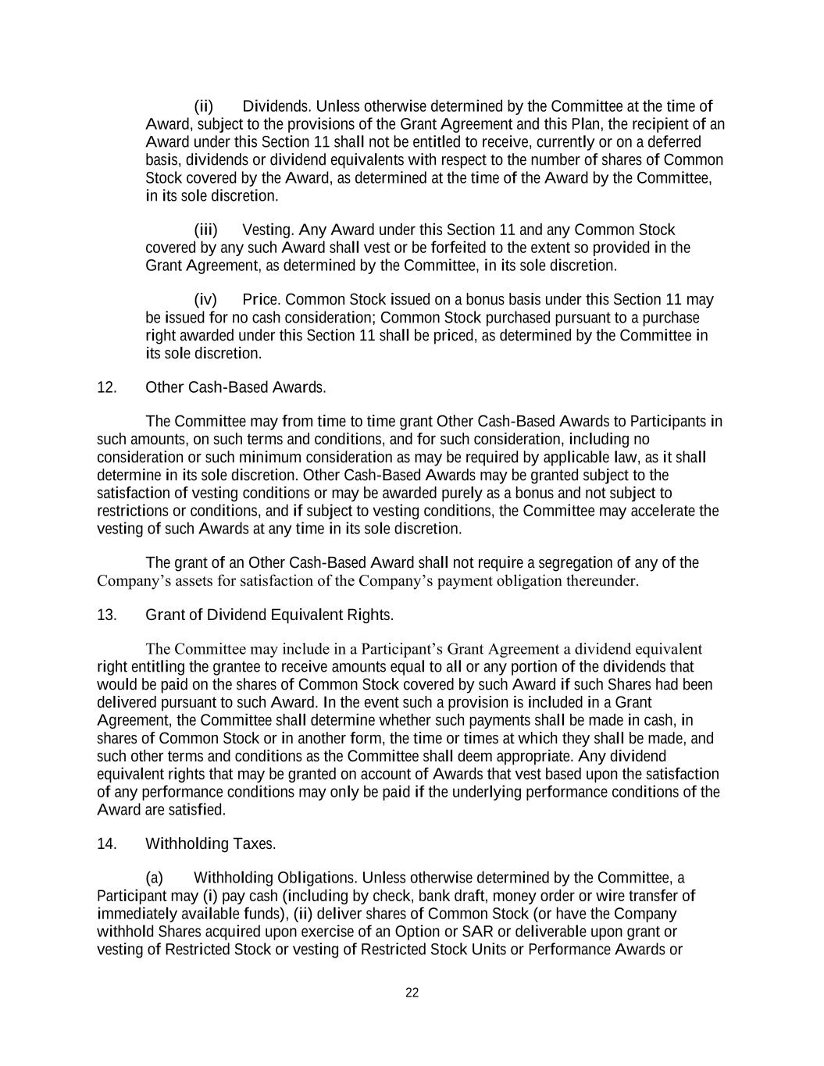
22 (ii) Dividends. Unless otherwise determined by the Committee at the time of Award, subject to the provisions of the Grant Agreement and this Plan, the recipient of an Award under this Section 11 shall not be entitled to receive, currently or on a deferred basis, dividends or dividend equivalents with respect to the number of shares of Common Stock covered by the Award, as determined at the time of the Award by the Committee, in its sole discretion. (iii) Vesting. Any Award under this Section 11 and any Common Stock covered by any such Award shall vest or be forfeited to the extent so provided in the Grant Agreement, as determined by the Committee, in its sole discretion. (iv) Price. Common Stock issued on a bonus basis under this Section 11 may be issued for no cash consideration; Common Stock purchased pursuant to a purchase right awarded under this Section 11 shall be priced, as determined by the Committee in its sole discretion. 12. Other Cash-Based Awards. The Committee may from time to time grant Other Cash-Based Awards to Participants in such amounts, on such terms and conditions, and for such consideration, including no consideration or such minimum consideration as may be required by applicable law, as it shall determine in its sole discretion. Other Cash-Based Awards may be granted subject to the satisfaction of vesting conditions or may be awarded purely as a bonus and not subject to restrictions or conditions, and if subject to vesting conditions, the Committee may accelerate the vesting of such Awards at any time in its sole discretion. The grant of an Other Cash-Based Award shall not require a segregation of any of the Company’s assets for satisfaction of the Company’s payment obligation thereunder. 13. Grant of Dividend Equivalent Rights. The Committee may include in a Participant’s Grant Agreement a dividend equivalent right entitling the grantee to receive amounts equal to all or any portion of the dividends that would be paid on the shares of Common Stock covered by such Award if such Shares had been delivered pursuant to such Award. In the event such a provision is included in a Grant Agreement, the Committee shall determine whether such payments shall be made in cash, in shares of Common Stock or in another form, the time or times at which they shall be made, and such other terms and conditions as the Committee shall deem appropriate. Any dividend equivalent rights that may be granted on account of Awards that vest based upon the satisfaction of any performance conditions may only be paid if the underlying performance conditions of the Award are satisfied. 14. Withholding Taxes. (a) Withholding Obligations. Unless otherwise determined by the Committee, a Participant may (i) pay cash (including by check, bank draft, money order or wire transfer of immediately available funds), (ii) deliver shares of Common Stock (or have the Company withhold Shares acquired upon exercise of an Option or SAR or deliverable upon grant or vesting of Restricted Stock or vesting of Restricted Stock Units or Performance Awards or

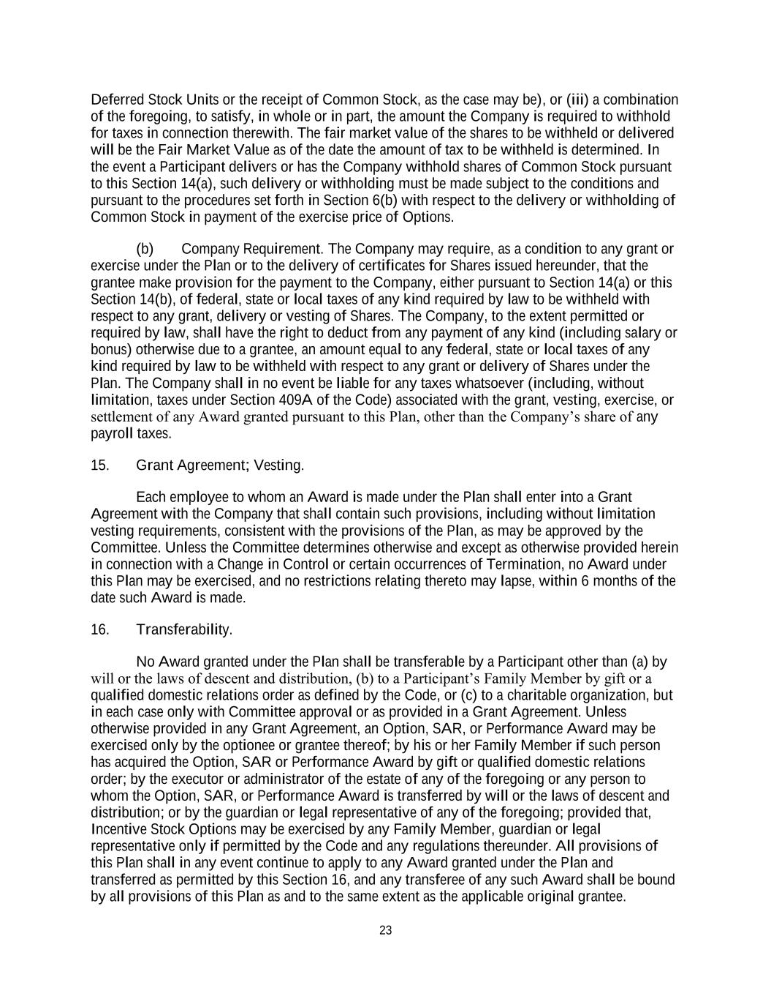
23 Deferred Stock Units or the receipt of Common Stock, as the case may be), or (iii) a combination of the foregoing, to satisfy, in whole or in part, the amount the Company is required to withhold for taxes in connection therewith. The fair market value of the shares to be withheld or delivered will be the Fair Market Value as of the date the amount of tax to be withheld is determined. In the event a Participant delivers or has the Company withhold shares of Common Stock pursuant to this Section 14(a), such delivery or withholding must be made subject to the conditions and pursuant to the procedures set forth in Section 6(b) with respect to the delivery or withholding of Common Stock in payment of the exercise price of Options. (b) Company Requirement. The Company may require, as a condition to any grant or exercise under the Plan or to the delivery of certificates for Shares issued hereunder, that the grantee make provision for the payment to the Company, either pursuant to Section 14(a) or this Section 14(b), of federal, state or local taxes of any kind required by law to be withheld with respect to any grant, delivery or vesting of Shares. The Company, to the extent permitted or required by law, shall have the right to deduct from any payment of any kind (including salary or bonus) otherwise due to a grantee, an amount equal to any federal, state or local taxes of any kind required by law to be withheld with respect to any grant or delivery of Shares under the Plan. The Company shall in no event be liable for any taxes whatsoever (including, without limitation, taxes under Section 409A of the Code) associated with the grant, vesting, exercise, or settlement of any Award granted pursuant to this Plan, other than the Company’s share of any payroll taxes. 15. Grant Agreement; Vesting. Each employee to whom an Award is made under the Plan shall enter into a Grant Agreement with the Company that shall contain such provisions, including without limitation vesting requirements, consistent with the provisions of the Plan, as may be approved by the Committee. Unless the Committee determines otherwise and except as otherwise provided herein in connection with a Change in Control or certain occurrences of Termination, no Award under this Plan may be exercised, and no restrictions relating thereto may lapse, within 6 months of the date such Award is made. 16. Transferability. No Award granted under the Plan shall be transferable by a Participant other than (a) by will or the laws of descent and distribution, (b) to a Participant’s Family Member by gift or a qualified domestic relations order as defined by the Code, or (c) to a charitable organization, but in each case only with Committee approval or as provided in a Grant Agreement. Unless otherwise provided in any Grant Agreement, an Option, SAR, or Performance Award may be exercised only by the optionee or grantee thereof; by his or her Family Member if such person has acquired the Option, SAR or Performance Award by gift or qualified domestic relations order; by the executor or administrator of the estate of any of the foregoing or any person to whom the Option, SAR, or Performance Award is transferred by will or the laws of descent and distribution; or by the guardian or legal representative of any of the foregoing; provided that, Incentive Stock Options may be exercised by any Family Member, guardian or legal representative only if permitted by the Code and any regulations thereunder. All provisions of this Plan shall in any event continue to apply to any Award granted under the Plan and transferred as permitted by this Section 16, and any transferee of any such Award shall be bound by all provisions of this Plan as and to the same extent as the applicable original grantee.

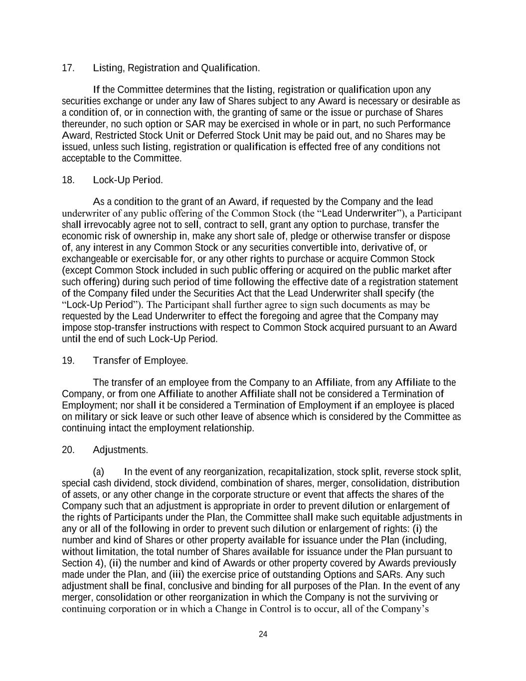
24 17. Listing, Registration and Qualification. If the Committee determines that the listing, registration or qualification upon any securities exchange or under any law of Shares subject to any Award is necessary or desirable as a condition of, or in connection with, the granting of same or the issue or purchase of Shares thereunder, no such option or SAR may be exercised in whole or in part, no such Performance Award, Restricted Stock Unit or Deferred Stock Unit may be paid out, and no Shares may be issued, unless such listing, registration or qualification is effected free of any conditions not acceptable to the Committee. 18. Lock-Up Period. As a condition to the grant of an Award, if requested by the Company and the lead underwriter of any public offering of the Common Stock (the “Lead Underwriter”), a Participant shall irrevocably agree not to sell, contract to sell, grant any option to purchase, transfer the economic risk of ownership in, make any short sale of, pledge or otherwise transfer or dispose of, any interest in any Common Stock or any securities convertible into, derivative of, or exchangeable or exercisable for, or any other rights to purchase or acquire Common Stock (except Common Stock included in such public offering or acquired on the public market after such offering) during such period of time following the effective date of a registration statement of the Company filed under the Securities Act that the Lead Underwriter shall specify (the “Lock-Up Period”). The Participant shall further agree to sign such documents as may be requested by the Lead Underwriter to effect the foregoing and agree that the Company may impose stop-transfer instructions with respect to Common Stock acquired pursuant to an Award until the end of such Lock-Up Period. 19. Transfer of Employee. The transfer of an employee from the Company to an Affiliate, from any Affiliate to the Company, or from one Affiliate to another Affiliate shall not be considered a Termination of Employment; nor shall it be considered a Termination of Employment if an employee is placed on military or sick leave or such other leave of absence which is considered by the Committee as continuing intact the employment relationship. 20. Adjustments. (a) In the event of any reorganization, recapitalization, stock split, reverse stock split, special cash dividend, stock dividend, combination of shares, merger, consolidation, distribution of assets, or any other change in the corporate structure or event that affects the shares of the Company such that an adjustment is appropriate in order to prevent dilution or enlargement of the rights of Participants under the Plan, the Committee shall make such equitable adjustments in any or all of the following in order to prevent such dilution or enlargement of rights: (i) the number and kind of Shares or other property available for issuance under the Plan (including, without limitation, the total number of Shares available for issuance under the Plan pursuant to Section 4), (ii) the number and kind of Awards or other property covered by Awards previously made under the Plan, and (iii) the exercise price of outstanding Options and SARs. Any such adjustment shall be final, conclusive and binding for all purposes of the Plan. In the event of any merger, consolidation or other reorganization in which the Company is not the surviving or continuing corporation or in which a Change in Control is to occur, all of the Company’s

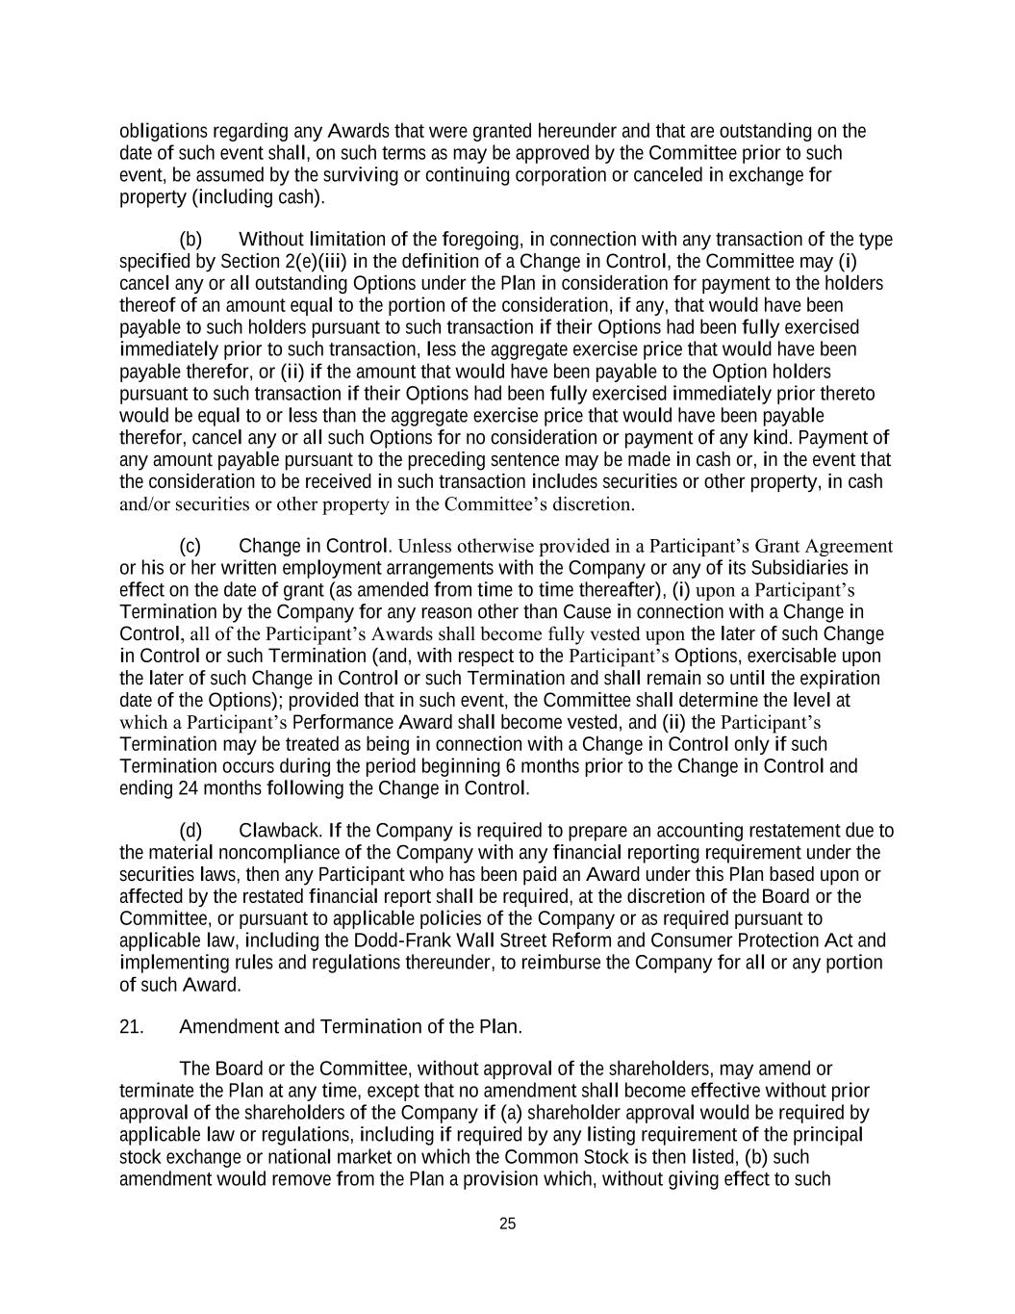
25 obligations regarding any Awards that were granted hereunder and that are outstanding on the date of such event shall, on such terms as may be approved by the Committee prior to such event, be assumed by the surviving or continuing corporation or canceled in exchange for property (including cash). (b) Without limitation of the foregoing, in connection with any transaction of the type specified by Section 2(e)(iii) in the definition of a Change in Control, the Committee may (i) cancel any or all outstanding Options under the Plan in consideration for payment to the holders thereof of an amount equal to the portion of the consideration, if any, that would have been payable to such holders pursuant to such transaction if their Options had been fully exercised immediately prior to such transaction, less the aggregate exercise price that would have been payable therefor, or (ii) if the amount that would have been payable to the Option holders pursuant to such transaction if their Options had been fully exercised immediately prior thereto would be equal to or less than the aggregate exercise price that would have been payable therefor, cancel any or all such Options for no consideration or payment of any kind. Payment of any amount payable pursuant to the preceding sentence may be made in cash or, in the event that the consideration to be received in such transaction includes securities or other property, in cash and/or securities or other property in the Committee’s discretion. (c) Change in Control. Unless otherwise provided in a Participant’s Grant Agreement or his or her written employment arrangements with the Company or any of its Subsidiaries in effect on the date of grant (as amended from time to time thereafter), (i) upon a Participant’s Termination by the Company for any reason other than Cause in connection with a Change in Control, all of the Participant’s Awards shall become fully vested upon the later of such Change in Control or such Termination (and, with respect to the Participant’s Options, exercisable upon the later of such Change in Control or such Termination and shall remain so until the expiration date of the Options); provided that in such event, the Committee shall determine the level at which a Participant’s Performance Award shall become vested, and (ii) the Participant’s Termination may be treated as being in connection with a Change in Control only if such Termination occurs during the period beginning 6 months prior to the Change in Control and ending 24 months following the Change in Control. (d) Clawback. If the Company is required to prepare an accounting restatement due to the material noncompliance of the Company with any financial reporting requirement under the securities laws, then any Participant who has been paid an Award under this Plan based upon or affected by the restated financial report shall be required, at the discretion of the Board or the Committee, or pursuant to applicable policies of the Company or as required pursuant to applicable law, including the Dodd-Frank Wall Street Reform and Consumer Protection Act and implementing rules and regulations thereunder, to reimburse the Company for all or any portion of such Award. 21. Amendment and Termination of the Plan. The Board or the Committee, without approval of the shareholders, may amend or terminate the Plan at any time, except that no amendment shall become effective without prior approval of the shareholders of the Company if (a) shareholder approval would be required by applicable law or regulations, including if required by any listing requirement of the principal stock exchange or national market on which the Common Stock is then listed, (b) such amendment would remove from the Plan a provision which, without giving effect to such

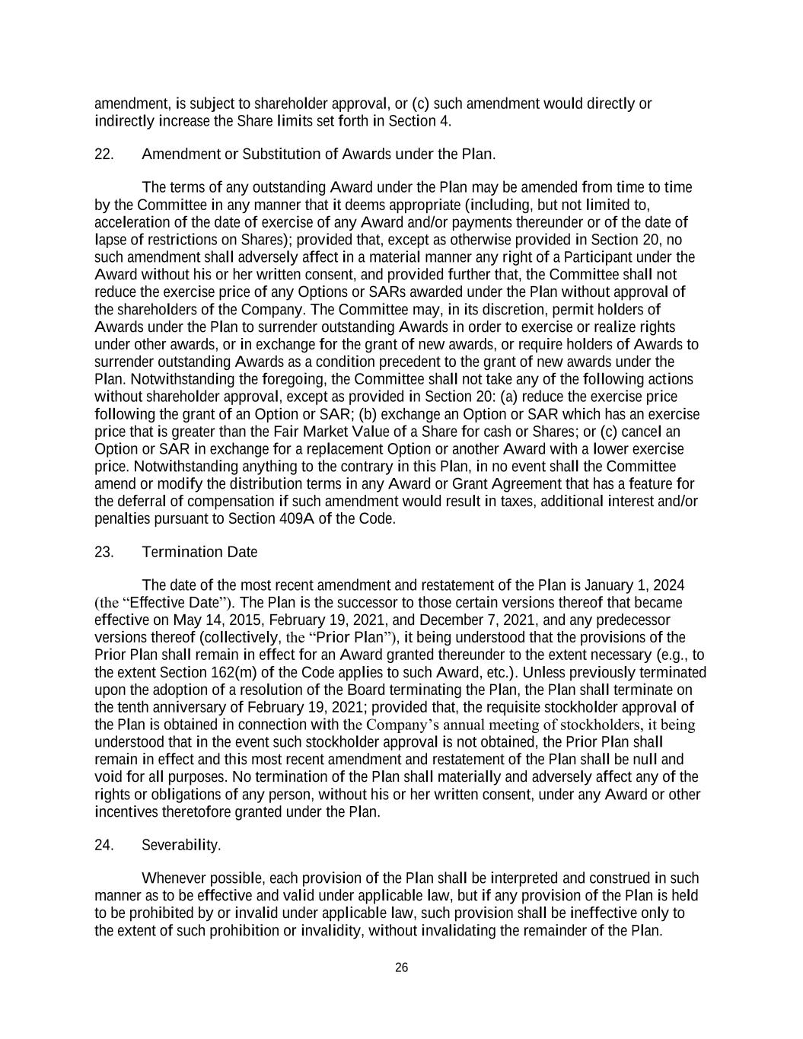
26 amendment, is subject to shareholder approval, or (c) such amendment would directly or indirectly increase the Share limits set forth in Section 4. 22. Amendment or Substitution of Awards under the Plan. The terms of any outstanding Award under the Plan may be amended from time to time by the Committee in any manner that it deems appropriate (including, but not limited to, acceleration of the date of exercise of any Award and/or payments thereunder or of the date of lapse of restrictions on Shares); provided that, except as otherwise provided in Section 20, no such amendment shall adversely affect in a material manner any right of a Participant under the Award without his or her written consent, and provided further that, the Committee shall not reduce the exercise price of any Options or SARs awarded under the Plan without approval of the shareholders of the Company. The Committee may, in its discretion, permit holders of Awards under the Plan to surrender outstanding Awards in order to exercise or realize rights under other awards, or in exchange for the grant of new awards, or require holders of Awards to surrender outstanding Awards as a condition precedent to the grant of new awards under the Plan. Notwithstanding the foregoing, the Committee shall not take any of the following actions without shareholder approval, except as provided in Section 20: (a) reduce the exercise price following the grant of an Option or SAR; (b) exchange an Option or SAR which has an exercise price that is greater than the Fair Market Value of a Share for cash or Shares; or (c) cancel an Option or SAR in exchange for a replacement Option or another Award with a lower exercise price. Notwithstanding anything to the contrary in this Plan, in no event shall the Committee amend or modify the distribution terms in any Award or Grant Agreement that has a feature for the deferral of compensation if such amendment would result in taxes, additional interest and/or penalties pursuant to Section 409A of the Code. 23. Termination Date The date of the most recent amendment and restatement of the Plan is January 1, 2024 (the “Effective Date”). The Plan is the successor to those certain versions thereof that became effective on May 14, 2015, February 19, 2021, and December 7, 2021, and any predecessor versions thereof (collectively, the “Prior Plan”), it being understood that the provisions of the Prior Plan shall remain in effect for an Award granted thereunder to the extent necessary (e.g., to the extent Section 162(m) of the Code applies to such Award, etc.). Unless previously terminated upon the adoption of a resolution of the Board terminating the Plan, the Plan shall terminate on the tenth anniversary of February 19, 2021; provided that, the requisite stockholder approval of the Plan is obtained in connection with the Company’s annual meeting of stockholders, it being understood that in the event such stockholder approval is not obtained, the Prior Plan shall remain in effect and this most recent amendment and restatement of the Plan shall be null and void for all purposes. No termination of the Plan shall materially and adversely affect any of the rights or obligations of any person, without his or her written consent, under any Award or other incentives theretofore granted under the Plan. 24. Severability. Whenever possible, each provision of the Plan shall be interpreted and construed in such manner as to be effective and valid under applicable law, but if any provision of the Plan is held to be prohibited by or invalid under applicable law, such provision shall be ineffective only to the extent of such prohibition or invalidity, without invalidating the remainder of the Plan.

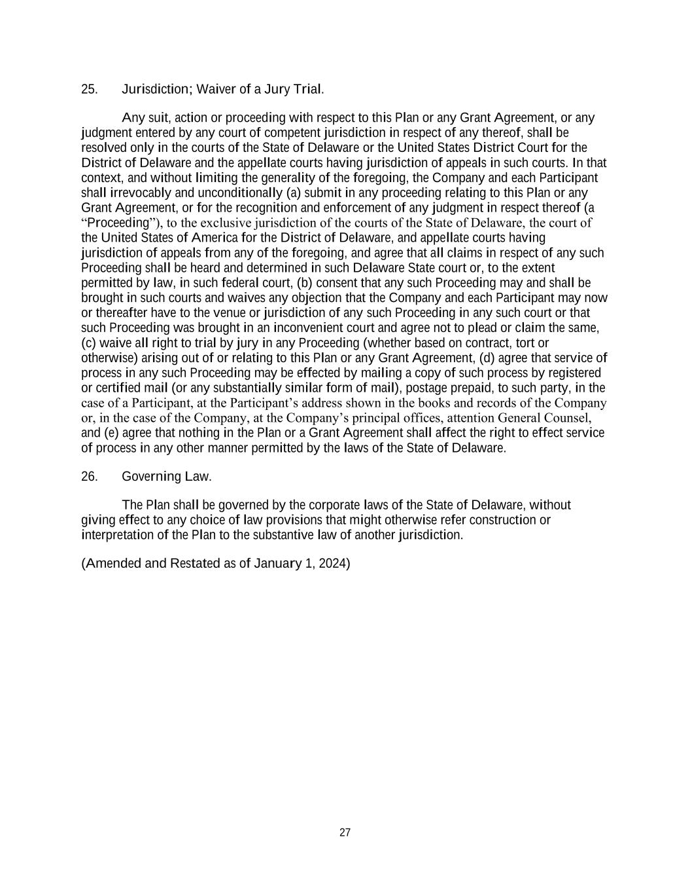
27 25. Jurisdiction; Waiver of a Jury Trial. Any suit, action or proceeding with respect to this Plan or any Grant Agreement, or any judgment entered by any court of competent jurisdiction in respect of any thereof, shall be resolved only in the courts of the State of Delaware or the United States District Court for the District of Delaware and the appellate courts having jurisdiction of appeals in such courts. In that context, and without limiting the generality of the foregoing, the Company and each Participant shall irrevocably and unconditionally (a) submit in any proceeding relating to this Plan or any Grant Agreement, or for the recognition and enforcement of any judgment in respect thereof (a “Proceeding”), to the exclusive jurisdiction of the courts of the State of Delaware, the court of the United States of America for the District of Delaware, and appellate courts having jurisdiction of appeals from any of the foregoing, and agree that all claims in respect of any such Proceeding shall be heard and determined in such Delaware State court or, to the extent permitted by law, in such federal court, (b) consent that any such Proceeding may and shall be brought in such courts and waives any objection that the Company and each Participant may now or thereafter have to the venue or jurisdiction of any such Proceeding in any such court or that such Proceeding was brought in an inconvenient court and agree not to plead or claim the same, (c) waive all right to trial by jury in any Proceeding (whether based on contract, tort or otherwise) arising out of or relating to this Plan or any Grant Agreement, (d) agree that service of process in any such Proceeding may be effected by mailing a copy of such process by registered or certified mail (or any substantially similar form of mail), postage prepaid, to such party, in the case of a Participant, at the Participant’s address shown in the books and records of the Company or, in the case of the Company, at the Company’s principal offices, attention General Counsel, and (e) agree that nothing in the Plan or a Grant Agreement shall affect the right to effect service of process in any other manner permitted by the laws of the State of Delaware. 26. Governing Law. The Plan shall be governed by the corporate laws of the State of Delaware, without giving effect to any choice of law provisions that might otherwise refer construction or interpretation of the Plan to the substantive law of another jurisdiction. (Amended and Restated as of January 1, 2024)

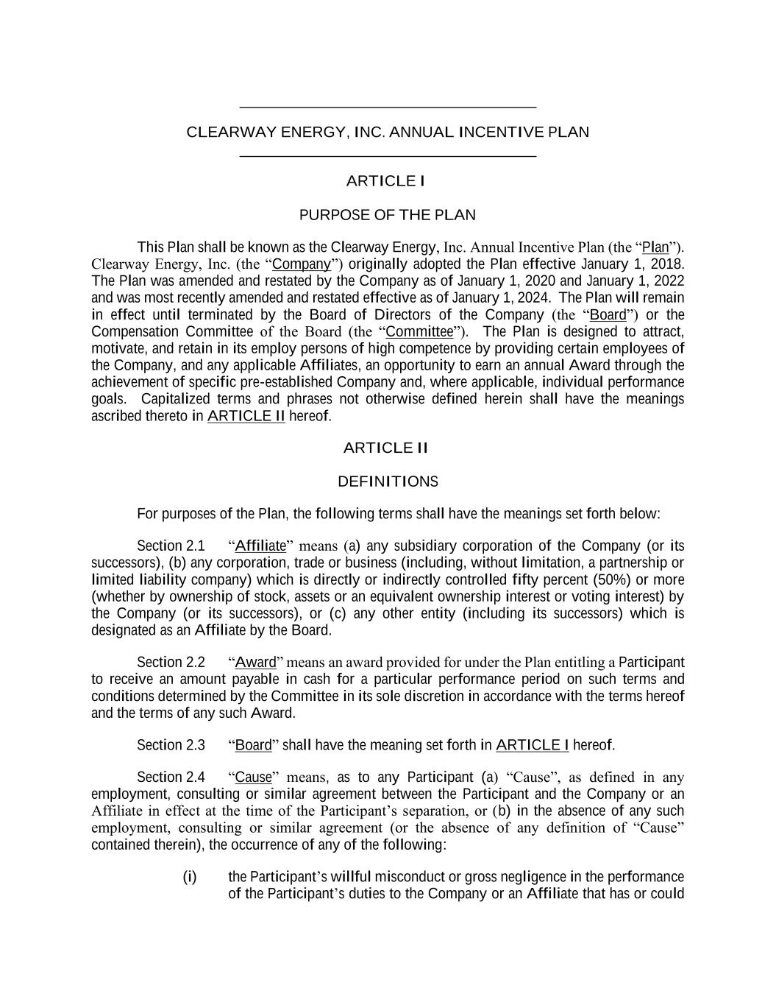
_______________________________________ CLEARWAY ENERGY, INC. ANNUAL INCENTIVE PLAN _______________________________________ ARTICLE I PURPOSE OF THE PLAN This Plan shall be known as the Clearway Energy, Inc. Annual Incentive Plan (the “Plan”). Clearway Energy, Inc. (the “Company”) originally adopted the Plan effective January 1, 2018. The Plan was amended and restated by the Company as of January 1, 2020 and January 1, 2022 and was most recently amended and restated effective as of January 1, 2024. The Plan will remain in effect until terminated by the Board of Directors of the Company (the “Board”) or the Compensation Committee of the Board (the “Committee”). The Plan is designed to attract, motivate, and retain in its employ persons of high competence by providing certain employees of the Company, and any applicable Affiliates, an opportunity to earn an annual Award through the achievement of specific pre-established Company and, where applicable, individual performance goals. Capitalized terms and phrases not otherwise defined herein shall have the meanings ascribed thereto in ARTICLE II hereof. ARTICLE II DEFINITIONS For purposes of the Plan, the following terms shall have the meanings set forth below: Section 2.1 “Affiliate” means (a) any subsidiary corporation of the Company (or its successors), (b) any corporation, trade or business (including, without limitation, a partnership or limited liability company) which is directly or indirectly controlled fifty percent (50%) or more (whether by ownership of stock, assets or an equivalent ownership interest or voting interest) by the Company (or its successors), or (c) any other entity (including its successors) which is designated as an Affiliate by the Board. Section 2.2 “Award” means an award provided for under the Plan entitling a Participant to receive an amount payable in cash for a particular performance period on such terms and conditions determined by the Committee in its sole discretion in accordance with the terms hereof and the terms of any such Award. Section 2.3 “Board” shall have the meaning set forth in ARTICLE I hereof. Section 2.4 “Cause” means, as to any Participant (a) “Cause”, as defined in any employment, consulting or similar agreement between the Participant and the Company or an Affiliate in effect at the time of the Participant’s separation, or (b) in the absence of any such employment, consulting or similar agreement (or the absence of any definition of “Cause” contained therein), the occurrence of any of the following: (i) the Participant’s willful misconduct or gross negligence in the performance of the Participant’s duties to the Company or an Affiliate that has or could

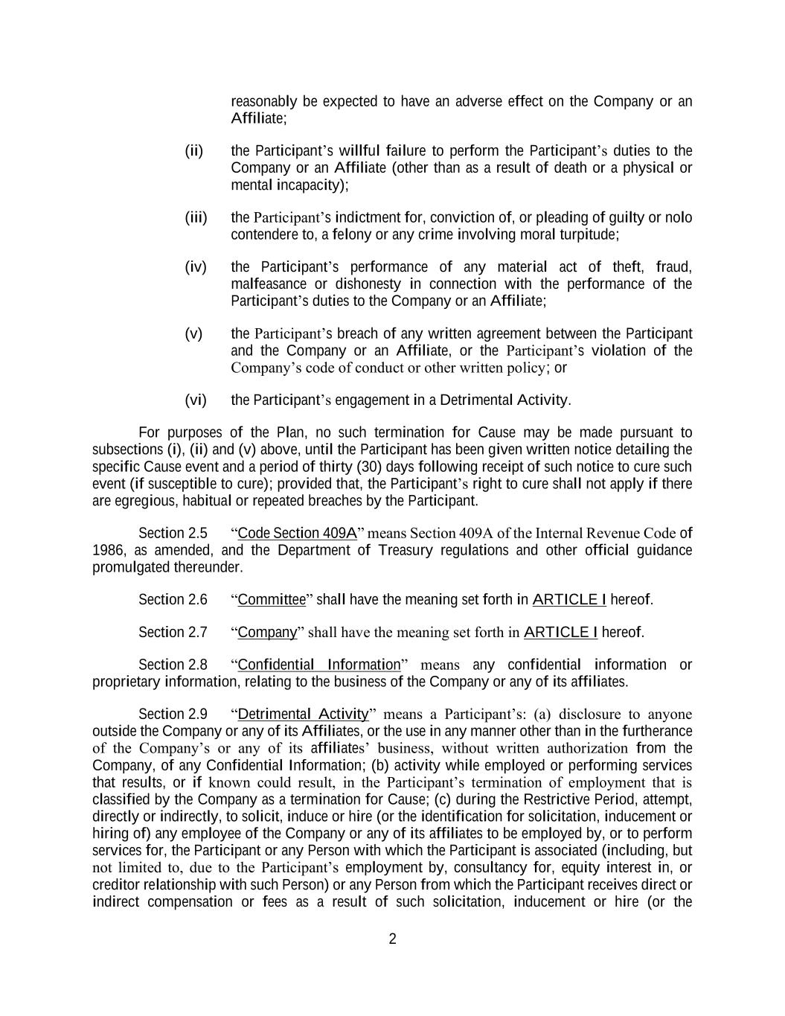
2 reasonably be expected to have an adverse effect on the Company or an Affiliate; (ii) the Participant’s willful failure to perform the Participant’s duties to the Company or an Affiliate (other than as a result of death or a physical or mental incapacity); (iii) the Participant’s indictment for, conviction of, or pleading of guilty or nolo contendere to, a felony or any crime involving moral turpitude; (iv) the Participant’s performance of any material act of theft, fraud, malfeasance or dishonesty in connection with the performance of the Participant’s duties to the Company or an Affiliate; (v) the Participant’s breach of any written agreement between the Participant and the Company or an Affiliate, or the Participant’s violation of the Company’s code of conduct or other written policy; or (vi) the Participant’s engagement in a Detrimental Activity. For purposes of the Plan, no such termination for Cause may be made pursuant to subsections (i), (ii) and (v) above, until the Participant has been given written notice detailing the specific Cause event and a period of thirty (30) days following receipt of such notice to cure such event (if susceptible to cure); provided that, the Participant’s right to cure shall not apply if there are egregious, habitual or repeated breaches by the Participant. Section 2.5 “Code Section 409A” means Section 409A of the Internal Revenue Code of 1986, as amended, and the Department of Treasury regulations and other official guidance promulgated thereunder. Section 2.6 “Committee” shall have the meaning set forth in ARTICLE I hereof. Section 2.7 “Company” shall have the meaning set forth in ARTICLE I hereof. Section 2.8 “Confidential Information” means any confidential information or proprietary information, relating to the business of the Company or any of its affiliates. Section 2.9 “Detrimental Activity” means a Participant’s: (a) disclosure to anyone outside the Company or any of its Affiliates, or the use in any manner other than in the furtherance of the Company’s or any of its affiliates’ business, without written authorization from the Company, of any Confidential Information; (b) activity while employed or performing services that results, or if known could result, in the Participant’s termination of employment that is classified by the Company as a termination for Cause; (c) during the Restrictive Period, attempt, directly or indirectly, to solicit, induce or hire (or the identification for solicitation, inducement or hiring of) any employee of the Company or any of its affiliates to be employed by, or to perform services for, the Participant or any Person with which the Participant is associated (including, but not limited to, due to the Participant’s employment by, consultancy for, equity interest in, or creditor relationship with such Person) or any Person from which the Participant receives direct or indirect compensation or fees as a result of such solicitation, inducement or hire (or the

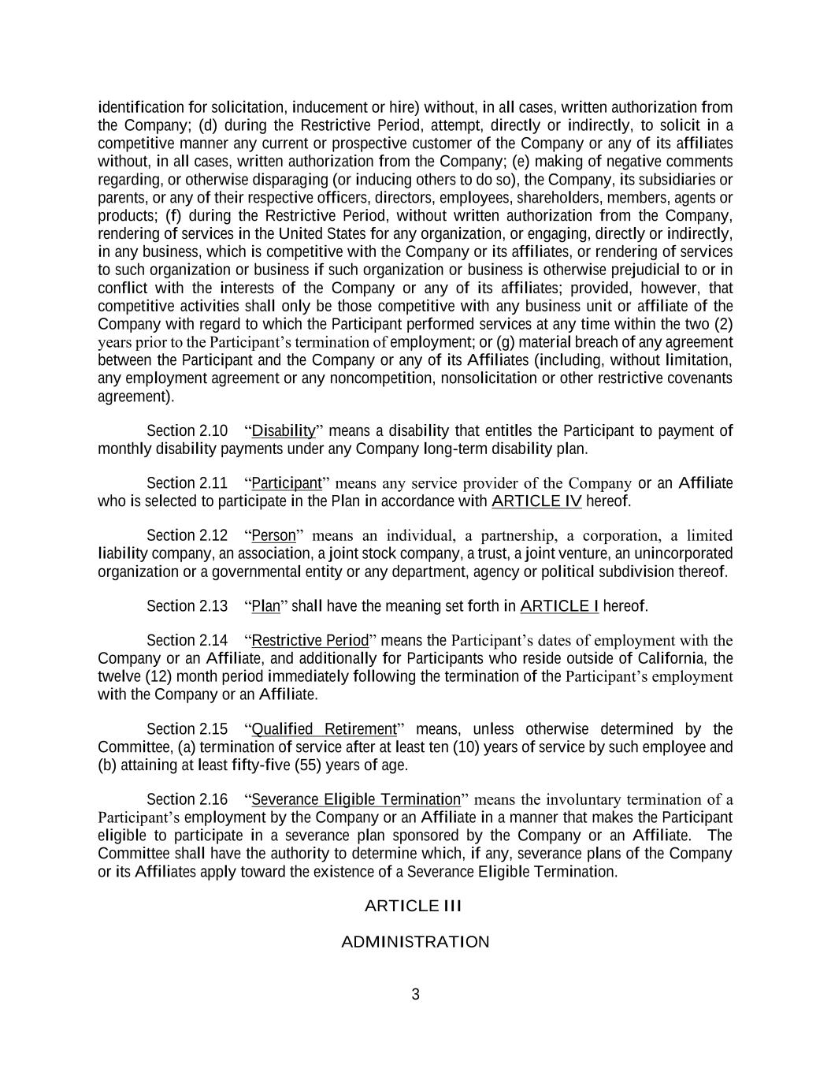
3 identification for solicitation, inducement or hire) without, in all cases, written authorization from the Company; (d) during the Restrictive Period, attempt, directly or indirectly, to solicit in a competitive manner any current or prospective customer of the Company or any of its affiliates without, in all cases, written authorization from the Company; (e) making of negative comments regarding, or otherwise disparaging (or inducing others to do so), the Company, its subsidiaries or parents, or any of their respective officers, directors, employees, shareholders, members, agents or products; (f) during the Restrictive Period, without written authorization from the Company, rendering of services in the United States for any organization, or engaging, directly or indirectly, in any business, which is competitive with the Company or its affiliates, or rendering of services to such organization or business if such organization or business is otherwise prejudicial to or in conflict with the interests of the Company or any of its affiliates; provided, however, that competitive activities shall only be those competitive with any business unit or affiliate of the Company with regard to which the Participant performed services at any time within the two (2) years prior to the Participant’s termination of employment; or (g) material breach of any agreement between the Participant and the Company or any of its Affiliates (including, without limitation, any employment agreement or any noncompetition, nonsolicitation or other restrictive covenants agreement). Section 2.10 “Disability” means a disability that entitles the Participant to payment of monthly disability payments under any Company long-term disability plan. Section 2.11 “Participant” means any service provider of the Company or an Affiliate who is selected to participate in the Plan in accordance with ARTICLE IV hereof. Section 2.12 “Person” means an individual, a partnership, a corporation, a limited liability company, an association, a joint stock company, a trust, a joint venture, an unincorporated organization or a governmental entity or any department, agency or political subdivision thereof. Section 2.13 “Plan” shall have the meaning set forth in ARTICLE I hereof. Section 2.14 “Restrictive Period” means the Participant’s dates of employment with the Company or an Affiliate, and additionally for Participants who reside outside of California, the twelve (12) month period immediately following the termination of the Participant’s employment with the Company or an Affiliate. Section 2.15 “Qualified Retirement” means, unless otherwise determined by the Committee, (a) termination of service after at least ten (10) years of service by such employee and (b) attaining at least fifty-five (55) years of age. Section 2.16 “Severance Eligible Termination” means the involuntary termination of a Participant’s employment by the Company or an Affiliate in a manner that makes the Participant eligible to participate in a severance plan sponsored by the Company or an Affiliate. The Committee shall have the authority to determine which, if any, severance plans of the Company or its Affiliates apply toward the existence of a Severance Eligible Termination. ARTICLE III ADMINISTRATION

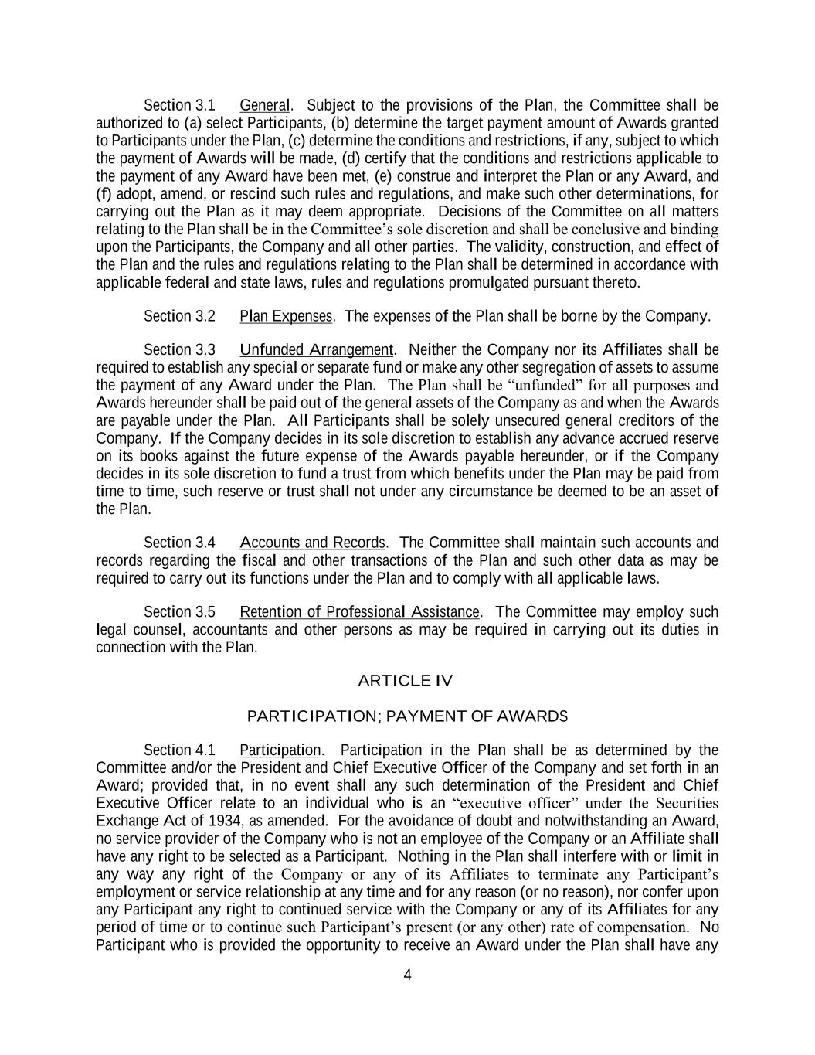
4 Section 3.1 General. Subject to the provisions of the Plan, the Committee shall be authorized to (a) select Participants, (b) determine the target payment amount of Awards granted to Participants under the Plan, (c) determine the conditions and restrictions, if any, subject to which the payment of Awards will be made, (d) certify that the conditions and restrictions applicable to the payment of any Award have been met, (e) construe and interpret the Plan or any Award, and (f) adopt, amend, or rescind such rules and regulations, and make such other determinations, for carrying out the Plan as it may deem appropriate. Decisions of the Committee on all matters relating to the Plan shall be in the Committee’s sole discretion and shall be conclusive and binding upon the Participants, the Company and all other parties. The validity, construction, and effect of the Plan and the rules and regulations relating to the Plan shall be determined in accordance with applicable federal and state laws, rules and regulations promulgated pursuant thereto. Section 3.2 Plan Expenses. The expenses of the Plan shall be borne by the Company. Section 3.3 Unfunded Arrangement. Neither the Company nor its Affiliates shall be required to establish any special or separate fund or make any other segregation of assets to assume the payment of any Award under the Plan. The Plan shall be “unfunded” for all purposes and Awards hereunder shall be paid out of the general assets of the Company as and when the Awards are payable under the Plan. All Participants shall be solely unsecured general creditors of the Company. If the Company decides in its sole discretion to establish any advance accrued reserve on its books against the future expense of the Awards payable hereunder, or if the Company decides in its sole discretion to fund a trust from which benefits under the Plan may be paid from time to time, such reserve or trust shall not under any circumstance be deemed to be an asset of the Plan. Section 3.4 Accounts and Records. The Committee shall maintain such accounts and records regarding the fiscal and other transactions of the Plan and such other data as may be required to carry out its functions under the Plan and to comply with all applicable laws. Section 3.5 Retention of Professional Assistance. The Committee may employ such legal counsel, accountants and other persons as may be required in carrying out its duties in connection with the Plan. ARTICLE IV PARTICIPATION; PAYMENT OF AWARDS Section 4.1 Participation. Participation in the Plan shall be as determined by the Committee and/or the President and Chief Executive Officer of the Company and set forth in an Award; provided that, in no event shall any such determination of the President and Chief Executive Officer relate to an individual who is an “executive officer” under the Securities Exchange Act of 1934, as amended. For the avoidance of doubt and notwithstanding an Award, no service provider of the Company who is not an employee of the Company or an Affiliate shall have any right to be selected as a Participant. Nothing in the Plan shall interfere with or limit in any way any right of the Company or any of its Affiliates to terminate any Participant’s employment or service relationship at any time and for any reason (or no reason), nor confer upon any Participant any right to continued service with the Company or any of its Affiliates for any period of time or to continue such Participant’s present (or any other) rate of compensation. No Participant who is provided the opportunity to receive an Award under the Plan shall have any

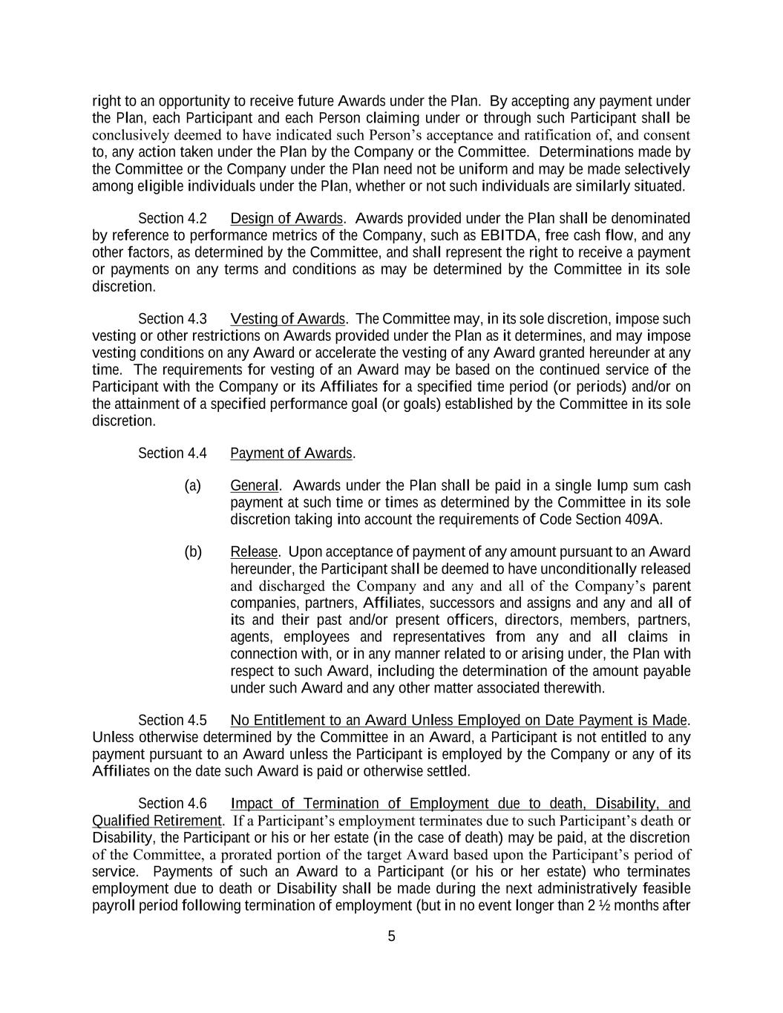
5 right to an opportunity to receive future Awards under the Plan. By accepting any payment under the Plan, each Participant and each Person claiming under or through such Participant shall be conclusively deemed to have indicated such Person’s acceptance and ratification of, and consent to, any action taken under the Plan by the Company or the Committee. Determinations made by the Committee or the Company under the Plan need not be uniform and may be made selectively among eligible individuals under the Plan, whether or not such individuals are similarly situated. Section 4.2 Design of Awards. Awards provided under the Plan shall be denominated by reference to performance metrics of the Company, such as EBITDA, free cash flow, and any other factors, as determined by the Committee, and shall represent the right to receive a payment or payments on any terms and conditions as may be determined by the Committee in its sole discretion. Section 4.3 Vesting of Awards. The Committee may, in its sole discretion, impose such vesting or other restrictions on Awards provided under the Plan as it determines, and may impose vesting conditions on any Award or accelerate the vesting of any Award granted hereunder at any time. The requirements for vesting of an Award may be based on the continued service of the Participant with the Company or its Affiliates for a specified time period (or periods) and/or on the attainment of a specified performance goal (or goals) established by the Committee in its sole discretion. Section 4.4 Payment of Awards. (a) General. Awards under the Plan shall be paid in a single lump sum cash payment at such time or times as determined by the Committee in its sole discretion taking into account the requirements of Code Section 409A. (b) Release. Upon acceptance of payment of any amount pursuant to an Award hereunder, the Participant shall be deemed to have unconditionally released and discharged the Company and any and all of the Company’s parent companies, partners, Affiliates, successors and assigns and any and all of its and their past and/or present officers, directors, members, partners, agents, employees and representatives from any and all claims in connection with, or in any manner related to or arising under, the Plan with respect to such Award, including the determination of the amount payable under such Award and any other matter associated therewith. Section 4.5 No Entitlement to an Award Unless Employed on Date Payment is Made. Unless otherwise determined by the Committee in an Award, a Participant is not entitled to any payment pursuant to an Award unless the Participant is employed by the Company or any of its Affiliates on the date such Award is paid or otherwise settled. Section 4.6 Impact of Termination of Employment due to death, Disability, and Qualified Retirement. If a Participant’s employment terminates due to such Participant’s death or Disability, the Participant or his or her estate (in the case of death) may be paid, at the discretion of the Committee, a prorated portion of the target Award based upon the Participant’s period of service. Payments of such an Award to a Participant (or his or her estate) who terminates employment due to death or Disability shall be made during the next administratively feasible payroll period following termination of employment (but in no event longer than 2 ½ months after

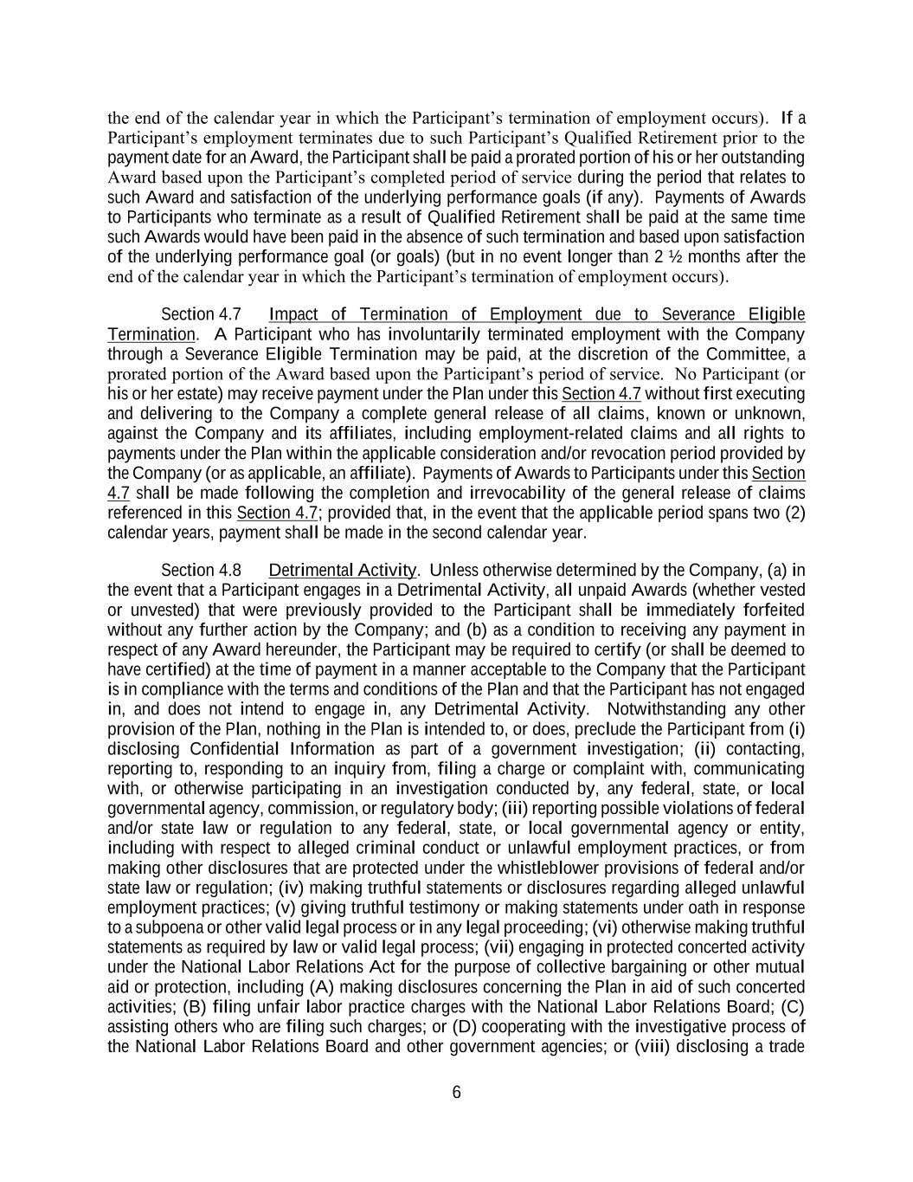
6 the end of the calendar year in which the Participant’s termination of employment occurs). If a Participant’s employment terminates due to such Participant’s Qualified Retirement prior to the payment date for an Award, the Participant shall be paid a prorated portion of his or her outstanding Award based upon the Participant’s completed period of service during the period that relates to such Award and satisfaction of the underlying performance goals (if any). Payments of Awards to Participants who terminate as a result of Qualified Retirement shall be paid at the same time such Awards would have been paid in the absence of such termination and based upon satisfaction of the underlying performance goal (or goals) (but in no event longer than 2 ½ months after the end of the calendar year in which the Participant’s termination of employment occurs). Section 4.7 Impact of Termination of Employment due to Severance Eligible Termination. A Participant who has involuntarily terminated employment with the Company through a Severance Eligible Termination may be paid, at the discretion of the Committee, a prorated portion of the Award based upon the Participant’s period of service. No Participant (or his or her estate) may receive payment under the Plan under this Section 4.7 without first executing and delivering to the Company a complete general release of all claims, known or unknown, against the Company and its affiliates, including employment-related claims and all rights to payments under the Plan within the applicable consideration and/or revocation period provided by the Company (or as applicable, an affiliate). Payments of Awards to Participants under this Section 4.7 shall be made following the completion and irrevocability of the general release of claims referenced in this Section 4.7; provided that, in the event that the applicable period spans two (2) calendar years, payment shall be made in the second calendar year. Section 4.8 Detrimental Activity. Unless otherwise determined by the Company, (a) in the event that a Participant engages in a Detrimental Activity, all unpaid Awards (whether vested or unvested) that were previously provided to the Participant shall be immediately forfeited without any further action by the Company; and (b) as a condition to receiving any payment in respect of any Award hereunder, the Participant may be required to certify (or shall be deemed to have certified) at the time of payment in a manner acceptable to the Company that the Participant is in compliance with the terms and conditions of the Plan and that the Participant has not engaged in, and does not intend to engage in, any Detrimental Activity. Notwithstanding any other provision of the Plan, nothing in the Plan is intended to, or does, preclude the Participant from (i) disclosing Confidential Information as part of a government investigation; (ii) contacting, reporting to, responding to an inquiry from, filing a charge or complaint with, communicating with, or otherwise participating in an investigation conducted by, any federal, state, or local governmental agency, commission, or regulatory body; (iii) reporting possible violations of federal and/or state law or regulation to any federal, state, or local governmental agency or entity, including with respect to alleged criminal conduct or unlawful employment practices, or from making other disclosures that are protected under the whistleblower provisions of federal and/or state law or regulation; (iv) making truthful statements or disclosures regarding alleged unlawful employment practices; (v) giving truthful testimony or making statements under oath in response to a subpoena or other valid legal process or in any legal proceeding; (vi) otherwise making truthful statements as required by law or valid legal process; (vii) engaging in protected concerted activity under the National Labor Relations Act for the purpose of collective bargaining or other mutual aid or protection, including (A) making disclosures concerning the Plan in aid of such concerted activities; (B) filing unfair labor practice charges with the National Labor Relations Board; (C) assisting others who are filing such charges; or (D) cooperating with the investigative process of the National Labor Relations Board and other government agencies; or (viii) disclosing a trade

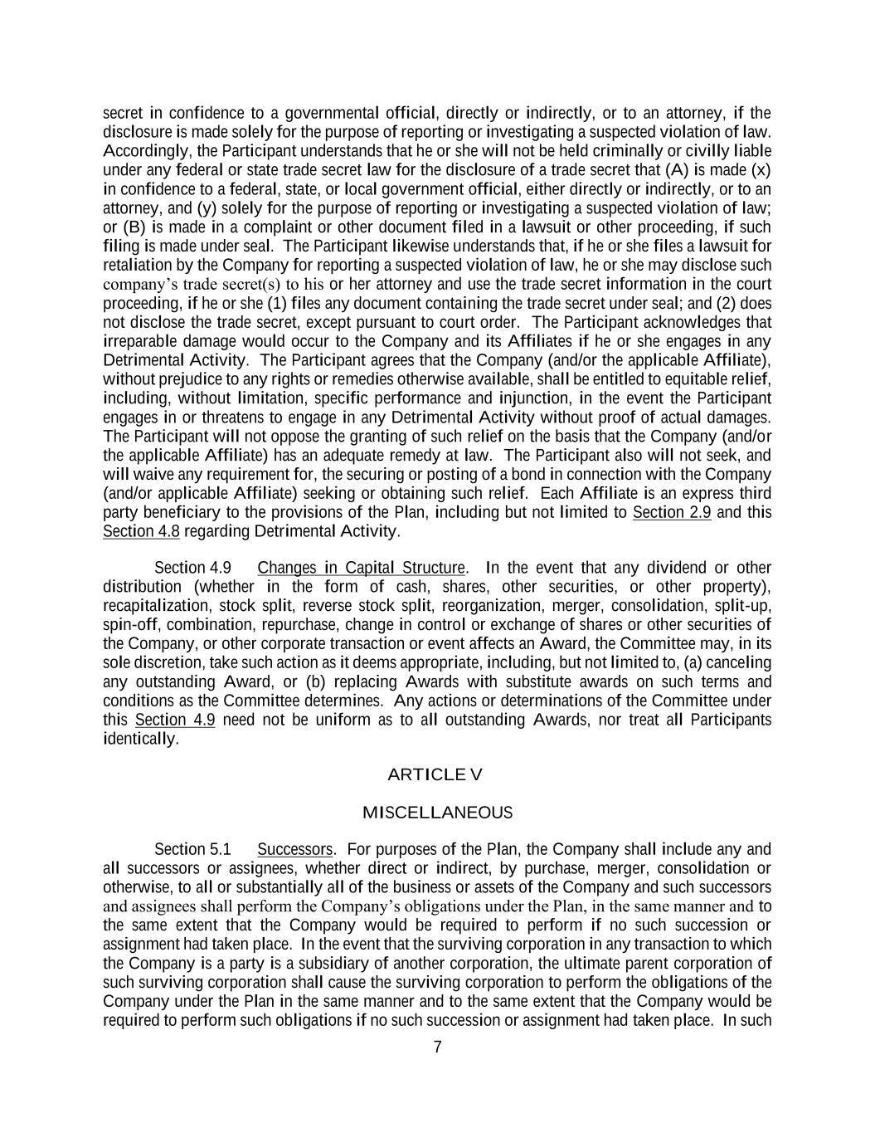
7 secret in confidence to a governmental official, directly or indirectly, or to an attorney, if the disclosure is made solely for the purpose of reporting or investigating a suspected violation of law. Accordingly, the Participant understands that he or she will not be held criminally or civilly liable under any federal or state trade secret law for the disclosure of a trade secret that (A) is made (x) in confidence to a federal, state, or local government official, either directly or indirectly, or to an attorney, and (y) solely for the purpose of reporting or investigating a suspected violation of law; or (B) is made in a complaint or other document filed in a lawsuit or other proceeding, if such filing is made under seal. The Participant likewise understands that, if he or she files a lawsuit for retaliation by the Company for reporting a suspected violation of law, he or she may disclose such company’s trade secret(s) to his or her attorney and use the trade secret information in the court proceeding, if he or she (1) files any document containing the trade secret under seal; and (2) does not disclose the trade secret, except pursuant to court order. The Participant acknowledges that irreparable damage would occur to the Company and its Affiliates if he or she engages in any Detrimental Activity. The Participant agrees that the Company (and/or the applicable Affiliate), without prejudice to any rights or remedies otherwise available, shall be entitled to equitable relief, including, without limitation, specific performance and injunction, in the event the Participant engages in or threatens to engage in any Detrimental Activity without proof of actual damages. The Participant will not oppose the granting of such relief on the basis that the Company (and/or the applicable Affiliate) has an adequate remedy at law. The Participant also will not seek, and will waive any requirement for, the securing or posting of a bond in connection with the Company (and/or applicable Affiliate) seeking or obtaining such relief. Each Affiliate is an express third party beneficiary to the provisions of the Plan, including but not limited to Section 2.9 and this Section 4.8 regarding Detrimental Activity. Section 4.9 Changes in Capital Structure. In the event that any dividend or other distribution (whether in the form of cash, shares, other securities, or other property), recapitalization, stock split, reverse stock split, reorganization, merger, consolidation, split-up, spin-off, combination, repurchase, change in control or exchange of shares or other securities of the Company, or other corporate transaction or event affects an Award, the Committee may, in its sole discretion, take such action as it deems appropriate, including, but not limited to, (a) canceling any outstanding Award, or (b) replacing Awards with substitute awards on such terms and conditions as the Committee determines. Any actions or determinations of the Committee under this Section 4.9 need not be uniform as to all outstanding Awards, nor treat all Participants identically. ARTICLE V MISCELLANEOUS Section 5.1 Successors. For purposes of the Plan, the Company shall include any and all successors or assignees, whether direct or indirect, by purchase, merger, consolidation or otherwise, to all or substantially all of the business or assets of the Company and such successors and assignees shall perform the Company’s obligations under the Plan, in the same manner and to the same extent that the Company would be required to perform if no such succession or assignment had taken place. In the event that the surviving corporation in any transaction to which the Company is a party is a subsidiary of another corporation, the ultimate parent corporation of such surviving corporation shall cause the surviving corporation to perform the obligations of the Company under the Plan in the same manner and to the same extent that the Company would be required to perform such obligations if no such succession or assignment had taken place. In such

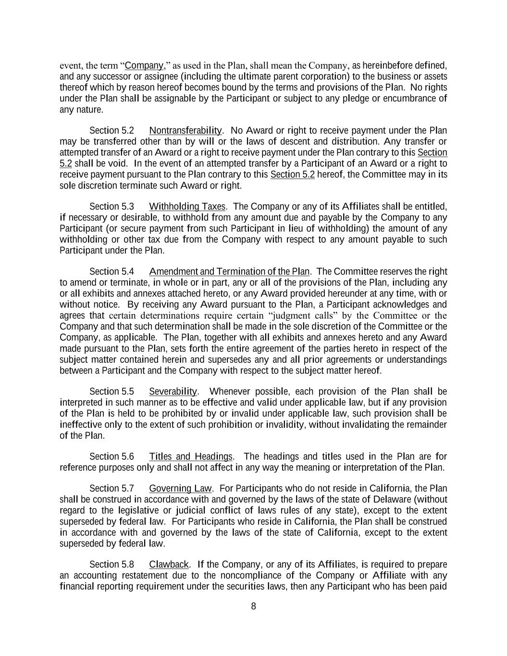
8 event, the term “Company,” as used in the Plan, shall mean the Company, as hereinbefore defined, and any successor or assignee (including the ultimate parent corporation) to the business or assets thereof which by reason hereof becomes bound by the terms and provisions of the Plan. No rights under the Plan shall be assignable by the Participant or subject to any pledge or encumbrance of any nature. Section 5.2 Nontransferability. No Award or right to receive payment under the Plan may be transferred other than by will or the laws of descent and distribution. Any transfer or attempted transfer of an Award or a right to receive payment under the Plan contrary to this Section 5.2 shall be void. In the event of an attempted transfer by a Participant of an Award or a right to receive payment pursuant to the Plan contrary to this Section 5.2 hereof, the Committee may in its sole discretion terminate such Award or right. Section 5.3 Withholding Taxes. The Company or any of its Affiliates shall be entitled, if necessary or desirable, to withhold from any amount due and payable by the Company to any Participant (or secure payment from such Participant in lieu of withholding) the amount of any withholding or other tax due from the Company with respect to any amount payable to such Participant under the Plan. Section 5.4 Amendment and Termination of the Plan. The Committee reserves the right to amend or terminate, in whole or in part, any or all of the provisions of the Plan, including any or all exhibits and annexes attached hereto, or any Award provided hereunder at any time, with or without notice. By receiving any Award pursuant to the Plan, a Participant acknowledges and agrees that certain determinations require certain “judgment calls” by the Committee or the Company and that such determination shall be made in the sole discretion of the Committee or the Company, as applicable. The Plan, together with all exhibits and annexes hereto and any Award made pursuant to the Plan, sets forth the entire agreement of the parties hereto in respect of the subject matter contained herein and supersedes any and all prior agreements or understandings between a Participant and the Company with respect to the subject matter hereof. Section 5.5 Severability. Whenever possible, each provision of the Plan shall be interpreted in such manner as to be effective and valid under applicable law, but if any provision of the Plan is held to be prohibited by or invalid under applicable law, such provision shall be ineffective only to the extent of such prohibition or invalidity, without invalidating the remainder of the Plan. Section 5.6 Titles and Headings. The headings and titles used in the Plan are for reference purposes only and shall not affect in any way the meaning or interpretation of the Plan. Section 5.7 Governing Law. For Participants who do not reside in California, the Plan shall be construed in accordance with and governed by the laws of the state of Delaware (without regard to the legislative or judicial conflict of laws rules of any state), except to the extent superseded by federal law. For Participants who reside in California, the Plan shall be construed in accordance with and governed by the laws of the state of California, except to the extent superseded by federal law. Section 5.8 Clawback. If the Company, or any of its Affiliates, is required to prepare an accounting restatement due to the noncompliance of the Company or Affiliate with any financial reporting requirement under the securities laws, then any Participant who has been paid

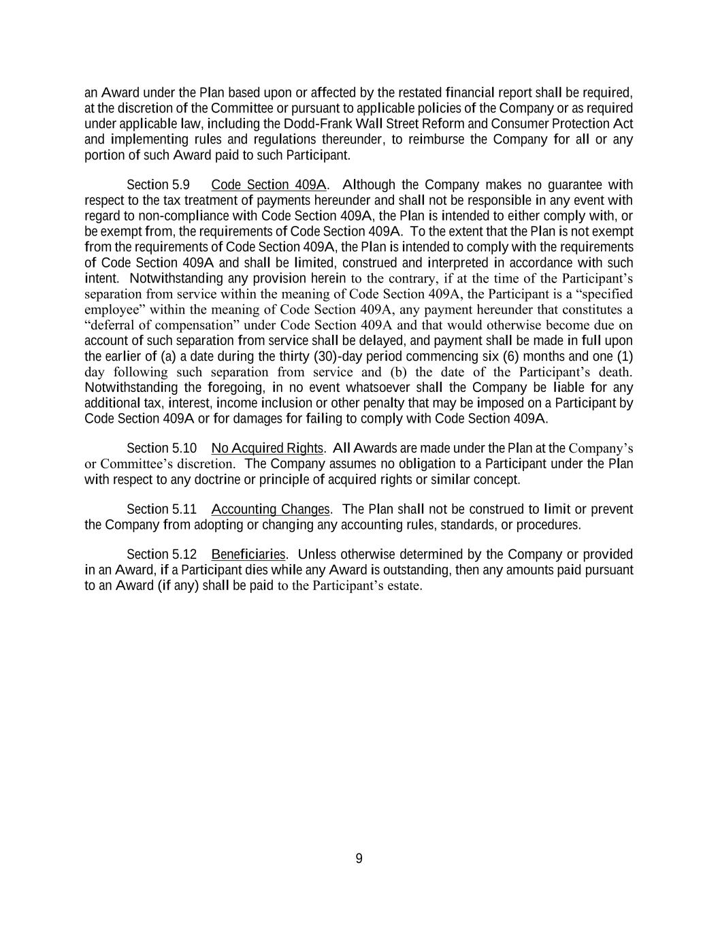
9 an Award under the Plan based upon or affected by the restated financial report shall be required, at the discretion of the Committee or pursuant to applicable policies of the Company or as required under applicable law, including the Dodd-Frank Wall Street Reform and Consumer Protection Act and implementing rules and regulations thereunder, to reimburse the Company for all or any portion of such Award paid to such Participant. Section 5.9 Code Section 409A. Although the Company makes no guarantee with respect to the tax treatment of payments hereunder and shall not be responsible in any event with regard to non-compliance with Code Section 409A, the Plan is intended to either comply with, or be exempt from, the requirements of Code Section 409A. To the extent that the Plan is not exempt from the requirements of Code Section 409A, the Plan is intended to comply with the requirements of Code Section 409A and shall be limited, construed and interpreted in accordance with such intent. Notwithstanding any provision herein to the contrary, if at the time of the Participant’s separation from service within the meaning of Code Section 409A, the Participant is a “specified employee” within the meaning of Code Section 409A, any payment hereunder that constitutes a “deferral of compensation” under Code Section 409A and that would otherwise become due on account of such separation from service shall be delayed, and payment shall be made in full upon the earlier of (a) a date during the thirty (30)-day period commencing six (6) months and one (1) day following such separation from service and (b) the date of the Participant’s death. Notwithstanding the foregoing, in no event whatsoever shall the Company be liable for any additional tax, interest, income inclusion or other penalty that may be imposed on a Participant by Code Section 409A or for damages for failing to comply with Code Section 409A. Section 5.10 No Acquired Rights. All Awards are made under the Plan at the Company’s or Committee’s discretion. The Company assumes no obligation to a Participant under the Plan with respect to any doctrine or principle of acquired rights or similar concept. Section 5.11 Accounting Changes. The Plan shall not be construed to limit or prevent the Company from adopting or changing any accounting rules, standards, or procedures. Section 5.12 Beneficiaries. Unless otherwise determined by the Company or provided in an Award, if a Participant dies while any Award is outstanding, then any amounts paid pursuant to an Award (if any) shall be paid to the Participant’s estate.

EXHIBIT 21.1
SUBSIDIARIES OF CLEARWAY ENERGY, INC.

Entity Name |  |  |  |  |  | Jurisdiction
2011 Finance Holdco LLC |  |  |  |  |  | Delaware
AC Solar Holdings LLC |  |  |  |  |  | Delaware
Adams Community Solar Garden I LLC |  |  |  |  |  | Colorado
Adams Community Solar Garden II LLC |  |  |  |  |  | Colorado
Adams Community Solar Garden III LLC |  |  |  |  |  | Colorado
Adams Community Solar Gardens LLC |  |  |  |  |  | Colorado
Agua Caliente Borrower 1 LLC |  |  |  |  |  | Delaware
Agua Caliente Borrower 2 LLC |  |  |  |  |  | Delaware
Agua Caliente Solar Holdings LLC |  |  |  |  |  | Delaware
Agua Caliente Solar, LLC |  |  |  |  |  | Delaware
Alta Interconnection Management II, LLC |  |  |  |  |  | Delaware
Alta Interconnection Management III, LLC |  |  |  |  |  | Delaware
Alta Interconnection Management, LLC |  |  |  |  |  | Delaware
Alta Landco LLC |  |  |  |  |  | Delaware
Alta Realty Holdings, LLC |  |  |  |  |  | Delaware
Alta Realty Investments, LLC |  |  |  |  |  | Delaware
Alta Vista LLC |  |  |  |  |  | Delaware
Alta Wind 1-5 Holding Company, LLC |  |  |  |  |  | Delaware
Alta Wind Asset Management Holdings, LLC |  |  |  |  |  | Delaware
Alta Wind Asset Management, LLC |  |  |  |  |  | Delaware
Alta Wind Company, LLC |  |  |  |  |  | Delaware
Alta Wind Holdings, LLC |  |  |  |  |  | Delaware
Alta Wind I Holding Company, LLC |  |  |  |  |  | Delaware
Alta Wind I, LLC |  |  |  |  |  | Delaware
Alta Wind II Holding Company, LLC |  |  |  |  |  | Delaware
Alta Wind II, LLC |  |  |  |  |  | Delaware
Alta Wind III Holding Company, LLC |  |  |  |  |  | Delaware
Alta Wind III, LLC |  |  |  |  |  | Delaware
Alta Wind IV Holding Company, LLC |  |  |  |  |  | Delaware
Alta Wind IV, LLC |  |  |  |  |  | Delaware
Alta Wind V Holding Company, LLC |  |  |  |  |  | Delaware
Alta Wind V, LLC |  |  |  |  |  | Delaware
Alta Wind X Holding Company, LLC |  |  |  |  |  | Delaware
Alta Wind X, LLC |  |  |  |  |  | Delaware
Alta Wind XI Holding Company, LLC |  |  |  |  |  | Delaware
Alta Wind XI, LLC |  |  |  |  |  | Delaware
Alta Wind X-XI TE Holdco LLC |  |  |  |  |  | Delaware
Apple I LLC |  |  |  |  |  | Delaware
Arapahoe Community Solar Garden I LLC |  |  |  |  |  | Colorado
Arica Solar Pledgor LLC |  |  |  |  |  | Delaware
Arica Solar, LLC |  |  |  |  |  | Delaware
Avenal Park LLC |  |  |  |  |  | Delaware
EXHIBIT 21.1

SUBSIDIARIES OF CLEARWAY ENERGY, INC.

Entity Name |  |  |  |  |  | Jurisdiction
Avenal Solar Holdings LLC |  |  |  |  |  | Delaware
Bashaw Solar 1, LLC |  |  |  |  |  | Delaware
Big Lake Holdco LLC |  |  |  |  |  | Delaware
Black Cat Road Solar, LLC |  |  |  |  |  | Delaware
Black Rock Class B Holdco LLC |  |  |  |  |  | Delaware
Black Rock TE Holdco LLC |  |  |  |  |  | Delaware
Black Rock Wind Force, LLC |  |  |  |  |  | Delaware
Black Rock Wind Holding LLC |  |  |  |  |  | Delaware
Black Start Battery Holdings LLC |  |  |  |  |  | Delaware
Black Start Battery LLC |  |  |  |  |  | Delaware
Bluestone Solar, LLC |  |  |  |  |  | Delaware
BMP Wind LLC |  |  |  |  |  | Delaware
Broken Bow Wind, LLC |  |  |  |  |  | Delaware
Brook Street Solar 1, LLC |  |  |  |  |  | Delaware
Buckthorn Holdings, LLC |  |  |  |  |  | Delaware
Buckthorn Renewables, LLC |  |  |  |  |  | Delaware
Buckthorn Solar Portfolio, LLC |  |  |  |  |  | Delaware
Buckthorn Westex, LLC |  |  |  |  |  | Delaware
Buffalo Bear, LLC |  |  |  |  |  | Oklahoma
Bullock Road Solar 1, LLC |  |  |  |  |  | Delaware
BWC Swan Pond River, LLC |  |  |  |  |  | Delaware
Capistrano Portfolio Holdco LLC |  |  |  |  |  | Delaware
Capistrano Portfolio Holdings LLC |  |  |  |  |  | Delaware
Carlsbad Energy Center LLC |  |  |  |  |  | Delaware
Carlsbad Energy Holdings LLC |  |  |  |  |  | Delaware
Carlsbad Holdco II, LLC |  |  |  |  |  | Delaware
Carlsbad Holdco, LLC |  |  |  |  |  | Delaware
CBAD Holdings II, LLC |  |  |  |  |  | Delaware
CBAD Holdings, LLC |  |  |  |  |  | Delaware
Cedar Creek Wind Holdco LLC |  |  |  |  |  | Delaware
Cedar Creek Wind Holdings LLC |  |  |  |  |  | Delaware
Cedro Hill BL Borrower Holdco LLC |  |  |  |  |  | Delaware
Cedro Hill Class B Member LLC |  |  |  |  |  | Delaware
Cedro Hill TE Holdco LLC |  |  |  |  |  | Delaware
Cedro Hill Wind LLC |  |  |  |  |  | Delaware
Center St Solar 1, LLC |  |  |  |  |  | Delaware
Chestnut Class B LLC |  |  |  |  |  | Delaware
Chestnut Fund Sub LLC |  |  |  |  |  | Delaware
Chisago Holdco LLC |  |  |  |  |  | Delaware
Clara City Solar LLC |  |  |  |  |  | Delaware
Clearway & EFS Distributed Solar LLC |  |  |  |  |  | Delaware
Clearway AC Solar Holdings LLC |  |  |  |  |  | Delaware
EXHIBIT 21.1

SUBSIDIARIES OF CLEARWAY ENERGY, INC.

Entity Name |  |  |  |  |  | Jurisdiction
Clearway Chestnut Fund LLC |  |  |  |  |  | Delaware
Clearway DG Lakeland LLC |  |  |  |  |  | Delaware
Clearway Energy LLC |  |  |  |  |  | Delaware
Clearway Energy Operating LLC |  |  |  |  |  | Delaware
Clearway Solar Star LLC |  |  |  |  |  | Delaware
Clearway Walnut Creek II LLC |  |  |  |  |  | Delaware
Clearway West Holdings LLC |  |  |  |  |  | Delaware
CMR Solar, LLC |  |  |  |  |  | Delaware
Colorado Shared Solar I LLC |  |  |  |  |  | Delaware
Colorado Springs Solar Garden LLC |  |  |  |  |  | Colorado
Continental Energy, LLC |  |  |  |  |  | Arizona
Crofton Bluffs Wind, LLC |  |  |  |  |  | Delaware
CVSR Holdco LLC |  |  |  |  |  | Delaware
CVSR Holdings LLC |  |  |  |  |  | Delaware
CWEN Pinnacle Repowering Holdco LLC |  |  |  |  |  | Delaware
CWEN Pinnacle Repowering Holdings LLC |  |  |  |  |  | Delaware
CWSP Rattlesnake Holding LLC |  |  |  |  |  | Delaware
Daggett 2 Class B LLC |  |  |  |  |  | Delaware
Daggett 2 Project Sub II LLC |  |  |  |  |  | Delaware
Daggett 2 Project Sub LLC |  |  |  |  |  | Delaware
Daggett 2 TargetCo LLC |  |  |  |  |  | Delaware
Daggett 2 TE Holdco LLC |  |  |  |  |  | Delaware
Daggett 3 Project Sub II LLC |  |  |  |  |  | Delaware
Daggett 3 Project Sub LLC |  |  |  |  |  | Delaware
Daggett Class B LLC |  |  |  |  |  | Delaware
Daggett Renewable Holdco LLC |  |  |  |  |  | Delaware
Daggett Solar Holdco LLC |  |  |  |  |  | Delaware
Daggett Solar Investment LLC |  |  |  |  |  | Delaware
Daggett Solar Power 2 LLC |  |  |  |  |  | Delaware
Daggett Solar Power 3 LLC |  |  |  |  |  | Delaware
Daggett TargetCo LLC |  |  |  |  |  | Delaware
Daggett TE Holdco LLC |  |  |  |  |  | Delaware
Dan’s Mountain Parent Holdco LLC |  |  |  |  |  | Delaware
Dan’s Mountain Parent Holdings LLC |  |  |  |  |  | Delaware
Denver Community Solar Garden I LLC |  |  |  |  |  | Colorado
Denver Community Solar Garden II LLC |  |  |  |  |  | Colorado
Desert Sunlight 250, LLC |  |  |  |  |  | Delaware
Desert Sunlight 300, LLC |  |  |  |  |  | Delaware
Desert Sunlight Holdings LLC |  |  |  |  |  | Delaware
Desert Sunlight Investment Holdings, LLC |  |  |  |  |  | Delaware
DG Berkeley Rec LLC |  |  |  |  |  | Delaware
DG Berkeley Village LLC |  |  |  |  |  | Delaware
EXHIBIT 21.1

SUBSIDIARIES OF CLEARWAY ENERGY, INC.

Entity Name |  |  |  |  |  | Jurisdiction
DG Central East LLC |  |  |  |  |  | Delaware
DG Central West LLC |  |  |  |  |  | Delaware
DG Contra Costa Operations LLC |  |  |  |  |  | Delaware
DG Contra Costa Waste LLC |  |  |  |  |  | Delaware
DG Crystal Spring LLC |  |  |  |  |  | Delaware
DG Dighton LLC |  |  |  |  |  | Delaware
DG Foxborough Elm LLC |  |  |  |  |  | Delaware
DG Foxborough Landfill LLC |  |  |  |  |  | Delaware
DG Grantland LLC |  |  |  |  |  | Delaware
DG Haverhill LLC |  |  |  |  |  | Delaware
DG Imperial Admin LLC |  |  |  |  |  | Delaware
DG Imperial Building LLC |  |  |  |  |  | Delaware
DG Lathrop Louise LLC |  |  |  |  |  | Delaware
DG Lincoln Middle LLC |  |  |  |  |  | Delaware
DG Marathon LLC |  |  |  |  |  | Delaware
DG Rosedale Elementary LLC |  |  |  |  |  | Delaware
DG Rosedale Middle LLC |  |  |  |  |  | Delaware
DG San Joaquin LLC |  |  |  |  |  | Delaware
DG SREC HoldCo LLC |  |  |  |  |  | Delaware
DG SREC Holdings 1 LLC |  |  |  |  |  | Delaware
DG Tufts Knoll LLC |  |  |  |  |  | Delaware
DG Tufts Science LLC |  |  |  |  |  | Delaware
DG Washington Middle LLC |  |  |  |  |  | Delaware
DG Webster LLC |  |  |  |  |  | Delaware
DG-CS Holdco LLC |  |  |  |  |  | Delaware
DG-CS Holdings LLC |  |  |  |  |  | Delaware
DG-CS Master Borrower LLC |  |  |  |  |  | Delaware
DGPV 1 LLC |  |  |  |  |  | Delaware
DGPV 2 LLC |  |  |  |  |  | Delaware
DGPV 3 LLC |  |  |  |  |  | Delaware
DGPV 4 LLC |  |  |  |  |  | Delaware
DGPV Fund 1 LLC |  |  |  |  |  | Delaware
DGPV Fund 2 HoldCo A LLC |  |  |  |  |  | Delaware
DGPV Fund 2 HoldCo B LLC |  |  |  |  |  | Delaware
DGPV Fund 2 LLC |  |  |  |  |  | Delaware
DGPV Fund 4 LLC |  |  |  |  |  | Delaware
DGPV Fund 4 Sub LLC |  |  |  |  |  | Delaware
DGPV Holding LLC |  |  |  |  |  | Delaware
Dodge Holdco LLC |  |  |  |  |  | Delaware
Eastman Street Solar 1, LLC |  |  |  |  |  | Delaware
El Mirage Energy, LLC |  |  |  |  |  | Arizona
El Segundo Energy Center LLC |  |  |  |  |  | Delaware
EXHIBIT 21.1

SUBSIDIARIES OF CLEARWAY ENERGY, INC.

Entity Name |  |  |  |  |  | Jurisdiction
Elbow Creek Repowering Tax Equity Holdco LLC |  |  |  |  |  | Delaware
Elbow Creek Wind Project LLC |  |  |  |  |  | Texas
Elkhorn Holdings LLC |  |  |  |  |  | Delaware
Elkhorn Ridge Wind, LLC |  |  |  |  |  | Delaware
Enterprise Solar, LLC |  |  |  |  |  | Delaware
Escalante Solar I, LLC |  |  |  |  |  | Delaware
Escalante Solar II, LLC |  |  |  |  |  | Delaware
Escalante Solar III, LLC |  |  |  |  |  | Delaware
ETCAP NES CS MN 02 LLC |  |  |  |  |  | Delaware
ETCAP NES CS MN 06 LLC |  |  |  |  |  | Delaware
Farmington Holdco LLC |  |  |  |  |  | Delaware
Federal Road Solar 1, LLC |  |  |  |  |  | Delaware
Forest Lake Holdco LLC |  |  |  |  |  | Delaware
Forward WindPower LLC |  |  |  |  |  | Delaware
Four Brothers Holdings, LLC |  |  |  |  |  | Delaware
Four Brothers Solar, LLC |  |  |  |  |  | Delaware
Frontenac Holdco LLC |  |  |  |  |  | Delaware
FUSD Energy, LLC |  |  |  |  |  | Arizona
GCE Holding LLC |  |  |  |  |  | Connecticut
GenConn Devon LLC |  |  |  |  |  | Connecticut
GenConn Energy LLC |  |  |  |  |  | Connecticut
GenConn Middletown LLC |  |  |  |  |  | Connecticut
Goat Wind LLC |  |  |  |  |  | Texas
Golden Fields Solar III, LLC |  |  |  |  |  | Delaware
Golden Puma Fund LLC |  |  |  |  |  | Delaware
Grabinski Solar, LLC |  |  |  |  |  | Delaware
Granite Mountain Holdings, LLC |  |  |  |  |  | Delaware
Granite Mountain Renewables, LLC |  |  |  |  |  | Delaware
Granite Mountain Solar East, LLC |  |  |  |  |  | Delaware
Granite Mountain Solar West, LLC |  |  |  |  |  | Delaware
High Plains Ranch II, LLC |  |  |  |  |  | Delaware
HLE Solar Holdings, LLC |  |  |  |  |  | Delaware
HSD Solar Holdings, LLC |  |  |  |  |  | California
Hwy 14 Holdco LLC |  |  |  |  |  | Delaware
Iron Springs Holdings, LLC |  |  |  |  |  | Delaware
Iron Springs Renewables, LLC |  |  |  |  |  | Delaware
Iron Springs Solar, LLC |  |  |  |  |  | Delaware
Langford Class B Holdco LLC |  |  |  |  |  | Delaware
Langford Holding LLC |  |  |  |  |  | Delaware
Langford Tax Equity Partnership LLC |  |  |  |  |  | Delaware
Langford Wind Power, LLC |  |  |  |  |  | Texas
Lanikuhana Solar, LLC |  |  |  |  |  | Hawaii
EXHIBIT 21.1

SUBSIDIARIES OF CLEARWAY ENERGY, INC.

Entity Name |  |  |  |  |  | Jurisdiction
Laredo Ridge Wind, LLC |  |  |  |  |  | Delaware
Lenape II Solar LLC |  |  |  |  |  | Delaware
Lighthouse Renewable Class A LLC |  |  |  |  |  | Delaware
Lighthouse Renewable Holdco 2 LLC |  |  |  |  |  | Delaware
Lighthouse Renewable Holdco LLC |  |  |  |  |  | Delaware
Lighthouse Renewable Holding Sub LLC |  |  |  |  |  | Delaware
Lighthouse Renewable Holdings LLC |  |  |  |  |  | Delaware
Lindberg Field Solar 1, LLC |  |  |  |  |  | Delaware
Lindberg Field Solar 2, LLC |  |  |  |  |  | Delaware
Longhorn Energy, LLC |  |  |  |  |  | Arizona
Lookout WindPower LLC |  |  |  |  |  | Delaware
Mapleton Solar LLC |  |  |  |  |  | Delaware
Marsh Landing Holdco LLC |  |  |  |  |  | Delaware
Marsh Landing Holdings LLC |  |  |  |  |  | Delaware
Marsh Landing LLC |  |  |  |  |  | Delaware
MC1 Solar Farm, LLC |  |  |  |  |  | North Carolina
Mesquite Sky Class B Holdco LLC |  |  |  |  |  | Delaware
Mesquite Sky Holding LLC |  |  |  |  |  | Delaware
Mesquite Sky TE Holdco LLC |  |  |  |  |  | Delaware
Mesquite Star Class B Holdco LLC |  |  |  |  |  | Delaware
Mesquite Star Special, LLC |  |  |  |  |  | Delaware
Mesquite Star Tax Equity Holdco LLC |  |  |  |  |  | Delaware
Mililani BL Borrower Holdco LLC |  |  |  |  |  | Delaware
Mililani Class B Member Holdco LLC |  |  |  |  |  | Delaware
Mililani I Solar, LLC |  |  |  |  |  | Delaware
Mililani TE Holdco LLC |  |  |  |  |  | Delaware
Minisink Solar 1, LLC |  |  |  |  |  | Delaware
Minisink Solar 2, LLC |  |  |  |  |  | Delaware
Mission Iowa Wind, LLC |  |  |  |  |  | California
Mission Minnesota Wind II, LLC |  |  |  |  |  | Delaware
Mission Wind Broken Bow, LLC |  |  |  |  |  | Delaware
Mission Wind Cedro, LLC |  |  |  |  |  | Delaware
Mission Wind Crofton Bluffs, LLC |  |  |  |  |  | Delaware
Mission Wind Laredo, LLC |  |  |  |  |  | Delaware
Mission Wind New Mexico, LLC |  |  |  |  |  | Delaware
Mission Wind Oklahoma, LLC |  |  |  |  |  | Delaware
Mission Wind PA One, LLC |  |  |  |  |  | Delaware
Mission Wind PA Three, LLC |  |  |  |  |  | Delaware
Mission Wind PA Two, LLC |  |  |  |  |  | Delaware
Mission Wind Pennsylvania, LLC |  |  |  |  |  | Delaware
Mission Wind Utah, LLC |  |  |  |  |  | Delaware
Mission Wind Wyoming, LLC |  |  |  |  |  | Delaware
EXHIBIT 21.1

SUBSIDIARIES OF CLEARWAY ENERGY, INC.

Entity Name |  |  |  |  |  | Jurisdiction
Monster Energy, LLC |  |  |  |  |  | Arizona
Montevideo Solar LLC |  |  |  |  |  | Delaware
Mount Hope Solar 1, LLC |  |  |  |  |  | Delaware
Mountain Wind Power II LLC |  |  |  |  |  | Delaware
Mountain Wind Power, LLC |  |  |  |  |  | Delaware
Natural Gas CA Holdco LLC |  |  |  |  |  | Delaware
Natural Gas CA Holdings LLC |  |  |  |  |  | Delaware
Natural Gas Repowering LLC |  |  |  |  |  | Delaware
NedPower Mount Storm LLC |  |  |  |  |  | Delaware
New Munich Solar LLC |  |  |  |  |  | Delaware
NIMH Solar HoldCo LLC |  |  |  |  |  | Delaware
NIMH Solar Holdings LLC |  |  |  |  |  | Delaware
NIMH Solar LLC |  |  |  |  |  | Delaware
Northfield Holdco LLC |  |  |  |  |  | Delaware
NS Smith, LLC |  |  |  |  |  | Delaware
Oahu Renewables, LLC |  |  |  |  |  | Delaware
Oahu Solar Holdings LLC |  |  |  |  |  | Delaware
Oahu Solar LLC |  |  |  |  |  | Delaware
OC Solar 2010, LLC |  |  |  |  |  | California
Ocotillo Windpower Holdco 2 LLC |  |  |  |  |  | Delaware
Ocotillo Windpower Holdco LLC |  |  |  |  |  | Delaware
Ocotillo Windpower Holdings LLC |  |  |  |  |  | Delaware
Ocotillo Windpower, LP |  |  |  |  |  | Delaware
Odin Wind Farm LLC |  |  |  |  |  | Minnesota
Old Westminster Solar 1, LLC |  |  |  |  |  | Delaware
Old Westminster Solar 2, LLC |  |  |  |  |  | Delaware
Olinda Trail Solar LLC |  |  |  |  |  | Delaware
Osakis Solar LLC |  |  |  |  |  | Delaware
OWF Eight, LLC |  |  |  |  |  | Minnesota
OWF Five, LLC |  |  |  |  |  | Minnesota
OWF Four, LLC |  |  |  |  |  | Minnesota
OWF One, LLC |  |  |  |  |  | Minnesota
OWF Seven, LLC |  |  |  |  |  | Minnesota
OWF Six, LLC |  |  |  |  |  | Minnesota
OWF Three, LLC |  |  |  |  |  | Minnesota
OWF Two, LLC |  |  |  |  |  | Minnesota
Partridgeville Road Solar 1, LLC |  |  |  |  |  | Delaware
PAWVA Wind Holdco LLC |  |  |  |  |  | Delaware
PAWVA Wind Holdings LLC |  |  |  |  |  | Delaware
PC Dinuba LLC |  |  |  |  |  | Delaware
PESD Energy, LLC |  |  |  |  |  | Arizona
Pikes Peak Solar Garden I LLC |  |  |  |  |  | Colorado
EXHIBIT 21.1

SUBSIDIARIES OF CLEARWAY ENERGY, INC.

Entity Name |  |  |  |  |  | Jurisdiction
Pine Island Holdco LLC |  |  |  |  |  | Delaware
Pinnacle Repowering Partnership Holdco LLC |  |  |  |  |  | Delaware
Pinnacle Repowering Partnership LLC |  |  |  |  |  | Delaware
Pinnacle Repowering Tax Equity Holdco LLC |  |  |  |  |  | Delaware
Pinnacle Wind, LLC |  |  |  |  |  | Delaware
PM Solar Holdings, LLC |  |  |  |  |  | California
Pond Road Solar, LLC |  |  |  |  |  | Delaware
Portfolio Solar I, LLC |  |  |  |  |  | Delaware
Puma Class B LLC |  |  |  |  |  | Delaware
Rattlesnake Class B LLC |  |  |  |  |  | Delaware
Rattlesnake Flat, LLC |  |  |  |  |  | Delaware
Rattlesnake TE Holdco LLC |  |  |  |  |  | Delaware
Redbrook Solar 1, LLC |  |  |  |  |  | Delaware
Renew Canal 1 LLC |  |  |  |  |  | Delaware
Renew Solar CS4 Class B LLC |  |  |  |  |  | Delaware
Renew Solar CS4 Fund LLC |  |  |  |  |  | Delaware
Renew Spark 2 LLC |  |  |  |  |  | Delaware
Repowering Partnership Holdco LLC |  |  |  |  |  | Delaware
Repowering Partnership II LLC |  |  |  |  |  | Delaware
Rollingstone Holdco LLC |  |  |  |  |  | Delaware
Rosamond Solar Holdco LLC |  |  |  |  |  | Delaware
Rosamond Solar Investment LLC |  |  |  |  |  | Delaware
Rosie BESS Devco LLC |  |  |  |  |  | Delaware
Rosie Class B LLC |  |  |  |  |  | Delaware
Rosie Project HoldCo LLC |  |  |  |  |  | Delaware
Rosie TargetCo LLC |  |  |  |  |  | Delaware
Rosie TE HoldCo LLC |  |  |  |  |  | Delaware
Rounseville Solar 1, LLC |  |  |  |  |  | Delaware
RPV Holding LLC |  |  |  |  |  | Delaware
San Juan Mesa Investments, LLC |  |  |  |  |  | Delaware
San Juan Mesa Wind Project, LLC |  |  |  |  |  | Delaware
Sand Drag LLC |  |  |  |  |  | Delaware
Sartell Solar LLC |  |  |  |  |  | Delaware
SCDA Solar 1, LLC |  |  |  |  |  | Delaware
SCWFD Energy, LLC |  |  |  |  |  | Arizona
SJA Solar LLC |  |  |  |  |  | Delaware
Sleeping Bear, LLC |  |  |  |  |  | Delaware
Solar Alpine LLC |  |  |  |  |  | Delaware
Solar Apple LLC |  |  |  |  |  | Delaware
Solar AV Holdco LLC |  |  |  |  |  | Delaware
Solar Avra Valley LLC |  |  |  |  |  | Delaware
Solar Blythe II LLC |  |  |  |  |  | Delaware
EXHIBIT 21.1

SUBSIDIARIES OF CLEARWAY ENERGY, INC.

Entity Name |  |  |  |  |  | Jurisdiction
Solar Blythe LLC |  |  |  |  |  | Delaware
Solar Borrego Holdco LLC |  |  |  |  |  | Delaware
Solar Borrego I LLC |  |  |  |  |  | Delaware
Solar Community 1 LLC |  |  |  |  |  | Delaware
Solar Community Holdco LLC |  |  |  |  |  | Delaware
Solar CVSR Holdings LLC |  |  |  |  |  | Delaware
Solar Flagstaff One LLC |  |  |  |  |  | Delaware
Solar Iguana LLC |  |  |  |  |  | Delaware
Solar Kansas South Holdings LLC |  |  |  |  |  | Delaware
Solar Kansas South LLC |  |  |  |  |  | Delaware
Solar Las Vegas MB 1 LLC |  |  |  |  |  | Delaware
Solar Las Vegas MB 2 LLC |  |  |  |  |  | Delaware
Solar Mayfair LLC |  |  |  |  |  | Delaware
Solar Mule LLC |  |  |  |  |  | Delaware
Solar Oasis LLC |  |  |  |  |  | Delaware
Solar Roadrunner Holdings LLC |  |  |  |  |  | Delaware
Solar Roadrunner LLC |  |  |  |  |  | Delaware
Solar Tabernacle LLC |  |  |  |  |  | Delaware
Solar Warren LLC |  |  |  |  |  | Delaware
Solar Wauwinet LLC |  |  |  |  |  | Delaware
Solar West Shaft LLC |  |  |  |  |  | Delaware
South Trent Holdings LLC |  |  |  |  |  | Delaware
South Trent Wind LLC |  |  |  |  |  | Delaware
Spanish Fork Wind Park 2, LLC |  |  |  |  |  | Utah
SPP Asset Holdings, LLC |  |  |  |  |  | Delaware
SPP Fund II Holdings, LLC |  |  |  |  |  | Delaware
SPP Fund II, LLC |  |  |  |  |  | Delaware
SPP Fund II-B, LLC |  |  |  |  |  | Delaware
SPP Fund III, LLC |  |  |  |  |  | Delaware
SPP Lease Holdings, LLC |  |  |  |  |  | Delaware
SPP P-IV Master Lessee, LLC |  |  |  |  |  | Delaware
Spring Canyon Energy II LLC |  |  |  |  |  | Delaware
Spring Canyon Energy III LLC |  |  |  |  |  | Delaware
Spring Canyon Expansion Class B Holdings LLC |  |  |  |  |  | Delaware
Spring Canyon Expansion Holdings LLC |  |  |  |  |  | Delaware
Spring Canyon Expansion LLC |  |  |  |  |  | Delaware
Spring Canyon Interconnection LLC |  |  |  |  |  | Delaware
Spring Street Solar 1, LLC |  |  |  |  |  | Delaware
Stafford St Solar 1, LLC |  |  |  |  |  | Delaware
Stafford St Solar 2, LLC |  |  |  |  |  | Delaware
Stafford St Solar 3, LLC |  |  |  |  |  | Delaware
Stearns Solar I LLC |  |  |  |  |  | Delaware
EXHIBIT 21.1

SUBSIDIARIES OF CLEARWAY ENERGY, INC.

Entity Name |  |  |  |  |  | Jurisdiction
Steel Bridge Solar, LLC |  |  |  |  |  | Delaware
Sun City Project LLC |  |  |  |  |  | Delaware
TA - High Desert, LLC |  |  |  |  |  | California
Taloga Wind, L.L.C. |  |  |  |  |  | Oklahoma
Tapestry Wind, LLC |  |  |  |  |  | Delaware
Texas Solar Nova 1, LLC |  |  |  |  |  | Delaware
Topeka Solar 1, LLC |  |  |  |  |  | Delaware
TOS Solar 1, LLC |  |  |  |  |  | Delaware
TOS Solar 2, LLC |  |  |  |  |  | Delaware
TOS Solar 4, LLC |  |  |  |  |  | Delaware
TOS Solar 5, LLC |  |  |  |  |  | Delaware
TSN1 BL Borrower Holdco LLC |  |  |  |  |  | Delaware
TSN1 Class B Member LLC |  |  |  |  |  | Delaware
TSN1 TE Holdco LLC |  |  |  |  |  | Delaware
Tully Farms Solar 1, LLC |  |  |  |  |  | Delaware
Underhill Solar, LLC |  |  |  |  |  | Delaware
Utah Solar Holdings II LLC |  |  |  |  |  | Delaware
Utah Solar Holdings LLC |  |  |  |  |  | Delaware
Utah Solar Master HoldCo LLC |  |  |  |  |  | Delaware
Utah Solar Master Holdings LLC |  |  |  |  |  | Delaware
Vail Energy, LLC |  |  |  |  |  | Arizona
Victory Pass I, LLC |  |  |  |  |  | Delaware
Victory Pass Pledgor LLC |  |  |  |  |  | Delaware
Viento Funding II, LLC |  |  |  |  |  | Delaware
Viento Funding, LLC |  |  |  |  |  | Delaware
VP-Arica Class B LLC |  |  |  |  |  | Delaware
VP-Arica Parent Holdco LLC |  |  |  |  |  | Delaware
VP-Arica Parent Holdings LLC |  |  |  |  |  | Delaware
VP-Arica TargetCo LLC |  |  |  |  |  | Delaware
VP-Arica TE Holdco LLC |  |  |  |  |  | Delaware
Wabasha Holdco LLC |  |  |  |  |  | Delaware
Wabasha Solar II LLC |  |  |  |  |  | Delaware
Wabasha Solar III LLC |  |  |  |  |  | Delaware
Wabasha Solar LLC |  |  |  |  |  | Delaware
Waiawa Solar Power LLC |  |  |  |  |  | Delaware
Waipio PV, LLC |  |  |  |  |  | Delaware
Walnut Creek Energy, LLC |  |  |  |  |  | Delaware
Walnut Creek LLC |  |  |  |  |  | Delaware
Waterford Holdco LLC |  |  |  |  |  | Delaware
WCEP Holdings, LLC |  |  |  |  |  | Delaware
Webster Holdco LLC |  |  |  |  |  | Delaware
EXHIBIT 21.1

SUBSIDIARIES OF CLEARWAY ENERGY, INC.

Entity Name |  |  |  |  |  | Jurisdiction
WECAT LLC |  |  |  |  |  | Delaware
Wildcat Energy, LLC |  |  |  |  |  | Arizona
Wildorado Interconnect, LLC |  |  |  |  |  | Texas
Wildorado Repowering Tax Equity Holdco LLC |  |  |  |  |  | Delaware
Wildorado Wind, LLC |  |  |  |  |  | Texas
Wilmarth Lane Solar 1, LLC |  |  |  |  |  | Delaware
Wind TE Holdco LLC |  |  |  |  |  | Delaware
Winona Solar I LLC |  |  |  |  |  | Delaware
Winona Solar II LLC |  |  |  |  |  | Delaware
WSD Solar Holdings, LLC |  |  |  |  |  | Delaware
WV Wind Holdco LLC |  |  |  |  |  | Delaware
WV Wind Holdings LLC |  |  |  |  |  | Delaware
Zephyr Oahu Partnership LLC |  |  |  |  |  | Delaware

EXHIBIT 23.1
Consent of Independent Registered Public Accounting Firm
We consent to the incorporation by reference in the following Registration Statements:
(1) Registration Statement (Form S-8 No. 333-206061) pertaining to the NRG Yield, Inc. 2013 Equity Incentive Plan,
(2) Registration Statement (Form S-8 No. 333-190071) pertaining to the NRG Yield, Inc. 2013 Equity Incentive Plan,
(3) Registration Statement (Form S-8 No. 333-255727) pertaining to Clearway Energy, Inc. 2013 Amended and Restated Equity Incentive Plan, and
(4) Registration Statement (Form S-3 No. 333-273804) of Clearway Energy, Inc..

of our reports dated February 22, 2024, with respect to the consolidated financial statements of Clearway Energy, Inc. and the effectiveness of internal control over financial reporting of Clearway Energy, Inc. included in this Annual Report (Form 10-K) of Clearway Energy, Inc. for the year ended December 31, 2023.

/s/ Ernst & Young LLP
Philadelphia, Pennsylvania
February 22, 2024

EXHIBIT 31.1
CERTIFICATION
I, Christopher S. Sotos, certify that:

1.I have reviewed this annual report on Form 10-K of Clearway Energy, Inc.;
2.Based on my knowledge, this report does not contain any untrue statement of a material fact or omit to state a material fact necessary to make the statements made, in light of the circumstances under which such statements were made, not misleading with respect to the period covered by this report;
3.Based on my knowledge, the financial statements, and other financial information included in this report, fairly present in all material respects the financial condition, results of operations and cash flows of the registrant as of, and for, the periods presented in this report;
4.The registrant's other certifying officer and I are responsible for establishing and maintaining disclosure controls and procedures (as defined in Exchange Act Rules 13a-15(e) and 15d-15(e)) and internal control over financial reporting (as defined in Exchange Act Rules 13a-15(f) and 15d-15(f)) for the registrant and have:
(a)Designed such disclosure controls and procedures, or caused such disclosure controls and procedures to be designed under our supervision, to ensure that material information relating to the registrant, including its consolidated subsidiaries, is made known to us by others within those entities, particularly during the period in which this report is being prepared;
(b)Designed such internal control over financial reporting, or caused such internal control over financial reporting to be designed under our supervision, to provide reasonable assurance regarding the reliability of financial reporting and the preparation of financial statements for external purposes in accordance with generally accepted accounting principles;
(c)Evaluated the effectiveness of the registrant's disclosure controls and procedures and presented in this report our conclusions about the effectiveness of the disclosure controls and procedures, as of the end of the period covered by this report based on such evaluation; and
(d)Disclosed in this report any change in the registrant's internal control over financial reporting that occurred during the registrant's most recent fiscal quarter (the registrant's fourth fiscal quarter in the case of an annual report) that has materially affected, or is reasonably likely to materially affect, the registrant's internal control over financial reporting; and
5.The registrant's other certifying officer and I have disclosed, based on our most recent evaluation of internal control over financial reporting, to the registrant's auditors and the audit committee of the registrant's board of directors (or persons performing the equivalent functions):
(a)All significant deficiencies and material weaknesses in the design or operation of internal control over financial reporting which are reasonably likely to adversely affect the registrant's ability to record, process, summarize and report financial information; and
(b)Any fraud, whether or not material, that involves management or other employees who have a significant role in the registrant's internal control over financial reporting.
/s/ CHRISTOPHER S. SOTOS
Christopher S. Sotos
President and Chief Executive Officer
(Principal Executive Officer)
Date: February 22, 2024

EXHIBIT 31.2
CERTIFICATION
I, Sarah Rubenstein, certify that:

1.I have reviewed this annual report on Form 10-K of Clearway Energy, Inc.;
2.Based on my knowledge, this report does not contain any untrue statement of a material fact or omit to state a material fact necessary to make the statements made, in light of the circumstances under which such statements were made, not misleading with respect to the period covered by this report;
3.Based on my knowledge, the financial statements, and other financial information included in this report, fairly present in all material respects the financial condition, results of operations and cash flows of the registrant as of, and for, the periods presented in this report;
4.The registrant's other certifying officer and I are responsible for establishing and maintaining disclosure controls and procedures (as defined in Exchange Act Rules 13a-15(e) and 15d-15(e)) and internal control over financial reporting (as defined in Exchange Act Rules 13a-15(f) and 15d-15(f)) for the registrant and have:
(a)Designed such disclosure controls and procedures, or caused such disclosure controls and procedures to be designed under our supervision, to ensure that material information relating to the registrant, including its consolidated subsidiaries, is made known to us by others within those entities, particularly during the period in which this report is being prepared;
(b)Designed such internal control over financial reporting, or caused such internal control over financial reporting to be designed under our supervision, to provide reasonable assurance regarding the reliability of financial reporting and the preparation of financial statements for external purposes in accordance with generally accepted accounting principles;
(c)Evaluated the effectiveness of the registrant's disclosure controls and procedures and presented in this report our conclusions about the effectiveness of the disclosure controls and procedures, as of the end of the period covered by this report based on such evaluation; and
(d)Disclosed in this report any change in the registrant's internal control over financial reporting that occurred during the registrant's most recent fiscal quarter (the registrant's fourth fiscal quarter in the case of an annual report) that has materially affected, or is reasonably likely to materially affect, the registrant's internal control over financial reporting; and
5.The registrant's other certifying officer and I have disclosed, based on our most recent evaluation of internal control over financial reporting, to the registrant's auditors and the audit committee of the registrant's board of directors (or persons performing the equivalent functions):
(a)All significant deficiencies and material weaknesses in the design or operation of internal control over financial reporting which are reasonably likely to adversely affect the registrant's ability to record, process, summarize and report financial information; and
(b)Any fraud, whether or not material, that involves management or other employees who have a significant role in the registrant's internal control over financial reporting.
/s/ SARAH RUBENSTEIN
Sarah Rubenstein
Executive Vice President and Chief Financial Officer
(Principal Financial Officer and
Principal Accounting Officer)
Date: February 22, 2024

EXHIBIT 32

CERTIFICATION PURSUANT TO
18 U.S.C. SECTION 1350,
AS ADOPTED PURSUANT TO
SECTION 906 OF THE SARBANES-OXLEY ACT OF 2002

In connection with the Annual Report of Clearway Energy, Inc. on Form 10-K for the year ended December 31, 2023, as filed with the Securities and Exchange Commission on the date hereof (the “Form 10-K”), each of the undersigned officers of the Company certifies, pursuant to 18 U.S.C. Section 1350, as adopted pursuant to Section 906 of the Sarbanes-Oxley Act of 2002, that, to such officer's knowledge:
(1)The Form 10-K fully complies with the requirements of Section 13(a) or 15(d) of the Securities Exchange Act of 1934; and
(2)The information contained in the Form 10-K fairly presents, in all material respects, the financial condition and results of operations of the Company as of the dates and for the periods expressed in the Form 10-K.

Date: February 22, 2024
/s/ CHRISTOPHER S. SOTOS
Christopher S. Sotos
President and Chief Executive Officer
(Principal Executive Officer)
/s/ SARAH RUBENSTEIN
Sarah Rubenstein
Executive Vice President and Chief Financial Officer
(Principal Financial Officer and
Principal Accounting Officer)
The foregoing certification is being furnished solely pursuant to 18 U.S.C. Section 1350 and is not being filed as part of this Form 10-K or as a separate disclosure document.
A signed original of this written statement required by Section 906, or other document authenticating, acknowledging or otherwise adopting the signature that appears in typed form within the electronic version of this written statement required by Section 906, has been provided to Clearway Energy, Inc. and will be retained by Clearway Energy, Inc. and furnished to the Securities and Exchange Commission or its staff upon request.
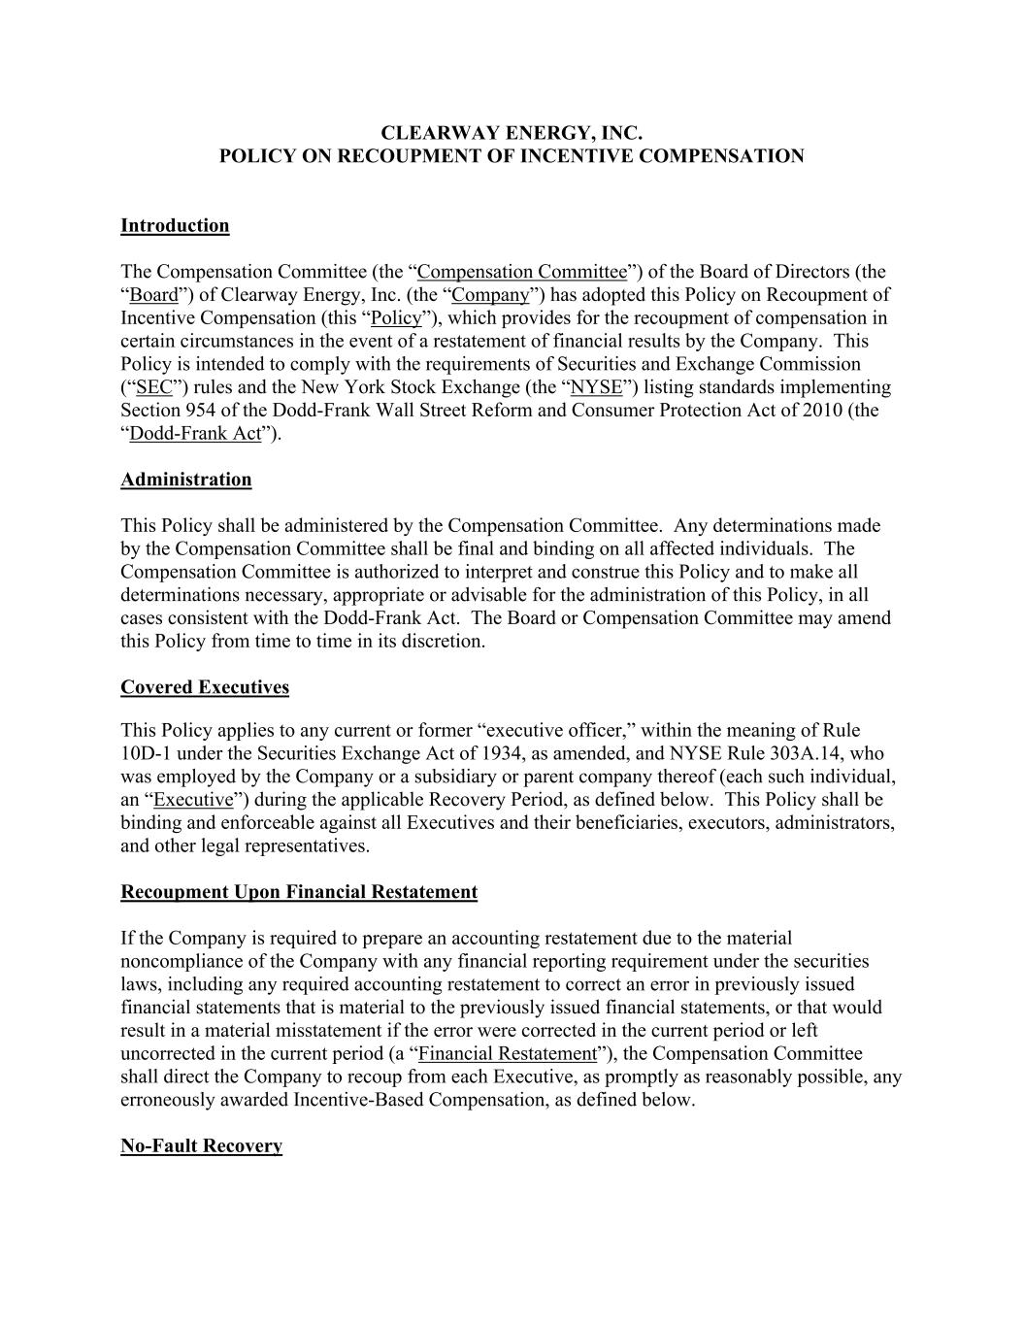

CLEARWAY ENERGY, INC. POLICY ON RECOUPMENT OF INCENTIVE COMPENSATION Introduction The Compensation Committee (the “Compensation Committee”) of the Board of Directors (the “Board”) of Clearway Energy, Inc. (the “Company”) has adopted this Policy on Recoupment of Incentive Compensation (this “Policy”), which provides for the recoupment of compensation in certain circumstances in the event of a restatement of financial results by the Company. This Policy is intended to comply with the requirements of Securities and Exchange Commission (“SEC”) rules and the New York Stock Exchange (the “NYSE”) listing standards implementing Section 954 of the Dodd-Frank Wall Street Reform and Consumer Protection Act of 2010 (the “Dodd-Frank Act”). Administration This Policy shall be administered by the Compensation Committee. Any determinations made by the Compensation Committee shall be final and binding on all affected individuals. The Compensation Committee is authorized to interpret and construe this Policy and to make all determinations necessary, appropriate or advisable for the administration of this Policy, in all cases consistent with the Dodd-Frank Act. The Board or Compensation Committee may amend this Policy from time to time in its discretion. Covered Executives This Policy applies to any current or former “executive officer,” within the meaning of Rule 10D-1 under the Securities Exchange Act of 1934, as amended, and NYSE Rule 303A.14, who was employed by the Company or a subsidiary or parent company thereof (each such individual, an “Executive”) during the applicable Recovery Period, as defined below. This Policy shall be binding and enforceable against all Executives and their beneficiaries, executors, administrators, and other legal representatives. Recoupment Upon Financial Restatement If the Company is required to prepare an accounting restatement due to the material noncompliance of the Company with any financial reporting requirement under the securities laws, including any required accounting restatement to correct an error in previously issued financial statements that is material to the previously issued financial statements, or that would result in a material misstatement if the error were corrected in the current period or left uncorrected in the current period (a “Financial Restatement”), the Compensation Committee shall direct the Company to recoup from each Executive, as promptly as reasonably possible, any erroneously awarded Incentive-Based Compensation, as defined below. No-Fault Recovery

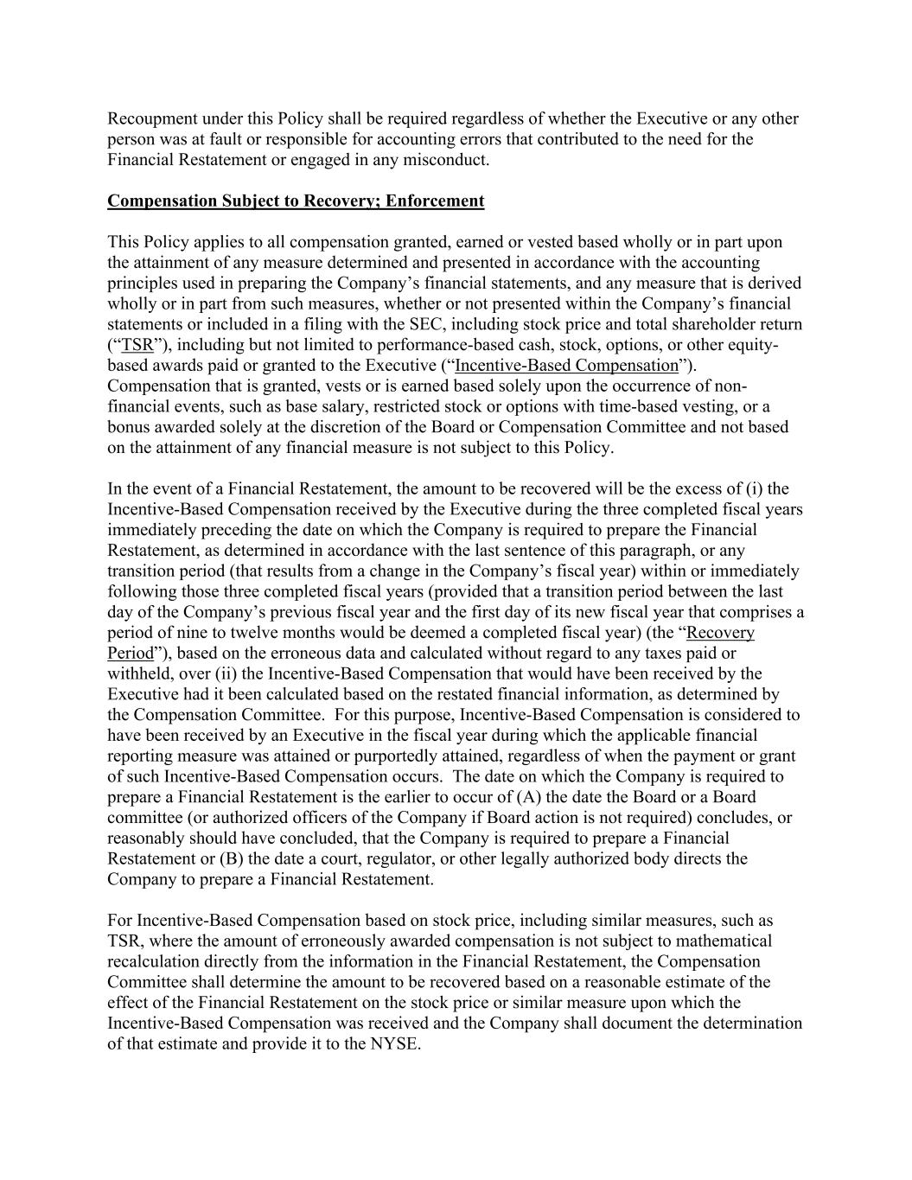
Recoupment under this Policy shall be required regardless of whether the Executive or any other person was at fault or responsible for accounting errors that contributed to the need for the Financial Restatement or engaged in any misconduct. Compensation Subject to Recovery; Enforcement This Policy applies to all compensation granted, earned or vested based wholly or in part upon the attainment of any measure determined and presented in accordance with the accounting principles used in preparing the Company’s financial statements, and any measure that is derived wholly or in part from such measures, whether or not presented within the Company’s financial statements or included in a filing with the SEC, including stock price and total shareholder return (“TSR”), including but not limited to performance-based cash, stock, options, or other equity- based awards paid or granted to the Executive (“Incentive-Based Compensation”). Compensation that is granted, vests or is earned based solely upon the occurrence of non- financial events, such as base salary, restricted stock or options with time-based vesting, or a bonus awarded solely at the discretion of the Board or Compensation Committee and not based on the attainment of any financial measure is not subject to this Policy. In the event of a Financial Restatement, the amount to be recovered will be the excess of (i) the Incentive-Based Compensation received by the Executive during the three completed fiscal years immediately preceding the date on which the Company is required to prepare the Financial Restatement, as determined in accordance with the last sentence of this paragraph, or any transition period (that results from a change in the Company’s fiscal year) within or immediately following those three completed fiscal years (provided that a transition period between the last day of the Company’s previous fiscal year and the first day of its new fiscal year that comprises a period of nine to twelve months would be deemed a completed fiscal year) (the “Recovery Period”), based on the erroneous data and calculated without regard to any taxes paid or withheld, over (ii) the Incentive-Based Compensation that would have been received by the Executive had it been calculated based on the restated financial information, as determined by the Compensation Committee. For this purpose, Incentive-Based Compensation is considered to have been received by an Executive in the fiscal year during which the applicable financial reporting measure was attained or purportedly attained, regardless of when the payment or grant of such Incentive-Based Compensation occurs. The date on which the Company is required to prepare a Financial Restatement is the earlier to occur of (A) the date the Board or a Board committee (or authorized officers of the Company if Board action is not required) concludes, or reasonably should have concluded, that the Company is required to prepare a Financial Restatement or (B) the date a court, regulator, or other legally authorized body directs the Company to prepare a Financial Restatement. For Incentive-Based Compensation based on stock price, including similar measures, such as TSR, where the amount of erroneously awarded compensation is not subject to mathematical recalculation directly from the information in the Financial Restatement, the Compensation Committee shall determine the amount to be recovered based on a reasonable estimate of the effect of the Financial Restatement on the stock price or similar measure upon which the Incentive-Based Compensation was received and the Company shall document the determination of that estimate and provide it to the NYSE.

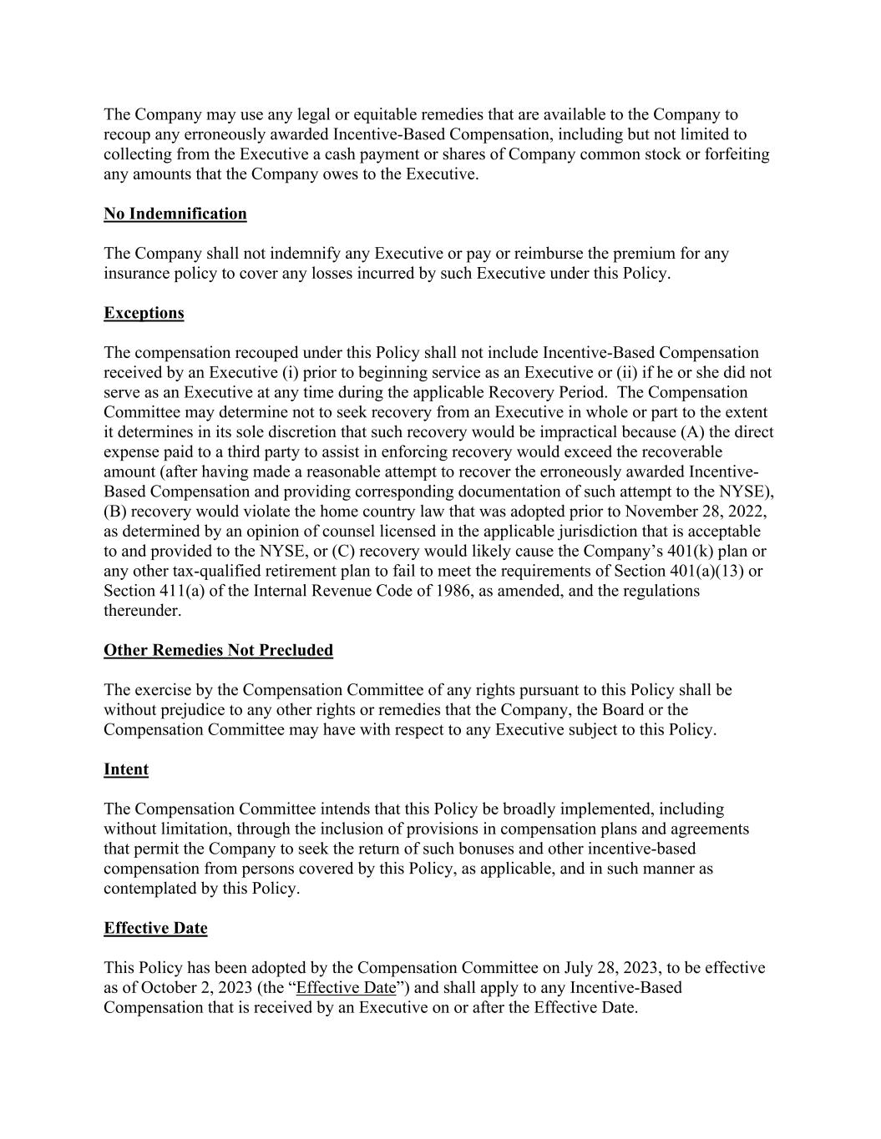
The Company may use any legal or equitable remedies that are available to the Company to recoup any erroneously awarded Incentive-Based Compensation, including but not limited to collecting from the Executive a cash payment or shares of Company common stock or forfeiting any amounts that the Company owes to the Executive. No Indemnification The Company shall not indemnify any Executive or pay or reimburse the premium for any insurance policy to cover any losses incurred by such Executive under this Policy. Exceptions The compensation recouped under this Policy shall not include Incentive-Based Compensation received by an Executive (i) prior to beginning service as an Executive or (ii) if he or she did not serve as an Executive at any time during the applicable Recovery Period. The Compensation Committee may determine not to seek recovery from an Executive in whole or part to the extent it determines in its sole discretion that such recovery would be impractical because (A) the direct expense paid to a third party to assist in enforcing recovery would exceed the recoverable amount (after having made a reasonable attempt to recover the erroneously awarded Incentive- Based Compensation and providing corresponding documentation of such attempt to the NYSE), (B) recovery would violate the home country law that was adopted prior to November 28, 2022, as determined by an opinion of counsel licensed in the applicable jurisdiction that is acceptable to and provided to the NYSE, or (C) recovery would likely cause the Company’s 401(k) plan or any other tax-qualified retirement plan to fail to meet the requirements of Section 401(a)(13) or Section 411(a) of the Internal Revenue Code of 1986, as amended, and the regulations thereunder. Other Remedies Not Precluded The exercise by the Compensation Committee of any rights pursuant to this Policy shall be without prejudice to any other rights or remedies that the Company, the Board or the Compensation Committee may have with respect to any Executive subject to this Policy. Intent The Compensation Committee intends that this Policy be broadly implemented, including without limitation, through the inclusion of provisions in compensation plans and agreements that permit the Company to seek the return of such bonuses and other incentive-based compensation from persons covered by this Policy, as applicable, and in such manner as contemplated by this Policy. Effective Date This Policy has been adopted by the Compensation Committee on July 28, 2023, to be effective as of October 2, 2023 (the “Effective Date”) and shall apply to any Incentive-Based Compensation that is received by an Executive on or after the Effective Date.

