UNITED STATES SECURITIES AND EXCHANGE COMMISSION

Washington, D.C. 20549

FORM 10-Q

- Quarterly report pursuant to Section 13 or 15(d) of the Securities Exchange Act of 1934

For the quarterly period ended September 30, 2024

- Transition report pursuant to Section 13 or 15(d) of the Securities Exchange Act of 1934

Commission File Number: 001-36002

Clearway Energy, Inc.

 | (Exact name of registrant as specified in its charter)
Delaware |  |  | 46-1777204
(State or other jurisdiction |  |  | (I.R.S. Employer
of incorporation or organization) |  |  | Identification No.)
300 Carnegie Center, Suite 300 | Princeton | New Jersey | 08540
(Address of principal executive offices) |  |  | (Zip Code)
 |  | (609) 608-1525
 | (Registrant’s telephone number, including area code)
 | Securities registered pursuant to Section 12(b) of the Act:
Title of each class |  | Trading Symbol(s) | Name of each exchange on which registered
Class A Common Stock, par value $0.01 |  | CWEN.A | New York Stock Exchange
Class C Common Stock, par value $0.01 |  | CWEN | New York Stock Exchange

Indicate by check mark whether the registrant (1) has filed all reports required to be filed by Section 13 or 15(d) of the Securities Exchange Act of 1934 during the preceding 12 months (or for such shorter period that the registrant was required to file such reports), and (2) has been subject to such filing requirements for the past 90 days.

Yes ☒ No ☐

Indicate by check mark whether the registrant has submitted electronically every Interactive Data File required to be submitted pursuant to Rule 405 of Regulation S-T (§232.405 of this chapter) during the preceding 12 months (or for such shorter period that the registrant was required to submit such files).

Yes ☒ No ☐

Indicate by check mark whether the registrant is a large accelerated filer, an accelerated filer, a non-accelerated filer, a smaller reporting company or an emerging growth company. See the definitions of “large accelerated filer,” “accelerated filer,” “smaller reporting company,” and "emerging growth company" in Rule 12b-2 of the Exchange Act.

Large accelerated filer | ☒ | Accelerated filer | ☐
Non-accelerated filer | ☐ | Smaller reporting company | ☐
 |  | Emerging growth company | ☐

If an emerging growth company, indicate by check mark if the registrant has elected not to use the extended transition period for complying with any new or revised financial accounting standards provided pursuant to Section 13(a) of the Exchange Act. ☐

Indicate by check mark whether the registrant is a shell company (as defined in Rule 12b-2 of the Exchange Act). Yes ☐ No ☒

As of October 28, 2024, there were 34,613,853 shares of Class A common stock outstanding, par value $0.01 per share, 42,738,750 shares of Class B common stock outstanding, par value $0.01 per share, 82,831,652 shares of Class C common stock outstanding, par value $0.01 per share, and 41,961,750 shares of Class D common stock outstanding, par value $0.01 per share.

TABLE OF CONTENTS

Index

CAUTIONARY STATEMENT REGARDING FORWARD LOOKING INFORMATION |  |  |  |  |  |  |  |  |  |  |  |  |  |  |  | 3
GLOSSARY OF TERMS |  |  |  |  |  |  |  |  |  |  |  |  |  |  |  | 4
PART I — FINANCIAL INFORMATION |  |  |  |  |  |  |  |  |  |  |  |  |  |  |  | 6
 | ITEM 1 — FINANCIAL STATEMENTS AND NOTES |  |  |  |  |  |  |  |  |  |  |  |  |  |  | 6
 | ITEM 2 — MANAGEMENT’S DISCUSSION AND ANALYSIS OF FINANCIAL CONDITION AND RESULTS OF OPERATIONS |  |  |  |  |  |  |  |  |  |  |  |  |  |  |  | 35
 | ITEM 3 — QUANTITATIVE AND QUALITATIVE DISCLOSURES ABOUT MARKET RISK |  |  |  |  |  |  |  |  |  |  |  |  |  |  | 54
 | ITEM 4 — CONTROLS AND PROCEDURES |  |  |  |  |  |  |  |  |  |  |  |  |  |  |  | 55
PART II — OTHER INFORMATION |  |  |  |  |  |  |  |  |  |  |  |  |  |  |  |  | 56
 | ITEM 1 — LEGAL PROCEEDINGS |  |  |  |  |  |  |  |  |  |  |  |  |  |  |  | 56
 | ITEM 1A — RISK FACTORS |  |  |  |  |  |  |  |  |  |  |  |  |  |  | 56
 | ITEM 2 — UNREGISTERED SALES OF EQUITY SECURITIES AND USE OF PROCEEDS |  |  |  |  |  |  |  |  |  |  |  |  |  |  |  | 56
 | ITEM 3 | — DEFAULTS UPON SENIOR SECURITIES |  |  |  |  |  |  |  |  |  |  |  |  |  | 56
 | ITEM 4 | — MINE SAFETY DISCLOSURES |  |  |  |  |  |  |  |  |  |  |  |  |  |  | 56
 | ITEM 5 | — OTHER INFORMATION |  |  |  |  |  |  |  |  |  |  |  |  |  |  | 56
 | ITEM 6 | — EXHIBITS |  |  |  |  |  |  |  |  |  |  |  |  |  |  | 58
 | SIGNATURES |  |  |  |  |  |  |  |  |  |  |  |  |  |  |  | 59

2

CAUTIONARY STATEMENT REGARDING FORWARD-LOOKING INFORMATION

This Quarterly Report on Form 10-Q of Clearway Energy, Inc., together with its consolidated subsidiaries, or the Company, includes forward-looking statements within the meaning of Section 27A of the Securities Act of 1933, as amended, or the Securities Act, and Section 21E of the Securities Exchange Act of 1934, as amended, or the Exchange Act. The words “believes,” “projects,” “anticipates,” “plans,” “expects,” “intends,” “estimates” and similar expressions are intended to identify forward-looking statements. These forward-looking statements involve known and unknown risks, uncertainties and other factors that may cause the Company’s actual results, performance and achievements, or industry results, to be materially different from any future results, performance or achievements expressed or implied by such forward-looking statements. These factors, risks and uncertainties include the factors described under Item 1A — Risk Factors in Part I of the Company’s Annual Report on Form 10-K for the year ended December 31, 2023, as well as the following:

- The Company’s ability to maintain and grow its quarterly dividend;

- Potential risks related to the Company's relationships with CEG and its owners;

- The Company’s ability to successfully identify, evaluate and consummate acquisitions from, and dispositions to, third parties;

- The Company’s ability to acquire assets from CEG;

- The Company’s ability to borrow additional funds and access capital markets, as well as the Company’s substantial indebtedness and the possibility that the Company may incur additional indebtedness going forward;
- Changes in law, including judicial decisions;

- Hazards customary to the power production industry and power generation operations such as fuel and electricity price volatility, unusual weather conditions (including wind and solar conditions), catastrophic weather-related or other damage to facilities, unscheduled generation outages, maintenance or repairs, unanticipated changes to fuel supply costs or availability due to higher demand, shortages, transportation problems or other developments, environmental incidents, or electric transmission or gas pipeline system constraints and the possibility that the Company may not have adequate insurance to cover losses as a result of such hazards;

- The Company’s ability to operate its businesses efficiently, manage maintenance capital expenditures and costs effectively, and generate earnings and cash flows from its asset-based businesses in relation to its debt and other obligations;
- The willingness and ability of counterparties to the Company’s offtake agreements to fulfill their obligations under such agreements;

- The Company’s ability to enter into contracts to sell power and procure fuel on acceptable terms and prices;

- Government regulation, including compliance with regulatory requirements and changes in market rules, rates, tariffs and environmental laws;

- Operating and financial restrictions placed on the Company that are contained in the facility-level debt facilities and other agreements of certain subsidiaries and facility-level subsidiaries generally, in the Clearway Energy Operating LLC amended and restated revolving credit facility and in the indentures governing the Senior Notes; and
- Cyber terrorism and inadequate cybersecurity, or the occurrence of a catastrophic loss and the possibility that the Company may not have adequate insurance to cover losses resulting from such hazards or the inability of the Company’s insurers to provide coverage.

Forward-looking statements speak only as of the date they were made, and the Company undertakes no obligation to publicly update or revise any forward-looking statements, whether as a result of new information, future events or otherwise. The foregoing review of factors that could cause the Company’s actual results to differ materially from those contemplated in any forward-looking statements included in this Quarterly Report on Form 10-Q should not be construed as exhaustive.

3

 | GLOSSARY OF TERMS
When the following terms and abbreviations appear in the text of this report, they have the meanings indicated below:
2028 Senior Notes | $850 million aggregate principal amount of 4.75% unsecured senior notes due 2028, issued by Clearway Energy Operating LLC
2031 Senior Notes | $925 million aggregate principal amount of 3.75% unsecured senior notes due 2031, issued by Clearway Energy Operating LLC
2032 Senior Notes | $350 million aggregate principal amount of 3.75% unsecured senior notes due 2032, issued by Clearway Energy Operating LLC
Adjusted EBITDA | A non-GAAP measure, represents earnings before interest (including loss on debt extinguishment), tax, depreciation and amortization adjusted for
 | mark-to-market gains or losses, asset write offs and impairments; and factors which the Company does not consider indicative of future operating
 | performance
ASC | The FASB Accounting Standards Codification, which the FASB established as the source of authoritative GAAP
ATM Program | At-The-Market Equity Offering Program
BESS | Battery energy storage system
BlackRock | BlackRock, Inc.
CAFD | A non-GAAP measure, Cash Available for Distribution is defined as of September 30, 2024 as Adjusted EBITDA plus cash distributions/return of
 | investment from unconsolidated affiliates, cash receipts from notes receivable, cash distributions from noncontrolling interests, adjustments to
 | reflect sales-type lease cash payments and payments for lease expenses, less cash distributions to noncontrolling interests, maintenance capital
 | expenditures, pro-rata Adjusted EBITDA from unconsolidated affiliates, cash interest paid, income taxes paid, principal amortization of
 | indebtedness, changes in prepaid and accrued capacity payments and adjusted for development expenses
Capistrano Portfolio Holdco LLC | The holding company that owns four wind facilities representing 263 MW of capacity, which includes Broken Bow and Crofton Bluffs located in
 | Nebraska and Mountain Wind 1 and Mountain Wind 2 located in Wyoming
CEG | Clearway Energy Group LLC (formerly Zephyr Renewables LLC)
CEG Master Services Agreement | Amended and Restated Master Services Agreement, dated as of April 30, 2024, among the Company, Clearway Energy LLC, Clearway Energy
 | Operating LLC and CEG
Clearway Energy LLC | The holding company through which the facilities are owned by Clearway Energy Group LLC, the holder of Class B and Class D units, and
 | Clearway Energy, Inc., the holder of the Class A and Class C units
Clearway Energy Group LLC | The holder of all shares of the Company’s Class B and Class D common stock and Clearway Energy LLC’s Class B and Class D units and, from
 | time to time, possibly shares of the Company’s Class A and/or Class C common stock
Clearway Energy Operating LLC | The holder of facilities that are owned by Clearway Energy LLC
Clearway Renew | Clearway Renew LLC, a subsidiary of CEG, and its wholly-owned subsidiaries
Company | Clearway Energy, Inc., together with its consolidated subsidiaries
CVSR | California Valley Solar Ranch
CVSR Holdco | CVSR Holdco LLC, the indirect owner of CVSR
Distributed Solar | Solar power facilities, typically less than 20 MW in size (on an alternating current, or AC, basis), that primarily sell power produced to customers
 | for usage on site, or are interconnected to sell power into the local distribution grid
Drop Down Assets | Assets under common control acquired by the Company from CEG
ERCOT | Electric Reliability Council of Texas, the ISO and the regional reliability coordinator of the various electricity systems within Texas
Exchange Act | The Securities Exchange Act of 1934, as amended
FASB | Financial Accounting Standards Board
GAAP | Accounting principles generally accepted in the U.S.
GenConn | GenConn Energy LLC
GIM | Global Infrastructure Management, LLC, the manager of GIP
 | 4

GIP | Global Infrastructure Partners
HLBV | Hypothetical Liquidation at Book Value
IRA | Inflation Reduction Act of 2022
IRS | Internal Revenue Service
ISO | Independent System Operator, also referred to as an RTO
ITC | Investment Tax Credit
Mesquite Star | Mesquite Star Special LLC
MMBtu | Million British Thermal Units
Mt. Storm | NedPower Mount Storm LLC
MW | Megawatt
MWh | Saleable megawatt hours, net of internal/parasitic load megawatt-hours
Natural Gas Holdco | Natural Gas CA Holdco LLC
Net Exposure | Counterparty credit exposure to Clearway Energy, Inc. net of collateral
NOLs | Net Operating Losses
OCI | Other comprehensive income
O&M | Operations and Maintenance
PG&E | Pacific Gas and Electric Company
PJM | PJM Interconnection, LLC
PPA | Power Purchase Agreement
PTC | Production Tax Credit
RA | Resource adequacy
RENOM | Clearway Renewable Operation & Maintenance LLC, a wholly-owned subsidiary of CEG
Rosie Central BESS | Rosie BESS Devco LLC
RTO | Regional Transmission Organization
SCE | Southern California Edison
SEC | U.S. Securities and Exchange Commission
Senior Notes | Collectively, the 2028 Senior Notes, the 2031 Senior Notes and the 2032 Senior Notes
SOFR | Secured Overnight Financing Rate
SPP | Solar Power Partners
SREC | Solar Renewable Energy Credit
TotalEnergies | TotalEnergies SE
U.S. | United States of America
Utah Solar Portfolio | Seven utility-scale solar farms located in Utah, representing 530 MW of capacity
Utility Scale Solar | Solar power facilities, typically 20 MW or greater in size (on an alternating current, or AC, basis), that are interconnected into the transmission or
 | distribution grid to sell power at a wholesale level
VIE | Variable Interest Entity

5

PART I — FINANCIAL INFORMATION

ITEM 1 — FINANCIAL STATEMENTS

CLEARWAY ENERGY, INC.

CONSOLIDATED STATEMENTS OF INCOME

(Unaudited)

 |  | Three months ended September 30, |  |  |  |  |  | Nine months ended September 30,
(In millions, except per share amounts) |  | 2024 |  |  | 2023 |  |  | 2024 |  |  | 2023
Operating Revenues
Total operating revenues | $ | 486 |  | $ | 371 |  | $ | 1,115 |  | $ | 1,065
Operating Costs and Expenses
Cost of operations, exclusive of depreciation, amortization and accretion shown separately
below |  | 135 |  |  | 134 |  |  | 378 |  |  | 360
Depreciation, amortization and accretion |  | 164 |  |  | 133 |  |  | 471 |  |  | 389
General and administrative |  | 9 |  |  | 9 |  |  | 29 |  |  | 28
Transaction and integration costs |  | — |  |  | 1 |  |  | 4 |  |  | 3
Total operating costs and expenses |  | 308 |  |  | 277 |  |  | 882 |  |  | 780
Operating Income |  | 178 |  |  | 94 |  |  | 233 |  |  | 285
Other Income (Expense)
Equity in earnings of unconsolidated affiliates |  | 13 |  |  | 11 |  |  | 33 |  |  | 11
Other income, net |  | 8 |  |  | 15 |  |  | 36 |  |  | 32
Loss on debt extinguishment |  | — |  |  | — |  |  | (3) |  |  | —
Interest expense |  | (139) |  |  | (48) |  |  | (284) |  |  | (202)
Total other expense, net |  | (118) |  |  | (22) |  |  | (218) |  |  | (159)
Income Before Income Taxes |  | 60 |  |  | 72 |  |  | 15 |  |  | 126
Income tax expense |  | 33 |  |  | 57 |  |  | 30 |  |  | 67
Net Income (Loss) |  | 27 |  |  | 15 |  |  | (15) |  |  | 59
Less: Net (loss) income attributable to noncontrolling interests and redeemable noncontrolling
interests |  | (9) |  |  | 11 |  |  | (100) |  |  | 17
Net Income Attributable to Clearway Energy, Inc. | $ | 36 |  | $ | 4 |  | $ | 85 |  | $ | 42
Earnings Per Share Attributable to Clearway Energy, Inc. Class A and Class C Common
Stockholders
Weighted average number of Class A common shares outstanding - basic and diluted |  | 35 |  |  | 35 |  |  | 35 |  |  | 35
Weighted average number of Class C common shares outstanding - basic and diluted |  | 83 |  |  | 82 |  |  | 83 |  |  | 82
Earnings Per Weighted Average Class A and Class C Common Share - Basic and Diluted | $ | 0.31 |  | $ | 0.03 |  | $ | 0.72 |  | $ | 0.36
Dividends Per Class A Common Share | $ | 0.4171 |  | $ | 0.3891 |  | $ | 1.2306 |  | $ | 1.1454
Dividends Per Class C Common Share | $ | 0.4171 |  | $ | 0.3891 |  | $ | 1.2306 |  | $ | 1.1454

See accompanying notes to consolidated financial statements.

6

CLEARWAY ENERGY, INC.

CONSOLIDATED STATEMENTS OF COMPREHENSIVE INCOME

(Unaudited)

 | Three months ended September 30, |  |  |  |  |  |  | Nine months ended September 30,
(In millions) | 2024 |  |  | 2023 |  |  |  | 2024 |  |  | 2023
Net Income (Loss) | $ | 27 |  | $ | 15 |  | $ | (15) |  | $ | 59
Other Comprehensive (Loss) Income
Unrealized (loss) gain on derivatives and changes in accumulated OCI, net of income tax
(benefit) expense of $(2), $1, $(2), and $1 |  | (13) |  |  | 8 |  |  | (13) |  |  | 8
Other comprehensive (loss) income |  | (13) |  |  | 8 |  |  | (13) |  |  | 8
Comprehensive Income (Loss) |  | 14 |  |  | 23 |  |  | (28) |  |  | 67
Less: Comprehensive (loss) income attributable to noncontrolling interests and redeemable
noncontrolling interests |  | (18) |  |  | 17 |  |  | (107) |  |  | 23
Comprehensive Income Attributable to Clearway Energy, Inc. | $ | 32 |  | $ | 6 |  | $ | 79 |  | $ | 44

See accompanying notes to consolidated financial statements.

7

CLEARWAY ENERGY, INC.

CONSOLIDATED BALANCE SHEETS

(In millions, except shares) |  | September 30, 2024 |  |  | December 31, 2023
ASSETS |  | (Unaudited)
Current Assets
Cash and cash equivalents | $ | 292 |  | $ | 535
Restricted cash |  | 382 |  |  | 516
Accounts receivable — trade |  | 199 |  |  | 171
Inventory |  | 63 |  |  | 55
Derivative instruments |  | 34 |  |  | 41
Note receivable — affiliate |  | — |  |  | 174
Prepayments and other current assets |  | 81 |  |  | 68
Total current assets |  | 1,051 |  |  | 1,560
Property, plant and equipment, net |  | 9,895 |  |  | 9,526
Other Assets
Equity investments in affiliates |  | 322 |  |  | 360
Intangible assets for power purchase agreements, net |  | 2,170 |  |  | 2,303
Other intangible assets, net |  | 70 |  |  | 71
Derivative instruments |  | 70 |  |  | 82
Right-of-use assets, net |  | 548 |  |  | 597
Other non-current assets |  | 123 |  |  | 202
Total other assets |  | 3,303 |  |  | 3,615
Total Assets | $ | 14,249 |  | $ | 14,701
LIABILITIES AND STOCKHOLDERS’ EQUITY
Current Liabilities
Current portion of long-term debt | $ | 412 |  | $ | 558
Accounts payable — trade |  | 78 |  |  | 130
Accounts payable — affiliates |  | 14 |  |  | 31
Derivative instruments |  | 51 |  |  | 51
Accrued interest expense |  | 35 |  |  | 57
Accrued expenses and other current liabilities |  | 71 |  |  | 79
Total current liabilities |  | 661 |  |  | 906
Other Liabilities
Long-term debt |  | 6,732 |  |  | 7,479
Deferred income taxes |  | 58 |  |  | 127
Derivative instruments |  | 279 |  |  | 281
Long-term lease liabilities |  | 570 |  |  | 627
Other non-current liabilities |  | 316 |  |  | 286
Total other liabilities |  | 7,955 |  |  | 8,800
Total Liabilities |  | 8,616 |  |  | 9,706
Redeemable noncontrolling interest in subsidiaries |  | 9 |  |  | 1
Commitments and Contingencies
Stockholders’ Equity
Preferred stock, $0.01 par value; 10,000,000 shares authorized; none issued |  | — |  |  | —
Class A, Class B, Class C and Class D common stock, $0.01 par value; 3,000,000,000 shares authorized (Class A 500,000,000, Class B
500,000,000, Class C 1,000,000,000, Class D 1,000,000,000); 202,143,697 shares issued and outstanding (Class A 34,613,853, Class B
42,738,750, Class C 82,829,344, Class D 41,961,750) at September 30, 2024 and 202,080,794 shares issued and outstanding (Class A 34,613,853, |  | 1 |  |  | 1
Class B 42,738,750, Class C 82,391,441, Class D 42,336,750) at December 31, 2023 |  | 1 |  |  | 1
Additional paid-in capital |  | 1,831 |  |  | 1,732
Retained earnings |  | 301 |  |  | 361
Accumulated other comprehensive income |  | 1 |  |  | 7
Noncontrolling interest |  | 3,490 |  |  | 2,893
Total Stockholders’ Equity |  | 5,624 |  |  | 4,994
Total Liabilities and Stockholders’ Equity | $ | 14,249 |  | $ | 14,701

See accompanying notes to consolidated financial statements.

8

CLEARWAY ENERGY, INC.

CONSOLIDATED STATEMENTS OF CASH FLOWS

(Unaudited)

 |  | Nine months ended September 30,
(In millions) |  | 2024 |  |  | 2023
Cash Flows from Operating Activities
Net (Loss) Income | $ | (15) |  | $ | 59
Adjustments to reconcile net (loss) income to net cash provided by operating activities:
Equity in earnings of unconsolidated affiliates |  | (33) |  |  | (11)
Distributions from unconsolidated affiliates |  | 21 |  |  | 17
Depreciation, amortization and accretion |  | 471 |  |  | 389
Amortization of financing costs and debt discounts |  | 10 |  |  | 9
Amortization of intangibles |  | 137 |  |  | 139
Loss on debt extinguishment |  | 3 |  |  | —
Reduction in carrying amount of right-of-use assets |  | 11 |  |  | 11
Changes in deferred income taxes |  | 23 |  |  | 49
Changes in derivative instruments and amortization of accumulated OCI |  | 34 |  |  | (64)
Cash provided by (used in) changes in other working capital:
Changes in prepaid and accrued liabilities for tolling agreements |  | 3 |  |  | (23)
Changes in other working capital |  | (87) |  |  | (79)
Net Cash Provided by Operating Activities |  | 578 |  |  | 496
Cash Flows from Investing Activities
Acquisition of Drop Down Assets, net of cash acquired |  | (671) |  |  | 100
Capital expenditures |  | (237) |  |  | (143)
Return of investment from unconsolidated affiliates |  | 38 |  |  | 14
Decrease (increase) in note receivable — affiliate |  | 184 |  |  | (215)
Investments in unconsolidated affiliates |  | — |  |  | (28)
Other |  | 12 |  |  | 1
Net Cash Used in Investing Activities |  | (674) |  |  | (271)
Cash Flows from Financing Activities
Contributions from noncontrolling interests, net of distributions |  | 1,385 |  |  | 294
Payments of dividends and distributions |  | (249) |  |  | (231)
Tax-related distributions |  | — |  |  | (21)
Proceeds from the issuance of long-term debt |  | 255 |  |  | 293
Payments of debt issuance costs |  | (7) |  |  | (14)
Payments for long-term debt |  | (1,664) |  |  | (384)
Other |  | (1) |  |  | (2)
Net Cash Used in Financing Activities |  | (281) |  |  | (65)
Net (Decrease) Increase in Cash, Cash Equivalents and Restricted Cash |  | (377) |  |  | 160
Cash, Cash Equivalents and Restricted Cash at Beginning of Period |  | 1,051 |  |  | 996
Cash, Cash Equivalents and Restricted Cash at End of Period | $ | 674 |  | $ | 1,156

See accompanying notes to consolidated financial statements.

9

CLEARWAY ENERGY, INC.

CONSOLIDATED STATEMENTS OF STOCKHOLDERS’ EQUITY

For the Nine Months Ended September 30, 2024

(Unaudited)

 |  |  |  |  |  |  |  | Additional |  |  |  |  |  | Accumulated |  |  | Noncontrolling |  |  | Total
(In millions) |  |  |  |  |  |  |  | Paid-In |  |  |  |  |  | Other |  |  |  |  |  | Stockholders’
(In millions) | Preferred Stock |  |  | Common Stock |  |  |  | Capital |  |  | Retained Earnings |  |  | Comprehensive Income |  |  | Interest |  |  | Equity
Balances at December 31, 2023 | $ | — |  | $ | 1 |  | $ | 1,732 |  | $ | 361 |  | $ | 7 |  | $ | 2,893 |  | $ | 4,994
Net loss |  | — |  |  | — |  |  | — |  |  | (2) |  |  | — |  |  | (45) |  |  | (47)
Unrealized (loss) gain on derivatives and changes in accumulated OCI, net |  | — |  |  | — |  |  | — |  |  | — |  |  | (2) |  |  | 1 |  |  | (1)
of tax |  |  |  |  |  |  |  |  |  |  |  |  |  | (2) |  |  | 1 |  |  | (1)
Distributions to CEG, net of contributions, cash |  | — |  |  | — |  |  | — |  |  | — |  |  | — |  |  | (1) |  |  | (1)
Contributions from noncontrolling interests, net of distributions, cash |  | — |  |  | — |  |  | — |  |  | — |  |  | — |  |  | 215 |  |  | 215
Transfers of assets under common control |  | — |  |  | — |  |  | 2 |  |  | — |  |  | — |  |  | (42) |  |  | (40)
Non-cash adjustments for change in tax basis |  | — |  |  | — |  |  | 6 |  |  | — |  |  | — |  |  | — |  |  | 6
Stock-based compensation |  | — |  |  | — |  |  | 1 |  |  | — |  |  | — |  |  | — |  |  | 1
Common stock dividends and distributions to CEG unit holders |  | — |  |  | — |  |  | — |  |  | (47) |  |  | — |  |  | (34) |  |  | (81)
Other |  | — |  |  | — |  |  | — |  |  | (1) |  |  | — |  |  | — |  |  | (1)
Balances at March 31, 2024 |  | — |  |  | 1 |  |  | 1,741 |  |  | 311 |  |  | 5 |  |  | 2,987 |  |  | 5,045
Net income (loss) |  | — |  |  | — |  |  | — |  |  | 51 |  |  | — |  |  | (51) |  |  | —
Unrealized gain on derivatives and changes in accumulated OCI, net of tax |  | — |  |  | — |  |  | — |  |  | — |  |  | — |  |  | 1 |  |  | 1
Contributions from CEG, net of distributions, cash |  | — |  |  | — |  |  | — |  |  | — |  |  | — |  |  | 222 |  |  | 222
Contributions from noncontrolling interests, net of distributions, cash |  | — |  |  | — |  |  | — |  |  | — |  |  | — |  |  | 988 |  |  | 988
Distributions to noncontrolling interests, net of contributions, non-cash |  | — |  |  | — |  |  | — |  |  | — |  |  | — |  |  | (1) |  |  | (1)
Transfers of assets under common control |  | — |  |  | — |  |  | 5 |  |  | — |  |  | — |  |  | (549) |  |  | (544)
Non-cash adjustments for change in tax basis |  | — |  |  | — |  |  | 85 |  |  | — |  |  | — |  |  | — |  |  | 85
Stock-based compensation |  | — |  |  | — |  |  | (1) |  |  | — |  |  | — |  |  | — |  |  | (1)
Common stock dividends and distributions to CEG unit holders |  | — |  |  | — |  |  | — |  |  | (48) |  |  | — |  |  | (35) |  |  | (83)
Other |  | — |  |  | — |  |  | — |  |  | — |  |  | — |  |  | (1) |  |  | (1)
Balances at June 30, 2024 |  | — |  |  | 1 |  |  | 1,830 |  |  | 314 |  |  | 5 |  |  | 3,561 |  |  | 5,711
Net income (loss) |  | — |  |  | — |  |  | — |  |  | 36 |  |  | — |  |  | (13) |  |  | 23
Unrealized loss on derivatives and changes in accumulated OCI, net of tax |  | — |  |  | — |  |  | — |  |  | — |  |  | (4) |  |  | (9) |  |  | (13)
Contributions from CEG, cash |  | — |  |  | — |  |  | — |  |  | — |  |  | — |  |  | 6 |  |  | 6
Distributions to noncontrolling interests, net of contributions, cash |  | — |  |  | — |  |  | — |  |  | — |  |  | — |  |  | (19) |  |  | (19)
Stock-based compensation |  | — |  |  | — |  |  | 1 |  |  | — |  |  | — |  |  | — |  |  | 1
Common stock dividends and distributions to CEG unit holders |  | — |  |  | — |  |  | — |  |  | (49) |  |  | — |  |  | (36) |  |  | (85)
Balances at September 30, 2024 | $ | — |  | $ | 1 |  | $ | 1,831 |  | $ | 301 |  | $ | 1 |  | $ | 3,490 |  | $ | 5,624

See accompanying notes to consolidated financial statements.

10

CLEARWAY ENERGY, INC.

CONSOLIDATED STATEMENTS OF STOCKHOLDERS’ EQUITY

For the Nine Months Ended September 30, 2023

(Unaudited)

 |  |  |  |  |  |  |  | Additional |  |  |  |  |  | Accumulated |  |  | Noncontrolling |  |  | Total
(In millions) |  |  |  |  |  |  |  | Paid-In |  |  |  |  |  | Other |  |  |  |  |  | Stockholders’
(In millions) | Preferred Stock |  |  | Common Stock |  |  |  | Capital |  |  | Retained Earnings |  |  | Comprehensive Income |  |  | Interest |  |  | Equity
Balances at December 31, 2022 | $ | — |  | $ | 1 |  | $ | 1,761 |  | $ | 463 |  | $ | 9 |  | $ | 1,792 |  | $ | 4,026
Net loss |  | — |  |  | — |  |  | — |  |  | — |  |  | — |  |  | (43) |  |  | (43)
Unrealized loss on derivatives and changes in accumulated OCI, net of tax |  | — |  |  | — |  |  | — |  |  | — |  |  | (1) |  |  | (2) |  |  | (3)
Contributions from CEG, net of distributions, cash |  | — |  |  | — |  |  | — |  |  | — |  |  | — |  |  | 30 |  |  | 30
Contributions from noncontrolling interests, net of distributions, cash |  | — |  |  | — |  |  | — |  |  | — |  |  | — |  |  | 215 |  |  | 215
Transfers of assets under common control |  | — |  |  | — |  |  | (52) |  |  | — |  |  | — |  |  | 46 |  |  | (6)
Non-cash adjustments for change in tax basis |  | — |  |  | — |  |  | 9 |  |  | — |  |  | — |  |  | — |  |  | 9
Stock based compensation |  | — |  |  | — |  |  | 1 |  |  | — |  |  | — |  |  | — |  |  | 1
Common stock dividends and distributions to CEG unit holders |  | — |  |  | — |  |  | — |  |  | (44) |  |  | — |  |  | (32) |  |  | (76)
Balances at March 31, 2023 |  | — |  |  | 1 |  |  | 1,719 |  |  | 419 |  |  | 8 |  |  | 2,006 |  |  | 4,153
Net income |  | — |  |  | — |  |  | — |  |  | 38 |  |  | — |  |  | 40 |  |  | 78
Unrealized gain on derivatives and changes in accumulated OCI, net of tax |  | — |  |  | — |  |  | — |  |  | — |  |  | 1 |  |  | 2 |  |  | 3
Distributions to CEG, net of contributions, cash |  | — |  |  | — |  |  | — |  |  | — |  |  | — |  |  | (4) |  |  | (4)
Distributions to noncontrolling interests, net of contributions, cash |  | — |  |  | — |  |  | — |  |  | — |  |  | — |  |  | (5) |  |  | (5)
Tax-related distribution |  | — |  |  | — |  |  | — |  |  | — |  |  | — |  |  | (19) |  |  | (19)
Stock based compensation |  | — |  |  | — |  |  | (1) |  |  | — |  |  | — |  |  | — |  |  | (1)
Common stock dividends and distributions to CEG unit holders |  | — |  |  | — |  |  | — |  |  | (45) |  |  | — |  |  | (32) |  |  | (77)
Other |  | — |  |  | — |  |  | — |  |  | — |  |  | — |  |  | (1) |  |  | (1)
Balances at June 30, 2023 |  | — |  |  | 1 |  |  | 1,718 |  |  | 412 |  |  | 9 |  |  | 1,987 |  |  | 4,127
Net income |  | — |  |  | — |  |  | — |  |  | 4 |  |  | — |  |  | 6 |  |  | 10
Unrealized gain on derivatives and changes in accumulated OCI, net of tax |  | — |  |  | — |  |  | — |  |  | — |  |  | 2 |  |  | 6 |  |  | 8
Distributions to CEG, cash |  | — |  |  | — |  |  | — |  |  | — |  |  | — |  |  | (1) |  |  | (1)
Contributions from noncontrolling interests, net of distributions, cash |  | — |  |  | — |  |  | — |  |  | — |  |  | — |  |  | 12 |  |  | 12
Distributions to noncontrolling interests, non-cash |  | — |  |  | — |  |  | — |  |  | — |  |  | — |  |  | (7) |  |  | (7)
Tax-related distribution |  | — |  |  | — |  |  | — |  |  | — |  |  | — |  |  | (2) |  |  | (2)
Transfer of assets under common control |  | — |  |  | — |  |  | — |  |  | — |  |  | — |  |  | 171 |  |  | 171
Non-cash adjustments for change in tax basis |  | — |  |  | — |  |  | 8 |  |  | — |  |  | — |  |  | — |  |  | 8
Stock based compensation |  | — |  |  | — |  |  | 2 |  |  | (1) |  |  | — |  |  | — |  |  | 1
Common stock dividends and distributions to CEG unit holders |  | — |  |  | — |  |  | — |  |  | (45) |  |  | — |  |  | (33) |  |  | (78)
Other |  | — |  |  | — |  |  | — |  |  | — |  |  | — |  |  | 1 |  |  | 1
Balances at September 30, 2023 | $ | — |  | $ | 1 |  | $ | 1,728 |  | $ | 370 |  | $ | 11 |  | $ | 2,140 |  | $ | 4,250

See accompanying notes to consolidated financial statements.

11

CLEARWAY ENERGY, INC.

NOTES TO CONSOLIDATED FINANCIAL STATEMENTS

(Unaudited)

Note 1 — Nature of Business

Clearway Energy, Inc., together with its consolidated subsidiaries, or the Company, is a publicly-traded energy infrastructure investor with a focus on investments in clean energy and owner of modern, sustainable and long-term contracted assets across North America. The Company is sponsored by GIP and TotalEnergies through the portfolio company, Clearway Energy Group LLC, or CEG, which is equally owned by GIP and TotalEnergies. GIP is an independent infrastructure fund manager that makes equity and debt investments in infrastructure assets and businesses. TotalEnergies is a global multi-energy company. CEG is a leading developer of renewable energy infrastructure in the U.S. On October 1, 2024, BlackRock acquired 100% of the business and assets of GIM, which is the investment manager of the GIP funds that own an interest in CEG. BlackRock is a publicly-traded global investment management firm.

The Company is one of the largest renewable energy owners in the U.S. with approximately 6,500 net MW of installed wind, solar and battery energy storage system, or BESS, facilities. The Company’s approximately 9,000 net MW of assets also includes approximately 2,500 net MW of environmentally-sound, highly efficient natural gas-fired generation facilities. Through this environmentally-sound, diversified and primarily contracted portfolio, the Company endeavors to provide its investors with stable and growing dividend income. The majority of the Company’s revenues are derived from long-term contractual arrangements for the output or capacity from these assets.

The Company consolidates the results of Clearway Energy LLC through its controlling interest, with CEG’s interest shown as noncontrolling interest in the consolidated financial statements. The holders of the Company’s outstanding shares of Class A and Class C common stock are entitled to dividends as declared. CEG receives its distributions from Clearway Energy LLC through its ownership of Clearway Energy LLC Class B and Class D units. From time to time, CEG may also hold shares of the Company’s Class A and/or Class C common stock.

As of September 30, 2024, the Company owned 58.10% of the economic interests of Clearway Energy LLC, with CEG owning 41.90% of the economic interests of Clearway Energy LLC.

12

The following table represents a summarized structure of the Company as of September 30, 2024:
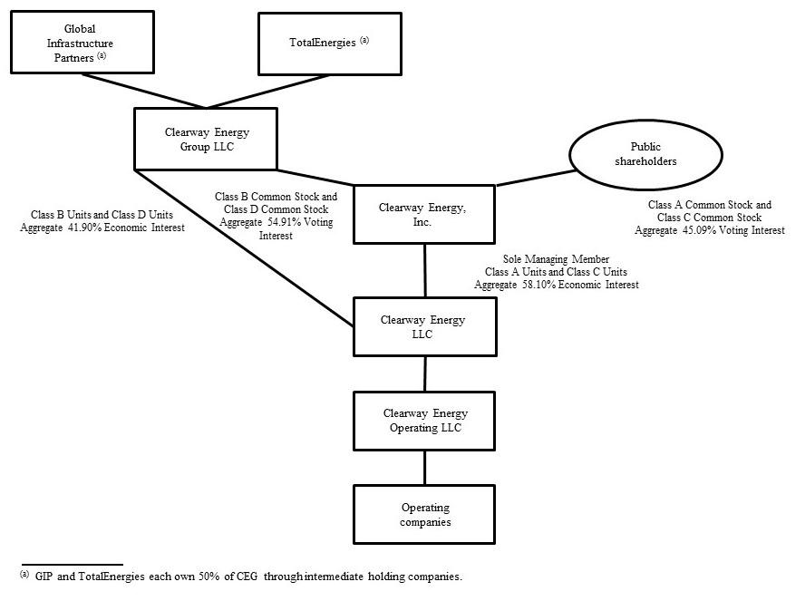

Basis of Presentation

The accompanying unaudited interim consolidated financial statements have been prepared in accordance with the SEC’s regulations for interim financial information and with the instructions to Form 10-Q. Accordingly, they do not include all of the information and notes required by GAAP for complete financial statements. The following notes should be read in conjunction with the accounting policies and other disclosures as set forth in the notes to the consolidated financial statements included in the Company’s 2023 Form 10-K. Interim results are not necessarily indicative of results for a full year.

In the opinion of management, the accompanying unaudited interim consolidated financial statements contain all material adjustments consisting of normal and recurring accruals necessary for a fair statement of the Company’s consolidated financial position as of September 30, 2024, and results of operations, comprehensive income and cash flows for the three and nine months ended September 30, 2024 and 2023.

Note 2 — Summary of Significant Accounting Policies

Use of Estimates

The preparation of consolidated financial statements in accordance with GAAP requires management to make estimates and assumptions. These estimates and assumptions impact the reported amounts of assets and liabilities and disclosures of contingent assets and liabilities as of the date of the consolidated financial statements. They also impact the reported amounts of net earnings during the reporting periods. Actual results could be different from these estimates.

13

Cash, Cash Equivalents and Restricted Cash

Cash and cash equivalents include highly liquid investments with an original maturity of three months or less at the time of purchase. Cash and cash equivalents held at subsidiary facilities was $202 million and $125 million as of September 30, 2024 and December 31, 2023, respectively.

The following table provides a reconciliation of cash, cash equivalents and restricted cash reported within the consolidated balance sheets that sum to the total of the same such amounts shown in the consolidated statements of cash flows:

 | September 30, 2024 |  |  |  | December 31, 2023
 |  | (In millions)
Cash and cash equivalents | $ | 292 |  | $ | 535
Restricted cash |  | 382 |  |  | 516
Cash, cash equivalents and restricted cash shown in the consolidated statements of cash flows | $ | 674 |  | $ | 1,051

Restricted cash consists primarily of funds held to satisfy the requirements of certain debt agreements and funds held within the Company’s facilities that are restricted in their use. As of September 30, 2024, these restricted funds were comprised of $183 million designated to fund operating expenses, $71 million designated for current debt service payments and $89 million restricted for reserves including debt service, performance obligations and other reserves as well as capital expenditures. The remaining $39 million is held in distributions reserve accounts.

Supplemental Cash Flow Information

The following table provides a disaggregation of the amounts classified as Acquisition of Drop Down Assets, net of cash acquired, shown in the consolidated statements of cash flows:

 | Nine months ended September 30,
 | 2024 |  |  | 2023
 |  | (In millions)
Cash paid to acquire Drop Down Assets | $ | (673) |  | $ | (34)
Cash acquired from the acquisition of Drop Down Assets |  | 2 |  |  | 134
Acquisition of Drop Down Assets, net of cash acquired | $ | (671) |  | $ | 100

Accumulated Depreciation and Accumulated Amortization

The following table presents the accumulated depreciation included in property, plant and equipment, net, and accumulated amortization included in intangible assets, net:

 |  |  | September 30, 2024 |  |  |  |  | December 31, 2023
 |  |  |  |  |  | (In millions)
Property, Plant and Equipment Accumulated Depreciation |  | $ |  |  |  | 3,938 | $ |  |  | 3,485
Intangible Assets Accumulated Amortization |  |  |  |  |  | 1,147 |  |  |  | 1,009
Dividends to Class A and Class C Common Stockholders
The following table lists the dividends paid on the Company's Class A and Class C common stock during the nine months ended September 30, 2024:
 |  | Third Quarter 2024 |  |  |  | Second Quarter 2024 |  |  |  | First Quarter 2024
Dividends per Class A share | $ | 0.4171 |  |  | $ |  | 0.4102 |  | $ | 0.4033
Dividends per Class C share |  | 0.4171 |  |  |  |  | 0.4102 |  |  | 0.4033

Dividends on the Class A and Class C common stock are subject to available capital, market conditions, and compliance with associated laws, regulations and other contractual obligations. The Company expects that, based on current circumstances, comparable cash dividends will continue to be paid in the foreseeable future.

On October 29, 2024, the Company declared quarterly dividends on its Class A and Class C common stock of $0.4240 per share payable on December 16, 2024 to stockholders of record as of December 2, 2024.

14

Noncontrolling Interests

Clearway Energy LLC Distributions to CEG

The following table lists distributions paid to CEG during the nine months ended September 30, 2024 on Clearway Energy LLC’s Class B and D units:

 |  | Third Quarter 2024 |  |  | Second Quarter 2024 |  |  | First Quarter 2024
Distributions per Class B Unit | $ | 0.4171 |  | $ | 0.4102 |  | $ | 0.4033
Distributions per Class D Unit |  | 0.4171 |  |  | 0.4102 |  |  | 0.4033

On October 29, 2024, Clearway Energy LLC declared a distribution on its Class B and Class D units of $0.4240 per unit payable on December 16, 2024 to unit holders of record as of December 2, 2024.

Revenue Recognition

Disaggregated Revenues

The following tables represent the Company’s disaggregation of revenue from contracts with customers along with the reportable segment for each category:

Three months ended September 30, 2024

(In millions) Conventional Generation Renewables Total

Energy revenue ^{(a)}

Capacity revenue ^{(a)}

Other revenues

Contract amortization

Mark-to-market for economic hedges

Total operating revenues

Less: Contract amortization
Less: Mark-to-market for economic hedges

Less: Lease revenue

Total revenue from contracts with customers

- The following amounts of energy and capacity revenues relate to leases and are accounted for under ASC 842:

$ | 35 |  | $ | 315 |  | $ | 350
 | 65 |  |  | 22 |  |  | 87
 | 3 |  |  | 20 |  |  | 23
 | (5) |  |  | (41) |  |  | (46)
 | 4 |  |  | 68 |  |  | 72
 | 102 |  |  | 384 |  |  | 486
 | 5 |  |  | 41 |  |  | 46
 | (4) |  |  | (68) |  |  | (72)
 | (27) |  |  | (247) |  |  | (274)
$ | 76 |  | $ | 110 |  | $ | 186

 | (In millions) |  |  |  | Conventional Generation |  |  | Renewables |  |  | Total
 | Energy revenue |  |  | $ | 1 |  | $ | 234 |  | $ | 235
 | Capacity revenue |  |  |  | 26 |  |  | 13 |  |  | 39
 | Total |  |  | $ | 27 |  | $ | 247 |  | $ | 274
 |  |  | 15

 |  |  |  | Three months ended September 30, 2023
 | (In millions) |  |  | Conventional Generation |  |  | Renewables |  |  | Total
 | Energy revenue ^{(a)} |  | $ | 57 |  | $ | 280 |  | $ | 337
 | Capacity revenue ^{(a)} |  |  | 74 |  |  | 5 |  |  | 79
 | Other revenues |  |  | 3 |  |  | 17 |  |  | 20
 | Contract amortization |  |  | (5) |  |  | (42) |  |  | (47)
 | Mark-to-market for economic hedges |  |  | 3 |  |  | (21) |  |  | (18)
 | Total operating revenues |  |  | 132 |  |  | 239 |  |  | 371
 | Less: Contract amortization |  |  | 5 |  |  | 42 |  |  | 47
 | Less: Mark-to-market for economic hedges |  |  | (3) |  |  | 21 |  |  | 18
 | Less: Lease revenue |  |  | (41) |  |  | (233) |  |  | (274)
 | Total revenue from contracts with customers |  | $ | 93 |  | $ | 69 |  | $ | 162

- The following amounts of energy and capacity revenues relate to leases and are accounted for under ASC 842:

 | (In millions) |  |  |  | Conventional Generation |  |  | Renewables |  |  | Total
 | Energy revenue |  |  | $ | 2 |  | $ | 228 |  | $ | 230
 | Capacity revenue |  |  |  | 39 |  |  | 5 |  |  | 44
 | Total |  |  | $ | 41 |  | $ | 233 |  | $ | 274
 |  |  |  |  | Nine months ended September 30, 2024
 | (In millions) |  |  |  | Conventional Generation |  |  | Renewables |  |  | Total
 | Energy revenue ^{(a)} |  |  | $ | 67 |  | $ | 870 |  | $ | 937
 | Capacity revenue ^{(a)} |  |  |  | 195 |  |  | 44 |  |  | 239
 | Other revenues |  |  |  | 6 |  |  | 63 |  |  | 69
 | Contract amortization |  |  |  | (14) |  |  | (124) |  |  | (138)
 | Mark-to-market for economic hedges |  |  |  | 12 |  |  | (4) |  |  | 8
 | Total operating revenue |  |  |  | 266 |  |  | 849 |  |  | 1,115
 | Less: Contract amortization |  |  |  | 14 |  |  | 124 |  |  | 138
 | Less: Mark-to-market for economic hedges |  |  |  | (12) |  |  | 4 |  |  | (8)
 | Less: Lease revenue |  |  |  | (84) |  |  | (691) |  |  | (775)
 | Total revenue from contracts with customers |  |  | $ | 184 |  | $ | 286 |  | $ | 470

- The following amounts of energy and capacity revenues relate to leases and are accounted for under ASC 842:

(In millions) |  |  | Conventional Generation |  |  | Renewables |  |  | Total
Energy revenue |  | $ | 2 |  | $ | 661 |  | $ | 663
Capacity revenue |  |  | 82 |  |  | 30 |  |  | 112
Total |  | $ | 84 |  | $ | 691 |  | $ | 775
 | 16

 |  | Nine months ended September 30, 2023
(In millions) |  | Conventional Generation |  |  | Renewables |  |  | Total
Energy revenue ^{(a)} | $ | 61 |  | $ | 753 |  | $ | 814
Capacity revenue ^{(a)} |  | 270 |  |  | 15 |  |  | 285
Other revenues ^{(a)} |  | 24 |  |  | 56 |  |  | 80
Contract amortization |  | (16) |  |  | (125) |  |  | (141)
Mark-to-market for economic hedges |  | 3 |  |  | 24 |  |  | 27
Total operating revenue |  | 342 |  |  | 723 |  |  | 1,065
Less: Contract amortization |  | 16 |  |  | 125 |  |  | 141
Less: Mark-to-market for economic hedges |  | (3) |  |  | (24) |  |  | (27)
Less: Lease revenue |  | (246) |  |  | (626) |  |  | (872)
Total revenue from contracts with customers | $ | 109 |  | $ | 198 |  | $ | 307

- The following amounts of energy, capacity and other revenues relate to leases and are accounted for under ASC 842:

(In millions) |  |  | Conventional Generation |  | Renewables |  |  |  | Total
Energy revenue |  | $ | 4 |  | $ | 613 |  | $ | 617
Capacity revenue |  |  | 221 |  |  | 13 |  |  | 234
Other revenues ^{(b)} |  |  | 21 |  |  | — |  |  | 21
Total |  | $ | 246 |  | $ | 626 |  | $ | 872

- Includes sales-type lease revenue recognized for the Marsh Landing Black Start addition that reached commercial operations on May 31, 2023.

Contract Balances

The following table reflects the contract assets and liabilities included on the Company’s consolidated balance sheets:

 | September 30, 2024 |  |  |  | December 31, 2023
 |  | (In millions)
Accounts receivable, net - Contracts with customers | $ | 79 |  | $ | 66
Accounts receivable, net - Leases |  | 120 |  |  | 105
Total accounts receivable, net | $ | 199 |  | $ | 171

Note 3 — Acquisitions

Cedar Creek Drop Down — On April 16, 2024, the Company, through its indirect subsidiary, Cedar Creek Wind Holdco LLC, acquired Cedar Creek Holdco LLC, the indirect owner of Cedar Creek, a 160 MW wind facility that is located in Bingham County, Idaho, from Clearway Renew for cash consideration of $117 million. Cedar Creek Holdco LLC consolidates as primary beneficiary, Cedar Creek TE Holdco LLC, a tax equity fund that owns the Cedar Creek wind facility, as further described in Note 4, Investments Accounted for by the Equity Method and Variable Interest Entities. Cedar Creek has a 25-year PPA with an investment-grade utility that commenced in March 2024. The Cedar Creek operations are reflected in the Company’s Renewables segment and the acquisition was funded with existing sources of liquidity. The acquisition was determined to be an asset acquisition and the Company consolidates Cedar Creek on a prospective basis in its financial statements. The assets and liabilities transferred to the Company relate to interests under common control and were recorded at historical cost in accordance with ASC 805-50, Business Combinations - Related Issues. The difference between the cash paid of $117 million and the historical cost of the Company’s net assets acquired of $17 million was recorded as an adjustment to CEG’s noncontrolling interest balance. In addition, the Company reflected the entire $117 million of the Company’s purchase price, which was contributed back to the Company by CEG to pay down the acquired long-term debt, in the line item contributions from CEG, net of distributions in the consolidated statements of stockholders’ equity.

17

The following is a summary of assets and liabilities transferred in connection with the acquisition as of April 16, 2024:

(In millions) |  |  | Cedar Creek
Restricted cash |  | $ | 1
Property, plant and equipment |  |  | 311
Right-of-use assets, net |  |  | 6
Derivative assets |  |  | 14
Other current and non-current assets |  |  | 14
Total assets acquired |  |  | 346
Long-term debt ^{(a)} |  |  | 309
Long-term lease liabilities |  |  | 7
Other current and non-current liabilities |  |  | 13
Total liabilities assumed |  |  | 329
Net assets acquired |  | $ | 17

- Includes a $112 million construction loan, a $91 million cash equity bridge loan, and a $109 million tax equity bridge loan, offset by $3 million in unamortized debt issuance costs. See Note 7, Long-term Debt, for further discussion of the long-term debt assumed in the acquisition.

Texas Solar Nova 2 Drop Down — On March 15, 2024, the Company, through its indirect subsidiary, TSN1 TE Holdco LLC, acquired Texas Solar Nova 2, a 200 MW solar facility that is located in Kent County, Texas, from Clearway Renew for cash consideration of $112 million, $17 million of which was funded by the Company with the remaining $95 million funded through a contribution from the cash equity investor in Lighthouse Renewable Holdco 2 LLC, which is a partnership. Lighthouse Renewable Holdco 2 LLC indirectly consolidates as primary beneficiary, TSN1 TE Holdco LLC, a tax equity fund that owns Texas Solar Nova 1 and Texas Solar Nova 2, as further described in Note 4, Investments Accounted for by the Equity Method and Variable Interest Entities. Texas Solar Nova 2 has an 18-year PPA with an investment-grade counterparty that commenced in February 2024. The Texas Solar Nova 2 operations are reflected in the Company’s Renewables segment and the Company’s portion of the purchase price was funded with existing sources of liquidity. The acquisition was determined to be an asset acquisition and the Company consolidates Texas Solar Nova 2 on a prospective basis in its financial statements. The assets and liabilities transferred to the Company relate to interests under common control and were recorded at historical cost in accordance with ASC 805-50, Business Combinations - Related Issues. The difference between the cash paid of $112 million and the historical cost of the Company’s net assets acquired of $72 million was recorded as an adjustment to CEG’s noncontrolling interest balance. In addition, the Company reflected $9 million of the Company’s purchase price, which was contributed back to the Company by CEG to pay down the acquired long-term debt, in the line item distributions to CEG, net of contributions in the consolidated statements of stockholders’ equity.

The following is a summary of assets and liabilities transferred in connection with the acquisition as of March 15, 2024:

(In millions) |  | Texas Solar Nova 2
Restricted cash | $ | 1
Property, plant and equipment |  | 280
Right-of-use assets, net |  | 21
Derivative assets |  | 6
Other current and non-current assets |  | 4
Total assets acquired |  | 312
Long-term debt ^{(a)} |  | 194
Long-term lease liabilities |  | 19
Other current and non-current liabilities |  | 27
Total liabilities assumed |  | 240
Net assets acquired | $ | 72

- Includes an $80 million term loan and a $115 million tax equity bridge loan, offset by $1 million in unamortized debt issuance costs. See Note 7, Long-term Debt, for further discussion of the long-term debt assumed in the acquisition.

18

Note 4 — Investments Accounted for by the Equity Method and Variable Interest Entities

Entities that are not Consolidated

The Company has interests in entities that are considered VIEs under ASC 810, but for which it is not considered the primary beneficiary. The Company accounts for its interests in these entities and entities in which it has a significant investment under the equity method of accounting, as further described under Item 15 — Note 5, Investments Accounted for by the Equity Method and Variable Interest Entities, to the consolidated financial statements included in the Company’s 2023 Form 10-K.

The following table reflects the Company’s equity investments in unconsolidated affiliates as of September 30, 2024:

Name | Economic Interest |  | Investment Balance ^{(a)}
 |  |  | (In millions)
Avenal | 50% | $ | 8
Desert Sunlight | 25% |  | 227
Elkhorn Ridge | 66.7% |  | 9
GenConn ^{(b)} | 50% |  | 75
San Juan Mesa | 75% |  | 3
 |  | $ | 322

^{(a)} The Company’s maximum exposure to loss is limited to its investment balances.
^{(b)} GenConn is a VIE.

Rosie Central BESS

On June 13, 2024, when the Rosamond Central BESS facility reached substantial completion, Clearway Renew redeemed Rosie Class B LLC’s entire investment of $28 million in Rosie Central BESS that was accounted for as an equity method investment, as further discussed in Note 7, Long-term Debt. Rosie Class B LLC’s equity investment in Rosie Central BESS was comprised of contributions from the Company and the cash equity investor in Rosie TargetCo LLC during the year ended December 31, 2023.

Entities that are Consolidated

As further described under Item 15 — Note 5, Investments Accounted for by the Equity Method and Variable Interest Entities, to the consolidated financial statements included in the Company’s 2023 Form 10-K, the Company has a controlling financial interest in certain entities which have been identified as VIEs under ASC 810, Consolidations, or ASC 810. These arrangements are primarily related to tax equity arrangements entered into with third parties in order to monetize certain tax credits associated with wind, solar and BESS facilities. The Company also has a controlling financial interest in certain partnership arrangements with third-party investors, which also have been identified as VIEs. Under the Company’s arrangements that have been identified as VIEs, the third-party investors are allocated earnings, tax attributes and distributable cash in accordance with the respective limited liability company agreements. Many of these arrangements also provide a mechanism to facilitate achievement of the investor’s specified return by providing incremental cash distributions to the investor at a specified date if the specified return has not yet been achieved.

The following is a summary of significant activity during the nine months ended September 30, 2024 related to the Company’s consolidated VIEs:

Cedar Creek TE Holdco LLC

As described in Note 3, Acquisitions, on April 16, 2024, the Company, through its indirect subsidiary, Cedar Creek Wind Holdco LLC, acquired Cedar Creek Holdco LLC. Cedar Creek Holdco LLC consolidates as primary beneficiary, Cedar Creek TE Holdco LLC, a tax equity fund that owns the Cedar Creek wind facility. The Class A membership interests in Cedar Creek TE Holdco LLC are held by a tax equity investor and are reflected as noncontrolling interest on the Company’s consolidated balance sheet.

19

Lighthouse Renewable Holdco 2 LLC

As described in Note 3, Acquisitions, on March 15, 2024, TSN1 TE Holdco LLC, an indirect subsidiary of the Company, acquired Texas Solar Nova 2. The Company, through Lighthouse Renewable Holdco 2 LLC, a partnership, consolidates TSN1 TE Holdco LLC, a tax equity fund that owns Texas Solar Nova 1 and Texas Solar Nova 2. The Company recorded the noncontrolling interest of the cash equity investor in Lighthouse Renewable Holdco 2 LLC at historical carrying amount, with the offset to additional-paid in capital. The Class A membership interests in TSN1 TE Holdco LLC are held by a tax equity investor and are reflected as noncontrolling interest on the Company’s consolidated balance sheet.

Daggett Renewable Holdco LLC

Effective January 1, 2024, the Company and the cash equity investor in Daggett Renewable HoldCo LLC and Daggett 2 TargetCo LLC, the indirect owner of the Daggett 2 solar and BESS facility, agreed to transfer Daggett 2 TargetCo LLC to Daggett Renewable Holdco LLC. As the transfer was among entities under common control, the transaction was recognized at historical cost and no gain or loss was recognized.

Summarized financial information for the Company’s consolidated VIEs consisted of the following as of September 30, 2024:

(In millions) |  |  |  |  | Cedar Creek TE Holdco |  | Daggett Renewable Holdco |  |  | DGPV Funds ^{(b)} |  |  | Lighthouse Renewable Holdco |  |  | Lighthouse Renewable Holdco
(In millions) | Buckthorn Holdings, LLC |  |  |  | LLC |  |  | LLC ^{(a)} |  | DGPV Funds ^{(b)} |  |  |  | LLC ^{(c)} |  |  | 2 LLC ^{(d)}
Other current and non-current assets | $ | 5 |  | $ | 35 |  | $ | 220 |  | $ | 59 |  | $ | 61 |  | $ | 139
Property, plant and equipment |  | 179 |  |  | 308 |  |  | 1,353 |  |  | 366 |  |  | 398 |  |  | 1,311
Intangible assets |  | — |  |  | — |  |  | — |  |  | 1 |  |  | — |  |  | 2
Total assets |  | 184 |  |  | 343 |  |  | 1,573 |  |  | 426 |  |  | 459 |  |  | 1,452
Current and non-current liabilities |  | 12 |  |  | 119 |  |  | 648 |  |  | 50 |  |  | 136 |  |  | 547
Total liabilities |  | 12 |  |  | 119 |  |  | 648 |  |  | 50 |  |  | 136 |  |  | 547
Noncontrolling interest |  | 8 |  |  | 102 |  |  | 927 |  |  | 12 |  |  | 244 |  |  | 682
Net assets less noncontrolling interest | $ | 164 |  | $ | 122 |  | $ | (2) |  | $ | 364 |  | $ | 79 |  | $ | 223

- Daggett Renewable Holdco LLC consolidates Daggett TE Holdco LLC and Daggett 2 TE Holdco LLC, which are consolidated VIEs.

- DGPV Funds is comprised of Clearway & EFS Distributed Solar LLC, Golden Puma Fund LLC, Renew Solar CS4 Fund LLC and Chestnut Fund LLC, which are all tax equity funds.

- Lighthouse Renewable Holdco LLC consolidates Black Rock TE Holdco LLC and Mililani TE Holdco LLC, which are consolidated VIEs.

- Lighthouse Renewable Holdco 2 LLC consolidates Mesquite Sky TE Holdco LLC, Mesquite Star Tax Equity Holdco LLC and TSN1 TE Holdco LLC, which are consolidated VIEs.

(In millions) |  | Oahu Solar LLC |  | Rattlesnake TE Holdco LLC |  |  |  | Rosie TargetCo LLC |  | VP-Arica TargetCo LLC ^{(a)} |  |  | Wildorado TE Holdco LLC |  |  |  | Other ^{(b)}
Other current and non-current assets | $ | 38 |  | $ | 14 |  | $ | 55 |  | $ | 69 |  | $ | 25 |  | $ | 44
Property, plant and equipment |  | 151 |  |  | 168 |  |  | 535 |  |  | 996 |  |  | 182 |  |  | 332
Intangible assets |  | — |  |  | — |  |  | — |  |  | 2 |  |  | — |  |  | 14
Total assets |  | 189 |  |  | 182 |  |  | 590 |  |  | 1,067 |  |  | 207 |  |  | 390
Current and non-current liabilities |  | 22 |  |  | 16 |  |  | 222 |  |  | 40 |  |  | 20 |  |  | 149
Total liabilities |  | 22 |  |  | 16 |  |  | 222 |  |  | 40 |  |  | 20 |  |  | 149
Noncontrolling interest |  | 21 |  |  | 77 |  |  | 281 |  |  | 345 |  |  | 86 |  |  | 141
Net assets less noncontrolling interest | $ | 146 |  | $ | 89 |  | $ | 87 |  | $ | 682 |  | $ | 101 |  | $ | 100

- VP-Arica TargetCo LLC consolidates VP-Arica TE Holdco LLC, a consolidated VIE that owns the Victory Pass and Arica solar and BESS facilities.

- Other is comprised of Elbow Creek TE Holdco LLC, Langford TE Partnership LLC, Pinnacle Repowering TE Holdco LLC and the Spring Canyon facilities.

20

Note 5 — Fair Value of Financial Instruments

Fair Value Accounting under ASC 820

ASC 820 establishes a fair value hierarchy that prioritizes the inputs to valuation techniques used to measure fair value into three levels as follows:

- Level 1—quoted prices (unadjusted) in active markets for identical assets or liabilities that the Company has the ability to access as of the measurement date.

- Level 2—inputs other than quoted prices included within Level 1 that are directly observable for the asset or liability or indirectly observable through corroboration with observable market data.
- Level 3—unobservable inputs for the asset or liability only used when there is little, if any, market activity for the asset or liability at the measurement date.

In accordance with ASC 820, the Company determines the level in the fair value hierarchy within which each fair value measurement in its entirety falls, based on the lowest level input that is significant to the fair value measurement.

For cash and cash equivalents, restricted cash, accounts receivable — trade, accounts receivable — affiliates, accounts payable — trade, accounts payable — affiliates and accrued expenses and other current liabilities, the carrying amounts approximate fair value because of the short-term maturity of those instruments and are classified as Level 1 within the fair value hierarchy.

The carrying amount and estimated fair value of the Company’s recorded financial instrument not carried at fair market value or that does not approximate fair value is as follows:

 |  | As of September 30, 2024 |  |  |  |  | As of December 31, 2023
 |  | Carrying Amount |  | Fair Value |  |  | Carrying Amount |  | Fair Value
 |  |  |  | (In millions)
Long-term debt, including current portion ^{(a)} | $ | 7,201 | $ | 6,897 |  | $ | 8,102 | $ | 7,611

- Excludes net debt issuance costs, which are recorded as a reduction to long-term debt on the Company’s consolidated balance sheets.

The fair value of the Company’s publicly-traded long-term debt is based on quoted market prices and is classified as Level 2 within the fair value hierarchy. The fair value of debt securities, non-publicly traded long-term debt and certain notes receivable of the Company are based on expected future cash flows discounted at market interest rates, or current interest rates for similar instruments with equivalent credit quality and are classified as Level 3 within the fair value hierarchy. The following table presents the level within the fair value hierarchy for long-term debt, including current portion:

 |  | As of September 30, 2024 |  |  |  |  | As of December 31, 2023
 |  | Level 2 |  | Level 3 |  |  | Level 2 |  | Level 3
 |  |  |  | (In millions)
Long-term debt, including current portion | $ | 2,002 | $ | 4,895 |  | $ | 1,939 | $ | 5,672

21

Recurring Fair Value Measurements

The Company records its derivative assets and liabilities at fair market value on its consolidated balance sheets. The following table presents assets and liabilities measured and recorded at fair value on the Company’s consolidated balance sheets on a recurring basis and their level within the fair value hierarchy:

 |  | As of September 30, 2024 |  |  |  |  |  | As of December 31, 2023
 |  | Fair Value ^{(a)} |  |  |  |  |  | Fair Value ^{(a)}
(In millions) |  | Level 2 ^{(b)} |  |  | Level 3 |  |  | Level 2 ^{(b)} |  |  | Level 3
Derivative assets:
Energy-related commodity contracts ^{(c)} | $ | — |  | $ | 7 |  | $ | 2 |  | $ | —
Interest rate contracts |  | 97 |  |  | — |  |  | 121 |  |  | —
Other financial instruments ^{(d)} |  | — |  |  | 10 |  |  | — |  |  | 13
Total assets | $ | 97 |  | $ | 17 |  | $ | 123 |  | $ | 13
Derivative liabilities:
Energy-related commodity contracts ^{(e)} | $ | 1 |  | $ | 326 |  | $ | — |  | $ | 330
Interest rate contracts |  | 3 |  |  | — |  |  | 2 |  |  | —
Total liabilities | $ | 4 |  | $ | 326 |  | $ | 2 |  | $ | 330

- There were no derivative assets or liabilities classified as Level 1 as of September 30, 2024 and December 31, 2023.

- The Company’s interest rate swaps are measured at fair value using an income approach, which uses readily observable inputs, such as forward interest rates (e.g., SOFR) and contractual terms to estimate fair value.

- Includes long-term backbone transportation service contracts classified as Level 2 and short-term heat rate call option contracts classified as Level 3.

- Includes SREC contract.

- Includes long-term backbone transportation contracts classified as Level 2 and long-term power commodity contracts and short-term heat rate call option contracts classified as Level 3. As of September 30, 2024 and December 31, 2023, Level 3 amounts include $326 million and $325 million related to long-term power commodity contracts and zero and $5 million related to short-term heat rate call option contracts, respectively.

The following table reconciles the beginning and ending balances for instruments that are recognized at fair value in the consolidated financial statements using significant unobservable inputs:

 | Three months ended September 30, |  |  |  |  |  |  | Nine months ended September 30,
 | 2024 |  |  | 2023 |  |  |  | 2024 |  |  | 2023
(In millions) | Fair Value Measurement Using Significant Unobservable |  |  |  |  |  | Fair Value Measurement Using Significant Unobservable
(In millions) |  | Inputs (Level 3) |  |  |  |  |  | Inputs (Level 3)
Beginning balance | $ | (381) |  | $ | (291) |  | $ | (317) |  | $ | (336)
Settlements |  | 6 |  |  | 21 |  |  | — |  |  | 30
Total gains (losses) for the period included in earnings |  | 66 |  |  | (39) |  |  | 8 |  |  | (3)
Ending balance | $ | (309) |  | $ | (309) |  | $ | (309) |  | $ | (309)
Change in unrealized gains included in earnings for derivatives and other financial
instruments held as of September 30, 2024 | $ | 66 |  |  |  |  | $ | 8

Derivative and Financial Instruments Fair Value Measurements

The Company's contracts are non-exchange-traded and valued using prices provided by external sources. The Company uses quoted observable forward prices to value its energy-related commodity contracts, which includes long-term power commodity contracts and heat rate call option contracts. To the extent that observable forward prices are not available, the quoted prices reflect the average of the forward prices from the prior year, adjusted for inflation. As of September 30, 2024, contracts valued with prices provided by models and other valuation techniques make up 7% of derivative assets and 99% of derivative liabilities and other financial instruments.

22

The Company’s significant positions classified as Level 3 include physical and financial energy-related commodity contracts executed in illiquid markets. The significant unobservable inputs used in developing fair value include illiquid power tenors and location pricing, which is derived by extrapolating pricing as a basis to liquid locations. The tenor pricing and basis spread are based on observable market data when available or derived from historic prices and forward market prices from similar observable markets when not available.

The following table quantifies the significant unobservable inputs used in developing the fair value of the Company’s Level 3 positions:

September 30, 2024

 |  |  | Fair Value |  |  |  |  |  | Input/Range
 |  | Assets | Liabilities | Valuation Technique | Significant |  | Low |  | High |  | Weighted Average
 |  | Assets | Liabilities | Valuation Technique | Unobservable Input |  | Low |  | High |  | Weighted Average
 |  | (In millions)
Long-term Power Commodity Contracts $ |  | — $ | 326 | Discounted Cash Flow | Forward Market Price (per | $ | 19.67 | $ | 69.48 | $ | 41.94
 |  |  |  |  | MWh)
 |  | 7 | — | Option Model | Forward Market Price (per | $ | (33.90) | $ | 1,083.78 | $ | 56.23
Heat Rate Call Option Commodity |  | 7 | — | Option Model | MWh)
Contracts |  |  |  |  | Forward Market Price (per
 |  |  |  | Option Model | Forward Market Price (per | $ | 2.31 | $ | 12.52 | $ | 5.73
 |  |  |  | Option Model | MMBtu)
 |  |  |  |  | Forecast annual generation
Other Financial Instruments |  | 10 | — | Discounted Cash Flow | levels of certain DG solar |  | 59,425 MWh |  | 118,850 MWh |  | 111,091 MWh
 |  |  |  |  | facilities |  | 59,425 MWh |  | 118,850 MWh |  | 111,091 MWh

The following table provides the impact on the fair value measurements to increases/(decreases) in significant unobservable inputs as of September 30, 2024:

Type | Significant Unobservable Input | Position | Change In Input | Impact on Fair Value Measurement
Energy-Related Commodity Contracts | Forward Market Price Power | Sell | Increase/(Decrease) | Lower/(Higher)
Energy-Related Commodity Contracts | Forward Market Price Gas | Sell | Increase/(Decrease) | Higher/(Lower)
Other Financial Instruments | Forecast Generation Levels | Sell | Increase/(Decrease) | Higher/(Lower)

The fair value of each contract is discounted using a risk-free interest rate. In addition, a credit reserve is applied to reflect credit risk, which is, for interest rate swaps, calculated based on credit default swaps using the bilateral method. For commodities, to the extent that the Net Exposure under a specific master agreement is an asset, the Company uses the counterparty’s default swap rate. If the Net Exposure under a specific master agreement is a liability, the Company uses a proxy of its own default swap rate. For interest rate swaps and commodities, the credit reserve is added to the discounted fair value to reflect the exit price that a market participant would be willing to receive to assume the liabilities or that a market participant would be willing to pay for the assets. As of September 30, 2024, the non-performance reserve was a $17 million gain recorded primarily to total operating revenues in the consolidated statements of income. It is possible that future market prices could vary from those used in recording assets and liabilities and such variations could be material.

Concentration of Credit Risk

In addition to the credit risk discussion as disclosed under Item 15 — Note 2, Summary of Significant Accounting Policies, to the consolidated financial statements included in the Company’s 2023 Form 10-K, the following item is a discussion of the concentration of credit risk for the Company’s financial instruments. Credit risk relates to the risk of loss resulting from non-performance or non-payment by counterparties pursuant to the terms of their contractual obligations. The Company monitors and manages credit risk through credit policies that include: (i) an established credit approval process; (ii) monitoring of counterparties’ credit limits on an as needed basis; (iii) as applicable, the use of credit mitigation measures such as margin, collateral, prepayment arrangements, or volumetric limits; (iv) the use of payment netting agreements; and (v) the use of master netting agreements that allow for the netting of positive and negative exposures of various contracts associated with a single counterparty. Risks surrounding counterparty performance and credit could ultimately impact the amount and timing of expected cash flows. The Company seeks to mitigate counterparty risk by having a diversified portfolio of counterparties.

23

Counterparty credit exposure includes credit risk exposure under certain long-term agreements, including solar and other PPAs. As external sources or observable market quotes are not available to estimate such exposure, the Company estimates the exposure related to these contracts based on various techniques including, but not limited to, internal models based on a fundamental analysis of the market and extrapolation of observable market data with similar characteristics. A significant portion of these energy-related commodity contracts are with utilities with strong credit quality and public utility commission or other regulatory support. However, such regulated utility counterparties can be impacted by changes in government regulations or adverse financial conditions, which the Company is unable to predict. Certain subsidiaries of the Company sell the output of their facilities to PG&E, a significant counterparty of the Company, under long-term PPAs, and PG&E’s credit rating is below investment-grade.

Note 6 — Derivative Instruments and Hedging Activities

This footnote should be read in conjunction with the complete description under Item 15 — Note 7, Accounting for Derivative Instruments and Hedging Activities, to the consolidated financial statements included in the Company’s 2023 Form 10-K.

Interest Rate Swaps

The Company enters into interest rate swap agreements in order to hedge the variability of expected future cash interest payments. As of September 30, 2024, the Company had interest rate derivative instruments on non-recourse debt extending through 2040, a portion of which were designated as cash flow hedges. Under the interest rate swap agreements, the Company pays a fixed rate and the counterparties to the agreements pay a variable interest rate.

Energy-Related Commodity Contracts

As of September 30, 2024, the Company had energy-related derivative instruments extending through 2033. At September 30, 2024, these contracts were not designated as cash flow or fair value hedges.

Volumetric Underlying Derivative Transactions

The following table summarizes the net notional volume buy/(sell) of the Company’s open derivative transactions broken out by commodity:

 |  |  |  |  |  |  |  | Total Volume
 |  |  |  |  |  |  | September 30, 2024 |  |  | December 31, 2023
 | Commodity |  | Units |  |  |  |  | (In millions)
 | Power |  | MWh |  |  |  |  | (18) |  | (23)
 | Natural Gas |  | MMBtu |  |  |  |  | 13 |  | 17
 | Interest |  | Dollars |  |  | $ |  | 1,711 | $ | 2,467
 |  |  |  |  |  | 24

Fair Value of Derivative Instruments

The following table summarizes the fair value within the derivative instrument valuation on the consolidated balance sheets:

 |  |  |  |  | Fair Value
 |  | Derivative Assets |  |  |  |  |  | Derivative Liabilities
 |  | September 30, 2024 |  |  | December 31, 2023 |  |  | September 30, 2024 |  |  | December 31, 2023
 |  |  |  |  | (In millions)
Derivatives Designated as Cash Flow Hedges:
Interest rate contracts current | $ | 4 |  | $ | 7 |  | $ | — |  | $ | —
Interest rate contracts long-term |  | 10 |  |  | 12 |  |  | 2 |  |  | 2
Total Derivatives Designated as Cash Flow Hedges | $ | 14 |  | $ | 19 |  | $ | 2 |  | $ | 2
Derivatives Not Designated as Cash Flow Hedges:
Interest rate contracts current | $ | 23 |  | $ | 33 |  | $ | — |  | $ | —
Interest rate contracts long-term |  | 60 |  |  | 69 |  |  | 1 |  |  | —
Energy-related commodity contracts current |  | 7 |  |  | 1 |  |  | 51 |  |  | 51
Energy-related commodity contracts long-term |  | — |  |  | 1 |  |  | 276 |  |  | 279
Total Derivatives Not Designated as Cash Flow Hedges | $ | 90 |  | $ | 104 |  | $ | 328 |  | $ | 330
Total Derivatives | $ | 104 |  | $ | 123 |  | $ | 330 |  | $ | 332

The Company has elected to present derivative assets and liabilities on the balance sheet on a trade-by-trade basis and does not offset amounts at the counterparty level. As of September 30, 2024 and December 31, 2023, the amount of outstanding collateral paid or received was immaterial. The following tables summarize the offsetting of derivatives by counterparty:

 |  | Gross Amounts Not Offset in the Statement of Financial Position
As of September 30, 2024 | Gross Amounts of Recognized Assets/Liabilities |  |  |  | Derivative Instruments |  |  | Net Amount
Energy-related commodity contracts |  |  |  |  | (In millions)
Derivative assets | $ | 7 |  | $ | — |  | $ | 7
Derivative liabilities |  | (327) |  |  | — |  |  | (327)
Total energy-related commodity contracts | $ | (320) |  | $ | — |  | $ | (320)
Interest rate contracts
Derivative assets | $ | 97 |  | $ | (2) |  | $ | 95
Derivative liabilities |  | (3) |  |  | 2 |  |  | (1)
Total interest rate contracts | $ | 94 |  | $ | — |  | $ | 94
Total derivative instruments | $ | (226) |  | $ | — |  | $ | (226)
 |  | Gross Amounts Not Offset in the Statement of Financial Position
As of December 31, 2023 | Gross Amounts of Recognized Assets/Liabilities |  |  |  | Derivative Instruments |  |  | Net Amount
Energy-related commodity contracts |  |  |  |  | (In millions)
Derivative assets | $ | 2 |  | $ | — |  | $ | 2
Derivative liabilities |  | (330) |  |  | — |  |  | (330)
Total energy-related commodity contracts | $ | (328) |  | $ | — |  | $ | (328)
Interest rate contracts
Derivative assets | $ | 121 |  | $ | (2) |  | $ | 119
Derivative liabilities |  | (2) |  |  | 2 |  |  | —
Total interest rate contracts | $ | 119 |  | $ | — |  | $ | 119
Total derivative instruments | $ | (209) |  | $ | — |  | $ | (209)
 |  | 25

Accumulated Other Comprehensive Income

The following table summarizes the effects on the Company’s accumulated OCI balance attributable to interest rate swaps designated as cash flow hedge derivatives, net of tax:

 | Three months ended September 30, |  |  |  |  |  | Nine months ended September 30,
 | 2024 |  |  | 2023 |  |  | 2024 |  |  | 2023
 |  |  |  |  | (In millions)
Accumulated OCI beginning balance | $ | 18 |  | $ | 24 |  | $ | 18 |  | $ | 24
Reclassified from accumulated OCI to income due to realization of previously deferred
amounts |  | (1) |  |  | (1) |  |  | (3) |  |  | (2)
Mark-to-market of cash flow hedge accounting contracts |  | (12) |  |  | 9 |  |  | (10) |  |  | 10
Accumulated OCI ending balance, net of income tax expense of $—, $4, $— and $4,
respectively |  | 5 |  |  | 32 |  |  | 5 |  |  | 32
Accumulated OCI attributable to noncontrolling interests |  | 4 |  |  | 21 |  |  | 4 |  |  | 21
Accumulated OCI attributable to Clearway Energy, Inc. | $ | 1 |  | $ | 11 |  | $ | 1 |  | $ | 11
Gains expected to be realized from OCI during the next 12 months, net of income tax expense
of $1 | $ | 2 |  |  |  |  | $ | 2

Amounts reclassified from accumulated OCI into income are recorded to interest expense.

Impact of Derivative Instruments on the Consolidated Statements of Income

Mark-to-market gains/(losses) related to the Company’s derivatives are recorded in the consolidated statements of income as follows:

 | Three months ended September 30, |  |  |  |  |  | Nine months ended September 30,
 | 2024 |  | 2023 |  |  |  | 2024 |  | 2023
 |  |  |  | (In millions)
Interest Rate Contracts (Interest expense) | $ | (57) | $ | 33 |  | $ | (33) | $ | 34
Energy-Related Commodity Contracts (Mark-to-market for economic hedging activities
included in Total operating revenues) ^{(a)} |  | 72 |  | (22) |  |  | 11 |  | 28
Energy-Related Commodity Contracts (Mark-to-market for economic hedging activities
included in Cost of operations) ^{(b)} |  | — |  | 3 |  |  | (3) |  | 3

- Relates to long-term energy related commodity contracts at Elbow Creek, Mesquite Star, Mt. Storm, Langford and Mesquite Sky and short-term heat rate call option energy-related commodity contracts at El Segundo, Marsh Landing and Walnut Creek.

- Relates to long-term backbone transportation service energy-related commodity contracts at El Segundo and Walnut Creek.

See Note 5, Fair Value of Financial Instruments, for a discussion regarding concentration of credit risk.

26

Note 7 — Long-term Debt

This note should be read in conjunction with the complete description under Item 15 — Note 10, Long-term Debt, to the consolidated financial statements included in the Company’s 2023 Form

10-K. The Company’s borrowings, including short-term and long-term portions, consisted of the following:

(In millions, except rates) |  | September 30, 2024 |  |  | December 31, 2023 |  | September 30, 2024 interest rate |  | Letters of Credit Outstanding at
(In millions, except rates) |  |  |  |  | December 31, 2023 |  | % (a) |  |  | September 30, 2024
2028 Senior Notes | $ | 850 |  | $ | 850 |  | 4.750
2031 Senior Notes |  | 925 |  |  | 925 | 3.750
2032 Senior Notes |  | 350 |  |  | 350 | 3.750
Clearway Energy LLC and Clearway Energy Operating LLC Revolving Credit Facility, due 2028 ^{(b)} |  | — |  |  | — |  | S+1.500 |  | $ | 108
Non-recourse facility-level debt:
Agua Caliente Solar LLC, due 2037 |  | 591 |  |  | 612 | 2.395-3.633 |  |  |  | 14
Alta Wind Asset Management LLC, due 2031 |  | 10 |  |  | 11 |  | S+2.775 |  |  | —
Alta Wind I-V lease financing arrangements, due 2034 and 2035 |  | 629 |  |  | 660 | 5.696-7.015 |  |  |  | 67
Alta Wind Realty Investments LLC, due 2031 |  | 18 |  |  | 20 | 7.000 |  |  |  | —
Borrego, due 2024 and 2038 |  | 46 |  |  | 48 |  | Various |  |  | 4
Broken Bow, due 2031 |  | 38 |  |  | 41 |  | S+2.350 |  |  | 6
Buckthorn Solar, due 2025 |  | 113 |  |  | 116 |  | S+2.100 |  |  | 21
Carlsbad Energy Holdings LLC, due 2027 |  | 76 |  |  | 93 |  | S+1.900 |  |  | 68
Carlsbad Energy Holdings LLC, due 2038 |  | 407 |  |  | 407 | 4.120 |  |  |  | —
Carlsbad Holdco, LLC, due 2038 |  | 195 |  |  | 195 | 4.210 |  |  |  | 6
Cedar Creek, due 2029 |  | 109 |  |  | — |  | S+1.625 |  |  | 19
Cedro Hill, due 2024 and 2029 |  | 186 |  |  | 165 |  | S+1.250-1.375 |  |  | —
Crofton Bluffs, due 2031 |  | 25 |  |  | 27 |  | S+2.350 |  |  | 3
CVSR, due 2037 |  | 573 |  |  | 601 | 2.339-3.775 |  |  |  | 12
CVSR Holdco Notes, due 2037 |  | 143 |  |  | 152 | 4.680 |  |  |  | —
Daggett 2, due 2028 |  | 155 |  |  | 156 |  | S+1.762 |  |  | 32
Daggett 3, due 2028 |  | 217 |  |  | 217 |  | S+1.762 |  |  | 44
DG-CS Master Borrower LLC, due 2040 |  | 356 |  |  | 385 | 3.510 |  |  |  | 30
Mililani Class B Member Holdco LLC, due 2028 |  | 90 |  |  | 92 |  | S+1.600 |  |  | 18
Natural Gas Holdco LC Facility, due 2027 |  | — |  |  | — |  | S+1.750 |  |  | 107
NIMH Solar, due 2031 and 2033 |  | 130 |  |  | 148 |  | S+2.000-2.125 |  |  | 17
Oahu Solar Holdings LLC, due 2026 |  | 79 |  |  | 81 |  | S+1.525 |  |  | 10
Rosie Class B LLC, due 2029 |  | 192 |  |  | 347 |  | S+1.750 |  |  | 31
Texas Solar Nova 1, due 2028 ^{(c)} |  | — |  |  | 102 |  |  |  |  | —
TSN1 Class B Member LLC, due 2029 ^{(c)} |  | 179 |  |  | — |  | S+1.750 |  |  | 54
Utah Solar Holdings, due 2036 |  | 238 |  |  | 242 | 3.590 |  |  |  | 161
Viento Funding II, LLC, due 2029 |  | 164 |  |  | 175 |  | S+1.475 |  |  | 29
Victory Pass and Arica, due 2024 |  | — |  |  | 757 |  |  |  |  | —
Other |  | 115 |  |  | 124 |  | Various |  |  | 76
Subtotal non-recourse facility-level debt |  | 5,074 |  |  | 5,974
Total debt |  | 7,199 |  |  | 8,099
Less current maturities |  | (412) |  |  | (558)
Less net debt issuance costs |  | (57) |  |  | (65)
Add premiums ^{(d)} |  | 2 |  |  | 3
Total long-term debt | $ | 6,732 |  | $ | 7,479

- As of September 30, 2024, S+ equals SOFR plus x%.

- Applicable rate is determined by the borrower leverage ratio, as defined in the credit agreement, and only applies to outstanding borrowings.

- On March 15, 2024, Texas Solar Nova 1’s financing agreement was amended to merge the facility-level debt of Texas Solar Nova 1 and Texas Solar Nova 2 as a combined term loan under TSN1 Class B Member LLC.

- Premiums relate to the 2028 Senior Notes.

27

The financing arrangements listed above contain certain covenants, including financial covenants that the Company is required to be in compliance with during the term of the respective arrangement. As of September 30, 2024, the Company was in compliance with all of the required covenants.

The discussion below describes material changes to or additions of long-term debt for the nine months ended September 30, 2024.

Facility-level Debt

Capistrano Portfolio Holdco LLC

On October 23, 2024, the Company, through its indirect subsidiary, Capistrano Portfolio Holdco LLC, entered into a financing agreement which included the issuance of a $121 million term loan, as well as $42 million in letters of credit in support of debt service and facility obligations, supported by the Company’s interests in the Broken Bow, Crofton Bluffs, Mountain Wind 1 and Mountain Wind 2 wind facilities. The term loan bears interest at a rate of SOFR plus 1.625% per annum and matures on September 28, 2033. The Company utilized the proceeds from the term loan to pay off the existing debt in the amount of $63 million related to Broken Bow and Crofton Bluffs and to pay related financing costs.

Natural Gas Holdco LC Facility

On July 25, 2024, the Company, through its indirect subsidiary, Natural Gas Holdco, entered into a financing agreement that provides for a $200 million letter of credit facility, which is being utilized to support the collateral needs of the Company’s merchant conventional facilities. The letter of credit facility has an initial term of three years and the option for two additional one-year extensions.

Rosamond Central (Rosie Class B LLC)

On June 13, 2024, when the Rosamond Central BESS facility reached substantial completion, the Company paid $279 million to Clearway Renew as additional purchase price to complete its acquisition of the facility, which occurred on December 1, 2023. The Company’s entire additional purchase price was recorded as an adjustment to CEG’s noncontrolling interest balance. The additional purchase price consisted of $64 million that was funded by the Company from existing sources of liquidity and $215 million funded through contributions from the cash equity investor in Rosie TargetCo LLC and the tax equity investor in Rosie TE Holdco LLC. Clearway Renew utilized the proceeds to repay the balance of $184 million on the loan previously issued to its consolidated subsidiary by Rosie Class B LLC and to redeem Rosie Class B LLC’s entire equity investment in Rosie Central BESS of $28 million, as further discussed in Note 4, Investments Accounted for by the Equity Method and Variable Interest Entities. The Company utilized proceeds from Clearway Renew, along with $39 million held previously in escrow and $56 million of the Company’s additional purchase price that was contributed back by CEG, to repay the $186 million tax equity bridge loan, to distribute $44 million to the cash equity investor, to fund $21 million in construction completion reserves, which is included in restricted cash on the Company’s consolidated balance sheet, and to pay $11 million in associated fees.

Additionally, on June 13, 2024, the outstanding construction loans were converted to a term loan in the amount of $115 million.

NIMH Solar

On June 11, 2024, the Company, through its indirect subsidiary, NIMH Solar LLC, refinanced its amended and restated credit agreement, which was scheduled to mature in September 2024, resulting in the issuance of a $137 million term loan facility, as well as $17 million in letters of credit in support of debt service and facility obligations. The obligations under the new financing arrangement are supported by the Company’s interests in the Alpine, Blythe and Roadrunner solar facilities. The Company utilized the proceeds from the term loan and existing sources of liquidity to pay off the existing debt in the amount of $146 million.

28

Victory Pass and Arica

On May 1, 2024, when the Victory Pass and Arica solar and BESS facilities reached substantial completion, the Company paid $165 million to Clearway Renew as additional purchase price, in connection with the Company’s acquisition of the Class A membership interests in VP-Arica TargetCo LLC on October 31, 2023, which was funded with existing sources of liquidity. The Company’s entire additional purchase price was recorded as an adjustment to CEG’s noncontrolling interest balance. Also on May 1, 2024, the cash equity investor contributed an additional $347 million, the tax equity investor contributed an additional $410 million and CEG contributed $52 million, which were utilized, along with $103 million held previously in escrow, to repay the $351 million cash equity bridge loan, to repay the $468 million tax equity bridge loan, to fund $75 million in construction completion reserves, which is included in restricted cash on the Company’s consolidated balance sheet, and to pay $18 million in associated fees. Prior to the repayment of the tax equity bridge loan, the Company borrowed an additional $62 million in 2024.

Cedar Creek

On April 16, 2024, as part of the acquisition of Cedar Creek, as further described in Note 3, Acquisitions, the Company assumed the facility’s financing agreement, which included a $112 million construction loan, a $91 million cash equity bridge loan and a $109 million tax equity bridge loan, offset by $3 million in unamortized debt issuance costs. At acquisition date, the tax equity investor contributed $108 million, which was utilized, along with the Company’s entire purchase price that was contributed back by CEG, to repay the tax equity bridge loan, to repay the cash equity bridge loan, to partially repay $2 million in construction loans, to fund $16 million in construction completion reserves, which is included in restricted cash on the Company’s consolidated balance sheet, and to pay $6 million in associated fees. Also at acquisition date, the outstanding construction loans were converted to a term loan in the amount of $110 million.

Texas Solar Nova 1 and Texas Solar Nova 2

On March 15, 2024, as part of the acquisition of Texas Solar Nova 2, as further described in Note 3, Acquisitions, the Company assumed the facility’s financing agreement, which included an $80 million term loan and a $115 million tax equity bridge loan, offset by $1 million in unamortized debt issuance costs. At acquisition date, the tax equity investor contributed $130 million, which was utilized, along with $9 million of the Company’s purchase price that was contributed back by CEG, to repay the $115 million tax equity bridge loan, to fund $19 million in construction completion reserves, which is included in restricted cash on the Company’s consolidated balance sheet, and to pay $4 million in associated fees.

Additionally, on March 15, 2024, Texas Solar Nova 1’s financing agreement was amended to merge the Texas Solar Nova 1 and Texas Solar Nova 2 term loans as a combined term loan under TSN1 Class B Member LLC.

29

Note 8 — Earnings Per Share

Basic earnings per common share is computed by dividing net income (loss) by the weighted average number of common shares outstanding. Shares issued during the year are weighted for the portion of the year that they were outstanding. Diluted earnings per share is computed in a manner consistent with that of basic losses per share while giving effect to all potentially dilutive common shares that were outstanding during the period.

The reconciliation of the Company’s basic and diluted earnings per share is shown in the following tables:

 |  |  |  |  |  | Three months ended September 30,
 |  |  | 2024 |  |  |  |  |  | 2023
(In millions, except per share data) ^{(a)} |  |  | Common Class A |  |  | Common Class C |  |  | Common Class A |  |  | Common Class C
Basic and diluted income per share attributable to Clearway Energy, Inc. common stockholders
Net income attributable to Clearway Energy, Inc. |  | $ | 11 |  | $ | 25 |  | $ | 1 |  | $ | 3
Weighted average number of common shares outstanding — basic and diluted |  |  | 35 |  |  | 83 |  |  | 35 |  |  | 82
Earnings per weighted average common share — basic and diluted |  | $ | 0.31 |  | $ | 0.31 |  | $ | 0.03 |  | $ | 0.03

- Net income attributable to Clearway Energy, Inc. and basic and diluted earnings per share might not recalculate due to presenting amounts in millions rather than whole dollars.

 |  |  |  |  |  |  | Nine months ended September 30,
 |  |  |  | 2024 |  |  |  |  |  | 2023
(In millions, except per share data) ^{(a)} |  |  | Common Class A |  |  |  | Common Class C |  |  | Common Class A |  |  | Common Class C
Basic and diluted income per share attributable to Clearway Energy, Inc. common stockholders
Net income attributable to Clearway Energy, Inc. |  | $ | 25 | $ |  |  | 60 |  | $ | 12 |  | $ | 30
Weighted average number of common shares outstanding — basic and diluted |  |  | 35 |  |  |  | 83 |  |  | 35 |  |  | 82
Earnings per weighted average common share — basic and diluted |  | $ | 0.72 |  |  | $ | 0.72 |  | $ | 0.36 |  | $ | 0.36

- Net income attributable to Clearway Energy, Inc. and basic and diluted earnings per share might not recalculate due to presenting amounts in millions rather than whole dollars.

30

Note 9 — Segment Reporting

The Company’s segment structure reflects how management currently operates and allocates resources. The Company’s businesses are segregated based on conventional power generation and renewable businesses, which consist of solar, wind and battery energy storage system, or BESS, facilities. The Corporate segment reflects the Company’s corporate costs and includes eliminating entries. The Company’s chief operating decision maker, its Chief Executive Officer, evaluates the performance of its segments based on net income (loss).

 |  |  |  |  |  |  |  |  |  | Three months ended September 30, 2024
 | (In millions) |  |  | Conventional Generation |  |  |  |  |  | Renewables |  |  |  |  | Corporate ^{(a)} |  |  |  |  | Total
 | Operating revenues |  |  | $ |  | 102 |  |  | $ |  | 384 |  |  |  | $ |  | — |  | $
 | Cost of operations, exclusive of depreciation, amortization and accretion shown separately below |  |  |  |  | 41 |  |  |  |  | 95 |  |  |  |  | (1)
 | Depreciation, amortization and accretion |  |  |  |  | 29 |  |  |  |  | 135 |  |  |  |  |  | —
 | General and administrative |  |  |  |  |  | — |  |  |  |  |  | — |  |  | 9
 | Operating income (loss) |  |  |  |  | 32 |  |  |  |  | 154 |  |  |  |  | (8)
 | Equity in earnings of unconsolidated affiliates |  |  |  |  | 1 |  |  |  |  | 12 |  |  |  |  |  | —
 | Other income, net |  |  |  |  | 1 |  |  |  |  | 6 |  |  |  |  | 1
 | Interest expense |  |  |  |  | (9) |  |  |  |  | (106) |  |  |  |  | (24) |  |  |  | (1
 | Income (loss) before income taxes |  |  |  |  | 25 |  |  |  |  | 66 |  |  |  |  | (31)
 | Income tax expense |  |  |  |  |  | — |  |  |  |  |  | — |  |  | 33
 | Net Income (Loss) |  |  | $ |  | 25 |  |  | $ |  | 66 |  |  |  | $ | (64) |  |  | $
 | Total Assets
 |  |  |  | $ | 1,976 |  |  |  | $ | 12,164 |  |  |  |  | $ | 109 |  |  | $ | 14,
^{(a)} Includes eliminations.
 |  |  |  |  |  |  |  |  | Three months ended September 30, 2023
(In millions) |  |  | Conventional Generation |  |  |  |  |  | Renewables |  |  |  |  |  | Corporate ^{(a)} |  |  |  |  | Total
Operating revenues |  |  | $ |  | 132 |  | $ |  |  | 239 |  |  | $ |  | — |  | $ |  |  | 371
Cost of operations, exclusive of depreciation, amortization and accretion shown separately below |  |  |  |  | 54 |  |  |  |  | 80 |  |  |  |  | — |  |  |  |  | 134
Depreciation, amortization and accretion |  |  |  |  | 33 |  |  |  |  | 100 |  |  |  |  | — |  |  |  |  | 133
General and administrative |  |  |  |  | — |  |  |  |  | — |  |  |  |  | 9 |  |  |  |  | 9
Transaction and integration costs |  |  |  |  | — |  |  |  |  | — |  |  |  |  | 1 |  |  |  |  | 1
Operating income (loss) |  |  |  |  | 45 |  |  |  |  | 59 |  |  |  |  | (10) |  |  |  |  | 94
Equity in earnings of unconsolidated affiliates |  |  |  |  | — |  |  |  |  | 11 |  |  |  |  | — |  |  |  |  | 11
Other income, net |  |  |  |  | 1 |  |  |  |  | 8 |  |  |  |  | 6 |  |  |  |  | 15
Interest expense |  |  |  |  | (8) |  |  |  |  | (16) |  |  |  |  | (24) |  |  |  |  | (48)
Income (loss) before income taxes |  |  |  |  | 38 |  |  |  |  | 62 |  |  |  |  | (28) |  |  |  |  | 72
Income tax expense |  |  |  |  | — |  |  |  |  | — |  |  |  |  | 57 |  |  |  |  | 57
Net Income (Loss) |  |  | $ |  | 38 |  | $ |  |  | 62 |  |  | $ |  | (85) |  | $ |  |  | 15

^{(a)} Includes eliminations.

31

 |  |  |  |  |  | Nine months ended September 30, 2024
(In millions) |  | Conventional Generation |  |  |  | Renewables |  |  | Corporate ^{(a)} |  |  | Total
Operating revenues |  | $ | 266 |  | $ | 849 |  | $ | — |  | $ | 1,115
Cost of operations, exclusive of depreciation, amortization and accretion shown separately below |  |  | 109 |  |  | 271 |  |  | (2) |  |  | 378
Depreciation, amortization and accretion |  |  | 88 |  |  | 383 |  |  | — |  |  | 471
General and administrative |  |  | — |  |  | — |  |  | 29 |  |  | 29
Transaction and integration costs |  |  | — |  |  | — |  |  | 4 |  |  | 4
Operating income (loss) |  |  | 69 |  |  | 195 |  |  | (31) |  |  | 233
Equity in earnings of unconsolidated affiliates |  |  | 2 |  |  | 31 |  |  | — |  |  | 33
Other income, net |  |  | 4 |  |  | 23 |  |  | 9 |  |  | 36
Loss on debt extinguishment |  |  | — |  |  | (3) |  |  | — |  |  | (3)
Interest expense |  |  | (25) |  |  | (186) |  |  | (73) |  |  | (284)
Income (loss) before income taxes |  |  | 50 |  |  | 60 |  |  | (95) |  |  | 15
Income tax expense |  |  | — |  |  | — |  |  | 30 |  |  | 30
Net Income (Loss) |  | $ | 50 |  | $ | 60 |  | $ | (125) |  | $ | (15)
^{(a)} Includes eliminations.
 |  |  |  |  |  | Nine months ended September 30, 2023
(In millions) |  | Conventional Generation |  |  |  | Renewables |  |  | Corporate ^{(a)} |  |  | Total
Operating revenues |  | $ | 342 |  | $ | 723 |  | $ | — |  | $ | 1,065
Cost of operations, exclusive of depreciation, amortization and accretion shown separately below |  |  | 123 |  |  | 238 |  |  | (1) |  |  | 360
Depreciation, amortization and accretion |  |  | 98 |  |  | 291 |  |  | — |  |  | 389
General and administrative |  |  | — |  |  | — |  |  | 28 |  |  | 28
Transaction and integration costs |  |  | — |  |  | — |  |  | 3 |  |  | 3
Operating income (loss) |  |  | 121 |  |  | 194 |  |  | (30) |  |  | 285
Equity in earnings of unconsolidated affiliates |  |  | 2 |  |  | 9 |  |  | — |  |  | 11
Other income, net |  |  | 3 |  |  | 12 |  |  | 17 |  |  | 32
Interest expense |  |  | (27) |  |  | (103) |  |  | (72) |  |  | (202)
Income (loss) before income taxes |  |  | 99 |  |  | 112 |  |  | (85) |  |  | 126
Income tax expense |  |  | — |  |  | — |  |  | 67 |  |  | 67
Net Income (Loss) |  | $ | 99 |  | $ | 112 |  | $ | (152) |  | $ | 59

^{(a)} Includes eliminations.

32

Note 10 — Income Taxes

Effective Tax Rate

The income tax provision consisted of the following amounts:

 | Three months ended September 30, |  |  |  |  |  |  | Nine months ended September 30,
 | 2024 |  |  | 2023 |  |  |  | 2024 |  |  | 2023
 |  |  |  | (In millions, except percentages)
Income before income taxes | $ | 60 |  | $ | 72 |  | $ | 15 |  | $ | 126
Income tax expense |  | 33 |  |  | 57 |  |  | 30 |  |  | 67
Effective income tax rate |  | 55.0 % |  |  | 79.2 % |  |  | 200.0 % |  |  | 53.2 %

For the three and nine months ended September 30, 2024 and 2023, the overall effective tax rate was different than the statutory rate of 21% primarily due to the allocation of taxable earnings and losses based on the partners’ interest in Clearway Energy LLC, which includes the effects of applying the HLBV method of accounting for book purposes for certain partnerships.

For the nine months ended September 30, 2024, the income tax expense was calculated based on year-to-date results as this represents the best estimate of the income tax rate. This differs from prior periods where income tax expense was calculated based on a forecasted effective tax rate under ASC 740-270.

For tax purposes, Clearway Energy LLC is treated as a partnership; therefore, the Company and CEG each record their respective share of taxable income or loss. Note 11 — Related Party Transactions

In addition to the transactions and relationships described elsewhere in the notes to the consolidated financial statements, certain subsidiaries of CEG provide services to the Company and its subsidiaries. Amounts due to CEG subsidiaries are recorded as accounts payable — affiliates and amounts due to the Company from CEG subsidiaries are recorded as accounts receivable — affiliates in the Company’s consolidated balance sheets. The disclosures below summarize the Company’s material related party transactions with CEG and its subsidiaries that are included in the Company’s operating costs.

O&M Services Agreements by and between the Company and Clearway Renewable Operation & Maintenance LLC

Various subsidiaries of the Company in the Renewables segment are party to services agreements with Clearway Renewable Operation & Maintenance LLC, or RENOM, a wholly-owned subsidiary of CEG, which provides operation and maintenance, or O&M, services to these subsidiaries. The Company incurred total expenses for these services of $22 million and $18 million for the three months ended September 30, 2024 and 2023, respectively. The Company incurred total expenses for these services of $59 million and $54 million for the nine months ended September 30, 2024 and 2023, respectively. There was a balance of $10 million and $13 million due to RENOM as of September 30, 2024 and December 31, 2023, respectively.

Administrative Services Agreements by and between the Company and CEG

Various subsidiaries of the Company are parties to services agreements with Clearway Asset Services LLC and Solar Asset Management LLC, two wholly-owned subsidiaries of CEG, which provide various administrative services to the Company's subsidiaries. The Company incurred expenses under these agreements of $5 million for each of the three months ended September 30, 2024 and 2023. The Company incurred expenses under these agreements of $17 million and $15 million for the nine months ended September 30, 2024 and 2023, respectively. There was a balance of $3 million and $2 million due to CEG as of September 30, 2024 and December 31, 2023, respectively.

CEG Master Services Agreement

The Company is a party to the CEG Master Services Agreement, pursuant to which CEG and certain of its affiliates or third-party service providers provide certain services to the Company, including operational and administrative services, which include human resources, information systems, cybersecurity, external affairs, accounting, procurement and risk management services, and the Company provides certain services to CEG, including accounting, internal audit, tax and treasury services, in exchange for the payment of fees in respect of such services. The Company incurred net expenses under these agreements of $1 million for each of the three months ended September 30, 2024 and 2023. The Company incurred net expenses under these agreements of $4 million for each of the nine months ended September 30, 2024 and 2023.

33

On April 30, 2024, the CEG Master Services Agreement was amended and restated as a result of a reorganization effected by the Company pursuant to which all of the employees and operations of the Company will transfer to CEG as of January 1, 2025. Under the amended and restated agreement, CEG and certain of its affiliates or third-party service providers will continue to provide the operational and administrative services outlined above, and, effective January 1, 2025, CEG will also provide accounting, internal audit, tax, legal and treasury services, in exchange for payment of fees in respect of such services. Certain independent functions will be directed by the Company’s Governance, Conflicts and Nominating Committee and paid for by the Company, while being administered by CEG.

34

ITEM 2 — Management’s Discussion and Analysis of Financial Condition and the Results of Operations The following discussion analyzes the Company’s historical financial condition and results of operations.

As you read this discussion and analysis, refer to the Company’s consolidated financial statements to this Form 10-Q, which present the results of operations for the three and nine months ended September 30, 2024 and 2023. Also refer to the Company’s 2023 Form 10-K, which includes detailed discussions of various items impacting the Company’s business, results of operations and financial condition.

The discussion and analysis below has been organized as follows:

- Executive Summary, including a description of the business and significant events that are important to understanding the results of operations and financial condition;

- Results of operations, including an explanation of significant differences between the periods in the specific line items of the consolidated statements of income;

- Financial condition addressing liquidity position, sources and uses of cash, capital resources and requirements, commitments and off-balance sheet arrangements;

- Known trends that may affect the Company’s results of operations and financial condition in the future; and

- Critical accounting policies which are most important to both the portrayal of the Company’s financial condition and results of operations, and which require management's most difficult, subjective or complex judgment.

35

Executive Summary

Introduction and Overview

Clearway Energy, Inc., together with its consolidated subsidiaries, or the Company, is a publicly-traded energy infrastructure investor with a focus on investments in clean energy and owner of modern, sustainable and long-term contracted assets across North America. The Company is sponsored by GIP and TotalEnergies through the portfolio company, Clearway Energy Group LLC, or CEG, which is equally owned by GIP and TotalEnergies. GIP is an independent infrastructure fund manager that makes equity and debt investments in infrastructure assets and businesses. TotalEnergies is a global multi-energy company. CEG is a leading developer of renewable energy infrastructure in the U.S. On October 1, 2024, BlackRock acquired 100% of the business and assets of GIM, which is the investment manager of the GIP funds that own an interest in CEG. BlackRock is a publicly-traded global investment management firm.

The Company is one of the largest renewable energy owners in the U.S. with approximately 6,500 net MW of installed wind, solar and battery energy storage system, or BESS, facilities. The Company’s approximately 9,000 net MW of assets also includes approximately 2,500 net MW of environmentally-sound, highly efficient natural gas-fired generation facilities. Through this environmentally-sound, diversified and primarily contracted portfolio, the Company endeavors to provide its investors with stable and growing dividend income. The majority of the Company’s revenues are derived from long-term contractual arrangements for the output or capacity from these assets. The weighted average remaining contract duration of these offtake agreements was approximately 10 years as of September 30, 2024 based on CAFD.

As of September 30, 2024, the Company’s operating assets are comprised of the following facilities:

Facilities | Percentage Ownership | Net Capacity (MW) | Counterparty | Contract Expiration
Facilities | Percentage Ownership | (a) | Counterparty | Contract Expiration

Conventional

Carlsbad | 100 % | 527 | San Diego Gas & Electric | 2038
El Segundo | 100 % | 550 | SCE | 2026 - 2027
GenConn Devon | 50 % | 95 | Connecticut Light & Power | 2040
GenConn Middletown | 50 % | 95 | Connecticut Light & Power | 2041
Marsh Landing | 100 % | 720 | Various | 2026 - 2030
Walnut Creek | 100 % | 501 | Various | 2026 - 2027

Total Conventional |  | 2,488
Utility Scale Solar
Agua Caliente | 51 % | 148 | PG&E | 2039
Alpine | 100 % | 66 | PG&E | 2033
Arica ^{(b)} | 40 % | 105 | Various | 2039
Avenal | 50 % | 23 | PG&E | 2031
Avra Valley | 100 % | 27 | Tucson Electric Power | 2032
Blythe | 100 % | 21 | SCE | 2029
Borrego | 100 % | 26 | San Diego Gas and Electric | 2038
Buckthorn Solar ^{(b)} | 100 % | 150 | City of Georgetown, TX | 2043
CVSR | 100 % | 250 | PG&E | 2038
Daggett 2 ^{(b)} | 25 % | 46 | Various | 2038
Daggett 3 ^{(b)} | 25 % | 75 | Various | 2033 - 2038
Desert Sunlight 250 | 25 % | 63 | SCE | 2034
Desert Sunlight 300 | 25 % | 75 | PG&E | 2039
Kansas South | 100 % | 20 | PG&E | 2033
Mililani I ^{(b)} | 50 % | 20 | Hawaiian Electric Company | 2042
Oahu Solar ^{(b)} | 100 % | 61 | Hawaiian Electric Company | 2041
Roadrunner | 100 % | 20 | El Paso Electric | 2031
Rosamond Central ^{(b)} | 50 % | 96 | Various | 2035 - 2047
TA High Desert | 100 % | 20 | SCE | 2033
Texas Solar Nova 1 ^{(b)} | 50 % | 126 | Verizon | 2042

36

Facilities |  | Percentage Ownership |  | Net Capacity (MW) |  | Counterparty |  | Contract Expiration
 |  |  |  | (a) |  |  |  | Contract Expiration
Texas Solar Nova 2 ^{(b)} |  | 50 % |  | 100 |  | Verizon |  | 2042
Utah Solar Portfolio |  | 100 % |  | 530 |  | PacifiCorp |  | 2036
Victory Pass ^{(b)} |  | 40 % |  | 80 |  | Various |  | 2039
Waiawa ^{(b)} |  | 50 % |  | 18 |  | Hawaiian Electric Company |  | 2043

Total Utility Scale Solar |  | 2,166
BESS
Arica ^{(b)} | 40 % | 54 | Various | 2039
Daggett 2 ^{(b)} | 25 % | 33 | Various | 2038
Daggett 3 ^{(b)} | 25 % | 37 | Various | 2033 - 2038
Mililani I ^{(b)} | 50 % | 20 | Hawaiian Electric Company | 2042
Rosamond Central ^{(b)} | 50 % | 74 | SCE | 2039
Victory Pass ^{(b)} | 40 % | 20 | Various | 2039
Waiawa ^{(b)} | 50 % | 18 | Hawaiian Electric Company | 2043
Total BESS |  | 256
Distributed Solar
DGPV Funds ^{(b)} | 100 % | 286 | Various | 2030 - 2044
Solar Power Partners (SPP) | 100 % | 24 | Various | 2026 - 2037
Other DG Facilities | 100 % | 20 | Various | 2025 - 2039
Total Distributed Solar |  | 330
Wind
Alta I | 100 % | 150 | SCE | 2035
Alta II | 100 % | 150 | SCE | 2035
Alta III | 100 % | 150 | SCE | 2035
Alta IV | 100 % | 102 | SCE | 2035
Alta V | 100 % | 168 | SCE | 2035
Alta X | 100 % | 137 | SCE | 2038
Alta XI | 100 % | 90 | SCE | 2038
Black Rock ^{(b)} | 50 % | 58 | Toyota and AEP | 2036
Broken Bow | 100 % | 80 | Nebraska Public Power District | 2032
Buffalo Bear | 100 % | 19 | Western Farmers Electric Co-operative | 2033
Cedar Creek ^{(b)} | 100 % | 160 | PacifiCorp | 2049
Cedro Hill | 100 % | 150 | CPS Energy | 2030
Crofton Bluffs | 100 % | 42 | Nebraska Public Power District | 2032
Elbow Creek ^{(b)} | 100 % | 122 | Various | 2029
Elkhorn Ridge | 66.7 % | 54 | Nebraska Public Power District | 2029
Forward | 100 % | 29 | Constellation NewEnergy, Inc. | 2025
Goat Wind | 100 % | 150 | Dow Pipeline Company | 2025
Langford ^{(b)} | 100 % | 160 | Goldman Sachs | 2033
Laredo Ridge | 100 % | 81 | Nebraska Public Power District | 2031
Lookout | 100 % | 38 | Southern Maryland Electric Cooperative | 2030
Mesquite Sky ^{(b)} | 50 % | 170 | Various | 2033 - 2036
Mesquite Star ^{(b)} | 50 % | 210 | Various | 2032 - 2035
Mountain Wind 1 | 100 % | 61 | PacifiCorp | 2033
Mountain Wind 2 | 100 % | 80 | PacifiCorp | 2033
Mt. Storm | 100 % | 264 | Citigroup | 2031
Ocotillo | 100 % | 55 | N/A
Pinnacle ^{(b)} | 100 % | 54 | Maryland Department of General Services and University System of Maryland | 2031

37

Facilities |  | Percentage Ownership |  | Net Capacity (MW) |  | Counterparty |  | Contract Expiration
 |  |  |  | (a) |  |  |  | Contract Expiration
Rattlesnake ^{(b) (c)} |  | 100 % |  | 160 |  | Avista Corporation |  | 2040
San Juan Mesa |  | 75 % |  | 90 |  | Southwestern Public Service Company |  | 2025
Sleeping Bear |  | 100 % |  | 95 |  | Public Service Company of Oklahoma |  | 2032
South Trent |  | 100 % |  | 101 |  | AEP Energy Partners |  | 2029
Spanish Fork |  | 100 % |  | 19 |  | PacifiCorp |  | 2028
Spring Canyon II ^{(b)} |  | 90.1 % |  | 31 |  | Platte River Power Authority |  | 2039
Spring Canyon III ^{(b)} |  | 90.1 % |  | 26 |  | Platte River Power Authority |  | 2039
Taloga |  | 100 % |  | 130 |  | Oklahoma Gas & Electric |  | 2031
Wildorado ^{(b)} |  | 100 % |  | 161 |  | Southwestern Public Service Company |  | 2027
Total Wind |  |  |  | 3,797
Total net generation capacity |  |  |  | 9,037

- Net capacity represents the maximum, or rated, generating or storage capacity of the facility multiplied by the Company’s percentage ownership in the facility as of September 30, 2024.

- Facilities are part of tax equity arrangements, as further described in Note 4, Investments Accounted for by the Equity Method and Variable Interest Entities.

- Rattlesnake has a deliverable capacity of 144 MW.

38

Significant Events

Drop Down Transactions

- On October 28, 2024, the Company, through an indirect subsidiary, entered into an agreement with Clearway Renew to acquire the Class A membership interests in Pine Forest TE Holdco LLC, a tax equity fund that upon mechanical completion will own Pine Forest, a 300 MW solar facility that will be paired with a 200 MW BESS facility currently under construction in Hopkins County, Texas, for $46 million in cash consideration, subject to closing adjustments. Also, on October 28, 2024, the Company, through an indirect subsidiary, entered into an agreement with Clearway Renew to acquire 50% of the Class B membership interests in Pine Forest TE Holdco LLC for $90 million in cash consideration, subject to closing adjustments. The consummation of the transaction is subject to customary closing conditions and certain third-party approvals and is expected in the second half of 2025.

- On June 27, 2024, the Company, through an indirect subsidiary, entered into an agreement with Clearway Renew to acquire the Class A membership interests in Luna Valley, a 200 MW solar facility currently under construction in Fresno County, California, and Daggett 1, a 114 MW BESS facility currently under construction in San Bernardino, California, for $143 million in cash consideration, subject to closing adjustments. The consummation of the transaction is subject to customary closing conditions and certain third-party approvals and is expected in the first half of 2025.

- On May 7, 2024, the Company, through an indirect subsidiary, entered into an agreement with Clearway Renew to acquire the Class A membership interests in Rosamond South I, a 140 MW solar facility that will be paired with a 117 MW BESS facility currently under construction in Rosamond, California, for $21 million in cash consideration, subject to closing adjustments. The consummation of the transaction is subject to customary closing conditions and certain third-party approvals and is expected in the first half of 2025.

- On May 3, 2024, the Company, through an indirect subsidiary, entered into an agreement with Clearway Renew to acquire the Class A membership interests in Dan’s Mountain, a 55 MW wind facility currently under construction in Allegany County, Maryland, for $44 million in cash consideration, subject to closing adjustments. The consummation of the transaction is subject to customary closing conditions and certain third-party approvals and is expected in the fourth quarter of 2024.

- On April 16, 2024, the Company, through its indirect subsidiary, Cedar Creek Wind Holdco LLC, acquired Cedar Creek Holdco LLC, the indirect owner of Cedar Creek, a 160 MW wind facility that is located in Bingham County, Idaho, from Clearway Renew for cash consideration of $117 million. Cedar Creek Holdco LLC consolidates as primary beneficiary, Cedar Creek TE Holdco LLC, a tax equity fund that owns the Cedar Creek wind facility. See Note 3, Acquisitions, for further discussion of the transaction.

- On March 15, 2024, the Company, through its indirect subsidiary, TSN1 TE Holdco LLC, acquired Texas Solar Nova 2, a 200 MW solar facility that is located in Kent County, Texas, from Clearway Renew for cash consideration of $112 million, $17 million of which was funded by the Company with the remaining $95 million funded through a contribution from the cash equity investor in Lighthouse Renewable Holdco 2 LLC, which is a partnership. Lighthouse Renewable Holdco 2 LLC indirectly consolidates as primary beneficiary, TSN1 TE Holdco LLC, a tax equity fund that owns Texas Solar Nova 1 and Texas Solar Nova 2. See Note 3, Acquisitions, for further discussion of the transaction.

RA Agreements

- On May 6, 2024, the Company contracted with a load serving entity to sell approximately 97 MW of Walnut Creek’s RA commencing in January 2027 and ending in December 2027. Walnut Creek is contracted for 100% of its capacity through 2026 and is now contracted for approximately 20% of its capacity through 2027.

- On March 28, 2024, the Company contracted with a load serving entity to sell approximately 90 MW of Marsh Landing’s RA commencing in September 2026 and ending in December 2030. On July 31, 2024, the Company contracted with an additional load serving entity to sell approximately 195 MW of Marsh Landing’s RA commencing in October 2026 and ending in December 2028. Marsh Landing is now contracted for approximately 99% of its capacity through 2027 and approximately 49% of its capacity through 2028.

Facility-level Financing Activities

- In connection with the 2024 Drop Downs of Texas Solar Nova 2 and Cedar Creek, the Company assumed non-recourse facility-level debt. See Note 7, Long-term Debt, for further discussion of the non-recourse facility-level debt associated with each facility.

39

- On October 23, 2024, the Company, through its indirect subsidiary, Capistrano Portfolio Holdco LLC, entered into a financing agreement which included the issuance of a $121 million term loan, as well as $42 million in letters of credit in support of debt service and facility obligations. The Company utilized the proceeds from the term loan to pay off the existing debt related to Broken Bow and Crofton Bluffs and to pay related financing costs.

- On July 25, 2024, the Company, through its indirect subsidiary, Natural Gas Holdco, entered into a financing agreement that provides for a $200 million letter of credit facility, which is being utilized to support the collateral needs of the Company’s merchant conventional facilities and freed up capacity on the Company’s corporate revolving credit facility. See Note 7, Long-term Debt, for further discussion of the letter of credit facility.

- On June 13, 2024, when the Rosamond Central BESS facility reached substantial completion, the Company paid $279 million to Clearway Renew as additional purchase price to complete its acquisition of the facility, which occurred on December 1, 2023. The additional purchase price consisted of $64 million that was funded by the Company from existing sources of liquidity and $215 million funded through contributions from third-party investors. Clearway Renew utilized the proceeds to repay the loan that was previously issued to its consolidated subsidiary by Rosie Class B LLC and to redeem Rosie Class B LLC’s entire equity investment in Rosie Central BESS. The Company utilized proceeds from Clearway Renew, along with $39 million held previously in escrow and $56 million of the Company’s additional purchase price contributed back by CEG, to repay the tax equity bridge loan, to make a distribution to the cash equity investor, to fund construction completion reserves and to pay associated fees. See Note 4, Investments Accounted for by the Equity Method and Variable Interest Entities, and Note 7, Long-term Debt, for further discussion of the transactions.

- On June 11, 2024, the Company, through its indirect subsidiary, NIMH Solar LLC, refinanced its amended and restated credit agreement, which was scheduled to mature in September 2024, resulting in the issuance of a $137 million term loan facility, as well as $17 million in letters of credit in support of debt service and facility obligations. The Company utilized the proceeds from the term loan and existing sources of liquidity to pay off the existing debt. See Note 7, Long-term Debt, for further discussion of the refinanced credit agreement.

- On May 1, 2024, when the Victory Pass and Arica solar and BESS facilities reached substantial completion, the Company paid $165 million to Clearway Renew as additional purchase price, in connection with the Company’s acquisition of the Class A membership interests in VP-Arica TargetCo LLC on October 31, 2023. Also on May 1, 2024, the cash equity investor contributed an additional $347 million, the tax equity investor contributed an additional $410 million and CEG contributed $52 million, which were utilized, along with $103 million held previously in escrow, to repay the cash equity bridge loan, to repay the tax equity bridge loan, to fund construction completion reserves and to pay associated fees. See Note 7, Long-term Debt, for further discussion of the transactions.

Environmental Matters

The Company is subject to a wide range of environmental laws during the development, construction, ownership and operation of facilities. These existing and future laws generally require that governmental permits and approvals be obtained before construction and maintained during operation of facilities. The Company is obligated to comply with all environmental laws and regulations applicable within each jurisdiction and required to implement environmental programs and procedures to monitor and control risks associated with the construction, operation and decommissioning of regulated or permitted energy assets. Federal and state environmental laws have historically become more stringent over time, although this trend could change in the future.

The Company’s environmental matters are further described in the Company’s 2023 Form 10-K in Item 1, Business — Environmental Matters and Item 1A, Risk Factors.

40

Regulatory Matters

The following disclosures about the Company’s regulatory matters provide an update to, and should be read in conjunction with, Item 1, Business — Regulatory Matters and Item 1A, Risk Factors, of the Company’s 2023 Form 10-K.

On March 6, 2024, the SEC adopted a new set of rules that require a wide range of climate-related disclosures, including material climate-related risks, information on any climate-related targets or goals that are material to the registrant’s business, results of operations or financial condition, Scope 1 and Scope 2 GHG emissions on a phased-in basis by certain larger registrants when those emissions are material and the filing of an attestation report covering the same, and disclosure of the financial statement effects of severe weather events and other natural conditions including costs and losses. Compliance dates under the final rule are phased in by registrant category. Multiple lawsuits have been filed challenging the SEC’s new climate rules, which have been consolidated and will be heard in the U.S. Court of Appeals for the Eighth Circuit. On April 4, 2024, the SEC issued an order staying the final rules until judicial review is complete.

41

Consolidated Results of Operations

The following table provides selected financial information:

 |  |  |  |  | Three months ended September 30, |  |  |  |  |  |  |  |  |  |  |  | Nine months ended September 30,
 | (In millions) |  |  |  | 2024 |  |  | 2023 |  |  |  | Change |  |  |  |  | 2024 |  |  |  | 2023 |  |  | Change
 | Operating Revenues
 | Energy and capacity revenues |  |  | $ | 437 | $ |  | 416 |  | $ |  | 21 |  |  |  | $ | 1,176 |  | $ |  | 1,099 |  | $ | 77
 | Other revenues |  |  |  | 23 |  |  | 20 |  |  |  | 3 |  |  |  |  | 69 |  |  |  | 80 |  |  | (11)
 | Contract amortization |  |  |  | (46) |  |  | (47) |  |  |  | 1 |  |  |  |  | (138) |  |  |  | (141) |  |  | 3
 | Mark-to-market for economic hedges |  |  |  | 72 |  |  | (18) |  |  |  | 90 |  |  |  |  | 8 |  |  |  | 27 |  |  | (19)
 | Total operating revenues |  |  |  | 486 |  |  | 371 |  |  |  | 115 |  |  |  |  | 1,115 |  |  |  | 1,065 |  |  | 50
 | Operating Costs and Expenses
 | Cost of fuels |  |  |  | 19 |  |  | 32 |  |  |  | (13) |  |  |  |  | 35 |  |  |  | 48 |  |  | (13)
 | Operations and maintenance |  |  |  | 87 |  |  | 78 |  |  |  | 9 |  |  |  |  | 256 |  |  |  | 237 |  |  | 19
 | Mark-to-market for economic hedges |  |  |  | — |  |  |  | — |  |  |  | — |  |  |  | 3 |  |  |  | — |  |  | 3
 | Other costs of operations |  |  |  | 29 |  |  | 24 |  |  |  | 5 |  |  |  |  | 84 |  |  |  | 75 |  |  | 9
 | Depreciation, amortization and accretion |  |  |  | 164 |  |  | 133 |  |  |  | 31 |  |  |  |  | 471 |  |  |  | 389 |  |  | 82
 | General and administrative |  |  |  | 9 |  |  | 9 |  |  |  |  | — |  |  |  | 29 |  |  |  | 28 |  |  | 1
 | Transaction and integration costs |  |  |  | — |  |  | 1 |  |  |  | (1) |  |  |  |  | 4 |  |  |  | 3 |  |  | 1
 | Total operating costs and expenses |  |  |  | 308 |  |  | 277 |  |  |  | 31 |  |  |  |  | 882 |  |  |  | 780 |  |  | 102
 | Operating Income |  |  |  | 178 |  |  | 94 |  |  |  | 84 |  |  |  |  | 233 |  |  |  | 285 |  |  | (52)
 | Other Income (Expense)
 | Equity in earnings of unconsolidated affiliates |  |  |  | 13 |  |  | 11 |  |  |  | 2 |  |  |  |  | 33 |  |  |  | 11 |  |  | 22
 | Other income, net |  |  |  | 8 |  |  | 15 |  |  |  | (7) |  |  |  |  | 36 |  |  |  | 32 |  |  | 4
 | Loss on debt extinguishment |  |  |  | — |  |  |  | — |  |  |  | — |  |  |  | (3) |  |  |  | — |  |  | (3)
 | Derivative interest (expense) income |  |  |  | (57) |  |  | 33 |  |  |  | (90) |  |  |  |  | (33) |  |  |  | 34 |  |  | (67)
 | Other interest expense |  |  |  | (82) |  |  | (81) |  |  |  | (1) |  |  |  |  | (251) |  |  |  | (236) |  |  | (15)
 | Total other expense, net |  |  |  | (118) |  |  | (22) |  |  |  | (96) |  |  |  |  | (218) |  |  |  | (159) |  |  | (59)
 | Income Before Income Taxes |  |  |  | 60 |  |  | 72 |  |  |  | (12) |  |  |  |  | 15 |  |  |  | 126 |  |  | (111)
 | Income tax expense |  |  |  | 33 |  |  | 57 |  |  |  | (24) |  |  |  |  | 30 |  |  |  | 67 |  |  | (37)
 | Net Income (Loss) |  |  |  | 27 |  |  | 15 |  |  |  | 12 |  |  |  |  | (15) |  |  |  | 59 |  |  | (74)
 | Less: Net (loss) income attributable to noncontrolling interests and redeemable
 | noncontrolling interests |  |  |  | (9) |  |  | 11 |  |  |  | (20) |  |  |  |  | (100) |  |  |  | 17 |  |  | (117)
 | Net Income Attributable to Clearway Energy, Inc. |  |  | $ | 36 |  | $ | 4 |  |  | $ | 32 |  |  |  | $ | 85 |  | $ |  | 42 |  | $ | 43
 |  |  |  |  | Three months ended September 30, |  |  |  |  |  |  |  |  |  |  |  | Nine months ended September 30,
 | Business metrics: |  |  |  | 2024 |  |  |  |  | 2023 |  |  |  |  |  |  | 2024 |  |  |  |  |  | 2023
 | Solar MWh generated/sold (in thousands) ^{(a)} |  |  |  | 2,943 |  |  |  |  |  |  | 1,822 |  |  |  |  | 6,999 |  |  |  |  |  |  | 4,232
 | Wind MWh generated/sold (in thousands) ^{(a)} |  |  |  | 2,012 |  |  |  |  |  |  | 2,085 |  |  |  |  | 7,478 |  |  |  |  |  |  | 7,262
 | Renewables MWh generated/sold (in thousands) ^{(a)} |  |  |  | 4,955 |  |  |  |  |  |  | 3,907 |  |  |  |  | 14,477 |  |  |  |  |  |  | 11,494
 | Solar weighted-average capacity factor ^{(b)}
 |  |  |  |  | 38.9 % |  |  |  |  |  |  | 34.2 % |  |  |  |  | 32.5 % |  |  |  |  |  |  | 31.7 %
 | Wind weighted-average capacity factor ^{(c)} |  |  |  | 22.4 % |  |  |  |  |  |  | 24.0 % |  |  |  |  | 29.4 % |  |  |  |  |  |  | 28.9 %
 | Conventional MWh generated (in thousands) |  |  |  |  | 445 |  |  |  |  |  | 551 |  |  |  |  | 695 |  |  |  |  |  |  | 778
 | Conventional equivalent availability factor |  |  |  | 87.5 % |  |  |  |  |  |  | 97.9 % |  |  |  |  | 90.3 % |  |  |  |  |  |  | 87.5 %

- Volumes do not include the MWh generated/sold by the Company’s equity method investments.

- Typical average capacity factors for solar facilities is 25%. The weighted-average capacity factors can vary based on seasonality and weather.

- Typical average capacity factors for wind facilities is 25-45%. The weighted-average capacity factors can vary based on seasonality and weather.

42

Management’s Discussion of the Results of Operations for the Three Months Ended September 30, 2024 and 2023 Operating Revenues

Operating revenues increased by $115 million during the three months ended September 30, 2024, compared to the same period in 2023, due to a combination of the drivers summarized in the table below:

(In millions)

Conventional Segment | Decrease in energy revenue primarily driven by lower prices from merchant operations at the Walnut Creek and Marsh Landing
 | facilities, offset in part by lower cost of fuels as noted below.
 | Decrease primarily driven by lower prices for capacity revenue due to the PPA expiration and commencement of RA capacity
 | revenue at the El Segundo facility during the third quarter of 2023.
Renewables Segment | Increase driven by the Daggett 2, Daggett 3, Victory Pass and Arica solar and BESS acquisitions, which reached commercial
 | operations in December 2023, July 2023, March 2024 and April 2024, respectively, the acquisitions of Texas Solar Nova 1 and
 | Texas Solar Nova 2 in December 2023 and March 2024, respectively, and the Rosamond Central BESS acquisition, which
 | reached commercial operations in June 2024.
Contract amortization | Increase driven by the acquisition of the Cedar Creek wind facility in April 2024.
Contract amortization | Increase driven by PPA amortization for various facilities.
Mark-to-market economic hedging | Increase primarily driven by decreases in forward power prices in the ERCOT and PJM markets.
activities

- (22)

(9)

51

4

1

90

- 115

Cost of Fuels

Cost of fuels decreased by $13 million during the three months ended September 30, 2024, compared to the same period in 2023, primarily driven by lower prices on fuel purchases at the Walnut Creek and Marsh Landing facilities.

Interest Expense

Interest expense increased by $91 million during the three months ended September 30, 2024, compared to the same period in 2023, primarily due to the following:

 |  | (In millions)
Change in fair value of interest rate swaps due to changes in interest rates | $ | 90
Increase in interest expense due to an increase in principal balances for the Renewables segment primarily due to solar and BESS acquisitions |  | 2
Other |  | (1)
 | $ | 91

Income Tax Expense

For the three months ended September 30, 2024, the Company recorded an income tax expense of $33 million on pretax income of $60 million. For the same period in 2023, the Company recorded an income tax expense of $57 million on pretax income of $72 million. The $24 million decrease in income tax expense during the three months ended September 30, 2024, compared to the same period in 2023, was primarily due to the allocation of taxable earnings and losses, which includes the effect of applying the HLBV method of accounting for book purposes for certain partnerships.

43

Net (Loss) Income Attributable to Noncontrolling Interests and Redeemable Noncontrolling Interests

For the three months ended September 30, 2024, the Company had a net loss of $9 million attributable to noncontrolling interests and redeemable noncontrolling interests comprised of the following:

Losses attributable to tax equity financing arrangements and the application of the HLBV method (primarily due to VP-Arica TE Holdco LLC and Rosie TE HoldCo LLC HLBV losses)
Income attributable to third-party partnerships (primarily due to VP-Arica TE Holdco LLC and Rosie TE Holdco LLC HLBV losses)

CEG’s economic interest in Clearway Energy LLC

(In millions)

- (112)

54

49

- (9)

For the three months ended September 30, 2023, the Company had a net income of $11 million attributable to noncontrolling interests and redeemable noncontrolling interests comprised of the following:

Income attributable to third-party partnerships (primarily due to Daggett TE Holdco LLC HLBV losses)

CEG’s economic interest in Clearway Energy LLC

Losses attributable to tax equity financing arrangements and the application of the HLBV method (primarily due to Daggett TE Holdco LLC HLBV losses)

(In millions)

- 129

43

(161)

- 11

44

Management’s Discussion of the Results of Operations for the Nine Months Ended September 30, 2024 and 2023 Operating Revenues

Operating revenues increased by $50 million during the nine months ended September 30, 2024, compared to the same period in 2023, due to a combination of the drivers summarized in the table below:

 |  |  | (In millions)
Conventional Segment | Decrease primarily driven by lower prices for capacity revenue due to the expiration of PPAs and commencement of RA capacity
 | revenue at the Walnut Creek and Marsh Landing facilities during the second quarter of 2023 and the El Segundo facility during
 | the third quarter of 2023. | $ | (75)
 | Decrease driven by the sales-type lease revenue recognition of the Marsh Landing Black Start addition during the second quarter
 | of 2023. |  | (21)
 | Increase primarily driven by higher energy revenue due to the commencement of merchant operations following the expiration of
 | PPAs at the Walnut Creek, Marsh Landing and El Segundo facilities during 2023. |  | 9
Renewables Segment | Increase driven by the Daggett 2, Daggett 3, Victory Pass and Arica solar and BESS acquisitions, which reached commercial
 | operations in December 2023, July 2023, March 2024 and April 2024, respectively, the acquisition of Texas Solar Nova 1 and
 | Texas Solar Nova 2 in December 2023 and March 2024, respectively, and the Rosamond Central BESS acquisition, which |  | 105
 | reached commercial operations in June 2024. |  | 105
 | Increase primarily driven by higher wind production at the Alta wind facilities. |  | 39
 | Increase driven by the acquisition of the Cedar Creek wind facility in April 2024. |  | 9
Contract amortization | Increase primarily driven by the Walnut Creek PPA, which was fully amortized during the second quarter of 2023. |  | 3
Mark-to-market economic hedging | Decrease primarily driven by an increase in forward power prices in the PJM market.
activities |  |  | (28)
 | Increase due to heat rate call option contracts entered into by El Segundo, Marsh Landing and Walnut Creek during the third
 | quarter of 2023. |  | 9
 |  | $ | 50

Cost of Fuels

Cost of fuels decreased by $13 million during the nine months ended September 30, 2024, compared to the same period in 2023, primarily due to the associated costs of the sales-type lease recognition of the Marsh Landing Black Start addition during the second quarter of 2023.

Operations and Maintenance

Operations and maintenance expense increased by $19 million during the nine months ended September 30, 2024, compared to the same period in 2023, primarily due to solar and BESS acquisitions.

Depreciation, Amortization and Accretion

Depreciation, amortization and accretion increased $82 million during the nine months ended September 30, 2024, compared to the same period in 2023, primarily due to the acquisitions of the Daggett 2, Daggett 3, Victory Pass and Arica solar and BESS facilities, Texas Solar Nova 1 and Texas Solar Nova 2.

Equity in Earnings of Unconsolidated Affiliates

Equity in earnings of unconsolidated affiliates increased by $22 million during nine months ended September 30, 2024, compared to the same period in 2023, due to changes in the fair value of interest rate swaps, lower depreciation expense and higher wind production.

45

Interest Expense

Interest expense increased by $82 million during the nine months ended September 30, 2024, compared to the same period in 2023, primarily due to the following:

 |  | (In millions)
Change in fair value of interest rate swaps due to changes in interest rates | $ | 67
Increase in interest expense due to an increase in principal balances for the Renewables segment primarily due to solar and BESS acquisitions |  | 18
Other |  | (3)
 | $ | 82

Income Tax Expense

For the nine months ended September 30, 2024, the Company recorded an income tax expense of $30 million on pretax income of $15 million. For the same period in 2023, the Company recorded an income tax expense of $67 million on a pretax income of $126 million. The $37 million decrease in income tax expense during the nine months ended September 30, 2024, compared to the same period in 2023, was primarily due to the allocation of taxable earnings and losses, which includes the effect of applying the HLBV method of accounting for book purposes for certain partnerships. Additionally, the income tax expense for the nine months ended September 30, 2024 was calculated based on year-to-date results as this represents the best estimate of the income tax rate. This differs from prior periods where income tax expense was calculated based on a forecasted effective tax rate under ASC 740-270.

Net (Loss) Income Attributable to Noncontrolling Interests and Redeemable Noncontrolling Interests

For the nine months ended September 30, 2024, the Company had a net loss of $100 million attributable to noncontrolling interests and redeemable noncontrolling interests comprised of the following:

 |  | (In millions)
Losses attributable to tax equity financing arrangements and the application of the HLBV method (primarily due to VP-Arica TE Holdco LLC, Rosie TE HoldCo LLC, Daggett
TE Holdco LLC and Daggett 2 TE Holdco LLC HLBV losses) | $ | (307)
Income attributable to third-party partnerships (primarily due to VP-Arica TE Holdco LLC, Rosie TE Holdco LLC, Daggett TE Holdco LLC and Daggett 2 TE Holdco LLC
HLBV losses) |  | 124
CEG’s economic interest in Clearway Energy LLC |  | 83
 | $ | (100)

For the nine months ended September 30, 2023, the Company had a net income of $17 million attributable to noncontrolling interests and redeemable noncontrolling interests comprised of the following:

Income attributable to third-party partnerships (primarily due to Daggett TE Holdco LLC HLBV losses during the third quarter of 2023)

CEG’s economic interest in Clearway Energy LLC

Losses attributable to tax equity financing arrangements and the application of the HLBV method (primarily due to Daggett TE Holdco LLC HLBV losses during the third quarter of 2023)

(In millions)

- 143

79

(205)

- 17

46

Liquidity and Capital Resources

The Company’s principal liquidity requirements are to meet its financial commitments, finance current operations, fund capital expenditures, including acquisitions from time to time, service debt and pay dividends. As a normal part of the Company’s business, depending on market conditions, the Company will from time to time consider opportunities to repay, redeem, repurchase or refinance its indebtedness. Changes in the Company’s operating plans, lower than anticipated sales, increased expenses, acquisitions or other events may cause the Company to seek additional debt or equity financing in future periods. There can be no guarantee that financing will be available on acceptable terms or at all. Debt financing, if available, could impose additional cash payment obligations and additional covenants and operating restrictions.

Current Liquidity Position

As of September 30, 2024 and December 31, 2023, the Company’s liquidity was approximately $1.27 billion and $1.51 billion, respectively, comprised of cash, restricted cash and availability under the Company’s revolving credit facility.
 | (In millions) |  |  | September 30, 2024 |  |  | December 31, 2023
 | Cash and cash equivalents:
 | Clearway Energy, Inc. and Clearway Energy LLC, excluding subsidiaries |  | $ | 90 |  | $ | 410
 | Subsidiaries |  |  | 202 |  |  | 125
 | Restricted cash:
 | Operating accounts |  |  | 183 |  |  | 176
 | Reserves, including debt service, distributions, performance obligations and other reserves |  |  | 199 |  |  | 340
 | Total cash, cash equivalents and restricted cash |  |  | 674 |  |  | 1,051
 | Revolving credit facility availability |  |  | 592 |  |  | 454
 | Total liquidity |  | $ | 1,266 |  | $ | 1,505

The Company’s liquidity includes $382 million and $516 million of restricted cash balances as of September 30, 2024 and December 31, 2023, respectively. Restricted cash consists primarily of funds to satisfy the requirements of certain debt arrangements and funds held within the Company’s facilities that are restricted in their use. As of September 30, 2024, these restricted funds were comprised of $183 million designated to fund operating expenses, approximately $71 million designated for current debt service payments and $89 million restricted for reserves including debt service, performance obligations and other reserves, as well as capital expenditures. The remaining $39 million is held in distribution reserve accounts.

Clearway Energy LLC and Clearway Energy Operating LLC Revolving Credit Facility

As of September 30, 2024, the Company had no outstanding borrowings under the revolving credit facility and $108 million in letters of credit outstanding. The facility will continue to be used for general corporate purposes including financing of future acquisitions and posting letters of credit.

Management believes that the Company’s liquidity position, cash flows from operations and availability under its revolving credit facility will be adequate to meet the Company’s financial commitments; debt service obligations; growth, operating and maintenance capital expenditures; and to fund dividends to holders of the Company’s Class A common stock and Class C common stock. Management continues to regularly monitor the Company’s ability to finance the needs of its operating, financing and investing activity within the dictates of prudent balance sheet management.

Credit Ratings

Credit rating agencies rate a firm’s public debt securities. These ratings are utilized by the debt markets in evaluating a firm’s credit risk. Ratings influence the price paid to issue new debt securities by indicating to the market the Company’s ability to pay principal, interest and preferred dividends. Rating agencies evaluate a firm’s industry, cash flow, leverage, liquidity and hedge profile, among other factors, in their credit analysis of a firm’s credit risk.

47

The following table summarizes the credit ratings for the Company and its Senior Notes as of September 30, 2024:

 | S&P |  | Moody’s
Clearway Energy, Inc. | BB |  | Ba2
4.750% Senior Notes, due 2028 | BB |  | Ba2
3.750% Senior Notes, due 2031 | BB |  | Ba2
3.750% Senior Notes, due 2032 | BB |  | Ba2

Sources of Liquidity

The Company’s principal sources of liquidity include cash on hand, cash generated from operations, proceeds from sales of assets, borrowings under new and existing financing arrangements and the issuance of additional equity and debt securities as appropriate given market conditions. As described in Note 7, Long-term Debt, to this Form 10-Q and Item 15 — Note 10, Long-term Debt, to the consolidated financial statements included in the Company’s 2023 Form 10-K, the Company’s financing arrangements consist of corporate level debt, which includes Senior Notes and the revolving credit facility; the ATM Program; and facility-level financings for its various assets.

Capistrano Portfolio Holdco LLC Financing

On October 23, 2024, the Company, through its indirect subsidiary, Capistrano Portfolio Holdco LLC, entered into a financing agreement which included the issuance of a $121 million term loan, as well as $42 million in letters of credit in support of debt service and facility obligations. The term loan bears interest at a rate of SOFR plus 1.625% per annum and matures on September 28, 2033. The Company utilized the proceeds from the term loan to pay off the existing debt in the amount of $63 million related to Broken Bow and Crofton Bluffs and to pay related financing costs.

Natural Gas Holdco LC Facility

On July 25, 2024, the Company, through its indirect subsidiary, Natural Gas Holdco, entered into a financing agreement that provides for a $200 million letter of credit facility, which is being utilized to support the collateral needs of the Company’s merchant conventional facilities and freed up capacity on the Company’s corporate revolving credit facility. The letter of credit facility has an initial term of three years and the option for two additional one-year extensions. As of September 30, 2024, $107 million was outstanding under the letter of credit facility.

Uses of Liquidity

The Company’s requirements for liquidity and capital resources, other than for operating its facilities, are categorized as: (i) debt service obligations, as described more fully in Note 7, Long-term Debt; (ii) capital expenditures; (iii) off-balance sheet arrangements; (iv) acquisitions and investments, as described more fully in Note 3, Acquisitions and Note 4, Investments Accounted for by the Equity Method and Variable Interest Entities; and (v) cash dividends to investors.

Capital Expenditures

The Company’s capital spending program is mainly focused on maintenance capital expenditures, consisting of costs to maintain the assets currently operating, such as costs to replace or refurbish assets during routine maintenance, and growth capital expenditures consisting of costs to construct new assets and costs to complete the construction of assets where construction is in process.

For the nine months ended September 30, 2024, the Company used approximately $237 million to fund capital expenditures, including growth expenditures of $229 million, primarily in the Renewables segment, funded through construction-related financing. Growth capital expenditures included $106 million incurred in connection with the Victory Pass and Arica solar and BESS facilities, $41 million incurred in connection with the Rosamond Central BESS facility, $28 million incurred in connection with the repowering of the Cedro Hill wind facility, $18 million incurred in connection with the Texas Solar Nova 1 and Texas Solar Nova 2 facilities, $14 million incurred in connection with the Daggett 2 solar and BESS facility, $9 million incurred in connection with the Daggett 3 solar and BESS facility, $8 million incurred in connection with the Cedar Creek wind facility and $5 million incurred by other facilities. In addition, the Company incurred $8 million in maintenance capital expenditures.

48

Off-Balance Sheet Arrangements

Obligations under Certain Guarantee Contracts

The Company may enter into guarantee arrangements in the normal course of business to facilitate commercial transactions with third parties.

Retained or Contingent Interests

The Company does not have any material retained or contingent interests in assets transferred to an unconsolidated entity.

Obligations Arising Out of a Variable Interest in an Unconsolidated Entity

Variable interest in equity investments — As of September 30, 2024, the Company has several investments with an ownership interest percentage of 50% or less. GenConn is a VIE for which the Company is not the primary beneficiary. The Company’s pro-rata share of non-recourse debt held by unconsolidated affiliates was approximately $290 million as of September 30, 2024. This indebtedness may restrict the ability of these subsidiaries to issue dividends or distributions to the Company.

Contractual Obligations and Commercial Commitments

The Company has a variety of contractual obligations and other commercial commitments that represent prospective cash requirements in addition to the Company’s capital expenditure programs, as disclosed in the Company’s 2023 Form 10-K.

Acquisitions and Investments

The Company intends to acquire generation assets developed and constructed by CEG, as well as generation assets from third parties where the Company believes its knowledge of the market and operating expertise provides a competitive advantage, and to utilize such acquisitions as a means to grow its business.

Rosamond Central BESS Drop Down and Financing Activities — On June 13, 2024, when the Rosamond Central BESS facility reached substantial completion, the Company paid $279 million to Clearway Renew as additional purchase price to complete its acquisition of the facility, which occurred on December 1, 2023. The additional purchase price consisted of $64 million that was funded by the Company from existing sources of liquidity and $215 million funded through contributions from third-party investors. Including the additional purchase price, the Company’s total purchase price was $349 million, $80 million of which was funded by the Company with the remaining $269 million funded through contributions from third-party investors. Clearway Renew utilized the additional proceeds to repay the balance of $184 million on the loan previously issued to its consolidated subsidiary by Rosie Class B LLC and to redeem Rosie Class B LLC’s entire equity investment in Rosie Central BESS of $28 million. The Company utilized proceeds from Clearway Renew, along with $39 million held previously in escrow and $56 million of the Company’s additional purchase price that was contributed back by CEG, to repay the tax equity bridge loan, to make a distribution to the cash equity investor, to fund construction completion reserves and to pay associated fees. Additionally, on June 13, 2024, the outstanding construction loans were converted to a term loan.

Victory Pass and Arica Drop Down — On May 1, 2024, when the Victory Pass and Arica solar and BESS facilities reached substantial completion, the Company paid $165 million to Clearway Renew as additional purchase price, in connection with the Company’s acquisition of the Class A membership interests in VP-Arica TargetCo LLC on October 31, 2023, which was funded with existing sources of liquidity. Also on May 1, 2024, the cash equity investor contributed an additional $347 million, the tax equity investor contributed an additional $410 million and CEG contributed $52 million, which were utilized, along with $103 million held previously in escrow, to repay the cash equity bridge loan, to repay the tax equity bridge loan, to fund construction completion reserves and to pay associated fees. Prior to the repayment of the tax equity bridge loan, the Company borrowed an additional $62 million during 2024.

Cedar Creek Drop Down — On April 16, 2024, the Company, through its indirect subsidiary, Cedar Creek Wind Holdco LLC, acquired Cedar Creek Holdco LLC, the indirect owner of Cedar Creek, a 160 MW wind facility that is located in Bingham County, Idaho, from Clearway Renew for cash consideration of $117 million. Cedar Creek Holdco LLC consolidates as primary beneficiary, Cedar Creek TE Holdco LLC, a tax equity fund that owns the Cedar Creek wind facility. Cedar Creek has a 25-year PPA with an investment-grade utility that commenced in March 2024. The acquisition was funded with existing sources of liquidity. Additionally, the Company assumed the facility’s financing agreement, which included a construction loan that converted to a term loan at acquisition date along with a cash equity bridge loan and tax equity bridge loan that were both repaid at acquisition date.

49

Texas Solar Nova 2 Drop Down — On March 15, 2024, the Company, through its indirect subsidiary, TSN1 TE Holdco LLC, acquired Texas Solar Nova 2, a 200 MW solar facility that is located in Kent County, Texas, from Clearway Renew for cash consideration of $112 million, $17 million of which was funded by the Company with the remaining $95 million funded through a contribution from the cash equity investor in Lighthouse Renewable Holdco 2 LLC, which is a partnership. Lighthouse Renewable Holdco 2 LLC indirectly consolidates as primary beneficiary, TSN1 TE Holdco LLC, a tax equity fund that owns Texas Solar Nova 1 and Texas Solar Nova 2. Texas Solar Nova 2 has an 18-year PPA with an investment-grade counterparty that commenced in February 2024. The Company’s portion of the purchase price was funded with existing sources of liquidity. Additionally, the Company assumed the facility’s financing agreement, which included a tax equity bridge loan that was repaid at acquisition date and a term loan.

Cash Dividends to Investors

The Company intends to use the amount of cash that it receives from its distributions from Clearway Energy LLC to pay quarterly dividends to the holders of its Class A common stock and Class C common stock. Clearway Energy LLC intends to distribute to its unit holders in the form of a quarterly distribution all of the CAFD that is generated each quarter, less reserves for the prudent conduct of the business. Dividends on the Class A common stock and Class C common stock are subject to available capital, market conditions and compliance with associated laws, regulations and other contractual obligations. The Company expects that, based on current circumstances, comparable cash dividends will continue to be paid in the foreseeable future.

The following table lists the dividends paid on the Company’s Class A common stock and Class C common stock during the nine months ended September 30, 2024:

 |  | Third Quarter 2024 |  |  | Second Quarter 2024 |  |  | First Quarter 2024
Dividends per Class A share | $ | 0.4171 |  | $ | 0.4102 |  | $ | 0.4033
Dividends per Class C share |  | 0.4171 |  |  | 0.4102 |  |  | 0.4033

On October 29, 2024, the Company declared quarterly dividends on its Class A and Class C common stock of $0.4240 per share payable on December 16, 2024 to stockholders of record as of December 2, 2024.

50

Cash Flow Discussion

The following tables reflect the changes in cash flows for the comparative periods:

 | Nine months ended September 30,
 | 2024 |  | 2023 |  |  |  |  | Change
 |  |  | (In millions)
Net cash provided by operating activities | $ | 578 | $ | 496 | $ |  |  | 82
Net cash used in investing activities |  | (674) |  | (271) |  |  |  | (403)
Net cash used in financing activities |  | (281) |  | (65) |  |  |  | (216)
Net Cash Provided by Operating Activities
Changes to net cash provided by operating activities were driven by: |  |  |  |  |  |  |  | (In millions)
Increase in operating income after adjusting for non-cash items |  |  |  |  |  | $ |  | 60
Increase from changes in working capital primarily driven by the timing of accounts receivable collections and payments of current liabilities, including accounts payable and
current income taxes |  |  |  |  |  |  |  | 18
Increase in distributions from unconsolidated affiliates |  |  |  |  |  |  |  | 4
 |  |  |  |  |  | $ |  | 82
Net Cash Used in Investing Activities
Changes to net cash used in investing activities were driven by: |  |  |  |  |  |  |  | (In millions)
Increase in cash paid for Drop Down Assets, net of cash acquired |  |  |  |  |  | $ |  | (771)
Increase in capital expenditures |  |  |  |  |  |  |  | (94)
Decrease in note receivable – affiliate |  |  |  |  |  |  |  | 399
Decrease in investments in unconsolidated affiliates |  |  |  |  |  |  |  | 28
Increase in the return of investment from unconsolidated affiliates |  |  |  |  |  |  |  | 24
Other |  |  |  |  |  |  |  | 11
 |  |  |  |  |  | $ |  | (403)
Net Cash Used in Financing Activities
Changes in net cash used in financing activities were driven by: |  |  |  |  |  |  |  | (In millions)
Increase in contributions from noncontrolling interests, net of distributions |  |  |  |  |  | $ |  | 1,091
Decrease in tax-related distributions |  |  |  |  |  |  |  | 21
Decrease in payments of debt issuance costs |  |  |  |  |  |  |  | 7
Increase in payments for long-term debt and a decrease in proceeds from issuance of long-term debt |  |  |  |  |  |  |  | (1,318)
Increase in dividends paid to common stockholders and distributions paid to CEG unit holders |  |  |  |  |  |  |  | (18)
Other |  |  |  |  |  |  |  | 1
 |  |  |  |  |  | $ |  | (216)
51

NOLs, Deferred Tax Assets and Uncertain Tax Position Implications, under ASC 740

As of December 31, 2023, the Company had a cumulative federal NOL carryforward balance of $353 million for financial statement purposes, none of which were subject to expiration. Additionally, as of December 31, 2023, the Company had a cumulative state NOL carryforward balance of $102 million for financial statement purposes, which will expire between 2024 and 2040 if unutilized. The Company does not anticipate material income tax payments through 2026. In addition, as of December 31, 2023, the Company had PTC and ITC carryforward balances totaling $21 million, which will expire between 2035 and 2043 if unutilized.

As of December 31, 2023, the Company had an interest disallowance carryforward of $75 million as a result of Internal Revenue Code §163(j). The disallowed interest deduction has an indefinite carryforward period and any limitations on the utilization of this carryforward have been factored into the Company’s valuation allowance analysis.

The Company, after the utilization of various federal and state NOL carryforwards, paid $1 million in federal and state income taxes during the nine months ended September 30, 2024 and does not expect to pay additional material federal or state income taxes for the remainder of the current year. The Company does not anticipate being subject to the corporate minimum tax on financial statement income as enacted by the recently passed the IRA, which is discussed in further detail below.

The IRA contains a number of revisions to the Internal Revenue Code, including a 15% corporate minimum income tax for certain taxpayers, a 1% excise tax on corporate stock repurchases in tax years beginning after December 31, 2022 and business tax credits and incentives for the development of clean energy facilities and the production of clean energy. The Company continues to analyze the potential impact of the IRA and monitor guidance to be issued by the United States Department of the Treasury, but it does not anticipate the corporate minimum tax will apply to it or that the IRA will otherwise have a material impact on its consolidated financial statements.

The Company is subject to examination by taxing authorities for income tax returns filed in the U.S. federal and various state jurisdictions. All tax returns filed by the Company for the year ended December 31, 2013 and forward remain subject to audit. As of September 30, 2024, the U.S. federal partnership returns of three of the Company’s subsidiaries are under audit by the IRS. The IRS has issued proposed adjustments with respect to one of the subsidiaries under audit, which the Company believes that such proposed adjustments are without merit and would not impact the Company’s tax liability or the tax liability of such subsidiary. The IRS has not yet issued any proposed adjustments with respect to the other two subsidiaries under audit. The Company believes that the ultimate resolution of each of these audits will not be material to the Company’s financial condition, results of operations or liquidity. The Company believes that an adequate provision has been made for any adjustments that may result from tax examinations. The outcome of tax audits cannot be predicted with certainty and if any issues addressed in tax audits of the Company are resolved in a manner inconsistent with its expectations, the Company could be required to adjust its provision for income taxes in the period such resolution occurs.

The Company has no material uncertain tax benefits as of September 30, 2024.

Fair Value of Derivative Instruments

The Company may enter into energy-related commodity contracts to mitigate variability in earnings due to fluctuations in spot market prices. In addition, in order to mitigate interest rate risk associated with the issuance of variable rate debt, the Company enters into interest rate swap agreements.

The tables below disclose the activities of non-exchange traded contracts accounted for at fair value in accordance with ASC 820. Specifically, these tables disaggregate realized and unrealized changes in fair value; disaggregate estimated fair values at September 30, 2024, based on their level within the fair value hierarchy defined in ASC 820; and indicate the maturities of contracts at September 30, 2024. For a full discussion of the Company’s valuation methodology of its contracts, see Derivative Fair Value Measurements in Note 5, Fair Value of Financial Instruments.

 | Derivative Activity (Losses) Gains |  |  |  | (In millions)
 | Fair value of contracts as of December 31, 2023 |  |  | $ | (209)
 | Contracts realized or otherwise settled during the period |  |  |  | (9)
 | Changes in fair value |  |  |  | (8)
 | Fair value of contracts as of September 30, 2024 |  |  | $ | (226)
 |  |  | 52

 |  |  |  |  |  |  | Fair value of contracts as of September 30, 2024
 |  |  |  |  |  |  |  |  |  | Maturity
 | Fair Value Hierarchy (Losses) Gains |  |  |  |  |  | Greater Than |  |  | Greater Than |  | Greater Than |  |  |  | Total Fair
 | Fair Value Hierarchy (Losses) Gains |  |  | 1 Year or Less |  |  | 1 Year to 3 Years |  |  | 3 Years to 5 Years |  | 5 Years |  |  |  | Value
 |  |  |  |  |  |  |  |  |  | (In millions)
 | Level 2 |  | $ | 26 |  | $ | 12 |  | $ | 51 |  | $ | 4 |  | $ | 93
 | Level 3 |  |  | (43) |  |  | (104) |  |  | (89) |  |  | (83) |  |  | (319)
 | Total |  | $ | (17) |  | $ | (92) |  | $ | (38) |  | $ | (79) |  | $ | (226)

The Company has elected to disclose derivative assets and liabilities on a trade-by-trade basis and does not offset amounts at the counterparty master agreement level.

Critical Accounting Policies and Estimates

The Company’s discussion and analysis of the financial condition and results of operations are based upon the consolidated financial statements, which have been prepared in accordance with GAAP. The preparation of these financial statements and related disclosures in compliance with GAAP requires the application of appropriate technical accounting rules and guidance, as well as the use of estimates and judgments that affect the reported amounts of assets, liabilities, revenues and expenses, and related disclosures of contingent assets and liabilities. The application of these policies necessarily involves judgments regarding future events, including the likelihood of success of particular facilities, legal and regulatory challenges and the fair value of certain assets and liabilities. These judgments, in and of themselves, could materially affect the financial statements and disclosures based on varying assumptions, which may be appropriate to use. In addition, the financial and operating environment may also have a significant effect, not only on the operation of the business, but on the results reported through the application of accounting measures used in preparing the financial statements and related disclosures, even if the nature of the accounting policies has not changed.

On an ongoing basis, the Company evaluates these estimates, utilizing historic experience, consultation with experts and other methods the Company considers reasonable. Actual results may differ substantially from the Company’s estimates. Any effects on the Company’s business, financial position or results of operations resulting from revisions to these estimates are recorded in the period in which the information that gives rise to the revision becomes known.

The Company identifies its most critical accounting policies as those that are the most pervasive and important to the portrayal of the Company’s financial position and results of operations, and that require the most difficult, subjective and/or complex judgments by management regarding estimates about matters that are inherently uncertain. The Company’s critical accounting policies include income taxes and valuation allowance for deferred tax assets, accounting utilizing HLBV, acquisition accounting and determining the fair value of financial instruments.

Recent Accounting Developments

See Note 2, Summary of Significant Accounting Policies, for a discussion of recent accounting developments.

53

ITEM 3 — Quantitative and Qualitative Disclosures About Market Risk

The Company is exposed to several market risks in its normal business activities. Market risk is the potential loss that may result from market changes associated with the Company’s power generation or with an existing or forecasted financial or commodity transaction. The types of market risks the Company is exposed to are commodity price risk, interest rate risk, liquidity risk and credit risk. The following disclosures about market risk provide an update to, and should be read in conjunction with, Item 7A — Quantitative and Qualitative Disclosures About Market Risk, of the Company’s 2023 Form 10-K.

Commodity Price Risk

Commodity price risks result from exposures to changes in spot prices, forward prices, volatilities and correlations between various commodities, such as electricity, natural gas and emissions credits. The Company manages the commodity price risk of certain of its merchant generation operations by entering into derivative or non-derivative instruments to hedge the variability in future cash flows from forecasted power sales. The portion of forecasted transactions hedged may vary based upon management's assessment of market, weather, operation and other factors.

Based on a sensitivity analysis using simplified assumptions, the impact of a $0.50 per MWh increase or decrease in power prices across the term of the long-term power commodity contracts would cause a change of approximately $6 million to the net value of the related derivatives as of September 30, 2024.

Interest Rate Risk

The Company is exposed to fluctuations in interest rates through its issuance of variable rate debt. Exposures to interest rate fluctuations may be mitigated by entering into derivative instruments known as interest rate swaps, caps, collars and put or call options. These contracts reduce exposure to interest rate volatility and result in primarily fixed rate debt obligations when taking into account the combination of the variable rate debt and the interest rate derivative instrument. See Note 6, Derivative Instruments and Hedging Activities, for more information.

Most of the Company’s subsidiaries enter into interest rate swaps intended to hedge the risks associated with interest rates on non-recourse facility-level debt. See Item 15 — Note 10, Long-term Debt, to the Company’s audited consolidated financial statements for the year ended December 31, 2023 included in the 2023 Form 10-K for more information about interest rate swaps of the Company’s subsidiaries.

If all of the interest rate swaps had been discontinued on September 30, 2024, the counterparties would have owed the Company $100 million. Based on the credit ratings of the counterparties, the Company believes its exposure to credit risk due to nonperformance by counterparties to its hedge contracts to be insignificant.

The Company has long-term debt instruments that subject it to the risk of loss associated with movements in market interest rates. As of September 30, 2024, a change of 1%, or 100 basis points, in interest rates would result in an approximately $1 million change in market interest expense on a rolling twelve-month basis.

As of September 30, 2024, the fair value of the Company’s debt was $6.90 billion and the carrying value was $7.20 billion. The Company estimates that a decrease of 1%, or 100 basis points, in market interest rates would have increased the fair value of its long-term debt by approximately $328 million.

Liquidity Risk

Liquidity risk arises from the general funding needs of the Company’s activities and in the management of the Company’s assets and liabilities.

Counterparty Credit Risk

Credit risk relates to the risk of loss resulting from non-performance or non-payment by counterparties pursuant to the terms of their contractual obligations. The Company monitors and manages credit risk through credit policies that include: (i) an established credit approval process; and (ii) the use of credit mitigation measures such as prepayment arrangements or volumetric limits. Risks surrounding counterparty performance and credit could ultimately impact the amount and timing of expected cash flows. The Company seeks to mitigate counterparty risk by having a diversified portfolio of counterparties. See Note 5, Fair Value of Financial Instruments, to the consolidated financial statements for more information about concentration of credit risk.

54

ITEM 4 — Controls and Procedures

Conclusion Regarding the Effectiveness of Disclosure Controls and Procedures

Under the supervision and with the participation of the Company’s management, including its principal executive officer, principal financial officer and principal accounting officer, the Company conducted an evaluation of the effectiveness of the design and operation of its disclosure controls and procedures, as such term is defined in Rules 13a-15(e) or 15d-15(e) of the Exchange Act. Based on this evaluation, the Company’s principal executive officer, principal financial officer and principal accounting officer concluded that the disclosure controls and procedures were effective as of the end of the period covered by this Quarterly Report on Form 10-Q.

Changes in Internal Control over Financial Reporting

There were no changes in the Company’s internal control over financial reporting (as such term is defined in Rule 13a-15(f) under the Exchange Act) during the quarter ended September 30,

2024 that materially affected, or are reasonably likely to materially affect, the Company’s internal control over financial reporting.

55

PART II — OTHER INFORMATION

ITEM 1 — LEGAL PROCEEDINGS

None.

ITEM 1A — RISK FACTORS

Information regarding risk factors appears in Part I, Item 1A, Risk Factors, in the Company’s 2023 Form 10-K. There have been no material changes in the Company’s risk factors since those reported in its 2023 Form 10-K.

ITEM 2 — UNREGISTERED SALES OF EQUITY SECURITIES AND USE OF PROCEEDS

None.

ITEM 3 — DEFAULTS UPON SENIOR SECURITIES

None.

ITEM 4 — MINE SAFETY DISCLOSURES

Not applicable.

ITEM 5 — OTHER INFORMATION

Disclosure Pursuant to Item 1.01 of Form 8-K – Entry Into a Material Definitive Agreement

In connection with the Company entering into definitive agreements to acquire 100% of the Class A membership interests and 50% of the Class B membership interests in Pine Forest TE HoldCo LLC, as described in Part I, Item 2, Management’s Discussion and Analysis of Financial Condition and the Results of Operations – Significant Events – Drop Down Transactions, on October 28, 2024, the Company, Clearway Energy LLC and CEG amended and restated the Amended and Restated Exchange Agreement, dated as of May 14, 2015, or the First Amended Exchange Agreement, by entering into a Second Amended and Restated Exchange Agreement, or the Second Amended Exchange Agreement, pursuant to which CEG (and certain permitted assignees and permitted transferees who acquire Class B units or Class D units of Clearway Energy LLC, or collectively with CEG, the CEG Unitholders) may from time to time cause Clearway Energy LLC to exchange their Class B units for shares of the Company’s Class A common stock, or exchange their Class D units for shares of the Company’s Class C common stock, on a one-for-one basis, subject to equitable adjustments for stock splits, stock dividends and reclassifications.

The Second Amended Exchange Agreement amends and restates the First Amended Exchange Agreement to, among other things, provide for an equitable cash settlement, to be paid by the exchanging CEG Unitholder to the Company on the applicable exchange date, for the value of certain assets of the Company that are not held by Clearway Energy LLC, including the membership interests of Pine Forest TE HoldCo LLC held by the Company. The amount of any such payment will be calculated based on the net present value of the projected discounted cash flow of such assets, using a discount rate equal to the weighted average cost of capital for such assets, and the daily volume-weighted average closing price of the Company’s Class A common stock or Class C common stock, as applicable, for the trailing 30 trading days ending on the second trading day prior to the applicable exchange date. The intent of this amendment is to maintain parity in the value of the shares of Class A or Class C common stock received in return for the Class B or Class D units exchanged, to accommodate investments that may be held directly or indirectly by the Company but that are not held through Clearway Energy LLC.

The foregoing description of the Second Amended Exchange Agreement does not purport to be complete and is qualified in its entirety by reference to the complete text of the Second Amended Exchange Agreement, which is filed herewith as Exhibit 10.2 and is incorporated herein by reference.

56

Disclosure Pursuant to Item 5.02 of Form 8-K – Departure of Directors or Certain Officers; Election of Directors; Appointment of Certain Officers; Compensatory Arrangements of Certain Officers.

As previously disclosed, on October 10, 2024, Vincent Stoquart informed the Company of his intention to resign from the board of directors, or the Board, of the Company effective as of the close of business on October 23, 2024. On October 24, 2024, the Board elected Olivier Jouny to replace Mr. Stoquart and to serve as a member of the Board, effective as of such date.

Mr. Jouny will not initially serve on any committee of the Board or receive any separate compensation for his service as a director.

Mr. Jouny, age 44, has served as Senior Vice President of the Renewables division of TotalEnergies since September 1, 2024. From January 2023 to August 2024, he was Senior Vice President of the Integrated Power division of TotalEnergies inside the Gas, Renewables and Power branch, where he developed an expertise in electricity markets and flexible power generation assets. Prior to that, Mr. Jouny served as Managing Director of TotalEnergies E&P in Angola. He was, during this period, also the country chair for TotalEnergies in Angola. In September 2016, he joined the Marketing & Services branch where he was appointed Managing Director of Total Marine Fuels, TotalEnergies’ worldwide business unit in charge of bunkering activities, based in Singapore. In 2008, he joined the Exploration & Production branch where he held several positions in Yemen, France and the Republic of Congo. He was successively Commercial Manager of Yemen LNG, Head of E&P New Ventures Economics Department and Business Development Manager of Total E&P Congo based in Pointe Noire. Mr. Jouny began his career in the Gas & Power Division serving in marketing activities on the European gas markets and then LNG downstream developments in North & Central Americas. Mr. Jouny graduated as a mechanical engineer from the Mines Paris Tech.

The Company and Mr. Jouny have entered into an indemnification agreement that provides Mr. Jouny with contractual rights to indemnification, expense advancement and reimbursement to the fullest extent permitted under Delaware law. The foregoing description of such indemnification agreement does not purport to be complete and is qualified in its entirety by reference to the complete text of the Form of Indemnification Agreement, the form of which was filed as Exhibit 10.4 to the Company’s 2023 Form 10-K, and which is incorporated herein by reference.

There are no arrangements or understandings between Mr. Jouny and any other person pursuant to which Mr. Jouny was elected to serve on the Board. Mr. Jouny does not have any direct or indirect material interest in any transaction required to be disclosed pursuant to Item 404(a) of Regulation S-K.

Insider Trading Plans

During the three months ended September 30, 2024, no director or officer of the Company adopted or terminated a “Rule 10b5-1 trading arrangement” or “non-Rule 10b5-1 trading arrangement,” as each term is defined in Item 408(a) of Regulation S-K.

57

ITEM 6 — EXHIBITS

Number Description

10.1 Consulting Agreement, dated as of June 20, 2024, by and between Clearway Energy, Inc. and Christopher Sotos.

Method of Filing

Incorporated herein by reference to Exhibit 10.1 to the Company’s Current Report on Form 8-K filed on June 25, 2024.

10.2 |  | Second Amended and Restated Exchange Agreement, dated as of October 28, 2024, by and among Clearway |  |  |  |  |  | Filed herewith.
 |  | Energy, Inc., Clearway Energy LLC and Clearway Energy Group LLC.
31.1 |  | Rule 13a-14(a)/15d-14(a) certification of Craig Cornelius. |  |  |  |  |  | Filed herewith.
31.2 |  | Rule 13a-14(a)/15d-14(a) certification of Sarah Rubenstein. |  |  |  |  |  | Filed herewith.
32 |  | Section 1350 Certification. |  |  |  |  |  | Furnished herewith.
101 | INS | Inline XBRL Instance Document. |  |  |  |  |  | Filed herewith.
101 | SCH | Inline XBRL Taxonomy Extension Schema. |  |  |  |  |  | Filed herewith.
101 | CAL | Inline XBRL Taxonomy Extension Calculation Linkbase. |  |  |  |  |  | Filed herewith.
101 | DEF | Inline XBRL Taxonomy Extension Definition Linkbase. |  |  |  |  |  | Filed herewith.
101 | LAB | Inline XBRL Taxonomy Extension Label Linkbase. |  |  |  |  |  | Filed herewith.
101 | PRE | Inline XBRL Taxonomy Extension Presentation Linkbase. |  |  |  |  |  | Filed herewith.
104 |  | Cover Page Interactive Data File (the cover page interactive data file does not appear in Exhibit 104 because its |  |  |  |  |  | Filed herewith.
 |  | Inline XBRL tags are embedded within the Inline XBRL document).

58

SIGNATURES

Pursuant to the requirements of Section 13 or 15(d) of the Securities Exchange Act of 1934, the registrant has duly caused this report to be signed on its behalf by the undersigned thereunto duly

authorized.

Date: October 30, 2024

CLEARWAY ENERGY, INC.
(Registrant)

/s/ CRAIG CORNELIUS

Craig Cornelius

President and Chief Executive Officer
(Principal Executive Officer)

/s/ SARAH RUBENSTEIN

Sarah Rubenstein

Executive Vice President and Chief Financial Officer
(Principal Financial Officer and Principal Accounting Officer)

59

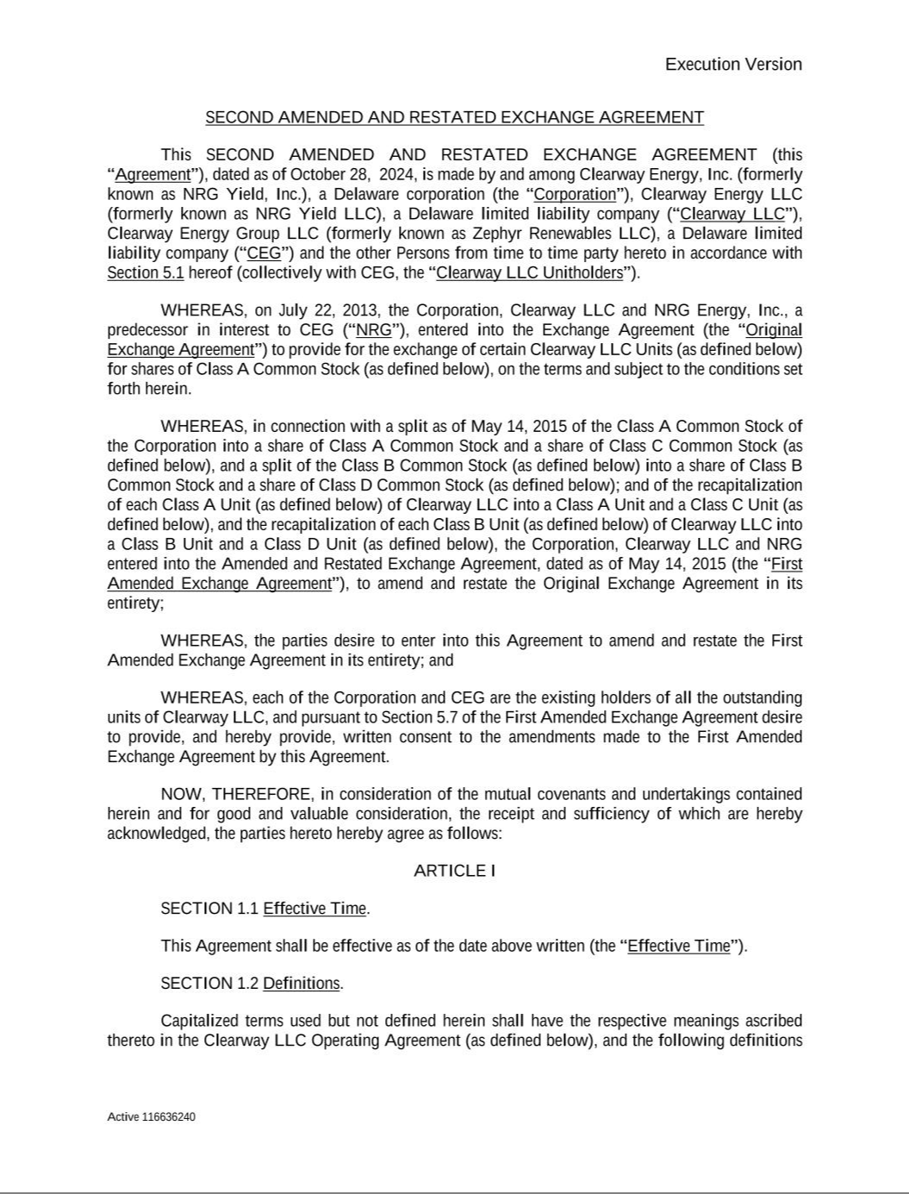

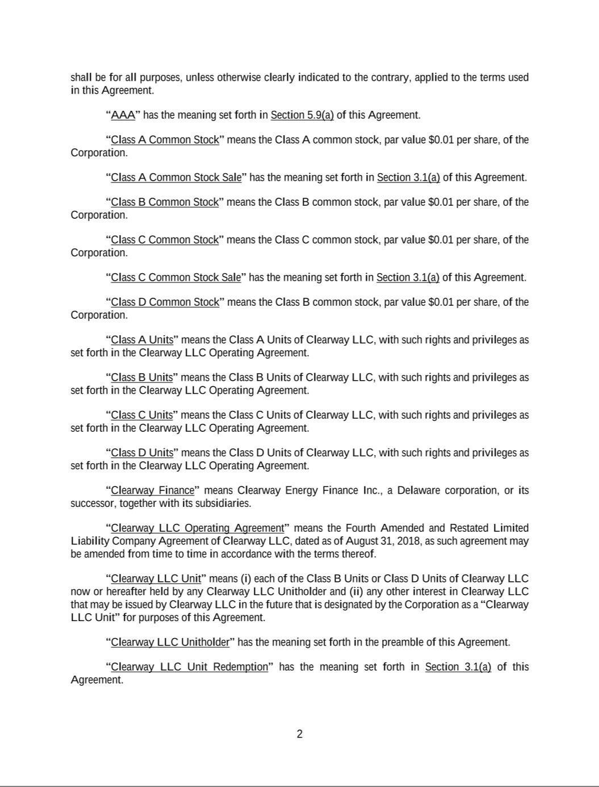

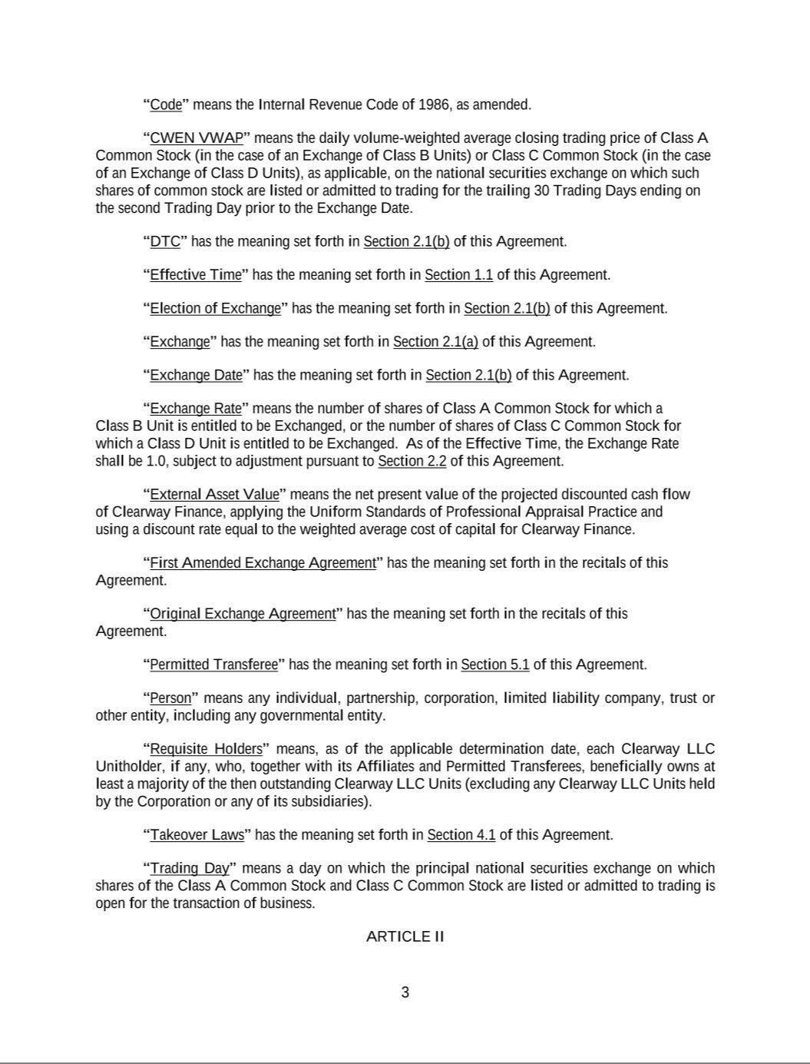

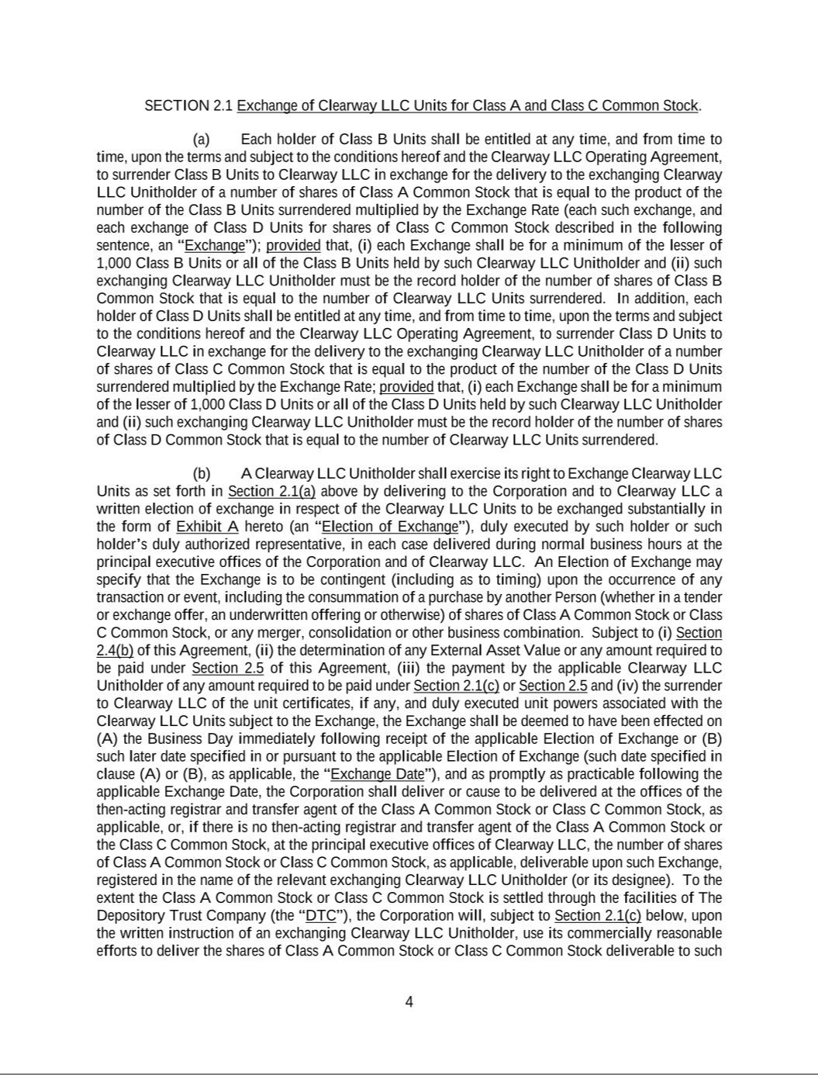

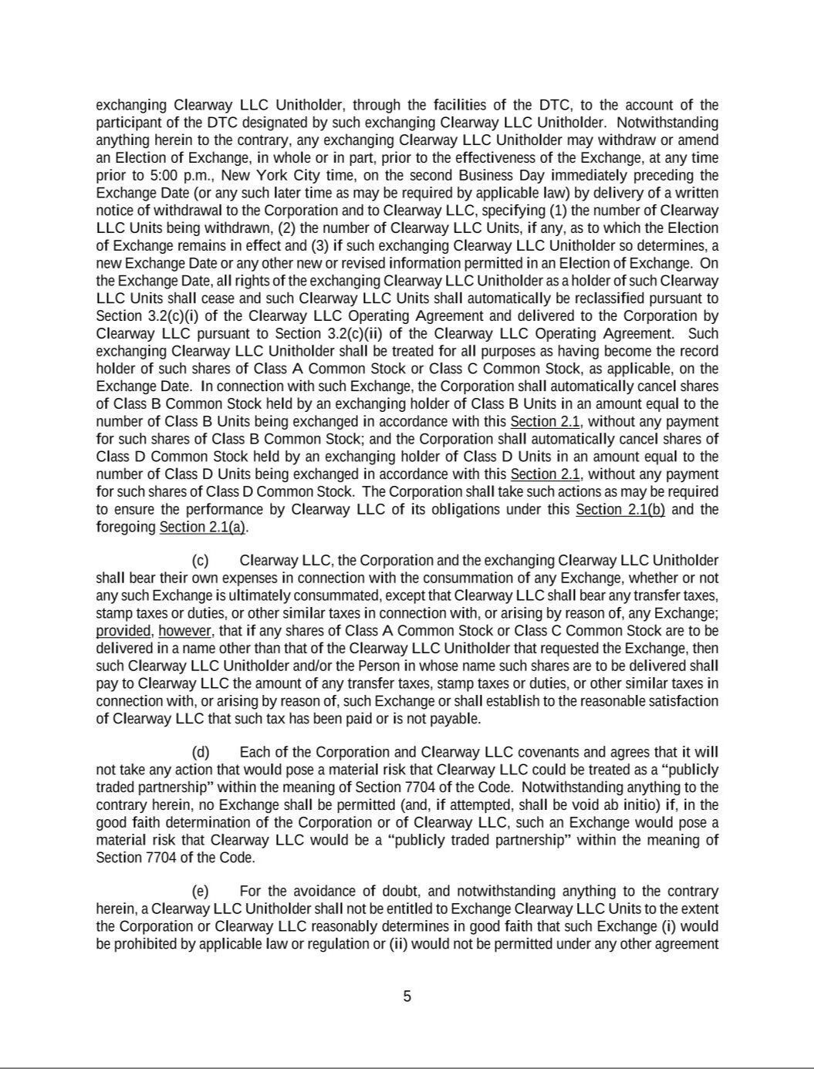

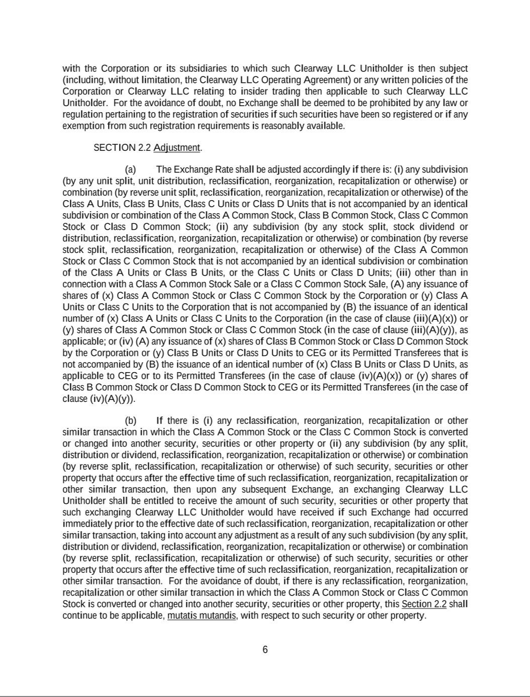

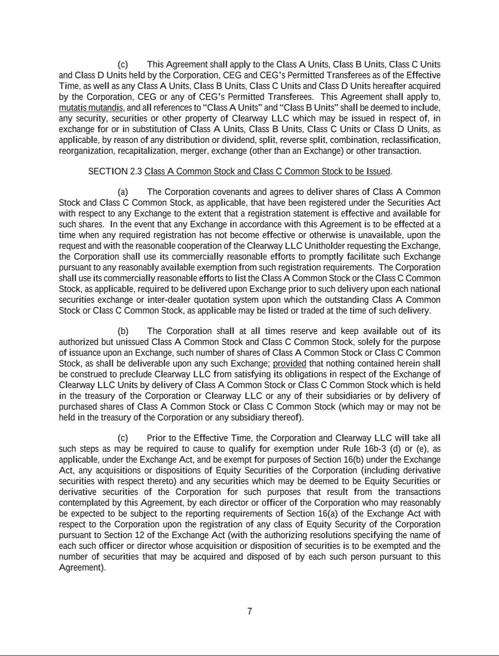

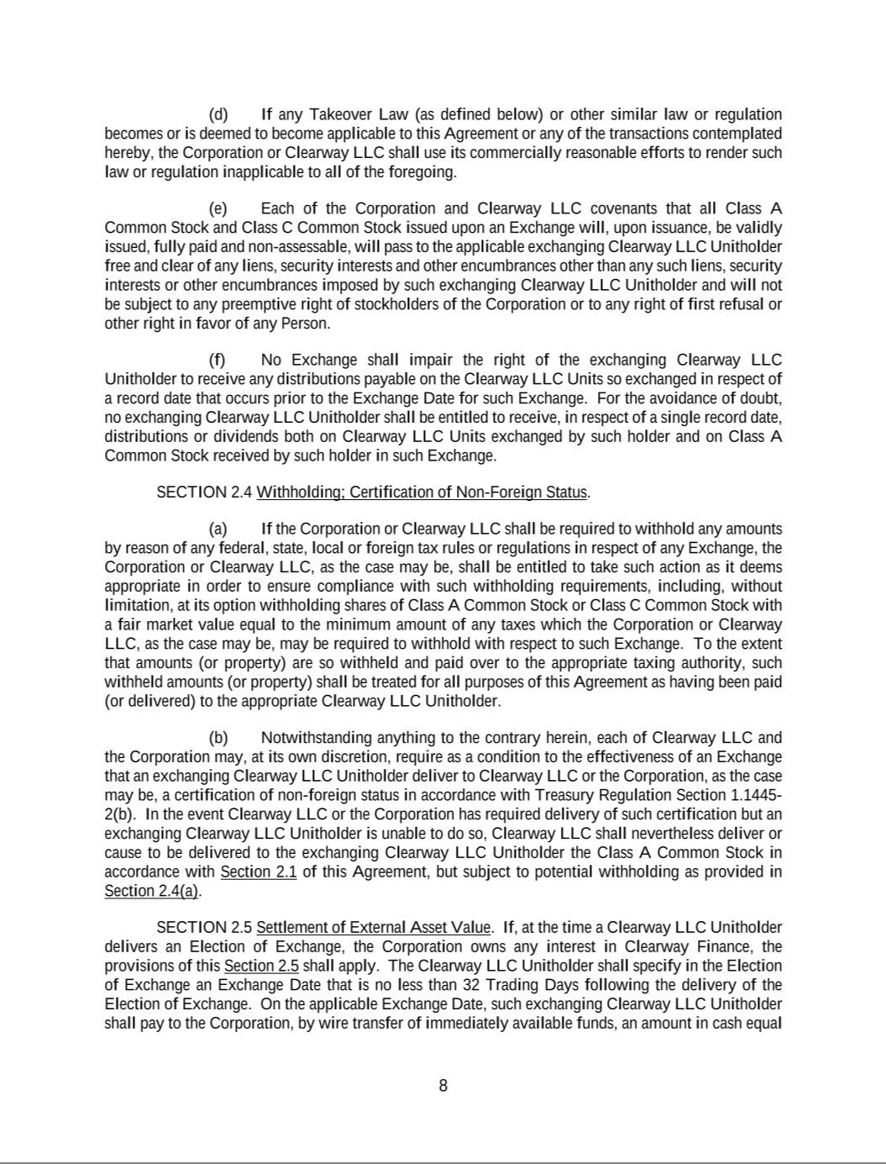

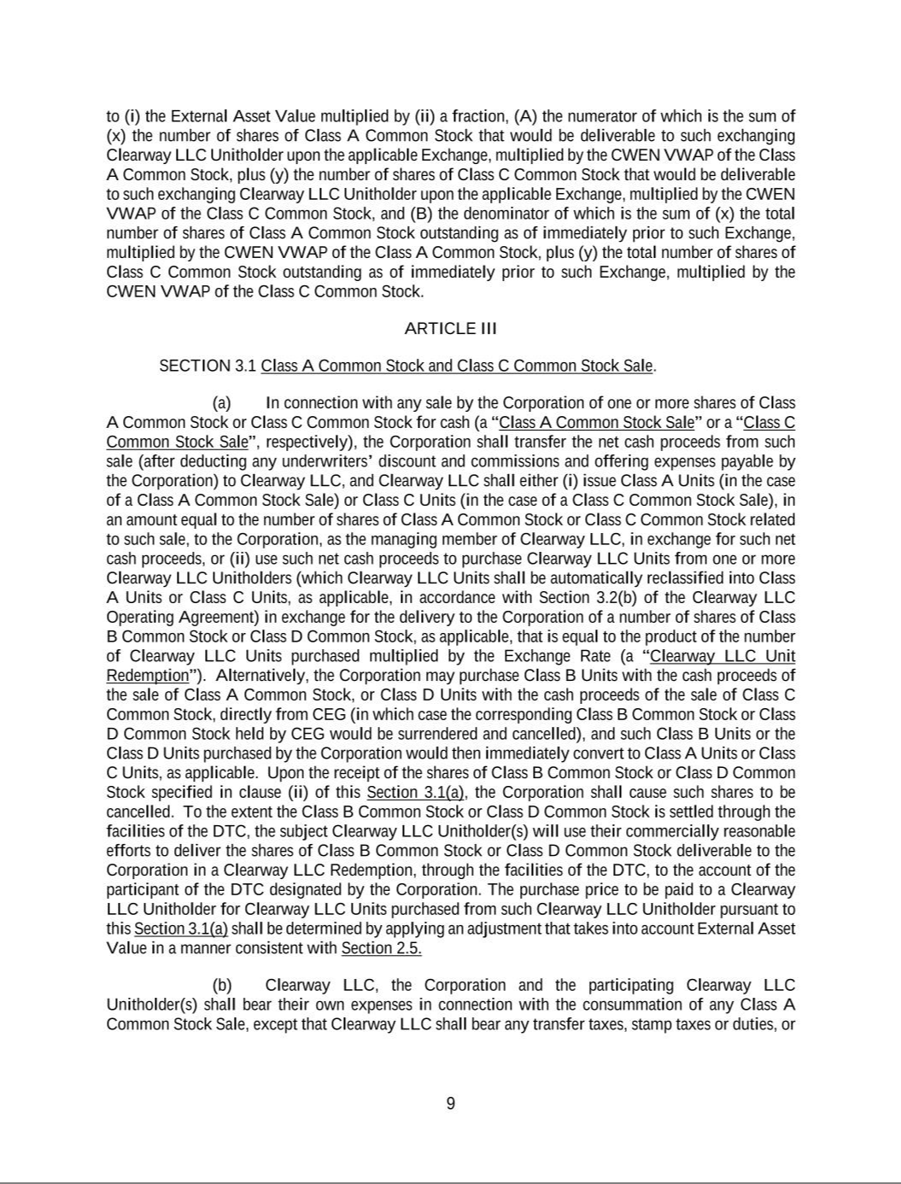

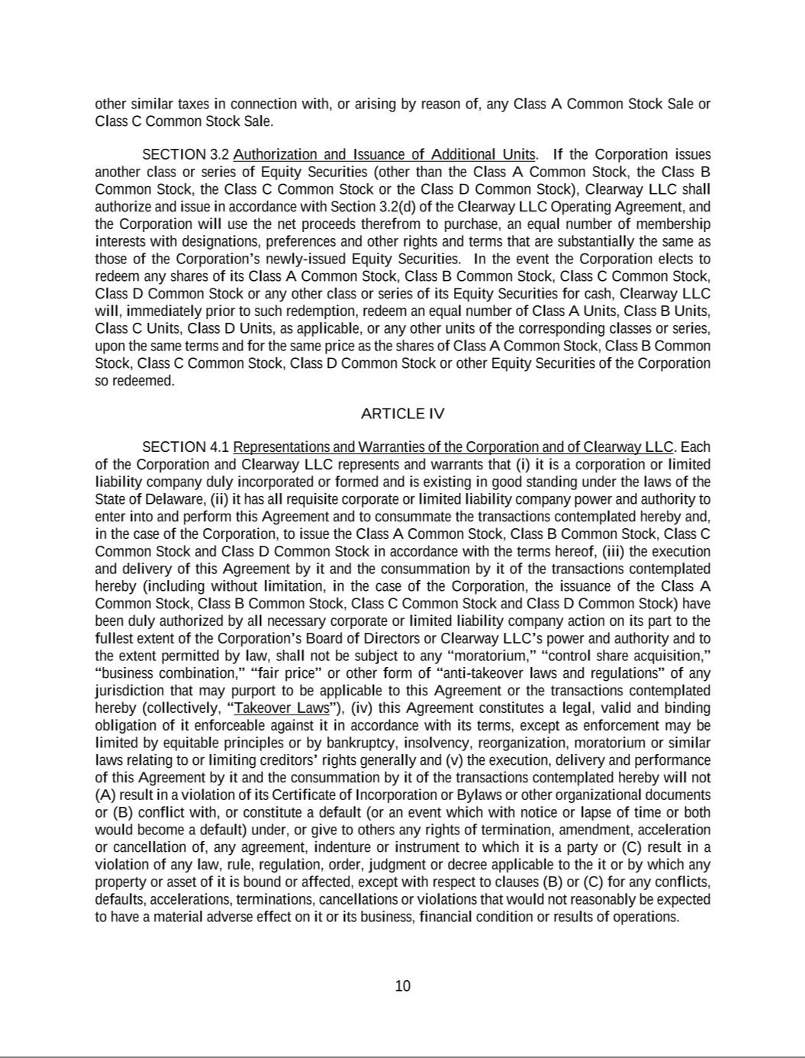

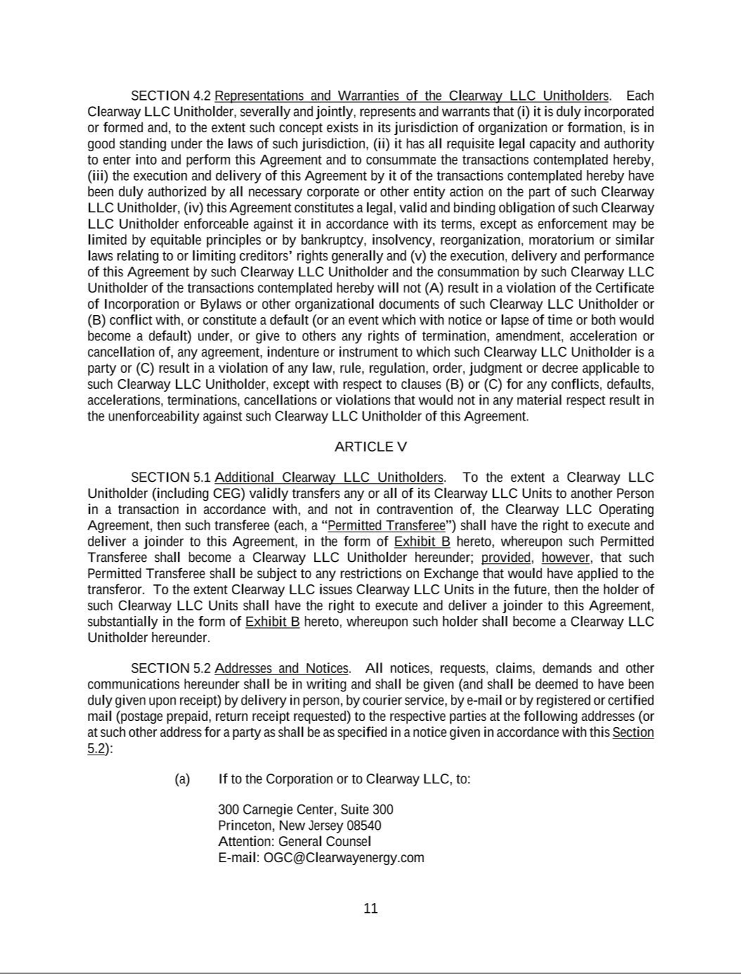

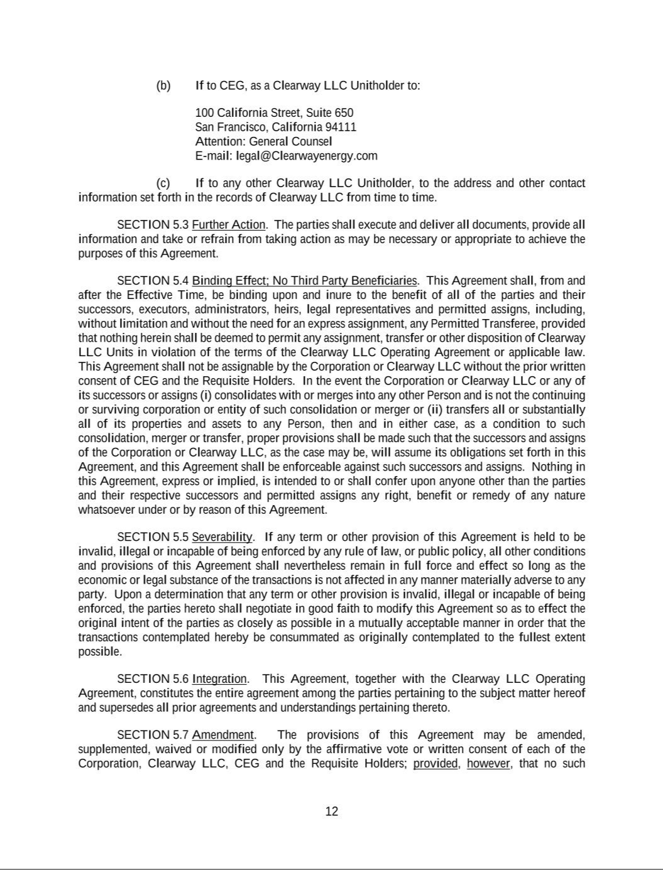

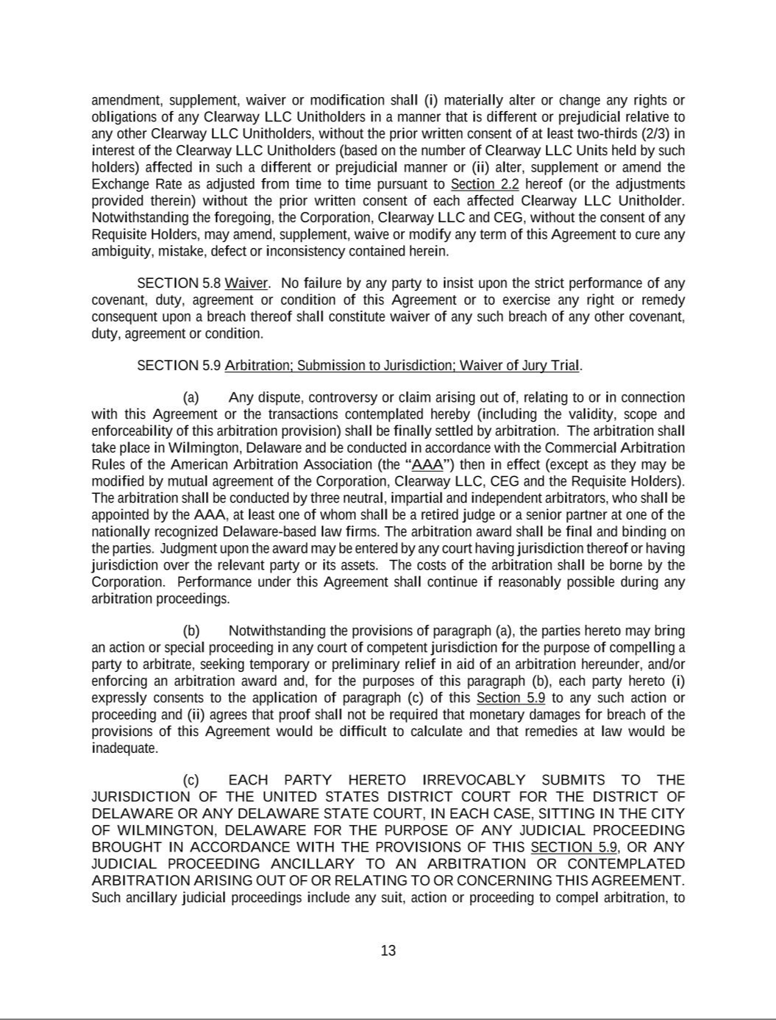

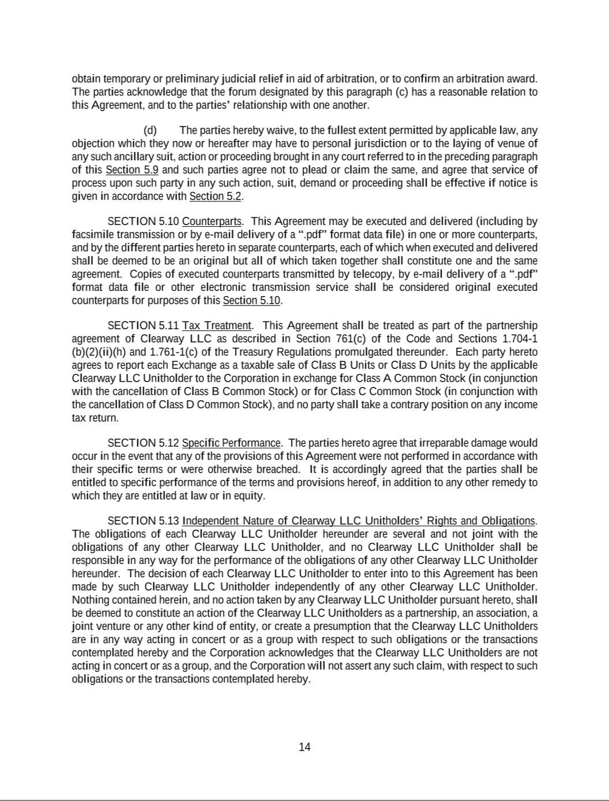

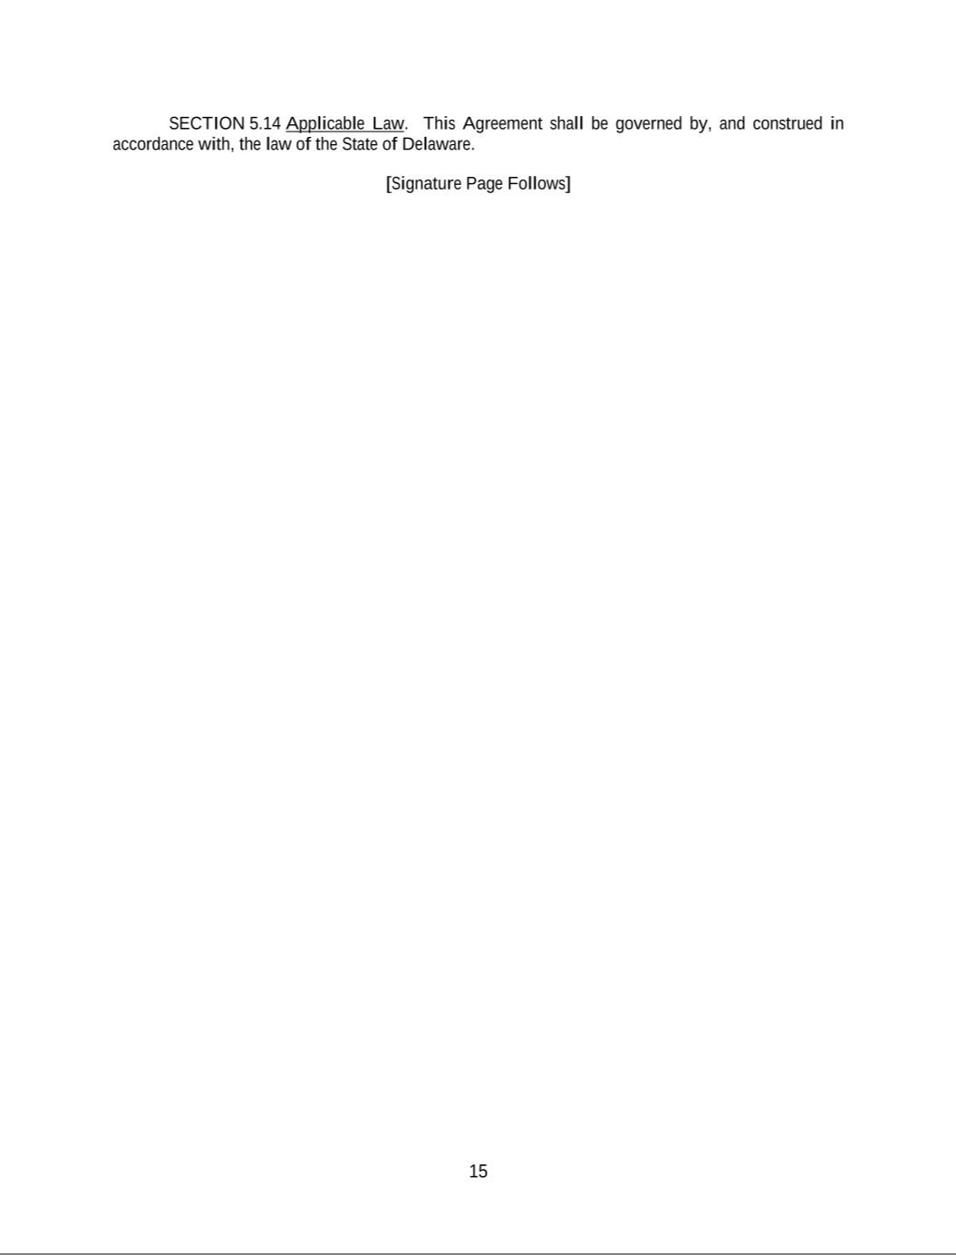

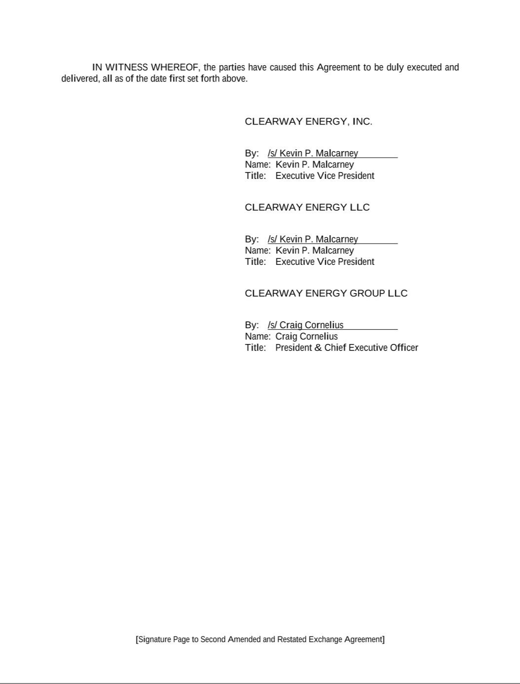

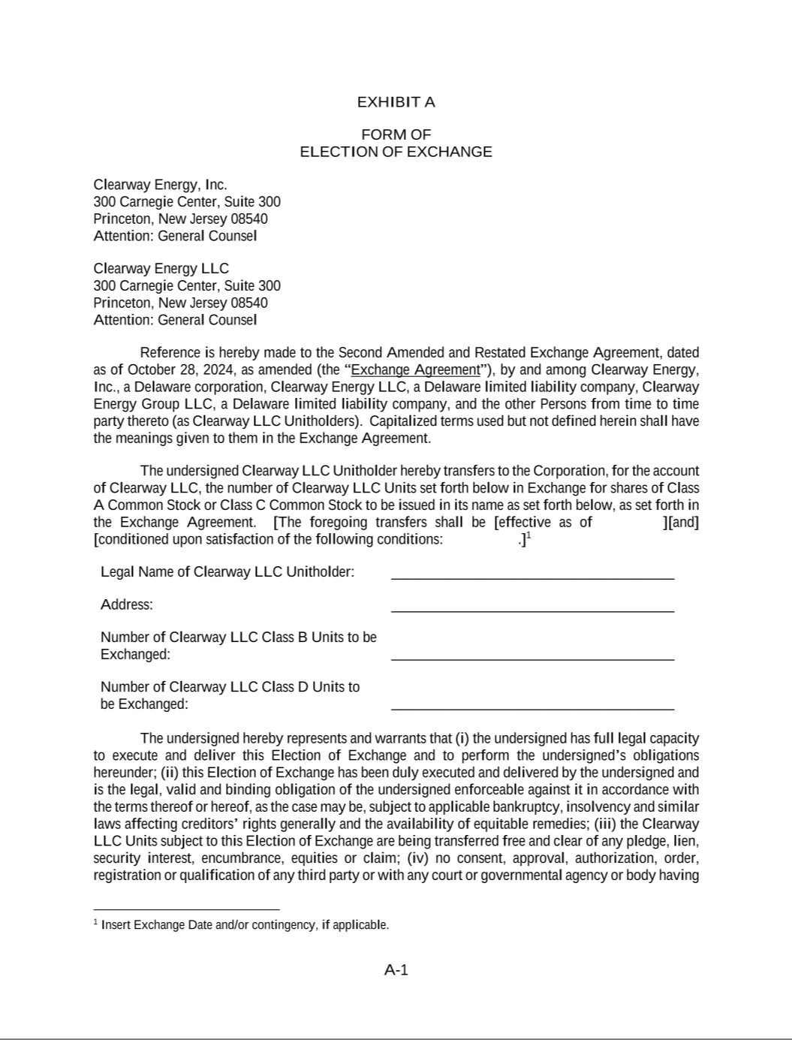

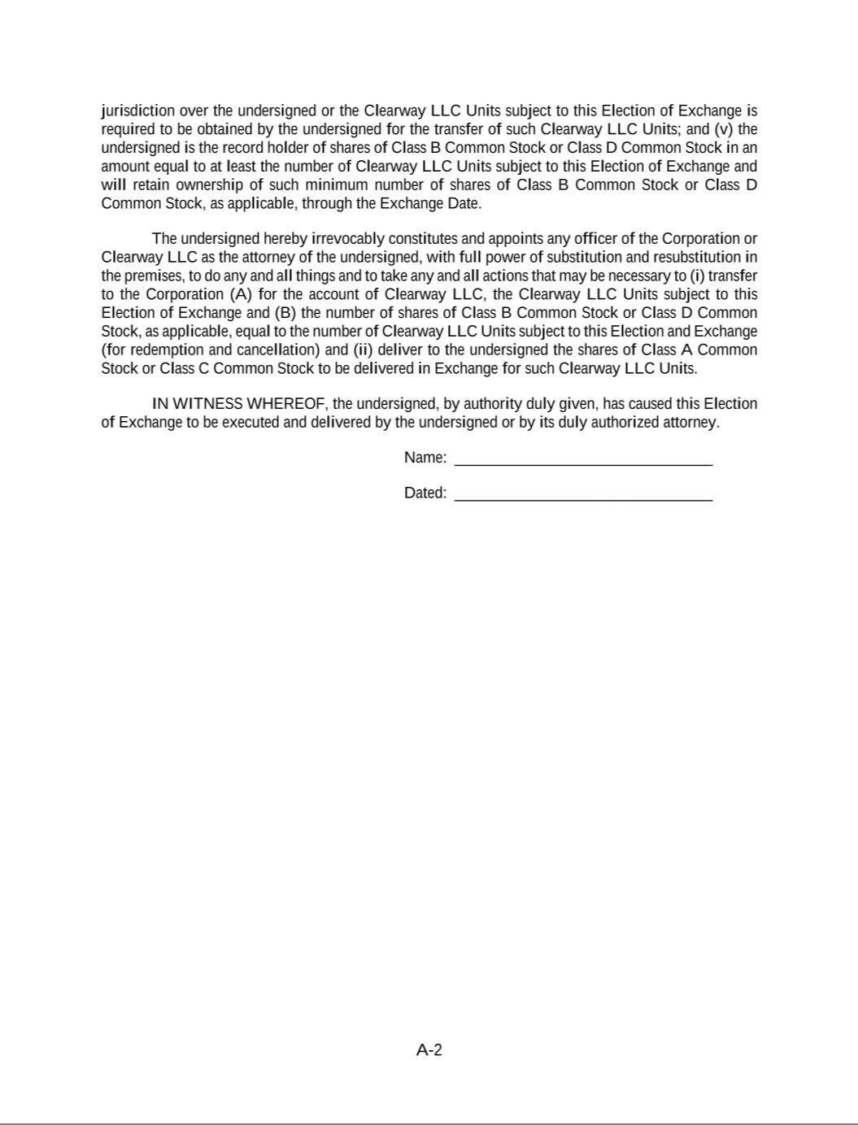

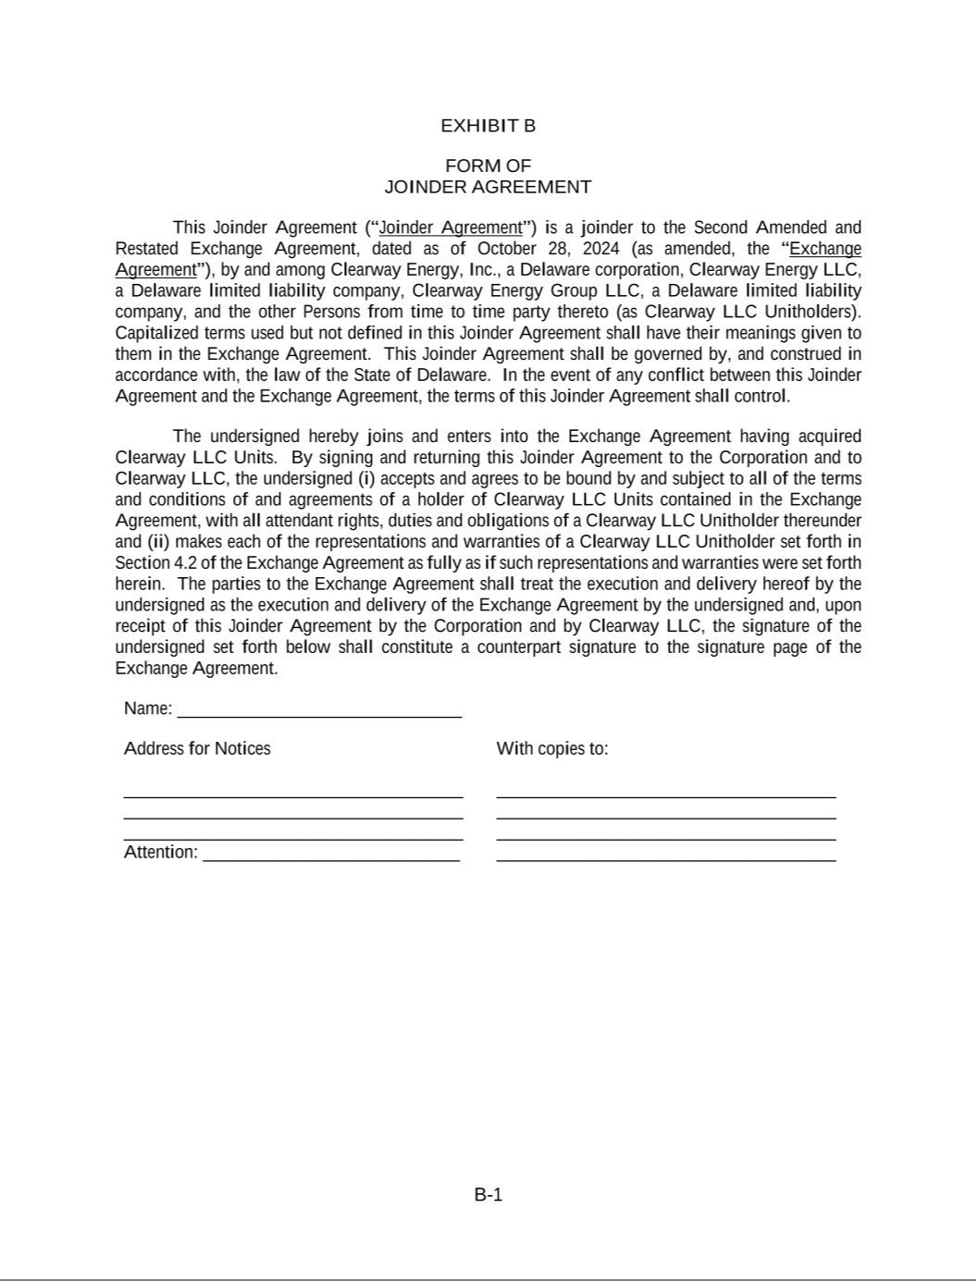

EXHIBIT 31.1

CERTIFICATION

I, Craig Cornelius, certify that:

- I have reviewed this quarterly report on Form 10-Q of Clearway Energy, Inc.;

- Based on my knowledge, this report does not contain any untrue statement of a material fact or omit to state a material fact necessary to make the statements made, in light of the circumstances under which such statements were made, not misleading with respect to the period covered by this report;

- Based on my knowledge, the financial statements, and other financial information included in this report, fairly present in all material respects the financial condition, results of operations and cash flows of the registrant as of, and for, the periods presented in this report;

- The registrant's other certifying officers and I are responsible for establishing and maintaining disclosure controls and procedures (as defined in Exchange Act Rules 13a-15(e) and 15d-15(e)) and internal control over financial reporting (as defined in Exchange Act Rules 13a-15(f) and 15d-15(f)) for the registrant and have:

  - Designed such disclosure controls and procedures, or caused such disclosure controls and procedures to be designed under our supervision, to ensure that material information relating to the registrant, including its consolidated subsidiaries, is made known to us by others within those entities, particularly during the period in which this report is being prepared;

  - Designed such internal control over financial reporting, or caused such internal control over financial reporting to be designed under our supervision, to provide reasonable assurance regarding the reliability of financial reporting and the preparation of financial statements for external purposes in accordance with generally accepted accounting principles;

  - Evaluated the effectiveness of the registrant's disclosure controls and procedures and presented in this report our conclusions about the effectiveness of the disclosure controls and procedures, as of the end of the period covered by this report based on such evaluation; and

  - Disclosed in this report any change in the registrant's internal control over financial reporting that occurred during the registrant's most recent fiscal quarter (the registrant's fourth fiscal quarter in the case of an annual report) that has materially affected, or is reasonably likely to materially affect, the registrant's internal control over financial reporting; and

- The registrant's other certifying officers and I have disclosed, based on our most recent evaluation of internal control over financial reporting, to the registrant's auditors and the audit committee of the registrant's board of directors (or persons performing the equivalent functions):

  - All significant deficiencies and material weaknesses in the design or operation of internal control over financial reporting which are reasonably likely to adversely affect the registrant's ability to record, process, summarize and report financial information; and

  - Any fraud, whether or not material, that involves management or other employees who have a significant role in the registrant's internal control over financial reporting.

/s/ CRAIG CORNELIUS

Craig Cornelius
President and Chief Executive Officer
(Principal Executive Officer)

Date: October 30, 2024

EXHIBIT 31.2

CERTIFICATION

I, Sarah Rubenstein, certify that:

- I have reviewed this quarterly report on Form 10-Q of Clearway Energy, Inc.;

- Based on my knowledge, this report does not contain any untrue statement of a material fact or omit to state a material fact necessary to make the statements made, in light of the circumstances under which such statements were made, not misleading with respect to the period covered by this report;

- Based on my knowledge, the financial statements, and other financial information included in this report, fairly present in all material respects the financial condition, results of operations and cash flows of the registrant as of, and for, the periods presented in this report;

- The registrant's other certifying officers and I are responsible for establishing and maintaining disclosure controls and procedures (as defined in Exchange Act Rules 13a-15(e) and 15d-15(e)) and internal control over financial reporting (as defined in Exchange Act Rules 13a-15(f) and 15d-15(f)) for the registrant and have:

  - Designed such disclosure controls and procedures, or caused such disclosure controls and procedures to be designed under our supervision, to ensure that material information relating to the registrant, including its consolidated subsidiaries, is made known to us by others within those entities, particularly during the period in which this report is being prepared;

  - Designed such internal control over financial reporting, or caused such internal control over financial reporting to be designed under our supervision, to provide reasonable assurance regarding the reliability of financial reporting and the preparation of financial statements for external purposes in accordance with generally accepted accounting principles;

  - Evaluated the effectiveness of the registrant's disclosure controls and procedures and presented in this report our conclusions about the effectiveness of the disclosure controls and procedures, as of the end of the period covered by this report based on such evaluation; and

  - Disclosed in this report any change in the registrant's internal control over financial reporting that occurred during the registrant's most recent fiscal quarter (the registrant's fourth fiscal quarter in the case of an annual report) that has materially affected, or is reasonably likely to materially affect, the registrant's internal control over financial reporting; and

- The registrant's other certifying officers and I have disclosed, based on our most recent evaluation of internal control over financial reporting, to the registrant's auditors and the audit committee of the registrant's board of directors (or persons performing the equivalent functions):

  - All significant deficiencies and material weaknesses in the design or operation of internal control over financial reporting which are reasonably likely to adversely affect the registrant's ability to record, process, summarize and report financial information; and

  - Any fraud, whether or not material, that involves management or other employees who have a significant role in the registrant's internal control over financial reporting.

/s/ SARAH RUBENSTEIN

Sarah Rubenstein
Executive Vice President and Chief Financial
Officer
(Principal Financial Officer and Principal
Accounting Officer)

Date: October 30, 2024

EXHIBIT 32

CERTIFICATION PURSUANT TO

18 U.S.C. SECTION 1350,

AS ADOPTED PURSUANT TO

SECTION 906 OF THE SARBANES-OXLEY ACT OF 2002

In connection with the Quarterly Report of Clearway Energy, Inc. on Form 10-Q for the quarter ended September 30, 2024, as filed with the Securities and Exchange Commission on the date hereof (the “Form 10-Q”), each of the undersigned officers of the Company certifies, pursuant to 18 U.S.C. Section 1350, as adopted pursuant to Section 906 of the Sarbanes-Oxley Act of 2002, that, to such officer's knowledge:

- The Form 10-Q fully complies with the requirements of Section 13(a) or 15(d) of the Securities Exchange Act of 1934; and

- The information contained in the Form 10-Q fairly presents, in all material respects, the financial condition and results of operations of the Company as of the dates and for the periods expressed in the Form 10-Q.

Date: October 30, 2024

/s/ CRAIG CORNELIUS

Craig Cornelius

President and Chief Executive Officer
(Principal Executive Officer)

/s/ SARAH RUBENSTEIN

Sarah Rubenstein

Executive Vice President and Chief Financial Officer
(Principal Financial Officer and Principal Accounting Officer)

The foregoing certification is being furnished solely pursuant to 18 U.S.C. Section 1350 and is not being filed as part of this Form 10-Q or as a separate disclosure document.

A signed original of this written statement required by Section 906, or other document authenticating, acknowledging or otherwise adopting the signature that appears in typed form within the electronic version of this written statement required by Section 906, has been provided to Clearway Energy, Inc. and will be retained by Clearway Energy, Inc. and furnished to the Securities and Exchange Commission or its staff upon request.

