Use these links to rapidly review the document

Table of Contents

Table of Contents

As filed with the United States Securities and Exchange Commission on May 9, 2017

No. 333-

UNITED STATES

SECURITIES AND EXCHANGE COMMISSION

Washington, D.C. 20549

FORM S-4

REGISTRATION STATEMENT

UNDER

THE SECURITIES ACT OF 1933

NRG Yield LLC

NRG Yield Operating LLC*

(Exact name of registrant as specified in its charter)

Delaware |  | 4911 | 32-0407370
Delaware |  | 4911 | 30-0780012
(State or other jurisdiction of |  | (Primary Standard Industrial | (I.R.S. Employer
incorporation or |  | Classification Code Number) | Identification No.)
organization)

804 Carnegie Center, Princeton, NJ 08540

Telephone: (609) 524-4500
(Address, including zip code, and telephone number, including
area code, of registrant's principal executive offices)

 | Copies to:
David R. Hill | Gerald T. Nowak, P.C.
Executive Vice President and General | Paul D. Zier
Counsel | Kirkland & Ellis LLP
804 Carnegie Center | 300 North LaSalle Street
Princeton, NJ 08540 | Chicago, Illinois 60654
Telephone: (609) 524-4500 | (312) 862-2000

(Name, address, including zip code, and telephone number, including

area code, of agent for service)

Approximate date of commencement of proposed sale of the securities to the public:

The exchange will occur as soon as practicable after the effective date of this Registration Statement.

If the securities being registered on this Form are being offered in connection with the formation of a holding company and there is compliance with General Instruction G, check the following box. o

If this Form is filed to register additional securities for an offering pursuant to Rule 462(b) under the Securities Act, check the following box and list the Securities Act registration statement number of the earlier effective registration statement for the same offering. o

If this Form is a post-effective amendment filed pursuant to Rule 462(d) under the Securities act, check the following box and list the Securities Act registration statement number of the earlier effective registration statement for the same offering. o

Indicate by check mark whether the registrant is a large accelerated filer, an accelerated filer, a non-accelerated filer, smaller reporting company, or an emerging growth company. See the definitions of "large accelerated filer," "accelerated filer," "smaller reporting company," and "emerging growth company" in Rule 12b-2 of the Exchange Act. (Check one):

Large accelerated filer o

Accelerated filer o

Non-accelerated filer ☒

(Do not check if a
smaller reporting company)

Smaller reporting company o

Emerging growth company o

If an emerging growth company, indicate by check mark if the registrant has elected not to use the extended transition period for complying with any new or revised financial accounting standards provided pursuant to Section 7(a)(2)(B) of the Securities Act. o

If applicable, place an X in the box to designate the appropriate rule provision relied upon in conducting this transaction:

Exchange Act Rule 13e-4(i) (Cross-Border Issuer Tender Offer): o

Exchange Act Rule 14d-1(d) (Cross-Border Third-Party Tender Offer): o

CALCULATION OF REGISTRATION FEE

 |  |  | Proposed Maximum
 | Title of Each Class of Securities | Amount to be | Offering Price Per | Amount of
 | to be Registered | Registered | Unit(1) | Registration Fee
 | 5.000% Senior Notes due 2026 | $350,000,000 | 100% | $40,565
Guarantees related to the 5.000% Senior Notes due 2026(2) |  | — | — | —(3)

- Calculated in accordance with Rule 457 under the Securities Act of 1933, as amended.

- No separate consideration was received for the issuance of the guarantees.

- Pursuant to Rule 457(n), no separate fee is payable with respect to the guarantees being registered hereby.

The Registrants hereby amend this Registration Statement on such date or dates as may be necessary to delay its effective date until the Registrants shall file a further amendment which specifically states that this Registration Statement shall thereafter become effective in accordance with Section 8(a) of the Securities Act of 1933 or until this Registration Statement shall become effective on such date as the Commission, acting pursuant to said Section 8(a), may determine.

- The additional Co-Registrants listed on the next page are also included in this Form S-4 Registration Statement as additional Registrants.

Table of Contents

Table of Additional Registrants

 |  |  | Jurisdiction of |  | I.R.S. Employer
Exact Name of Additional Registrants* |  |  | Formation |  | Identification No.
Alta Wind 1-5 Holding Company, LLC |  |  | Delaware | 35-2526443
Alta Wind Company, LLC |  |  | Delaware | 47-2576803
NRG Energy Center Omaha LLC |  |  | Delaware | 35-2492633
NRG Energy Center Omaha Holdings LLC |  |  | Delaware | 46-4164574
NRG Yield DGPV Holding LLC |  |  | Delaware | 47-3724471
NRG South Trent Holdings LLC |  |  | Delaware | 27-2207561
NRG Yield RPV Holding LLC |  |  | Delaware | 47-2898953
NYLD Fuel Cell Holdings LLC |  |  | Delaware | 47-2588093
UB Fuel Cell, LLC |  |  | Connecticut | 46-5519511

- The address for each of the additional Registrants is c/o NRG Yield Operating LLC, 804 Carnegie Center, Princeton, NJ 08540, telephone: (609) 524-4500. The primary standard industrial classification number for each of the additional Registrants is 4911.

The name, address, including zip code of the agent for service for each of the additional Registrants is David R. Hill, Executive Vice President and General Counsel of NRG Yield, Inc., 804 Carnegie Center, Princeton, NJ 08540, Telephone: (609) 524-4500.

Table of Contents

The information in this prospectus is not complete and may be changed. We may not sell these securities until the registration statement filed with the Securities and Exchange Commission is effective. The prospectus is not an offer to sell these securities nor a solicitation of an offer to buy these securities in any jurisdiction where the offer and sale is not permitted.

Subject to Completion Dated May 9, 2017

PRELIMINARY PROSPECTUS


NRG Yield Operating LLC

Exchange Offer for

$350,000,000 5.000% Senior Notes due 2026

We are offering to exchange:

up to $350,000,000 of our new 5.000% Senior Notes due 2026

(which we refer to as the "Exchange Notes")

for

a like amount of our outstanding 5.000% Senior Notes due 2026

(which we refer to as the "Old Notes")

We refer to the Exchange Notes and Old Notes collectively as the "notes."

Material Terms of Exchange Offer:

- The terms of the Exchange Notes to be issued in the exchange offer are substantially identical to the Old Notes, except that the transfer restrictions and registration rights relating to the Old Notes will not apply to the Exchange Notes.

- The Exchange Notes will be guaranteed on a full and unconditional and joint and several basis by each of our current and future subsidiaries that guarantees indebtedness under our Revolving Credit Facility (as defined herein).

- There is no existing public market for the Old Notes or the Exchange Notes. We do not intend to list the Exchange Notes on any securities exchange or seek approval for quotation through any automated trading system.

- You may withdraw your tender of Old Notes at any time before the expiration of the exchange offer. We will exchange all of the Old Notes that are validly tendered and not withdrawn.

• The exchange offer expires at 12:00 midnight, New York City time, on , 2017, unless extended.

- The exchange of Old Notes will not be a taxable event for U.S. federal income tax purposes.

- The exchange offer is subject to certain customary conditions, including that it not violate applicable law or any applicable interpretation of the Staff of the Securities and Exchange Commission (the "SEC").

- We will not receive any proceeds from the exchange offer.

For a discussion of certain factors that you should consider before participating in this exchange offer, see "Risk Factors" beginning on page 15 of this prospectus.

Neither the SEC nor any state securities commission has approved the notes to be distributed in the exchange offer, nor have any of these organizations determined that this prospectus is truthful or complete. Any representation to the contrary is a criminal offense.

Each broker-dealer that receives Exchange Notes for its own account pursuant to this exchange offer must acknowledge that it will deliver a prospectus in connection with any resale of such Exchange Notes. The letter of transmittal accompanying this prospectus states that by so acknowledging and by delivering a prospectus, a broker-dealer will not be deemed to admit that it is an "underwriter" within the meaning of the Securities Act of 1933, as amended (the "Securities Act"). This prospectus, as it may be amended or supplemented from time to time, may be used by a broker-dealer in connection with resales of Exchange Notes where the Old Notes were acquired by such broker-dealer as a result of market-making activities or other trading activities. We have agreed that, starting on the expiration date and ending on the close of business one year after the expiration date, we will make this prospectus available, as amended or supplemented, to any broker-dealer for use in connection with any such resale. See "Plan of Distribution."

, 2017

Table of Contents
 |  |  |  |  |  |  |  |  |  |  |  |  |  |  |  |  | Table of Contents
 | WHERE YOU CAN FIND MORE INFORMATION |  |  |  |  |  |  |  |  |  |  |  |  |  |  |  |  |  |  |  |  |  | i
 | INCORPORATION BY REFERENCE |  |  |  |  |  |  |  |  |  |  |  |  |  |  |  |  |  |  |  |  | ii
 | SUMMARY |  |  |  |  |  |  |  |  |  |  |  |  |  |  |  |  |  |  |  |  | 1
 | SUMMARY OF THE EXCHANGE OFFER |  |  |  |  |  |  |  |  |  |  |  |  |  |  |  |  |  |  |  |  | 7
 | CONSEQUENCES OF NOT EXCHANGING OLD NOTES |  |  |  |  |  |  |  |  |  |  |  |  |  |  |  |  |  |  |  |  | 10
 | SUMMARY OF TERMS OF EXCHANGE NOTES |  |  |  |  |  |  |  |  |  |  |  |  |  |  |  |  |  |  |  |  | 11
 | RISK FACTORS |  |  |  |  |  |  |  |  |  |  |  |  |  |  |  |  |  |  |  |  | 15
 | FORWARD-LOOKING STATEMENTS |  |  |  |  |  |  |  |  |  |  |  |  |  |  |  |  |  |  |  |  | 20
 | EXCHANGE OFFER |  |  |  |  |  |  |  |  |  |  |  |  |  |  |  |  |  |  |  |  | 22
 | USE OF PROCEEDS |  |  |  |  |  |  |  |  |  |  |  |  |  |  |  |  |  |  |  |  | 33
 | RATIO OF EARNINGS TO FIXED CHARGES |  |  |  |  |  |  |  |  |  |  |  |  |  |  |  |  |  |  |  |  | 33
 | CAPITALIZATION |  |  |  |  |  |  |  |  |  |  |  |  |  |  |  |  |  |  |  |  | 34
 | DESCRIPTION OF CERTAIN OTHER INDEBTEDNESS |  |  |  |  |  |  |  |  |  |  |  |  |  |  |  |  |  |  |  |  | 35
 | DESCRIPTION OF THE NOTES |  |  |  |  |  |  |  |  |  |  |  |  |  |  |  |  |  |  |  |  | 40
 | BOOK-ENTRY, DELIVERY AND FORM |  |  |  |  |  |  |  |  |  |  |  |  |  |  |  |  |  |  |  |  | 65
 | CERTAIN FEDERAL INCOME TAX CONSEQUENCES |  |  |  |  |  |  |  |  |  |  |  |  |  |  |  |  |  |  |  |  | 67
 | PLAN OF DISTRIBUTION |  |  |  |  |  |  |  |  |  |  |  |  |  |  |  |  |  |  |  |  | 68
 | LEGAL MATTERS |  |  |  |  |  |  |  |  |  |  |  |  |  |  |  |  |  |  |  |  | 69
 | EXPERTS |  |  |  |  |  |  |  |  |  |  |  |  |  |  |  |  |  |  |  |  | 69

WHERE YOU CAN FIND MORE INFORMATION

NRG Yield Operating LLC ("Yield Operating LLC") is not currently required to file annual, quarterly and current reports and other information with the SEC. NRG Yield LLC ("Yield LLC") files periodic reports and other information with the SEC pursuant to Section 15(d) of the Securities Exchange Act of 1934, as amended (the "Exchange Act"). You may read and copy any document Yield LLC has filed or will file with the SEC at the SEC's public website (www.sec.gov) or at the Public Reference Room of the SEC located at 100 F Street, N.E., Washington, DC 20549. Copies of such materials can be obtained from the Public Reference Room of the SEC at prescribed rates. You can call the SEC at 1-800-SEC-0330 to obtain information on the operation of the Public Reference Room.

So long as Yield LLC continues to own, directly or indirectly, all of the equity interests of Yield Operating LLC, the quarterly, annual and current reports and consolidated financial statements referred to above in respect of Yield LLC will be deemed to satisfy the obligations of Yield Operating LLC under the reporting covenant of the indenture governing the notes. See "Description of the Notes—Certain Covenants—Reports."

i

Table of Contents

INCORPORATION BY REFERENCE

The SEC allows us to "incorporate by reference" the information Yield LLC files with them into this prospectus, which means that we can disclose important information to you by referring you to those documents and those documents will be considered part of this prospectus. Information that Yield LLC files later with the SEC will automatically update and supersede the previously filed information. We incorporate by reference the documents listed below and any future filings Yield LLC makes with the SEC under Sections 13(a), 13(c), 14 or 15(d) of the Exchange Act, until the completion of the exchange offer (other than portions of these documents deemed to be "furnished" or not deemed to be "filed," including the portions of these documents that are either (1) described in paragraphs (d)(1), (d)(2), (d)(3) or (e)(5) of Item 407 of Regulation S-K promulgated by the SEC or (2) furnished under Item 2.02 or Item 7.01 of a current report on Form 8-K, including any exhibits included with such Items):

- Yield LLC's annual report on Form 10-K for the year ended December 31, 2016 filed on February 28, 2017, which we refer to as our "2016 Form 10-K";

- Yield LLC's quarterly report on Form 10-Q for the quarter ended March 31, 2017 filed on May 2, 2017, which we refer to as our "First Quarter Form 10-Q"; and

- Yield LLC's current reports on Form 8-K filed on February 3, 2017 and May 9, 2017.

Furthermore, all filings Yield LLC makes with the SEC under Sections 13(a), 13(c), 14 or 15(d) of the Exchange Act after the date of the initial filing of this registration statement and prior to effectiveness of the registration statement (other than portions of these documents deemed to be "furnished" or not deemed to be "filed," including the portions of these documents that are either (1) described in paragraphs (d)(1), (d)(2), (d)(3) or (e)(5) of Item 407 of Regulation S-K promulgated by the SEC or (2) furnished under Item 2.02 or Item 7.01 of a current report on Form 8-K, including any exhibits included with such Items) shall be deemed to be incorporated by reference into this prospectus.

If you make a request for such information in writing or by telephone, we will provide you, without charge, a copy of any or all of the information incorporated by reference in this prospectus. Any such request should be directed to:

NRG Yield Operating LLC

804 Carnegie Center

Princeton, NJ 08540

- 524-4500

Attention: General Counsel

You should rely only on the information contained in, or incorporated by reference in, this prospectus. We have not authorized anyone else to provide you with different or additional information. This prospectus does not offer to sell or solicit any offer to buy any notes in any jurisdiction where the offer or sale is unlawful. You should not assume that the information in this prospectus or in any document incorporated by reference is accurate as of any date other than the date on the front cover of the applicable document.

ii

Table of Contents


SUMMARY

This summary highlights selected information appearing elsewhere in this prospectus. This summary is not complete and does not contain all of the information that you should consider before deciding whether to participate in this exchange offer. You should carefully read this summary together with the entire prospectus, including the information set forth in the section entitled "Risk Factors" and the financial statements and related notes thereto, before deciding whether to participate in the exchange offer.

Unless the context otherwise requires or as otherwise indicated, references in this prospectus to "we," "our," "the Company" and "Yield" refer to Yield Operating LLC, together with its consolidated subsidiaries and direct parent Yield LLC and references to "Issuer" refer to Yield Operating LLC, exclusive of its subsidiaries. As of March 31, 2017, NRG Yield, Inc. ("Yield Inc.") (NYSE: NYLD.A, NYLD) owned approximately 53.4% of the economic interests in and was the sole managing member of Yield LLC.

Our Businesses

We are a company formed to serve as the primary vehicle through which NRG Energy, Inc. ("NRG") (NYSE: NRG) owns, operates and acquires contracted renewable and conventional generation and thermal infrastructure assets. We believe we are well positioned to be a premier company for investors seeking stable and growing dividend income from a diversified portfolio of lower-risk high-quality assets.

We own a diversified portfolio of contracted renewable and conventional generation and thermal infrastructure assets in the United States. Our contracted generation portfolio collectively represents 4,879 net MW as of March 31, 2017. Each of these assets sells substantially all of its output pursuant to long-term offtake agreements with creditworthy counterparties. The weighted average remaining contract duration of these offtake agreements was approximately 16 years as of March 31, 2017, based on cash available for distribution ("CAFD"). We also own thermal infrastructure assets with an aggregate steam and chilled water capacity of 1,319 net MWt and electric generation capacity of 123 net MW. These thermal infrastructure assets provide steam, hot and/or chilled water, and, in some instances, electricity, to commercial businesses, universities, hospitals and governmental units in multiple locations, principally through long-term contracts or pursuant to rates regulated by state utility commissions.

Business Strategy

Our primary business strategy is to focus on the acquisition and ownership of assets with predictable, long-term cash flows in order that it may be able to increase the cash distributions to Yield Inc. and NRG over time without compromising the ongoing stability of our business. Our plan for executing this strategy includes the following key components:

Focus on contracted renewable energy and conventional generation and thermal infrastructure assets. We own and operate utility scale and distributed renewable energy and natural gas-fired generation, thermal and other infrastructure assets with proven technologies, low operating risks and stable cash flows. We believe by focusing on this core asset class and leveraging our industry knowledge, we will maximize our strategic opportunities, be a leader in operational efficiency and maximize our overall financial performance.

Growing the business through acquisitions of contracted operating assets. We believe that our base of operations and relationship with NRG provide a platform in the conventional and renewable power generation and thermal sectors for strategic growth through cash accretive and tax advantaged acquisitions complementary to our existing portfolio. In addition to acquiring renewable generation, conventional generation and thermal infrastructure assets from third parties where we believe our knowledge of the market and operating expertise provides us with a competitive advantage, we entered

1

Table of Contents


into a Right of First Offer Agreement with NRG (the "ROFO Agreement"). On February 24, 2017, we amended and restated the ROFO Agreement, expanding the NRG ROFO pipeline with the addition of 234 net MW of utility-scale solar projects, consisting of Buckthorn, a 154 net MW solar facility in Texas, and Hawaii solar projects, which have a combined capacity of 80 net MW. Under the ROFO Agreement, NRG has granted us and our affiliates a right of first offer on any proposed sale, transfer or other disposition of certain assets of NRG until February 24, 2022. In addition to the assets described in the table below which reflects the assets subject to sale, the ROFO Agreement also provides us with a right of first offer with respect to up to $250 million of equity in one or more distributed solar generation portfolios developed by affiliates of NRG, together with the assets listed in the table below (the "NRG ROFO Assets").

 |  |  |  |  | Net
 |  |  |  |  | Capacity
Asset |  |  | Fuel Type |  | (MW)(1) |  | COD
 |  |  | Solar | 195 |  |  | 2013
Ivanpah(2) |  |  | Solar |  |  |  | 2013
Agua Caliente(3) |  |  | Solar | 102 |  |  | 2014
Buckthorn |  |  | Solar | 154 |  |  | 2018
Hawaii |  |  | Solar | 80 |  |  | 2019
Carlsbad |  |  | Conventional | 527 |  |  | 2018
Puente/Mandalay |  |  | Conventional | 262 |  |  | 2020
Wind TE Holdco(4):
Elkhorn Ridge |  |  | Wind | 13 |  |  | 2009
San Juan Mesa |  |  | Wind | 22 |  |  | 2005
Wildorado |  |  | Wind | 40 |  |  | 2007
Crosswinds |  |  | Wind | 5 |  |  | 2007
Forward |  |  | Wind | 7 |  |  | 2008
Hardin |  |  | Wind | 4 |  |  | 2007
Odin |  |  | Wind | 5 |  |  | 2007
Sleeping Bear |  |  | Wind | 24 |  |  | 2007
Spanish Fork |  |  | Wind | 5 |  |  | 2008
Goat Wind |  |  | Wind | 37 |  |  | 2008/2009
Lookout |  |  | Wind | 9 |  |  | 2008
Elbow Creek |  |  | Wind | 30 |  |  | 2008
Community |  |  | Wind | 30 |  |  | 2011
Jeffers |  |  | Wind | 50 |  |  | 2008
Minnesota Portfolio(5) |  |  | Wind | 38 |  |  | 2003/2006

- Represents the maximum, or rated, electricity generating capacity of the facility in MW multiplied by NRG's percentage ownership interest in the facility as of March 31, 2017.

- Represents 49.95% of NRG's 50.01% ownership interest in Ivanpah. Following a sale of this 49.95% interest, the remaining 50.05% of Ivanpah would be owned by NRG, Google Inc. and BrightSource Energy Inc.

- Represents NRG's 35% ownership interest in Agua Caliente. 49% of Agua Caliente is owned by BHE AC Holdings, LLC. As further described below, we acquired 16% of Agua Caliente from NRG on March 27, 2017.

- Represents NRG's remaining 25% of the Class B interests of NRG Wind TE Holdco. NRG Yield, Inc. acquired 75% of the Class B interests in November 2015. A tax equity investor owns the Class A interests in NRG Wind TE Holdco.

- Includes Bingham Lake, Eastridge, and Westridge projects.

2

Table of Contents


NRG is not obligated to sell the remaining NRG ROFO Assets to us and, if offered by NRG, we cannot be sure whether these assets will be offered on acceptable terms, or that we will choose to consummate such acquisitions. In addition, NRG may offer additional assets to us, as described in the "Management's Discussion and Analysis of Financial Condition and Results of Operations" section of our 2016 Form 10-K.

On March 27, 2017, we acquired the following interests from NRG: (i) Agua Caliente Borrower 2 LLC, which owns a 16% interest (approximately 31% of NRG's 51% interest) in the Agua Caliente solar farm, one of the NRG ROFO Assets, representing ownership of approximately 46 net MW of capacity, and (ii) NRG's interests in seven utility-scale solar farms located in Utah, which are part of a tax equity structure with Dominion Solar Projects III, Inc. from which we would receive 50% of cash to be distributed. We paid cash consideration of $130 million, plus $1 million of working capital and assumed non-recourse project debt of $328 million, which we consolidate, as well as our pro-rata share of non-recourse project-level debt of $135 million. The purchase price for the acquisition was funded with cash on hand.

On May 1, 2017, NRG offered us the remaining 25% interest in NRG Wind TE Holdco, an 814 net MW portfolio of twelve wind projects. We currently own a 75% interest in the portfolio which we acquired in 2015. The acquisition is subject to approval by Yield Inc.'s independent directors.

Primary focus on North America. We intend to primarily focus our investments in North America (including the unincorporated territories of the United States). We believe that industry fundamentals in North America present it with significant opportunity to acquire renewable, natural gas-fired generation and thermal infrastructure assets, without creating significant exposure to currency and sovereign risk. By primarily focusing our efforts on North America, we believe we will best leverage our regional knowledge of power markets, industry relationships and skill sets to maximize our performance.

Competitive Strengths

Stable, high quality cash flows. Our facilities have a highly stable, predictable cash flow profile consisting of predominantly long-life electric generation assets that sell electricity under long-term fixed priced contracts or pursuant to regulated rates with investment grade and certain other credit-worthy counterparties. Additionally, our facilities have minimal fuel risk. For our conventional assets, fuel is provided by the toll counterparty or the cost thereof is a pass-through cost under the applicable Contract—for—Difference ("CfD"). Renewable facilities have no fuel costs, and most of our thermal infrastructure assets have contractual or regulatory tariff mechanisms for fuel cost recovery. The offtake agreements for our conventional and renewable generation facilities have a weighted-average remaining duration of approximately 16 years as of March 31, 2017, based on CAFD, providing long-term cash flow stability. Our generation offtake agreements with counterparties for whom credit ratings are available have a weighted-average Moody's rating of A3 based on rated capacity under contract. All of our assets are in the United States and accordingly have no currency or repatriation risks.

High quality, long-lived assets with low operating and capital requirements. We benefit from a portfolio of relatively newly-constructed assets, other than thermal infrastructure assets. Our assets are comprised of proven and reliable technologies, provided by leading original solar and wind equipment manufacturers such as General Electric, Siemens AG, SunPower Corporation, First Solar Inc., Vestas Wind Systems A/S, Suzlon Energy Ltd. and Mitsubishi Corporation. Given the modern nature of the portfolio, which includes a substantial number of relatively low operating and maintenance cost solar and wind generation assets, we expect to achieve high fleet availability and expend modest maintenance-related capital expenditures. Additionally, with the support of services provided by NRG, we expect to continue to implement the same rigorous preventative operating and management practices that NRG uses across its fleet of assets.

3

Table of Contents


Significant scale and diversity. We own and operate a large and diverse portfolio of contracted electric generation and thermal infrastructure assets. As of March 31, 2017, our 4,879 net MW contracted generation portfolio benefits from significant diversification in terms of technology, fuel type, counterparty and geography. Our thermal business consists of 12 operations, seven of which are district energy centers that provide steam and chilled water to approximately 705 customers, and five of which provide generation. We believe our scale and access to best practices across the fleet improves our business development opportunities through enhanced industry relationships, reputation and understanding of regional power market dynamics. Furthermore, our diversification reduces our operating risk profile and reliance on any single market.

Relationship with NRG. We believe our relationship with NRG, including NRG's expressed intention to maintain a controlling interest in us, provides significant benefits to us, including:

- Management and Operational Expertise. We have access to the significant resources of NRG, the largest competitive power generator in the United States, to support the operational, financial, legal, regulatory and environmental functions of our business.

- Development and Acquisition Track Record. NRG's development and strategic teams are focused on the development and acquisition of renewable and conventional generation assets, which may provide future growth opportunities for us in addition to the assets set forth in the ROFO Agreement. We believe NRG's ownership position in us incentivizes NRG to support our growth strategy, including through the development of renewable and conventional generation projects. During 2016, NRG acquired 1,639 MWs of utility scale solar and wind projects and 107 MWs of distributed generation and community solar projects that are currently under development or in operation.

- Financing Expertise. With the support of NRG, we have been able to achieve a successful track record of sourcing attractive low-cost, long duration capital to fund acquisitions. We expect to continue to realize benefits from NRG's financing and structuring expertise as well as its relationships with financial institutions and other lenders.

Environmentally well-positioned portfolio of assets. As of March 31, 2017, our portfolio of electric generation assets consists of 2,934 net MW of renewable generation capacity that are non-emitting sources of power generation. Our conventional assets consist of the dual fuel-fired GenConn assets as well as the Marsh Landing and Walnut Creek simple cycle natural gas-fired peaking generation facilities and the El Segundo combined cycle natural gas-fired peaking facility. We do not anticipate having to expend any significant capital expenditures in the foreseeable future to comply with current environmental regulations applicable to our generation assets. Taken as a whole, we believe our strategy will be a net beneficiary of current and potential environmental legislation and regulatory requirements that may serve as a catalyst for capacity retirements and improve market opportunities for environmentally well-positioned assets like our assets once such assets' current offtake agreements expire.

Thermal infrastructure business has high entry costs. Significant capital has been invested to construct our thermal infrastructure assets, serving as a barrier to entry in the markets in which such assets operate. As of March 31, 2017, our thermal gross property, plant, and equipment was approximately $472 million. Our thermal district energy centers are located in urban city areas, with the chilled water and steam delivery systems located underground. Constructing underground delivery systems in urban areas requires long lead times for permitting, rights of way and inspections and is costly. By contrast, the incremental cost to add new customers in existing markets is relatively low. Once thermal infrastructure is established, we believe it has the ability to retain customers over long periods of time and to compete effectively for additional business against stand-alone on-site heating and cooling generation facilities. Installation of stand-alone equipment can require significant

4

Table of Contents
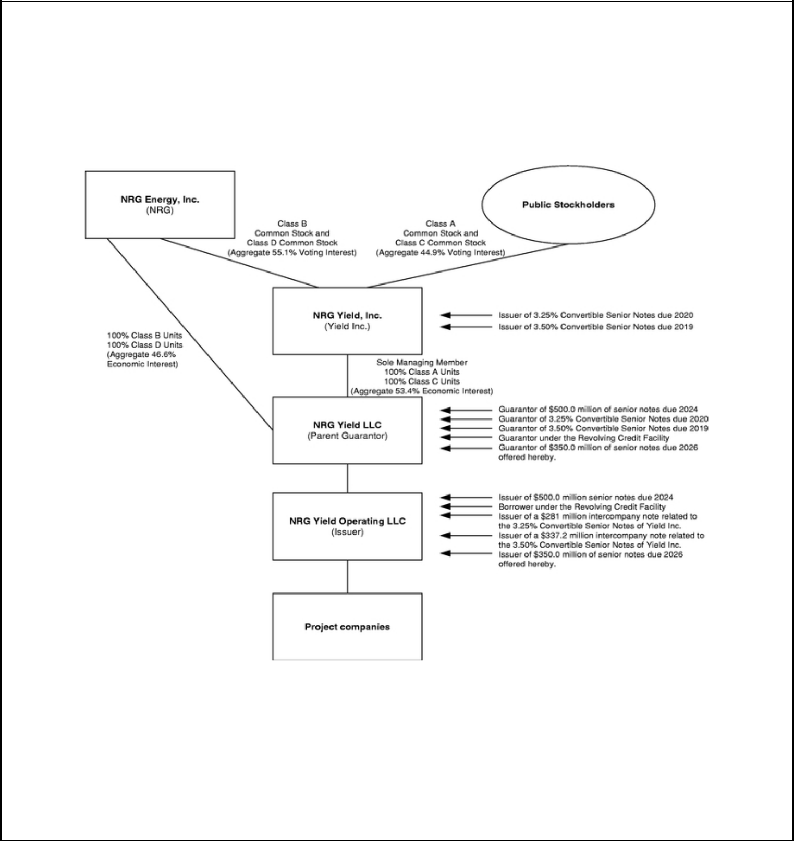

modification to a building as well as significant space for equipment and funding for capital expenditures. Our system technologies often provide economies of scale in terms of fuel procurement, ability to switch between multiple types of fuel to generate thermal energy, and fuel conversion efficiency.

Organizational Structure

As of March 31, 2017, Yield Inc. owned an aggregate 53.4% economic interest in Yield LLC. The following table summarizes certain relevant aspects of our organizational structure:

Summary of Risk Factors

We and our peer group, along with the broader energy sector, have recently experienced volatile conditions in the capital markets, including debt and equity markets, due to continued depressed commodity markets. Additionally, we are subject to a variety of risks related to our competitive position and business strategies. Some of the more significant challenges and risks include if we are unable to to address costs or delays in the construction and operation of new plants, if we are unable to address the volatility in power prices and fuel costs, if we are unable to utilize our leveraged capital structure and if governmental regulation is revised in a such a manner that is less favorable to us. See "Risk Factors" contained elsewhere in this prospectus, the "Risk Factors Related to the Company's Business" section

5

Table of Contents


of our 2016 Form 10-K for a discussion of the factors you should consider before deciding to participate in this exchange offer.

Corporate Information

Both Yield LLC and Yield Operating LLC were formed as Delaware limited liability companies on March 5, 2013. Our principal executive offices are located at NRG Yield Operating LLC, 804 Carnegie Center, Princeton, New Jersey. Our telephone number is (609) 524-4500. Our website is located at http://www.nrgyield.com. Yield Operating LLC is not currently required to file or furnish periodic reports and other information with the SEC pursuant to Section 13(a) or 15(d) of the Securities Exchange Act of 1934, as amended (the "Exchange Act"). See "Incorporation by Reference." Yield LLC files periodic reports and other information with the SEC pursuant to Section 15(d) of the Exchange Act. Information on our website or any other website is not incorporated by reference into this prospectus and does not constitute a part of this prospectus. The SEC maintains an internet site at http://www.sec.gov that contains reports and other information regarding issuers that file electronically with the SEC.

6

Table of Contents


SUMMARY OF THE EXCHANGE OFFER

On August 18, 2016, we sold, through a private placement exempt from the registration requirements of the Securities Act, $350,000,000 of our 5.000% Senior Notes due 2026, which are eligible to be exchanged for Exchange Notes. We refer to these notes as "Old Notes" in this prospectus.

Simultaneously with the private placement, we entered into a registration rights agreement with the initial purchasers of the Old Notes (the "Registration Rights Agreement"). Under the Registration Rights Agreement, we are required to use commercially reasonable efforts to register Exchange Notes with the SEC having substantially identical terms as the Old Notes (except for the provisions relating to the transfer restrictions and payment of additional interest) as part of an offer to exchange freely tradable exchange notes for the notes, and use commercially reasonable efforts to consummate the exchange offer within 365 days after the issue date of the Old Notes. If required under certain circumstances, Yield Operating LLC and the guarantors will file a shelf registration statement with the SEC covering resales of the notes.

We refer to the notes to be registered under this exchange offer registration statement as "Exchange Notes" and collectively with the Old Notes, we refer to them as the "notes" in this prospectus. You may exchange your Old Notes for the applicable Exchange Notes in this exchange offer. You should read the discussion under the headings "—Summary of Terms of Exchange Notes," "Exchange Offer" and "Description of the Notes" for further information regarding the Exchange Notes.

Exchange Notes offered | $350,000,000 aggregate principal amount of 5.000% Senior Notes due
 | 2026.
Exchange offer | We are offering to exchange the Old Notes for a like principal amount at
 | maturity of the Exchange Notes. Old Notes may be exchanged only in
 | minimum principal amounts of $2,000 and integral multiples of $1,000 in
 | excess thereof. The exchange offer is being made pursuant to the
 | Registration Rights Agreement which grants the initial purchasers and any
 | subsequent holders of the Old Notes certain exchange and registration
 | rights. This exchange offer is intended to satisfy those exchange and
 | registration rights with respect to the Old Notes. After the exchange offer is
 | complete, you will no longer be entitled to any exchange or registration
 | rights with respect to your Old Notes.
Expiration date; Withdrawal of tender | The exchange offer will expire at 12:00 midnight, New York City time,
 | on | , 2017, or a later time if we choose to extend this exchange
 | offer in our sole and absolute discretion. You may withdraw your tender of
 | Old Notes at any time prior to 12:00 midnight, New York City time, on the
 | expiration date. All outstanding Old Notes that are validly tendered and not
 | validly withdrawn will be exchanged. We will issue the Exchange Notes
 | promptly after the expiration of the exchange offer. Any Old Notes not
 | accepted by us for exchange for any reason will be returned to you at our
 | expense promptly after the expiration or termination of the exchange offer.
 | 7

Table of Contents


Resales We believe that you can offer for resale, resell and otherwise transfer the

Exchange Notes without complying with the registration and prospectus

delivery requirements of the Securities Act so long as:

• you acquire the Exchange Notes in the ordinary course of business;

• you are not participating, do not intend to participate, and have no

arrangement or understanding with any person to participate, in the

distribution of the Exchange Notes;

• you are not an affiliate of ours; and

• you are not a broker-dealer.

If any of these conditions is not satisfied and you transfer any Exchange

Notes without delivering a proper prospectus or without qualifying for a

registration exemption, you may incur liability under the Securities Act.

We do not assume, or indemnify you against, any such liability.

Broker-Dealer Each broker-dealer acquiring Exchange Notes issued for its own account in

exchange for Old Notes, which it acquired through market-making

activities or other trading activities, must acknowledge that it will deliver a

proper prospectus when any Exchange Notes issued in the exchange offer

are transferred. A broker-dealer may use this prospectus for an offer to

resell, a resale or other retransfer of the Exchange Notes issued in the

exchange offer. See "Plan of Distribution."

Conditions to the exchange offer Our obligation to accept for exchange, or to issue the Exchange Notes in

exchange for, any Old Notes is subject to certain customary conditions,

including our determination that the exchange offer does not violate any

law, statute, rule, regulation or interpretation by the Staff of the SEC or any

regulatory authority or other foreign, federal, state or local government

agency or court of competent jurisdiction, some of which may be waived

by us. We currently expect that each of the conditions will be satisfied and

that no waivers will be necessary. See "Exchange Offer—Conditions to the

exchange offer."

Procedures for tendering Old Notes Held in the Form of Book-Entry interests

The Old Notes were issued as global securities and were deposited upon issuance with Delaware Trust Company, which issued uncertificated depositary interests in those outstanding Old Notes, which represent a 100% interest in those Old Notes, to The Depositary Trust Company ("DTC").

Beneficial interests in the outstanding Old Notes, which are held by direct or indirect participants in DTC, are shown on, and transfers of the Old Notes can only be made through, records maintained in book-entry form by DTC.

8

Table of Contents

 | You may tender your outstanding Old Notes by instructing your broker or
 | bank where you keep the Old Notes to tender them for you. In some cases
 | you may be asked to submit the letter of transmittal that may accompany
 | this prospectus. By tendering your Old Notes you will be deemed to have
 | acknowledged and agreed to be bound by the terms set forth under
 | "Exchange Offer." Your outstanding Old Notes must be tendered in
 | minimum denominations of $2,000 and integral multiples of $1,000 in
 | excess thereof.
 | In order for your tender to be considered valid, the exchange agent must
 | receive a confirmation of book-entry transfer of your outstanding Old
 | Notes into the exchange agent's account at DTC, under the procedure
 | described in this prospectus under the heading "Exchange Offer," on or
 | before 12:00 midnight, New York City time, on the expiration date of the
 | exchange offer.
Special procedures for beneficial owners | If you are the beneficial owner of book-entry interests and your name does
 | not appear on a security position listing of DTC as the holder of the book-
 | entry interests or if you are a beneficial owner of Old Notes that are
 | registered in the name of a broker, dealer, commercial bank, trust company
 | or other nominee and you wish to tender the book-entry interest or Old
 | Notes in the exchange offer, you should contact the person in whose name
 | your book- entry interests or Old Notes are registered promptly and
 | instruct that person to tender on your behalf.
United States federal income tax considerations | The exchange offer should not result in any income, gain or loss to the
 | holders of Old Notes or to us for United States federal income tax
 | purposes. See "Certain Federal Income Tax Consequences."
Use of proceeds | We will not receive any proceeds from the issuance of the Exchange Notes
 | in the exchange offer.
Exchange agent | Delaware Trust Company is serving as the exchange agent for the
 | exchange offer.
Shelf registration statement | In limited circumstances, holders of Old Notes may require us to register
 | their Old Notes under a shelf registration statement.
 | 9

Table of Contents


CONSEQUENCES OF NOT EXCHANGING OLD NOTES

If you do not exchange your Old Notes in the exchange offer, your Old Notes will continue to be subject to the restrictions on transfer currently applicable to the Old Notes. In general, you may offer or sell your Old Notes only:

- if they are registered under the Securities Act and applicable state securities laws;

- if they are offered or sold under an exemption from registration under the Securities Act and applicable state securities laws; or

- if they are offered or sold in a transaction not subject to the Securities Act and applicable state securities laws.

We do not currently intend to register the Old Notes under the Securities Act. Under some circumstances, however, holders of the Old Notes, including holders who are not permitted to participate in the exchange offer or who may not freely resell Exchange Notes received in the exchange offer, may require us to file, and to cause to become effective, a shelf registration statement covering resales of notes by these holders. For more information regarding the consequences of not tendering your Old Notes and our obligation to file a shelf registration statement, see "Exchange Offer—Consequences of failure to exchange."

10

Table of Contents


SUMMARY OF TERMS OF EXCHANGE NOTES

The summary below describes the principal terms of the Exchange Notes, the guarantees and the related indenture. Certain of the terms and conditions described below are subject to important limitations and exceptions. The "Description of the Notes" section of this prospectus contains more detailed descriptions of the terms and conditions of the Exchange Notes and the related indenture.

Issuer | NRG Yield Operating LLC
Securities offered | $350.0 million in aggregate principal amount of 5.000% Senior Notes due
 | 2026. The Exchange Notes will evidence the same debt as the Old Notes.
Maturity date | The Exchange Notes will mature on September 15, 2026.
Interest rate | The Exchange Notes will accrue interest at the rate of 5.000% per annum.
Interest payment dates | Interest on the Exchange Notes will be payable on March 15 and
 | September 15 of each year. The Exchange Notes will accrue interest from
 | and including the last interest payment date on which interest has been paid
 | on the Old Notes and, if no interest has been paid, the Exchange Notes will
 | accrue interest since the issue date of the Old Notes.
 | No interest will be paid on either the Exchange Notes or the Old Notes at
 | the time of exchange. Accordingly, the holders of Old Notes that are
 | accepted for exchange will not receive accrued but unpaid interest on such
 | Old Notes at the time of tender. Rather, that interest will be payable on the
 | Exchange Notes delivered in exchange for the Old Notes on the first
 | interest payment date following the expiration date of the exchange offer.
Ranking | The Exchange Notes will:
 | • be general unsecured obligations of Yield Operating LLC;
 | • be pari passu in right of payment with all existing and future senior
 | indebtedness of Yield Operating LLC, including Yield Operating LLC's
 | indebtedness under the Revolving Credit Facility (as defined herein);
 | • be senior in right of payment to any future subordinated indebtedness of
 | Yield Operating LLC; and
 | • be guaranteed as described under "—Parent Guarantee" and "—
 | Subsidiary Guarantees".
 | 11

Table of Contents

 | The Exchange Notes will be effectively subordinated to all borrowings
 | under the Revolving Credit Facility, which is secured by substantially all of
 | the assets of Yield Operating LLC and the guarantors of the Exchange
 | Notes, and any other secured indebtedness (including any secured hedging
 | obligations) of Yield Operating LLC or the guarantors of the notes, in each
 | case to the extent of the value of the assets that secure the Revolving Credit
 | Facility or such other secured indebtedness. See "Risk Factors—Risks
 | related to the notes—In the event of a bankruptcy or insolvency, holders of
 | our secured indebtedness and other secured obligations will have a prior
 | secured claim to any collateral securing such indebtedness or other
 | obligations."
Parent Guarantee | The Exchange Notes will be guaranteed by Yield LLC, Yield
 | Operating LLC's parent company (the "Parent Guarantor"). The parent
 | guarantee of the Exchange Notes will:
 | • be a general unsecured obligation of the Parent Guarantor;
 | • be pari passu in right of payment with all existing and future senior
 | indebtedness of the Parent Guarantor, including the Parent Guarantor's
 | guarantee under the Revolving Credit Facility; and
 | • be senior in right of payment to any future subordinated indebtedness of
 | the Parent Guarantor.
 | The Parent Guarantor's guarantee of the Exchange Notes will be effectively
 | subordinated to the Parent Guarantor's guarantee under the Revolving
 | Credit Facility and any other secured indebtedness of the Parent Guarantor
 | (including any hedging obligations), in each case, to the extent of the value
 | of the assets of the Parent Guarantor that secure the Revolving Credit
 | Facility or such other secured indebtedness.
Subsidiary Guarantees | In addition to the guarantee by the Parent Guarantor, the Exchange Notes
 | will be guaranteed on a joint and several basis by each wholly-owned
 | subsidiary of Yield Operating LLC that guarantees any obligations of Yield
 | Operating LLC under the Revolving Credit Facility or any other material
 | indebtedness of Yield Operating LLC. Each subsidiary guarantee of the
 | notes will:
 | • be a general unsecured obligation of that subsidiary guarantor;
 | • be pari passu in right of payment with all existing and future senior
 | indebtedness of that subsidiary guarantor, including the subsidiary
 | guarantor's guarantee under the Revolving Credit Facility; and
 | • be senior in right of payment to any future subordinated indebtedness of
 | that subsidiary guarantor.
 | 12

Table of Contents

 | Each subsidiary guarantor's guarantee of the Exchange Notes will be
 | effectively subordinated to such subsidiary guarantor's guarantee under the
 | Revolving Credit Facility and any other secured indebtedness of such
 | subsidiary guarantor (including any hedging obligations), in each case, to
 | the extent of the value of the assets of such subsidiary guarantor that
 | secures the Revolving Credit Facility or such other secured indebtedness.
 | Our operations are primarily conducted through our subsidiaries and,
 | therefore, we will depend on the cash flow of our subsidiaries to meet our
 | obligations under the notes. Not all of our subsidiaries will guarantee the
 | Exchange Notes.
 | The Exchange Notes will be structurally subordinated in right of payment
 | to all indebtedness and other liabilities and commitments of our non-
 | guarantor subsidiaries. The subsidiary guarantors accounted for
 | approximately 2% and 2% of Yield Operating LLC's revenues from
 | operations for the year period ended December 31, 2016 and three months
 | ended March 31, 2017, respectively. The subsidiary guarantors held
 | approximately 10% and 9% of Yield Operating LLC's consolidated assets
 | as of December 31, 2016 and March 31, 2017, respectively. As of
 | December 31, 2016 and March 31, 2017, Yield Operating LLC's non-
 | guarantor subsidiaries had approximately $4,388 million and
 | $4,347 million, respectively in aggregate principal amount of non-current
 | liabilities and outstanding trade payables of approximately $18 million and
 | $25 million, respectively. See "Risk Factors—Risks related to the notes—
 | We may not have access to the cash flow and other assets of our
 | subsidiaries that may be needed to make payment on the notes."
Optional redemption | Prior to September 15, 2019, we may redeem up to 35% of the notes with
 | an amount equal to the net cash proceeds of certain equity offerings at the
 | redemption price listed in the "Description of the Notes—Optional
 | Redemption" section of this prospectus, plus accrued and unpaid interest;
 | provided at least 65% of the aggregate principal amount of the notes
 | remain outstanding after the redemption and the redemption occurs within
 | 90 days of such equity offering.
 | We may redeem some or all of the notes at any time prior to September 15,
 | 2021 at a price equal to 100% of the principal amount of the notes
 | redeemed plus a "make-whole" premium and accrued and unpaid interest.
 | On or after September 15, 2021, we may redeem some or all of the notes at
 | the redemption prices listed in the "Description of the Notes—Optional
 | Redemption" section of this prospectus, plus accrued and unpaid interest.
 | 13

Table of Contents

Change of control offer | If a change of control triggering event occurs, subject to certain conditions,
 | we must offer to repurchase the notes at a price equal to 101% of the
 | principal amount of the notes, plus accrued and unpaid interest to the date
 | of repurchase. See "Description of the Notes—Repurchase at the option of
 | holders—Change of control triggering event."
Covenants | We have agreed to certain restrictions on incurring liens to secure
 | indebtedness. See "Description of the Notes—Certain Covenants."
Events of default | For a discussion of events that will permit acceleration of the payment of
 | the principal of and accrued interest on the Notes, see "Description of the
 | Notes—Events of default and remedies."
No prior market | The Exchange Notes will be new securities for which there is currently no
 | market. We cannot assure you as to the liquidity of markets that may
 | develop for the Exchange Notes, your ability to sell the notes or the price
 | at which you would be able to sell the notes. See "Risk Factors—Risks
 | related to the notes—Your ability to transfer the notes may be limited by
 | the absence of an active trading market, and there is no assurance that any
 | active market will develop for the notes."
Listing | We do not intend to list the Exchange Notes on any securities exchange.
Use of proceeds | We will not receive any proceeds from the issuance of the Exchange Notes.
 | See "Use of Proceeds."
Form and denomination | The Exchange Notes will be delivered in fully-registered form. The
 | Exchange Notes will be represented by one or more global notes, deposited
 | with the trustee as a custodian for DTC and registered in the name of
 | Cede & Co., DTC's nominee. Beneficial interests in the global notes will
 | be shown on, and any transfers will be effective only through, records
 | maintained by DTC and its participants. The Exchange Notes will be
 | issued in denominations of $2,000 and integral multiples of $1,000.
Governing law | The Exchange Notes and the indenture governing the Exchange Notes will
 | be governed by, and construed in accordance with, the laws of the State of
 | New York.
Trustee | Delaware Trust Company (successor in interest to Law Debenture Trust
 | Company of New York), as trustee.
 | 14

Table of Contents

RISK FACTORS

You should carefully consider the risk factors set forth below and the risk factors incorporated into this prospectus by reference to our 2016 Form 10-K as well as the other information contained in and incorporated by reference into this prospectus before deciding to participate in this exchange offer. The selected risks described below and the risks that are incorporated into this prospectus by reference to our 2016 Form 10-K are not our only risks. Additional risks and uncertainties not currently known to us or those we currently view to be immaterial also may materially and adversely affect our business, financial condition or results of operations. Any of the following risks or any of the risks described in our 2016 Form 10-K could materially and adversely affect our business, financial condition, operating results or cash flow. In such a case, the trading price of the notes could decline, or we may not be able to make payments of interest and principal on the notes, and you may lose all or part of your original investment.

Risks related to the notes

Credit rating downgrades could adversely affect the trading price of the notes.

The trading price for the notes may be affected by our credit rating. Credit ratings are continually revised. Any downgrade in our credit rating could adversely affect the trading prices of the notes or the trading markets for the notes to the extent the trading markets for the notes develop.

Despite current indebtedness levels, we may still be able to incur substantially more debt. This could increase the risks associated with our already substantial leverage.

We may be able to incur substantial additional indebtedness in the future. The terms of the indenture governing the notes offered hereby and other indentures relating to outstanding indebtedness restrict our ability to do so, but we retain the ability to incur material amounts of additional indebtedness. If new indebtedness is added to our current indebtedness levels, the related risks that we now face could increase. See "Description of Certain Other Indebtedness."

To service our indebtedness, we will require a significant amount of cash. Our ability to generate cash depends on many factors beyond our control.

Our ability to make payments on and to refinance our indebtedness, including these notes, and to fund planned capital expenditures depends on our ability to generate cash in the future. This, to a significant extent, is subject to general economic, financial, competitive, legislative, tax, regulatory, environmental and other factors that are beyond our control.

Based on our current level of operations and anticipated cost savings and operating improvements, we believe our cash flow from operations, available cash and available borrowings under our Revolving Credit Facility, will be adequate to meet our future liquidity needs for at least the next twelve months.

We cannot assure you, however, that our business will generate sufficient cash flow from operations, that currently anticipated cost savings and operating improvements will be realized on schedule or at all or that future borrowings will be available to us under our Revolving Credit Facility in an amount sufficient to enable us to pay our indebtedness, including the notes offered hereby, or to fund our other liquidity needs. We may need to refinance all or a portion of our indebtedness, including the notes offered hereby on or before maturity. We cannot assure you that we will be able to refinance any of our indebtedness on commercially reasonable terms or at all.

In the event of a bankruptcy or insolvency, holders of our secured indebtedness and other secured obligations will have a prior secured claim to any collateral securing such indebtedness or other obligations.

Holders of our secured indebtedness and other secured obligations will have a prior secured claim to any collateral securing such indebtedness or other obligations. Holders of our secured indebtedness

15

Table of Contents

and the secured indebtedness of the guarantors will have claims that are prior to your claims as holders of the notes to the extent of the value of the assets securing that other indebtedness. Our Revolving Credit Facility is secured by first priority liens on substantially all of our assets and the assets of the guarantors. We have granted first and second priority liens on substantially all of our assets to secure our obligations under certain long-term power and gas hedges as well as interest rate hedges. In the event of any distribution or payment of our assets in any foreclosure, dissolution, winding-up, liquidation, reorganization or other bankruptcy proceeding, holders of secured indebtedness will have prior claims to those of our assets that constitute their collateral. Holders of the notes will participate ratably in our remaining assets with all holders of our unsecured indebtedness that is deemed to be of the same class as the notes, and potentially with all our other general creditors, based upon the respective amounts owed to each holder or creditor. In any of the foregoing events, we cannot assure you that there will be sufficient assets to pay amounts due on the notes. As a result, holders of notes may receive less, ratably, than holders of secured indebtedness.

Your right to receive payments on these notes could be adversely affected if any of our non-guarantor subsidiaries declare bankruptcy, liquidate or reorganize.

Some, but not all, of our subsidiaries will guarantee the notes. In the event of a bankruptcy, liquidation or reorganization of any of our non-guarantor subsidiaries, holders of their indebtedness and their trade creditors will generally be entitled to payment of their claims from the assets of those subsidiaries before any assets are made available for distribution to us. As of March 31, 2017, we had approximately $4,568 million of project-level debt which was incurred by our non-guarantor subsidiaries. In addition, our share of our unconsolidated affiliates' total indebtedness and letters of credit outstanding, as of March 31, 2017, totaled approximately $592 million and $88 million, respectively (calculated as our unconsolidated affiliates' total indebtedness as of such date multiplied by our percentage membership interest in such assets). We also had $454 million of letters of credit outstanding to support contracted obligations at our project-level entities as of March 31, 2017. In addition, the indenture governing the notes will permit us, subject to certain covenant limitations, to provide credit support for the obligations of the non-guarantor subsidiaries and such credit support may be effectively senior to our obligations under the notes. Further, the indenture governing the notes will allow us to transfer assets, including certain specified facilities, to the non-guarantor subsidiaries.

We may not have access to the cash flow and other assets of our subsidiaries that may be needed to make payment on the notes.

Much of our business is conducted through our subsidiaries. Although certain of our subsidiaries will guarantee the notes, some of our subsidiaries will not become guarantors and thus will not be obligated to make funds available to us for payment on the notes. Our ability to make payments on the notes will be dependent on the earnings and the distribution of funds from subsidiaries, some of which are non-guarantors. Our subsidiaries will be permitted under the terms of the indenture to incur additional indebtedness that may restrict or prohibit the making of distributions, the payment of dividends or the making of loans by such subsidiaries to us. We cannot assure you that the agreements governing the current and future indebtedness of our subsidiaries will permit our subsidiaries to provide us with sufficient dividends, distributions or loans to fund payments on the notes when due. Furthermore, certain of our subsidiaries and affiliates are already subject to project financing. Such entities will not guarantee our obligations on the notes. The debt agreements of these subsidiaries and project affiliates generally restrict their ability to pay dividends, make distributions or otherwise transfer funds to us.

16

Table of Contents

We may not have the ability to raise the funds necessary to finance the change of control offer required by the indenture governing the notes.

Upon the occurrence of certain specific kinds of change of control events, we will be required to offer to repurchase all outstanding notes at 101% of the principal amount thereof plus accrued and unpaid interest, if any, to the date of repurchase. However, it is possible that we will not have sufficient funds at the time of a change of control to make the required repurchase of notes and/or that restrictions in our Revolving Credit Facility or other senior indebtedness will not allow such repurchases. In addition, certain important corporate events, such as leveraged recapitalizations that would increase the level of our indebtedness, would not constitute a "Change of Control" under the indenture. See "Description of the Notes—Repurchase at the Option of Holders."

Federal and state statutes allow courts, under specific circumstances, to void guarantees and require note holders to return payments received from guarantors.

Under the federal bankruptcy law and comparable provisions of state fraudulent transfer laws, a guarantee can be voided, or claims in respect of a guarantee can be subordinated to all other debts of that guarantor if, among other things, the guarantor, at the time it incurred the indebtedness evidenced by its guarantee:

- received less than reasonably equivalent value or fair consideration for the incurrence of such guarantee; and

- was insolvent or rendered insolvent by reason of such incurrence; or

- was engaged in a business or transaction for which the guarantor's remaining assets constituted unreasonably small capital; or

- intended to incur, or believed that it would incur, debts beyond its ability to pay such debts as they mature.

In addition, any payment by that guarantor pursuant to its guarantee can be voided and required to be returned to the guarantor, or to a fund for the benefit of the creditors of the guarantor.

The measures of insolvency for purposes of these fraudulent transfer laws will vary depending upon the law applied in any proceeding to determine whether a fraudulent transfer has occurred. Generally, however, a guarantor will be considered insolvent if:

- the sum of its debts, including contingent liabilities, is greater than the fair saleable value of all of its assets; or

- if the present fair saleable value of its assets is less than the amount that would be required to pay its probable liability on its existing debts, including contingent liabilities, as they become absolute and mature; or

- it cannot pay its debts as they become due.

On the basis of historical financial information, recent operating history and other factors, we believe that each guarantor, after giving effect to its guarantee of the notes, will not be insolvent, will not have unreasonably small capital for the business in which it is engaged and will not have incurred debts beyond its ability to pay such debts as they mature. We cannot assure you, however, as to what standard a court would apply in making these determinations or that a court would agree with our conclusions in this regard.

17

Table of Contents

Your ability to transfer the notes may be limited by the absence of an active trading market, and there is no assurance that any active trading market will develop for the notes.

The Exchange Notes will be registered under the Securities Act, but will constitute a new issue of securities for which there is no established trading market.

We do not intend to have the notes listed on a national securities exchange or included in any automated quotation system.

The liquidity of any market for the notes will depend upon the number of holders of the notes, our performance, the market for similar securities, the interest in securities dealers making a market in the notes and other factors. Therefore, we cannot assure you that an active market for the notes or exchange notes will develop or, if developed, that it will continue. If an active market does not develop or is not maintained, the price and liquidity of the notes will be adversely affected.

Historically, the market for non investment-grade debt has been subject to disruptions that have caused substantial volatility in the prices of securities similar to the notes. We cannot assure you that the market, if any, for the notes will be free from similar disruptions or that any such disruptions may not adversely affect the prices at which you may sell your notes.

We offered the Old Notes in reliance upon an exemption from registration under the Securities Act and applicable state securities laws. Therefore, the Old Notes may be transferred or resold only in a transaction registered under or exempt from the Securities Act and applicable state securities laws. We are conducting the exchange offer pursuant to an effective registration statement, whereby we are offering to exchange the Old Notes for nearly identical notes that you will be able to trade without registration under the Securities Act provided you are not one of our affiliates. We cannot assure you that this exchange offer will be conducted in a timely fashion. Moreover, we cannot assure you that an active or liquid trading market for the Exchange Notes will develop. See "Exchange Offer."

Risks related to the exchange offer

Holders of Old Notes who fail to exchange their Old Notes in the exchange offer will continue to be subject to restrictions on transfer.

If you do not exchange your Old Notes for Exchange Notes in the exchange offer, you will continue to be subject to the restrictions on transfer applicable to the Old Notes. The restrictions on transfer of your Old Notes arise because we issued the Old Notes under exemptions from, or in transactions not subject to, the registration requirements of the Securities Act and applicable state securities laws. In general, you may only offer or sell the Old Notes if they are registered under the Securities Act and applicable state securities laws, or offered and sold under an exemption from these requirements. We do not plan to register the Old Notes under the Securities Act. For further information regarding the consequences of tendering your Old Notes in the exchange offer, see the discussion under the caption "Exchange Offer—Consequences of failure to exchange."

You must comply with the exchange offer procedures in order to receive new, freely tradable Exchange Notes.

Delivery of Exchange Notes in exchange for Old Notes tendered and accepted for exchange pursuant to the exchange offer will be made only after timely receipt by the exchange agent of the following:

- certificates for outstanding notes or a book-entry confirmation of a book-entry transfer of outstanding notes into the exchange agent's account at DTC, as depository, including an agent's message, as defined in this prospectus, if the tendering holder does not deliver a letter of transmittal;

18

Table of Contents

- a complete and signed letter of transmittal, or facsimile copy, with any required signature guarantees, or, in the case of a book-entry transfer, an agent's message in place of the letter of transmittal; and

- any other documents required by the letter of transmittal.

Therefore, holders of Old Notes who would like to tender Old Notes in exchange for Exchange Notes should allow enough time for the necessary documents to be timely received by the exchange agent. We are not required to notify you of defects or irregularities in tenders of Old Notes for exchange. Exchange Notes that are not tendered or that are tendered but we do not accept for exchange will, following consummation of the exchange offer, continue to be subject to the existing transfer restrictions under the Securities Act and, upon consummation of the exchange offer, certain registration and other rights under the Registration Rights Agreement will terminate. See "Exchange Offer—Procedures for tendering Old Notes through brokers and banks" and "Exchange Offer—Consequences of failure to exchange."

Some holders who exchange their Old Notes may be deemed to be underwriters, and these holders will be required to comply with the registration and prospectus delivery requirements in connection with any resale transaction.

If you exchange your Old Notes in the exchange offer for the purpose of participating in a distribution of the Exchange Notes, you may be deemed to have received restricted securities and, if so, will be required to comply with the registration and prospectus delivery requirements of the Securities Act in connection with any resale transaction.

An active trading market may not develop for the Exchange Notes.

The Exchange Notes have no established trading market and will not be listed on any securities exchange. The initial purchasers are not obligated to make a market in the Exchange Notes. The liquidity of any market for the exchange notes will depend upon various factors, including:

- the number of holders of the exchange notes;

- the interest of securities dealers in making a market for the Exchange Notes;

- the overall market for high yield securities;

- our financial performance or prospects; and

- the prospects for companies in our industry generally.

Accordingly, we cannot assure you that a market or liquidity will develop for the Exchange Notes.

19

Table of Contents

FORWARD-LOOKING STATEMENTS

This prospectus, including the information incorporated into this prospectus by reference, contains "forward-looking statements," which involve risks and uncertainties. All statements, other than statements of historical facts, that are included in or incorporated by reference into this prospectus, or made in presentations, in response to questions or otherwise, that address activities, events or developments that we expect or anticipate to occur in the future, including such matters as projections, capital allocation, future capital expenditures, business strategy, competitive strengths, goals, future acquisitions or dispositions, development or operation of power generation assets, market and industry developments and the growth of our business and operations (often, but not always, through the use of words or phrases such as "will likely result," "are expected to," "will continue," "is anticipated," "estimated," "projection," "target," "goal," "objective" and "outlook"), are forward-looking statements. Although we believe that in making any such forward-looking statement our expectations are based on reasonable assumptions, any such forward-looking statement involves uncertainties and is qualified in its entirety by reference to the discussion of risk factors under "Risk Factors" contained elsewhere in this prospectus, the section captioned "Risk Factors Related to the Company's Business" of our 2016 Form 10-K, which is incorporated in this prospectus by reference, and the following important factors, among others, that could cause our actual results to differ materially from those projected in such forward-looking statement:

- Our ability to maintain and grow our quarterly distributions;

- Our ability to successfully identify, evaluate and consummate acquisitions from third parties;

- Our ability to acquire assets from NRG;

- Our ability to raise additional capital due to our indebtedness, corporate structure, market conditions or otherwise;

- Hazards customary to the power production industry and power generation operations such as fuel and electricity price volatility, unusual weather conditions (including wind and solar conditions), catastrophic weather-related or other damage to facilities, unscheduled generation outages, maintenance or repairs, unanticipated changes to fuel supply costs or availability due to higher demand, shortages, transportation problems or other developments, environmental incidents, or electric transmission or gas pipeline system constraints and the possibility that we may not have adequate insurance to cover losses as a result of such hazards;

- Our ability to operate our businesses efficiently, manage maintenance capital expenditures and costs effectively, and generate earnings and cash flows from our asset-based businesses in relation to our debt and other obligations;

- The willingness and ability of counterparties to our offtake agreements to fulfill their obligations under such agreements;

- Our ability to enter into contracts to sell power and procure fuel on acceptable terms and prices as current offtake agreements expire;

- Government regulation, including compliance with regulatory requirements and changes in market rules, rates, tariffs and environmental laws;

- Changes in law, including judicial decisions;

- Operating and financial restrictions placed on us that are contained in the project-level debt facilities and other agreements of certain subsidiaries and project-level subsidiaries generally, in our Revolving Credit Facility and in our indentures governing the notes and the 2024 Senior Notes (as defined herein);

20

Table of Contents

- Cyber terrorism and inadequate cybersecurity, or the occurrence of a catastrophic loss and the possibility that we may not have adequate insurance to cover losses resulting from such hazards or the inability of our insurers to provide coverage;

- Our ability ability to engage in successful mergers and acquisitions activity; and

- Our ability to borrow additional funds and access capital markets, as well as our substantial indebtedness and the possibility that we may incur additional indebtedness going forward.

Forward-looking statements speak only as of the date on which they were made, and except as may be required by applicable law, we undertake no obligation to update any forward-looking statement to reflect events or circumstances after the date on which it is made or to reflect the occurrence of unanticipated events. The foregoing review of factors that could cause our actual results to differ materially from those contemplated in any forward looking statements included in this prospectus should not be construed as exhaustive. New factors emerge from time to time, and it is not possible for us to predict all of them; nor can we assess the impact of each such factor or the extent to which any factor, or combination of factors, may cause results to differ materially from those contained in any forward-looking statement. You should not unduly rely on such forward-looking statements.

21

Table of Contents

EXCHANGE OFFER

Purpose of the exchange offer

The exchange offer is designed to provide holders of Old Notes with an opportunity to acquire Exchange Notes which, unlike the Old Notes, will be freely transferable at all times, subject to any restrictions on transfer imposed by state "blue sky" laws and provided that the holder is not our affiliate within the meaning of the Securities Act and represents that the Exchange Notes are being acquired in the ordinary course of the holder's business and the holder is not engaged in, and does not intend to engage in, a distribution of the Exchange Notes.

The Old Notes were originally issued and sold on August 18, 2016, to the initial purchasers, pursuant to the purchase agreement dated August 15, 2016. The Old Notes were issued and sold in a transaction not registered under the Securities Act in reliance upon the exemption provided by Section 4(2) of the Securities Act. The concurrent resale of the Old Notes by the initial purchasers to investors was done in reliance upon the exemptions provided by Rule 144A and Regulation S promulgated under the Securities Act. The Old Notes may not be reoffered, resold or transferred other than (i) to us or our subsidiaries, (ii) to a qualified institutional buyer in compliance with Rule 144A promulgated under the Securities Act, (iii) outside the United States to a non-U.S. person in a transaction complying with Rule 903 or Rule 904 of Regulation S under the Securities Act, (iv) pursuant to the exemption from registration provided by Rule 144 promulgated under the Securities Act (if available), (v) in accordance with another exemption from the registration requirements of the Securities Act or (vi) pursuant to an effective registration statement under the Securities Act.

In connection with the original issuance and sale of the Old Notes, we entered into the Registration Rights Agreement, pursuant to which we agreed to file with the SEC a registration statement covering the exchange by us of the Exchange Notes for the Old Notes, pursuant to the exchange offer. The Registration Rights Agreement provides that we will file with the SEC an exchange offer registration statement on an appropriate form under the Securities Act and offer to holders of Old Notes who are able to make certain representations the opportunity to exchange their Old Notes for Exchange Notes. Under some circumstances, holders of the Old Notes, including holders who are not permitted to participate in the exchange offer, may require us to file, and to cause to become effective, a shelf registration statement covering resales of Old Notes to these holders.

Under existing interpretations by the Staff of the SEC as set forth in no-action letters issued to third parties in other transactions, the Exchange Notes would, in general, be freely transferable after the exchange offer without further registration under the Securities Act; provided, however, that in the case of broker-dealers participating in the exchange offer, a prospectus meeting the requirements of the Securities Act must be delivered by such broker-dealers in connection with resales of the Exchange Notes. We have agreed to furnish a prospectus meeting the requirements of the Securities Act to any such broker-dealer for use in connection with any resale of any Exchange Notes acquired in the exchange offer. A broker-dealer that delivers such a prospectus to purchasers in connection with such resales will be subject to certain of the civil liability provisions under the Securities Act and will be bound by the provisions of the Registration Rights Agreement (including certain indemnification rights and obligations).

We do not intend to seek our own interpretation regarding the exchange offer, and we cannot assure you that the Staff of the SEC would make a similar determination with respect to the Exchange Notes as it has in other interpretations to third parties.

22

Table of Contents

Terms of the exchange offer; period for tendering outstanding Old Notes

Upon the terms and subject to the conditions set forth in this prospectus, we will accept any and all Old Notes that were acquired pursuant to Rule 144A or Regulation S validly tendered and not withdrawn prior to 12:00 midnight, New York City time, on the expiration date of the exchange offer. We will issue $1,000 principal amount of Exchange Notes in exchange for each $1,000 principal amount of Old Notes accepted in the exchange offer. We will issue the Exchange Notes promptly after expiration of the exchange offer.

Holders may tender some or all of their Old Notes pursuant to the exchange offer. However, Old Notes may be tendered only in minimum principal amounts of $2,000 and integral multiples of $1,000 in excess thereof.

The form and terms of the Exchange Notes are the same as the form and terms of the outstanding Old Notes except that:

- the Exchange Notes will be registered under the Securities Act and will not have legends restricting their transfer; and

- the Exchange Notes will not contain the registration rights and liquidated damages provisions contained in the outstanding Old Notes. The Exchange Notes will evidence the same debt as the Old Notes and will be entitled to the benefits of the indenture governing the Old Notes.
We intend to conduct the exchange offer in accordance with the applicable requirements of the Exchange Act, and the rules and regulations of the SEC.

We will be deemed to have accepted validly tendered Old Notes when, as and if we have given oral (promptly confirmed in writing) or written notice of our acceptance to the exchange agent. The exchange agent will act as agent for the tendering holders for the purpose of receiving the Exchange Notes from us.

If any tendered Old Notes are not accepted for exchange because of an invalid tender or the occurrence of certain specified events set forth in this prospectus, the certificates for any unaccepted Old Notes will be promptly returned, without expense, to the tendering holder.

Holders who tender Old Notes in the exchange offer will not be required to pay brokerage commissions or fees or transfer taxes with respect to the exchange of Old Notes pursuant to the exchange offer. We will pay all charges and expenses, other than transfer taxes in certain circumstances, in connection with the exchange offer. See "—Fees and expenses" and "—Transfer taxes" below.

The exchange offer will remain open for at least 20 full business days. The term "expiration date" will mean 12:00 midnight, New York City time,

on , 2017, unless we extend the exchange offer, in which case the term "expiration date" will mean the latest date and time to which the exchange offer is extended.

To extend the exchange offer, prior to 9:00 a.m., New York City time, on the next business day after the previously scheduled expiration date, we will:

- notify the exchange agent of any extension by oral notice (promptly confirmed in writing) or written notice, and

- mail to the registered holders an announcement of any extension, and issue a notice by press release or other public announcement before such expiration date.

23

Table of Contents

We reserve the right:

- if any of the conditions below under the heading "Conditions to the Exchange Offer" shall have not been satisfied, to delay accepting any Old Notes in connection with the extension of the exchange offer, to extend the exchange offer, or to terminate the exchange offer, or

- to amend the terms of the exchange offer in any manner, provided however, that if we amend the exchange offer to make a material change, including the waiver of a material condition, we will extend the exchange offer, if necessary, to keep the exchange offer open for at least five business days after such amendment or waiver; provided further, that if we amend the exchange offer to change the percentage of Notes being exchanged or the consideration being offered, we will extend the exchange offer, if necessary, to keep the exchange offer open for at least ten business days after such amendment or waiver.

Any delay in acceptance, extension, termination or amendment will be followed promptly by oral or written notice by us to the registered holders.

Required representations

To participate in the exchange offer, we require that you represent to us, among other things, that:

- either you or any other person acquiring Exchange Notes in exchange for your Old Notes in the exchange offer is acquiring them in the ordinary course of business;

- neither you nor any other person acquiring Exchange Notes for your Old Notes in the exchange offer is engaging in or intends to engage in (or entered into any arrangement or understanding with any person to participate in) a distribution of the Exchange Notes within the meaning of the federal securities laws;

- neither you nor any other person acquiring Exchange Notes for your Old Notes in the exchange offer is our "affiliate" as defined under Rule 405 of the Securities Act;

- you are not a broker-dealer tendering Old Notes directly acquired from us for your own account;

- if you or another person acquiring Exchange Notes in exchange for Old Notes in the exchange offer is a broker dealer:

  - the Old Notes to be exchanged for Exchange Notes were acquired as a result of market-making activities or other trading activities;

  - neither you nor any other person acquiring Exchange Notes for your Old Notes in the exchange offer has entered into any arrangement or understanding with the Issuer or an affiliate of the Issuer to distribute the Exchange Notes; and

  - either you or such other person acquiring Exchange Notes for your Old Notes in the exchange offer will deliver a prospectus meeting the requirements of the Securities Act in connection with any resale of such Exchange Notes (by so representing and by delivering a prospectus, a broker-dealer will not be deemed to admit that it is an "underwriter" within the meaning of the Securities Act); and

- you are not acting on behalf of any person or entity that could not truthfully make those representations.

BY TENDERING YOUR OLD NOTES YOU ARE DEEMED TO HAVE MADE THESE REPRESENTATIONS.

24

Table of Contents

Broker-dealers who cannot make the representations above cannot use this exchange offer prospectus in connection with resales of the Exchange Notes issued in the exchange offer.

Resale of Exchange Notes

Based on interpretations of the SEC Staff set forth in no-action letters issued to unrelated third parties, we believe that Exchange Notes issued in the exchange offer in exchange for Old Notes may be offered for resale, resold and otherwise transferred by any Exchange Note holder without compliance with the registration and prospectus delivery provisions of the Securities Act, if:

- such holder is not an "affiliate" of ours within the meaning of Rule 405 under the Securities Act;

- such Exchange Notes are acquired in the ordinary course of the holder's business; and

- the holder does not intend to participate in the distribution of such Exchange Notes.

Any holder who tenders in the exchange offer with the intention of participating in any manner in a distribution of the Exchange Notes, who is an affiliate of ours or who is a broker or dealer who acquired Old Notes directly from us:

- cannot rely on the position of the Staff of the SEC set forth in "Exxon Capital Holdings Corporation" or similar interpretive letters; and

- must comply with the registration and prospectus delivery requirements of the Securities Act in connection with a secondary resale transaction.

If, as stated above, a holder cannot rely on the position of the Staff of the SEC set forth in "Exxon Capital Holdings Corporation" or similar interpretive letters, any effective registration statement used in connection with a secondary resale transaction must contain the selling security holder information required by Item 507 of Regulation S-K under the Securities Act.

With regard to broker-dealers, only broker-dealers that acquired the Old Notes as a result of market-making activities or other trading activities may participate in the exchange offer. Each broker-dealer that receives Exchange Notes for its own account in exchange for Old Notes, where such Old Notes were acquired by such broker-dealer as a result of market-making activities or other trading activities, must acknowledge that it will deliver a prospectus in connection with any resale of the Exchange Notes.

This prospectus may be used for an offer to resell, for the resale or for other retransfer of Exchange Notes only as specifically set forth in this prospectus.

Please read the section captioned "Plan of Distribution" for more details regarding these procedures for the transfer of Exchange Notes.

Procedures for tendering Old Notes through brokers and banks

Since the Old Notes are represented by global book-entry notes, DTC, as depositary, or its nominee is treated as the registered holder of the Old Notes and will be the only entity that can tender your Old Notes for Exchange Notes. Therefore, to tender Old Notes subject to this exchange offer and to obtain Exchange Notes, you must instruct the institution where you keep your Old Notes to tender your Old Notes on your behalf so that they are received on or prior to the expiration of this exchange offer.

YOU SHOULD CONSULT YOUR ACCOUNT REPRESENTATIVE AT THE BROKER OR BANK WHERE YOU KEEP YOUR OLD NOTES TO DETERMINE THE PREFERRED PROCEDURE.

25

Table of Contents

IF YOU WISH TO ACCEPT THIS EXCHANGE OFFER, PLEASE INSTRUCT YOUR BROKER OR ACCOUNT REPRESENTATIVE IN TIME

FOR YOUR OLD NOTES TO BE TENDERED BEFORE THE 12:00 MIDNIGHT (NEW YORK CITY TIME) DEADLINE ON | , 2017.

You may tender some or all of your Old Notes in this exchange offer. However, your Old Notes may be tendered only in minimum principal amounts of $2,000 and integral multiples of $1,000 in excess thereof.

When you tender your outstanding Old Notes and we accept them, the tender will be a binding agreement between you and us as described in this prospectus.

The method of delivery of outstanding Old Notes and all other required documents to the exchange agent is at your election and risk.

We will decide all questions about the validity, form, eligibility, acceptance and withdrawal of tendered Old Notes. We reserve the absolute right to:

- reject any and all tenders of any particular Old Note not properly tendered;

- refuse to accept any Old Note if, in our reasonable judgment or the judgment of our counsel, the acceptance would be unlawful; and

- waive any defects or irregularities or conditions of the exchange offer as to any particular Old Notes before the expiration of the offer.

Our interpretation of the terms and conditions of the exchange offer will be final and binding on all parties. You must cure any defects or irregularities in connection with tenders of Old Notes as we will reasonably determine. Neither us, the exchange agent nor any other person will incur any liability for failure to notify you of any defect or irregularity with respect to your tender of Old Notes. If we waive any terms or conditions with respect to a noteholder, we will extend the same waiver to all noteholders with respect to that term or condition being waived.

Procedures for brokers and custodian banks; DTC ATOP accounts

In order to accept this exchange offer on behalf of a holder of Old Notes you must submit or cause your DTC participant to submit an Agent's Message as described below.

The exchange agent, on our behalf, will seek to establish separate Automated Tender Offer Program ("ATOP") accounts with respect to each series of outstanding Old Notes at DTC promptly after the delivery of this prospectus. Any financial institution that is a DTC participant, including your broker or bank, may make book-entry tender of outstanding Old Notes by causing the book- entry transfer of such Old Notes into the relevant ATOP account in accordance with DTC's procedures for such transfers. Although delivery of the Old Notes may be effected through book-entry transfer into the exchange agent's account at DTC, unless an Agent's Message is received by the exchange agent in compliance with ATOP procedures, an appropriate letter of transmittal properly completed and duly executed with any required signature guarantee and all other required documents must in each case be transmitted to and received or confirmed by the exchange agent at its address set forth in this prospectus prior to 12:00 midnight, New York City time on to the expiration date. The confirmation of a book entry transfer into the ATOP account as described above is referred to herein as a "Book-Entry Confirmation."

The term "Agent's Message" means a message transmitted by the DTC participants to DTC, and thereafter transmitted by DTC to the exchange agent, forming a part of the Book-Entry Confirmation which states that DTC has received an express acknowledgment from the participant in DTC described in such Agent's Message stating that such participant has received the letter of transmittal and this prospectus and agrees to be bound by the terms of the letter of transmittal and the exchange offer set forth in this prospectus and that we may enforce such agreement against the participant.

26

Table of Contents

Each Agent's Message must include the following information:

- Name of the beneficial owner tendering such Old Notes;

- Account number of the beneficial owner tendering such Old Notes;

- Principal amount of Old Notes tendered by such beneficial owner; and

- A confirmation that the beneficial holder of the Old Notes tendered has made the representations for our benefit set forth under "—Required representations."

BY SENDING AN AGENT'S MESSAGE THE DTC PARTICIPANT IS DEEMED TO HAVE CERTIFIED THAT THE BENEFICIAL HOLDER FOR WHOM NOTES ARE BEING TENDERED HAS BEEN PROVIDED WITH A COPY OF THIS PROSPECTUS.

The delivery of Old Notes through DTC, delivery of a letter of transmittal, and any transmission of an Agent's Message through ATOP, is at the election and risk of the person tendering Old Notes. We will ask the exchange agent to instruct DTC to promptly return those Old Notes, if any, that were tendered through ATOP but were not accepted by us, to the DTC participant that tendered such Old Notes on behalf of holders of the Old Notes.

THE AGENT'S MESSAGE MUST BE TRANSMITTED TO THE EXCHANGE AGENT ON OR BEFORE 12:00 MIDNIGHT, NEW YORK CITY TIME, ON THE EXPIRATION DATE.

Acceptance of outstanding Old Notes for exchange; Delivery of Exchange Notes

We will accept validly tendered Old Notes when the conditions to the exchange offer have been satisfied or we have waived them. We will have accepted your validly tendered Old Notes when we have given oral (promptly confirmed in writing) or written notice to the exchange agent. The exchange agent will act as agent for the tendering holders for the purpose of receiving the Exchange Notes from us. We will issue the Exchange Notes promptly after termination of the exchange offer. If we do not accept any tendered Old Notes for exchange by book-entry transfer because of an invalid tender or other valid reason, we will credit the Old Notes to an account maintained with DTC promptly after the exchange offer terminates or expires.

Guaranteed delivery procedures

If you desire to tender Old Notes pursuant to the exchange offer and (1) time will not permit your letter of transmittal and all other required documents to reach the exchange agent on or prior to the expiration date, or (2) the procedures for book-entry transfer (including delivery of an agent's message) cannot be completed on or prior to the expiration date, you may nevertheless tender such Old Notes with the effect that such tender will be deemed to have been received on or prior to the expiration date if all the following conditions are satisfied:

- you must effect your tender through an "eligible guarantor institution";

- a properly completed and duly executed notice of guaranteed delivery, substantially in the form provided by us herewith, or an agent's message with respect to guaranteed delivery that is accepted by us, is received by the exchange agent on or prior to the expiration date as provided below; and

- a book-entry confirmation of the transfer of such notes into the exchange agent account at DTC as described above, together with a letter of transmittal (or a manually signed facsimile of the letter of transmittal) properly completed and duly executed, with any signature guarantees and any other documents required by the letter of transmittal or a properly transmitted agent's message, are received by the exchange agent within three business days after the date of execution of the notice of guaranteed delivery.

27

Table of Contents

The notice of guaranteed delivery may be sent by hand delivery, facsimile transmission or mail to the exchange agent and must include a guarantee by an eligible guarantor institution in the form set forth in the notice of guaranteed delivery.

Withdrawal rights

You may withdraw your tender of Old Notes at any time before 12:00 midnight, New York City time, on the expiration date.

For a withdrawal to be effective, you should contact your bank or broker where your Old Notes are held and have them send a telegram, telex, letter or facsimile transmission notice of withdrawal (or in the case of Old Notes transferred by book-entry transfer, an electronic ATOP transmission notice of withdrawal) so that it is received by the exchange agent before 12:00 midnight, New York City time, on the expiration date. Such notice of withdrawal must:

- specify the name of the person that tendered the Old Notes to be withdrawn;

- identify the Old Notes to be withdrawn, including the CUSIP number and principal amount at maturity of the Old Notes; specify the name and number of an account at the DTC to which your withdrawn Old Notes can be credited;

- if applicable, be signed by the holder in the same manner as the original signature on the letter of transmittal by which such Old Notes were tendered, with any required signature guarantees, or be accompanied by documents of transfer sufficient to have the trustee with respect to the Old Notes register the transfer of such Old Notes into the name of the person withdrawing the tender; and

- specify the name in which any such notes are to be registered, if different from that of the registered holder.

We will decide all questions as to the validity, form and eligibility of the notices and our determination will be final and binding on all parties. Any tendered Old Notes that you withdraw will not be considered to have been validly tendered. We will promptly return any outstanding Old Notes that have been tendered but not exchanged, or credit them to the DTC account. You may re-tender properly withdrawn Old Notes by following one of the procedures described above before the expiration date.

Conditions to the exchange offer

Notwithstanding any other provision of the exchange offer, or any extension of the exchange offer, we will not be required to accept for exchange, or to issue Exchange Notes in exchange for, any outstanding Old Notes and may terminate the exchange offer (whether or not any Old Notes have been accepted for exchange) or amend the exchange offer, if any of the following conditions has occurred or exists or has not been satisfied, or has not been waived by us, prior to the expiration date:

- there is threatened, instituted or pending any action or proceeding before, or any injunction, order or decree issued by, any court or governmental agency or other governmental regulatory or administrative agency or commission:

  - seeking to restrain or prohibit the making or completion of the exchange offer or any other transaction contemplated by the exchange offer, or assessing or seeking any damages as a result of this transaction;

  - resulting in a material delay in our ability to accept for exchange or exchange some or all of the Old Notes in the exchange offer;

28

Table of Contents

  - any statute, rule, regulation, order or injunction has been sought, proposed, introduced, enacted, promulgated or deemed applicable to the exchange offer or any of the transactions contemplated by the exchange offer by any governmental authority, domestic or foreign; or

- any action has been taken, proposed or threatened, by any governmental authority, domestic or foreign, that would, directly or indirectly, result in any of the consequences referred to in clauses (1), (2) or (3) above or would result in the holders of Exchange Notes having obligations with respect to resales and transfers of Exchange Notes which are greater than those described in the interpretation of the SEC referred to above;

- any of the following has occurred:

  - any general suspension of or general limitation on prices for, or trading in, securities on any national securities exchange or in the over-the-counter market;

  - any limitation by a governmental authority which adversely affects our ability to complete the transactions contemplated by the exchange offer;

  - a declaration of a banking moratorium or any suspension of payments in respect of banks in the United States or any limitation by any governmental agency or authority which adversely affects the extension of credit;

  - a commencement of a war, armed hostilities or other similar international calamity directly or indirectly involving the United States, or, in the case of any of the preceding events existing at the time of the commencement of the exchange offer, a material acceleration or worsening of these calamities; or

- any change, or any development involving a prospective change, has occurred or been threatened in our business, financial condition, operations or prospects and those of our subsidiaries taken as a whole that is or may be adverse to us, or we have become aware of facts that have or may have an adverse impact on the value of the Old Notes or the Exchange Notes;

- there shall occur a change in the current interpretation by the Staff of the SEC which permits the Exchange Notes issued pursuant to the exchange offer in exchange for Old Notes to be offered for resale, resold and otherwise transferred by holders thereof (other than broker-dealers and any such holder which is our affiliate within the meaning of Rule 405 promulgated under the Securities Act) without compliance with the registration and prospectus delivery provisions of the Securities Act, provided that such Exchange Notes are acquired in the ordinary course of such holders' business and such holders have no arrangement or understanding with any person to participate in the distribution of such Exchange Notes;

- any law, statute, rule or regulation shall have been adopted or enacted which would impair our ability to proceed with the exchange offer;

- a stop order shall have been issued by the SEC or any state securities authority suspending the effectiveness of the registration statement, or proceedings shall have been initiated or, to our knowledge, threatened for that purpose, or any governmental approval necessary for the consummation of the exchange offer as contemplated hereby has not been obtained; or

- we have received an opinion of counsel experienced in such matters to the effect that there exists any actual or threatened legal impediment (including a default or prospective default under an agreement, indenture or other instrument or obligation to which we are a party or by which we are bound) to the consummation of the transactions contemplated by the exchange offer.

29

Table of Contents

If any of the foregoing events or conditions has occurred or exists or has not been satisfied, we may, subject to applicable law, terminate the exchange offer (whether or not any Old Notes have been accepted for exchange) or may waive any such condition or otherwise amend the terms of the exchange offer in any respect. If such waiver or amendment constitutes a material change to the exchange offer, we will promptly disclose such waiver or amendment by means of a prospectus supplement that will be distributed to the registered holders of the Old Notes and will extend the exchange offer to the extent required by Rule 14e-1 promulgated under the Exchange Act.

These conditions are for our sole benefit and we may assert them regardless of the circumstances giving rise to any of these conditions, or we may waive them, in whole or in part, provided that we will not waive any condition with respect to an individual holder of Old Notes unless we waive that condition for all such holders. Any reasonable determination made by us concerning an event, development or circumstance described or referred to above will be final and binding on all parties. Our failure at any time to exercise any of the foregoing rights will not be a waiver of our rights and each such right will be deemed an ongoing right which may be asserted at any time before the expiration of the exchange offer.

Exchange agent

We have appointed Delaware Trust Company as the exchange agent for the exchange offer. You should direct questions, requests for assistance, and requests for additional copies of this prospectus and the letter of transmittal that may accompany this prospectus to the exchange agent addressed as follows:

DELAWARE TRUST COMPANY, EXCHANGE AGENT

By Registered or Certified Mail or | Facsimile Transmission: | By Hand Delivery:
Overnight Carrier: | (for eligible institutions only)
Delaware Trust Company | (302) 636-8666 | Delaware Trust Company
103 Foulk Road |  | 103 Foulk Road
Wilmington, DE 19803 | Confirm by Telephone: | Wilmington, DE 19803
Attention: Trust Administration | (877) 374-6010 | Attention: Trust Administration

Delivery to an address other than set forth above will not constitute a valid delivery.

Fees and expenses

The principal solicitation is being made through DTC by Delaware Trust Company, as exchange agent on our behalf. We will pay the exchange agent customary fees for its services, reimburse the exchange agent for its reasonable costs and expenses (including reasonable fees, costs and expenses of its counsel) incurred in connection with the provisions of these services and pay other registration expenses, including registration and filing fees, fees and expenses of compliance with federal securities and state blue sky securities laws, printing expenses, messenger and delivery services and telephone, fees and disbursements to our counsel, application and filing fees and any fees and disbursements to our independent certified public accountants. We will not make any payment to brokers, dealers, or others soliciting acceptances of the exchange offer except for reimbursement of mailing expenses.

Additional solicitations may be made by telephone, facsimile or in person by our and our affiliates' officers employees and by persons so engaged by the exchange agent.

Accounting treatment

The Exchange Notes will be recorded at the same carrying value as the existing Old Notes, as reflected in our accounting records on the date of exchange. Accordingly, we will recognize no gain or

30

Table of Contents

loss for accounting purposes. The expenses of the exchange offer will be capitalized and expensed over the term of the Exchange Notes.

Transfer taxes

If you tender outstanding Old Notes for exchange you will not be obligated to pay any transfer taxes. However, if you instruct us to register Exchange Notes in the name of, or request that your Old Notes not tendered or not accepted in the exchange offer be returned to, a person other than the registered tendering holder, you will be responsible for paying any transfer tax owed.

YOU MAY SUFFER ADVERSE CONSEQUENCES IF YOU FAIL TO EXCHANGE OUTSTANDING OLD NOTES.

If you do not tender your outstanding Old Notes, you will not have any further registration rights, except for the rights described in the Registration Rights Agreement and described above, and your Old Notes will continue to be subject to the provisions of the respective indenture governing the Old Notes regarding transfer and exchange of the Old Notes and the restrictions on transfer of the Old Notes imposed by the Securities Act and states securities law when we complete the exchange offer. These transfer restrictions are required because the Old Notes were issued under an exemption from, or in a transaction not subject to, the registration requirements of the Securities Act and applicable state securities laws. Accordingly, if you do not tender your Old Notes in the exchange offer, your ability to sell your Old Notes could be adversely affected. Once we have completed the exchange offer, holders who have not tendered notes will not continue to be entitled to any increase in interest rate that the indenture governing the Old Note provides for if we do not complete the exchange offer.

Consequences of failure to exchange

The Old Notes that are not exchanged for Exchange Notes pursuant to the exchange offer will remain restricted securities. Accordingly, the Old Notes may be resold only:

- to us upon redemption thereof or otherwise;

- so long as the outstanding securities are eligible for resale pursuant to Rule 144A, to a person inside the United States who is a qualified institutional buyer within the meaning of Rule 144A under the Securities Act in a transaction meeting the requirements of Rule 144A, in accordance with
Rule 144 under the Securities Act, or pursuant to another exemption from the registration requirements of the Securities Act, which other exemption is based upon an opinion of counsel reasonably acceptable to us;

- outside the United States to a foreign person in a transaction meeting the requirements of Rule 904 under the Securities Act; or

- pursuant to an effective registration statement under the Securities Act, in each case in accordance with any applicable securities laws of any state of the United States.

Under certain limited circumstances, the Registration Rights Agreement requires that we file a shelf registration statement if:

- we are not permitted by applicable law or SEC policy to file a registration statement covering the exchange offer or to consummate the exchange offer; or

- any holder of the Old Notes notifies the Issuer prior to the 20th calendar day following the consummation of the exchange offer that:

- it is prohibited by law or SEC policy from participating in the exchange offer; 31

Table of Contents

•

•

it may not resell the Exchange Notes acquired by it in the exchange offer to the public without delivering a prospectus and this prospectus is not appropriate or available for such resales; or

it is a broker-dealer and owns Old Notes acquired directly from the Issuer or an affiliate of the Issuer.

We will also register the Exchange Notes under the securities laws of jurisdictions that holders may request before offering or selling notes in a public offering.

We do not intend to register Exchange Notes in any jurisdiction unless a holder requests that we do so.

Old Notes may be subject to restrictions on transfer until:

- a person other than a broker-dealer has exchanged the Old Notes in the exchange offer;

- a broker-dealer has exchanged the Old Notes in the exchange offer and sells them to a purchaser that receives a prospectus from the broker, dealer on or before the sale;

- the Old Notes are sold under an effective shelf registration statement that we have filed; or

- the Old Notes are sold to the public under Rule 144 of the Securities Act.

32

Table of Contents

USE OF PROCEEDS

This exchange offer is intended to satisfy our obligations under the Registration Rights Agreement. We will not receive any cash proceeds, or otherwise, from the issuance of the Exchange Notes. The Old Notes properly tendered and exchanged for Exchange Notes will be retired and cancelled. Accordingly, no additional debt will result from the exchange. We have agreed to bear the expense of the exchange offer.

RATIO OF EARNINGS TO FIXED CHARGES

The ratio of earnings to fixed charges for the periods indicated is stated below. For this purpose, "earnings" include pre-tax income before adjustments for noncontrolling interest in our consolidated subsidiaries and income or loss from equity investees, plus fixed charges and distributed income of equity investees, reduced by interest capitalized. "Fixed charges" include interest, whether expensed or capitalized, amortization of debt expense and the portion of rental expense that is representative of the interest factor in these rentals.

 |  |  | Three Months |  |  |  | Year Ended December 31,
 |  |  | Ended
 |  |  | March 31, 2017 |  | 2016 |  | 2015 |  | 2014 |  | 2013 |  | 2012
 | Ratio of earnings to fixed charges | 0.93 |  |  | 1.03 |  | 1.42 |  | 1.57 |  | 2.06 |  | 0.73
 |  | 33

Table of Contents

CAPITALIZATION

The following table sets forth our cash and cash equivalents and capitalization as of March 31, 2017 on an actual historical basis. The table below should be read in conjunction with "Use of Proceeds," the "Management's Discussion and Analysis of Financial Condition and Results of Operations" contained in our 2016 Form 10-K and the consolidated financial statements and the related notes thereto incorporated by reference into this prospectus.

 |  |  | As of
 |  |  | March 31,
 |  |  | 2017
 |  |  | (in millions)
Cash, cash equivalents and restricted cash:
Cash and cash equivalents |  | $ | 210
Restricted cash |  |  | 106
Total cash, cash equivalents and restricted cash |  | $ | 316
Long-term debt:
Revolving Credit Facility(1) |  |  | —
Intercompany notes—Yield Inc. |  |  | 618
5.375% Senior Notes due 2024 |  |  | 500
5.000% Senior Notes due 2026 |  |  | 350
Project-level debt |  |  | 4,568
Total long-term debt |  | $ | 6,036
Member's Equity:
Contributed capital |  |  | 1,865
Retained earnings |  |  | 6
Accumulated other comprehensive loss |  |  | (76)
Noncontrolling interest |  |  | 313
Total member's equity |  | $ | 2,108
Total capitalization
 |  | $ | 8,144

- As of March 31, 2017, the total borrowing capacity under the Revolving Credit Facility was $495 million, with $431 million of available borrowings and $64 million in letters of credit outstanding thereunder.

For more information on the various components of our debt, see Note 6—Long-term Debt in the Notes to Consolidated Financial Statements included in our First Quarter Form 10-Q and Note 10—Long-term Debt in the Notes to Consolidated Financial Statements included in our 2016 Form 10-K, which are incorporated herein by reference.

34

Table of Contents

DESCRIPTION OF CERTAIN OTHER INDEBTEDNESS

Credit Agreement

On April 25, 2014, each of Yield Operating LLC, as borrower, and Yield LLC, as a guarantor, entered into the Amended and Restated Credit Agreement with certain subsidiaries of Yield Operating LLC party thereto, as guarantors, Royal Bank of Canada, as administrative agent, the lenders and letter of credit issuers party thereto and the other parties listed on the signature pages thereof, as amended by that certain First Amendment to Amended & Restated Credit Agreement (the "First Amendment"), dated as of June 26, 2015, among Yield Operating LLC, Yield LLC, the other guarantors party thereto, the lenders and letter of credit issuers party thereto and Royal Bank of Canada, as administrative agent (the "Revolving Credit Facility") that amended and restated that certain Credit Agreement, dated as of July 22, 2013, as amended, among Yield Operating LLC, Yield LLC, the lenders and letter of credit issuers party thereto and Bank of America, N.A., as administrative agent.

The Revolving Credit Facility provides that Yield Operating LLC can borrow (on a revolving basis) up to a maximum principal amount of $495 million at a rate per annum equal to LIBOR or a base rate plus an applicable margin determined by reference to a leverage based pricing grid and ranging from (a) 2.25% to

2.75% in the case of LIBOR loans and (b) 1.25% to 1.75% in the case of base rate loans. The Revolving Credit Facility will mature on April 25, 2019. The lenders under the Revolving Credit Facility will be paid a per annum commitment fee determined by reference to a leverage based pricing grid and ranging from 0.375% to 0.50% on the average daily amount of the unused portion of the commitments. The Revolving Credit Facility provides for the issuance of letters of credit pursuant to a letter of credit sub-facility, up to a maximum principal amount that is the lesser of (a) $450 million and (b) the aggregate amount of the letter of credit commitments accepted by Royal Bank of Canada and any additional letter of credit issuers (which letter of credit commitment is equal to $180 million in the aggregate pursuant to the First Amendment). The amount of Yield Operating LLC's outstanding letters of credit under the Revolving Credit Facility reduces the availability of the revolver commitment under the Revolving Credit Facility. We may raise additional revolving or term indebtedness under the Revolving Credit Facility pursuant to customary incremental or "accordion" facilities, up to an additional $200 million in revolver loans (of which $45 million of incremental revolver commitment was incurred pursuant to the First Amendment) and term loans up to the greater of $230 million and two times consolidated cash flows (as determined based on the most recently ended four fiscal quarter period) (to be no greater than $500 million).

Borrowings under the Revolving Credit Facility are guaranteed by Yield LLC and certain subsidiaries of Yield Operating LLC, other than subsidiaries that are excluded project companies, and are secured by substantially all of the assets of Yield Operating LLC and the guarantors, subject to certain customary exceptions. The Revolving Credit Facility contains covenants that limit certain of Yield Operating LLC's and the guarantors' activities, including those relating to: mergers; consolidations; the ability to secure additional indebtedness; sales, transfers and other dispositions of property and assets; providing new guarantees; investments; payment of cash dividends; and granting additional security interests. The Revolving Credit Facility also contains customary events of default and related cure provisions, including the requirement that Yield Operating LLC pay additional interest at the rate of 2.0% per year upon the occurrence of certain Events of Default. Additionally, Yield Operating LLC is required to comply with a maximum leverage ratio covenant and a minimum interest coverage ratio covenant on a quarterly basis.

Senior Notes

On August 5, 2014, Yield Operating LLC issued $500 million of senior unsecured notes (the "2024 Senior Notes"). The 2024 Senior Notes bear interest at 5.375% and mature in August 2024. Interest on

35

Table of Contents

the notes is payable semi-annually on February 15 and August 15 of each year. The 2024 Senior Notes are senior unsecured obligations of Yield Operating LLC and are guaranteed by Yield LLC and by certain of Yield Operating LLC's wholly owned current and future subsidiaries.

The indenture governing the 2024 Senior Notes provides for customary events of default, which include: nonpayment of principal or interest; breach of other agreements in the indenture; defaults in failure to pay certain other indebtedness; the rendering of judgments to pay certain amounts of money against Yield Operating LLC and its subsidiaries; the failure of certain guarantees to be enforceable; and certain events of bankruptcy or insolvency. Generally, if an event of default occurs, the Trustee or the holders of at least 25% in principal amount of the then outstanding series of 2024 Senior Notes may declare all of the 2024 Senior Notes to be due and payable immediately.

The terms of the 2024 Senior Notes, among other things, limit Yield Operating LLC's ability to create liens and consolidate or merge.

Prior to August 15, 2017, Yield Operating LLC may redeem up to 35% of the 2024 Senior Notes with net cash proceeds of certain equity offerings at a price of 105.375% of the principal amount of the notes redeemed, provided at least 65% of the aggregate principal amount of the notes issued remain outstanding after the redemption. Prior to August 15, 2019, Yield Operating LLC may redeem all or a portion of the 2024 Senior Notes at a price equal to 100% of the principal amount of the notes redeemed, plus a premium and any accrued and unpaid interest. The premium is the greater of (i) 1.0% of the principal amount of the notes redeemed, or (ii) the present value of 102.688% of the notes redeemed, plus interest payments due on the notes redeemed from the date of redemption through August 15, 2019, discounted at a Treasury rate plus 0.50% over the principal amount of the notes redeemed. On or after August 15, 2019 Yield Operating LLC may redeem some or all of the notes at redemption prices set forth in the indenture governing the 2024 Senior Notes, plus accrued and unpaid interest on the notes redeemed to the applicable redemption date.

Intercompany Note and 3.50% Convertible Notes

On February 11, 2014, in connection with the issuance by Yield Inc. of the 3.50% convertible notes due 2019 (the "3.50% Convertible Notes"), Yield Operating LLC and Yield Inc. entered into an intercompany note. Pursuant to the intercompany note, Yield Inc. loaned the net proceeds from the 3.50% Convertible Notes to Yield Operating LLC, and Yield Operating LLC agreed to pay interest, principal and other payments under the intercompany note on the same terms and conditions payable by Yield Inc. under the indenture governing the 3.50% Convertible Notes.

Yield Inc. has $345 million aggregate principal amount of the 3.50% Convertible Notes outstanding. The Indenture governing the 3.50% Convertible Notes (the "2019 Indenture") provides, among other things, that the 3.50% Convertible Notes are Yield Inc.'s unsecured and unsubordinated obligations and rank senior in right of payment to any of Yield Inc.'s indebtedness that is expressly subordinated in right of payment to the 3.50% Convertible Notes; rank equal in right of payment to Yield Inc.'s unsecured indebtedness that is not so subordinated; be effectively subordinated in right of payment to Yield Inc.'s secured indebtedness to the extent of the value of the assets securing such indebtedness; and be structurally subordinated to all indebtedness and liabilities of Yield Inc.'s non-guarantor subsidiaries. Interest is payable on the 3.50% Convertible Notes on February 1 and August 1 of each year beginning on August 1, 2014 until their maturity date of February 1, 2019.

Prior to the close of business on the business day immediately preceding August 1, 2018, holders may convert all or a portion of their 3.50% Convertible Notes, in principal amounts equal to $1,000 or an integral multiple thereof, only under the following circumstances: (1) during any calendar quarter commencing after March 31, 2014, if, for at least 20 trading days (whether or not consecutive) during the 30 consecutive trading day period ending on, and including, the last trading day of the immediately preceding calendar quarter, the last reported sale price of Yield Inc.'s Class A common stock on such

36

Table of Contents

trading day is greater than or equal to 130% of the applicable conversion price on such trading day; (2) during the five consecutive business day period immediately following any five consecutive trading day period (that five consecutive trading day period, the "measurement period") in which, for each trading day of that measurement period, the trading price (as defined in the 2019 Indenture) per $1,000 in principal amount of 3.50% Convertible Notes for such trading day was less than 98% of the product of the last reported sale price of Yield Inc.'s Class A common stock on such trading day and the applicable conversion rate on such trading day; or (3) upon the occurrence of specified corporate transactions described in the 2019 Indenture. On and after August 1, 2018 until the close of business on the second scheduled trading day immediately preceding the maturity date, holders may convert all or a portion of their 3.50% Convertible Notes, in principal amounts equal to $1,000 or an integral multiple thereof, at any time, regardless of the foregoing circumstances.

The conversion rate initially equals 21.4822 shares of Yield Inc.'s Class A common stock per $1,000 in principal amount of 3.50% Convertible Notes (which is equivalent to an initial conversion price of approximately $46.55 per share of Yield Inc.'s Class A common stock). On May 15, 2015, the conversion ratio increased to 42.9644 in connection with the Class A stock split. The conversion rate is subject to adjustment upon the occurrence of certain specified events but will not be adjusted for accrued and unpaid interest. In addition, upon the occurrence of a make-whole fundamental change (as defined in the Indenture), Yield Inc. will, in certain circumstances, increase the conversion rate by a number of additional shares for a holder that elects to convert its 3.50% Convertible Notes in connection with such make-whole fundamental change. Upon conversion of the 3.50% Convertible Notes, Yield Inc. will settle the conversion through payment or delivery, as the case may be, of cash, shares of Class A common stock or a combination thereof, at Yield Inc.'s election, as described in the 2019 Indenture. Yield Inc. may not redeem the 3.50% Convertible Notes prior to their maturity. Upon the occurrence of a fundamental change (as defined in the 2019 Indenture), holders may require Yield Inc. to purchase all or a portion of their 3.50% Convertible Notes, in principal amounts equal to $1,000 or an integral multiple thereof, for cash at a price equal to 100% of the principal amount of the 3.50% Convertible Notes to be purchased plus any accrued and unpaid interest, if any, to, but excluding, the fundamental change purchase date.

The 2019 Indenture provides for customary events of default, which include (subject in certain cases to customary grace and cure periods), among others: nonpayment of principal or interest; breach of other agreements in the indenture; defaults in failure to pay certain other indebtedness; the rendering of judgments to pay certain amounts of money against us and our subsidiaries; the failure of certain guarantees to be enforceable; and certain events of bankruptcy or insolvency. Generally, if an event of default occurs and is not cured within the time periods specified, the Trustee or the holders of at least 25% in principal amount of the 3.50% Convertible Notes may declare all the notes of such series to be due and payable immediately.

Intercompany Note and 3.25% Convertible Notes

On June 29, 2015, in connection with the issuance by Yield Inc. of the 3.25% convertible notes due 2020 (the "3.25% Convertible Notes"), Yield Operating LLC and Yield Inc. entered into an intercompany note. Pursuant to the intercompany note, Yield Inc. loaned the net proceeds from the 3.25% Convertible Notes to Yield Operating LLC, and Yield Operating LLC agreed to pay interest, principal and other payments under the intercompany note on the same terms and conditions payable by Yield Inc. under the indenture governing the 3.25% Convertible Notes.

Yield Inc. has $287.5 million aggregate principal amount of the 3.25% Convertible Notes outstanding. The Indenture governing the 3.25% Convertible Notes (the "2020 Indenture") provides, among other things, that the 3.25% Convertible Notes are Yield Inc.'s unsecured and unsubordinated obligations and rank senior in right of payment to any of Yield Inc.'s indebtedness that is expressly subordinated in right of payment to the 3.25% Convertible Notes; rank equal in right of payment to

37

Table of Contents

Yield Inc.'s unsecured indebtedness that is not so subordinated; be effectively subordinated in right of payment to Yield Inc.'s secured indebtedness to the extent of the value of the assets securing such indebtedness; and be structurally subordinated to all indebtedness and liabilities of Yield Inc.'s non-guarantor subsidiaries. Interest is payable on the 3.25% Convertible Notes on June 1 and December 1 of each year beginning on December 1, 2015 until their maturity date of June 1, 2020.

Prior to the close of business on the business day immediately preceding December 1, 2019, holders may convert all or a portion of their 3.25% Convertible Notes, in principal amounts equal to $1,000 or an integral multiple thereof, only under the following circumstances: (1) during any calendar quarter commencing after September 30, 2015, if, for at least 20 trading days (whether or not consecutive) during the 30 consecutive trading day period ending on, and including, the last trading day of the immediately preceding calendar quarter, the last reported sale price of Yield Inc.'s Class C common stock on such trading day is greater than or equal to 130% of the applicable conversion price on such trading day; (2) during the five consecutive business day period immediately following any five consecutive trading day period (that five consecutive trading day period, the "measurement period") in which, for each trading day of that measurement period, the trading price (as defined in the 2020 Indenture) per $1,000 in principal amount of 3.25% Convertible Notes for such trading day was less than 98% of the product of the last reported sale price of Yield Inc.'s Class C common stock on such trading day and the applicable conversion rate on such trading day; or (3) upon the occurrence of specified corporate transactions described in the 2020 Indenture. On and after December 1, 2019 until the close of business on the second scheduled trading day immediately preceding the maturity date, holders may convert all or a portion of their 3.25% Convertible Notes, in principal amounts equal to $1,000 or an integral multiple thereof, at any time, regardless of the foregoing circumstances.

The conversion rate initially equals 36.3636 shares of Yield Inc.'s Class C common stock per $1,000 in principal amount of 3.25% Convertible Notes (which is equivalent to an initial conversion price of approximately $27.50 per share of Yield Inc.'s Class C common stock). The conversion rate is subject to adjustment upon the occurrence of certain specified events but will not be adjusted for accrued and unpaid interest. In addition, upon the occurrence of a make-whole fundamental change (as defined in the 2020 Indenture), Yield Inc. will, in certain circumstances, increase the conversion rate by a number of additional shares for a holder that elects to convert its 3.25% Convertible Notes in connection with such make-whole fundamental change. Upon conversion of the 3.25% Convertible Notes, Yield Inc. will settle the conversion through payment or delivery, as the case may be, of cash, shares of Class C common stock or a combination thereof, at Yield Inc.'s election, as described in the 2020 Indenture. Yield Inc. may not redeem the 3.25% Convertible Notes prior to their maturity. Upon the occurrence of a fundamental change (as defined in the 2020 Indenture), holders may require Yield Inc. to purchase all or a portion of their 3.25% Convertible Notes, in principal amounts equal to $1,000 or an integral multiple thereof, for cash at a price equal to 100% of the principal amount of the 3.25% Convertible Notes to be purchased plus any accrued and unpaid interest, if any, to, but excluding, the fundamental change purchase date.

The 2020 Indenture provides for customary events of default, which include (subject in certain cases to customary grace and cure periods), among others: nonpayment of principal or interest; breach of other agreements in the indenture; defaults in failure to pay certain other indebtedness; the rendering of judgments to pay certain amounts of money against us and our subsidiaries; the failure of certain guarantees to be enforceable; and certain events of bankruptcy or insolvency. Generally, if an event of default occurs and is not cured within the time periods specified, the Trustee or the holders of at least 25% in principal amount of the 3.25% Convertible Notes may declare all the notes of such series to be due and payable immediately.

38

Table of Contents

Project-Level Financing Arrangements

In addition to the corporate level debt described above, we have outstanding project specific non-recourse financing that is backed by certain of our assets. These financing arrangements generally include customary covenants, including restrictive covenants that limit the ability of the project level entities to make cash distributions to their parent companies and ultimately to us, including if certain financial ratios are not met. For a description of such project level financing arrangements, see Note 10—Long-term Debt in the Notes to Consolidated Financial Statements included in our 2016 Form 10-K and Note 6—Long-term Debt in the Notes to Consolidated Financial Statements included in our First Quarter Form 10-Q, which are incorporated herein by reference.

39

Table of Contents

DESCRIPTION OF THE NOTES

In this description, "Yield Operating LLC" refers only to NRG Yield Operating LLC and not to any of its subsidiaries or parent entities.

Yield Operating LLC issued the Old Notes under an indenture among Yield Operating LLC, the Guarantors named therein and Delaware Trust Company (successor in interest to Law Debenture Trust Company of New York), as trustee (the "indenture"). The terms of the Exchange Notes offered in exchange for the Old Notes will be substantially identical to the terms of the Old Notes, except that the Exchange Notes are registered under the Securities Act, and the transfer restrictions, registration rights and related additional interest terms applicable to the Old Notes (as described under "Exchange Offer—Purpose of the exchange offer") will not apply to the Exchange Notes. As a result, we refer to the Exchange Notes and the Old Notes collectively as the "notes" for purposes of the following summary.

The statements under this caption relating to the indenture and the notes are summaries and are not a complete description thereof, and where reference is made to particular provisions, such provisions, including the definitions of certain terms, are qualified in their entirety by reference to all of the provisions of the indenture and the notes and those terms made part of the indenture by the Trust Indenture Act of 1939, as amended (the "Trust Indenture Act"). The definitions of certain capitalized terms used in the following summary are set forth under the caption "—Certain Definitions." Certain defined terms used in this description but not defined below under "—Certain Definitions" have the meanings assigned to them in the indenture and the registration rights agreement. Copies of the indenture are available upon request from Yield Operating LLC. We urge you to read these documents carefully because they, and not the following description, govern your rights as a holder.

The registered holder of a note is treated as the owner of it for all purposes. Only registered holders of notes have rights under the indenture.

Brief Description of the Notes

The notes:

- will be general unsecured obligations of Yield Operating LLC;

- will be pari passu in right of payment with all existing and future senior Indebtedness of Yield Operating LLC, including Yield Operating LLC's Indebtedness under the Credit Agreement;

- will be senior in right of payment to any future subordinated Indebtedness of Yield Operating LLC; and

- will be unconditionally guaranteed on a joint and several basis by the Guarantors.

However, the notes will be effectively subordinated to all borrowings under the Credit Agreement, which is secured by substantially all of the assets of Yield Operating LLC and the Guarantors, and any other secured Indebtedness (including any secured Hedging Obligations) of Yield Operating LLC or the Guarantors, in each case to the extent of the value of the assets that secure the Credit Agreement or such other secured Indebtedness. See "Risk Factors—Risks Related to the Notes—In the event of a bankruptcy or insolvency, holders of our secured indebtedness and other secured obligations will have a prior secured claim to any collateral securing such indebtedness or other obligations."

40

Table of Contents

The Parent Guarantor

The notes will be guaranteed by NRG Yield LLC (the "Parent Guarantor"). The Parent Guarantee of the notes:

- will be a general unsecured obligation of the Parent Guarantor;

- will be pari passu in right of payment with all existing and future senior Indebtedness of the Parent Guarantor, including the Parent Guarantor's guarantee under the Credit Agreement; and

- will be senior in right of payment to any future subordinated Indebtedness of the Parent Guarantor.

However, the Parent Guarantor's guarantee of the notes will be effectively subordinated to the Parent Guarantor's guarantee under the Credit Agreement and any other secured Indebtedness of the Parent Guarantor (including any secured Hedging Obligations), in each case, to the extent of the value of the assets of the Parent Guarantor that secure the Credit Agreement or such other secured Indebtedness.

The Subsidiary Guarantors

In addition to the Parent Guarantee, the notes will initially be guaranteed by each Wholly Owned Subsidiary of Yield Operating LLC that guarantees any obligations of Yield Operating LLC under the Credit Agreement of Yield Operating LLC. Each Subsidiary Guarantee of the notes:

- will be a general unsecured obligation of the Subsidiary Guarantor;

- will be pari passu in right of payment with all existing and future senior Indebtedness of that Subsidiary Guarantor, including such Subsidiary Guarantor's guarantee under the Credit Agreement; and

- will be senior in right of payment to any future subordinated Indebtedness of that Subsidiary Guarantor.

However, each Subsidiary Guarantor's guarantee of the notes will be effectively subordinated to such Subsidiary Guarantor's guarantee under the Credit Agreement and any other secured Indebtedness of such Subsidiary Guarantor (including any secured Hedging Obligations), in each case, to the extent of the value of the assets of such Subsidiary Guarantor that secure the Credit Agreement or such other secured Indebtedness.

The operations of Yield Operating LLC are primarily conducted through its subsidiaries and, therefore, Yield Operating LLC depends on the cash flow of its subsidiaries to meet its obligations, including its obligations under the notes. Not all of Yield Operating LLC's subsidiaries will guarantee the notes. The notes will be effectively subordinated in right of payment to all Indebtedness and other liabilities and commitments (including trade payables, lease obligations, project financing and other indebtedness for borrowed money and Hedging Obligations) of these non-guarantor subsidiaries. Any right of Yield Operating LLC to receive assets of any of its subsidiaries upon the subsidiary's liquidation or reorganization (and the consequent right of the holders of notes to participate in those assets) will be effectively subordinated to the claims of that subsidiary's creditors, except to the extent that Yield Operating LLC is itself recognized as a creditor of the subsidiary, in which case its claims would still be subordinate in right of payment to any security in the assets of the subsidiary and any indebtedness of the subsidiary senior to that held by Yield Operating LLC. The Subsidiary Guarantors accounted for approximately 2% and 2% of Yield Operating LLC's revenues from operations for the twelve months ended December 31, 2016 and the three months ended March 31, 2017, respectively. The Subsidiary Guarantors held approximately 9% of Yield Operating LLC's consolidated assets as of March 31, 2017. As of March 31, 2017, Yield Operating LLC's non-guarantor subsidiaries had

41

Table of Contents

approximately $4,347 million in aggregate principal amount of non-current liabilities and outstanding trade payables of approximately $25 million.

Principal, Maturity and Interest

Yield Operating LLC will issue up to $350 million aggregate principal amount of Exchange Notes in this offering. Yield Operating LLC may issue additional notes of the same series under the indenture from time to time after this offering. Any issuance of additional notes is subject to all of the covenants in the indenture. The notes and any additional notes of the same series subsequently issued under the indenture will be treated as a single class for all purposes under the indenture, including, without limitation, waivers, amendments, redemptions and offers to purchase.

Yield Operating LLC will issue notes in denominations of $2,000 and integral multiples of $1,000 in excess thereof. The notes will mature on September 15, 2026.

Interest will accrue at the rate of 5.000% per annum, and will be payable semi-annually in arrears on March 15 and September 15 of each year, commencing on March 15, 2017. Yield Operating LLC will make each interest payment to the holders of record on the immediately preceding March 1 and September 1.

Interest on the notes will accrue from the date of original issuance or, if interest has already been paid, from the date it was most recently paid. Interest will be computed on the basis of a 360-day year comprised of twelve 30-day months.

Methods of Receiving Payments on the Notes

If a holder of notes has given wire transfer instructions to Yield Operating LLC, Yield Operating LLC will pay or cause to be paid all principal, interest and premium on that holder's notes in accordance with those instructions. All other payments on notes will be made at the office or agency of the paying agent and registrar within the City and State of New York unless Yield Operating LLC elects to make interest payments by check mailed to the holders of the notes at their address set forth in the register of holders.

Paying Agent and Registrar for the Notes

The trustee will initially act as paying agent and registrar. Yield Operating LLC may change the paying agent or registrar without prior notice to the holders of the notes, and Yield Operating LLC or any of its Subsidiaries or parent entities may act as paying agent or registrar.

Transfer and Exchange

A holder may transfer or exchange notes in accordance with the provisions of the indenture. The registrar and the trustee may require a holder, among other things, to furnish appropriate endorsements and transfer documents in connection with a transfer of notes. Holders of the notes will be required to pay all taxes due on transfer. Yield Operating LLC is not required to transfer or exchange any note selected for redemption. Also, Yield Operating LLC is not required to transfer or exchange any note for a period of 15 days before a selection of notes to be redeemed.

Parent Guarantee

Yield Operating LLC's payment obligations under the notes will be guaranteed on a full and unconditional basis by the Parent Guarantor. The obligations of the Parent Guarantor under the Parent Guarantee will be limited as necessary to prevent the Parent Guarantee from constituting a fraudulent conveyance under Applicable Law. See "Risk Factors—Risks Related to the Notes—Federal and state

42

Table of Contents

statutes allow courts, under specific circumstances, to void guarantees and require holders of the notes to return payments received from guarantors."

Subsidiary Guarantees

Yield Operating LLC's payment obligations under the notes will be guaranteed on a full and unconditional basis by each of the Subsidiary Guarantors. These Subsidiary Guarantees will be joint and several obligations of the Subsidiary Guarantors. The obligations of each Subsidiary Guarantor under its Subsidiary Guarantee will be limited as necessary to prevent that Subsidiary Guarantee from constituting a fraudulent conveyance under Applicable Law. See "Risk Factors— Risks Related to the Notes—Federal and state statutes allow courts, under specific circumstances, to void guarantees and require holders of the notes to return payments received from guarantors."

The Subsidiary Guarantee of a Subsidiary Guarantor will be released automatically:

- in connection with any sale or other disposition of all or substantially all of the assets of that Subsidiary Guarantor (including by way of merger or consolidation) to a Person that is not (either before or after giving effect to such transaction) Yield Operating LLC or a Subsidiary of Yield Operating LLC;

- in connection with any sale or other disposition of Capital Stock of that Subsidiary Guarantor to a Person that is not (either before or after giving effect to such transaction) Yield Operating LLC or a Subsidiary of Yield Operating LLC, if following such sale or other disposition, that Subsidiary Guarantor is no longer a direct or indirect Subsidiary of Yield Operating LLC;

- upon repayment in full of the notes;

- upon defeasance or satisfaction and discharge of the notes as provided below under the captions "—Legal Defeasance and Covenant Defeasance" and "—Satisfaction and Discharge;"

- upon a dissolution of a Subsidiary Guarantor that is permitted under the indenture; or

- otherwise with respect to the Guarantee of any Subsidiary Guarantor:

  - upon the prior consent of holders of at least a majority in aggregate principal amount of the notes then outstanding;

  - if Yield Operating LLC has Indebtedness outstanding under the Credit Agreement at that time, upon the consent of the requisite lenders under the Credit Agreement to the release of such Subsidiary Guarantor's Guarantee of all Obligations under the Credit Agreement, or, if there is no Indebtedness of Yield Operating LLC outstanding under the Credit Agreement at that time, upon the requisite consent of the holders of all other Material Indebtedness ofYield Operating LLC that is guaranteed by such Subsidiary Guarantor at that time outstanding to the release of such Subsidiary Guarantor's Guarantee of all Obligations with respect to all such other Material Indebtedness that is guaranteed by such Subsidiary Guarantor at that time; or

  - if Yield Operating LLC has Indebtedness outstanding under the Credit Agreement at that time, upon the release of such Subsidiary Guarantor's Guarantee of all Obligations of Yield Operating LLC under the Credit Agreement, or, if there is no Indebtedness of Yield Operating LLC outstanding under the Credit Agreement at that time, upon the release of such Subsidiary Guarantor's Guarantee of all Obligations with respect to all other Material Indebtedness of Yield Operating LLC at that time outstanding.

43

Table of Contents

Optional Redemption

At any time prior to September 15, 2019, Yield Operating LLC may on any one or more occasions redeem up to 35% of the aggregate principal amount of the notes, upon not less than 30 nor more than 60 days' prior notice, at a redemption price equal to 105.000% of the principal amount of the notes redeemed, plus accrued and unpaid interest (including Special Interest), if any, to the redemption date, with an amount equal to the net cash proceeds of one or more Equity Offerings, subject to the rights of holders of the notes on the relevant record date to receive interest due on the relevant interest payment date; provided that:

- at least 65% of the aggregate principal amount of the notes issued in this offering (excluding notes held by Yield Operating LLC, its Subsidiaries and parent entities) remains outstanding immediately after the occurrence of such redemption; and

- the redemption occurs within 90 days of the date of the closing of such Equity Offering.

At any time prior to September 15, 2021, Yield Operating LLC may on any one or more occasions redeem all or a part of the notes, upon not less than 30 nor more than 60 days' prior notice, at a redemption price equal to 100% of the principal amount of notes redeemed plus the Applicable Premium as of, and accrued and unpaid interest (including Special Interest), if any, to, the redemption date, subject to the rights of holders of notes on the relevant record date to receive interest due on the relevant interest payment date.

Except pursuant to the preceding paragraphs, the notes will not be redeemable at Yield Operating LLC's option prior to September 15, 2021.

On or after September 15, 2021, Yield Operating LLC may on any one or more occasions redeem all or a part of the notes upon not less than 30 nor more than 60 days' prior notice, at the redemption prices (expressed as percentages of principal amount) set forth below plus accrued and unpaid interest (including Special Interest), if any, on the notes redeemed, to the applicable redemption date, if redeemed during the 12-month period beginning on September 15 of the years indicated below, subject to the rights of holders of notes on the relevant record date to receive interest on the relevant interest payment date.

Year |  | Percentage
2021 |  | 102.500%
2022 |  | 101.667%
2023 |  | 100.833%
2024 and thereafter |  | 100.000%

Yield Operating LLC and its affiliates are not prohibited, however, from acquiring the notes in market transactions by means other than a redemption, whether pursuant to a tender offer or otherwise, assuming such action does not otherwise violate the indenture.

Mandatory Redemption

Yield Operating LLC will not be required to make mandatory redemption or sinking fund payments with respect to the notes.

Repurchase at the Option of Holders

Change of Control Triggering Event

If a Change of Control Triggering Event occurs, each holder of notes will have the right to require Yield Operating LLC to repurchase all or any part (equal to $2,000 or an integral multiple of $1,000 in

44

Table of Contents

excess thereof) of that holder's notes pursuant to a Change of Control Offer on the terms set forth in the indenture.

In the Change of Control Offer, Yield Operating LLC will offer a Change of Control Payment in cash equal to 101% of the aggregate principal amount of the notes, plus accrued and unpaid interest (including Special Interest), if any, on the notes to the date of purchase, subject to the rights of holders of the notes on the relevant record date to receive interest due on the relevant interest payment date. Within 30 days following any Change of Control Triggering Event, Yield Operating LLC will mail a notice to each holder describing the transaction or transactions that constitute the Change of Control and offering to repurchase notes on the Change of Control Payment Date specified in the notice, which date will be no earlier than 30 days and no later than 60 days from the date such notice is mailed, pursuant to the procedures required by the indenture and described in such notice. Yield Operating LLC will comply with the requirements of Rule 14e-1 under the Exchange Act and any other securities laws and regulations thereunder to the extent those laws and regulations are applicable in connection with the repurchase of the notes as a result of a Change of Control. To the extent that the provisions of any securities laws or regulations conflict with the Change of Control provisions of the indenture, Yield Operating LLC will comply with the applicable securities laws and regulations and will not be deemed to have breached its obligations under the Change of Control provisions of the indenture by virtue of such compliance.

On the Change of Control Payment Date, Yield Operating LLC will, to the extent lawful:

- accept for payment all notes or portions of notes properly tendered pursuant to the Change of Control Offer;

- deposit with the paying agent an amount equal to the Change of Control Payment in respect of all notes or portions of notes properly tendered;

and

- deliver or cause to be delivered to the trustee the notes properly accepted together with an officers' certificate stating the aggregate principal amount of notes or portions of notes being purchased by Yield Operating LLC.

The paying agent will promptly mail to each holder of notes properly tendered the Change of Control Payment for the notes, and the trustee will promptly authenticate and mail (or cause to be transferred by book entry) to each holder a new note equal in principal amount to any unpurchased portion of the notes surrendered, if any; provided that each new note will be in a principal amount of $2,000 or an integral multiple of $1,000 in excess thereof. Yield Operating LLC will publicly announce the results of the Change of Control Offer on or as soon as practicable after the Change of Control Payment Date.

The provisions described above that require Yield Operating LLC to make a Change of Control Offer following a Change of Control Triggering Event will be applicable whether or not any other provisions of the indenture are applicable.

Except as described above with respect to a Change of Control Triggering Event, the indenture does not contain provisions that permit the holders of the notes to require that Yield Operating LLC repurchase or redeem the notes in the event of a takeover, recapitalization or similar transaction.

Yield Operating LLC will not be required to make a Change of Control Offer upon a Change of Control Triggering Event if (1) a third party makes the Change of Control Offer in the manner, at the times and otherwise in compliance with the requirements set forth in the indenture applicable to a Change of Control Offer made by Yield Operating LLC and purchases all notes properly tendered and not withdrawn under the Change of Control Offer, or (2) notice of redemption has been given pursuant to the indenture as described above under the caption "—Optional Redemption," unless and until there is a default in payment of the applicable redemption price. A Change of Control Offer may

45

Table of Contents

be made in advance of a Change of Control Triggering Event, with the obligation to pay and the timing of payment conditioned upon the occurrence of a Change of Control Triggering Event, if a definitive agreement to effect a Change of Control is in place at the time the Change of Control Offer is made.

The definition of Change of Control includes a phrase relating to the direct or indirect sale, lease, transfer, conveyance or other disposition of "all or substantially all" of the properties or assets of Yield Operating LLC and its Subsidiaries taken as a whole. There is a limited body of case law interpreting the phrase "substantially all," and there is no precise established definition of the phrase under Applicable Law. Accordingly, the ability of a holder of notes to require Yield Operating LLC to repurchase its notes as a result of a sale, lease, transfer, conveyance or other disposition of less than all of the assets of Yield Operating LLC and its Subsidiaries taken as a whole to another Person or group may be uncertain.

Selection and Notice

If less than all of the notes are to be redeemed at any time, the trustee for the notes will select notes for redemption on a pro rata basis unless otherwise required by law or applicable stock exchange requirements.

No notes of $2,000 or less can be redeemed in part. Notices of redemption will be mailed by first class mail at least 30 but not more than 60 days before the redemption date to each holder of notes to be redeemed at its registered address, except that redemption notices may be mailed more than 60 days prior to a redemption date if the notice is issued in connection with a defeasance of the notes or a satisfaction and discharge of the indenture. Any redemption notice may, in Yield Operating LLC's discretion, be subject to the satisfaction of one or more conditions precedent. If a redemption notice is subject to satisfaction of one or more conditions precedent, such notice will state that, at Yield Operating LLC's discretion, the redemption date may be delayed until such time as any or all such conditions are satisfied, or such redemption may not occur and such notice may be rescinded in the event that any or all such conditions have not been satisfied by the redemption date, or by the redemption date so delayed.

If any note is to be redeemed in part only, the notice of redemption that relates to that note will state the portion of the principal amount of that note that is to be redeemed. A new note in principal amount equal to the unredeemed portion of the original note will be issued in the name of the holder of notes upon cancellation of the original note. Notes called for redemption become due on the date fixed for redemption. On and after the redemption date, interest ceases to accrue on notes or portions of them called for redemption so long as Yield Operating LLC has deposited with the paying agent funds sufficient to pay the principal of, plus accrued and unpaid interest and premium, if any, on, the notes to be redeemed.

Certain Covenants

Liens

Yield Operating LLC will not, and will not permit any Subsidiary Guarantor, to create or permit to exist any Lien upon any Principal Property owned by Yield Operating LLC or any Subsidiary Guarantor or upon any Equity Interests issued by, or Indebtedness of, any direct or indirect Subsidiary of Yield Operating LLC to secure any Indebtedness of Yield Operating LLC or any Subsidiary Guarantor without providing for the notes to be equally and ratably secured with (or prior to) any and all such Indebtedness and any other Indebtedness similarly entitled to be equally and ratably secured,

46

Table of Contents

for so long as such Indebtedness is so secured; provided, however, that this restriction will not apply to, or prevent the creation or existence of:

  - Liens securing Indebtedness of Yield Operating LLC or any Subsidiary Guarantor under one or more Credit Facilities in an aggregate principal amount pursuant to this clause (1), measured as of the date of creation of any such Lien and the date of incurrence of any such Indebtedness, not exceeding the greatest of (a) 20% of Total Assets, (b) $1.0 billion and (c) 2.5 times Adjusted LTM CAFD;

  - Existing Liens;

  - Liens securing Indebtedness of any Person that (a) is acquired by Yield Operating LLC or any of its Subsidiaries after the date of the indenture,

- is merged or amalgamated with or into Yield Operating LLC or any of its Subsidiaries after the date of the indenture or (c) becomes consolidated in the financial statements of Yield Operating LLC or any of its Subsidiaries after the date of the indenture in accordance with GAAP; provided, however, that in each case contemplated by this clause (3), such Indebtedness was not incurred in contemplation of such acquisition, merger, amalgamation or consolidation and is only secured by Liens on the Equity Interests and assets of, the Person (and Subsidiaries of the Person) acquired by, or merged or amalgamated with or into, or consolidated in the financial statements of, Yield Operating LLC or any of its Subsidiaries;

  - Liens securing Indebtedness of Yield Operating LLC or any Subsidiary Guarantor incurred to finance (whether prior to or within 365 days after) the acquisition, construction or improvement of assets (whether through the direct purchase of assets or through the purchase of the Equity Interests of any Person owning such assets or through an acquisition of any such Person by merger); provided, however, that such Indebtedness is only secured by Liens on the Equity Interests and assets acquired, constructed or improved in such financing;

  - Liens in favor of Yield Operating LLC or any of its Subsidiaries;

  - Liens securing Hedging Obligations; provided that such agreements were not entered into for speculative purposes (as determined by Yield Operating LLC in its reasonable discretion acting in good faith);

  - Liens relating to current or future escrow arrangements securing Indebtedness of Yield Operating LLC or any Subsidiary Guarantor;

  - Liens to secure Environmental CapEx Debt or Necessary CapEx Debt that encumber only the assets purchased, installed or otherwise acquired with the proceeds of such Environmental CapEx Debt or Necessary CapEx Debt;

  - Liens encumbering deposits made to secure obligations arising from statutory, regulatory, contractual or warranty requirements of Yield Operating LLC or any Guarantor, including rights of offset and set-off;

  - Refinancing Liens;

  - Liens on the stock or assets of Project Subsidiaries securing Project Debt of one or more Project Subsidiaries;

  - Liens on cash and cash equivalents securing Indebtedness incurred to finance an acquisition of assets or a business or multiple businesses; provided, that within 180 days from the date the related Indebtedness was Incurred, such cash or cash equivalents are used to (a) fund the acquisition (or a similar transaction), including any related fees and expenses, and the related Indebtedness is (1) secured by Liens otherwise permitted under this covenant or (2) unsecured; or (b) retire or repay the Indebtedness that it secures and to pay any related fees and expenses; and

47

Table of Contents

- other Liens, in addition to those permitted in clauses (1) through (12) above, securing Indebtedness of Yield Operating LLC or any Subsidiary Guarantor having an aggregate principal amount, measured as of the date of creation of any such Lien and the date of incurrence of any such Indebtedness, not to exceed the greater of (i) 2.0% of Total Assets and (ii) $100.0 million.

Liens securing Indebtedness under the Credit Agreement existing on the date of the indenture will be deemed to have been incurred on such date in reliance on the exception provided by clause (1) above. For purposes of determining compliance with this "Liens" covenant, in the event that a proposed Lien meets the criteria of more than one of the categories of Liens described in clauses (1) through (13) above, Yield Operating LLC will be permitted to classify such Lien on the date of its incurrence, or later reclassify all or a portion of such Lien, in any manner that complies with this covenant.

If Yield Operating LLC or any Subsidiary Guarantor proposes to create or permit to exist any Lien upon any Principal Property owned by Yield

Operating LLC or any Subsidiary Guarantor or upon any Equity Interests or Indebtedness of any direct or indirect Subsidiary of Yield Operating LLC to secure any Indebtedness, other than as permitted by clauses (1) through (13) of the previous paragraph, Yield Operating LLC will give prior written notice thereof to the trustee, who will give notice to the holders of notes, and Yield Operating LLC will further agree, prior to or simultaneously with the creation of such Lien, effectively to secure all the notes equally and ratably with (or prior to) such other Indebtedness, for so long as such other Indebtedness is so secured.

Merger, Consolidation or Sale of Assets

Neither the Parent Guarantor nor Yield Operating LLC will, directly or indirectly: (1) consolidate or merge with or into another Person (whether or not the Parent Guarantor or Yield Operating LLC is the surviving Person); or (2) sell, assign, transfer, convey or otherwise dispose of all or substantially all of the properties or assets of the Parent Guarantor or the Parent Guarantor and its Subsidiaries taken as a whole or Yield Operating LLC or Yield Operating LLC and its Subsidiaries taken as a whole, in one or more related transactions, to another Person; unless:

- either: (a) the Parent Guarantor or Yield Operating LLC, as the case may be, is the surviving Person; or (b) the Person formed by or surviving any such consolidation or merger (if other than the Parent Guarantor or Yield Operating LLC, as the case may be) or to which such sale, assignment, transfer, conveyance or other disposition has been made is a corporation, partnership or limited liability company organized or existing under the laws of the United States, any state of the United States or the District of Columbia; provided that if the Person is a partnership or limited liability company, then a corporation wholly owned by such Person organized or existing under the laws of the United States, any state of the United States or the District of Columbia that does not and will not have any material assets or operations shall become a co-issuer of the notes pursuant to a supplemental indenture duly executed by the trustee;

- the Person formed by or surviving any such consolidation or merger (if other than the Parent Guarantor or Yield Operating LLC, as the case may be) or the Person to which such sale, assignment, transfer, conveyance or other disposition has been made assumes all the obligations of the Parent Guarantor or Yield Operating LLC, as the case may be, under the notes and the indenture pursuant to a supplemental indenture or other documents and agreements reasonably satisfactory to the trustee; and

- immediately after such transaction, no Default or Event of Default exists.

In addition, neither the Parent Guarantor nor Yield Operating LLC may, directly or indirectly, lease all or substantially all of its and its respective Subsidiaries' properties or assets, in one or more related transactions, to any other Person.

48

Table of Contents

This "Merger, Consolidation or Sale of Assets" covenant will not apply to (1) a merger of the Parent Guarantor or Yield Operating LLC, as the case may be, with an Affiliate solely for the purpose of reforming the Parent Guarantor or Yield Operating LLC, as the case may be, in another jurisdiction or forming a direct or indirect holding company of Yield Operating LLC that is a Wholly Owned Subsidiary of the Parent Guarantor; and (2) any sale, transfer, assignment, conveyance, lease or other disposition of assets between or among the Parent Guarantor, Yield Operating LLC and their respective Subsidiaries, including by way of merger or consolidation.

Additional Guarantees

If,

- Yield Operating LLC or any of its Subsidiaries acquires or creates another Wholly Owned Subsidiary after the issue date and such Wholly Owned Subsidiary Guarantees any Obligations of Yield Operating LLC under the Credit Agreement, or

- any Wholly Owned Subsidiary of Yield Operating LLC that does not currently Guarantee any Obligations of Yield Operating LLC under the Credit Agreement subsequently Guarantees any Obligations of Yield Operating LLC under the Credit Agreement, or

- if there is no Indebtedness of Yield Operating LLC outstanding under the Credit Agreement at that time, any Wholly Owned Subsidiary of Yield Operating LLC (including any newly acquired or created Wholly Owned Subsidiary) Guarantees any Obligations with respect to any other Material Indebtedness of Yield Operating LLC, then such newly acquired or created Wholly Owned Subsidiary or Wholly Owned Subsidiary that subsequently fully and unconditionally Guarantees obligations under the Credit Agreement or other Material Indebtedness of Yield Operating LLC, as the case may be, will become a Guarantor of the notes and execute a supplemental indenture and deliver an opinion of counsel satisfactory to the trustee within 30 business days of the date on which it was acquired or created or guaranteed other Material Indebtedness of Yield Operating LLC, as the case may be.

Reports

Whether or not required by the Commission's rules and regulations, so long as any notes are outstanding, Yield Operating LLC will furnish or cause to be furnished to the holders of notes or cause the trustee to furnish to the holders of notes, within the time periods (including any extensions thereof) specified in the Commission's rules and regulations:

- all quarterly and annual reports that would be required to be filed with the Commission on Forms 10-Q and 10-K if Yield Operating LLC were required to file such reports; and

- all current reports that would be required to be filed with the Commission on Form 8-K if Yield Operating LLC were required to file such reports.

All such reports will be prepared in all material respects in accordance with all of the rules and regulations applicable to such reports. Each annual report on Form 10-K will include a report on Yield Operating LLC's consolidated financial statements by Yield Operating LLC's independent registered public accounting firm. In addition, after consummation of the exchange offer contemplated by the registration rights agreement, Yield Operating LLC will file a copy of each of the reports referred to in clauses (1) and (2) above with the Commission for public availability within the time periods specified in the rules and regulations applicable to such reports (unless the Commission will not accept such a filing). To the extent such filings are made, the reports will be deemed to be furnished to the trustee and holders of notes.

49

Table of Contents

If Yield Operating LLC is no longer subject to the periodic reporting requirements of the Exchange Act for any reason, Yield Operating LLC will nevertheless continue filing the reports specified in the preceding paragraph with the Commission within the time periods specified above unless the Commission will not accept such a filing. Yield Operating LLC agrees that it will not take any action for the purpose of causing the Commission not to accept any such filings. If, notwithstanding the foregoing, the Commission will not accept Yield Operating LLC's filings for any reason, Yield Operating LLC will post the reports referred to in the preceding paragraph on NRG Yield, Inc.'s website within the time periods that would apply if Yield Operating LLC were required to file those reports with the Commission.

So long as the Parent Guarantor continues to own, directly or indirectly, all of the Equity Interests of Yield Operating LLC, the Parent Guarantor may elect to prepare and file and furnish the quarterly, annual and current reports and consolidated financial statements referred to above in respect of the Parent Guarantor and such reports and consolidated financial statements will be deemed to satisfy the obligations of Yield Operating LLC under this reporting covenant.

In addition, Yield Operating LLC, the Parent Guarantor and the Subsidiary Guarantors agree that, for so long as any notes remain outstanding, at any time they are not required to file the reports required by the preceding paragraphs with the Commission, they will furnish to the holders of the notes and to securities analysts and prospective investors, upon their request, the information required to be delivered pursuant to Rule 144A(d)(4) under the Securities Act.

Holding Company Status

The Parent Guarantor will not engage in any business, activity or transaction or own any interest (fee, leasehold or otherwise) in any real property, or incur, assume, or suffer to exist any Indebtedness other than:

- the ownership of debt or equity interests in Yield Operating LLC;

- maintaining its corporate existence;

- participating in tax, accounting and other administrative activities as the parent of a consolidated group of companies, including Yield Operating LLC;

- making distributions to holders of its debt or equity interests or to Yield Operating LLC or any Subsidiary of Yield Operating LLC;

- the performance of its obligations under the Exchange Agreement and similar agreements;

- issuing a Guarantee in respect of, or otherwise becoming liable with respect to, Indebtedness incurred by NRG Yield, Inc., Yield Operating LLC or any Subsidiary of Yield Operating LLC and the execution and delivery of any agreements related to the foregoing, including credit agreements, indentures, security agreements, notes and registration rights agreements;

- issuing equity securities and/or issuing or incurring Indebtedness, including to finance acquisitions; and

- activities incidental to the businesses or activities described in clauses (1) through (7) above.

50

Table of Contents

Events of Default and Remedies

Each of the following is an Event of Default with respect to the notes:

- default for 30 days in the payment when due of interest on the notes;

- default in payment when due of the principal of, or premium, if any, on the notes;

- failure by Yield Operating LLC or any Guarantor for 45 days after written notice given by the trustee or holders, to comply with any of the other agreements in the indenture;

- default under any mortgage, indenture or instrument under which there may be issued or by which there may be secured or evidenced any Indebtedness for money borrowed by Yield Operating LLC or any Guarantor (or the payment of which is guaranteed by Yield Operating LLC or any Guarantor) whether such Indebtedness or guarantee now exists, or is created after the issue date, if that default:

  - is caused by a failure to pay principal of, or interest or premium, if any, on such Indebtedness prior to the expiration of the grace period provided in such Indebtedness on the date of such default (a "Payment Default"); or

  - results in the acceleration of such Indebtedness prior to its express maturity, and, in each case, the principal amount of any such Indebtedness, together with the principal amount of any other such Indebtedness under which there has been a Payment Default or the maturity of which has been so accelerated, exceeds the greater of (i) 1.5% of Total Assets and (ii) $75.0 million;

provided that this clause (4) shall not apply to secured Indebtedness that becomes due as a result of the voluntary sale or transfer of the property or assets securing such Indebtedness to a Person that is not an Affiliate of Yield Operating LLC;

- one or more judgments for the payment of money in an aggregate amount in excess of the greater of (i) 1.5% of Total Assets and (ii) $75.0 million (excluding therefrom any amount reasonably expected to be covered by insurance) shall be rendered against Yield Operating LLC or any Guarantor or Guarantors or any combination thereof and the same shall not have been paid, discharged or stayed for a period of 60 days after such judgment became final and non-appealable;

- except as permitted by the indenture, any Guarantee shall be held in any final and non-appealable judicial proceeding to be unenforceable or invalid or shall cease for any reason to be in full force and effect or any Guarantor (or any group of Guarantors) that, if Subsidiaries of Yield Operating LLC, would constitute a Significant Subsidiary, or any Person acting on behalf of any Guarantor (or any group of Guarantors) that, if Subsidiaries of Yield Operating LLC, would constitute a Significant Subsidiary, shall deny or disaffirm its or their obligations under its or their Guarantee(s); and

- certain events of bankruptcy or insolvency described in the indenture with respect to Yield Operating LLC or any Guarantor that, if a Subsidiary of Yield Operating LLC, would constitute a Significant Subsidiary or any group of Guarantors that, if Subsidiaries of Yield Operating LLC, taken together, would constitute a Significant Subsidiary.

In the case of an Event of Default with respect to the notes arising from certain events of bankruptcy or insolvency with respect to Yield Operating LLC, any Guarantor or any group of Guarantors that, if subsidiaries of Yield Operating LLC, taken together, would constitute a Significant Subsidiary, all such notes that are outstanding will become due and payable immediately without further action or notice. If any other Event of Default occurs and is continuing, the trustee or the holders of at least 25% in principal amount of such notes that are outstanding may declare all the notes to be due and payable immediately.

51

Table of Contents

Subject to certain limitations, holders of a majority in principal amount of the notes that are then outstanding may direct the trustee in its exercise of any trust or power. The trustee may withhold from holders of the notes notice of any continuing Default or Event of Default if it determines that withholding notice is in their interest, except a Default or Event of Default relating to the payment of principal or interest.

Subject to the provisions of the indenture relating to the duties of the trustee, in case an Event of Default occurs and is continuing under the indenture, the trustee will be under no obligation to exercise any of the rights or powers under the indenture at the request or direction of any holders of the notes unless such holders have offered to the trustee reasonable indemnity or security against any loss, liability or expense. Except to enforce the right to receive payment of principal, premium (if any) or interest when due, no holder of a note may pursue any remedy with respect to the indenture unless:

- such holder has previously given the trustee notice that an Event of Default is continuing;

- holders of at least 25% in aggregate principal amount of the notes that are then outstanding have requested the trustee to pursue the remedy;

- such holders have offered the trustee reasonable security or indemnity against any loss, liability or expense;

- the trustee has not complied with such request within 60 days after the receipt thereof and the offer of security or indemnity; and

- holders of a majority in aggregate principal amount of the notes that are then outstanding have not given the trustee a direction inconsistent with such request within such 60-day period.

The holders of a majority in aggregate principal amount of the notes then outstanding by notice to the trustee may, on behalf of the holders of the notes, rescind an acceleration or waive any existing Default or Event of Default and its consequences under the indenture except a continuing Default or Event of Default in the payment of interest on, or the principal of, such notes.

Yield Operating LLC is required to deliver to the trustee annually a statement regarding compliance with the indenture. Upon becoming aware of any Default or Event of Default, Yield Operating LLC is required to deliver to the trustee a statement specifying such Default or Event of Default.

No Personal Liability of Directors, Officers, Employees and Stockholders

No director, officer, employee, incorporator, stockholder, member or unitholder of Yield Operating LLC or any Guarantor, as such, will have any liability for any obligations of Yield Operating LLC or the Guarantors under the notes, the indenture or the Guarantees, or for any claim based on, in respect of, or by reason of, such obligations or their creation. Each holder of notes by accepting a note waives and releases all such liability. The waiver and release are part of the consideration for issuance of the notes. The waiver may not be effective to waive liabilities under the federal securities laws.

Legal Defeasance and Covenant Defeasance

Yield Operating LLC may, at its option and at any time, elect to have all of its obligations discharged with respect to the notes that are outstanding and all obligations of the Guarantors of such notes discharged with respect to their Guarantees ("Legal Defeasance"), except for:

- the rights of holders of the notes that are then outstanding to receive payments in respect of the principal of, or interest or premium on such notes when such payments are due from the trust referred to below;

52

Table of Contents

- Yield Operating LLC's obligations with respect to the notes concerning issuing temporary notes, registration of notes, mutilated, destroyed, lost or stolen notes and the maintenance of an office or agency for payment and money for security payments held in trust;

- the rights, powers, trusts, duties and immunities of the trustee for the notes, and Yield Operating LLC's and the Guarantors' obligations in connection therewith; and

- the Legal Defeasance provisions of the indenture governing such notes.

In addition, Yield Operating LLC may, at its option and at any time, elect to have the obligations of Yield Operating LLC and the Guarantors released with respect to certain covenants (including its obligation to make Change of Control Offers) that are described in the indenture ("Covenant Defeasance") and thereafter any omission to comply with those covenants will not constitute a Default or Event of Default with respect to the notes. In the event Covenant Defeasance occurs, certain events (not including non-payment, bankruptcy, receivership, rehabilitation and insolvency events) described under "—Events of Default and Remedies" will no longer constitute an Event of Default with respect to the notes.

In order to exercise either Legal Defeasance or Covenant Defeasance:

- Yield Operating LLC must irrevocably deposit with the trustee, in trust, for the benefit of the holders of the notes, cash in U.S. dollars, non-callable Government Securities, or a combination of cash in U.S. dollars and non-callable Government Securities, in amounts as will be sufficient, in the opinion of a nationally recognized investment bank, appraisal firm or firm of independent public accountants to pay the principal of, or interest and premium on such notes that are then outstanding on the Stated Maturity or on the applicable redemption date, as the case may be, and Yield Operating LLC must specify whether such notes are being defeased to maturity or to a particular redemption date;

- in the case of Legal Defeasance, Yield Operating LLC has delivered to the trustee an opinion of counsel reasonably acceptable to the trustee confirming that (a) Yield Operating LLC has received from, or there has been published by, the Internal Revenue Service a ruling or (b) since the issue date, there has been a change in the applicable federal income tax law, in either case to the effect that, and based thereon such opinion of counsel will confirm that, the holders of the notes that are then outstanding will not recognize income, gain or loss for federal income tax purposes as a result of such Legal Defeasance and will be subject to federal income tax on the same amounts, in the same manner and at the same times as would have been the case if such Legal Defeasance had not occurred;

- in the case of Covenant Defeasance, Yield Operating LLC has delivered to the trustee an opinion of counsel reasonably acceptable to the trustee confirming that the holders of the notes that are then outstanding will not recognize income, gain or loss for federal income tax purposes as a result of such Covenant Defeasance and will be subject to federal income tax on the same amounts, in the same manner and at the same times as would have been the case if such Covenant Defeasance had not occurred;

- no Default or Event of Default with respect to the notes has occurred and is continuing on the date of such deposit (other than a Default or Event of Default resulting from the borrowing of funds to be applied to such deposit);

- such Legal Defeasance or Covenant Defeasance will not result in a breach or violation of, or constitute a default under any material agreement or instrument (other than the indenture) to which Yield Operating LLC or any of its Subsidiaries or the Parent Guarantor is a party or by which Yield Operating LLC or any of its Subsidiaries or the Parent Guarantor is bound;

53

Table of Contents

- Yield Operating LLC must deliver to the trustee an officers' certificate stating that the deposit was not made by Yield Operating LLC with the intent of preferring the holders of the notes over the other creditors of Yield Operating LLC with the intent of defeating, hindering, delaying or defrauding creditors of Yield Operating LLC or others; and

- Yield Operating LLC must deliver to the trustee an officers' certificate and an opinion of counsel, each stating that all conditions precedent relating to the Legal Defeasance or the Covenant Defeasance have been complied with.

Amendment, Supplement and Waiver

Except as provided in the next two succeeding paragraphs, the indenture or the notes outstanding thereunder may be amended or supplemented with the consent of the holders of at least a majority in principal amount of notes then outstanding (including, without limitation, consents obtained in connection with a purchase of, or tender offer or exchange offer for, the notes), and any existing default or compliance with any provision of the indenture or the notes outstanding thereunder may be waived with the consent of the holders of a majority in principal amount of the notes that are then outstanding (including, without limitation, consents obtained in connection with a purchase of, or tender offer or exchange offer for, the notes).

Without the consent of each holder of notes affected, an amendment or waiver may not (with respect to any such notes held by a non-consenting holder):

- reduce the principal amount of such notes whose holders must consent to an amendment, supplement or waiver;

- reduce the principal of or change the fixed maturity of any such note or alter the provisions with respect to the redemption of such notes (other than provisions relating to the covenants described above under the caption "—Repurchase at the Option of Holders" and provisions relating to the number of days of notice to be given in the event of a redemption);

- reduce the rate of or change the time for payment of interest on any such note;

- waive a Default or Event of Default in the payment of principal of, or interest or premium on such notes (except a rescission of acceleration of such notes by the holders of at least a majority in aggregate principal amount of such notes and a waiver of the payment default that resulted from such acceleration);

- make any such note payable in currency other than that stated in such notes;

- make any change in the provisions of the indenture relating to waivers of past Defaults or the rights of holders of such notes to receive payments of principal of, or interest or premium on such notes;

- waive a redemption payment with respect to any such note (other than a payment required by one of the covenants described above under the caption "—Repurchase at the Option of Holders"); or

- make any change in the preceding amendment and waiver provisions.

Notwithstanding the preceding, without the consent of any holder of notes, Yield Operating LLC, the Guarantors and the trustee may amend or supplement the indenture or the notes:

- to cure any ambiguity, mistake, defect or inconsistency;

- to provide for uncertificated notes in addition to or in place of certificated notes; 54

Table of Contents

- to provide for the assumption of Yield Operating LLC's obligations to holders of notes in the case of a merger or consolidation or sale of all or substantially all of Yield Operating LLC's assets;

- to make any change that would provide any additional rights or benefits to the holders of notes or that does not adversely affect the legal rights under any indenture of any such holder;

- to comply with requirements of the Commission in order to effect or maintain the qualification of any indenture under the Trust Indenture Act;

- to conform the text of the indenture or the notes to any provision of the "Description of the Notes" in the offering memorandum of Yield Operating LLC dated August 15, 2016;

- to evidence and provide for the acceptance and appointment under the indenture of a successor trustee pursuant to the requirements thereof;

- to provide for the issuance of additional notes in accordance with the limitations set forth in the indenture as of the date hereof; or

- to allow any Guarantor to execute a supplemental indenture and/or a Subsidiary Guarantee with respect to the notes.

Satisfaction and Discharge

The indenture will be discharged and will cease to be of further effect as to all notes issued thereunder, when:

- either:

  - all such notes that have been authenticated, except lost, stolen or destroyed notes that have been replaced or paid and notes for whose payment money has been deposited in trust and thereafter repaid to Yield Operating LLC, have been delivered to the trustee for such notes for cancellation; or

  - all such notes that have not been delivered to the trustee for cancellation have become due and payable by reason of the mailing of a notice of redemption or otherwise or will become due and payable within one year and Yield Operating LLC or any Guarantor has irrevocably deposited or caused to be deposited with the trustee as trust funds in trust solely for the benefit of the holders of notes, cash in U.S. dollars, non-callable Government Securities, or a combination of cash in U.S. dollars and non-callable Government Securities, in amounts as will be sufficient, without consideration of any reinvestment of interest, to pay and discharge the entire indebtedness on the notes not delivered to the trustee for cancellation for principal, premium and accrued interest to the date of maturity or redemption;

- no Default or Event of Default under such indenture has occurred and is continuing on the date of the deposit (other than a Default or Event of Default resulting from the borrowing of funds to be applied to such deposit) and the deposit will not result in a breach or violation of, or constitute a default under, any other instrument to which Yield Operating LLC or any Guarantor is a party or by which Yield Operating LLC or any Guarantor is bound;

- Yield Operating LLC or any Guarantor has paid or caused to be paid all sums payable by it under the indenture; and

- Yield Operating LLC has delivered irrevocable instructions to the trustee under the indenture to apply the deposited money toward the payment of the notes at maturity or the redemption date, as the case may be.

55

Table of Contents

In addition, Yield Operating LLC must deliver an officers' certificate and an opinion of counsel to the trustee stating that all conditions precedent to satisfaction and discharge have been satisfied.

Concerning the Trustee

If the trustee becomes a creditor of Yield Operating LLC or any Guarantor, the indenture limits its right to obtain payment of claims in certain cases, or to realize on certain property received in respect of any such claim as security or otherwise. The trustee will be permitted to engage in other transactions; however, if it acquires any conflicting interest it must eliminate such conflict within 90 days, apply to the Commission for permission to continue (if such indenture has been qualified under the Trust Indenture Act) or resign.

The holders of a majority in principal amount of the notes that are outstanding will have the right to direct the time, method and place of conducting any proceeding for exercising any remedy available to the trustee, subject to certain exceptions. The indenture provides that in case an Event of Default occurs and is continuing, the trustee will be required, in the exercise of its power, to use the degree of care of a prudent man in the conduct of his own affairs. Subject to the provisions of the indenture, the trustee will be under no obligation to exercise any of its rights or powers under the indenture at the request of any holder of notes, unless such holder has offered to the trustee security and indemnity satisfactory to it against any loss, liability or expense.

Additional Information

Anyone who receives this prospectus may obtain a copy of the indenture and the registration rights agreement without charge by writing to NRG Yield Operating LLC, 804 Carnegie Center, Princeton, NJ 08540, Attention: Investor Relations.

Certain Definitions

Set forth below are certain defined terms used in the indenture. Reference is made to the indenture for a full disclosure of all such terms, as well as any other capitalized terms used herein for which no definition is provided.

"Adjusted LTM CAFD" means, as of any date of determination (for purposes of this definition, the "Calculation Date"), the net income of Yield Operating LLC and its Subsidiaries during the most recent four-quarter period for which financial statements are publicly available as of the Calculation Date, calculated on a consolidated basis in accordance with GAAP, adjusted (without duplication) as follows:

- plus interest expense, to the extent deducted in calculating net income during such four-quarter period;

- plus income tax expense, net of income tax benefit, to the extent deducted in calculating net income during such four-quarter period;

- plus depreciation and amortization, to the extent deducted in calculating net income during such four-quarter period;

- minus equity in earnings of unconsolidated affiliates to the extent included in net income during four-quarter period;

- plus cash distributions from unconsolidated affiliates, to the extent not included in net income during such four-quarter period;

- minus cash interest payments made by Subsidiaries of Yield Operating LLC that were added back to net income pursuant to clause (1) above; 56

Table of Contents

- minus cash income tax payments made by Yield Operating LLC and its Subsidiaries that were added back to net income pursuant to clause (2)

above;

- minus principal payments and repayments of Indebtedness made by Yield Operating LLC's Subsidiaries, to the extent not deducted in calculating net income during such four-quarter period;

- plus any decrease or minus any increase in amounts attributable to contract amortization and any recurring changes in other assets;

- minus maintenance capital expenditures, to the extent not deducted in calculating net income during such four-quarter period;

- plus any expenses or charges related to any equity offering, investment, acquisition, disposition, recapitalization or incurrence of Indebtedness permitted to be incurred by the indenture including a refinancing thereof (whether or not successful), including such fees, expenses or charges related to the offering of the notes and the Credit Agreement, to the extent deducted in calculating net income during such four-quarter period; and

- plus any professional and underwriting fees related to any equity offering, investment, acquisition, recapitalization or Indebtedness permitted to be incurred under the indenture, to the extent deducted in calculating net income during such four-quarter period.

For purposes of making the computation referred to above:

- investments and acquisitions that have been made by Yield Operating LLC or any of its Subsidiaries, including through mergers or consolidations, or any Person or any of its Subsidiaries acquired by Yield Operating LLC or any of its Subsidiaries, and including any related financing transactions and including increases in ownership of Subsidiaries, during the four-quarter reference period or subsequent to such reference period and on or prior to the Calculation Date will be given pro forma effect (in accordance with Regulation S-X under the Securities Act, but including all Pro Forma Cost Savings) as if they had occurred on the first day of the four-quarter reference period;

- the Adjusted LTM CAFD attributable to discontinued operations, as determined in accordance with GAAP, and operations or businesses (and ownership interests therein) disposed of prior to the Calculation Date, will be excluded;

- any Person that is a Subsidiary on the Calculation Date will be deemed to have been a Subsidiary at all times during such four-quarter period; and

- any Person that is not a Subsidiary on the Calculation Date will be deemed not to have been a Subsidiary at any time during such four-quarter

period.

"Affiliate" of any specified Person means any other Person directly or indirectly controlling or controlled by or under direct or indirect common control with such specified Person. For purposes of this definition, "control," as used with respect to any Person, means the possession, directly or indirectly, of the power to direct or cause the direction of the management or policies of such Person, whether through the ownership of voting securities, by agreement or otherwise; provided that beneficial ownership of 10% or more of the Voting Stock of a Person will be deemed to be control. For purposes of this definition, the terms "controlling," "controlled by" and "under common control with" have correlative meanings.

"Applicable Laws" means, as to any Person, any law, rule, regulation, ordinance or treaty, or any determination, ruling or other directive by or from a court, arbitrator, governmental authority, independent system operator, or any other entity succeeding thereto, in each case applicable to or binding on such Person or any of its property or assets or to which such Person or any of its property or assets is subject.

57

Table of Contents

"Applicable Premium" means, with respect to any note on any redemption date, the greater of:

- 1.0% of the principal amount of such note; or

- the excess (if any) of:

  - the present value at such redemption date of (i) the redemption price of such note at September 15, 2021 (such redemption price being set forth in the table appearing above under the caption "—Optional Redemption") plus (ii) all required interest payments due on the note through September 15, 2021 (excluding accrued but unpaid interest to the redemption date), computed using a discount rate equal to the Treasury Rate as of such redemption date plus 50 basis points; over

  - the then outstanding principal amount of the note.

"Beneficial Owner" has the meaning assigned to such term in Rule 13d-3 and Rule 13d-5 under the Exchange Act. The terms "Beneficially Owns" and "Beneficially Owned" have a corresponding meaning.

"Board of Directors" means:

- with respect to a corporation, the board of directors of the corporation or any committee thereof duly authorized to act on behalf of such board;

- with respect to a partnership, the Board of Directors of the general partner of the partnership;

- with respect to a limited liability company, the managing member or members or any controlling committee of managing members thereof; and

- with respect to any other Person, the board or committee of such Person serving a similar function.

"Capital Lease Obligation" means, at the time any determination is to be made, the amount of the liability in respect of a capital lease that would at that time be required to be capitalized on a balance sheet in accordance with GAAP, and the Stated Maturity thereof shall be the date of the last payment of rent or any other amount due under such lease prior to the first date upon which such lease may be prepaid by the lessee without payment of a penalty.

"Capital Stock" means:

- in the case of a corporation, corporate stock;

- in the case of an association or business entity, any and all shares, interests, participations, rights or other equivalents (however designated) of corporate stock;

- in the case of a partnership or limited liability company, partnership interests (whether general or limited) or membership interests; and

- any other interest or participation that confers on a Person the right to receive a share of the profits and losses of, or distributions of assets of, the issuing Person, but excluding from all of the foregoing any debt securities convertible into Capital Stock, whether or not such debt securities include any right of participation with Capital Stock.

"Change of Control" means the occurrence of any of the following:

- the direct or indirect sale, transfer, conveyance or other disposition (other than by way of merger or consolidation), in one or a series of related transactions, of all or substantially all of the properties or assets of Yield Operating LLC and its Subsidiaries taken as a whole to any "person" (as that term is used in Section 13(d) of the Exchange Act, but excluding any employee benefit

58

Table of Contents

plan of Yield Operating LLC or any of its Subsidiaries, and any person or entity acting in its capacity as trustee, agent or other fiduciary or administrator of such plan);

- the adoption of a plan relating to the liquidation or dissolution of NRG Yield, Inc., the Parent Guarantor or Yield Operating LLC;

- the consummation of any transaction (including, without limitation, any merger or consolidation) the result of which is that any "person" (as defined above), other than (i) NRG Energy, Inc. or (ii) a corporation owned directly or indirectly by the stockholders of NRG Yield, Inc. in substantially the same proportion as their ownership of stock of NRG Yield, Inc. prior to such transaction, becomes the Beneficial Owner, directly or indirectly, of more than 50% of the Voting Stock of NRG Yield, Inc., measured by voting power rather than number of shares; or

- the first day on which either (i) NRG Yield, Inc. ceases to be the sole managing member of the Parent Guarantor or (ii) Yield Operating LLC ceases to be a Wholly Owned Subsidiary of the Parent Guarantor.

"Change of Control Offer" has the meaning assigned to it in the indenture governing the notes.

"Change of Control Triggering Event" means (i) a Change of Control has occurred and (ii) the notes are downgraded by both S&P and Moody's on any date during the period commencing 60 days prior to the consummation of such Change of Control and ending 60 days following consummation of such Change of Control.

"Credit Agreement" means the Amended and Restated Credit Agreement, dated April 25, 2014, among Yield Operating LLC, the Parent Guarantor, each other guarantor from time to time party thereto, each lender from time to time party thereto, Royal Bank of Canada, as administrative agent, and Royal Bank of Canada, Goldman Sachs Bank USA and Bank of America, N.A., as letter of credit issuers, as described in this prospectus under the heading "Description of Certain Other Indebtedness," as the same may be amended, restated, modified, renewed, refunded, replaced or refinanced from time to time.

"Credit Facilities" means (i) one or more debt facilities (including, without limitation, the Credit Agreement) or commercial paper facilities, in each case with banks or other institutional lenders or other counterparties providing for revolving credit loans, term loans, credit-linked deposits (or similar deposits) receivables financing (including through the sale of receivables to such lenders or to special purpose entities formed to borrow from such lenders against such receivables) or letters of credit, (ii) debt securities sold to institutional investors and/or (iii) Hedging Obligations with any counterparties, in each case, as amended, restated, modified, renewed, refunded, replaced or refinanced (including by means of sales of debt securities to institutional investors) in whole or in part from time to time.

"Default" means any event that is, or with the passage of time or the giving of notice or both would be, an Event of Default.

"Environmental CapEx Debt" means Indebtedness of Yield Operating LLC or any of its Subsidiaries incurred for the purpose of financing capital expenditures to the extent deemed reasonably necessary, as determined by Yield Operating LLC or any of its Subsidiaries, as applicable, in good faith and pursuant to prudent judgment, to comply with applicable Environmental Laws.

"Environmental Laws" means all former, current and future federal, state, local and foreign laws (including common law), treaties, regulations, rules, ordinances and codes, and legally binding decrees, judgments, directives and orders (including consent orders), in each case, relating to protection of the environment, natural resources, occupational health and safety or the presence, release of, or exposure to, hazardous materials, substances or wastes, or the generation, manufacture, processing, distribution,

59

Table of Contents

use, treatment, storage, disposal, transport, recycling or handling of, or the arrangement for such activities with respect to, hazardous materials, substances or wastes.

"Equity Interests" means Capital Stock and all warrants, options or other rights to acquire Capital Stock (but excluding any debt security that is convertible into, or exchangeable for, Capital Stock).

"Equity Offerings" means any public or private sale after the issue date of Capital Stock of the Parent Guarantor or NRG Yield, Inc., the proceeds of which have been contributed to Yield Operating LLC as common equity, other than:

- public offerings with respect to NRG Yield, Inc.'s common stock registered on Form S-4 or Form S-8; and

- issuances to any Subsidiary of NRG Yield, Inc.

"Exchange Agreement" means the Amended and Restated Exchange Agreement, dated as of May 14, 2015 by and among NRG Energy, Inc., NRG Yield, Inc.

and the Parent Guarantor and each of the other parties thereto from time to time, as amended, supplemented or otherwise modified from time to time.

"Exchange Notes" means the notes issued in the Exchange Offer in exchange for the notes offered hereby.

"Existing Liens" means Liens on the property or assets of Yield Operating LLC and/or any of its Subsidiaries existing on the date of the indenture securing Indebtedness of Yield Operating LLC or any of its Subsidiaries (other than Liens incurred pursuant to clause (1) of the covenant described above under the caption "—Liens").

"GAAP" means generally accepted accounting principles set forth in the opinions and pronouncements of the Accounting Principles Board of the American Institute of Certified Public Accountants and statements and pronouncements of the Financial Accounting Standards Board or in such other statements by such other entity as have been approved by a significant segment of the accounting profession, which are in effect from time to time; provided, however, that if any operating lease would be re-characterized as a capital lease due to changes in the accounting treatment of such operating leases under GAAP since the issue date, then solely with respect to the accounting treatment of any such lease, GAAP shall be interpreted as it was in effect on the issue date.

"Government Securities" means direct obligations of, or obligations guaranteed by, the United States of America (including any agency or instrumentality thereof) for the payment of which obligations or guarantees the full faith and credit of the United States of America is pledged and which are not callable or redeemable at the issuer's option.

"Guarantee" means a guarantee other than by endorsement of negotiable instruments for collection in the ordinary course of business, direct or indirect, in any manner including, without limitation, by way of a pledge of assets or through letters of credit or reimbursement agreements in respect thereof, of all or any part of any Indebtedness (whether arising by virtue of partnership arrangements, or by agreements to keep-well, to purchase assets, goods, securities or services, to take or pay or to maintain financial statement conditions or otherwise).

"Guarantors" means each of:

- the Parent Guarantor;

- the Subsidiary Guarantors, until such time as they are released pursuant to the provisions of the indenture; and

- any other Person that executes a Guarantee in accordance with the provisions of the indenture, and their respective successors and assigns. 60

Table of Contents

"Hedging Obligations" means, with respect to any specified Person, the obligations of such Person under:

- currency exchange, interest rate or commodity swap agreements, currency exchange, interest rate or commodity cap agreements and currency exchange, interest rate or commodity collar agreements; and

- (i) agreements or arrangements designed to protect such Person against fluctuations in currency exchange, interest rates, commodity prices or commodity transportation or transmission pricing or availability; (ii) any netting arrangements, power purchase and sale agreements, fuel purchase and sale agreements, swaps, options and other agreements, in each case, that fluctuate in value with fluctuations in energy, power or gas prices; and (iii) agreements or arrangements for commercial or trading activities with respect to the purchase, transmission, distribution, sale, lease or hedge of any energy related commodity or service.

"Indebtedness" means, with respect to any specified Person, any indebtedness of such Person (excluding accrued expenses and trade payables, except as provided in clause (5) below), whether or not contingent:

- in respect of borrowed money;

- evidenced by bonds, notes, debentures or similar instruments or letters of credit (or reimbursement agreements in respect thereof);

- in respect of banker's acceptances;

- representing Capital Lease Obligations in respect of sale and leaseback transactions;

- representing the balance of deferred and unpaid purchase price of any property or services with a scheduled due date more than six months after such property is acquired or such services are completed; or

- representing the net amount owing under any Hedging Obligations, if and to the extent any of the preceding items (other than letters of credit and Hedging Obligations) would appear as a liability upon a balance sheet of the specified Person prepared in accordance with GAAP.

In addition, the term "Indebtedness" includes all Indebtedness of others secured by a Lien on any asset of the specified Person (whether or not such Indebtedness is assumed by the specified Person) and, to the extent not otherwise included, the Guarantee by the specified Person of any Indebtedness of any other Person; provided that the amount of such Indebtedness shall be deemed not to exceed the lesser of the amount secured by such Lien and the value of the Person's property securing such Lien.

"issue date" means August 18, 2016.

"Lien" means, with respect to any asset:

- any mortgage, deed of trust, deed to secure debt, lien (statutory or otherwise), pledge, hypothecation, encumbrance, restriction, collateral assignment, charge or security interest in, on or of such asset;

- the interest of a vendor or a lessor under any conditional sale agreement, capital lease or title retention agreement (or any financing lease having substantially the same economic effect as any of the foregoing) relating to such asset; and

- in the case of Equity Interests or debt securities, any purchase option, call or similar right of a third party with respect to such Equity Interests or debt securities.

61

Table of Contents

"Material Indebtedness" means, as of any date, any series of Indebtedness with an aggregate principal amount outstanding in excess of the greater of (i) 1.5% of Total Assets, as of such date, and (ii) $75.0 million.

"Moody's" means Moody's Investors Service, Inc. or any successor entity.

"Necessary CapEx Debt" means Indebtedness of Yield Operating LLC or any of its Subsidiaries incurred for the purpose of financing capital expenditures (other than capital expenditures financed by Environmental CapEx Debt) that are required by Applicable Law or are undertaken for health and safety reasons. The term "Necessary CapEx Debt" does not include any Indebtedness incurred for the purpose of financing capital expenditures undertaken primarily to increase the efficiency of, expand or re-power any power generation facility.

"Obligations" means any principal, interest, penalties, fees, indemnifications, reimbursements, damages and other liabilities payable under the documentation governing any Indebtedness.

"Parent Guarantee" means the Guarantee by the Parent Guarantor of Yield Operating LLC's obligations under the indenture and on the notes, executed pursuant to the provisions of the indenture.

"Parent Guarantor" means NRG Yield LLC and its successors and assigns.

"Person" means any individual, corporation, partnership, joint venture, association, joint-stock company, trust, unincorporated organization, limited liability company or government or other entity.

"Principal Property" means any building, structure or other facility, and all related property, plant or equipment or other long-term assets used or useful in the ownership, development, construction or operation of such building, structure or other facility owned or leased by Yield Operating LLC or any Guarantor and having a net book value in excess of 2.0% of Total Assets, except any such building, structure or other facility (or related property, plant or equipment) that in the opinion of the Board of Directors is not of material importance to the business conducted by Yield Operating LLC and its consolidated Subsidiaries, taken as a whole.

"Pro Forma Cost Savings" means, without duplication, with respect to any period, reductions in costs and related adjustments that have been actually realized or are projected by Yield Operating LLC's Chief Financial Officer in good faith to result from reasonably identifiable and factually supportable actions or events, but only to the extent such reductions in costs and related adjustments are so projected by Yield Operating LLC to be realized prior to the end of the consecutive four-quarter period commencing after the transaction giving rise to such calculation.

"Project Debt" means Indebtedness of one or more Project Subsidiaries incurred for the purpose of holding, constructing or acquiring power generation facilities or related or ancillary assets or properties; provided that Yield Operating LLC is not liable with respect to such Indebtedness except to the extent of a non-recourse pledge of equity interests in one or more Project Subsidiaries.

"Project Subsidiary" means any Subsidiary of Yield Operating LLC held for the purpose of holding, constructing or acquiring power generation facilities or related or ancillary assets or properties and any Subsidiary of Yield Operating LLC whose assets consist primarily of equity interests in one or more other Project Subsidiaries; provided that a Subsidiary will cease to be a Project Subsidiary if it Guarantees any Indebtedness of Yield Operating LLC other than obligations of Yield Operating LLC related to Project Debt of one or more Project Subsidiaries.

"Refinancing Liens" means Liens granted in connection with amending, extending, modifying, renewing, replacing, refunding or refinancing in whole or in part any Indebtedness secured by Liens described in clauses (2) through (10) of the covenant described above under the caption "—Liens;" provided that Refinancing Liens do not (a) extend to property or assets other than property or assets of the type that were subject to the original Lien or (b) secure Indebtedness having a principal amount in

62

Table of Contents

excess of the amount of Indebtedness being extended, renewed, replaced or refinanced, plus the amount of any fees and expenses (including premiums) related to any such extension, renewal, replacement or refinancing.

"S&P" means Standard & Poor's Ratings Group or any successor entity.

"Significant Subsidiary" means any Subsidiary that would be a "significant subsidiary" as defined in Article 1, Rule 1-02 of Regulation S-X, promulgated pursuant to the Securities Act, as such Regulation is in effect on the date of the indenture.

"Stated Maturity" means, with respect to any installment of interest or principal on any series of Indebtedness, the date on which the payment of interest or principal was scheduled to be paid in the documentation governing such Indebtedness as of the date of the indenture, and will not include any contingent obligations to repay, redeem or repurchase any such interest or principal prior to the date originally scheduled for the payment thereof.

"Subsidiary" means, with respect to any specified Person:

- any corporation, association or other business entity of which more than 50% of the total voting power of shares of Capital Stock entitled (without regard to the occurrence of any contingency and after giving effect to any voting agreement or stockholders' agreement that effectively transfers voting power) to vote in the election of directors, managers or trustees of the corporation, association or other business entity is at the time owned or controlled, directly or indirectly, by that Person or one or more of the other Subsidiaries of that Person (or a combination thereof); and

- any partnership (a) the sole general partner or the managing general partner of which is such Person or a Subsidiary of such Person or (b) the only general partners of which are that Person or one or more Subsidiaries of that Person (or any combination thereof).

"Subsidiary Guarantee" means the Guarantee by each Subsidiary Guarantor of Yield Operating LLC's obligations under the indenture and on the notes, executed pursuant to the provisions of the indenture.

"Subsidiary Guarantors" means:

- each of Yield Operating LLC's Wholly Owned Subsidiaries that Guarantees the notes on the date of the indenture, until such time as it is released pursuant to the provisions of the indenture; and

- any other Subsidiary that executes a Subsidiary Guarantee in accordance with the provisions of the indenture, and their respective successors and

assigns.

"Total Assets" means, as of any date of determination, the total consolidated assets of Yield Operating LLC and its Subsidiaries, determined on a consolidated basis in accordance with GAAP, as shown on the most recent publicly available balance sheet of Yield Operating LLC as of such date.

"Total Secured Debt" means, as of any date of determination, the aggregate principal amount of Indebtedness of Yield Operating LLC and the Guarantors outstanding on such date that is secured by a Lien on any property or assets of Yield Operating LLC or any of the Guarantors (including Capital Stock of Subsidiaries of Yield Operating LLC or Indebtedness of Subsidiaries of Yield Operating LLC); provided that (i) Total Secured Debt will include only the amount of payments that Yield Operating LLC or any of the Guarantors would be required to make, on the date Total Secured Debt is being determined, in the event of any early termination or similar event on such date of determination and (ii) for the avoidance of doubt, Total Secured Debt will not include the undrawn amount of any outstanding letters of credit.

63

Table of Contents

"Treasury Rate" means, as of any redemption date, the yield to maturity as of such redemption date of United States Treasury securities with a constant maturity (as compiled and published in the most recent Federal Reserve Statistical Release H.15 (519) that has become publicly available at least two business days prior to the redemption date (or, if such Statistical Release is no longer published, any publicly available source of similar market data)) most nearly equal to the period from the redemption date to September 15, 2021; provided, however, that if the period from the redemption date to September 15, 2021 is less than one year, the weekly average yield on actually traded United States Treasury securities adjusted to a constant maturity of one year will be used.

"Voting Stock" of any Person as of any date means the Capital Stock of such Person that is at the time entitled to vote in the election of the Board of Directors of such Person.

"Wholly Owned Subsidiary" means, with respect to any specified Person, a direct or indirect Subsidiary of such Person, 100% of the outstanding Capital Stock or other ownership interests of which is at the time owned by such Person or by one or more Wholly Owned Subsidiaries of such Person.

64

Table of Contents

BOOK-ENTRY, DELIVERY AND FORM

The Exchange Notes will be initially represented by one or more global notes in fully registered form without interest coupons (the "Global Notes"). The Global Notes will be deposited with the trustee, as custodian for DTC, in New York, New York, and registered in the name of DTC or its nominee, in each case for the credit to an account of a direct or indirect participant in DTC as described below. We expect that, pursuant to procedures established by DTC, (i) upon the issuance of the Global Notes, DTC or its custodian will credit, on its internal system, the principal amount at maturity of the individual beneficial interests represented by such Global Notes to the respective accounts of persons who have accounts with such depositary ("participants") and (ii) ownership of beneficial interests in the Global Notes will be shown on, and the transfer of such ownership will be effected only through, records maintained by DTC or its nominee (with respect to interests of participants) and the records of participants (with respect to interests of persons other than participants). Such accounts initially will be designated by or on behalf of the initial purchasers and ownership of beneficial interests in the Global Notes will be limited to participants or persons who hold interests through participants. Holders may hold their interests in the Global Notes directly through DTC if they are participants in such system, or indirectly through organizations that are participants in such system.

So long as DTC or its nominee is the registered owner or holder of the notes, DTC or such nominee, as the case may be, will be considered the sole owner or holder of the notes represented by such Global Notes for all purposes under the indenture. No beneficial owner of an interest in the Global Notes will be able to transfer that interest except in accordance with DTC's procedures, in addition to those provided for under the indenture with respect to the notes.

Payments of the principal of, premium (if any), and interest on, the Global Notes will be made to DTC or its nominee, as the case may be, as the registered owner thereof. None of the Issuer, the trustee or any paying agent will have any responsibility or liability for any aspect of the records relating to or payments made on account of beneficial ownership interests in the Global Notes or for maintaining, supervising or reviewing any records relating to such beneficial ownership interest.

We expect that DTC or its nominee, upon receipt of any payment of principal of, premium (if any), and interest on the Global Notes, will credit participants' accounts with payments in amounts proportionate to their respective beneficial interests in the principal amount of the Global Notes as shown on the records of DTC or its nominee. We also expect that payments by participants to owners of beneficial interests in the Global Notes held through such participants will be governed by standing instructions and customary practice, as is now the case with securities held for the accounts of customers registered in the names of nominees for such customers. Such payments will be the responsibility of such participants.

Transfers between participants in DTC will be effected in the ordinary way through DTC's same-day funds system in accordance with DTC rules and will be settled in same-day funds.

DTC has advised us that it will take any action permitted to be taken by a holder of notes (including the presentation of notes for exchange as described below) only at the direction of one or more participants to whose account the DTC interests in the Global Notes are credited and only in respect of such portion of the aggregate principal amount of notes as to which such participant or participants has or have given such direction. However, if there is an event of default under the indenture governing the notes, DTC will exchange the global notes for Certificated Notes (as defined below), which it will distribute to its participants.

DTC has advised us as follows: DTC is a limited-purpose trust company organized under New York banking law, a "banking organization" within the meaning of the New York banking law, a member of the Federal Reserve System, a "clearing corporation" within the meaning of the New York

65

Table of Contents

Uniform Commercial Code and a "clearing agency" registered pursuant to the provisions of Section 17A of the Exchange Act. DTC holds and provides asset servicing for issues of U.S. and non-U.S. equity, corporate and municipal debt issues that participants deposit with DTC. DTC also facilitates the post-trade settlement among participants of sales and other securities transactions in deposited securities through electronic computerized book-entry transfers and pledges between participants' accounts. This eliminates the need for physical movement of securities certificates. Participants include both U.S. and non-U.S. securities brokers and dealers, banks, trust companies, clearing corporations and certain other organizations. Access to the DTC system is also available to indirect participants such as both U.S. and non-U.S. securities brokers and dealers, banks, trust companies and clearing corporations that clear through or maintain a custodial relationship with a participant, either directly or indirectly.

Although DTC has agreed to the foregoing procedures in order to facilitate transfers of interests in the Global Notes among participants of DTC, it is under no obligation to perform such procedures, and such procedures may be discontinued at any time. None of us, the trustee or any paying agent will have any responsibility for the performance by DTC or its participants or indirect participants of their respective obligations under the rules and procedures governing their operations.

Certificated Securities

A Global Note is exchangeable for certificated notes in fully registered form without interest coupons ("Certificated Securities") only in the following limited circumstances:

- DTC notifies us that it is unwilling or unable to continue as depositary for the Global Notes and we fail to appoint a successor depositary within 90 days of such notice, or

- there shall have occurred and be continuing an event of default with respect to the notes under the indenture and DTC shall have requested the issuance of Certificated Securities.

The laws of some states require that certain persons take physical delivery in definitive form of securities that they own. Consequently, the ability to transfer the notes is and will be limited to such extent.

66

Table of Contents

CERTAIN FEDERAL INCOME TAX CONSEQUENCES

The following is a summary of certain United States federal income tax considerations relating to the exchange of Old Notes for Exchange Notes in the exchange offer. It does not contain a complete analysis of all the potential tax considerations relating to the exchange. This summary is limited to holders of Old Notes who hold the Old Notes as "capital assets" (in general, assets held for investment). Special situations, such as the following, are not addressed:

- tax consequences to holders who may be subject to special tax treatment, such as tax-exempt entities, dealers in securities or currencies, banks, other financial institutions, insurance companies, regulated investment companies, traders in securities that elect to use a mark-to-market method of accounting for their securities holdings or corporations that accumulate earnings to avoid United States federal income tax;

- tax consequences to persons holding notes as part of a hedging, integrated, constructive sale or conversion transaction or a straddle or other risk reduction transaction;

- tax consequences to holders whose "functional currency" is not the United States dollar;

- tax consequences to persons who hold notes through a partnership or similar pass-through entity;

- United States federal gift tax, estate tax or alternative minimum tax consequences, if any; or

- any state, local or non-United States tax consequences.

The discussion below is based upon the provisions of the United States Internal Revenue Code of 1986, as amended, existing and proposed Treasury regulations promulgated thereunder, and rulings, judicial decisions and administrative interpretations thereunder, as of the date hereof. Those authorities may be changed, perhaps retroactively, so as to result in United States federal income tax consequences different from those discussed below.

Consequences of tendering Old Notes

The exchange of your Old Notes for Exchange Notes in the exchange offer should not constitute an exchange for United States federal income tax purposes because the Exchange Notes should not be considered to differ materially in kind or extent from the Old Notes. Accordingly, the exchange offer should have no United States federal income tax consequences to you if you exchange your Old Notes for Exchange Notes. For example, there should be no change in your tax basis and your holding period should carry over to the Exchange Notes. In addition, the United States federal income tax consequences of holding and disposing of your Exchange Notes should be the same as those applicable to your Old Notes.

The preceding discussion of certain United States federal income tax considerations of the exchange offer is for general information only and is not tax advice. Accordingly, each investor should consult its own tax advisor as to particular tax consequences to it of exchanging Old Notes for Exchange Notes, including the applicability and effect of any state, local or foreign tax laws, and of any proposed changes in applicable laws.

67

Table of Contents

PLAN OF DISTRIBUTION

Each broker-dealer that receives Exchange Notes for its own account pursuant to the exchange offer must acknowledge that it will deliver a prospectus in connection with any resale of Exchange Notes. This prospectus, as it may be amended or supplemented from time to time, may be used by a broker or dealer in connection with resales of Exchange Notes received in exchange for Old Notes if the Old Notes were acquired as a result of market-making activities or other trading activities.

We have agreed to make this prospectus, as amended or supplemented, available to any broker-dealer to use in connection with any such resale for a period of at least one year after the expiration date. In addition, until (90 days after the date of this prospectus), all broker-dealers effecting transactions in the Exchange Notes may be required to deliver a prospectus.

We will not receive any proceeds from any sale of Exchange Notes by broker-dealers. Exchange Notes received by broker-dealers for their own account pursuant to the exchange offer may be sold from time to time in one or more transactions:

- in the over-the-counter market;

- in negotiated transactions; or

- through the writing of options on the Exchange Notes or a combination of such methods of resale. These resales may be made:

- at market prices prevailing at the time of resale;

- at prices related to such prevailing market prices; or

- at negotiated prices.

Any such resale may be made directly to purchasers or to or through brokers or dealers. Brokers or dealers may receive compensation in the form of commissions or concessions from any such broker-dealer or the purchasers of any such Exchange Notes. Any broker or dealer that resells Exchange Notes that were received by it for its own account in the exchange offer may be deemed to be an underwriter within the meaning of the Securities Act.

Any profit on any resale of Exchange Notes and any commissions or concessions received by any broker or dealer may be deemed to be underwriting compensation under the Securities Act. The letter of transmittal states that, by acknowledging that it will deliver and by delivering a prospectus, a broker-dealer will not be deemed to admit that it is an "underwriter" within the meaning of the Securities Act.

Furthermore, any broker-dealer that acquired any of its Old Notes directly from us and any broker or dealer that participates in a distribution of the Exchange Notes:

- may not rely on the applicable interpretation of the Staff of the SEC's position contained in Exxon Capital Holdings Corp., SEC no-action letter (April 13, 1988), Morgan, Stanley & Co. Inc., SEC no-action letter (June 5, 1991) and Shearman & Sterling, SEC no-action letter (July 2, 1993) and therefore may not participate in the exchange offer; and

- must comply with the registration and prospectus delivery requirements of the Securities Act in connection with any resale of the Old Notes.

For a period of one year after the expiration of the exchange offer we will promptly send additional copies of this prospectus and any amendment or supplement to this prospectus to any broker-dealer that requests those documents in the letter of transmittal. We have agreed to pay all expenses incident to performance of our obligations in connection with the exchange offer, other than commissions or concessions of any brokers or dealers. We will indemnify the holders of the Exchange Notes (including any broker-dealers) against certain liabilities, including liabilities under the Securities Act, and will contribute to payments that they may be required to make in request thereof.

68

Table of Contents

LEGAL MATTERS

Certain legal matters relating to the validity of the Exchange Notes will be passed upon for us by Kirkland & Ellis LLP, Chicago, Illinois. Certain matters of Connecticut law will be passed on by Murtha Cullina LLP, Hartford, Connecticut.

EXPERTS

The consolidated financial statements and schedules of Yield LLC as of December 31, 2016 and 2015, and for each of the years in the three-year period ended December 31, 2016 have been incorporated by reference herein, in reliance upon the reports of KPMG LLP, independent registered public accounting firm, incorporated by reference herein, and upon authority of said firms as experts in accounting and auditing.

69

Table of Contents

NRG Yield Operating LLC

Exchange Offer for

$350,000,000

5.000% Senior Notes due 2026

PROSPECTUS

, 2017

We have not authorized any dealer, salesperson or other person to give any information or represent anything to you other than the information contained in this prospectus. You may not rely on unauthorized information or representations.

This prospectus does not offer to sell or ask for offers to buy any of the securities in any jurisdiction where it is unlawful, where the person making the offer is not qualified to do so, or to any person who cannot legally be offered the securities.

The information in this prospectus is current only as of the date on its cover, and may change after that date. For any time after the cover date of this prospectus, we do not represent that our affairs are the same as described or that the information in this prospectus is correct, nor do we imply those things by delivering this prospectus or selling securities to you.

Until , 2017, all dealers that effect transactions in these securities, whether or not participating in the exchange offer may be required to deliver a prospectus. This is in addition to the dealers' obligations to deliver a prospectus when acting as underwriters and with respect to their unsold allotments or subscriptions.

Table of Contents

PART II

INFORMATION NOT REQUIRED IN PROSPECTUS

Item 20. Indemnification of Directors and Officers.

Indemnification under the General Corporation Law and Limited Liability Company Act of the State of Delaware

NRG Yield, Inc., the direct parent to NRG Yield LLC, the direct parent to NRG Yield Operating LLC is a corporation incorporated under the laws of the State of Delaware. Section 102(b)(7) of the Delaware General Corporation Law ("DGCL") allows a corporation to provide in its certificate of incorporation that a director of the corporation will not be personally liable to the corporation or its stockholders for monetary damages for breach of fiduciary duty as a director, except where the director breached the duty of loyalty, failed to act in good faith, engaged in intentional misconduct or knowingly violated a law, authorized the payment of a dividend or approved a stock repurchase in violation of Delaware corporate law or obtained an improper personal benefit. Our certificate of incorporation provides for this limitation of liability.

Section 145 of the DGCL ("Section 145"), provides that a Delaware corporation may indemnify any person who was, is or is threatened to be made, party to any threatened, pending or completed action, suit or proceeding, whether civil, criminal, administrative or investigative (other than an action by or in the right of such corporation), by reason of the fact that such person is or was an officer, director, employee or agent of such corporation or is or was serving at the request of such corporation as a director, officer, employee or agent of another corporation or enterprise. The indemnity may include expenses (including attorneys' fees), judgments, fines and amounts paid in settlement actually and reasonably incurred by such person in connection with such action, suit or proceeding, provided such person acted in good faith and in a manner he reasonably believed to be in or not opposed to the corporation's best interests and, with respect to any criminal action or proceeding, had no reasonable cause to believe that his or her conduct was illegal. A Delaware corporation may indemnify any persons who are, were or are threatened to be made a party to any threatened, pending or completed action or suit by or in the right of the corporation by reason of the fact that such person is or was a director, officer, employee or agent of another corporation or enterprise. The indemnity may include expenses (including attorneys' fees) actually and reasonably incurred by such person in connection with the defense or settlement of such action or suit, provided such person acted in good faith and in a manner he reasonably believed to be in or not opposed to the corporation's best interests, provided that no indemnification is permitted without judicial approval if the officer, director, employee or agent is adjudged to be liable to the corporation. Where an officer or director is successful on the merits or otherwise in the defense of any action referred to above, the corporation must indemnify him against the expenses which such officer or director has actually and reasonably incurred.

Section 145 further authorizes a corporation to purchase and maintain insurance on behalf of any person who is or was a director, officer, employee or agent of the corporation or is or was serving at the request of the corporation as a director, officer, employee or agent of another corporation or enterprise, against any liability asserted against him and incurred by him in any such capacity, or arising out of his or her status as such, whether or not the corporation would otherwise have the power to indemnify him under Section 145.

Section 174 of the DGCL provides, among other things, that a director, who willfully or negligently approves of an unlawful payment of dividends or an unlawful stock purchase or redemption, will be held liable for such actions. A director who was either absent when the unlawful actions were approved or dissented at the time, may avoid liability by causing his or her dissent to such actions to be entered in the books containing the minutes of the meetings of the board of directors at the time such action occurred or immediately after such absent director receives notice of the unlawful acts.

II-1

Table of Contents

NRG Yield Operating LLC, Alta Wind 1-5 Holding Company, LLC, Alta Wind Company, LLC, NRG Energy Center Omaha LLC, NRG Energy Center Omaha Holdings LLC, NRG Yield DGPV Holding LLC, NRG Yield RPV Holding LLC, NRG South Trent Holdings LLC, NRG Yield LLC and NYLD Fuel Cell Holdings LLC are limited liability companies formed under the laws of the State of Delaware. Section 18-108 of the Delaware Limited Liability Company Act provides that a limited liability company may, and shall have the power to, indemnify and hold harmless any member or manager or other person from and against any and all claims and demands whatsoever.

Indemnification under the Limited Liability Company Act of the State of Connecticut

UB Fuel Cell, LLC is a limited liability company formed under the laws of the State of Connecticut. Section 34-143 of the Connecticut Limited Liability Company Act provides that an operating agreement may: (1) eliminate or limit the personal liability of a member or manager for monetary damages for breach of any duty provided for in Section 34-141 and (2) provide for indemnification of a member or manager for judgments, settlements, penalties, fines or expenses incurred in a proceeding to which an individual is a party because such individual is or was a member or manager.

Indemnification under the governing documents of NRG Yield Operating LLC

The limited liability company agreement of NRG Yield Operating LLC provides, to the fullest extent permitted by law, the company shall indemnify and hold harmless each covered person from and against any and all claims in which the covered person may be involved, or threatened to be involved, as a party or otherwise, by reason of its management of the affairs of the company or which relates to or arises out of the company or its property, business or affairs. A covered person shall not be entitled to indemnification under this section of the limited liability company agreement thereunder with respect to (i) any claim with respect to which such covered person has engaged in fraud, willful misconduct, bad faith or gross negligence or (ii) any claim initiated by such covered person unless such claim (or part thereof) (A) was brought to enforce such covered person's rights to indemnification thereunder or (B) was authorized or consented to by the board of directors. Expenses incurred by a covered person in defending any claim shall be paid by the company in advance of the final disposition of such claim upon receipt by the company of an undertaking by or on behalf of such covered person to repay such amount if it shall be ultimately determined that such covered person is not entitled to be indemnified by the company as authorized by this section of the limited liability company agreement thereunder.

Indemnification under the governing documents of the Guarantors

The limited liability company agreement of NRG Yield LLC provides, to the fullest extent permitted by applicable law but subject to the limitations expressly provided in the limited liability company agreement thereunder, all indemnitees shall be indemnified and held harmless by the company from and against any and all losses, claims, damages, liabilities, joint or several, expenses (including legal fees and expenses), judgments, fines, penalties (including excise and similar taxes and punitive damages), interest, settlements or other amounts arising from any and all claims, demands, actions, suits or proceedings, whether civil, criminal, administrative or investigative, in which any indemnitee may be involved, or is threatened to be involved, as a party or otherwise, by reason of its acting in the capacity that gave rise to its status as an indemnitee; provided, that the indemnitee shall not be indemnified and held harmless if there has been a final and non-appealable judgment entered by a court of competent jurisdiction determining that, in respect of the matter for which the indemnitee is seeking indemnification pursuant to this section of the limited liability company agreement thereunder, the indemnitee acted in bad faith or engaged in fraud, willful misconduct or, in the case of a criminal matter, acted with knowledge that the indemnitee's conduct was unlawful. Any

II-2

Table of Contents

indemnification pursuant to this section of the limited liability company agreement thereunder shall be made only out of the assets of the company, it being agreed that the managing member shall not be personally liable for such indemnification and shall have no obligation to contribute or loan any monies or property to the company to enable it to effectuate such indemnification. To the fullest extent permitted by law, expenses (including legal fees and expenses) incurred by an indemnitee who is indemnified pursuant to this section of the limited liability company agreement thereunder in defending any proceeding shall, from time to time, be advanced by the company prior to a determination that the indemnitee is not entitled to be indemnified upon receipt by the company of any undertaking by or on behalf of the indemnitee to repay such amount if it shall be determined that the indemnitee is not entitled to be indemnified as authorized in this section of the limited liability company agreement thereunder. In no event may an indemnitee subject the members to personal liability by reason of the indemnification provisions set forth in the limited liability company agreement thereunder. An indemnitee shall not be denied indemnification in whole or in part under this section of the limited liability company agreement thereunder because the indemnitee had an interest in the transaction with respect to which the indemnification applies if the transaction was otherwise permitted by the terms of the limited liability company agreement thereunder. Notwithstanding anything to the contrary set forth in the limited liability company agreement thereunder, no indemnitee shall be liable for monetary damages to the company, the members or any other persons who have acquired interests in the company, for losses sustained or liabilities incurred as a result of any act or omission of an indemnitee unless there has been a final and nonappealable judgment entered by a court of competent jurisdiction determining that, in respect of the matter in question, the indemnitee acted in bad faith or engaged in fraud, willful misconduct or, in the case of a criminal matter, acted with knowledge that the indemnitee's conduct was criminal. To the extent that, at law or in equity, an indemnitee has duties (including fiduciary duties) and liabilities relating thereto to the company or to the members, the managing member and any other indemnitee acting in connection with the company's business or affairs shall not be liable to the company or to any member for its good faith reliance on the provisions of the limited liability company agreement thereunder.

The limited liability company agreements of each of Alta Wind 1-5 Holding Company, LLC and Alta Wind Company, LLC are silent regarding indemnification of members and officers.

The limited liability company agreements of each of NRG Energy Center Omaha LLC, NRG Energy Center Omaha Holdings LLC and NRG South Trent Holdings LLC provide, to the fullest extent permitted by law, the company shall indemnify and hold harmless each covered person from and against any and all claims in which the covered person may be involved, or threatened to be involved, as a party or otherwise, by reason of its management of the affairs of the company or which relates to or arises out of the company or its property, business or affairs. A covered person shall not be entitled to indemnification under this section of the limited liability company agreement thereunder with respect to (i) any claim with respect to which such covered person has engaged in fraud, willful misconduct, bad faith or gross negligence or (ii) any claim initiated by such covered person unless such claim (or part thereof) (A) was brought to enforce such covered person's rights to indemnification thereunder or (B) was authorized or consented to by the board of directors. Expenses incurred by a covered person in defending any claim shall be paid by the company in advance of the final disposition of such claim upon receipt by the company of an undertaking by or on behalf of such covered person to repay such amount if it shall be ultimately determined that such covered person is not entitled to be indemnified by the company as authorized by this section of the limited liability company agreement thereunder.

The limited liability company agreements of each of NRG Yield DGPV Holding LLC, NRG Yield RPV Holding LLC, NYLD Fuel Cell Holdings LLC and UB Fuel Cell, LLC provide, to the fullest extent permitted by law, and without in any way limiting the indemnification provisions set forth in the Amended and Restated Certificate of Incorporation or the Second Amended and Restated By-Laws of

II-3

Table of Contents

NRG, or any successor governing documents, each covered party who was or is made a party or is threatened to be made a party to or is otherwise involved in any proceeding, by reason of the fact that he is or was a covered person or, while a covered person, is or was serving at the request of the company or any parent or subsidiary of the company as an indemnitee, shall be indemnified and held harmless by the company to the fullest extent authorized by the Delaware Limited Liability Company Act, as the same exists or may hereafter be amended, against all expense, liability and loss (including attorneys' fees and costs, judgments, fines, excise taxes or penalties and amounts paid in settlement) reasonably incurred or suffered by such indemnitee in connection therewith. Such indemnification shall continue as to an indemnitee who has ceased be a director, officer, employee, partner, member, manager, fiduciary agent, or covered person, and shall inure to the benefit of the indemnitee's heirs, executors and administrators; provided, however, that, except with respect to proceedings to enforce rights to indemnification or advance of expenses, the company shall not indemnify any such indemnitee in connection with a proceeding (or part thereof) initiated by such indemnitee except to the extent such proceeding (or part thereof) was authorized in writing by the majority members.

Other Contractual Indemnification

Indemnification Agreements

Yield Inc. has entered into indemnification agreements with each of its current directors and officers. These agreements require Yield Inc. to indemnify these individuals to the fullest extent permitted by the DGCL if by reason of their service to the company or by reason of anything done or not done by them in any such capacity, they are a party or are threatened to be made a party to any proceeding. Indemnitees shall be indemnified against all liabilities and expenses actually incurred by or on behalf of indemnitees in connection with such proceeding if indemnitee acted in good faith and in a manner indemnitee reasonably believed to be in or not opposed to the best interests of the company; provided, however, that no such indemnification in proceedings by or in the name of the company shall be made in respect of any claim, issue, or matter in such proceeding as to which Delaware law expressly prohibits such indemnification by reason of any adjudication of liability of indemnitee to the company, unless and only to the extent that the Court of Chancery of the State of Delaware or the court in which such action or suit was brought shall determine that, despite the adjudication of liability, the company may indemnify indemnitee for such liabilities and expenses.

No indemnification shall be paid to indemnitees (a) to the extent expressly prohibited by Delaware law or the company's certificate of incorporation or bylaws;

- for which payment is actually made to indemnitee under a valid and collectible insurance policy or under a valid and enforceable indemnity clause, by-law or agreement of the company or any other company or organization on whose board or other governing body indemnitee serves at the request of the company, except in respect of any indemnity exceeding the payment under such insurance, clause, by-law or agreement; (c) in connection with any proceeding (or any part thereof) initiated by indemnitee against the company or its directors, officers, employees or other indemnitees, except a proceeding or arbitration pursuant to Section 10 of the indemnification agreement thereunder to enforce such indemnitee's rights under the indemnification agreement or unless the proceeding (or part thereof) was authorized by the board of directors prior to its initiation; (d) with respect to any action, suit or proceeding brought by or on behalf of the company against indemnitee that is authorized by the board of directors, except as provided in certain sections of the indemnity agreement thereunder; or (e) in connection with any claim made against indemnitee for (i) an accounting of profits made from the purchase and sale (or sale and purchase) by indemnitee of securities of the company within the meaning of Section 16(b) of the Exchange Act or similar provisions of state statutory law or common law or (ii) for reimbursement to the company of any bonus or other incentive-based or equity-based compensation or of any profits realized by indemnitee from the sale of securities of the company in each case as required under the Exchange Act.

II-4

Table of Contents

Yield Inc. maintains one or more policies with reputable insurance companies to provide the directors and officers of the company with coverage for losses from wrongful acts and omissions and to ensure the company's performance of its indemnification obligations under the indemnification agreements thereunder.

Registration Rights Agreement

Each holder of notes covered by a registration statement (including each initial purchaser that is a Holder, in such capacity) has agreed, pursuant to the Registration Rights Agreement, to severally and not jointly indemnify and hold harmless the issuers, each of their respective directors, each of their respective officers who signs such registration statement and each person who controls any issuer within the meaning of either the Securities Act or the Exchange Act, to the same extent as the foregoing indemnity in the Registration Rights Agreement thereunder from the issuers to each such holder, but only with reference to written information relating to such holder furnished to the issuers by or on behalf of such holder specifically for inclusion in the documents referred to in the foregoing indemnity in the Registration Rights Agreement thereunder.

Item 21. Exhibits.

Reference is made to the attached Exhibit Index.

Item 22. Undertakings.

- Each of the undersigned registrants hereby undertakes:

  - to file, during any period in which offers or sales are being made, a post-effective amendment to this registration statement:

    - to include any prospectus required by Section 10(a)(3) of the Securities Act;

    - to reflect in the prospectus any facts or events arising after the effective date of the registration statement (or the most recent post-effective amendment thereof) which, individually or in the aggregate, represent a fundamental change in the information set forth in the registration statement. Notwithstanding the foregoing, any increase or decrease in volume of securities offered (if the total dollar value of securities offered would not exceed that which was registered) and any deviation from the low or high end of the estimated maximum offering range may be reflected in the form of prospectus filed with the Commission pursuant to Rule 424(b) if, in the aggregate, the changes in volume and price represent no more than a 20% change in the maximum aggregate offering price set forth in the "Calculation of Registration Fee" table in the effective registration statement; and

    - to include any material information with respect to the plan of distribution not previously disclosed in the registration statement or any material change to such information in the registration statement;

provided, however, that paragraphs (a)(1)(i), (a)(1)(ii) and (a)(1)(iii) of this section do not apply if information required to be included in a post-effective amendment by those paragraphs is contained in reports filed with or furnished to the Commission by the registrant pursuant to section 13 or section 15(d) of the Exchange Act that are incorporated by reference in the registration statement, or is contained in a form of prospectus filed pursuant to Rule 424(b) that is part of the registration statement.

- that, for the purpose of determining any liability under the Securities Act, each such post-effective amendment shall be deemed to be a new registration statement relating to the

II-5

Table of Contents

securities offered therein, and the offering of such securities at that time shall be deemed to be the initial bona fide offering thereof.

- to remove from registration by means of a post-effective amendment any of the securities being registered which remain unsold at the termination of the offering.

- that, for the purpose of determining liability under the Securities Act to any purchaser:

  - each prospectus filed by the registrant pursuant to Rule 424(b)(3) shall be deemed to be part of the registration statement as of the date the filed prospectus was deemed part of and included in the registration statement;

  - each prospectus required to be filed pursuant to Rule 424(b)(2), (b)(5), or (b)(7) as part of a registration statement in reliance on

Rule 430B relating to an offering made pursuant to Rule 415(a)(1)(i), (vii), or (x) for the purpose of providing the information required by section 10(a) of the Securities Act shall be deemed to be part of and included in the registration statement as of the earlier of the date such form of prospectus is first used after effectiveness or the date of the first contract of sale of securities in the offering described in the prospectus. As provided in Rule 430B, for liability purposes of the issuer and any person that is at that date an underwriter, such date shall be deemed to be a new effective date of the registration statement relating to the securities in the registration statement to which that prospectus relates, and the offering of such securities at that time shall be deemed to be the initial bona fide offering thereof. Provided, however, that no statement made in a registration statement or prospectus that is part of the registration statement or made in a document incorporated or deemed incorporated by reference into the registration statement or prospectus that is part of the registration statement will, as to a purchaser with a time of contract of sale prior to such effective date, supersede or modify any statement that was made in the registration statement or prospectus that was part of the registration statement or made in any such document immediately prior to such effective date; and

  - each prospectus filed pursuant to Rule 424(b) as part of a registration statement relating to an offering, other than registration statements relying on Rule 430B or other than prospectuses filed in reliance on Rule 430A, shall be deemed to be part of and included in the registration statement as of the date it is first used after effectiveness. Provided, however, that no statement made in a registration statement or prospectus that is part of the registration statement or made in a document incorporated or deemed incorporated by reference into the registration statement or prospectus that is part of the registration statement will, as to a purchaser with a time of contract of sale prior to such first use, supersede or modify any statement that was made in the registration statement or prospectus that was part of the registration statement or made in any such document immediately prior to such date of first use.

- that, for the purpose of determining liability of the registrants under the Securities Act to any purchaser in the initial distribution of the securities, the undersigned registrants undertake that in a primary offering of securities of the undersigned registrants pursuant to this registration statement, regardless of the underwriting method used to sell the securities to the purchaser, if the securities are offered or sold to such purchaser by means of any of the following communications, the undersigned registrants will be a seller to the purchaser and will be considered to offer or sell such securities to such purchaser:

  - any preliminary prospectus or prospectus of the undersigned registrants relating to the offering required to be filed pursuant to Rule 424; II-6

Table of Contents

  - any free writing prospectus relating to the offering prepared by or on behalf of the undersigned registrants or used or referred to by the undersigned registrants;

  - the portion of any other free writing prospectus relating to the offering containing material information about the undersigned registrants or their securities provided by or on behalf of the undersigned registrants; and

  - any other communication that is an offer in the offering made by the undersigned registrants to the purchaser.

- Each of the undersigned registrants hereby undertakes that, for purposes of determining any liability under the Securities Act, each filing of such annual report pursuant to Section 13(a) or Section 15(d) of the Exchange Act (and, where applicable, each filing of an employee benefit plan's annual report pursuant to Section 15(d) of the Exchange Act) that is incorporated by reference in the registration statement shall be deemed to be a new registration statement relating to the securities offered therein, and the offering of such securities at that time shall be deemed to be the initial bona fide offering thereof.

- Insofar as indemnification for liabilities arising under the Securities Act may be permitted to directors, officers and controlling persons of the registrants pursuant to the foregoing provisions, or otherwise, each of the registrants has been advised that in the opinion of the Securities and Exchange Commission such indemnification is against public policy as expressed in the Securities Act and is, therefore, unenforceable. In the event that a claim for indemnification against such liabilities (other than the payment by such registrants of expenses incurred or paid by a director, officer or controlling person of the registrants in the successful defense of any action, suit or proceeding) is asserted by such director, officer or controlling person in connection with the securities being registered, the registrants will, unless in the opinion of its counsel the matter has been settled by controlling precedent, submit to a court of appropriate jurisdiction the question whether such indemnification by it is against public policy as expressed in the Securities Act and will be governed by the final adjudication of such issue.

- The undersigned registrants hereby undertake to respond to requests for information that is incorporated by reference into the prospectus pursuant to

Item 4, 10(b), 11, or 13 of this form, within one business day of receipt of such request, and to send the incorporated documents by first class mail or other equally prompt means. This includes information contained in documents filed subsequent to the effective date of the registration statement through the date of responding to the request.

- The undersigned registrants hereby undertake to supply by means of a post-effective amendment all information concerning a transaction, and the company being acquired involved therein, that was not the subject of and included in the registration statement when it became effective.

II-7

Table of Contents

SIGNATURES

Pursuant to the requirements of the Securities Act of 1933, NRG Yield Operating LLC has duly caused this Registration Statement to be signed on its behalf by the undersigned, thereunto duly authorized, in the City of Princeton, State of New Jersey, on May 9, 2017.

NRG YIELD OPERATING LLC

By: /s/ CHAD PLOTKIN

Name: Chad Plotkin

Title: Senior Vice President, Chief Financial Officer &

Treasurer

POWER OF ATTORNEY

Each person whose signature appears below constitutes and appoints David R. Hill and Brian E. Curci, and each of them singly, his true and lawful attorneys-in-fact and agents, with full power of substitution and resubstitution, for him and in his name, place and stead, in any and all capacities, to sign any and all

- amendments (including post-effective amendments) and additions to this registration statement and (ii) any and all additional registration statements pursuant to Rule 462(b) of the Securities Act of 1933, as amended, and to file the same, with all exhibits thereto and other documents in connection therewith, with the Securities and Exchange Commission, granting unto each said attorney-in-fact and agents full power and authority to do and perform each and every act in person, hereby ratifying and confirming all that said attorneys-in-fact and agents or either of them or their or his substitute or substitutes may lawfully do or cause to be done by virtue hereof.

Pursuant to the requirements of the Securities Act of 1933, this Registration Statement has been signed by the following persons in the capacities indicated on May 9, 2017.

Signature Title

/s/ CHRISTOPHER S. SOTOS

Christopher S. Sotos

/s/ CHAD PLOTKIN

Chad Plotkin

/s/ DAVID CALLEN

David Callen

NRG YIELD LLC

President and Chief Executive Officer of NRG Yield Operating LLC (principal executive officer)

Senior Vice President, Chief Financial Officer & Treasurer of NRG Yield Operating LLC (principal financial officer)

Vice President and Chief Accounting Officer of NRG Yield Operating LLC (principal accounting officer)

Sole Managing Member

By: /s/ CHAD PLOTKIN

Name: Chad Plotkin

Title: Senior Vice President, Chief Financial Officer &

Treasurer

II-8

Table of Contents

SIGNATURES

Pursuant to the requirements of the Securities Act of 1933, NRG Yield LLC has duly caused this Registration Statement to be signed on its behalf by the undersigned, thereunto duly authorized, in the City of Princeton, State of New Jersey, on May 9, 2017.

NRG YIELD LLC

By: /s/ CHAD PLOTKIN

Name: Chad Plotkin

Title: Senior Vice President, Chief Financial Officer &

Treasurer

POWER OF ATTORNEY

Each person whose signature appears below constitutes and appoints David R. Hill and Brian E. Curci, and each of them singly, his true and lawful attorneys-in-fact and agents, with full power of substitution and resubstitution, for him and in his name, place and stead, in any and all capacities, to sign any and all

- amendments (including post-effective amendments) and additions to this registration statement and (ii) any and all additional registration statements pursuant to Rule 462(b) of the Securities Act of 1933, as amended, and to file the same, with all exhibits thereto and other documents in connection therewith, with the Securities and Exchange Commission, granting unto each said attorney-in-fact and agents full power and authority to do and perform each and every act in person, hereby ratifying and confirming all that said attorneys-in-fact and agents or either of them or their or his substitute or substitutes may lawfully do or cause to be done by virtue hereof.

Pursuant to the requirements of the Securities Act of 1933, this Registration Statement has been signed by the following persons in the capacities indicated on May 9, 2017.

Signature Title

/s/ CHRISTOPHER S. SOTOS

Christopher S. Sotos

/s/ CHAD PLOTKIN

Chad Plotkin

/s/ DAVID CALLEN

David Callen

NRG YIELD, INC.

President and Chief Executive Officer of NRG Yield Operating LLC (principal executive officer)

Senior Vice President, Chief Financial Officer & Treasurer of NRG Yield Operating LLC (principal financial officer)

Vice President and Chief Accounting Officer of NRG Yield Operating LLC (principal accounting officer)

Sole Managing Member

By: /s/ CHAD PLOTKIN

Name: Chad Plotkin

Title: Senior Vice President & Chief Financial Officer

II-9

Table of Contents

Signature

/s/ MAURICIO GUTIERREZ

Mauricio Gutierrez

/s/ KIRKLAND B. ANDREWS

Kirkland B. Andrews

/s/ JOHN F. CHLEBOWSKI

John F. Chlebowski

/s/ JOHN CHILLEMI

John Chillemi

/s/ BRIAN R. FORD

Brian R. Ford

/s/ FERRELL P. MCCLEAN

Ferrell P. McClean

/s/ CHRISTOPHER S. SOTOS

Christopher S. Sotos

Title

Director of NRG Yield, Inc., Sole Managing Member of NRG Yield LLC

Director of NRG Yield, Inc., Sole Managing Member of NRG Yield LLC

Director of NRG Yield, Inc., Sole Managing Member of NRG Yield LLC

Director of NRG Yield, Inc., Sole Managing Member of NRG Yield LLC

Director of NRG Yield, Inc., Sole Managing Member of NRG Yield LLC

Director of NRG Yield, Inc., Sole Managing Member of NRG Yield LLC

Director of NRG Yield, Inc., Sole Managing Member of NRG Yield LLC

II-10

Table of Contents

SIGNATURES

Pursuant to the requirements of the Securities Act of 1933, Alta Wind 1-5 Holding Company, LLC has duly caused this Registration Statement to be signed on its behalf by the undersigned, thereunto duly authorized, in the City of Princeton, State of New Jersey, on May 9, 2017.

ALTA WIND 1-5 HOLDING COMPANY, LLC

By: /s/ CHAD PLOTKIN

Name: Chad Plotkin

Title: Vice President and Treasurer

POWER OF ATTORNEY

Each person whose signature appears below constitutes and appoints David R. Hill and Brian E. Curci, and each of them singly, his true and lawful attorneys-in-fact and agents, with full power of substitution and resubstitution, for him and in his name, place and stead, in any and all capacities, to sign any and all

- amendments (including post-effective amendments) and additions to this registration statement and (ii) any and all additional registration statements pursuant to Rule 462(b) of the Securities Act of 1933, as amended, and to file the same, with all exhibits thereto and other documents in connection therewith, with the Securities and Exchange Commission, granting unto each said attorney-in-fact and agents full power and authority to do and perform each and every act in person, hereby ratifying and confirming all that said attorneys-in-fact and agents or either of them or their or his substitute or substitutes may lawfully do or cause to be done by virtue hereof.

Pursuant to the requirements of the Securities Act of 1933, this Registration Statement has been signed by the following persons in the capacities indicated on May 9, 2017.

Signature Title

/s/ CHRISTOPHER S. SOTOS

Christopher S. Sotos

/s/ CHAD PLOTKIN

Chad Plotkin

/s/ DAVID CALLEN

David Callen

ALTA WIND COMPANY, LLC

By: /s/ CHAD PLOTKIN

Name: Chad Plotkin

Title: Vice President and Treasurer

President and Chief Executive Officer of NRG Yield Operating LLC (principal executive officer)

Senior Vice President, Chief Financial Officer & Treasurer of NRG Yield Operating LLC (principal financial officer)

Vice President and Chief Accounting Officer of NRG Yield Operating LLC (principal accounting officer)

Sole Member

II-11

Table of Contents

SIGNATURES

Pursuant to the requirements of the Securities Act of 1933, Alta Wind Company, LLC has duly caused this Registration Statement to be signed on its behalf by the undersigned, thereunto duly authorized, in the City of Princeton, State of New Jersey, on May 9, 2017.

ALTA WIND COMPANY, LLC

By: /s/ CHAD PLOTKIN

Name: Chad Plotkin

Title: Vice President and Treasurer

POWER OF ATTORNEY

Each person whose signature appears below constitutes and appoints David R. Hill and Brian E. Curci, and each of them singly, his true and lawful attorneys-in-fact and agents, with full power of substitution and resubstitution, for him and in his name, place and stead, in any and all capacities, to sign any and all

- amendments (including post-effective amendments) and additions to this registration statement and (ii) any and all additional registration statements pursuant to Rule 462(b) of the Securities Act of 1933, as amended, and to file the same, with all exhibits thereto and other documents in connection therewith, with the Securities and Exchange Commission, granting unto each said attorney-in-fact and agents full power and authority to do and perform each and every act in person, hereby ratifying and confirming all that said attorneys-in-fact and agents or either of them or their or his substitute or substitutes may lawfully do or cause to be done by virtue hereof.

Pursuant to the requirements of the Securities Act of 1933, this Registration Statement has been signed by the following persons in the capacities indicated on May 9, 2017.

Signature Title

/s/ CHRISTOPHER S. SOTOS

Christopher S. Sotos

/s/ CHAD PLOTKIN

Chad Plotkin

/s/ DAVID CALLEN

David Callen

NRG YIELD OPERATING LLC

President and Chief Executive Officer of NRG Yield Operating LLC (principal executive officer)

Senior Vice President, Chief Financial Officer & Treasurer of NRG Yield Operating LLC (principal financial officer)

Vice President and Chief Accounting Officer of NRG Yield Operating LLC (principal accounting officer)

Sole Member

By: /s/ CHAD PLOTKIN

Name: Chad Plotkin

Title: Senior Vice President, Chief Financial Officer &

Treasurer

II-12

Table of Contents

SIGNATURES

Pursuant to the requirements of the Securities Act of 1933, NRG Energy Center Omaha LLC has duly caused this Registration Statement to be signed on its behalf by the undersigned, thereunto duly authorized, in the City of Princeton, State of New Jersey, on May 9, 2017.

NRG ENERGY CENTER OMAHA LLC

By: /s/ CHAD PLOTKIN

Name: Chad Plotkin

Title: Vice President and Treasurer

POWER OF ATTORNEY

Each person whose signature appears below constitutes and appoints David R. Hill and Brian E. Curci, and each of them singly, his true and lawful attorneys-in-fact and agents, with full power of substitution and resubstitution, for him and in his name, place and stead, in any and all capacities, to sign any and all

- amendments (including post-effective amendments) and additions to this registration statement and (ii) any and all additional registration statements pursuant to Rule 462(b) of the Securities Act of 1933, as amended, and to file the same, with all exhibits thereto and other documents in connection therewith, with the Securities and Exchange Commission, granting unto each said attorney-in-fact and agents full power and authority to do and perform each and every act in person, hereby ratifying and confirming all that said attorneys-in-fact and agents or either of them or their or his substitute or substitutes may lawfully do or cause to be done by virtue hereof.

Pursuant to the requirements of the Securities Act of 1933, this Registration Statement has been signed by the following persons in the capacities indicated on May 9, 2017.

Signature Title

/s/ CHRISTOPHER S. SOTOS

Christopher S. Sotos

/s/ CHAD PLOTKIN

Chad Plotkin

/s/ DAVID CALLEN

David Callen

NRG ENERGY CENTER OMAHA HOLDINGS LLC

By: /s/ CHAD PLOTKIN

President and Chief Executive Officer of NRG Yield Operating LLC (principal executive officer)

Senior Vice President, Chief Financial Officer & Treasurer of NRG Yield Operating LLC (principal financial officer)

Vice President and Chief Accounting Officer of NRG Yield Operating LLC (principal accounting officer)

Sole Member

Name: Chad Plotkin

Title: Vice President and Treasurer

II-13

Table of Contents

SIGNATURES

Pursuant to the requirements of the Securities Act of 1933, NRG Energy Center Omaha Holdings LLC has duly caused this Registration Statement to be signed on its behalf by the undersigned, thereunto duly authorized, in the City of Princeton, State of New Jersey, on May 9, 2017.

NRG ENERGY CENTER OMAHA HOLDINGS LLC

By: /s/ CHAD PLOTKIN

Name: Chad Plotkin

Title: Vice President and Treasurer

POWER OF ATTORNEY

Each person whose signature appears below constitutes and appoints David R. Hill and Brian E. Curci, and each of them singly, his true and lawful attorneys-in-fact and agents, with full power of substitution and resubstitution, for him and in his name, place and stead, in any and all capacities, to sign any and all

- amendments (including post-effective amendments) and additions to this registration statement and (ii) any and all additional registration statements pursuant to Rule 462(b) of the Securities Act of 1933, as amended, and to file the same, with all exhibits thereto and other documents in connection therewith, with the Securities and Exchange Commission, granting unto each said attorney-in-fact and agents full power and authority to do and perform each and every act in person, hereby ratifying and confirming all that said attorneys-in-fact and agents or either of them or their or his substitute or substitutes may lawfully do or cause to be done by virtue hereof.

Pursuant to the requirements of the Securities Act of 1933, this Registration Statement has been signed by the following persons in the capacities indicated on May 9, 2017.

Signature Title

/s/ CHRISTOPHER S. SOTOS

Christopher S. Sotos

/s/ CHAD PLOTKIN

Chad Plotkin

/s/ DAVID CALLEN

David Callen

NRG YIELD OPERATING LLC

President and Chief Executive Officer of NRG Yield Operating LLC (principal executive officer)

Senior Vice President, Chief Financial Officer & Treasurer of NRG Yield Operating LLC (principal financial officer)

Vice President and Chief Accounting Officer of NRG Yield Operating LLC (principal accounting officer)

Sole Member

By: /s/ CHAD PLOTKIN

Name: Chad Plotkin

Title: Senior Vice President, Chief Financial Officer &

Treasurer

II-14

Table of Contents

SIGNATURES

Pursuant to the requirements of the Securities Act of 1933, NRG Yield DGPV Holding LLC has duly caused this Registration Statement to be signed on its behalf by the undersigned, thereunto duly authorized, in the City of Princeton, State of New Jersey, on May 9, 2017.

NRG YIELD DGPV HOLDING LLC

By: /s/ CHAD PLOTKIN

Name: Chad Plotkin

Title: Senior Vice President, Chief Financial Officer

and Treasurer

POWER OF ATTORNEY

Each person whose signature appears below constitutes and appoints David R. Hill and Brian E. Curci, and each of them singly, his true and lawful attorneys-in-fact and agents, with full power of substitution and resubstitution, for him and in his name, place and stead, in any and all capacities, to sign any and all

- amendments (including post-effective amendments) and additions to this registration statement and (ii) any and all additional registration statements pursuant to Rule 462(b) of the Securities Act of 1933, as amended, and to file the same, with all exhibits thereto and other documents in connection therewith, with the Securities and Exchange Commission, granting unto each said attorney-in-fact and agents full power and authority to do and perform each and every act in person, hereby ratifying and confirming all that said attorneys-in-fact and agents or either of them or their or his substitute or substitutes may lawfully do or cause to be done by virtue hereof.

Pursuant to the requirements of the Securities Act of 1933, this Registration Statement has been signed by the following persons in the capacities indicated on May 9, 2017.

Signature Title

/s/ CHRISTOPHER S. SOTOS

Christopher S. Sotos

/s/ CHAD PLOTKIN

Chad Plotkin

/s/ DAVID CALLEN

David Callen

NRG YIELD OPERATING LLC

President and Chief Executive Officer of NRG Yield Operating LLC (principal executive officer)

Senior Vice President, Chief Financial Officer & Treasurer of NRG Yield Operating LLC (principal financial officer)

Vice President and Chief Accounting Officer of NRG Yield Operating LLC (principal accounting officer)

Sole Member

By: /s/ CHAD PLOTKIN

Name: Chad Plotkin

Title: Senior Vice President, Chief Financial Officer &

Treasurer

II-15

Table of Contents

SIGNATURES

Pursuant to the requirements of the Securities Act of 1933, NRG Yield RPV Holding LLC has duly caused this Registration Statement to be signed on its behalf by the undersigned, thereunto duly authorized, in the City of Princeton, State of New Jersey, on May 9, 2017.

NRG YIELD RPV HOLDING LLC

By: /s/ CHAD PLOTKIN

Name: Chad Plotkin

Title: Vice President and Treasurer

POWER OF ATTORNEY

Each person whose signature appears below constitutes and appoints David R. Hill and Brian E. Curci, and each of them singly, his true and lawful attorneys-in-fact and agents, with full power of substitution and resubstitution, for him and in his name, place and stead, in any and all capacities, to sign any and all

- amendments (including post-effective amendments) and additions to this registration statement and (ii) any and all additional registration statements pursuant to Rule 462(b) of the Securities Act of 1933, as amended, and to file the same, with all exhibits thereto and other documents in connection therewith, with the Securities and Exchange Commission, granting unto each said attorney-in-fact and agents full power and authority to do and perform each and every act in person, hereby ratifying and confirming all that said attorneys-in-fact and agents or either of them or their or his substitute or substitutes may lawfully do or cause to be done by virtue hereof.

Pursuant to the requirements of the Securities Act of 1933, this Registration Statement has been signed by the following persons in the capacities indicated on May 9, 2017.

Signature Title

/s/ CHRISTOPHER S. SOTOS

Christopher S. Sotos

/s/ CHAD PLOTKIN

Chad Plotkin

/s/ DAVID CALLEN

David Callen

NRG YIELD OPERATING LLC

President and Chief Executive Officer of NRG Yield Operating LLC (principal executive officer)

Senior Vice President, Chief Financial Officer & Treasurer of NRG Yield Operating LLC (principal financial officer)

Vice President and Chief Accounting Officer of NRG Yield Operating LLC (principal accounting officer)

Sole Member

By: /s/ CHAD PLOTKIN

Name: Chad Plotkin

Title: Senior Vice President, Chief Financial Officer &

Treasurer

II-16

Table of Contents

SIGNATURES

Pursuant to the requirements of the Securities Act of 1933, NRG South Trent Holdings LLC has duly caused this Registration Statement to be signed on its behalf by the undersigned, thereunto duly authorized, in the City of Princeton, State of New Jersey, on May 9, 2017.

NRG SOUTH TRENT HOLDINGS LLC

By: /s/ CHAD PLOTKIN

Name: Chad Plotkin

Title: Vice President and Treasurer

POWER OF ATTORNEY

Each person whose signature appears below constitutes and appoints David R. Hill and Brian E. Curci, and each of them singly, his true and lawful attorneys-in-fact and agents, with full power of substitution and resubstitution, for him and in his name, place and stead, in any and all capacities, to sign any and all

- amendments (including post-effective amendments) and additions to this registration statement and (ii) any and all additional registration statements pursuant to Rule 462(b) of the Securities Act of 1933, as amended, and to file the same, with all exhibits thereto and other documents in connection therewith, with the Securities and Exchange Commission, granting unto each said attorney-in-fact and agents full power and authority to do and perform each and every act in person, hereby ratifying and confirming all that said attorneys-in-fact and agents or either of them or their or his substitute or substitutes may lawfully do or cause to be done by virtue hereof.

Pursuant to the requirements of the Securities Act of 1933, this Registration Statement has been signed by the following persons in the capacities indicated on May 9, 2017.

Signature Title

/s/ CHRISTOPHER S. SOTOS

Christopher S. Sotos

/s/ CHAD PLOTKIN

Chad Plotkin

/s/ DAVID CALLEN

David Callen

NRG YIELD OPERATING LLC

By: /s/ CHAD PLOTKIN

Name: Chad Plotkin

Title: Senior Vice President, Chief Financial Officer & Treasurer

II-17

President and Chief Executive Officer of NRG Yield Operating LLC (principal executive officer)

Senior Vice President, Chief Financial Officer & Treasurer of NRG Yield Operating LLC (principal financial officer)

Vice President and Chief Accounting Officer of NRG Yield Operating LLC (principal accounting officer)

Sole Member

Table of Contents

SIGNATURES

Pursuant to the requirements of the Securities Act of 1933, NYLD Fuel Cell Holdings LLC has duly caused this Registration Statement to be signed on its behalf by the undersigned, thereunto duly authorized, in the City of Princeton, State of New Jersey, on May 9, 2017.

NYLD FUEL CELL HOLDINGS LLC

By: /s/ CHAD PLOTKIN

Name: Chad Plotkin

Title: Vice President and Treasurer

POWER OF ATTORNEY

Each person whose signature appears below constitutes and appoints David R. Hill and Brian E. Curci, and each of them singly, his true and lawful attorneys-in-fact and agents, with full power of substitution and resubstitution, for him and in his name, place and stead, in any and all capacities, to sign any and all

- amendments (including post-effective amendments) and additions to this registration statement and (ii) any and all additional registration statements pursuant to Rule 462(b) of the Securities Act of 1933, as amended, and to file the same, with all exhibits thereto and other documents in connection therewith, with the Securities and Exchange Commission, granting unto each said attorney-in-fact and agents full power and authority to do and perform each and every act in person, hereby ratifying and confirming all that said attorneys-in-fact and agents or either of them or their or his substitute or substitutes may lawfully do or cause to be done by virtue hereof.

Pursuant to the requirements of the Securities Act of 1933, this Registration Statement has been signed by the following persons in the capacities indicated on May 9, 2017.

Signature Title

/s/ CHRISTOPHER S. SOTOS

Christopher S. Sotos

/s/ CHAD PLOTKIN

Chad Plotkin

/s/ DAVID CALLEN

David Callen

NRG YIELD OPERATING LLC

By: /s/ CHAD PLOTKIN

Name: Chad Plotkin

Title: Senior Vice President, Chief Financial Officer & Treasurer

II-18

President and Chief Executive Officer of NRG Yield Operating LLC (principal executive officer)

Senior Vice President, Chief Financial Officer & Treasurer of NRG Yield Operating LLC (principal financial officer)

Vice President and Chief Accounting Officer of NRG Yield Operating LLC (principal accounting officer)

Sole Member

Table of Contents

SIGNATURES

Pursuant to the requirements of the Securities Act of 1933, UB Fuel Cell, LLC has duly caused this Registration Statement to be signed on its behalf by the undersigned, thereunto duly authorized, in the City of Princeton, State of New Jersey, on May 9, 2017.

UB FUEL CELL, LLC

By: /s/ CHAD PLOTKIN

Name: Chad Plotkin

Title: Vice President and Treasurer

POWER OF ATTORNEY

Each person whose signature appears below constitutes and appoints David R. Hill and Brian E. Curci, and each of them singly, his true and lawful attorneys-in-fact and agents, with full power of substitution and resubstitution, for him and in his name, place and stead, in any and all capacities, to sign any and all

- amendments (including post-effective amendments) and additions to this registration statement and (ii) any and all additional registration statements pursuant to Rule 462(b) of the Securities Act of 1933, as amended, and to file the same, with all exhibits thereto and other documents in connection therewith, with the Securities and Exchange Commission, granting unto each said attorney-in-fact and agents full power and authority to do and perform each and every act in person, hereby ratifying and confirming all that said attorneys-in-fact and agents or either of them or their or his substitute or substitutes may lawfully do or cause to be done by virtue hereof.

Pursuant to the requirements of the Securities Act of 1933, this Registration Statement has been signed by the following persons in the capacities indicated on May 9, 2017.

Signature Title

/s/ CHRISTOPHER S. SOTOS

Christopher S. Sotos

/s/ CHAD PLOTKIN

Chad Plotkin

/s/ DAVID CALLEN

David Callen

NYLD FUEL CELL HOLDINGS LLC

By: /s/ CHAD PLOTKIN

Name: Chad Plotkin

Title: Vice President and Treasurer

II-19

President and Chief Executive Officer of NRG Yield Operating LLC (principal executive officer)

Senior Vice President, Chief Financial Officer & Treasurer of NRG Yield Operating LLC (principal financial officer)

Vice President and Chief Accounting Officer of NRG Yield Operating LLC (principal accounting officer)

Sole Member

Table of Contents

EXHIBIT INDEX

Exhibit No. |  | Description |  | Method of Filing
3.01(a) |  | Certificate of Formation of NRG Yield |  | Incorporated herein by reference to Exhibit 3.01(a) to
 |  | Operating LLC. |  | NRG Yield LLC's Registration Statement on Form S-4
 |  |  |  | filed on April 13, 2015.
3.01(b) |  | Certificate of Amendment of Certificate of Formation |  | Incorporated herein by reference to Exhibit 3.01(b) to
 |  | of NRG Yield Operating LLC. |  | NRG Yield LLC's Registration Statement on Form S-4
 |  |  |  | filed on April 13, 2015.
3.02 |  | Second Amended and Restated Limited Liability |  | Incorporated herein by reference to Exhibit 3.02 to
 |  | Company Agreement of NRG Yield Operating LLC. |  | NRG Yield LLC's Registration Statement on Form S-4
 |  |  |  | filed on April 13, 2015.
3.03(a) |  | Certificate of Formation of NRG Yield LLC. |  | Incorporated herein by reference to Exhibit 3.03(a) to
 |  |  |  | NRG Yield LLC's Registration Statement on Form S-4
 |  |  |  | filed on April 13, 2015.

3.03(b) Certificate of Amendment of Certificate of Formation of NRG Yield LLC.

3.04 Third Amended and Restated Limited Liability Company Agreement of NRG Yield LLC, dated as of May 14, 2015.

3.05(a) Certificate of Formation of Alta Wind 1-5 Holding Company, LLC.

3.05(b) Certificate of Amendment of Certificate of Formation

of Alta Wind 1-5 Holding Company, LLC.

3.06 Limited Liability Company Agreement of Alta Wind

1-5 Holding Company, LLC.

3.07(a) Certificate of Formation of Alta Wind Company, LLC.

II-20

Incorporated herein by reference to Exhibit 3.03(b) to NRG Yield LLC's Registration Statement on Form S-4 filed on April 13, 2015.

Incorporated herein by reference to Exhibit 10.4 to NRG Yield, Inc.'s Current Report on Form 8-K filed on May 15, 2015.

Incorporated herein by reference to Exhibit 3.05(a) to NRG Yield LLC's Registration Statement on Form S-4 filed on April 13, 2015.

Incorporated herein by reference to Exhibit 3.05(b) to NRG Yield LLC's Registration Statement on Form S-4 filed on April 13, 2015.

Incorporated herein by reference to Exhibit 3.06 to NRG Yield LLC's Registration Statement on Form S-4 filed on April 13, 2015.

Incorporated herein by reference to Exhibit 3.07(a) to NRG Yield LLC's Registration Statement on Form S-4 filed on April 13, 2015.

Table of Contents

 | Exhibit No. |  | Description |  | Method of Filing
 | 3.07(b) |  | Certificate of Amendment of Certificate of Formation |  | Incorporated herein by reference to Exhibit 3.07(b) to
 |  |  | of Alta Wind Company, LLC. |  | NRG Yield LLC's Registration Statement on Form S-4
 |  |  |  |  | filed on April 13, 2015.
3.08 |  |  | Limited Liability Company Agreement of Alta Wind |  | Incorporated herein by reference to Exhibit 3.08 to
 |  |  | Company, LLC. |  | NRG Yield LLC's Registration Statement on Form S-4
 |  |  |  |  | filed on April 13, 2015.
 | 3.09(a) |  | Certificate of Conversion to a Limited Liability |  | Incorporated herein by reference to Exhibit 3.09(a) to
 |  |  | Company of NRG Energy Center Omaha LLC. |  | NRG Yield LLC's Registration Statement on Form S-4
 |  |  |  |  | filed on April 13, 2015.
 | 3.09(b) |  | Certificate of Formation of NRG Energy Center |  | Incorporated herein by reference to Exhibit 3.09(b) to
 |  |  | Omaha LLC. |  | NRG Yield LLC's Registration Statement on Form S-4
 |  |  |  |  | filed on April 13, 2015.
3.10 |  |  | Limited Liability Company Agreement of NRG |  | Incorporated herein by reference to Exhibit 3.10 to
 |  |  | Energy Center Omaha LLC. |  | NRG Yield LLC's Registration Statement on Form S-4
 |  |  |  |  | filed on April 13, 2015.
 | 3.11(a) |  | Certificate of Formation of NRG Energy Center |  | Incorporated herein by reference to Exhibit 3.11(a) to
 |  |  | Omaha Holdings LLC. |  | NRG Yield LLC's Registration Statement on Form S-4
 |  |  |  |  | filed on April 13, 2015.
 | 3.11(b) |  | Certificate of Amendment of Certificate of Formation |  | Incorporated herein by reference to Exhibit 3.11(b) to
 |  |  | of NRG Energy Center Omaha Holdings LLC. |  | NRG Yield LLC's Registration Statement on Form S-4
 |  |  |  |  | filed on April 13, 2015.
3.12 |  |  | Amended & Restated Limited Liability Company |  | Incorporated herein by reference to Exhibit 3.12 to
 |  |  | Agreement of NRG Energy Center Omaha |  | NRG Yield LLC's Registration Statement on Form S-4
 |  |  | Holdings LLC. |  | filed on April 13, 2015.
 | 3.13(a) |  | Certificate of Formation of NRG Yield RPV |  | Incorporated herein by reference to Exhibit 3.13(a) to
 |  |  | Holding LLC. |  | NRG Yield LLC's Registration Statement on Form S-4
 |  |  |  |  | filed on April 13, 2015.
 | 3.13(b) |  | Certificate of Amendment of Certificate of Formation |  | Incorporated herein by reference to Exhibit 3.13(b) to
 |  |  | of NRG Yield RPV Holding LLC. |  | NRG Yield LLC's Registration Statement on Form S-4
 |  |  |  |  | filed on April 13, 2015.
3.14 |  |  | Amended & Restated Limited Liability Company |  | Incorporated herein by reference to Exhibit 3.14 to
 |  |  | Agreement of NRG Yield RPV Holding LLC. |  | NRG Yield LLC's Registration Statement on Form S-4
 |  |  |  |  | filed on April 13, 2015.
 |  |  | II-21

Table of Contents

Exhibit No. |  | Description |  | Method of Filing
3.15 |  | Certificate of Formation of NRG South Trent |  | Incorporated herein by reference to Exhibit 3.15 to
 |  | Holdings LLC. |  | NRG Yield LLC's Registration Statement on Form S-4
 |  |  |  | filed on April 13, 2015.
3.16 |  | Second Amended and Restated Limited Liability |  | Incorporated herein by reference to Exhibit 3.16 to
 |  | Company Agreement of NRG South Trent |  | NRG Yield LLC's Registration Statement on Form S-4
 |  | Holdings LLC. |  | filed on April 13, 2015.
3.17(a) |  | Certificate of Formation of NYLD Fuel Cell |  | Incorporated herein by reference to Exhibit 3.17(a) to
 |  | Holdings LLC. |  | NRG Yield LLC's Registration Statement on Form S-4
 |  |  |  | filed on April 13, 2015.
3.17(b) |  | Certificate of Correction to Certificate of Formation of |  | Incorporated herein by reference to Exhibit 3.17(b) to
 |  | NYLD Fuel Cell Holdings LLC. |  | NRG Yield LLC's Registration Statement on Form S-4
 |  |  |  | filed on April 13, 2015.
3.18 |  | Limited Liability Company Agreement of NYLD Fuel |  | Incorporated herein by reference to Exhibit 3.18 to
 |  | Cell Holdings LLC. |  | NRG Yield LLC's Registration Statement on Form S-4
 |  |  |  | filed on April 13, 2015.
3.19 |  | Articles of Organization of UB Fuel Cell, LLC. |  | Incorporated herein by reference to Exhibit 3.19 to
 |  |  |  | NRG Yield LLC's Registration Statement on Form S-4
 |  |  |  | filed on April 13, 2015.

3.20 Amended & Restated Limited Liability Company Agreement of UB Fuel Cell, LLC.

3.21 Certificate of Formation of NRG Yield DGPV Holding LLC.

3.22 Limited Liability Company Agreement of NRG Yield DGPV Holding LLC.

4.01 Indenture, dated August 5, 2014, among NRG Yield Operating LLC, the guarantors named therein and Law Debenture Trust Company of New York, as trustee.

4.02 Form of 5.375% Senior Note due 2024.

II-22

Incorporated herein by reference to Exhibit 3.20 to NRG Yield LLC's Registration Statement on Form S-4 filed on April 13, 2015.

Incorporated herein by reference to Exhibit 3.21 to NRG Yield LLC's Registration Statement on Form S-4/A filed on June 2, 2015.

Incorporated herein by reference to Exhibit 3.22 to NRG Yield LLC's Registration Statement on Form S-4/A filed on June 2, 2015.

Incorporated herein by reference to Exhibit 4.1 to NRG Yield, Inc.'s Current Report on Form 8-K filed on August 5, 2014.

Incorporated herein by reference to Exhibit 4.2 to NRG Yield, Inc.'s Current Report on Form 8-K filed on August 5, 2014.

Table of Contents

Exhibit No. Description

4.03 Registration Rights Agreement, dated August 5, 2014, among NRG Yield Operating LLC, the guarantors named therein and Merrill Lynch, Pierce, Fenner & Smith Incorporated, as representative of the initial purchasers.

Method of Filing

Incorporated herein by reference to Exhibit 4.3 to NRG Yield, Inc.'s Current Report on Form 8-K filed on August 5, 2014.

4.04 Supplemental Indenture, dated November 7, 2014, among NRG Yield Operating LLC, the guarantors named therein and Law Debenture Trust Company of New York.

4.05 Supplemental Indenture, dated as of February 25, 2015, among NRG Yield Operating LLC, the guarantors named therein and Law Debenture Trust Company of New York.

4.06 Third Supplemental Indenture, dated as of April 10, 2015, among NRG Yield Operating LLC, NRG Yield LLC, the guarantors named therein and Law Debenture Trust Company of New York.

4.07 Fourth Supplemental Indenture, dated as of May 8, 2015, among NRG Yield Operating LLC, the guarantors named therein and Law Debenture Trust Company of New York.

4.08 Indenture, dated June 29, 2015, among NRG Yield, Inc., NRG Yield Operating LLC and NRG Yield LLC, as Guarantors, and Wilmington Trust, National Association, as Trustee.

4.09 Form of 3.25% Convertible Senior Note due 2020.

Incorporated herein by reference to Exhibit 4.1 to NRG Yield, Inc.'s Current Report on Form 8-K filed on November 13, 2014.

Incorporated herein by reference to Exhibit 4.1 to NRG Yield, Inc.'s Current Report on Form 8-K filed on February 27, 2015.

Incorporated herein by reference to Exhibit 4.07 to the Company's Registration Statement on Form S-4 filed on April 13, 2015.

Incorporated herein by reference to Exhibit 4.1 to NRG Yield, Inc.'s Current Report on Form 8-K filed on May 8, 2015.

Incorporated herein by reference to Exhibit 4.1 to NRG Yield, Inc.'s Current Report on Form 8-K filed on June 29, 2015.

Incorporated herein by reference to Exhibit 4.2 to NRG Yield, Inc.'s Current Report on Form 8-K filed on June 29, 2015.

4.10 Indenture, dated August 18, 2016, among NRG Yield Operating LLC, the guarantors named therein and Law Debenture Trust Company of New York.

4.11 Form of 5.000% Senior Note due 2026.

II-23

Incorporated herein by reference to Exhibit 4.1 to NRG Yield LLC's Current Report on Form 8-K filed on August 18, 2016.

Incorporated herein by reference to Exhibit 4.2 to NRG Yield LLC's Current Report on Form 8-K filed on August 18, 2016.

Table of Contents

Exhibit No. Description

4.12 Registration Rights Agreement, dated August 18, 2016, among NRG Yield Operating LLC, the guarantors named therein and J.P. Morgan Securities LLC, as representative of the initial purchasers.

Method of Filing

Incorporated herein by reference to Exhibit 4.3 to NRG Yield LLC's Current Report on Form 8-K filed on August 18, 2016.

5.01 | Opinion of Kirkland & Ellis LLP, with respect to | Filed herewith.
 | registrants organized under the laws of the State of
 | Delaware.
5.02 | Opinion of Murtha Cullina LLP, with respect to the | Filed herewith.
 | registrant organized under the laws of the State of
 | Connecticut.

10.01 Amended and Restated Registration Rights Agreement, dated as of May 14, 2015, by and between NRG Energy, Inc. and NRG Yield, Inc.

10.02 Amended and Restated Exchange Agreement, dated as of May 14, 2015, by and among NRG Energy, Inc., NRG Yield, Inc. and NRG Yield LLC.

10.03 Second Amended and Restated Right of First Offer Agreement, dated as of February 24, 2017, by and between NRG Energy, Inc. and NRG Yield, Inc.

10.04 Management Services Agreement, dated as of July 22, 2013, by and between NRG Energy, Inc., NRG Yield, Inc., NRG Yield LLC and NRG Yield Operating LLC.

10.05 Trademark License Agreement, dated as of July 22, 2013, by and between NRG Energy, Inc. and NRG Yield, Inc.

10.06 Loan Guarantee Agreement, dated as of September 30, 2011, by and among High Plains Ranch II, LLC, as borrower, the U.S. Department of Energy, as guarantor, and the U.S. Department of Energy, as loan servicer.

Incorporated herein by reference to Exhibit 10.2 to NRG Yield, Inc.'s Current Report on Form 8-K filed on May 15, 2015.

Incorporated herein by reference to Exhibit 10.1 to NRG Yield, Inc.'s Current Report on Form 8-K filed on May 15, 2015.

Incorporated herein by reference to Exhibit 10.3 to NRG Yield, Inc.'s Annual Report on Form 10-K filed on February 28, 2017.

Incorporated herein by reference to Exhibit 10.4 to NRG Yield, Inc.'s Current Report on Form 8-K filed on July 26, 2013.

Incorporated herein by reference to Exhibit 10.5 to NRG Yield, Inc.'s Current Report on Form 8-K filed on July 26, 2013

Incorporated herein by reference to Exhibit 10.8 to NRG Yield, Inc.'s Draft Registration Statement on Form S-1 filed on February 13, 2013

10.07 Operation and Maintenance Agreement, dated as of January 31, 2011, by and between Avenal Solar Holdings LLC and NRG Energy Services LLC.

10.08 Asset Management Agreement, dated as of August 30, 2012, by and between NRG Solar Avra Valley LLC and NRG Solar Asset Management LLC.

II-24

Incorporated herein by reference to Exhibit 10.11 to NRG Yield, Inc.'s Draft Registration Statement on Form S-1 filed on February 13, 2013.

Incorporated herein by reference to Exhibit 10.12 to NRG Yield, Inc.'s Draft Registration Statement on Form S-1 filed on February 13, 2013.

Table of Contents

Exhibit No. Description

10.09 Operation and Maintenance Agreement, dated as of August 1, 2012, by and between NRG Energy Services LLC and NRG Solar Borrego I LLC.

10.10 Asset Management Agreement, dated as of March 15, 2012, by and between NRG Solar Alpine LLC and NRG Solar Asset Management LLC.

10.11 Operation and Maintenance Agreement, dated as of September 30, 2011, by and between NRG Energy Services LLC and High Plains Ranch II, LLC.

10.12 Project Administration Agreement, dated as of August 16, 2010, by and between South Trent Wind LLC and NRG Texas Power LLC.

10.13 Operation and Maintenance Agreement, dated as of April 24, 2009, by and between GenConn Devon LLC and Devon Power LLC.

10.14 Operation and Maintenance Agreement, dated as of

April 24, 2009, by and between GenConn Middletown LLC and Middletown Power LLC.

10.15 Administrative Services Agreement, dated as of April 2, 2009, by and between GenOn Energy Services, LLC (formerly Mirant Services, LLC) and NRG Marsh Landing, LLC (formerly Mirant Marsh Landing, LLC).

Method of Filing

Incorporated herein by reference to Exhibit 10.13 to NRG Yield, Inc.'s Draft Registration Statement on Form S-1 filed on February 13, 2013.

Incorporated herein by reference to Exhibit 10.14 to NRG Yield, Inc.'s Draft Registration Statement on Form S-1 filed on February 13, 2013.

Incorporated herein by reference to Exhibit 10.15 to NRG Yield, Inc.'s Draft Registration Statement on Form S-1 filed on February 13, 2013.

Incorporated herein by reference to Exhibit 10.16 to NRG Yield, Inc.'s Draft Registration Statement on Form S-1 filed on February 13, 2013.

Incorporated herein by reference to Exhibit 10.15 to NRG Yield, Inc.'s Registration Statement on Form S-1 filed on June 7, 2013.

Incorporated herein by reference to Exhibit 10.16 to NRG Yield, Inc.'s Registration Statement on Form S-1 filed on June 7, 2013.

Incorporated herein by reference to Exhibit 10.17 to NRG Yield, Inc.'s Registration Statement on Form S-1 filed on June 7, 2013.

10.16† | NRG Yield, Inc. Amended and Restated 2013 Equity | Incorporated herein by reference to Exhibit 10.5 to
 | Incentive Plan, dated as of May 14, 2015. | NRG Yield, Inc.'s Current Report on Form 8-K filed
 |  | on May 15, 2015.
10.17 | Form of Indemnification Agreement. | Incorporated herein by reference to Exhibit 10.20 to
 |  | NRG Yield, Inc.'s Registration Statement on Form S-
 |  | 1/A filed on June 21, 2013.
 | II-25

Table of Contents

Exhibit No. Description

10.18(a) Amended and Restated Credit Agreement, dated April 25, 2014, by and among NRG Yield Operating LLC, NRG Yield LLC, Royal Bank of Canada, as Administrative Agent, the lenders party thereto, Royal Bank of Canada, Goldman Sachs Bank USA and Bank of America, N.A., as L/C Issuers and RBC Capital Markets as Sole Left Lead Arranger and Sole Left Lead Book Runner.

10.18(b) First Amendment to Amended & Restated Credit Agreement, dated June 26, 2015, by and among NRG Yield Operating LLC, NRG Yield LLC, Royal Bank of Canada and the Lenders party thereto.

10.19(a) Credit Agreement, dated as of August 23, 2011, among NRG West Holdings LLC, ING Capital LLC, Union Bank, N.A., Mizuho Corporate Bank, Ltd., RBS Securities Inc., Credit Agricole Corporate and Investment Bank, and each of lenders and issuing banks thereto.*

10.19(b) Amendment No. 1 to the Credit Agreement, dated October 7, 2011, by and between NRG West Holdings LLC and Credit Agricole Corporate and Investment Bank.

10.19(c) Amendment No. 2 to the Credit Agreement, dated February 29, 2012, by and between NRG West Holdings LLC and Credit Agricole Corporate and Investment Bank.

10.19(d) Amendment No. 3 to the Credit Agreement, dated as of January 27, 2014, by and between NRG West Holdings LLC and Credit Agricole Corporate and Investment Bank.

10.19(e) Amendment No. 4 to the Credit Agreement and Amendment No. 1 to the Collateral Agreement, dated as of May 16, 2014, by and between NRG West Holdings LLC, El Segundo Energy Center LLC and Credit Agricole Corporate and Investment Bank.

II-26

Method of Filing

Incorporated by reference to Exhibit 10.1 to NRG Yield, Inc.'s Current Report on Form 8-K filed on April 28, 2014.

Incorporated herein by reference to Exhibit 10.9 to NRG Yield, Inc.'s Quarterly Report on Form 10-Q filed on August 4, 2015.

Incorporated herein by reference to Exhibit 10.2 to NRG Yield, Inc.'s Quarterly Report on Form 10-Q filed on August 7, 2014.

Incorporated herein by reference to Exhibit 10.3 to NRG Yield, Inc.'s Quarterly Report on Form 10-Q filed on August 7, 2014.

Incorporated herein by reference to Exhibit 10.4 to NRG Yield, Inc.'s Quarterly Report on Form 10-Q filed on August 7, 2014.

Incorporated herein by reference to Exhibit 10.6 to NRG Yield, Inc.'s Quarterly Report on Form 10-Q filed on August 4, 2015.

Incorporated herein by reference to Exhibit 10.7 to NRG Yield, Inc.'s Quarterly Report on Form 10-Q filed on August 4, 2015.

Table of Contents

Exhibit No. Description

10.19(f) Amendment No. 5 to the Credit Agreement, dated as of May 29, 2015, by and between NRG West Holdings LLC and ING Capital LLC.

10.20(a) Amended and Restated Credit Agreement, dated July 17, 2014, by and among NRG Marsh Landing LLC, The Royal Bank of Scotland Plc, Deutsche Bank Trust Company Americas and the lenders party thereto.

10.20(b) First Amendment to the Credit Agreement and Collateral Agency and Intercreditor Agreement, dated July 17, 2014, by and among NRG Marsh

Landing LLC, The Royal Bank of Scotland Plc, Deutsche Bank Trust Company Americas and the lenders party thereto.

10.21^ Amended and Restated Limited Liability Company Agreement of NRG RPV Holdco 1 LLC, dated as of April 9, 2015.

10.22^ Amended and Restated Limited Liability Company Agreement of NRG DGPV Holdco 1 LLC, dated as of May 8, 2015.

10.23^ Amendment No. 1 to Amended and Restated Limited Liability Company Agreement of NRG RPV Holdco 1 LLC, dated as of March 1, 2016, by and between NRG Yield RPV Holding LLC and NRG Residential Solar Solutions LLC.

Method of Filing

Incorporated herein by reference to Exhibit 10.8 to NRG Yield, Inc.'s Quarterly Report on Form 10-Q filed on August 4, 2015.

Incorporated herein by reference to Exhibit 10.5 to NRG Yield, Inc.'s Quarterly Report on Form 10-Q filed on August 7, 2014.

Incorporated herein by reference to Exhibit 10.6 to NRG Yield, Inc.'s Quarterly Report on Form 10-Q filed on August 7, 2014.

Incorporated herein by reference to Exhibit 10.1 to NRG Yield, Inc.'s Quarterly Report on Form 10-Q filed on August 4, 2015.

Incorporated herein by reference to Exhibit 10.2 to NRG Yield, Inc.'s Quarterly Report on Form 10-Q filed on August 4, 2015.

Incorporated herein by reference to Exhibit 10.1 to NRG Yield, Inc.'s Quarterly Report on Form 10-Q filed on May 5, 2016.

10.24^ Amendment No. 2 to Amended and Restated Limited Liability Company Agreement of NRG DGPV Holdco 1 LLC, dated as of March 1, 2016, by and among NRG Yield DGPV Holding LLC, NRG Renew DG Holdings LLC and NRG Renew LLC.

Incorporated herein by reference to Exhibit 10.2 to NRG Yield, Inc.'s Quarterly Report on Form 10-Q filed on May 5, 2016.

10.25^ Amended and Restated Limited Liability Company Agreement of NRG DGPV Holdco 2 LLC, dated as of March 1, 2016, by and among NRG Yield DGPV Holding LLC, NRG Renew DG Holdings LLC, and NRG Renew LLC.

II-27

Incorporated herein by reference to Exhibit 10.3 to NRG Yield, Inc.'s Quarterly Report on Form 10-Q filed on May 5, 2016.

Table of Contents

Exhibit No. Description

10.26 Amendment No. 2 to Amended and Restated Limited Liability Company Agreement of NRG RPV Holdco 1 LLC, dated as of August 5, 2016, by and between NRG Yield RPV Holding LLC and NRG Residential Solar Solutions LLC.

Method of Filing

Incorporated herein by reference to Exhibit 10.1 to NRG Yield, Inc.'s Quarterly Report on Form 10-Q, filed on August 9, 2016.

10.27† Employment Agreement, dated as of May 6, 2016, between NRG Yield, Inc. and Christopher S. Sotos.

12.01 Statement re: Computation of Ratio of Earnings to Fixed Charges.

21.01 Subsidiaries of NRG Yield LLC.

23.01 Consent of Kirkland & Ellis LLP.

23.02 Consent of Murtha Cullina LLP.

23.03 Consent of KPMG LLP, independent registered public accounting firm with respect to the audited financial statements of NRG Yield LLC.

Incorporated herein by reference to Exhibit 10.1 to NRG Yield, Inc.'s Current Report on Form 8-K/A, filed on August 9, 2016.

Filed herewith.

Filed herewith.

Included in Exhibit 5.01.

Included in Exhibit 5.02.

Filed herewith.

24.01 Powers of Attorney with respect to NRG Yield Operating LLC and the additional registrants.

25.01 Statement of Eligibility of Trustee on Form T-1 under the Trust Indenture Act of 1939 of Delaware Trust Company (successor in interest to Law Debenture Trust Company of New York), as trustee.

Included on the signature pages to the Registration Statement.

Filed herewith.

99.01 | Form of Letter of Transmittal. |  | Filed herewith.
99.02 | Form of Notice of Guaranteed Delivery. |  | Filed herewith.
99.03 | Form of Letter to Brokers, Dealers and Other |  | Filed herewith.
 | Nominees.
99.04 | Form of Instructions to Registered Holder and/or DTC |  | Filed herewith.
 | Participant From Beneficial Owner.

- Exhibit relates to compensation arrangements.

- This filing excludes schedules pursuant to Item 601(b)(2) of Regulation S-K, which the registrant agrees to furnish supplementary to the Securities and Exchange Commission upon request by the Commission.

- Portions of this exhibit have been redacted and are subject to a confidential treatment request filed with the Secretary of the Securities and Exchange Commission pursuant to Rule 24b-2 under the Securities Exchange Act of 1934, as amended.

II-28

Exhibit 5.01

300 North LaSalle

Chicago, Illinois 60654

(312) 862-2000 Facsimile:

(312) 862-2200

www.kirkland.com

May 9, 2017

NRG Yield Operating LLC

and the Guarantors set forth on Exhibits A and B

804 Carnegie Center

Princeton, New Jersey 08540

Re: Registration Statement on Form S-4

Ladies and Gentlemen:

We are issuing this opinion letter in our capacity as special legal counsel to NRG Yield Operating LLC, a Delaware limited liability company (the

“Issuer”), the Delaware entities set forth on Exhibit A hereto (the “Delaware Guarantors”) and the Connecticut entity set forth on Exhibit B hereto (the

“Connecticut Guarantor,” and together with the Delaware Guarantors, the “Guarantors”). The Guarantors and the Issuer are collectively referred to herein as

the “Registrants.” This opinion letter is being delivered in connection with the proposed registration of $350,000,000 in aggregate principal amount of the

Issuer’s 5.000% Senior Notes due 2026 (the “Exchange Notes”) pursuant to a Registration Statement on Form S-4 (as supplemented or amended, the

“Registration Statement”), filed with the Securities and Exchange Commission (the “Commission”) on May 9, 2017, under the Securities Act of 1933, as

amended (the “Securities Act”). The Registration Statement is being filed in accordance with a Registration Rights Agreement entered into by the Issuer, the

Guarantors and certain initial purchasers on August 18, 2016. The Exchange Notes are being offered in exchange for $350,000,000 5.000% Senior Notes due

2026 issued by the Issuer on August 18, 2016 (the “Old Notes”) through a private placement exempt from the registration requirements of the Securities Act.

The obligations of the Issuer under the Exchange Notes will be guaranteed by the Guarantors (the “Guarantees”).

The Exchange Notes are to be issued pursuant to the Indenture, dated as of August 18, 2016 (the “Indenture”), among the Issuer, the Guarantors and Delaware Trust Company (successor in interest to Law Debenture Trust Company of New York), as trustee (the “Trustee”).

In connection with issuing this opinion letter, we have examined originals, or copies certified or otherwise identified to our satisfaction, of such documents, corporate records and other instruments as we have deemed necessary for the purposes of this opinion, including (i) resolutions of the Registrants with respect to the issuance of the Exchange Notes and the Guarantees, (ii) organizational documents of the Registrants, (iii) the Indenture and (iv) the Registration Statement.

For purposes of this opinion, we have assumed the authenticity of all documents submitted to us as originals, the conformity to the originals of all documents submitted to us as copies and the authenticity of the originals of all documents submitted to us as copies. We have also assumed the genuineness of the signatures of persons signing all documents in connection with which this opinion is rendered, the authority of such persons signing on behalf of the parties thereto (other than the Registrants) and the due authorization, execution and delivery of all documents by the parties thereto (other than the Registrants). As to any facts material to the opinions

Beijing Hong Kong Houston London Los Angeles Munich New York Palo Alto San Francisco Shanghai Washington, D.C.

expressed herein which we have not independently established or verified, we have relied upon statements and representations of officers and other representatives of the Registrants and others.

Our opinion expressed below is subject to the qualification that we express no opinion as to the applicability of, compliance with, or effect of (i) any bankruptcy, insolvency, reorganization, fraudulent transfer, fraudulent conveyance, moratorium or other similar law affecting the enforcement of creditors’ rights generally, (ii) general principles of equity (regardless of whether enforcement is considered in a proceeding in equity or at law) or (iii) other commonly recognized statutory and judicial constraints on enforceability including statutes of limitations.

Based upon and subject to the foregoing qualifications, assumptions and limitations and the further limitations set forth below, we are of the opinion that, when (i) the Registration Statement becomes effective, (ii) the Indenture has been duly qualified under the Trust Indenture Act of 1939, as amended, and

- the Exchange Notes and the Guarantees have been duly executed and authenticated in accordance with the provisions of the Indenture and duly delivered to holders of the Old Notes in exchange for the Old Notes and the guarantees related thereto, the Exchange Notes will be validly issued and binding obligations of the Issuer and the Guarantees will be validly issued and binding obligations of the Guarantors.

We hereby consent to the filing of this opinion with the Commission as Exhibit 5.01 to the Registration Statement. We also consent to the reference to our firm under the heading “Legal Matters” in the Registration Statement. In giving this consent, we do not thereby admit that we are in the category of persons whose consent is required under Section 7 of the Act or the rules and regulations of the Commission.

Our advice on every legal issue addressed in this letter is based exclusively on the law of the States of Delaware and New York or the federal law of the United States. The manner in which any particular issue relating to the opinions would be treated in any actual court case would depend in part on facts and circumstances particular to the case and would also depend on how the court involved chose to exercise the wide discretionary authority generally available to

it. For purposes of our opinion with respect to the Connecticut Guarantor, we have assumed, without conducting any research or investigation with respect thereto, that the Connecticut Guarantor is validly existing and has the limited liability company power and authority to execute and deliver the Indenture and to perform its obligations thereunder, including its Guarantee of the Exchange Notes. With respect to such matters, we understand that there has been filed with the Commission as an exhibit to the Registration Statement an opinion of Murtha Cullina LLP, with respect to the Connecticut Guarantor. We have made no investigation of, and do not express or imply an opinion on, the laws of Connecticut. This letter is not intended to guarantee the outcome of any legal dispute which may arise in the future. Our opinion herein regarding Delaware law is limited solely to our review of provisions of the General Corporation Law of the State of Delaware and the Limited Liability Company Act of the State of Delaware (including the statutory provisions, all applicable provisions of the Delaware constitution and reported judicial decisions interpreting the foregoing), without our having made any special investigation as to the applicability of another statute, law, rule or regulation. None of the opinions or other advice contained in this letter considers or covers any foreign or state securities (or “blue sky”) laws or regulations.

This opinion is limited to the specific issues addressed herein, and no opinion may be inferred or implied beyond that expressly stated herein. We assume no obligation to revise or supplement this opinion after the date of effectiveness of the Registration Statement should the present federal laws of the United States or the laws of the States of Delaware or New York be changed by legislative action, judicial decision or otherwise.

2

This opinion is furnished to you in connection with the filing of the Registration Statement and in accordance with the requirements of Item 601(b)(5)

- of Regulation S-K promulgated under the Securities Act, and is not to be used, circulated, quoted or otherwise relied upon for any other purposes. Sincerely,
/s/ Kirkland & Ellis LLP KIRKLAND & ELLIS LLP 3

Exhibit A

Delaware Guarantors

NRG Yield LLC

Alta Wind 1-5 Holding Company, LLC

Alta Wind Company, LLC

NRG Energy Center Omaha LLC

NRG Energy Center Omaha Holdings LLC

NRG Yield DGPV Holding LLC

NRG Yield RPV Holding LLC

NRG South Trent Holdings LLC

NYLD Fuel Cell Holdings LLC

Exhibit B

Connecticut Guarantor

UB Fuel Cell, LLC

Exhibit 5.02

May 9, 2017

NRG Yield Operating LLC

and the Addressees set forth on Exhibit B

804 Carnegie Center

Princeton, New Jersey 08540

Re: Registration Statement on Form S-4 — UB Fuel Cell, LLC

Ladies and Gentlemen:

We have acted as special Connecticut counsel to UB Fuel Cell, LLC, a Connecticut limited liability company (the “Guarantor”), the Guarantor being a subsidiary of NRG Yield Operating, LLC, a Delaware limited liability company (the “Issuer”), in connection with the Issuer’s filing of a Registration Statement on Form S-4 (the “Registration Statement”), with the Securities and Exchange Commission (the “SEC”), which relates to the registration under the Securities Act of 1933, as amended (the “Securities Act”), of the offer and exchange of up to $350,000,000 aggregate principal amount of the Issuer’s 5.00% Senior Notes due 2026 (the “Exchange Notes”) that are to be guaranteed on a senior unsecured basis by certain of the Issuer’s current and future direct and indirect subsidiaries, including the Guarantor.

The Exchange Notes are to be issued: (a) pursuant to that certain Indenture (the “Indenture”), dated as of August 18, 2016, among the Issuer, the guarantors named therein, and Delaware Law Trust Company (successor in interest to Law Debenture Trust Company of New York), as trustee (the “Trustee”); and (b) in accordance with that certain Registration Rights Agreement (the “Registration Agreement”), dated as of August 18, 2016, by and among the Issuer, the other guarantors party thereto and J.P. Morgan Securities LLC, as representative of the parties named therein as the initial purchasers therein.

All capitalized terms used but not otherwise defined herein shall have the same meanings that have been ascribed to them in the Indenture, unless the context otherwise requires. This opinion is being furnished solely for the purpose of the Issuer to comply with the requirements of Item 601(b)(5) of Regulation S-K under the Securities Act.

In connection with this opinion, we have examined originals, or copies certified or otherwise identified to our satisfaction, of the following: (i) the organizational documents of the Guarantor; (ii) a certificate of existence issued on May 5, 2017 by the Secretary of State of the State of Connecticut as to the Guarantor, a copy of which is attached hereto

as Exhibit A (the “Guarantor’s Legal Existence Certificate”); (iii) a certificate of the Sole Member of the Guarantor dated May 9, 2017 (the “Sole Member’s Certificate”); (iv) the Unanimous Written Consent of the Sole Member of the Guarantor dated August 15, 2016 (the “Unanimous Consent”) adopted by the sole member of the Guarantor with respect to, among other things, the execution and delivery by the Guarantor of the Indenture, the guaranty of the Exchange Notes and other matters; (v) the Registration Statement and the prospectus contained therein, in substantially the form to be filed with the SEC pursuant to the Securities Act, and (vi) the Indenture. We have also examined such other documents and certificates and such matters of law as we have deemed necessary for the purposes of this opinion.

In such examination, we have assumed the authenticity of all documents submitted to us as originals and the conformity to the originals of all documents submitted to us as certified or photostatic copies. We have also assumed the genuineness of the signatures of persons signing all documents in connection with which this opinion is rendered and that the Issuer’s execution of the Unanimous Consent has been duly authorized. We have also assumed that the terms and conditions of the Indenture and Registration Agreement have not been amended, modified or supplemented, directly or indirectly, by any other agreement or understanding of the parties or by waiver of any of the material provisions of the Indenture and Registration Agreement by any of the parties to such documents. As to any facts material to the opinions expressed herein, we have made no independent investigation of such facts and have relied upon certificates of public officials, the Sole Member’s Certificate, and certificates of the legally authorized agents of the Guarantor.

Based upon, and subject to, the foregoing and subject also to the assumptions, qualifications and limitations set forth herein, we are of the opinion that:

- The Guarantor is a limited liability company, validly existing under the laws of the State of Connecticut.

- The Guarantor has the authority to perform its obligations under the Indenture, including its guarantee of the Exchange Notes. Our opinion set forth in paragraph 1 above is rendered in reliance upon the Guarantor’s Legal Existence Certificate.

The opinions stated in this letter are limited to the applicable laws of the State of Connecticut as in effect on the date hereof, which laws are subject to change with

2

possible retroactive effect. We do not express any other opinion herein concerning any other laws.

We hereby consent to (i) the filing of this opinion with the SEC as an exhibit to the Registration Statement and all amendments thereto, and

- reliance on this opinion by Kirkland & Ellis LLP. We also consent to the reference to our firm under the caption “Legal Matters” in the prospectus that forms a part of the Registration Statement. In giving this consent, we do not thereby admit that we are included in the category of persons whose consent is required under Section 7 of the Securities Act or the rules and regulations of the SEC thereunder.

This opinion is rendered only as of the date hereof. We assume no obligation to revise or supplement this opinion after the date of effectiveness of the Registration Statement should the present laws of the State of Connecticut be changed by legislative action, judicial decision, or otherwise. We also undertake no obligation to update or supplement this opinion to reflect any matters which may hereafter come to our attention or any amendments to the Exchange Notes and the Indenture, or changes in law or any other matters that may occur after the date of this opinion.

It is understood that this opinion is to be used only in connection with the offer and sale of the Exchange Notes while the Registration Statement is in effect and may not be used, quoted or relied upon by any other person or for any other purpose whatsoever, without in each such other instance obtaining our prior written consent.

Very truly yours,

MURTHA CULLINA LLP

By: | /s/ Frank J. Saccomandi, III
 | Frank J. Saccomandi, III
 | A Partner of the Firm
3

Exhibit A

Certificate of Legal Existence

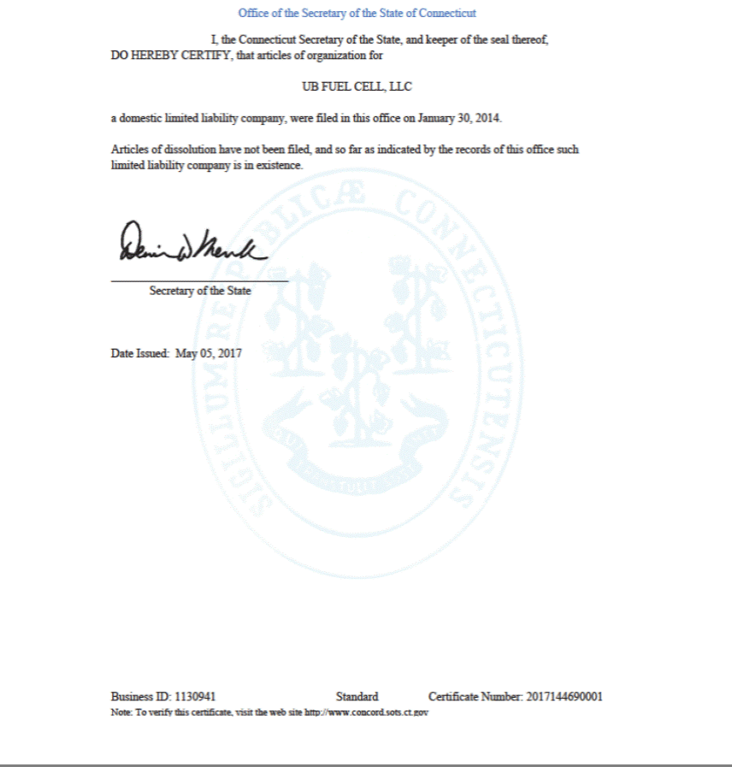

Exhibit B

Addressees

UB Fuel Cell, LLC

NRG Yield LLC

Alta Wind 1-5 Holding Company, LLC

Alta Wind Company, LLC

NRG Energy Center Omaha LLC

NRG Energy Center Omaha Holdings LLC

NRG Yield RPV Holding LLC

NRG South Trent Holdings LLC

NYLD Fuel Cell Holdings LLC

EXHIBIT 12.01

NRG YIELD OPERATING LLC AND SUBSIDIARIES

COMPUTATION OF RATIO OF EARNINGS TO FIXED CHARGES

 |  | Three Months |  |  |  |  |  |  |  | For the Year Ended December 31,
 |  | Ended
 |  | March 31, 2017 (a) |  |  |  | 2016 |  |  |  | 2015 |  |  | 2014 |  |  |  | 2013(c) |  |  |  | 2012(b)(c)
 |  |  |  |  |  |  |  |  |  |  |  |  | (in millions, except ratio)
Earnings:
Income from continuing operations before
income tax | $ | 1 |  | $ |  | 17 |  | $ |  | 93 |  | $ | 121 |  | $ |  | 140 |  | $ |  | 22
Less:
Equity in earnings of unconsolidated affiliates |  | (19) |  |  |  | (60) |  |  |  | (31) |  |  | (22) |  |  |  | (27) |  |  |  | (26)
Capitalized interest |  | — |  |  |  | — |  |  |  | — |  |  | — |  |  |  | (26) |  |  |  | (35)
Add:
Fixed charges |  | 74 |  |  |  | 273 |  |  |  | 257 |  |  | 214 |  |  |  | 98 |  |  |  | 66
Distributions from unconsolidated affiliates |  | 13 |  |  |  | 49 |  |  |  | 43 |  |  | 21 |  |  |  | 15 |  |  |  | 20
Amortization of capitalized interest |  | — |  |  |  | 3 |  |  |  | 3 |  |  | 3 |  |  |  | 2 |  |  |  | 1
Total Earnings: | $ | 69 |  |  | $ | 282 |  |  | $ | 365 |  | $ | 337 |  |  | $ | 202 |  |  | $ | 48
Fixed Charges:
Interest expense |  | 70 |  |  |  | 260 |  |  |  | 247 |  |  | 205 |  |  |  | 66 |  |  |  | 29
Capitalized interest |  | — |  |  |  | — |  |  |  | — |  |  | — |  |  |  | 26 |  |  |  | 35
Amortization of debt issuance costs |  | 3 |  |  |  | 8 |  |  |  | 7 |  |  | 6 |  |  |  | 5 |  |  |  | 1
Approximation of interest in rental expense |  | 1 |  |  |  | 5 |  |  |  | 3 |  |  | 3 |  |  |  | 1 |  |  |  | 1
Total Fixed Charges: | $ | 74 |  |  | $ | 273 |  |  | $ | 257 |  | $ | 214 |  |  | $ | 98 |  |  | $ | 66
Ratio of Earnings to Combined Fixed Charges |  | 0.93 |  |  |  | 1.03 |  |  |  | 1.42 |  |  | 1.57 |  |  |  | 2.06 |  |  |  | 0.73

- The ratio coverage for the three months ended March 31, 2017 was less than 1:1. NRG Yield Operating LLC would have needed to generate additional earnings of $5 million to achieve a ratio coverage of 1:1 for that period.

- The ratio coverage for the year ended December 31, 2012 was less than 1:1. NRG Yield Operating LLC would have needed to generate additional earnings of $18 million to achieve a ratio coverage of 1:1 for that year.

- For all periods prior to the Yield, Inc.’s initial public offering on July 22, 2013, the accompanying combined financial statements represent the combination of the assets that the Company acquired and were prepared using NRG’s historical basis in the assets and liabilities. For the purposes of the combined financial statements, the term “NRG Yield Operating LLC and Subsidiaries” represents the accounting predecessor, or the combination of the acquired businesses. For all periods subsequent to the Yield Inc. initial public offering, the accompanying audited consolidated financial statements represent the consolidated results of the Company.

 |  |  | EXHIBIT 21.1
 | SUBSIDIARIES OF NRG YIELD OPERATING LLC
Entity Name |  |  | Jurisdiction
AC Solar Holdings LLC |  |  | Delaware
Adams Community Solar Garden I LLC |  |  | Colorado
Adams Community Solar Garden II LLC |  |  | Colorado
Adams Community Solar Garden III LLC |  |  | Colorado
Adams Community Solar Gardens LLC |  |  | Colorado
Agua Caliente Borrower 2 LLC |  |  | Delaware
Agua Caliente Solar Holdings LLC |  |  | Delaware
Agua Caliente Solar, LLC |  |  | Delaware
Alta Interconnection Management II, LLC |  |  | Delaware
Alta Interconnection Management III, LLC |  |  | Delaware
Alta Interconnection Management, LLC |  |  | Delaware
Alta Realty Holdings, LLC |  |  | Delaware
Alta Realty Investments, LLC |  |  | Delaware
Alta Wind 1-5 Holding Company, LLC |  |  | Delaware
Alta Wind Asset Management Holdings, LLC |  |  | Delaware
Alta Wind Asset Management, LLC |  |  | Delaware
Alta Wind Company, LLC |  |  | Delaware
Alta Wind Holdings, LLC |  |  | Delaware
Alta Wind I Holding Company, LLC |  |  | Delaware
Alta Wind I, LLC |  |  | Delaware
Alta Wind II Holding Company, LLC |  |  | Delaware
Alta Wind II, LLC |  |  | Delaware
Alta Wind III Holding Company, LLC |  |  | Delaware
Alta Wind III, LLC |  |  | Delaware
Alta Wind IV Holding Company, LLC |  |  | Delaware
Alta Wind IV, LLC |  |  | Delaware
Alta Wind V Holding Company, LLC |  |  | Delaware
Alta Wind V, LLC |  |  | Delaware
Alta Wind X Holding Company, LLC |  |  | Delaware
Alta Wind X, LLC |  |  | Delaware
Alta Wind XI Holding Company, LLC |  |  | Delaware
Alta Wind XI, LLC |  |  | Delaware
Alta Wind X-XI TE Holdco LLC |  |  | Delaware
Apple I REC Holdco 2011 LLC |  |  | Delaware
Arapahoe Community Solar Garden I LLC |  |  | Colorado
Avenal Park LLC |  |  | Delaware
Avenal Solar Holdings LLC |  |  | Delaware
Bashaw Solar 1, LLC |  |  | Delaware
Buffalo Bear, LLC |  |  | Oklahoma
BWC Swan Pond River, LLC |  |  | Delaware
Clear View Acres Wind Farm, LLC |  |  | Iowa
Colorado Shared Solar I LLC |  |  | Colorado
Colorado Springs Solar Garden LLC |  |  | Colorado

Continental Energy, LLC | Arizona
Crosswind Transmission, LLC | Iowa
CVSR Holdco LLC | Delaware
Cy-Hawk Wind Energy, LLC | Iowa
Denver Community Solar Garden I LLC | Colorado
Denver Community Solar Garden II LLC | Colorado
Desert Sunlight 250, LLC | Delaware
Desert Sunlight 300, LLC | Delaware
Desert Sunlight Holdings LLC | Delaware
Desert Sunlight Investment Holdings, LLC | Delaware
Eagle View Acres Wind Farm, LLC | Iowa
El Mirage Energy, LLC | Arizona
El Segundo Energy Center LLC | Delaware
Elbow Creek Wind Project LLC | Texas
Elk Lake Wind Farm, LLC | Iowa
Elkhorn Ridge Wind, LLC | Delaware
Enterprise Solar, LLC | Delaware
Escalante Solar I, LLC | Delaware
Escalante Solar II, LLC | Delaware
Escalante Solar III, LLC | Delaware
Farmington Holdco LLC | Delaware
Federal Road Solar 1, LLC | Delaware
Forward WindPower LLC | Delaware
Four Brothers Capital, LLC | Delaware

Four Brothers Holdings, LLC | Delaware
Four Brothers Portfolio, LLC | Delaware
Four Brothers Solar, LLC | Delaware
FUSD Energy, LLC | Arizona
GCE Holding LLC | Connecticut
GenConn Devon LLC | Connecticut
GenConn Energy LLC | Connecticut
GenConn Middletown LLC | Connecticut
Goat Wind, LP | Texas
Granite Mountain Capital, LLC | Delaware
Granite Mountain Holdings, LLC | Delaware
Granite Mountain Renewables, LLC | Delaware
Granite Mountain Solar East, LLC | Delaware
Granite Mountain Solar West, LLC | Delaware
Green Prairie Energy, LLC | Iowa
Greene Wind Energy, LLC | Iowa
Hardin Hilltop Wind, LLC | Iowa
Hardin Wind Energy, LLC | Iowa
High Plains Ranch II, LLC | Delaware

Highland Township Wind Farm, LLC | Iowa
HLE Solar Holdings, LLC | Delaware
HSD Solar Holdings, LLC | California
Iron Springs Capital, LLC | Delaware
Iron Springs Holdings, LLC | Delaware
Iron Springs Renewables, LLC | Delaware
Iron Springs Solar, LLC | Delaware
Laredo Ridge Wind, LLC | Delaware
Lenape II Solar LLC | Delaware
Lindberg Field Solar 1, LLC | Delaware
Lindberg Field Solar 2, LLC | Delaware
Longhorn Energy, LLC | Arizona
Lookout WindPower LLC | Delaware
MC1 Solar Farm, LLC | North Carolina
Mission Iowa Wind, LLC | California
Mission Minnesota Wind II, LLC | Delaware
Mission Wind Goat Mountain, LLC | Delaware
Mission Wind Laredo, LLC | Delaware
Mission Wind New Mexico, LLC | Delaware
Mission Wind Oklahoma, LLC | Delaware
Mission Wind PA One, LLC | Delaware
Mission Wind PA Three, LLC | Delaware
Mission Wind PA Two, LLC | Delaware
Mission Wind Pennsylvania, LLC | Delaware
Mission Wind Texas II, LLC | Delaware
Mission Wind Texas, LLC | Delaware
Mission Wind Utah, LLC | Delaware
Mission Wind Wildorado, LLC | Delaware
Monster Energy, LLC | Arizona
Natural Gas Repowering LLC | Delaware
NRG & EFS Distributed Solar 2 LLC | Delaware
NRG & EFS Distributed Solar LLC | Delaware
NRG 2011 Finance Holdco LLC | Delaware
NRG Alta Vista LLC | Delaware
NRG Apple I LLC | Delaware
NRG CA Fund LLC | Delaware
NRG DG Berkeley Rec LLC | Delaware
NRG DG Berkeley Village LLC | Delaware
NRG DG Central East LLC | Delaware
NRG DG Central West LLC | Delaware
NRG DG Contra Costa Operations LLC | Delaware
NRG DG Contra Costa Waste LLC | Delaware
NRG DG Grantland LLC | Delaware

NRG DG Lakeland LLC | Delaware
NRG DG Lathrop Louise LLC | Delaware
NRG DG Lincoln Middle LLC | Delaware
NRG DG Rosedale Elementary LLC | Delaware
NRG DG Rosedale Middle LLC | Delaware
NRG DG San Joaquin LLC | Delaware

NRG DG Tufts Knoll LLC | Delaware
NRG DG Tufts Science LLC | Delaware
NRG DG Washington Middle LLC | Delaware
NRG DG Webster LLC | Delaware
NRG DGPV 1 LLC | Delaware
NRG DGPV 2 LLC | Delaware
NRG DGPV 3 LLC | Delaware
NRG DGPV 4 Borrower LLC | Delaware
NRG DGPV 4 LLC | Delaware
NRG DGPV Fund 1 LLC | Delaware
NRG DGPV Fund 2 HoldCo A LLC | Delaware
NRG DGPV Fund 2 HoldCo B LLC | Delaware
NRG DGPV Fund 2 LLC | Delaware
NRG DGPV Fund 4 LLC | Delaware
NRG DGPV Fund 4 Sub LLC | Delaware
NRG DGPV HoldCo 1 LLC | Delaware
NRG DGPV HoldCo 2 LLC | Delaware
NRG Electricity Sales Princeton LLC | Delaware
NRG Elkhorn Holdings LLC | Delaware
NRG Energy Center Dover LLC | Delaware
NRG Energy Center Harrisburg LLC | Delaware
NRG Energy Center HCEC LLC | Delaware
NRG Energy Center Minneapolis LLC | Delaware
NRG Energy Center Omaha Holdings LLC | Delaware
NRG Energy Center Omaha LLC | Delaware
NRG Energy Center Paxton LLC | Delaware
NRG Energy Center Phoenix LLC | Delaware
NRG Energy Center Pittsburgh LLC | Delaware
NRG Energy Center Princeton LLC | Delaware
NRG Energy Center San Diego LLC | Delaware
NRG Energy Center San Francisco LLC | Delaware
NRG Energy Center Smyrna LLC | Delaware
NRG Energy Center Tucson LLC | Arizona
NRG Golden Puma Fund LLC | Delaware
NRG Golden Puma Revolve LLC | Delaware
NRG Harrisburg Cooling LLC | Delaware
NRG Huntington Beach LLC | Delaware

NRG Marsh Landing Holdings LLC | Delaware
NRG Marsh Landing LLC | Delaware
NRG Puma Class B LLC | Delaware
NRG Renew Canal 1 LLC | Delaware
NRG Renew Spark 2 LLC | Delaware
NRG RPV 1 LLC | Delaware
NRG RPV 2 LLC | Delaware
NRG RPV Fund 11 LLC | Delaware
NRG RPV Fund 12 LLC | Delaware
NRG RPV Fund 13 LLC | Delaware
NRG RPV HoldCo 1 LLC | Delaware
NRG Solar Alpine LLC | Delaware
NRG Solar Apple LLC | Delaware
NRG Solar AV Holdco LLC | Delaware
NRG Solar Avra Valley LLC | Delaware
NRG Solar Blythe II LLC | Delaware
NRG Solar Blythe LLC | Delaware
NRG Solar Borrego Holdco LLC | Delaware
NRG Solar Borrego I LLC | Delaware
NRG Solar CVSR Holdings LLC | Delaware
NRG Solar Kansas South Holdings LLC | Delaware
NRG Solar Kansas South LLC | Delaware
NRG Solar Las Vegas MB 2 LLC | Delaware
NRG Solar Mayfair LLC | Delaware
NRG Solar Oasis LLC | Delaware
NRG Solar Roadrunner Holdings LLC | Delaware
NRG Solar Roadrunner LLC | Delaware
NRG Solar Warren LLC | Delaware
NRG South Trent Holdings LLC | Delaware
NRG Thermal LLC | Delaware
NRG Walnut Creek II LLC | Delaware
NRG Walnut Creek LLC | Delaware
NRG West Holdings LLC | Delaware
NRG Wind TE Holdco LLC | Delaware
NRG Yield AC Solar Holdings LLC | Delaware
NRG Yield CVSR Holdings LLC | Delaware

NRG Yield DGPV Holding LLC | Delaware
NRG Yield LLC | Delaware
NRG Yield Operating LLC | Delaware
NRG Yield RPV Holding LLC | Delaware
NRG Yield Utah Solar Holdings LLC | Delaware
NS Smith, LLC | Delaware
NYLD Fuel Cell Holdings LLC | Delaware

OC Solar 2010, LLC | California
Odin Wind Farm LLC | Minnesota
Old Westminster Solar 1, LLC | Delaware
Old Westminster Solar 2, LLC | Delaware
OWF Eight, LLC | Minnesota
OWF Five, LLC | Minnesota
OWF Four, LLC | Minnesota
OWF One, LLC | Minnesota
OWF Seven, LLC | Minnesota
OWF Six, LLC | Minnesota
OWF Three, LLC | Minnesota
OWF Two, LLC | Minnesota
Palo Alto County Wind Farm, LLC | Iowa
PESD Energy, LLC | Arizona
Pikes Peak Solar Garden I LLC | Colorado
Pine Island Holdco LLC | Delaware
Pinnacle Wind, LLC | Delaware
PM Solar Holdings, LLC | California
Pond Road Solar, LLC | Delaware
Poverty Ridge Wind, LLC | Iowa
San Juan Mesa Investments, LLC | Delaware
San Juan Mesa Wind Project, LLC | Delaware
Sand Drag LLC | Delaware
SCWFD Energy, LLC | Arizona
Silver Lake Acres Wind Farm, LLC | Iowa
SJA Solar LLC | Delaware
Sleeping Bear, LLC | Delaware
South Trent Wind LLC | Delaware
Spanish Fork Wind Park 2, LLC | Utah
Spring Canyon Energy II LLC | Delaware
Spring Canyon Energy III LLC | Delaware
Spring Canyon Expansion Class B Holdings | Delaware
Spring Canyon Expansion Holdings LLC | Delaware
Spring Canyon Expansion LLC | Delaware
Spring Canyon Interconnection LLC | Delaware
Spring Street Solar 1, LLC | Delaware
Statoil Energy Power/Pennsylvania, Inc. | Pennsylvania
Steel Bridge Solar, LLC | Delaware
Sun City Project LLC | Delaware
Sunrise View Wind Farm, LLC | Iowa
Sunset View Wind Farm, LLC | Iowa
Sutton Wind Energy, LLC | Iowa
TA - High Desert, LLC | California

Taloga Wind, L.L.C. | Oklahoma
Tapestry Wind, LLC | Delaware
Topeka Solar 1, LLC | Delaware
TOS Solar 4, LLC | Delaware
TOS Solar 5, LLC | Delaware
Tully Farms Solar 1, LLC | Delaware
UB Fuel Cell, LLC | Connecticut
Vail Energy, LLC | Arizona
Viento Funding II, LLC | Delaware
Viento Funding, LLC | Delaware
Virgin Lake Wind Farm, LLC | Iowa
Wabasha Holdco LLC | Delaware
Walnut Creek Energy, LLC | Delaware
WCEP Holdings, LLC | Delaware
Wildcat Energy, LLC | Arizona
Wildorado Interconnect, LLC | Texas
Wildorado Wind, LLC | Texas
Wind Family Turbine, LLC | Iowa

WSD Solar Holdings, LLC | Delaware
Zontos Wind, LLC | Iowa

Exhibit 23.03

Consent of Independent Registered Public Accounting Firm

The Members

NRG Yield, LLC

We consent to the use of our report dated May 9, 2017, with respect to the consolidated balance sheets of NRG Yield LLC as of December 31, 2016 and 2015, and the related consolidated statements of operations, comprehensive income (loss), members’ equity, and cash flows for each of the years in the three-year period ended December 31, 2016, incorporated by reference herein on the registration statement on Form S-4 to register $350,000,000 of 5.00% Senior Notes due 2026 and to the reference to our firm under the heading “Experts” in the prospectus.

/s/ KPMG LLP

Philadelphia, Pennsylvania

May 9, 2017

Exhibit 25.01

SECURITIES AND EXCHANGE COMMISSION

Washington, D.C. 20549

FORM T-1

STATEMENT OF ELIGIBILITY

UNDER THE TRUST INDENTURE ACT OF 1939 OF A
CORPORATION DESIGNATED TO ACT AS TRUSTEE

- CHECK IF AN APPLICATION TO DETERMINE ELIGIBILITY OF A TRUSTEE PURSUANT TO SECTION 305(b) (2)

Delaware Trust Company

(Exact name of trustee as specified in its charter)

Delaware | 51-0011500
(Jurisdiction of incorporation or organization if | (I.R.S. Employer
not a U.S. national bank) | Identification No.)
2711 Centerville Road
Wilmington, Delaware | 19808
(Address of principal executive offices) | (Zip code)
Corporation Service Company
2711 Centerville Road
Wilmington, Delaware
(800) 927-9801
(Name, address and telephone number of agent for service)

NRG Yield LLC

NRG Yield Operating LLC
(Exact name of obligor as specified in its charter)

Delaware |  | 32-0407370
Delaware |  | 30-0780012
(State or other jurisdiction of incorporation |  |  | (I.R.S. Employer
of organization) |  |  | Identification No.)
804 Carnegie Center
Princeton, NJ 08540 |  | 08540
(Address of principal executive offices) |  |  | (Zip code)
 |  | 5.000% Senior Notes due 2026
 |  | (Title of the indenture securities)

Item 1. General Information.

Furnish the following information as to the trustee:

- Name and address of each examining or supervising authority to which it is subject.

Office of the State Banking Commissioner State of Delaware
555 East Loockerman Street Dover, DE 19901

 |  | (b) | Whether it is authorized to exercise corporate trust powers.
 |  |  | The trustee is authorized to exercise corporate trust powers.
Item 2. | Affiliations with Obligor.
 |  | If the obligor is an affiliate of the trustee, describe each such affiliation.
 |  | None with respect to the trustee.
Items 3-14.
 |  | No responses are included for Items 3—14 because the obligor is not in default as provided under Item 13.
Item 15. |  | Foreign Trustee.
 |  | Not applicable.
Item 16. |  | List of Exhibits
 |  | List below all exhibits filed as a part of this Statement of Eligibility.
Exhibit 1. |  | A copy of the Articles of Association of the trustee now in effect is contained in the Certificate of Incorporation.
Exhibit 2. |  | A copy of the Certificate of Incorporation.
Exhibit 3. |  | See Exhibit 2.
Exhibit 4. |  | A copy of by-laws of the trustee as now in effect.
Exhibit 5. |  | Not applicable.
Exhibit 6. |  | The consent of the trustee required by Section 321(b) of the Act.
Exhibit 7. |  | A copy of the latest report of condition of the trustee published pursuant to law or the requirements of its supervising or examining authority.
Exhibit 8. |  | Not applicable.
Exhibit 9. |  | Not applicable.

Pursuant to the requirements of the Trust Indenture Act of 1939, as amended, the trustee, Delaware Trust Company, a non-depository trust company and corporation duly organized and existing under the laws of Delaware, has duly caused this statement of eligibility to be signed on its behalf by the undersigned, thereunto duly authorized, all in the City of Wilmington and State of Delaware on the 19th day of April 2017.

DELAWARE TRUST COMPANY

/s/ William G. Popeo

Name: William G. Popeo
Title: President & CEO

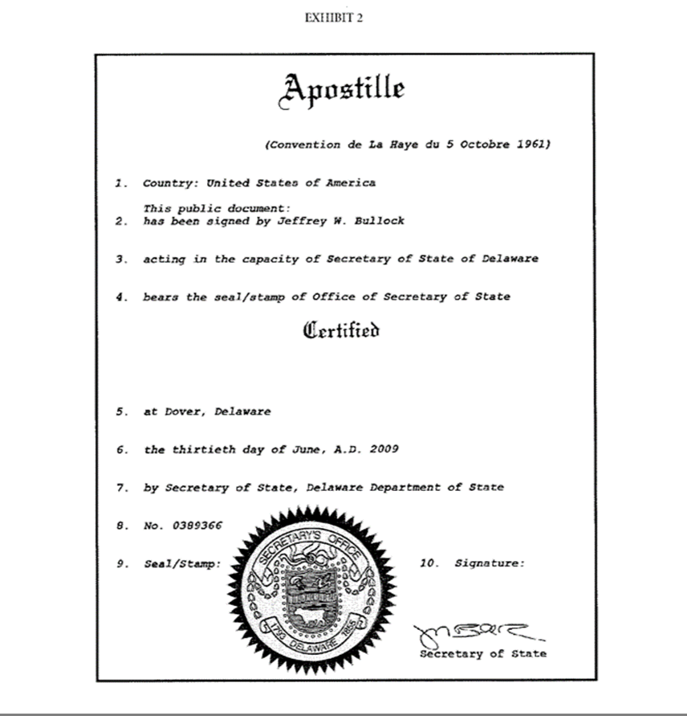

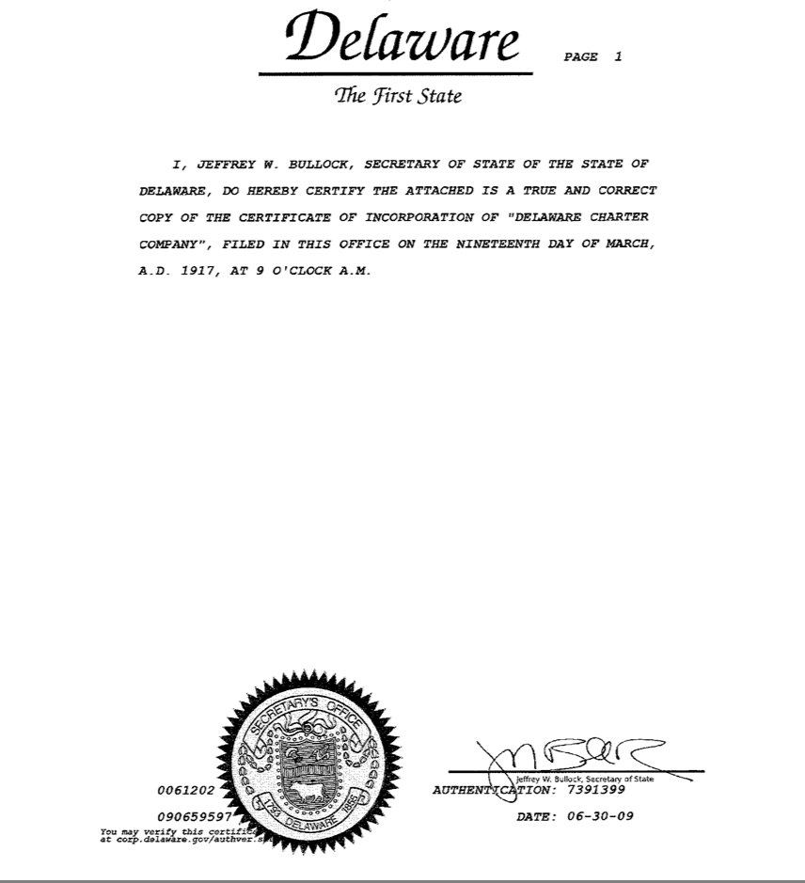

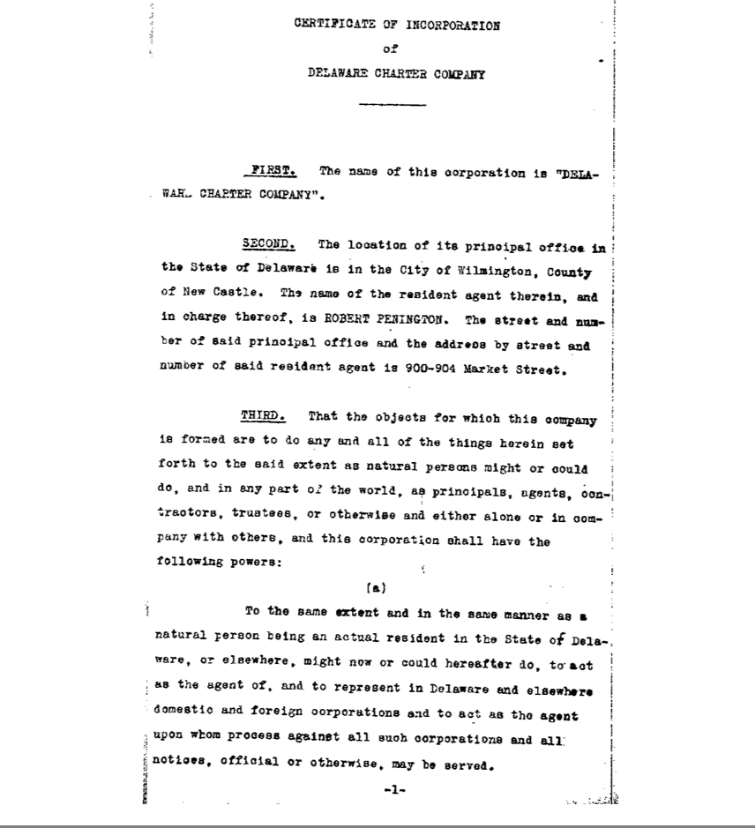

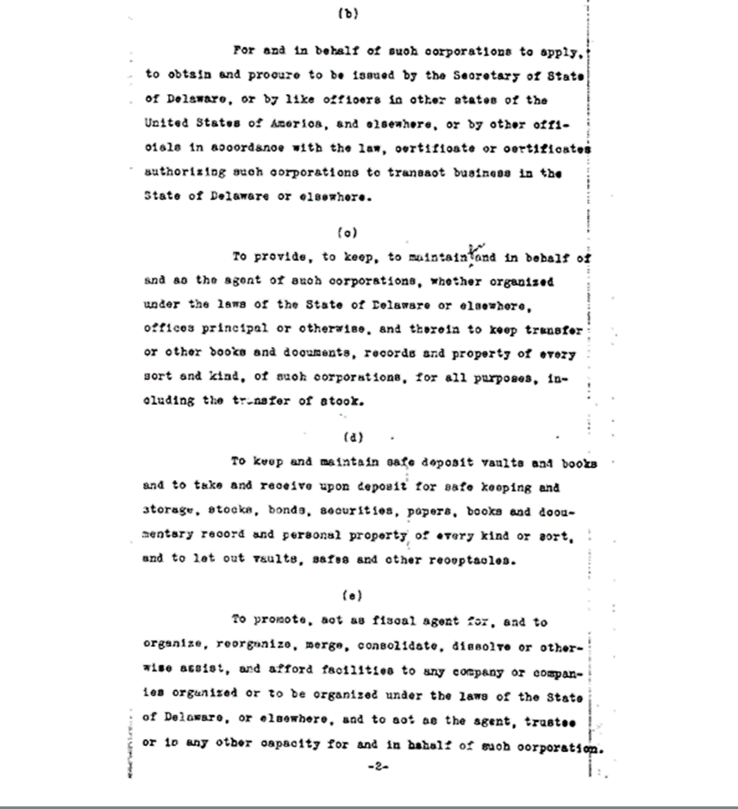

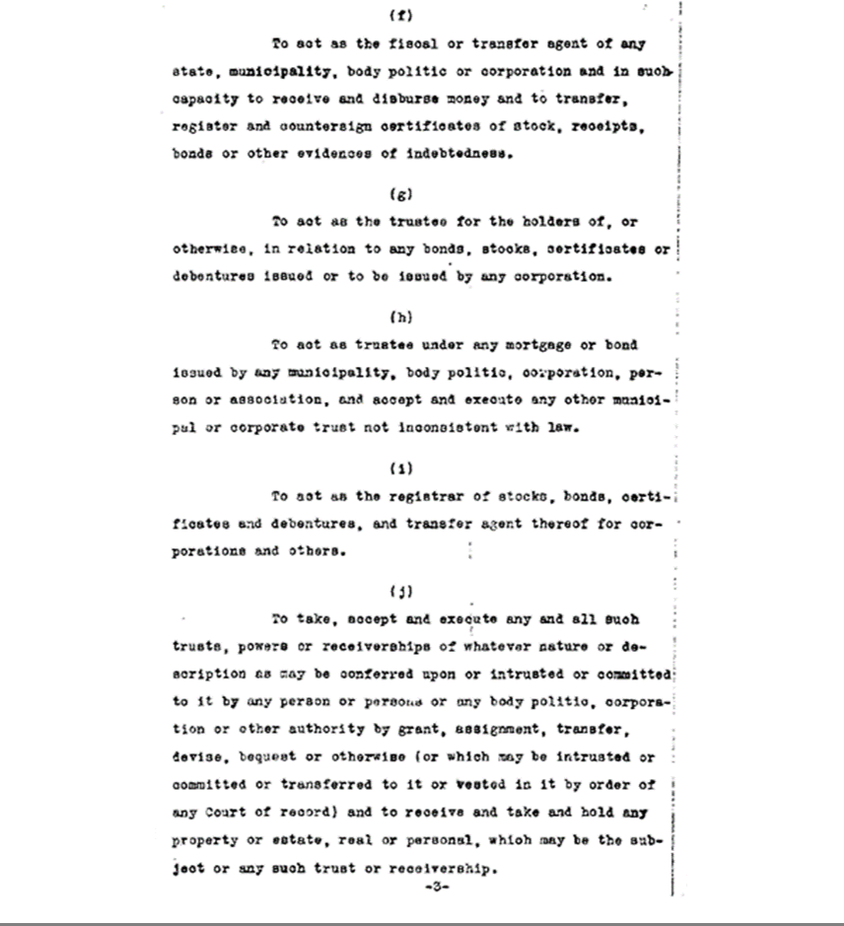

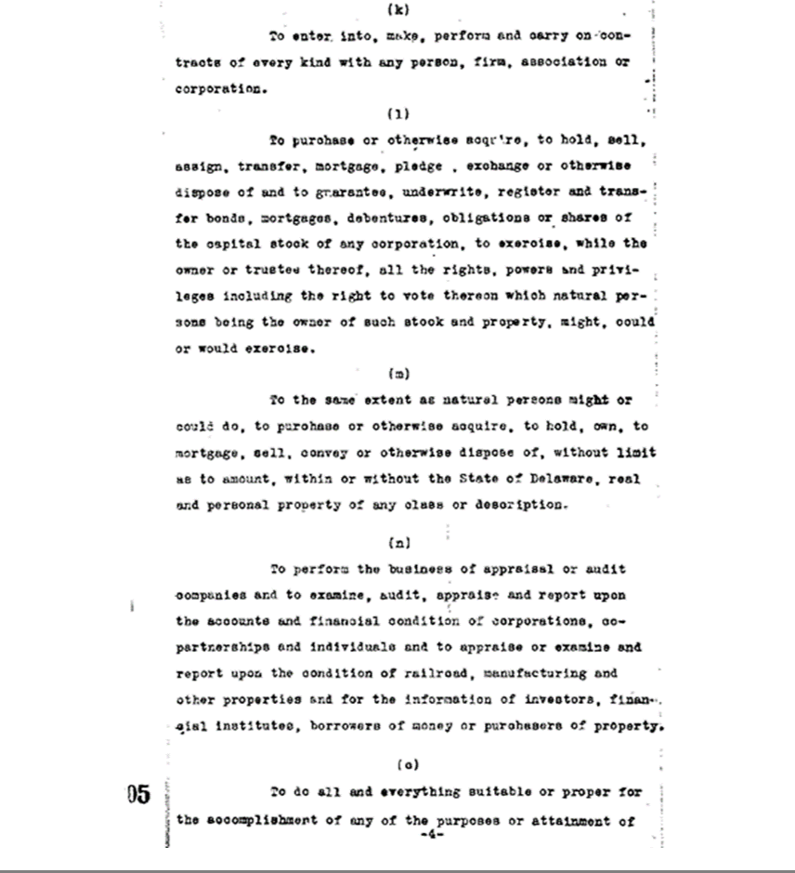

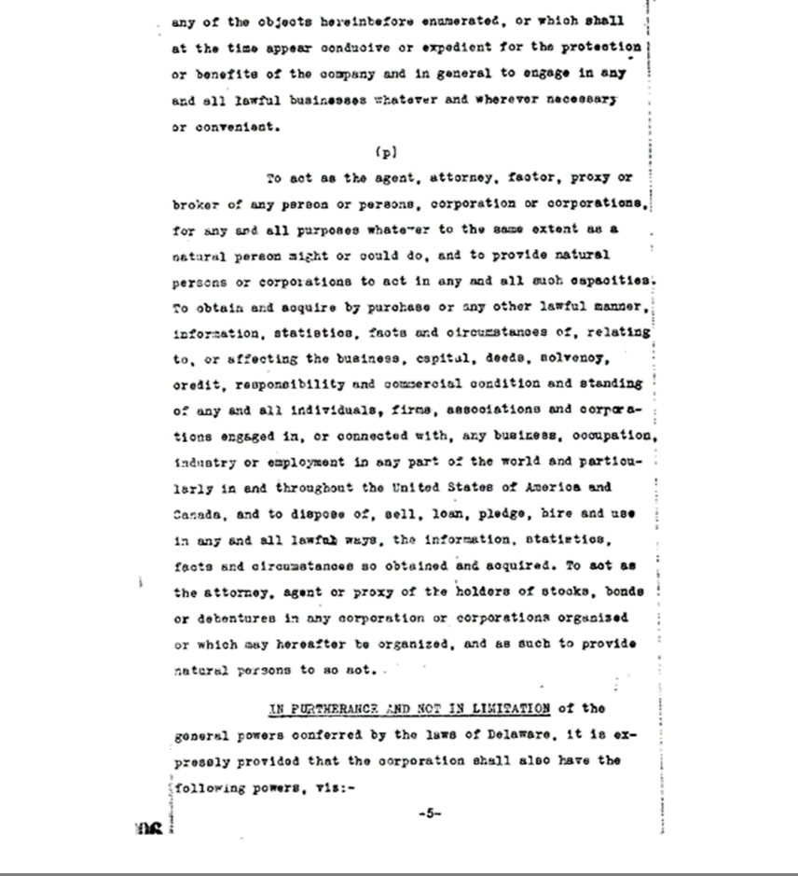

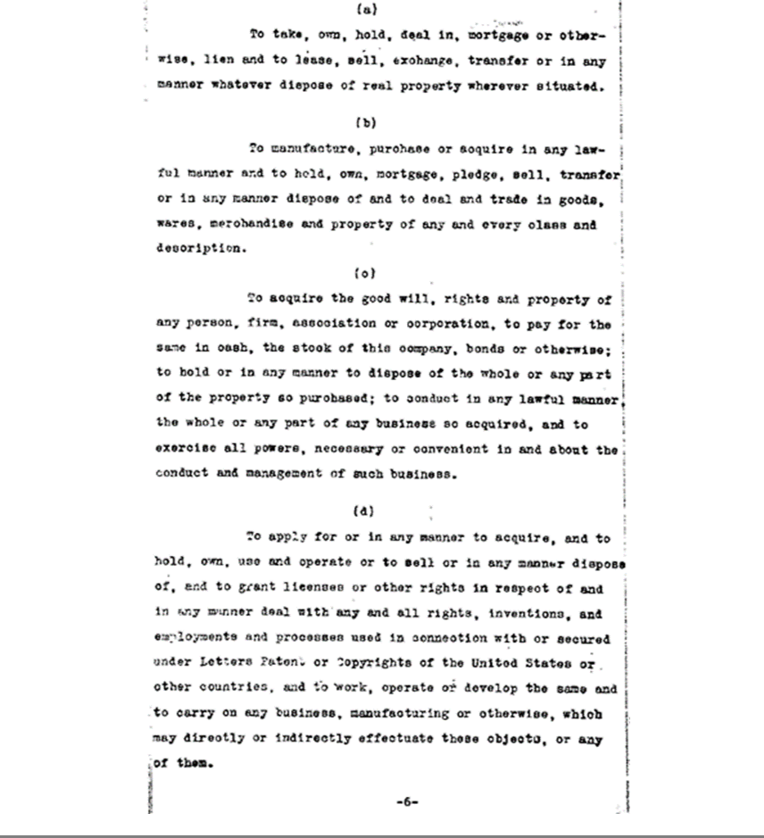

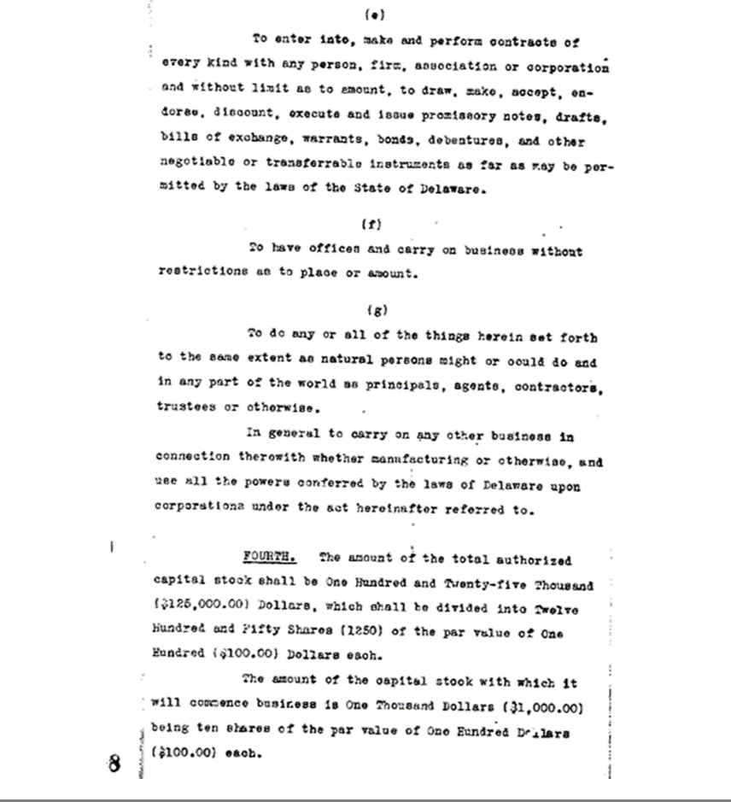

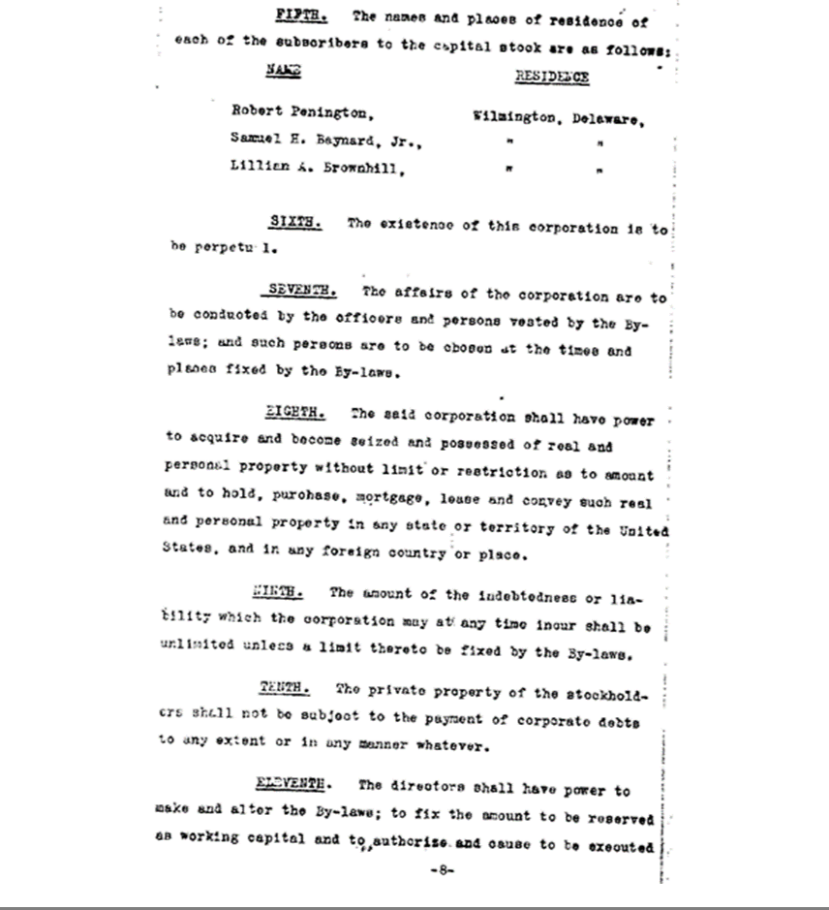

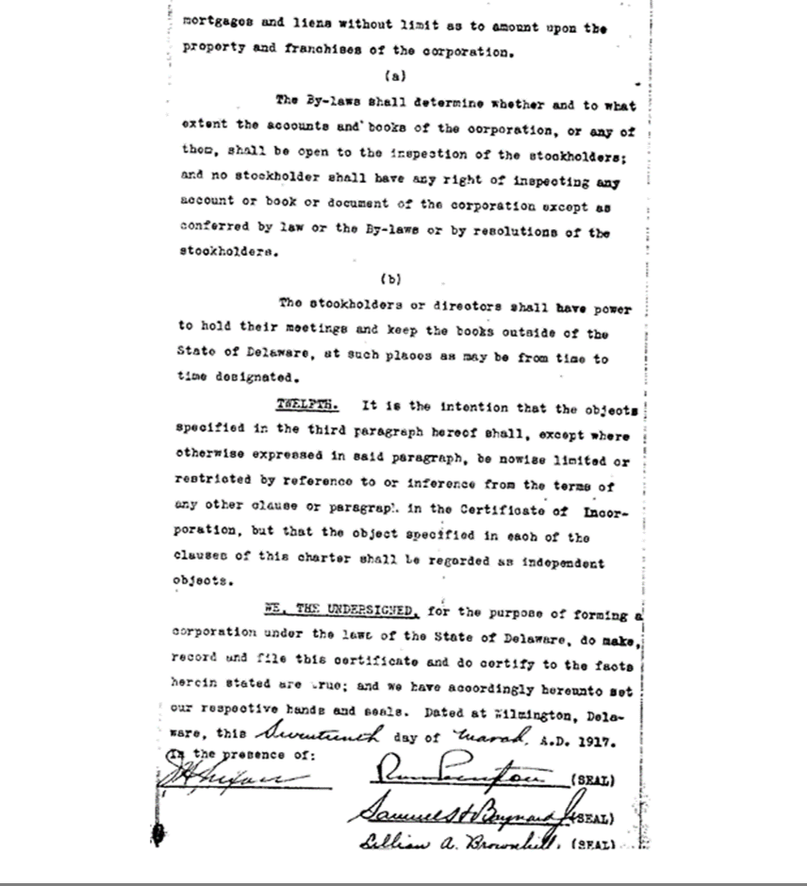

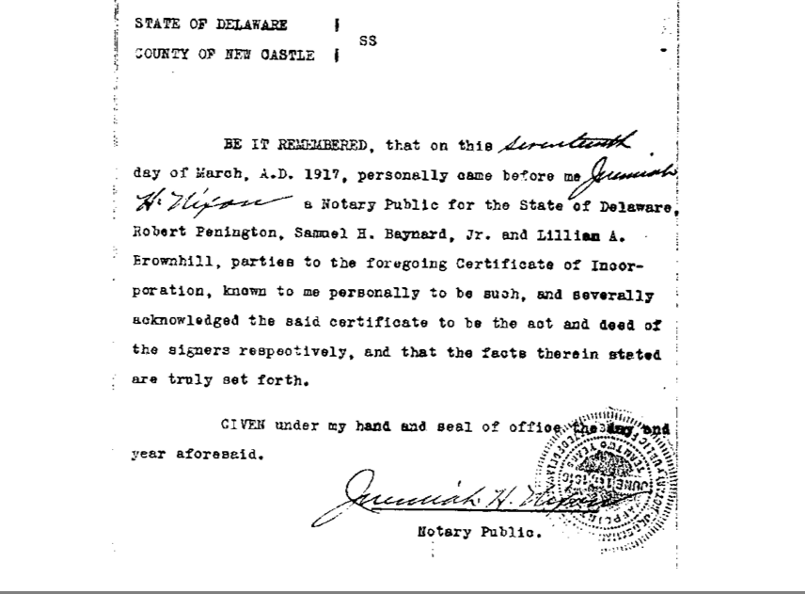

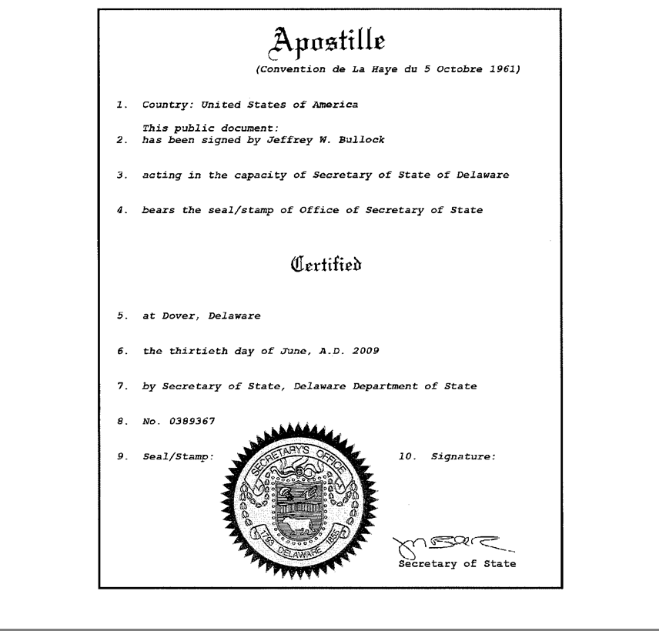

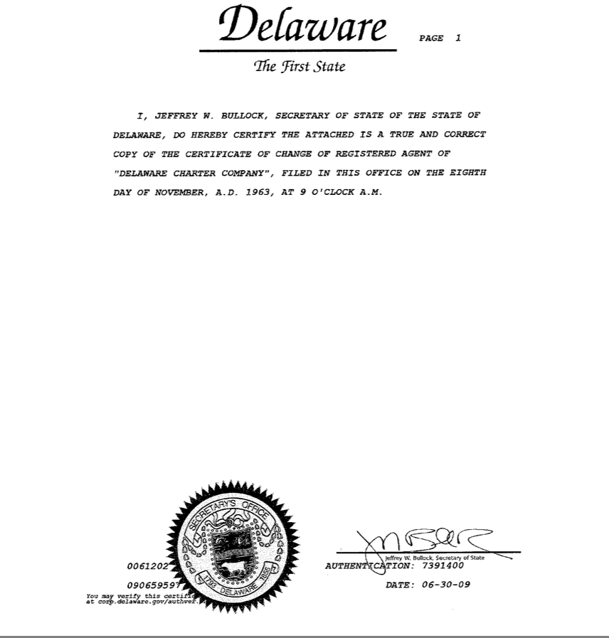

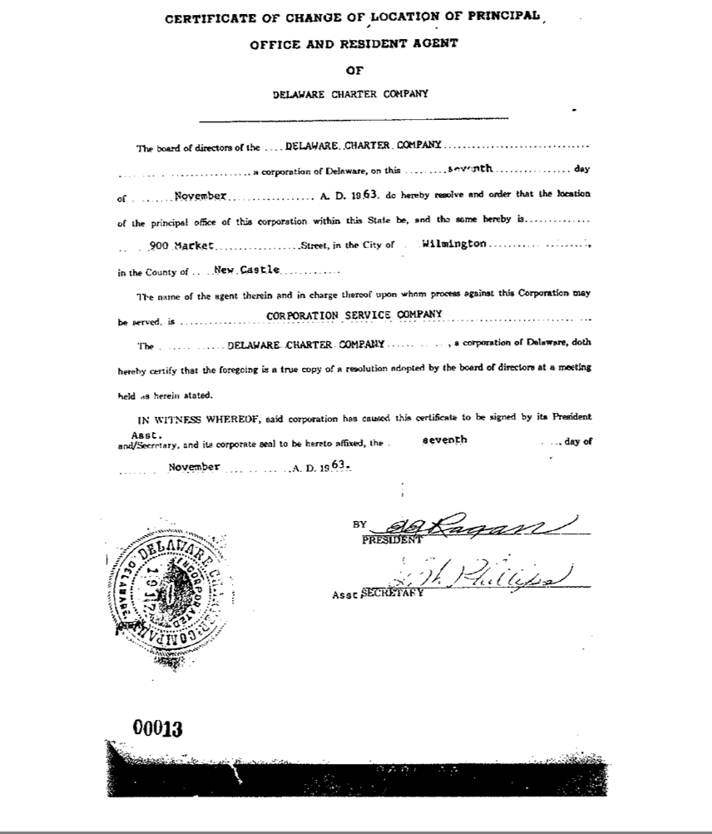

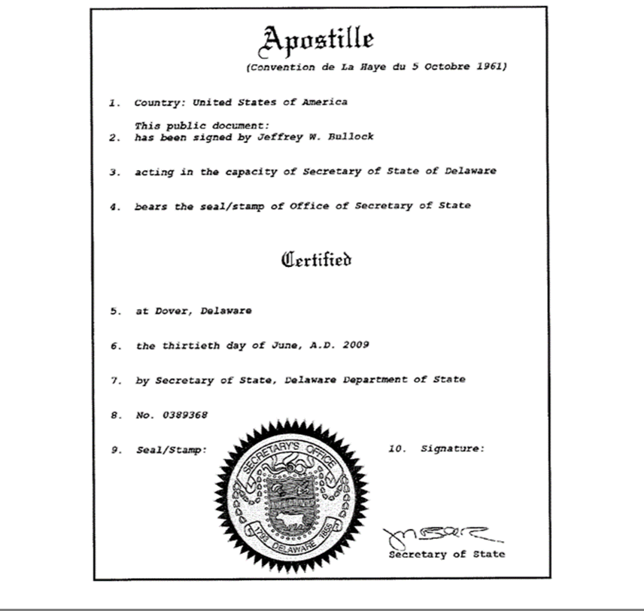

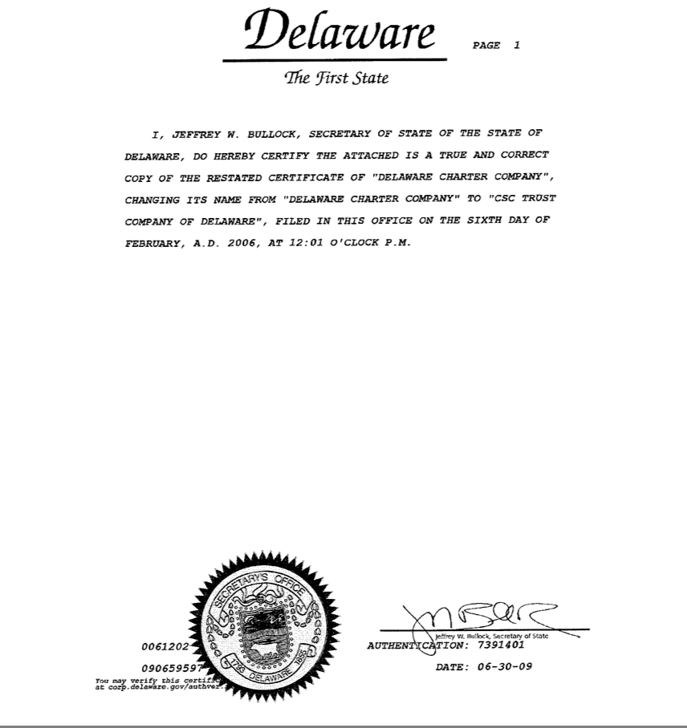

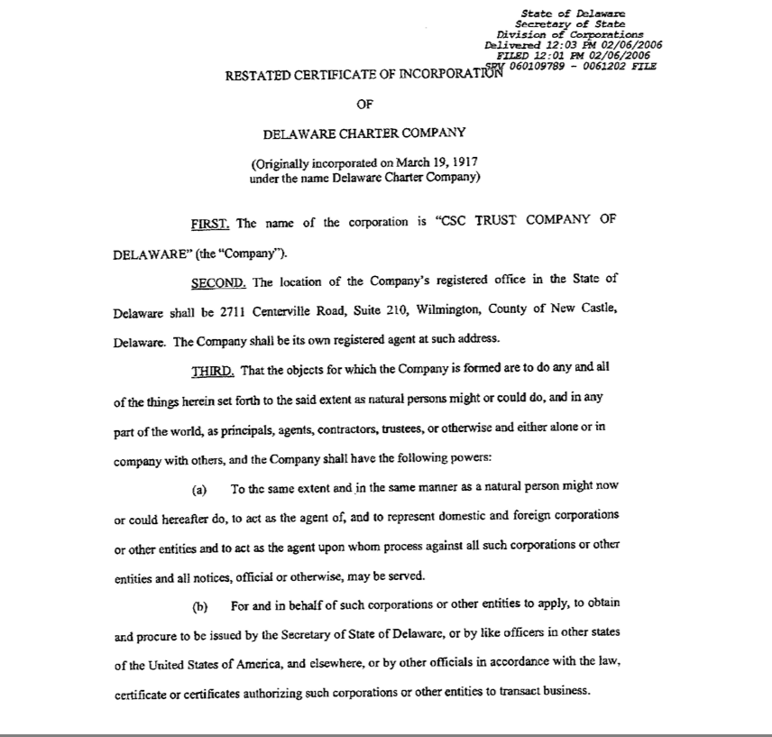

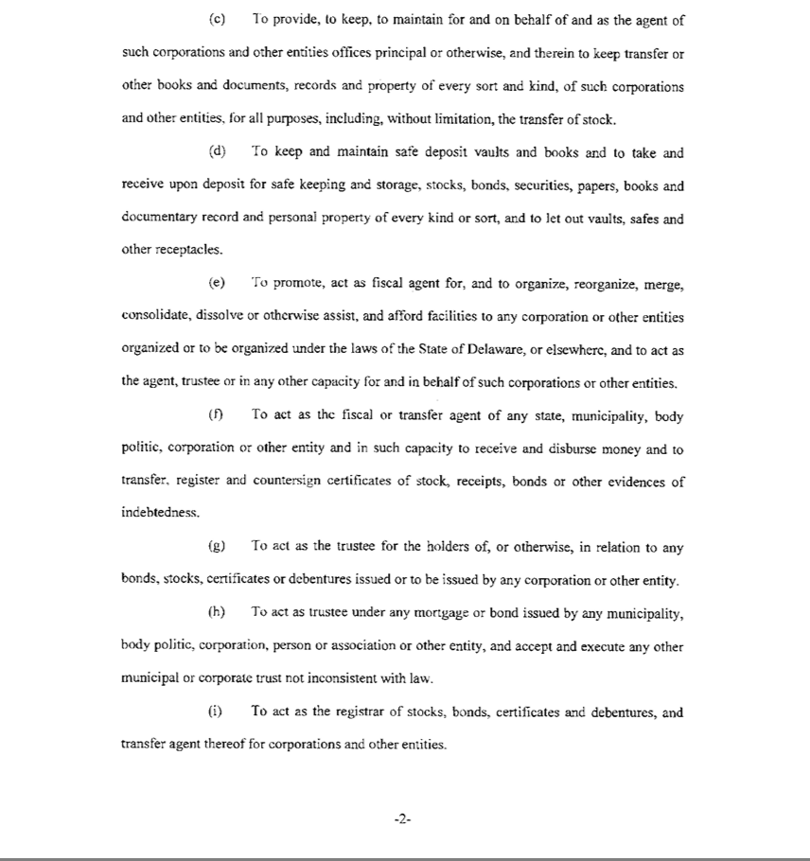

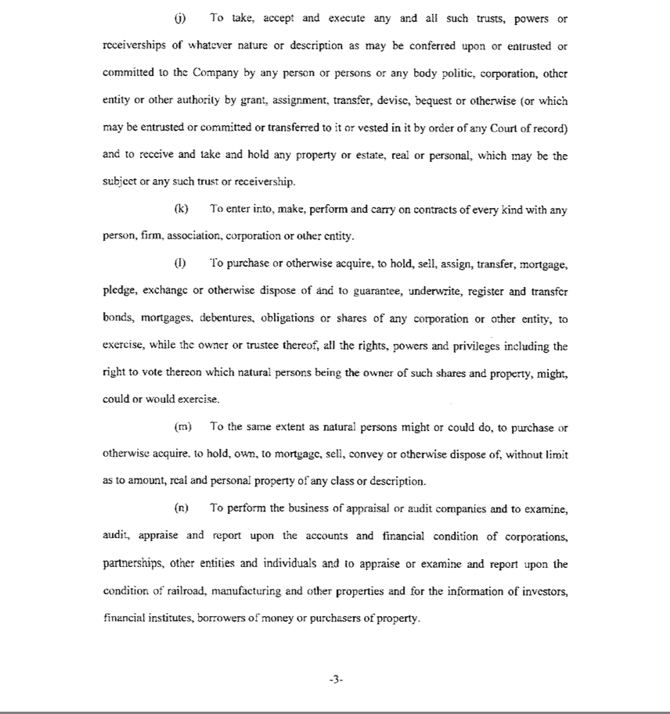

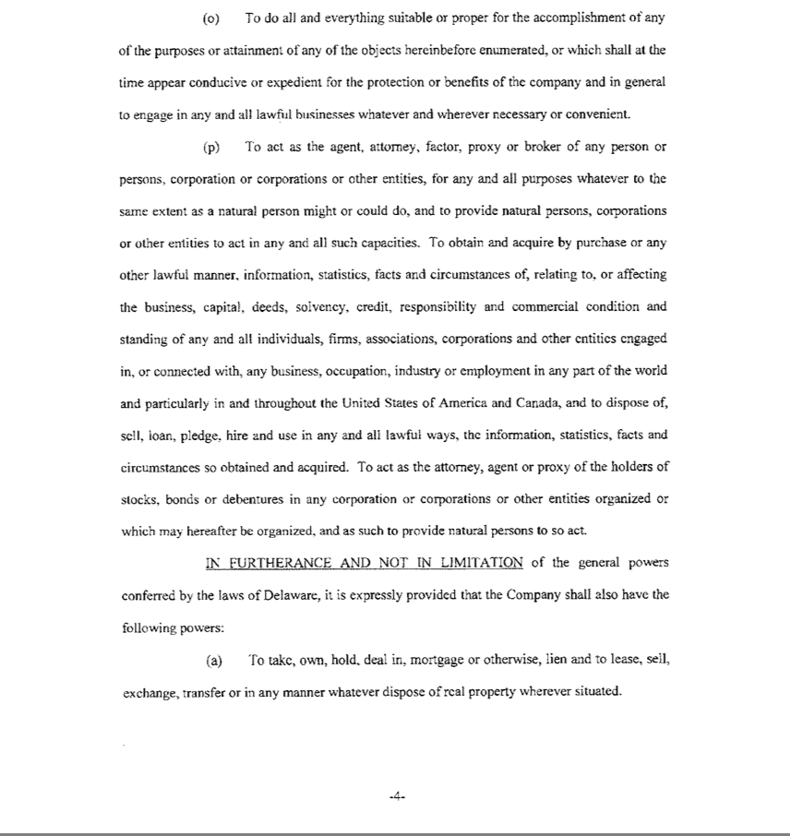

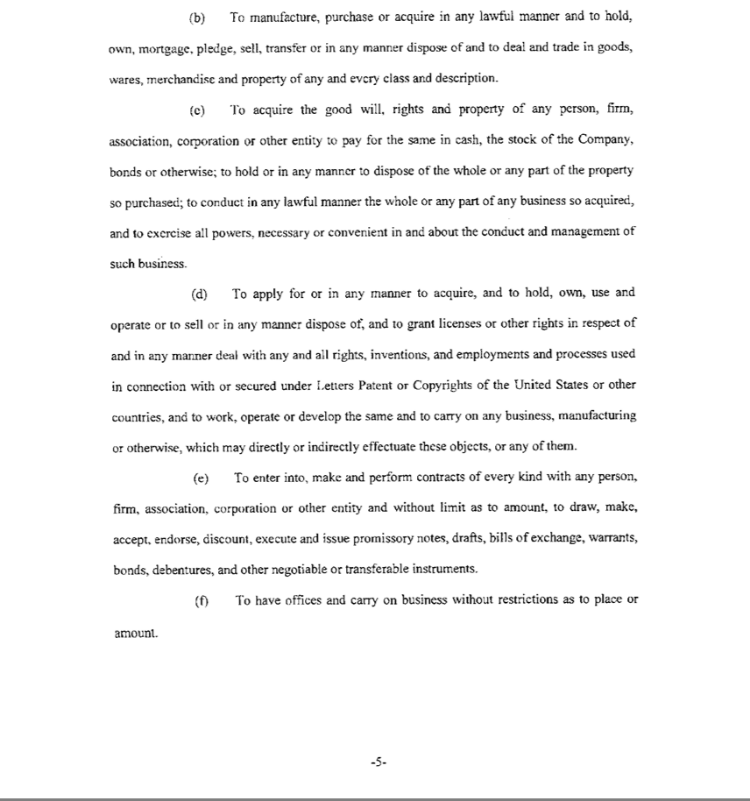

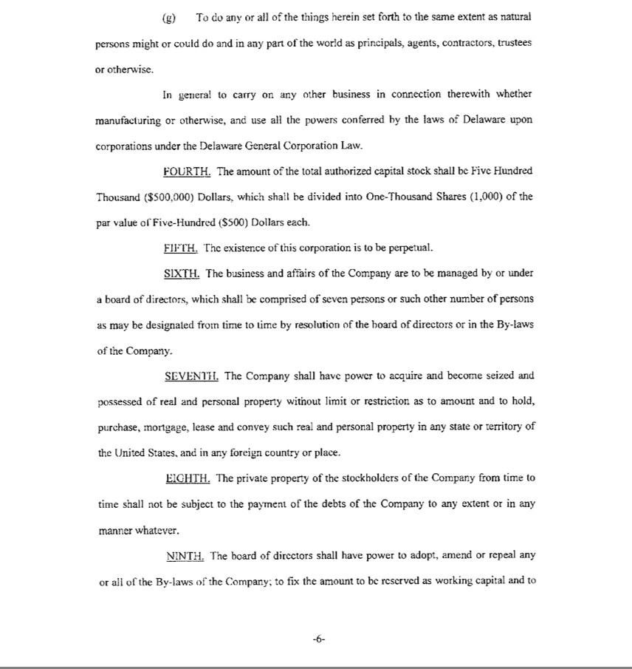

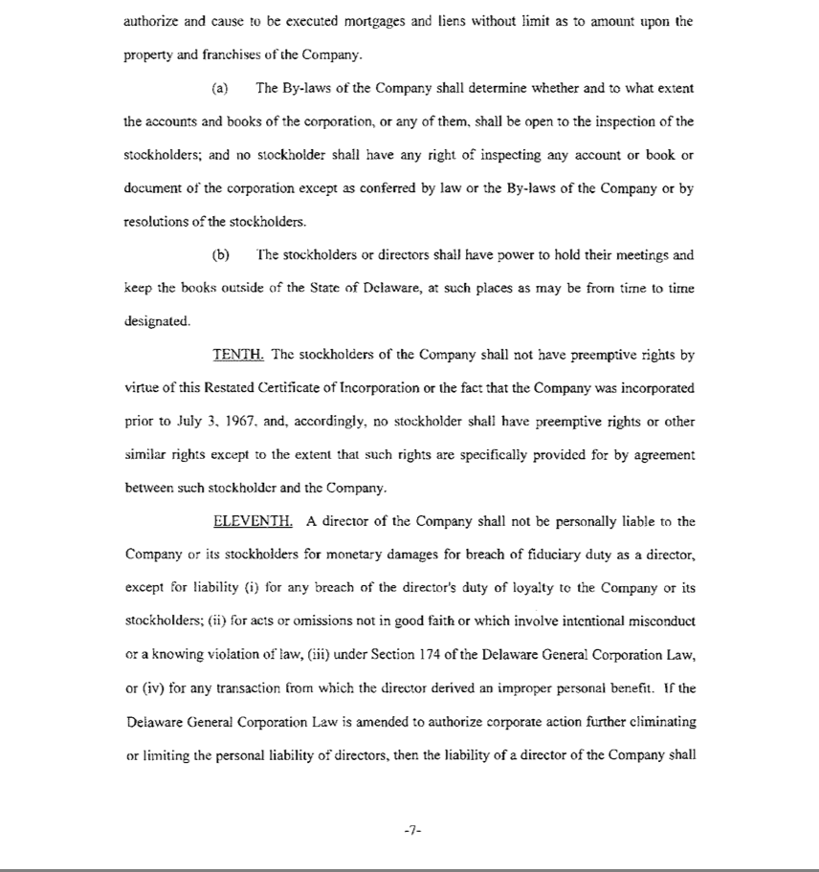

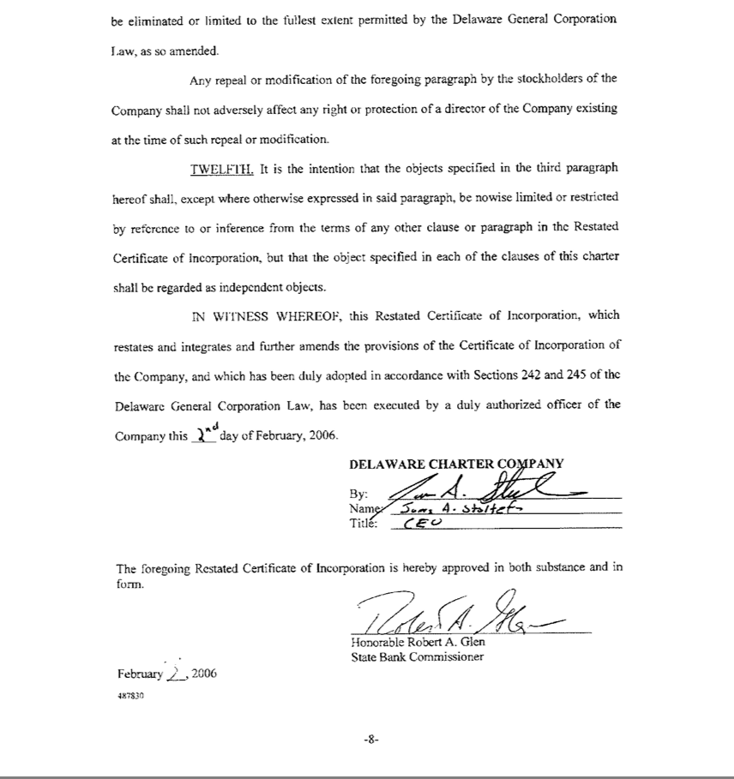

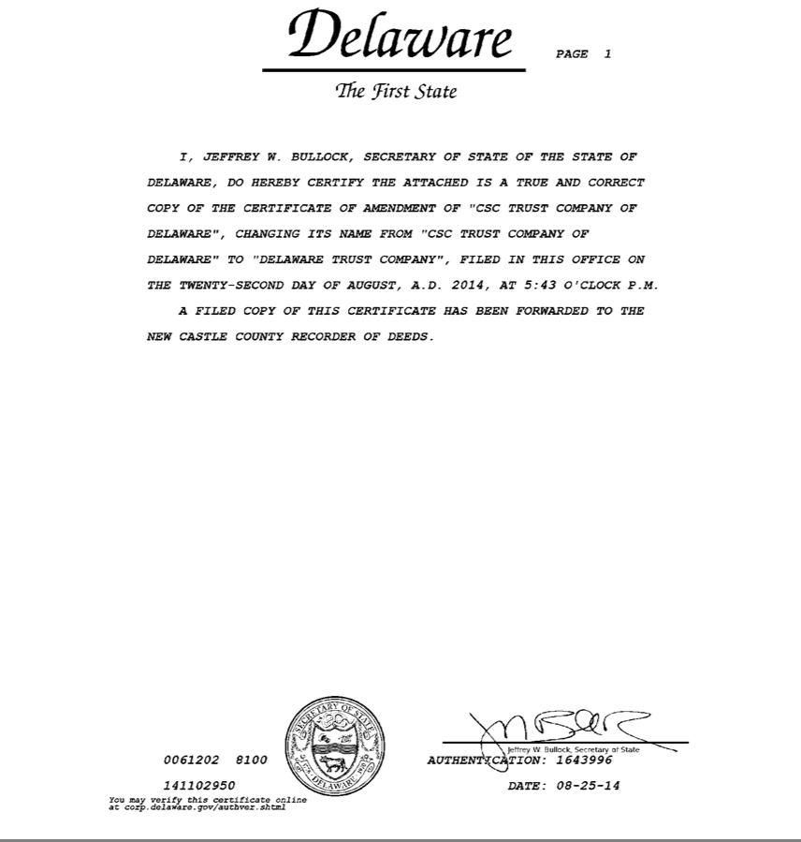

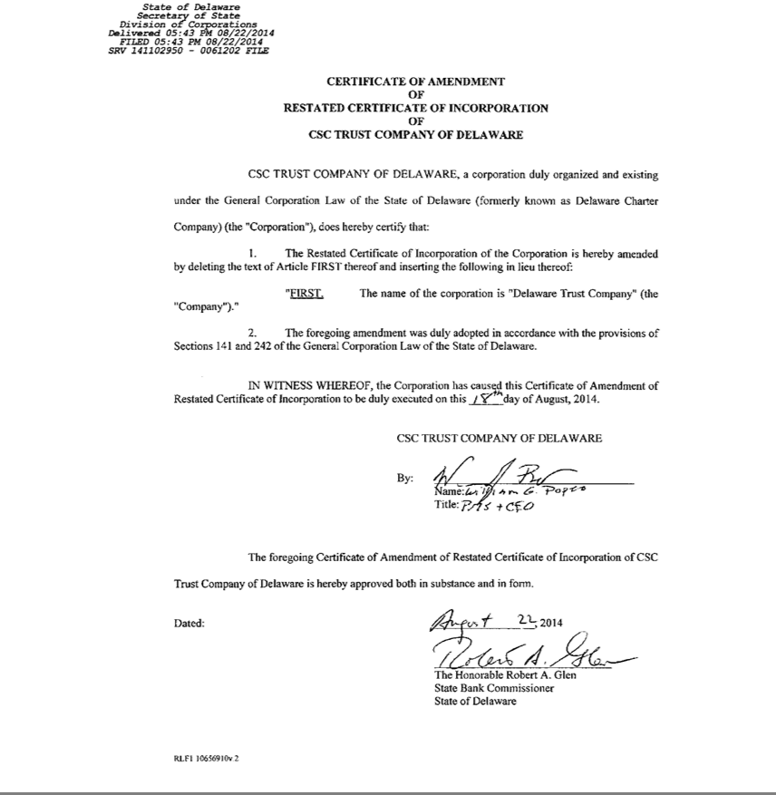

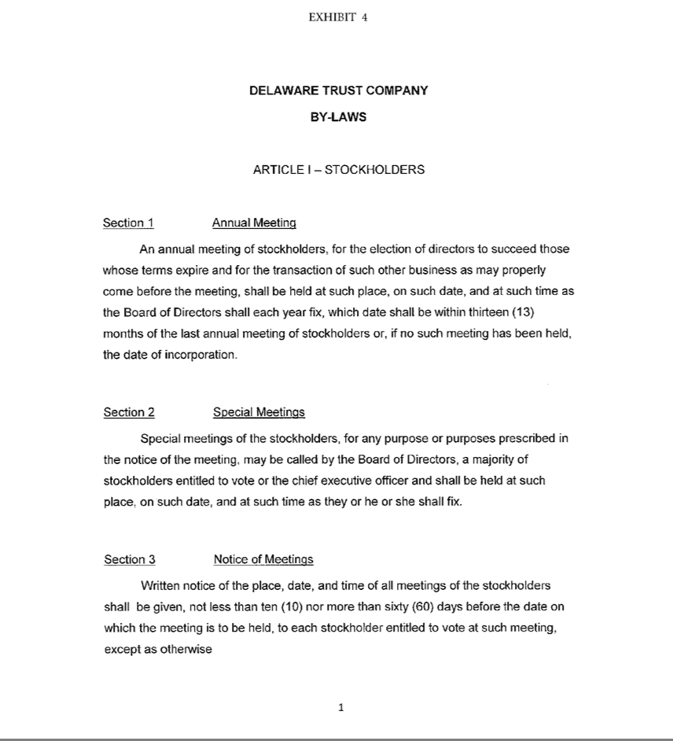

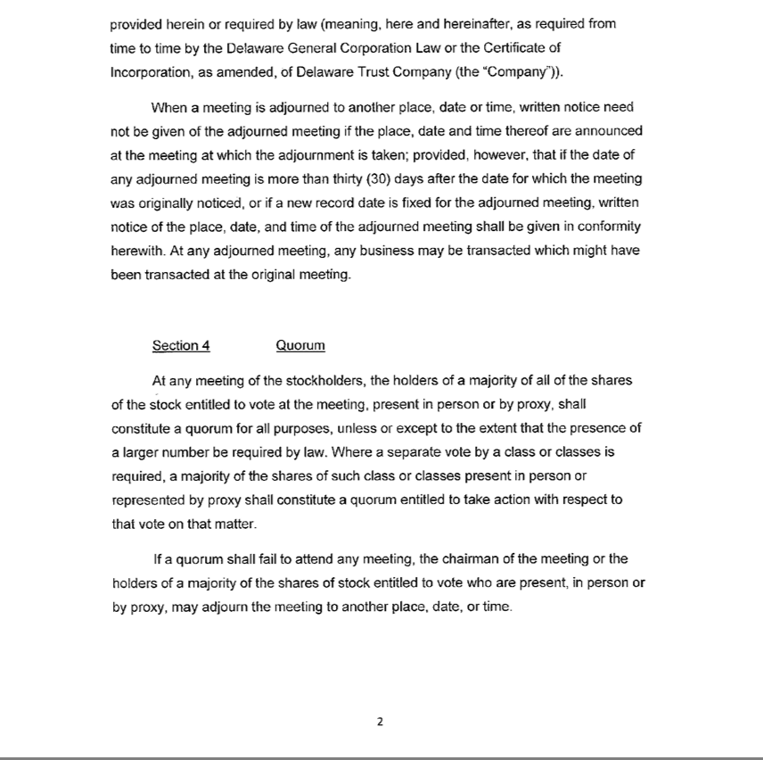

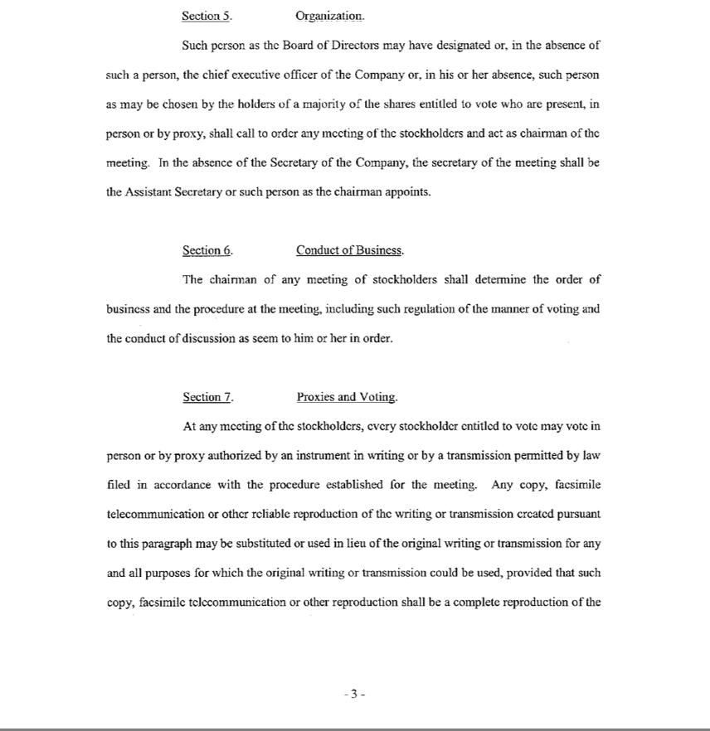

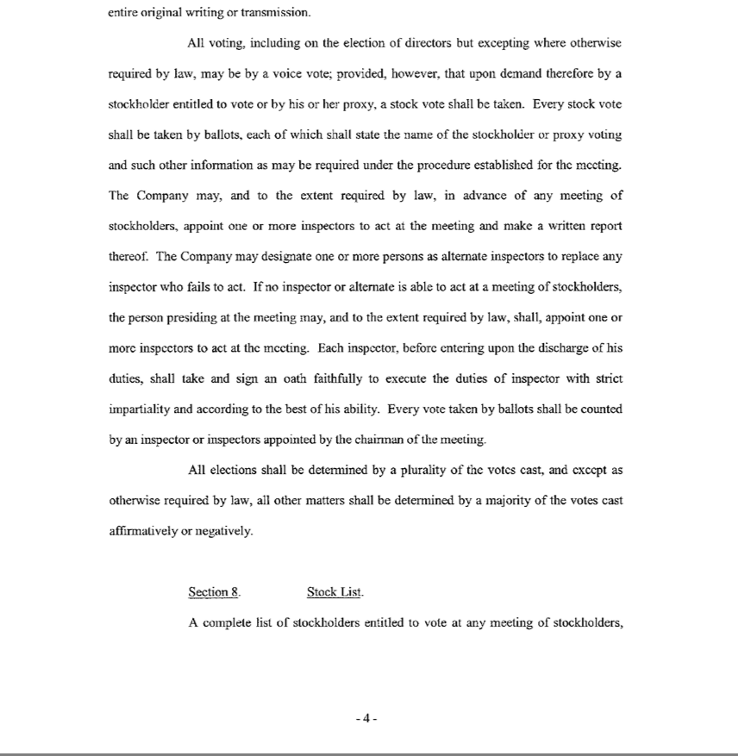

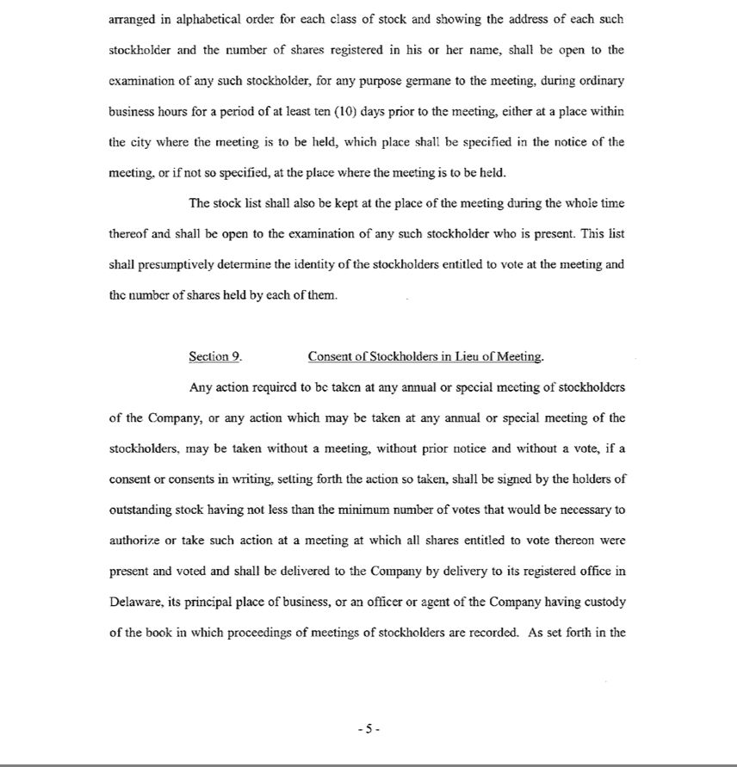

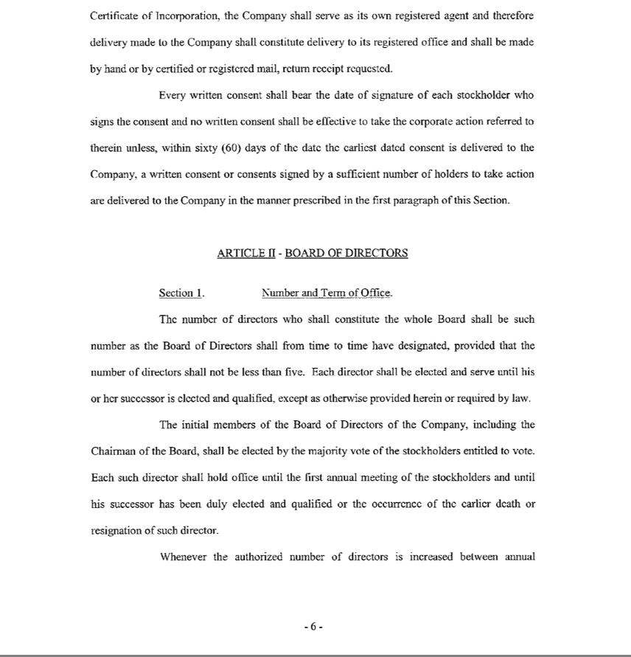

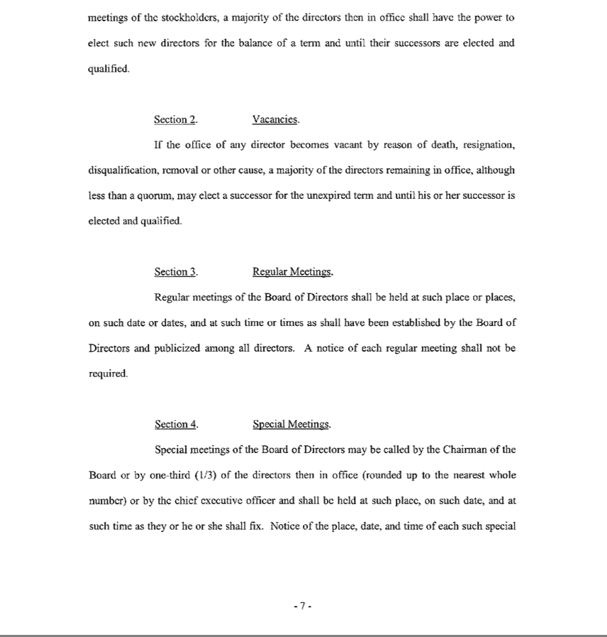

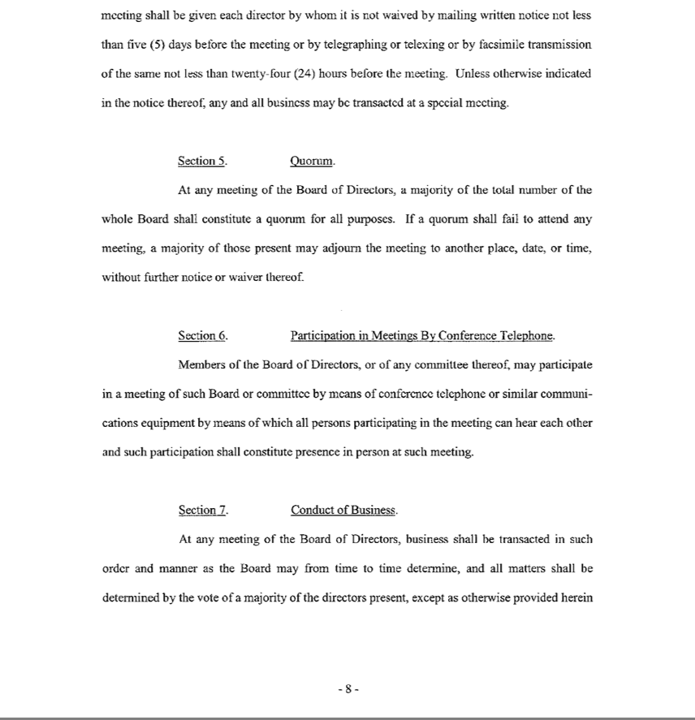

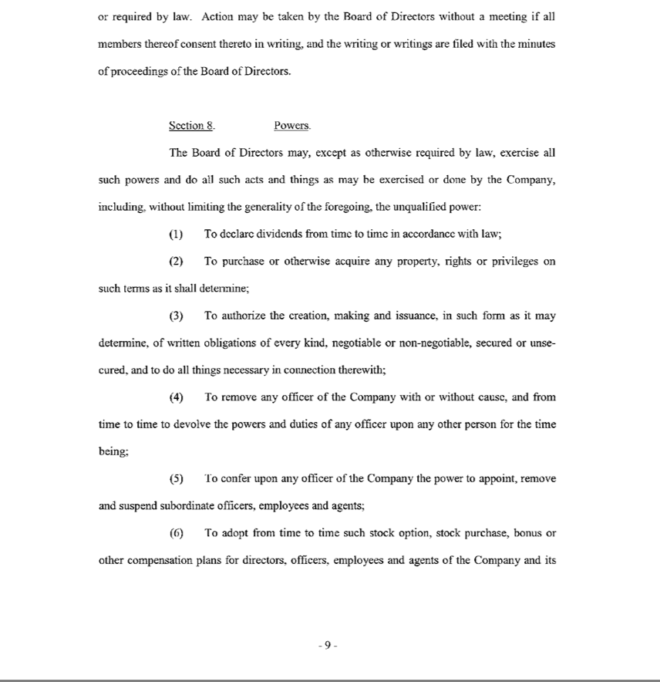

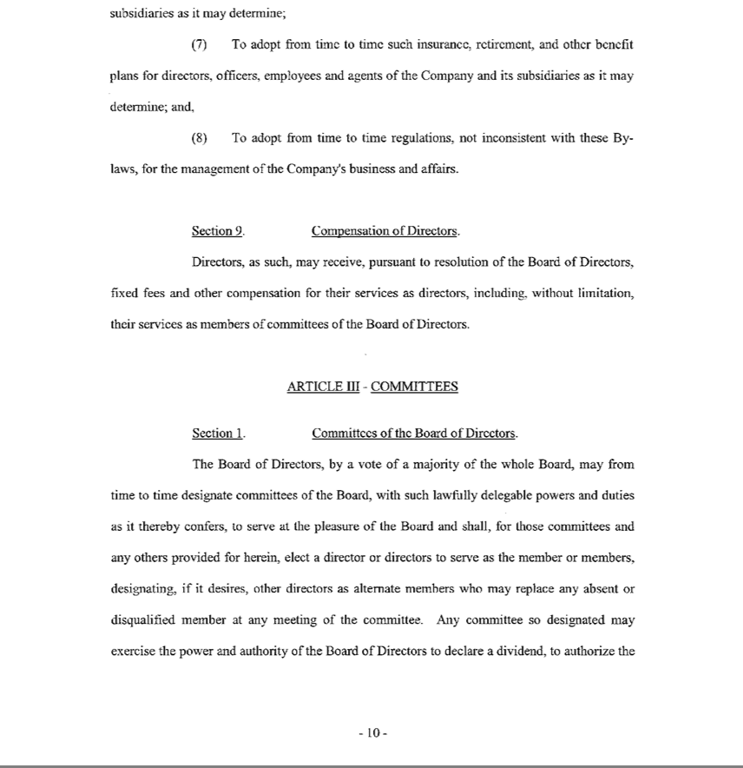

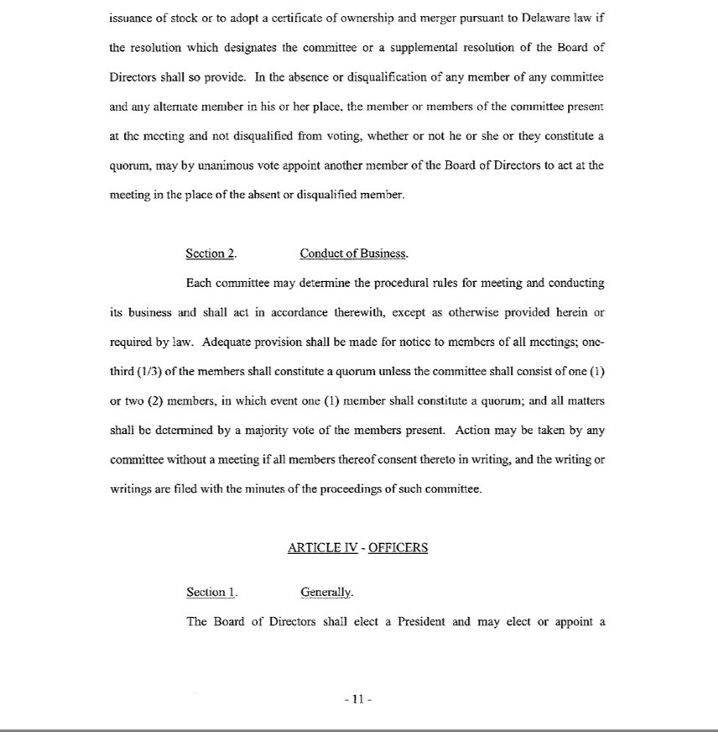

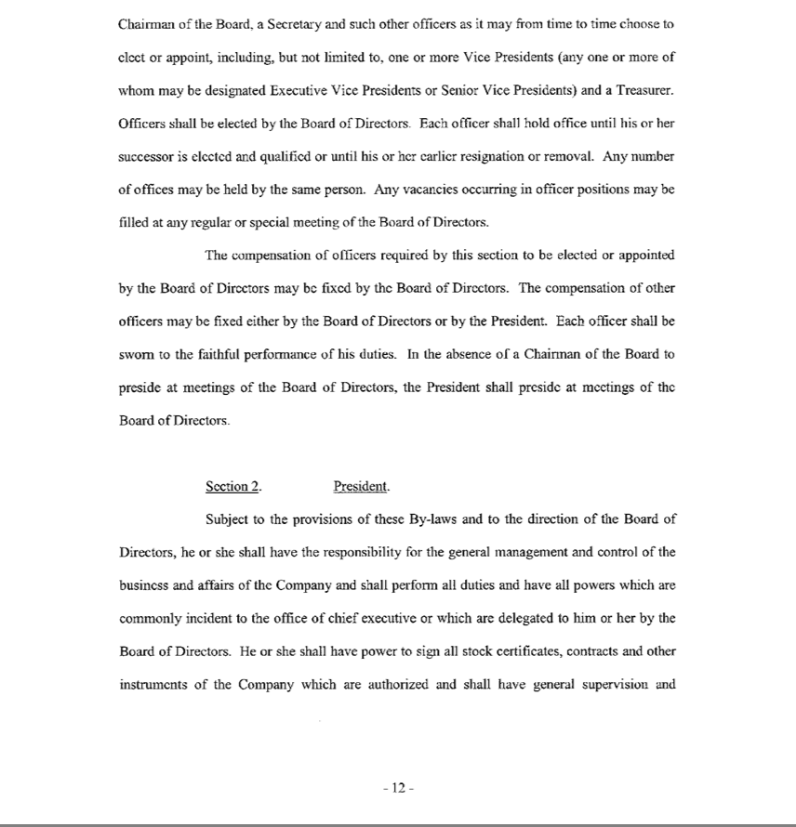

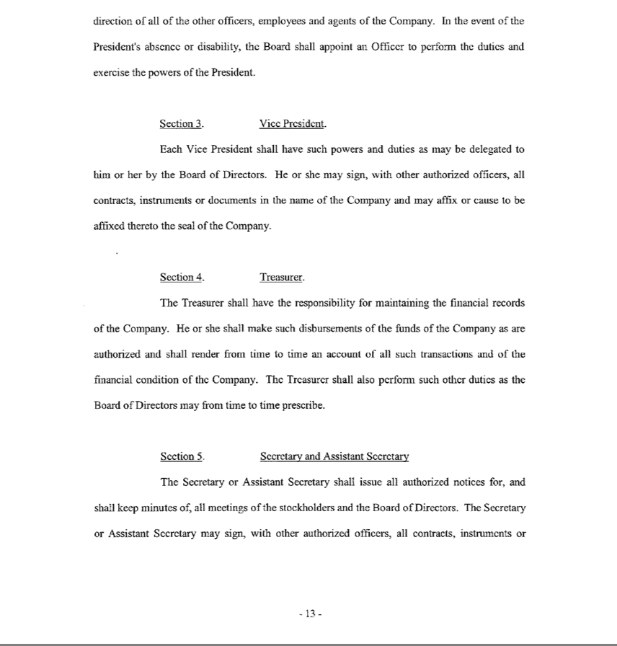

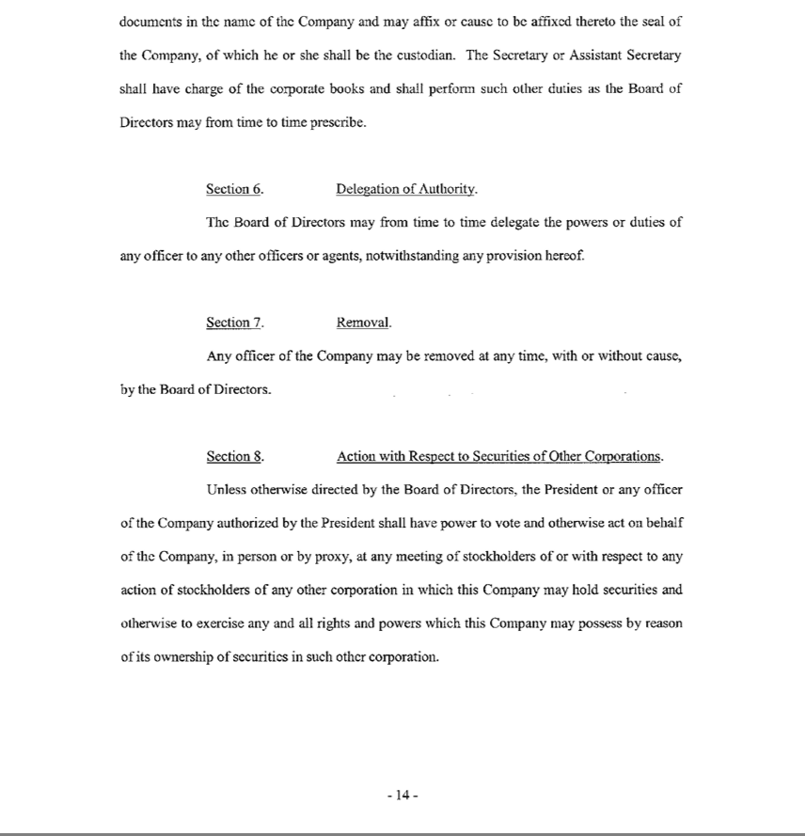

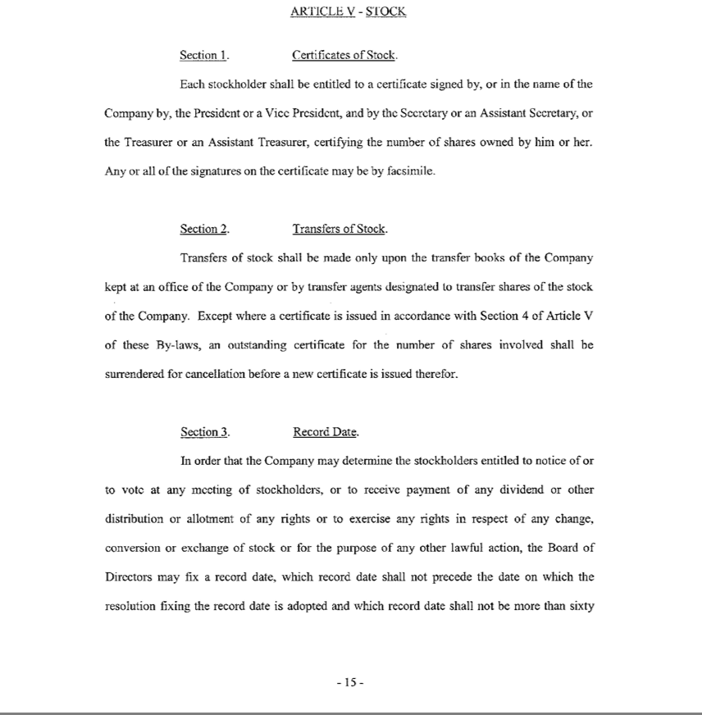

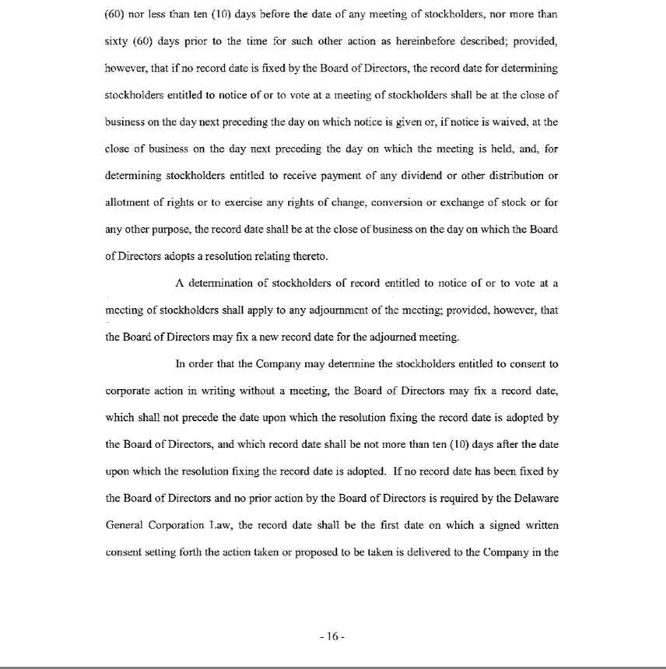

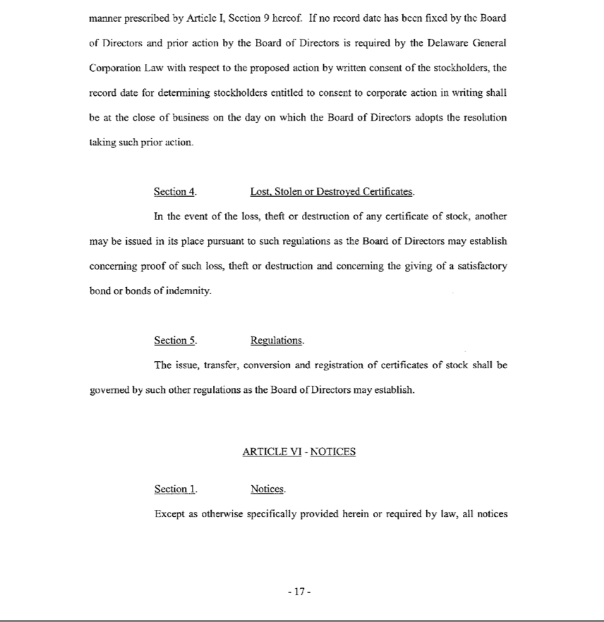

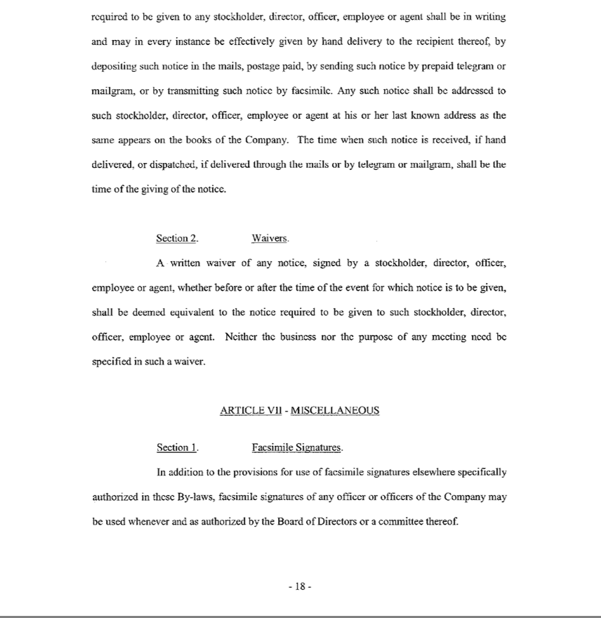

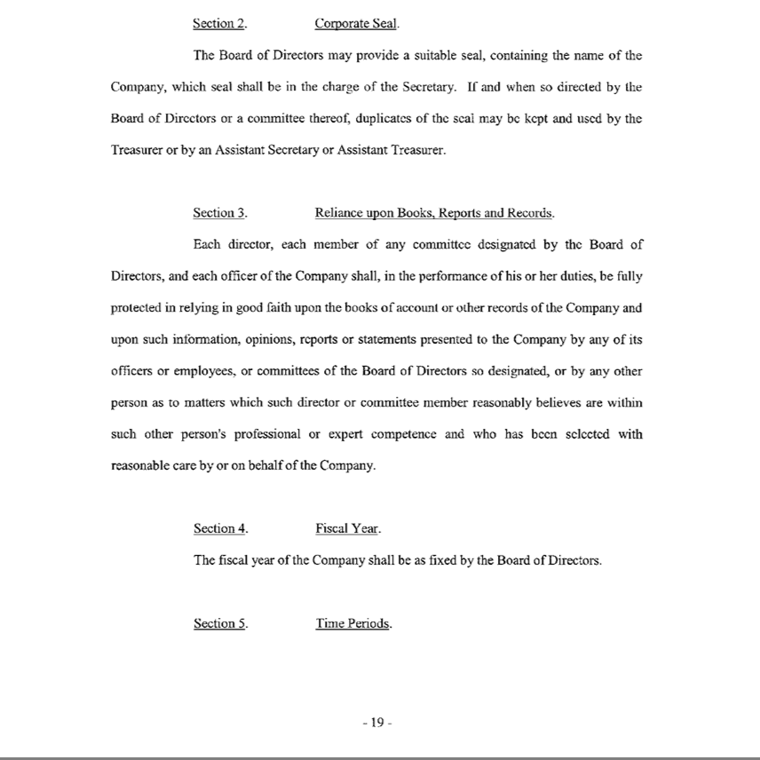

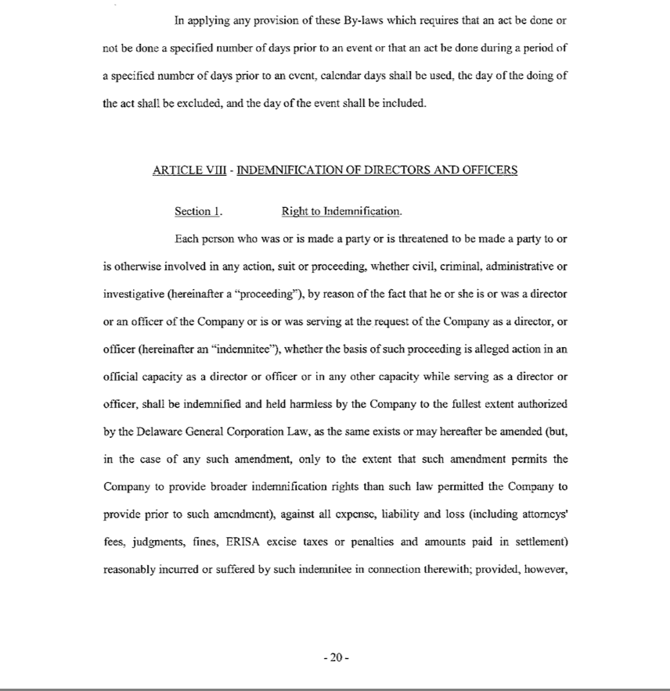

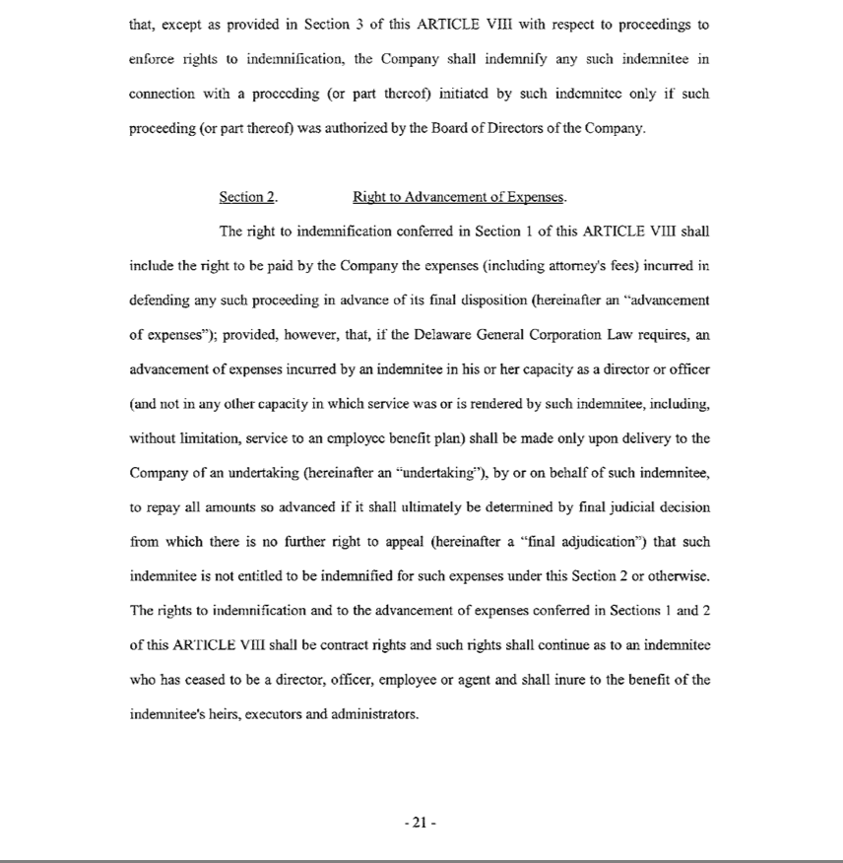

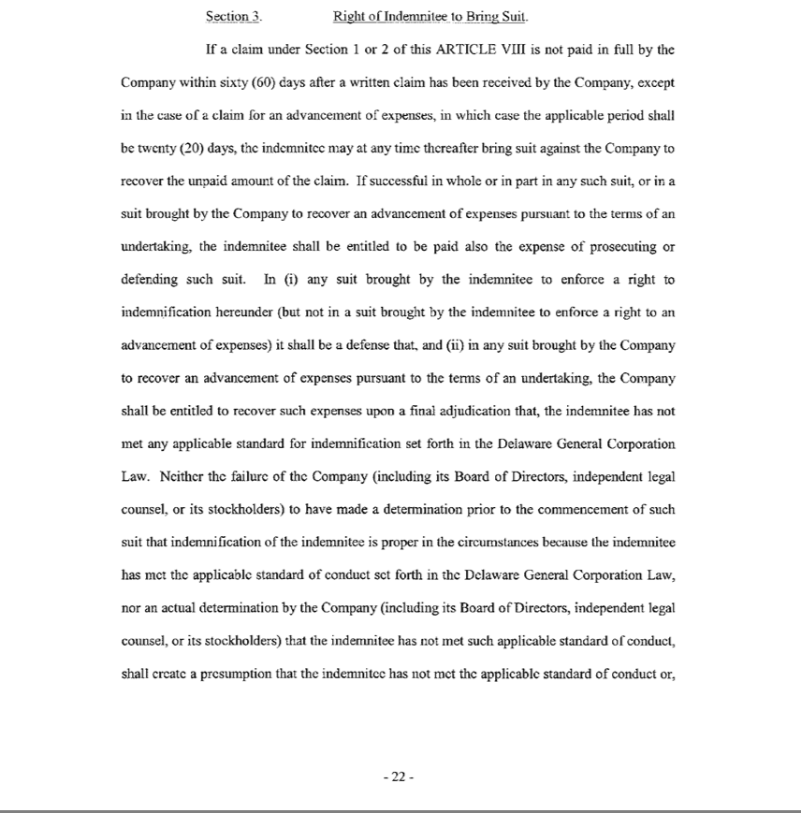

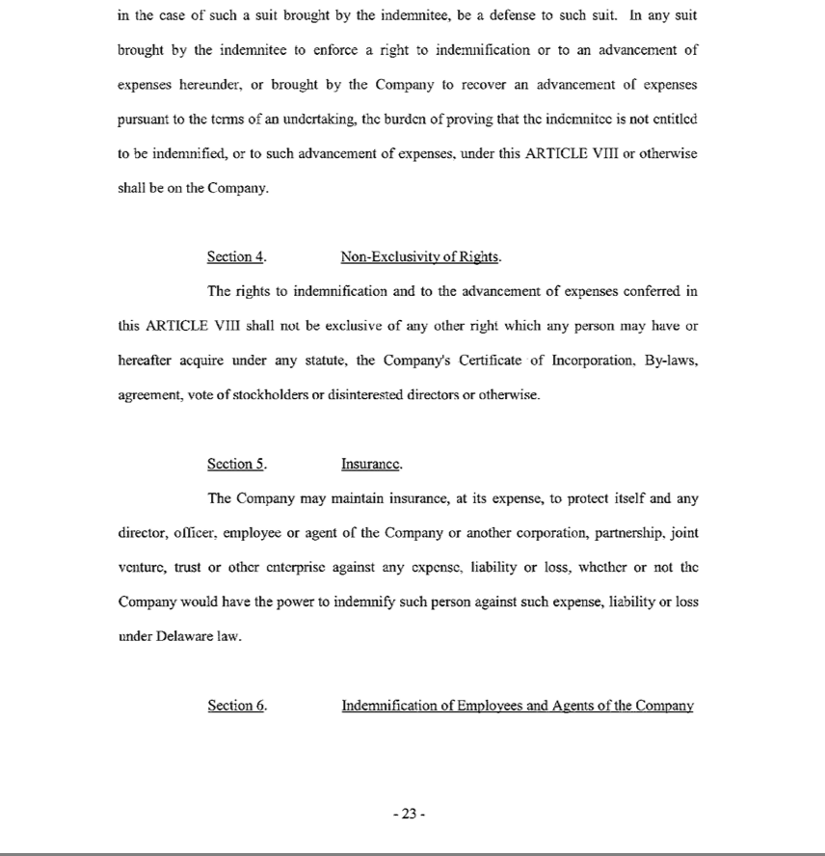

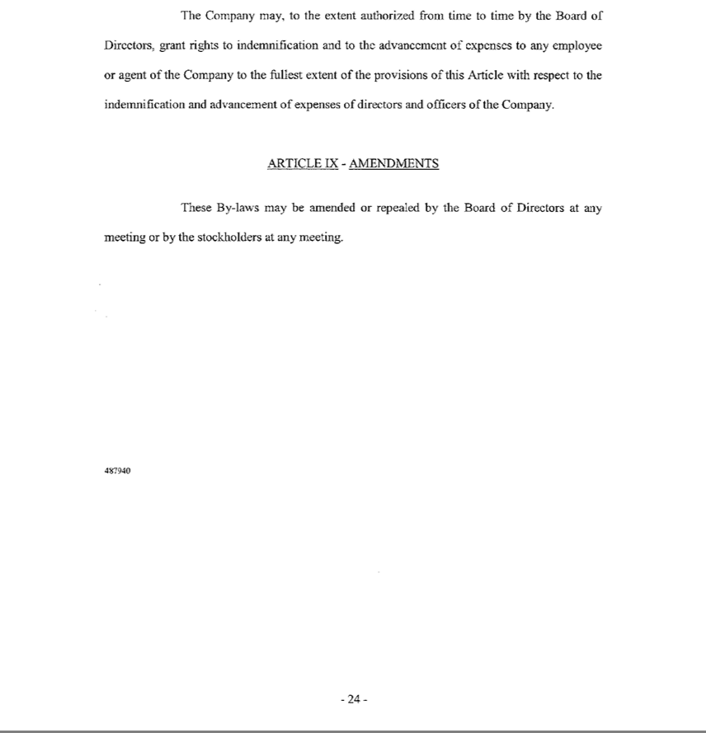

EXHIBIT 6

April 19, 2017

Securities and Exchange Commission

Washington, D.C. 20549

Gentlemen:

In accordance with Section 321(b) of the Trust Indenture Act of 1939, as amended, the undersigned hereby consents that reports of examination of the undersigned made by Federal, State, Territorial, or District authorities authorized to make such examination may be furnished by such authorities to the Securities and Exchange Commission upon its request therefor.

Very truly yours,

DELAWARE TRUST COMPANY

/s/ William G. Popeo

Name: William G. Popeo

Title: President & CEO

EXHIBIT 7

Report of Condition of

Delaware Trust Company

of 2711 Centerville Road, Suite 200, Wilmington, Delaware 19808

at the close of business December 31, 2016, filed in accordance with 5 Del. Laws, c.9, §904

 | Dollar Amounts
 | In Thousands
ASSETS
Cash and balances due from depository institutions:
Noninterest-bearing balances and currency and coin
Interest-bearing balances | 2,886
Securities:
Held-to-maturity securities
Available-for-sale securities
Federal funds sold and securities purchased under agreements to resell:
Federal funds sold in domestic offices
Securities purchased under agreements to resell
Loans and lease financing receivables:
Loans and leases held for sale
Loans and leases, net of unearned income
LESS: Allowance for loan and lease losses
Loans and leases, net of unearned income and allowance | 0
Trading Assets
Premises and fixed assets (including capitalized leases)
Other real estate owned
Investments in unconsolidated subsidiaries and associated companies
Direct and indirect investments in real estate ventures
Intangible assets
Goodwill
Other intangible assets
Other assets | 109,878
Total assets | 112,764

 | Dollar Amounts
 | In Thousands
LIABILITIES
Deposits:
In domestic offices
Noninterest-bearing
Interest-bearing
In foreign offices, Edge and Agreement subsidiaries, and IBFs
Noninterest-bearing
Interest-bearing
Federal funds purchased and securities sold under agreements to repurchase:
Federal funds purchased in domestic offices
Securities sold under agreements to repurchase
Trading liabilities
Other borrowed money
(includes mortgage indebtedness and obligations under capitalized leases)
Subordinated notes and debentures
Other liabilities | 2,199
Total liabilities | 2,199
EQUITY CAPITAL
Perpetual preferred stock and related surplus
Common stock | 500
Surplus (exclude all surplus related to preferred stock) | 105,501
Retained earnings | 4,564
Accumulated other comprehensive income
Other equity capital components
Total institution equity capital | 110,565

Noncontrolling (minority) interests in consolidated subsidiaries
Total equity capital | 110,565
Total liabilities, and equity capital | 112,764

I, Thomas C. Porth, CFO of the above-named State Non-Depository Trust Company, do hereby declare that this Report of Condition has been prepared in conformance with the instructions issued by the appropriate State regulatory authority and is true to the best of my knowledge and belief.

/s/ Thomas C. Porth

Thomas C. Porth
CFO

We, the undersigned directors, attest to the correctness of this Report of Condition and declare that it has been examined by us and to the best of our knowledge and belief has been prepared in conformance with the instructions issued by the appropriate State regulatory authority and is true and correct.

/s/ William G. Popeo |  | /s/ Ian R. McConnel
William G. Popeo |  | Ian R. McConnel

QuickLinks -- Click here to rapidly navigate through this document

Exhibit 99.01

Letter of Transmittal

Offer to Exchange

5.000% Senior Notes due 2026, which have been registered under the

Securities Act of 1933, as amended,

for any and all outstanding 5.000% Senior Notes due 2026

144A Notes (CUSIP 62943W AC3 and ISIN US62943WAC38)

Regulation S Notes (CUSIP U67007 AB7 and ISIN USU67007AB77)

of

NRG YIELD OPERATING LLC

THE EXCHANGE OFFER AND WITHDRAWAL RIGHTS WILL EXPIRE AT 12:00 MIDNIGHT, NEW YORK CITY TIME, ON | , 2017
(THE "EXPIRATION DATE"), UNLESS EXTENDED BY NRG YIELD OPERATING LLC IN ITS SOLE DISCRETION.

The Exchange Agent for the Exchange Offer is:

DELAWARE TRUST COMPANY, EXCHANGE AGENT

By Registered or Certified Mail or | Facsimile Transmission: | By Hand Delivery:
Overnight Carrier: | (for eligible institutions only)
Delaware Trust Company | (302) 636-8666 | Delaware Trust Company
103 Foulk Road |  | 103 Foulk Road
Wilmington, DE 19803 |  | Wilmington, DE 19803
Attention: Trust Administration | Confirm by Telephone: | Attention: Trust Administration
 | (877) 374-6010

Delivery of this Letter of Transmittal to an address other than as set forth above or transmission of this Letter of Transmittal via a facsimile transmission will not constitute a valid delivery.

PLEASE READ THE ENTIRE LETTER OF TRANSMITTAL, INCLUDING THE INSTRUCTIONS TO THIS LETTER, CAREFULLY BEFORE CHECKING ANY BOX BELOW.

Capitalized terms used in this Letter of Transmittal and not defined herein shall have the respective meanings ascribed to them in the Prospectus (as defined herein).

List in Box 1 below the Old Notes of which you are the holder. If the space provided in Box 1 is inadequate, list the principal amount at maturity of Old Notes on a separate signed schedule and affix that schedule to this Letter of Transmittal.

BOX 1


DESCRIPTION OF OLD NOTES

 | Names and Address(es) of Registered |  | Aggregate
 | Holder(s) | Certificate | Principal Amount | Principal Amount
 | (Please Fill In) | Number(s)* | Represented** | Tendered**
Total principal amount of Old Notes
* | need not be completed by holders delivering by book-entry transfer (see below)
** | Old Notes may be tendered in whole or in part in minimum denomination of $2,000 and integral
 | multiples of $1,000 in excess thereof. All Old Notes held shall be deemed tendered unless a lesser
 | number is specified in this column. See Instruction 4.

- Check here if tendered Old Notes are being delivered by book-entry transfer made to the account maintained by the Exchange Agent with The Depository Trust Company ("DTC") and complete the following:

Name of Tendering Institution:

Account Number with DTC:

Transaction Code Number:

By crediting the Old Notes to the Exchange Agent's (as defined herein) Account at DTC in accordance with DTC's Automated Tender Offer Program ("ATOP") and by complying with applicable ATOP procedures with respect to the Exchange Offer (as defined herein), including transmitting an agent's message to the Exchange Agent in which the holder of the Old Notes acknowledges receipt of this Letter of Transmittal and agrees to be bound by the terms of this Letter of Transmittal, the participant in DTC confirms on behalf of itself and the beneficial owners of such Old Notes all provisions of this Letter of Transmittal applicable to it and such beneficial owners as fully as if it had completed the information required herein and executed and transmitted this Letter of Transmittal to the Exchange Agent.

The undersigned acknowledges receipt of (i) the Prospectus, dated , 2017 (the "Prospectus"), of NRG Yield Operating LLC (the "Issuer") and the subsidiaries of the Issuer named as additional registrants in the registration statement in which the Prospectus is included (together, the "Guarantors") and

- this Letter of Transmittal, which may be amended from time to time, which together constitute the offer of the Issuer and the Guarantors (the "Exchange Offer") to exchange up to $350,000,000 aggregate principal amount of 5.000% Senior Notes due 2026 (together with the guarantees thereof, the "Exchange Notes"), which have been registered under the Securities Act of 1933, as amended (the "Securities Act"), for a like principal amount of outstanding 5.000% Senior Notes due 2026 (together with the guarantees thereof, the "Old Notes"), of the Issuer. The Old Notes were issued and sold in a transaction exempt from registration under the Securities Act.

The undersigned has completed, executed and delivered this Letter of Transmittal to indicate the action he or she desires to take with respect to the Exchange Offer.

A beneficial owner whose Old Notes are held by a broker, dealer, commercial bank, trust company or other nominee and who desires to tender such Old Notes in this Exchange Offer need not complete this Letter of Transmittal and must contact its nominee and instruct the nominee to tender its Old Notes on its behalf.

A participant through DTC who wishes to participate in the Exchange Offer must either (1) complete, sign, and mail or transmit this Letter of Transmittal to Delaware Trust Company

(the "Exchange Agent") or (2) electronically submit its acceptance through DTC's ATOP system, in either case, prior to the Expiration Date.

This Letter of Transmittal need not be completed by a DTC participant tendering through ATOP. A transmission of an acceptance to DTC through ATOP shall constitute your agreement to be bound by this Letter of Transmittal and your acceptance that we may enforce such agreement against you.

By crediting the Old Notes to the Exchange Agent's Account at DTC in accordance with ATOP and by complying with applicable ATOP procedures with respect to the Exchange Offer, including transmitting an agent's message to the Exchange Agent in which the holder of the Old Notes acknowledges receipt of this Letter of Transmittal and agrees to be bound by the terms of this Letter of Transmittal, the DTC Participant confirms on behalf of itself and the beneficial owners of such Old Notes all provisions of this Letter of Transmittal applicable to it and such beneficial owners as fully as if it had completed the information required herein and executed and transmitted this Letter of Transmittal to the Exchange Agent.

Such holders who wish to tender through DTC's ATOP procedures should allow sufficient time for completion of the ATOP procedures during the normal business hours of DTC on or before the Expiration Date.

Tenders of Old Notes may be withdrawn at any time prior to the Expiration Date. For a withdrawal of Old Notes to be effective, the Exchange Agent must receive a written or facsimile transmission containing a notice of withdrawal prior to the Expiration Date, or a properly transmitted "Request Message" through ATOP.

Beneficial owners of Old Notes who are not direct participants in DTC must contact their broker, bank or other nominee or custodian to arrange for their direct participation in DTC or to submit an instruction to DTC on their behalf in accordance with its requirements. The beneficial owners of Old Notes that are held in the name of a broker, bank or other nominee or custodian should contact such entity sufficiently in advance of the Expiration Date if they wish to tender their Old Notes and ensure that the Old Notes in DTC are blocked in accordance with the requirements and deadlines of DTC. Such beneficial owners of the Old Notes should not submit such instructions directly to DTC, us or the Exchange Agent.

The Instructions included with this Letter of Transmittal must be followed in their entirety. Questions and requests for assistance or for additional copies of the Prospectus or this Letter of Transmittal may be directed to the Exchange Agent, at the address listed above.

Ladies and Gentlemen:

Upon the terms and subject to the conditions of the Exchange Offer, the undersigned tenders to the Issuer and the Guarantors the principal amount of Old Notes indicated above. Subject to, and effective upon, the acceptance for exchange of the Old Notes tendered with this Letter of Transmittal, the undersigned exchanges, assigns and transfers to, or upon the order of, the Issuer and the Guarantors, all right, title and interest in and to the Old Notes tendered.

The undersigned constitutes and appoints the Exchange Agent as his or her agent and attorney-in-fact (with full knowledge that the Exchange Agent also acts as the agent of the Issuer and the Guarantors) with respect to the tendered Old Notes, with full power of substitution, to: (a) deliver Old Notes and all accompanying evidence of transfer and authenticity to or upon the order of the Issuer upon receipt by the Exchange Agent, as the undersigned's agent, of the Exchange Notes to which the undersigned is entitled upon the acceptance by the Issuer and the Guarantors of the Old Notes tendered under the Exchange Offer and

- receive all benefits and otherwise exercise all rights of beneficial ownership of the Old Notes, all in accordance with the terms of the Exchange Offer. The power of attorney granted in this paragraph shall be deemed irrevocable and coupled with an interest.

The undersigned hereby represents and warrants that he or she has full power and authority to tender, exchange, assign and transfer the Old Notes tendered hereby and to acquire Exchange Notes issuable upon exchange of the tendered Old Notes, and that, when the tendered Old Notes are accepted for exchange, the Issuer and the Guarantors will acquire good and unencumbered title thereto, free and clear of all liens, restrictions, charges and encumbrances and not subject to any adverse claims. The undersigned will, upon request, execute and deliver any additional documents deemed by the Issuer to be necessary or desirable to complete the exchange, assignment and transfer of the Old Notes tendered.

The undersigned agrees that acceptance of any tendered Old Notes by the Issuer and the Guarantors and the issuance of Exchange Notes in exchange therefore shall constitute performance in full by the Issuer and Guarantors of their respective obligations under the registration rights agreement that the Issuer and Guarantors entered into with the initial purchasers of the Old Notes (the "Registration Rights Agreement") and that, upon the issuance of the Exchange Notes, the Issuer and Guarantors will have no further obligations or liabilities under the Registration Rights Agreement (except in certain limited circumstances). By tendering Old Notes, the undersigned represents and certifies for the benefit of the Issuer that:

- the undersigned or any other person acquiring the Exchange Notes in exchange for Old Notes held for the account of the undersigned in the Exchange Offer, is acquiring such Exchange Notes in the ordinary course of business;

- neither the undersigned nor any other person acquiring Exchange Notes in exchange for Old Notes held for the account of the undersigned in the Exchange Offer is engaging in or intends to engage in (or has any arrangement or understanding with any person to participate in) a distribution of the Exchange Notes within the meaning of the federal securities laws;

- neither the undersigned nor any other person acquiring Exchange Notes in exchange for Old Notes held for the account of the undersigned is an "affiliate," as defined under Rule 405 of the Securities Act, of the Issuer;

- neither the undersigned nor any other person acquiring Exchange Notes in exchange for Old Notes held for the account of the undersigned in the Exchange Offer is a broker-dealer tendering Old Notes directly acquired from the Issuer for its own account; and

- the undersigned is not acting on behalf of any person or entity that could not truthfully make the foregoing representations.

The undersigned represents, certifies and acknowledges, for the benefit of the Issuer, that, if it is a broker-dealer that will receive Exchange Notes for its own account in exchange for Old Notes: (1) the Old Notes to be exchanged for Exchange Notes were acquired by it as a result of market-making or

other trading activities, (2) it has not entered into any arrangement or understanding with the Issuer or an affiliate of the Issuer to distribute the Exchange Notes and

- it will deliver a prospectus meeting the requirements of the Securities Act in connection with any resale of such Exchange Notes; however, by so acknowledging and by delivering a prospectus, a broker-dealer will not be deemed to admit that it is an "underwriter" within the meaning of the Securities Act.

Any holder who tenders in the Exchange Offer with the intention of participating in any manner in a distribution of the Exchange Notes, who is an affiliate of ours or who is a broker or dealer who acquired Old Notes directly from the Issuer cannot rely on the position of the Staff of the Securities and Exchange Commission set forth in "Exxon Capital Holdings Corporation" or similar interpretive letters and must comply with the registration and prospectus delivery requirements of the Securities Act in connection with a secondary resale transaction.

The undersigned understands that the Issuer and the Guarantors may accept the undersigned's tender by delivering oral (promptly confirmed in writing) or written notice of acceptance to the Exchange Agent following expiration of the Exchange Offer, at which time the undersigned's right to withdraw such tender will terminate.

All authority conferred or agreed to be conferred by this Letter of Transmittal shall survive the death or incapacity of the undersigned, and every obligation of the undersigned under this Letter of Transmittal shall be binding upon the undersigned's heirs, legal representatives, successors, assigns, executors and administrators of the undersigned. Tenders may be withdrawn only in accordance with the procedures set forth in the Instructions included with this Letter of Transmittal.

Unless otherwise indicated under "Special Delivery Instructions" below, the Exchange Agent will deliver Exchange Notes (and, if applicable, any Old Notes not tendered or properly withdrawn) to the undersigned's account indicated below by book-entry transfer.

Use of Guaranteed Delivery

(See Instruction 1)

To be completed only if tendered Old Notes are being delivered pursuant to a notice of guaranteed delivery previously sent to the Exchange Agent. Complete the following (please enclose a photocopy of such notice of guaranteed delivery):

Name of Registered Holder(s):

Window Ticket Number (if any):

Date of Execution of the Notice of Guaranteed Delivery:

Name of Eligible Institution that Guaranteed Delivery:

Name of Registered Holder(s):

If Delivered By Book-Entry Transfer, Complete The Following:

Name of Tendering Institution:

Account Number at DTC:

Transaction Code Number:

Broker-Dealer Status

- Check here if you are a broker-dealer that acquired your tendered Old Notes for your own account as a result of market-making or other trading activities and wish to receive 10 additional copies of the Prospectus and any amendments or supplements thereto.

Name:

Address:

NOTE:SIGNATURES MUST BE PROVIDED BELOW


BOX 2

PLEASE SIGN HERE

This Letter of Transmittal must be signed by the registered holder(s) of Old Notes exactly as their name(s) appear(s) on certificate(s) for Old Notes, if any, or on a security position listing, or by person(s) authorized to become registered holder(s) by endorsements and documents transmitted with this Letter of Transmittal. If the signature is by a trustee, executor, administrator, guardian, attorney-in-fact, officer or other person acting in a fiduciary or representative capacity, such person must set forth his or her full title below under "Capacity" and submit evidence satisfactory to the Exchange Agent of such person's authority to so act. See Instruction 3 below.

If the signature appearing below is not of the registered holder(s) of the Old Notes, then the registered holder(s) must sign a valid power of attorney.

X

X

Signature(s) of Holder(s) or Authorized Signatory

Dated:

Name(s):

Capacity:

Address:

Including Zip Code

Area Code and Telephone Number

Please Complete Substitute Form W-9 Herein

SIGNATURE GUARANTEE (If required—see Instruction 3)

Certain Signatures Must be Guaranteed by a Signature Guarantor

(Name of Signature Guarantor Guaranteeing Signatures)

(Address (including zip code) and Telephone Number (including area code) of Firm)

(Authorized Signature)

(Printed Name)

(Title)

Dated

SPECIAL ISSUANCE INSTRUCTIONS


(See Instructions 3, 4 and 5)

To be completed ONLY if certificates for Old Notes in a principal amount not tendered are to be issued in the name of, or Exchange Notes issued pursuant to the Exchange Offer are to be issued in the name of, someone other than the person or persons whose name(s) appear(s) within this Letter of Transmittal or issued to an address different from that shown in the box entitled "Description of Old Notes" within this Letter of Transmittal.

Issue: o Exchange Notes o Old Notes (Complete as applicable)

Name

(Please Print)

Address

(Please Print)

(Zip Code)

Tax Identification or Social Security Number

(See Substitute Form W-9 Herein)

Credit Old Notes not tendered by this Letter of Transmittal, by book-entry transfer to:

- The Depository Trust Company

- Account Number

Credit Exchange Notes issued pursuant to the Exchange Offer by book-entry transfer to:

- The Depository Trust Company

- Account Number

SPECIAL DELIVERY INSTRUCTIONS


(See Instructions 3 and 4)

To be completed ONLY if certificates for Old Notes in a principal amount not tendered or Exchange Notes are to be sent to someone other than the person or persons whose name(s) appear(s) within this Letter of Transmittal in the box entitled "Description of Old Notes" within this Letter of Transmittal.

Deliver: o Exchange Notes o Old Notes (Complete as applicable)

Name

(Please Print)

Address

(Please Print)

(Zip Code)

Is this a permanent address change:

o Yes o No (check one box)

INSTRUCTIONS

FORMING PART OF THE TERMS AND

CONDITIONS OF THE EXCHANGE OFFER

- Delivery of this Letter of Transmittal.

This Letter of Transmittal is to be completed by holders of Old Notes if certificates representing such Old Notes are to be forwarded herewith, or, unless an agent's message is utilized, if delivery of such certificates is to be made by book-entry transfer to the Exchange Agent's account maintained by DTC, pursuant to the procedures set forth in the Prospectus under "Exchange Offer—Procedures for brokers and custodian banks; DTC ATOP accounts." For a holder to properly tender Old Notes pursuant to the Exchange Offer, a properly completed and duly executed Letter of Transmittal (or a manually signed facsimile thereof), together with any signature guarantees and any other documents required by these Instructions, or a properly transmitted agent's message in the case of a book entry transfer, must be received by the Exchange Agent at its address set forth herein prior to 12:00 midnight, New York City time on the Expiration Date, and either (1) certificates representing such Old Notes must be received by the Exchange Agent at its address, or (2) such Old Notes must be transferred pursuant to the procedures for book-entry transfer described in the Prospectus under "Exchange Offer—Procedures for brokers and custodian banks; DTC ATOP accounts" and a book-entry confirmation must be received by the Exchange Agent prior to 12:00 midnight, New York City time on the Expiration Date.

The method of delivery of this Letter of Transmittal, the Old Notes and all other required documents to the Exchange Agent is at the election and sole risk of the holder. Instead of delivery by mail, holders should use an overnight or hand delivery service. In all cases, holders should allow for sufficient time to ensure delivery to the Exchange Agent prior to the expiration of the Exchange Offer. Holders may request their broker, dealer, commercial bank, trust company or nominee to effect these transactions for such holder. The delivery will be deemed made when actually received by the Exchange Agent. If delivery is by mail, the use of registered mail with return receipt requested, properly insured, is suggested.

Holders that cannot deliver their book-entry confirmation and all other required documents to the Exchange Agent on or before the Expiration Date may tender their Old Notes pursuant to the guaranteed delivery procedures set forth in the Prospectus. Pursuant to such procedure: (i) tender must be made by or through a firm that is a member of a recognized signature guarantee program within the meaning of Rule 17Ad-15 under the Securities Exchange Act of 1934 (an "Eligible Institution"); (ii) on or prior to the Expiration Date, the Exchange Agent must have received from the Eligible Institution a properly completed and duly executed notice of guaranteed delivery (by facsimile transmission, mail or hand delivery) (x) setting forth the name and address of the holder, the names in which the Old Notes are registered, the principal amount of Old Notes tendered, (y) stating that the tender is being made thereby and (z) guaranteeing that within three business days after the date of execution of such notice of guaranteed delivery, the book-entry confirmation will be delivered by the Eligible Institution together with this Letter of Transmittal, properly completed and duly executed, and any other required documents to the Exchange Agent; and (iii) a book-entry confirmation, as well as all other documents required by this Letter of Transmittal, must be received by the Exchange Agent within three business days after the date of execution of such notice of guaranteed delivery, all as provided in the Prospectus under the caption "Exchange Offer—Guaranteed delivery procedures."

All questions as to the validity, form, eligibility (including time of receipt), acceptance and withdrawal of tendered Old Notes will be determined by the Issuer, whose determination will be final and binding. The Issuer reserves the absolute right to reject any or all tenders that are not in proper form or the acceptances for exchange of which may, in the opinion of counsel to the Issuer, be unlawful. The Issuer also reserves the right to waive any of the conditions of the Exchange Offer or any defects or irregularities in tenders of any particular holder of Old Notes whether or not similar defects or irregularities are waived in the cases of other holders of Old Notes. All tendering holders, by

execution of this Letter of Transmittal, waive any right to receive notice of acceptance of their Old Notes.

None of the Issuer, the Guarantors, the Exchange Agent or any other person shall be obligated to give notice of defects or irregularities in any tender, nor shall any of them incur any liability for failure to give any such notice.

- Partial Tenders; Withdrawals.

If less than the entire principal amount of any Old Note evidenced by a book-entry confirmation is tendered, the tendering holder must fill in the principal amount tendered in the fourth column of Box 1 above. All of the Old Notes represented by a book-entry confirmation delivered to the Exchange Agent will be deemed to have been tendered unless otherwise indicated.

If not yet accepted, a tender pursuant to the Exchange Offer may be withdrawn at any time prior to 12:00 midnight, New York City time, on the Expiration Date. To be effective with respect to the tender of Old Notes, a written or facsimile transmission notice of withdrawal must: (i) be received by the Exchange Agent at its address set forth above before 12:00 midnight, New York City time, on the Expiration Date; (ii) specify the person named in the applicable Letter of Transmittal as having tendered Old Notes to be withdrawn; (iii) specify the principal amount of Old Notes to be withdrawn, which must be an authorized denomination; (iv) state that the holder is withdrawing its election to have those Old Notes exchanged; (v) state the name of the registered holder of those Old Notes; and (vi) be signed by the holder in the same manner as the signature on the applicable Letter of Transmittal, including any required signature guarantees, or be accompanied by evidence satisfactory to the Issuer that the person withdrawing the tender has succeeded to the beneficial ownership of the Old Notes being withdrawn.

- Signatures on this Letter of Transmittal; Assignments; Guarantee of Signatures.

If this Letter of Transmittal is signed by the holder(s) of Old Notes tendered hereby, the signature must correspond with the name(s) of the holder(s) of the Old Notes.

If any of the Old Notes tendered hereby are owned by two or more joint owners, all owners must sign this Letter of Transmittal.

If this Letter of Transmittal is signed by the holder of record and (i) the entire principal amount of the holder's Old Notes are tendered; and/or (ii) untendered Old Notes, if any, are to be issued to the holder of record, then the holder of record need not endorse any certificates for tendered Old Notes, if any, nor provide a separate bond power. In any other case, the holder of record must transmit a separate bond power with this Letter of Transmittal.

If this Letter of Transmittal or any assignment is signed by trustees, executors, administrators, guardians, attorneys-in-fact, officers of corporations or others acting in a fiduciary or representative capacity, such persons should so indicate when signing and proper evidence satisfactory to the Issuer of its authority to so act must be submitted, unless waived by the Issuer.

Signatures on this Letter of Transmittal must be guaranteed by an Eligible Institution, unless Old Notes are tendered: (i) by a holder who has not completed the Box entitled "Special Issuance Instructions" or "Special Delivery Instructions" on this Letter of Transmittal; or (ii) for the account of an Eligible Institution. In the event that the signatures in this Letter of Transmittal or a notice of withdrawal, as the case may be, are required to be guaranteed, such guarantees must be by an Eligible Institution which is a member of the Securities Transfer Agents Medallion Program (STAMP), the New York Stock Exchange Medallion Signature Program (MSP) or the Stock Exchanges Medallion Program (SEMP). If Old Notes are registered in the name of a person other than the signer of this Letter of Transmittal, the Old Notes surrendered for exchange must be endorsed by, or be accompanied by, a written instrument or instruments of transfer or exchange, in satisfactory form as determined by the Issuer, in its sole discretion, duly executed by the registered holder with the signature thereon guaranteed by an Eligible Institution.

- Special Issuance and Delivery Instructions.

Tendering holders should indicate, in Box 3 or 4, as applicable, the name and account to which the Exchange Notes or Old Notes not exchanged are to be issued, if different from the name and account of the person signing this Letter of Transmittal. In the case of issuance in a different name, the tax identification number of the person named must also be indicated. Holders tendering Old Notes by book-entry transfer may request that Old Notes not exchanged be credited to such account maintained at the Book-Entry Transfer Facility as such holder may designate.

- Taxpayer Identification Number and Substitute Form W-9.

Each tendering holder is required to provide the Exchange Agent with its correct taxpayer identification number, which, in the case of a holder who is an individual, is his or her social security number. If the Exchange Agent is not provided with the correct taxpayer identification number, the holder may be subject to backup withholding and a U.S. $50 penalty imposed by the Internal Revenue Service. If withholding results in an over-payment of taxes, a refund may be obtained. Certain holders (including, among others, all corporations and certain foreign individuals) are not subject to these backup withholding and reporting requirements. See the enclosed "Guidelines for Certification of Taxpayer Identification Number on Substitute Form W-9" for additional instructions.

To prevent backup withholding, each holder tendering Old Notes must provide such holder's correct taxpayer identification number by completing the Substitute Form W-9, certifying that the taxpayer identification number provided is correct (or that such holder is awaiting a taxpayer identification number), and that (i) the holder has not been notified by the Internal Revenue Service that such holder is subject to backup withholding as a result of failure to report all interest or dividends or (ii) the Internal Revenue Service has notified the holder that such holder is no longer subject to backup withholding. If the Old Notes are registered in more than one name or are not in the name of the actual owner, consult the "Guidelines for Certification of Taxpayer Identification Number on Substitute Form W-9" for information on which tax payer identification number to report.

The Issuer reserves the right in its sole discretion to take whatever steps are necessary to comply with its obligation regarding backup withholding.

- Transfer Taxes.

The Issuer and/or the Guarantors will pay all transfer taxes, if any, applicable to the transfer of Old Notes to them or their order pursuant to the Exchange Offer. If, however, the Exchange Notes or Old Notes not exchanged are to be delivered to, or are to be issued in the name of, any person other than the record holder, or if a transfer tax is imposed for any reason other than the transfer of Old Notes to the Issuer and the Guarantors or their order pursuant to the Exchange Offer, then the amount of such transfer taxes (whether imposed on the record holder or any other person) will be payable by the tendering holder. If satisfactory evidence of payment of taxes or exemption from taxes is not submitted with this Letter of Transmittal, the amount of transfer taxes will be billed directly to the tendering holder.

Except as provided in this Instruction 6, it will not be necessary for transfer tax stamps to be affixed to the certificates, if any, listed in this Letter of Transmittal.

- Waiver of Conditions.

The Issuer reserves the absolute right to amend or waive any of the specified conditions in the Exchange Offer in the case of any Old Notes tendered.

- Requests for Assistance or Additional Copies.

Questions relating to the procedure for tendering, as well as requests for additional copies of the Prospectus or this Letter of Transmittal, may be directed to the Exchange Agent.

IMPORTANT: This Letter of Transmittal (together with a book-entry confirmation and all other required documents) must be received by the Exchange Agent on or before the Expiration Date of the Exchange Offer (as described in the Prospectus).

PAYER'S NAME: Delaware Trust Company


Part 1—PLEASE PROVIDE | Social Security Number(s) OR Employer
YOUR TIN IN THE BOX AT | Identification Number(s)
RIGHT AND CERTIFY OR BY
SIGNING AND DATING BELOW

SUBSTITUTE
FORM W-9
Department of the Treasury
Internal Revenue Service
 | Part 2—Certification—Under Penalties of Perjury, I certify that (1) The number shown on this form is my correct taxpayer
 | identification number (or I am waiting for a number to be issued to me), and (2) I am not subject to backup withholding because: (a) I
 | am exempt from backup withholding, (b) I have not been notified by the Internal Revenue Service (the "IRS") that I am subject to
 | backup withholding as a result of a failure to report all interest or dividends, or (c) the IRS has notified me that I am no longer subject
 | to backup withholding.
Payer's Request for Taxpayer | Certification Instructions—You must cross out item (2) above if you
 | have been notified by the IRS that you are subject to backup withholding
 | because of underreporting interest or dividends on your tax return.
 | However, if after being notified by the IRS that you are subject to backup
 | withholding you receive another notification from the IRS stating that
 | you are no longer subject to backup withholding, do not cross out
 | item (2).

Signature |  | Date
Name
 | (please print)

YOU MUST COMPLETE THE FOLLOWING CERTIFICATE IF YOU CHECKED THE BOX IN PART 3 OF THE SUBSTITUTE FORM W-9.
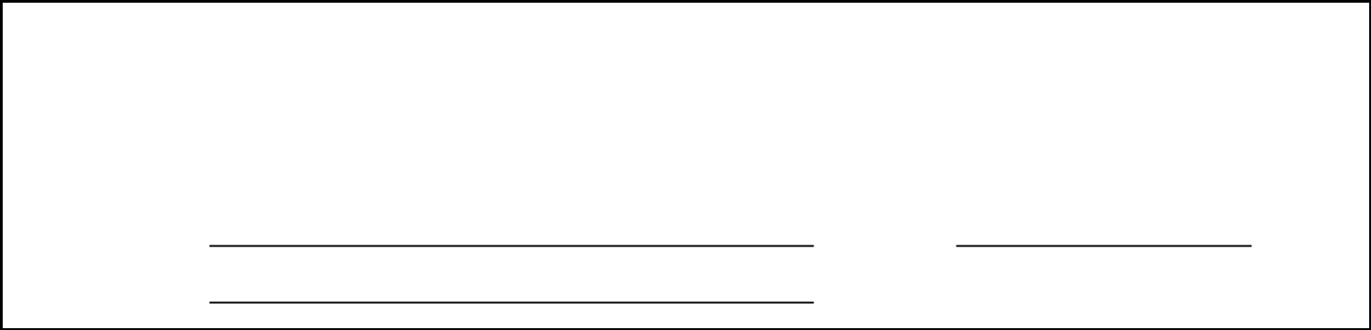

CERTIFICATE OF AWAITING TAXPAYER IDENTIFICATION NUMBER

I certify under penalties of perjury that a taxpayer identification number has not been issued to me, and either (1) I have mailed or delivered an application to receive a taxpayer identification number to the appropriate Internal Revenue Service Center or Social Security Administration office, or (2) I intend to mail or deliver an application in the near future. I understand that if I do not provide a taxpayer identification number by the time of payment, 28% of all reportable cash payments made to me thereafter will be withheld until I provide a taxpayer identification number to the payer and that, if I do not provide my taxpayer identification number within sixty days, such retained amounts shall be remitted to the IRS as backup withholding.

Signature Date

Name

(please print)

NOTE:FAILURE TO COMPLETE AND RETURN THIS FORM W-9 MAY RESULT IN BACKUP WITHHOLDING AND A $50 PENALTY IMPOSED BY THE INTERNAL REVENUE SERVICE. PLEASE REVIEW THE ENCLOSED GUIDELINES FOR CERTIFICATION OF TAXPAYER IDENTIFICATION NUMBER ON SUBSTITUTE FORM W-9 FOR ADDITIONAL DETAILS.

GUIDELINES FOR CERTIFICATION OF TAXPAYER IDENTIFICATION

NUMBER ON SUBSTITUTE FORM W-9

GUIDELINES FOR DETERMINING THE PROPER IDENTIFICATION NUMBER FOR THE PAYEE (YOU) TO GIVE THE PAYER—

Social security numbers have nine digits separated by two hyphens: i.e., 000-00-0000. Employee identification numbers have nine digits separated by only one hyphen: i.e., 00-0000000. The table below will help determine the number to give the payer. All "Section" references are to the Internal Revenue Code of 1986, as amended. "IRS" is the Internal Revenue Service.

SECURITY FOR THIS TYPE

OF ACCOUNT
- Individual

- Two or more individuals (joint account)

- Custodian account of a minor (Uniform Gift of Minors Act)

- a. The usual revocable savings trust account trustee(1)

b. So called trust account that is not a legal owner(1)

5. Sole proprietorship

GIVE THE SOCIAL

NUMBER OF
The individual

The actual owner of the combined account or, if individual funds, the first on the account(1)

The minor(2)

The grantor (grantor is also trustee)

The actual or valid trust under state law

The owner(1)

 |  |  |  | GIVE THE
 |  | EMPLOYER FOR THIS |  | IDENTIFICATION NUMBER
 |  | TYPE OF ACCOUNT |  | OF
 | 6. | Sole proprietorship |  | The owner(1)
7. |  | A valid trust, estate or pension | The legal entity(4)
trust
8. |  | Corporate | The corporation
9. |  | Association, club, religious, | The organization
charitable, educational, or other tax-
exempt organization account
10. Partnership |  |  | The partnership
11. A broker or registered nominee |  |  | The broker of nominee
12. Account with the Department of |  |  | The public entity
Agriculture in the name of a public
entity (such as a state or local
government, school district, or
prison) that receives agricultural
program payments

- List first and circle the name of the person whose number you furnish. If only one person on a joint account has a social security number, that person's number must be furnished.

- Circle the minor's name and furnish the minor's social security number.

- You must show your individual name, but you may also enter your business or "doing business as" name. You may use either your social security number or your employer identification number (if you have one).

- List first and circle the name of the legal trust, estate, or pension trust. (Do not furnish the taxpayer identification number of the personal representative or trustee unless the legal entity itself is not designated in the account title.)

NOTE:IF NO NAME IS CIRCLED WHEN THERE IS MORE THAN ONE NAME, THE NUMBER WILL BE CONSIDERED TO BE THAT OF THE FIRST NAME LISTED.

Obtaining a Number

If you don't have a taxpayer identification number or you don't know your number, obtain Form SS-5, Application for a Social Security Card, at the local Social Administration office, or Form SS-4, Application for Employer Identification Number, by calling 1 (800) TAX-FORM, and apply for a number.

Payees Exempt From Backup Withholding

Payees specifically exempted from withholding include:

- An organization exempt from tax under Section 501(a), an individual retirement account (IRA), or a custodial account under Section 403(b)(7), if the account satisfies the requirements of Section 401(0(2).

- The United States or a state thereof, the District of Columbia, a possession of the United States, or a political subdivision or wholly-owned agency or instrumentality of any one or more of the foregoing.

- An international organization or any agency or instrumentality thereof.

- A foreign government and any political subdivision, agency or instrumentality thereof.

Payees that may be exempt from backup withholding include:

- A corporation.

- A financial institution.

- A dealer in securities or commodities required to register in the United States, the District of Columbia, or a possession of the United States.

- A real estate investment trust.

- A common trust fund operated by a bank under Section 584(a).

- An entity registered at all times during the tax year under the Investment Company Act of 1940.

- A middleman known in the investment community as a nominee or who is listed in the most recent publication of the American Society of Corporate Secretaries, Inc., Nominee List.

- A futures commission merchant registered with the Commodity Futures Trading Commission.

- A foreign central bank of issue.

Payments of dividends and patronage dividends generally exempt from backup withholding include:

- Payments to nonresident aliens subject to withholding under Section 1441.

- Payments to partnerships not engaged in a trade or business in the United States and that have at least one nonresident alien partner.

- Payments of patronage dividends not paid in money.

- Payments made by certain foreign organizations.

- Section 404(k) payments made by an ESOP.

Payments of interest generally exempt from backup withholding include:

- Payments of interest on obligations issued by individuals. Note: You may be subject to backup withholding if this interest is $600 or more and you have not provided your correct taxpayer identification number to the payer.

- Payments of tax-exempt interest (including exempt-interest dividends under Section 852).

- Payments described in Section 6049(b)(5) to nonresident aliens.

- Payments on tax-free covenant bonds under Section 1451.

- Payments made by certain foreign organizations.

- Mortgage interest paid to you.

Certain payments, other than payments of interest, dividends, and patronage dividends that are exempt from information reporting are also exempt from backup withholding. For details, see the regulations under sections 6041, 6041A, 6042, 6044, 6045, 6049, 6050A and 6050N.

EXEMPT PAYEES DESCRIBED ABOVE MUST FILE FORM W-9 OR A SUBSTITUTE FORM W-9 TO AVOID POSSIBLE ERRONEOUS BACKUP WITHHOLDING. FILE THIS FORM WITH THE PAYER, FURNISH YOUR TAXPAYER IDENTIFICATION NUMBER, WRITE "EXEMPT" IN PART II OF THE FORM, AND RETURN IT TO THE PAYER. IF THE PAYMENTS ARE OF INTEREST, DIVIDENDS, OR PATRONAGE DIVIDENDS, ALSO SIGN AND DATE THE FORM.

PRIVACY ACT NOTICE—Section 6109 requires you to provide your correct taxpayer identification number to payers, who must report the payments to the IRS. The IRS uses the number for identification purposes and may also provide this information to various government agencies for tax enforcement or litigation purposes. Payers must be given the numbers whether or not recipients are required to file tax returns. Payers must generally withhold up to 28% of taxable interest, dividends, and certain other payments to a payee who does not furnish a taxpayer identification number to payer. Certain penalties may also apply.

Penalties

- FAILURE TO FURNISH TAXPAYER IDENTIFICATION NUMBER—If you fail to furnish your taxpayer identification number to a payer, you are subject to a penalty of $50 for each such failure unless your failure is due to reasonable cause and not to willful neglect.

- CIVIL PENALTY FOR FALSE INFORMATION WITH RESPECT TO WITHHOLDING—If you make a false statement with no reasonable basis that results in no backup withholding, you are subject to a $500 penalty.

- CRIMINAL PENALTY FOR FALSIFYING INFORMATION—Willfully falsifying certifications or affirmations may subject you to criminal penalties including fines and/or imprisonment.

FOR ADDITIONAL INFORMATION CONTACT YOUR TAX CONSULTANT OR THE INTERNAL REVENUE SERVICE.

QuickLinks

Exhibit 99.01

Use of Guaranteed Delivery (See Instruction 1)

Broker-Dealer Status

BOX 2 PLEASE SIGN HERE

INSTRUCTIONS FORMING PART OF THE TERMS AND CONDITIONS OF THE EXCHANGE OFFER GUIDELINES FOR CERTIFICATION OF TAXPAYER IDENTIFICATION NUMBER ON SUBSTITUTE FORM W-9

QuickLinks -- Click here to rapidly navigate through this document

Exhibit 99.02

Notice of Guaranteed Delivery

Offer to Exchange

5.000% Senior Notes due 2026, which have been registered under the

Securities Act of 1933, as amended,

for any and all outstanding 5.000% Senior Notes due 2026

144A Notes (CUSIP 62943W AC3 and ISIN US62943WAC38)

Regulation S Notes (CUSIP U67007 AB7 and ISIN USU67007AB77)

of

NRG Yield Operating LLC

THE EXCHANGE OFFER AND WITHDRAWAL RIGHTS WILL EXPIRE AT 12:00 MIDNIGHT, NEW YORK CITY TIME, ON | , 2017
(THE "EXPIRATION DATE"), UNLESS EXTENDED BY NRG YIELD OPERATING LLC IN ITS SOLE DISCRETION.

The Exchange Agent for the Exchange Offer is:

DELAWARE TRUST COMPANY, EXCHANGE AGENT

By Registered or Certified Mail or | Facsimile Transmission: | By Hand Delivery:
Overnight Carrier: | (for eligible institutions only)
Delaware Trust Company | (302) 636-8666 | Delaware Trust Company
103 Foulk Road |  | 103 Foulk Road
Wilmington, DE 19803 |  | Wilmington, DE 19803
Attention: Trust Administration |  | Attention: Trust Administration
 | Confirm by Telephone:
 | (877) 374-6010

For any questions regarding this Notice of Guaranteed Delivery or for any additional information, you may contact the Exchange Agent by telephone at (877) 374-6010.

Delivery of this Notice of Guaranteed Delivery to an address other than as set forth above or transmission of this Notice of Guaranteed Delivery via a facsimile transmission to a number other than as set forth above will not constitute a valid delivery.

Registered holders of outstanding 5.000% Senior Notes due 2026 (together with the guarantees thereof, the "Old Notes") who wish to tender their Old Notes in exchange for a like principal amount of 5.000% Senior Notes due 2026 (together with the guarantees thereof, the "Exchange Notes"), which have been registered under the Securities Act of 1933, as amended, may use this Notice of Guaranteed Delivery or one substantially equivalent hereto to tender Old Notes pursuant to the Exchange Offer (as defined below) if: (1) their Old Notes are not immediately available; (2) they cannot deliver their Old Notes (or a confirmation of book-entry transfer of Old Notes into the applicable account of the Exchange Agent at The Depository Trust Company), the Letter of Transmittal or any other documents required by the Letter of Transmittal to the Exchange Agent prior to the Expiration Date; or (3) they cannot complete the procedure for book-entry transfer on a timely basis. This Notice of Guaranteed Delivery may be delivered by hand or sent by facsimile transmission or mail to the Exchange Agent. See "Exchange Offer

—Guaranteed delivery procedures" in the prospectus dated , 2017 (the "Prospectus"), which together with the related Letter of Transmittal constitutes the "Exchange Offer" of NRG Yield Operating LLC.

Ladies and Gentlemen:

The undersigned hereby tenders the principal amount of Old Notes indicated below pursuant to the guaranteed delivery procedures set forth in the Prospectus and the Letter of Transmittal, upon the terms and subject to the conditions contained in the Prospectus and the Letter of Transmittal, receipt of which is hereby acknowledged.

All authority herein conferred or agreed to be conferred by this Notice of Guaranteed Delivery shall survive the death or incapacity of the undersigned and every obligation of the undersigned under this Notice of Guaranteed Delivery shall be binding upon the heirs, personal representatives, executors, administrators, successors, assigns, trustees in bankruptcy and other legal representatives of the undersigned.

The undersigned hereby tenders the Old Notes listed below:

Certificate Number(s) (If Known) of Old Notes or if Old Notes will be | Aggregate Principal
Delivered by Book-Entry Transfer at The Depositary Trust Company, | Amount | Aggregate Principal
Insert Account No. | Represented | Amount Tendered*

- Must be in minimum denominations of $2,000 and integral multiples of $1,000 in excess thereof.

PLEASE SIGN AND COMPLETE


Signature(s) of Registered Holder(s)

or Authorized Signatory:

Name(s) of Registered Holder(s):

Date:

Address:

Area Code and Telephone No.:

This Notice of Guaranteed Delivery must be signed by the registered holder(s) exactly as their name(s) appear(s) on certificate(s) for notes or on a security position listing as the owner of notes, or by person(s) authorized to become registered holder(s) by endorsements and documents transmitted with this Notice of Guaranteed Delivery. If signature is by a trustee, executor, administrator, guardian, attorney-in-fact, officer or other person acting in a fiduciary or representative capacity, such person must provide the following information:

Please print name(s) and address(es):

Name(s):

Capacity:

Address(es):

DO NOT SEND NOTES WITH THIS FORM. NOTES SHOULD BE SENT TO THE EXCHANGE AGENT TOGETHER WITH A PROPERLY COMPLETED AND DULY EXECUTED LETTER OF TRANSMITTAL OR PROPERLY TRANSMITTED AGENT'S MESSAGE.

THE GUARANTEE BELOW MUST BE COMPLETED


GUARANTEE

(Not To Be Used for Signature Guarantee)

The undersigned, an "eligible guarantor institution" within the meaning of Rule 17Ad-15 promulgated under the Securities Exchange Act of 1934, as amended, hereby guarantees that the notes to be tendered hereby are in proper form for transfer (pursuant to the procedures set forth in the prospectus under "Exchange Offer—Guaranteed delivery procedures"), and that the Exchange Agent will receive (a) such notes or a book-entry confirmation of the transfer of such notes into the applicable exchange agent's account at The Depository Trust Company and (b) a properly completed and duly executed letter of transmittal (or facsimile thereof) with any required signature guarantees and any other documents required by the letter of transmittal, or a properly transmitted agent's message, within three New York Stock Exchange, Inc. trading days after the date of execution hereof.

The eligible guarantor institution that completes this form must communicate the guarantee to the Exchange Agent and must deliver the Letter of Transmittal, or a properly transmitted agent's message, and notes, or a book-entry confirmation in the case of a book-entry transfer, to the Exchange Agent within the time period described above. Failure to do so could result in a financial loss to such eligible guarantor institution.

Name of Firm:

Authorized Signature:

Title:

Address:

(Zip Code)

Area Code and Telephone Number:

Dated:

QuickLinks

Exhibit 99.02

QuickLinks -- Click here to rapidly navigate through this document

Exhibit 99.03

, 2017

Offer to Exchange

5.000% Senior Notes due 2026, which have been registered under the

Securities Act of 1933, as amended,

for any and all outstanding 5.000% Senior Notes due 2026

144A Notes (CUSIP 62943W AC3 and ISIN US62943WAC38)

Regulation S Notes (CUSIP U67007 AB7 and ISIN USU67007AB77)

of

NRG YIELD OPERATING LLC

THE EXCHANGE OFFER AND WITHDRAWAL RIGHTS WILL EXPIRE AT 12:00 MIDNIGHT, NEW YORK CITY TIME, ON |  | ,
2017 (THE "EXPIRATION DATE"), UNLESS EXTENDED BY NRG YIELD OPERATING LLC IN ITS SOLE DISCRETION.
To Brokers, Dealers, DTC Participants, Commercial Banks,
Trust Companies and Other Nominees:
Enclosed for your consideration is a prospectus, dated | , 2017, of NRG Yield Operating LLC, a Delaware limited liability company (the
"Issuer"), and a related Letter of Transmittal, that together constitute the Issuer's offer to exchange (the "Exchange Offer") up to $350,000,000 of 5.000% Senior Notes due 2026 (together with the guarantees thereof, the "Exchange Notes"), which have been registered under the Securities Act of 1933, as amended, of the Issuer, for a like aggregate principal amount of outstanding 5.000% Senior Notes due 2026 (together with the guarantees thereof, the "Old Notes"), of the Issuer.

We are asking you to contact your clients for whom you hold Old Notes registered in your name or in the name of your nominee. In addition, we ask you to contact your clients who, to your knowledge, hold Old Notes registered in their own names.

Enclosed herewith are copies of the following documents for forwarding to your clients:

1. the prospectus, dated | , 2017;

- a form of letter of transmittal for your use and for the information of your clients, together with Guidelines for Certification of Taxpayer Identification Number on Substitute Form W-9 providing information relating to backup U.S. federal income tax withholding;

- a form of notice of guaranteed delivery to be used to accept the Exchange Offer if certificates and all other required documents are not immediately available or if time will not permit all required documents to reach the Exchange Agent on or prior to the Expiration Date or if the procedure for book-entry transfer (including a properly transmitted agent's message) cannot be completed on a timely basis; and

- instructions to a registered holder from the beneficial owner for obtaining your clients' instructions with regard to the Exchange Offer.

WE URGE YOU TO CONTACT YOUR CLIENTS AS PROMPTLY AS POSSIBLE IN ORDER TO OBTAIN THEIR INSTRUCTIONS.

The Issuer will not pay any fees or commissions to any broker, dealer or other person (other than the Exchange Agent as described in the prospectus) in connection with the solicitation of tenders of Old Notes pursuant to the Exchange Offer.

Please refer to "Exchange Offer—Procedures for brokers and custodian banks; DTC ATOP accounts" and "Exchange Offer—Guaranteed delivery procedures" in the prospectus for a description of the procedures which must be followed to tender Old Notes in the Exchange Offer.

Any inquiries you may have with respect to the Exchange Offer may be directed to the Exchange Agent at (877) 374-6010 or at the address set forth on the cover of the Letter of Transmittal. Additional copies of the enclosed material may be obtained from the Exchange Agent.

Very truly yours,

/s/ NRG Yield Operating LLC

NRG Yield Operating LLC

NOTHING CONTAINED HEREIN OR IN THE ENCLOSED DOCUMENTS SHALL CONSTITUTE YOU OR ANY OTHER PERSON, THE AGENT OF THE ISSUER OR THE EXCHANGE AGENT, OR AUTHORIZE YOU OR ANY OTHER PERSON TO USE ANY DOCUMENT OR MAKE ANY STATEMENT ON BEHALF OF ANY OF THEM IN CONNECTION WITH THE EXCHANGE OFFER OTHER THAN THE DOCUMENTS ENCLOSED HEREWITH AND THE STATEMENTS CONTAINED THEREIN.

QuickLinks

Exhibit 99.03

QuickLinks -- Click here to rapidly navigate through this document

Exhibit 99.04

Instructions to Registered Holder and/or

DTC Participant

from Beneficial Owner

of

NRG Yield Operating LLC

5.000% Senior Notes due 2026

144A Notes (CUSIP 62943W AC3 and ISIN US62943WAC38)

Regulation S Notes (CUSIP U67007 AB7 and ISIN USU67007AB77)

To Registered Holders and/or Participants of The Depository Trust Company:

The undersigned hereby acknowledges receipt of the prospectus, dated , 2017, of NRG Yield Operating LLC (the "Issuer") and accompanying Letter of Transmittal, that together constitute the Issuer's offer to exchange (the "Exchange Offer") up to $350,000,000 aggregate principal amount of 5.000% Senior Notes due 2026 (together with the guarantees thereof, the "Exchange Notes"), which have been registered under the Securities Act of 1933, as amended (the "Securities Act"), for a like aggregate principal amount of 5.000% Senior Notes due 2026 (together with the guarantees thereof, the "Old Notes"), of the Issuer.

This will instruct you, the registered holder and/or book-entry transfer facility participant, as to the action to be taken by you relating to the Exchange Offer with respect to the Old Notes held by you for the account of the undersigned.

The aggregate face amount of the Old Notes held by you for the account of the undersigned is:

U.S. $ of Old Notes

With respect to the Exchange Offer, the undersigned hereby instructs you (check appropriate box):

o

o

U.S. $

TO TENDER ALL of the Old Notes held by you for the account of the undersigned.

TO TENDER the following Old Notes held by you for the account of the undersigned (insert principal amount of Old Notes to be tendered (if any)):

of Old Notes

- NOT TO TENDER any Old Notes held by you for the account of the undersigned.

If the undersigned instructs you to tender Old Notes held by you for the account of the undersigned, it is understood that you are authorized to make, on behalf of the undersigned (and the undersigned, by its signature below, hereby makes to you), the representations and warranties contained in the Letter of Transmittal that are to be made with respect to the undersigned as a beneficial owner, including but not limited to the representations, that (1) the Exchange Notes acquired pursuant to the Exchange Offer are being acquired in the ordinary course of business of the undersigned, (2) neither the undersigned nor any other person acquiring Exchange Notes in exchange for Old Notes held for the account of the undersigned in the Exchange Offer is engaging in or intends to engage in a distribution of such Exchange Notes, (3) neither the undersigned nor any other person acquiring Exchange Notes in exchange for Old Notes held for the account of the undersigned in the Exchange Offer has an arrangement or understanding with any person to participate in the distribution of such Exchange Notes, (4) neither the undersigned nor any other person acquiring Exchange Notes in exchange for Old Notes held for the account of the undersigned in the Exchange Offer is an "affiliate" of the Issuer within the meaning of Rule 405 under the Securities Act, and (5) neither the undersigned nor any other person acquiring Exchange Notes in exchange for Old Notes held for the account of the undersigned in the Exchange Offer is acting on behalf of any person who could not truthfully make the foregoing representations. If any holder or any other person, including the undersigned, is an "affiliate," as defined under Rule 405 of the Securities Act, of the Issuer, or is engaged in or intends to engage in or has an arrangement or understanding with any person to participate in a distribution of the notes to be acquired in the Exchange Offer, the holder or any other person, including the

undersigned: (i) may not rely on applicable interpretations of the Staff of the Securities and Exchange Commission; and (ii) must comply with the registration and prospectus delivery requirements of the Securities Act in connection with any resale transaction. The undersigned represents, certifies and acknowledges, for the benefit of the Issuer, that, if it or any other person acquiring Exchange Notes in exchange for Old Notes held for the account of the undersigned in the Exchange Offer is a broker-dealer that will receive Exchange Notes for its own account in exchange for Old Notes: (i) the Old Notes to be exchanged for Exchange Notes were acquired as a result of market-making or other trading activities; (ii) neither it nor any other person acquiring Exchange Notes in exchange for Old Notes held for the account of the undersigned in the Exchange Offer has entered into any arrangement or understanding with the Issuer or an affiliate of the Issuer to distribute the Exchange Notes; and (iii) it or any other person acquiring Exchange Notes in exchange for Old Notes held for the account of the undersigned in the Exchange Offer will deliver a prospectus meeting the requirements of the Securities Act in connection with any resale of such Exchange Notes; however, by so acknowledging and by delivering a prospectus, a broker-dealer will not be deemed to admit that it is an "underwriter" within the meaning of the Securities Act.

The undersigned acknowledges that if an executed copy of this Letter of Transmittal is returned, the entire principal amount of Old Notes held for the undersigned's account will be tendered unless otherwise specified above.

The undersigned hereby represents and warrants that the undersigned (1) owns such Old Notes tendered and is entitled to tender such Old Notes and (2) has full power and authority to tender, sell, exchange, assign and transfer such tendered Old Notes and to acquire Exchange Notes issuable upon the exchange of such tendered Old Notes, and that, when the same are accepted for exchange, the Issuer will acquire good and marketable title to the tendered Old Notes, free and clear of all liens, restrictions, charges and encumbrances and not subject to any adverse claim or right or restriction of any kind.
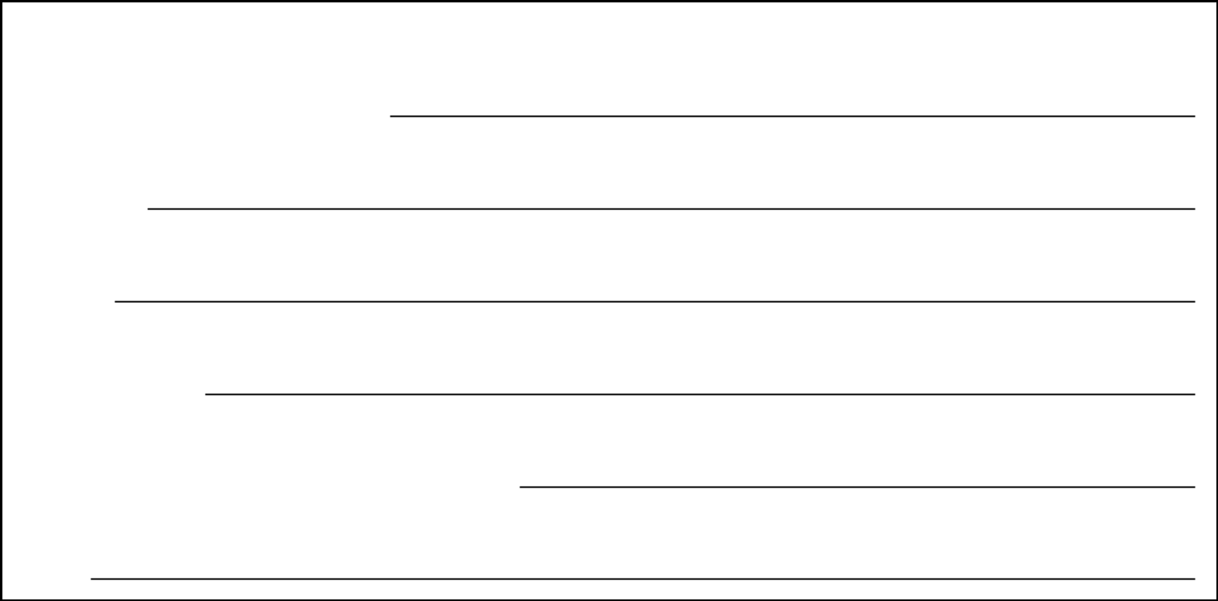

SIGN HERE

Name of beneficial owner(s) (please print):

Signature(s):

Address:

Telephone Number:

Taxpayer Identification Number or Social Security Number:

Date:

QuickLinks

Exhibit 99.04

SIGN HERE

