SEC Form 4

FORM 4

Check this box if no longer subject to Section 16. Form 4 or Form 5 obligations may continue. See Instruction 1(b).

UNITED STATES SECURITIES AND EXCHANGE COMMISSION
Washington, D.C. 20549
 |  | OMB APPROVAL
STATEMENT OF CHANGES IN BENEFICIAL OWNERSHIP
 |  | OMB Number: | 3235-0287
 |  | Estimated average burden
Filed pursuant to Section 16(a) of the Securities Exchange Act of 1934 |  | hours per response: | 0.5
or Section 30(h) of the Investment Company Act of 1940
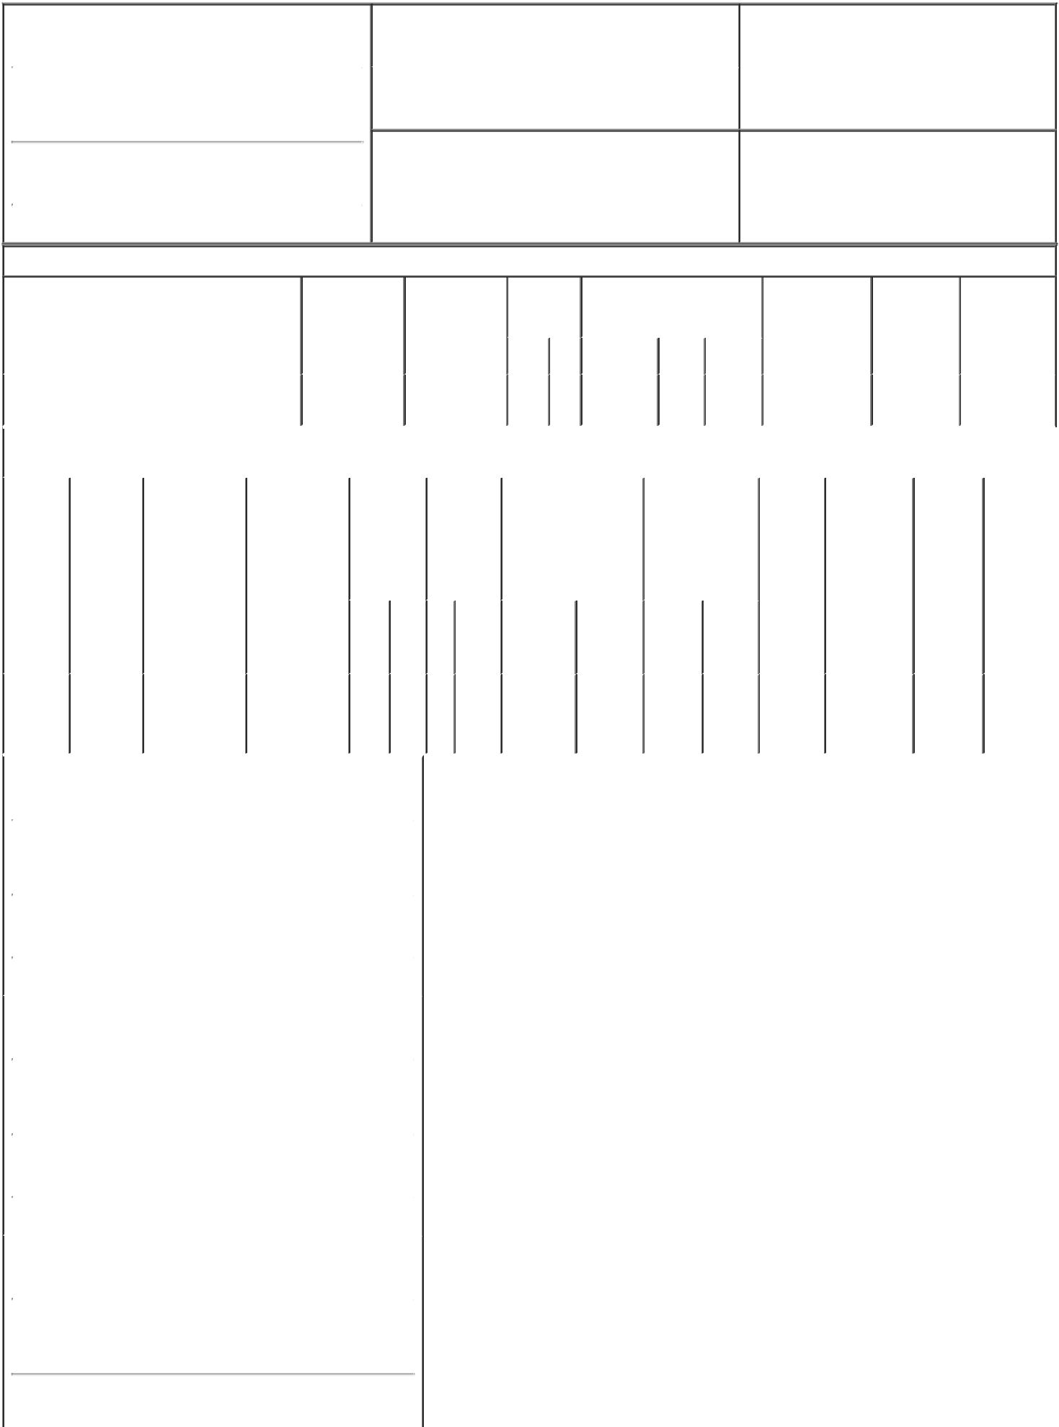

1. Name and Address of Reporting Person* |  |  |  |  |  | 2. |  |  | Issuer Name and Ticker or Trading Symbol
 |  | Global Infrastructure Investors III, LLC |  |  |  |  | Clearway Energy, Inc. [ CWEN ]
 |  | (Last) | (First) | (Middle) |  | 3. |  |  | Date of Earliest Transaction (Month/Day/Year)
 |  |  |  |  |  | 03/25/2022
1345 AVENUE OF THE AMERICAS, 30TH FLOOR

- Relationship of Reporting Person(s) to Issuer (Check all applicable)

Director X 10% Owner

Officer (give title Other (specify

below) below)

(Street)
 | NEW YORK | NY | 10105
 | (City) | (State) | (Zip)

4. If Amendment, Date of Original Filed (Month/Day/Year) 6. Individual or Joint/Group Filing (Check Applicable Line)

 | Form filed by One Reporting Person
X | Form filed by More than One Reporting
 | Person

Table I - Non-Derivative Securities Acquired, Disposed of, or Beneficially Owned

 | 1. Title of Security (Instr. 3) |  |  |  |  |  | 2. Transaction |  |  |  | 2A. Deemed |  |  |  | 3. |  | 4. Securities Acquired (A) or |  |  |  | 5. Amount of |  | 6. Ownership |  | 7. Nature of
 |  |  |  |  |  |  | Date |  |  |  | Execution Date, |  |  |  |  | Transaction | Disposed Of (D) (Instr. 3, 4 and |  |  |  | Securities |  | Form: Direct |  | Indirect
 |  |  |  |  |  |  | (Month/Day/Year) |  |  |  | if any |  |  |  |  | Code (Instr. | 5) |  |  |  | Beneficially |  | (D) or Indirect |  | Beneficial
 |  |  |  |  |  |  |  |  |  |  | (Month/Day/Year) |  |  |  | 8) |  |  |  |  |  | Owned Following |  | (I) (Instr. 4) |  | Ownership
 |  |  |  |  |  |  |  |  |  |  |  |  |  |  |  |  |  |  |  |  | Reported |  |  |  | (Instr. 4)
 |  |  |  |  |  |  |  |  |  |  |  |  |  |  |  | Code V | Amount | (A) or | Price |  | Transaction(s)
 |  |  |  |  |  |  |  |  |  |  |  |  |  |  |  |  |  | (D) |  |  | (Instr. 3 and 4)
 | Class C Common Stock |  |  |  |  | 03/25/2022 |  |  |  |  |  |  |  |  |  | C | 47,000 | A | (1) |  | 92,208 |  |  | I | See
 |  |  |  |  |  |  |  |  |  |  |  |  |  |  |  |  |  |  |  |  |  |  |  |  | footnotes⁽²⁾⁽³⁾
 |  |  |  |  |  | Table II - Derivative Securities Acquired, Disposed of, or Beneficially Owned
 |  |  |  |  |  |  | (e.g., puts, calls, warrants, options, convertible securities)
 | 1. Title of |  |  | 2. | 3. Transaction | 3A. Deemed |  |  |  | 4. |  |  |  | 5. Number | 6. Date Exercisable and |  |  | 7. Title and Amount |  |  | 8. Price of | 9. Number of |  | 10. |  | 11. Nature of
 | Derivative |  |  | Conversion | Date | Execution Date, |  |  |  | Transaction |  |  |  | of | Expiration Date |  |  | of Securities |  |  | Derivative | derivative |  | Ownership |  | Indirect
 | Security |  |  | or Exercise | (Month/Day/Year) | if any |  |  |  | Code (Instr. |  |  |  | Derivative | (Month/Day/Year) |  |  | Underlying |  |  | Security | Securities |  | Form: |  | Beneficial
 | (Instr. 3) |  |  | Price of |  | (Month/Day/Year) |  |  |  | 8) |  |  |  | Securities |  |  |  | Derivative Security |  |  | (Instr. 5) | Beneficially |  | Direct (D) |  | Ownership
 |  |  |  | Derivative |  |  |  |  |  |  |  |  |  | Acquired |  |  |  | (Instr. 3 and 4) |  |  |  | Owned |  | or Indirect |  | (Instr. 4)
 |  |  |  | Security |  |  |  |  |  |  |  |  |  | (A) or |  |  |  |  |  |  |  | Following |  | (I) (Instr. 4)
 |  |  |  |  |  |  |  |  |  |  |  |  |  | Disposed |  |  |  |  |  |  |  | Reported
 |  |  |  |  |  |  |  |  |  |  |  |  |  | of (D) (Instr. |  |  |  |  |  |  |  | Transaction(s)
 |  |  |  |  |  |  |  |  |  |  |  |  |  | 3, 4 and 5) |  |  |  |  |  |  |  | (Instr. 4)
 |  |  |  |  |  |  |  |  |  |  |  |  |  |  |  |  |  |  | Amount
 |  |  |  |  |  |  |  |  |  |  |  |  |  |  |  |  |  |  | or
 |  |  |  |  |  |  |  |  |  |  |  |  |  |  |  |  |  |  | Number
 |  |  |  |  |  |  |  |  |  |  |  |  |  |  | Date |  | Expiration |  | of
 |  |  |  |  |  |  |  |  |  | Code V |  |  |  | (A) (D) | Exercisable |  | Date | Title | Shares
 | Class D
 | Units of |  |  | (1) |  |  |  |  |  |  |  |  |  |  | (1) |  | (1) | Class C | 47,000 |  |  |  |  |  |  | See
 | Clearway |  |  |  | 03/25/2022 |  |  |  |  | C |  |  |  | 47,000 |  |  |  | Common |  |  | $0 | 42,586,750 |  | I
 |  |  |  |  |  |  |  |  |  |  |  |  |  |  |  |  |  |  |  |  |  |  |  |  |  | footnotes⁽²⁾⁽³⁾
 | Energy |  |  |  |  |  |  |  |  |  |  |  |  |  |  |  |  | Stock
 | LLC
 | 1. Name and Address of Reporting Person*
 |  |  | Global Infrastructure Investors III, LLC
 |  |  | (Last) |  | (First) |  | (Middle)
 |  |  | 1345 AVENUE OF THE AMERICAS, 30TH FLOOR
 | (Street)
 |  |  | NEW YORK |  | NY | 10105
 |  |  | (City) |  | (State) |  | (Zip)
 | 1. Name and Address of Reporting Person*
 |  |  | Global Infrastructure GP III, L.P.
 |  |  | (Last) |  | (First) |  | (Middle)
 |  |  | 1345 AVENUE OF THE AMERICAS, 30TH FLOOR
 | (Street)
 |  |  | NEW YORK |  | NY | 10105
 |  |  | (City) |  | (State) |  | (Zip)
 | 1. Name and Address of Reporting Person*
 |  |  | GIP III Zephyr Acquisition Partners L.P.
 |  |  | (Last) |  | (First) |  | (Middle)

1345 AVENUE OF THE AMERICAS, 30TH FLOOR

(Street)

NEW YORK NY 10105

 |  | (City) | (State) |  | (Zip)
1. Name and Address of Reporting Person*
 |  | Clearway Energy Group LLC
 |  | (Last) | (First) |  | (Middle)
1345 AVENUE OF THE AMERICAS, 30TH FLOOR

(Street)
 | NEW YORK | NY | 10105
 | (City) | (State) | (Zip)

Explanation of Responses:

- Pursuant to an Amended and Restated Exchange Agreement, dated as of May 14, 2015, among Clearway Energy, Inc. (the "Issuer"), Clearway Energy LLC ("Clearway LLC") and other parties thereto (the "Exchange Agreement"), the Class D Units of Clearway LLC are exchangeable at any time for shares of Class C common stock of the Issuer ("Class C Common Stock") on a one-for-one basis, subject to equitable adjustments for stock splits, stock dividends and reclassifications. As the holder exchanges the Class D Units for shares of Class C Common Stock pursuant to the Exchange Agreement, an equivalent number of shares of Class D Common Stock issued to the holder will automatically be canceled.

- Reflects securities held directly by Clearway Energy Group LLC ("Clearway Energy Group"). Global Infrastructure Investors III, LLC ("Global Investors") is the sole general partner of Global Infrastructure GP III, L.P. ("Global GP"), which is the general partner of GIP III Zephyr Acquisition Partners, L.P. ("GIP"), which is the sole member of Clearway Energy Group. As a result, Global Investors, Global GP, and GIP may be deemed to share beneficial ownership of the Issuer securities owned by Clearway Energy Group. Adebayo Ogunlesi, Jonathan Bram, William Brilliant, Matthew Harris, Michael McGhee, Rajaram Rao, William Woodburn, Salim Samaha and Robert O'Brien, as the voting members of the Investment Committee of Global Investors, may be deemed to share beneficial ownership of the Issuer securities beneficially owned by Global Investors. Such individuals expressly disclaim any such beneficial ownership.

- Each of the Reporting Persons disclaims beneficial ownership of the securities reported herein, except to the extent of such Reporting Person's pecuniary interest therein, and, pursuant to Rule 16a-1(a)(4) under the Securities Exchange Act of 1934, each of the Reporting Persons states that the inclusion of these securities in this report shall not be deemed an admission of beneficial ownership of the securities reported herein for purposes of Section 16 or for any other purpose.

GLOBAL
INFRASTRUCTURE
INVESTORS III, LLC By: /s/
Jonathan Bram Name: Jonathan
Bram Title: Partner

GLOBAL
INFRASTRUCTURE GP III,
L.P. By: Global Infrastructure
Investors III, LLC, its general
partner By: /s/ Jonathan Bram
Name: Jonathan Bram Title:
Partner

GIP III ZEPHYR
ACQUISITION PARTNERS,
L.P. By: Global Infrastructure
GP III, L.P., its general partner
By: Global Infrastructure
Investors III, LLC, its general
partner By: /s/ Jonathan Bram
Name: Jonathan Bram Title:
Partner

CLEARWAY ENERGY
GROUP LLC By: /s/ Craig
Cornelius Name: Craig
Cornelius Title: Chief
Executive Officer

03/29/2022

03/29/2022

03/29/2022

03/29/2022

** Signature of Reporting Person Date

Reminder: Report on a separate line for each class of securities beneficially owned directly or indirectly.

* If the form is filed by more than one reporting person, see Instruction 4 (b)(v).

- Intentional misstatements or omissions of facts constitute Federal Criminal Violations See 18 U.S.C. 1001 and 15 U.S.C. 78ff(a). Note: File three copies of this Form, one of which must be manually signed. If space is insufficient, see Instruction 6 for procedure.

Persons who respond to the collection of information contained in this form are not required to respond unless the form displays a currently valid OMB Number.

